Appendix A

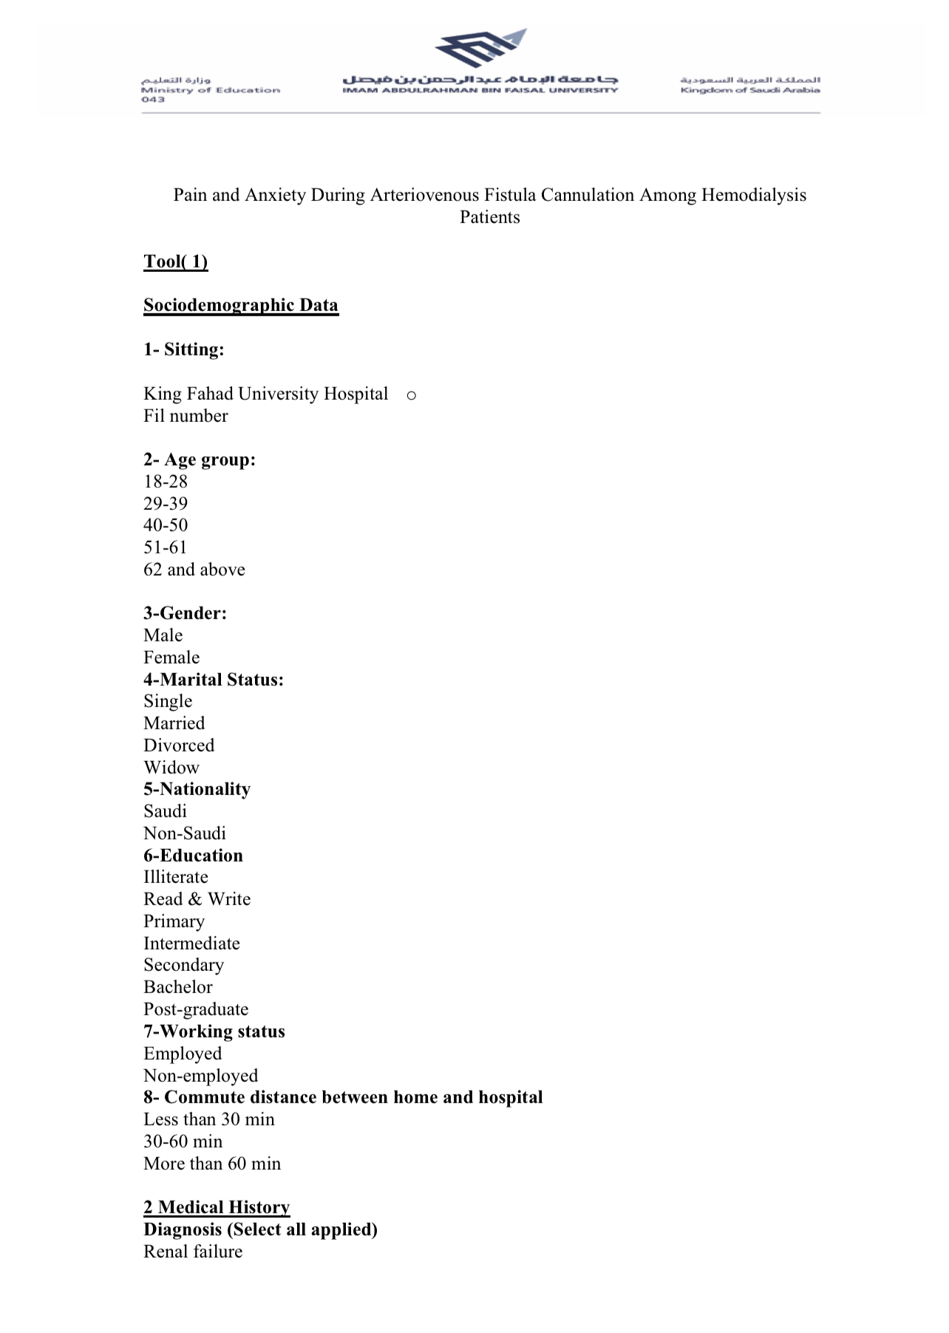

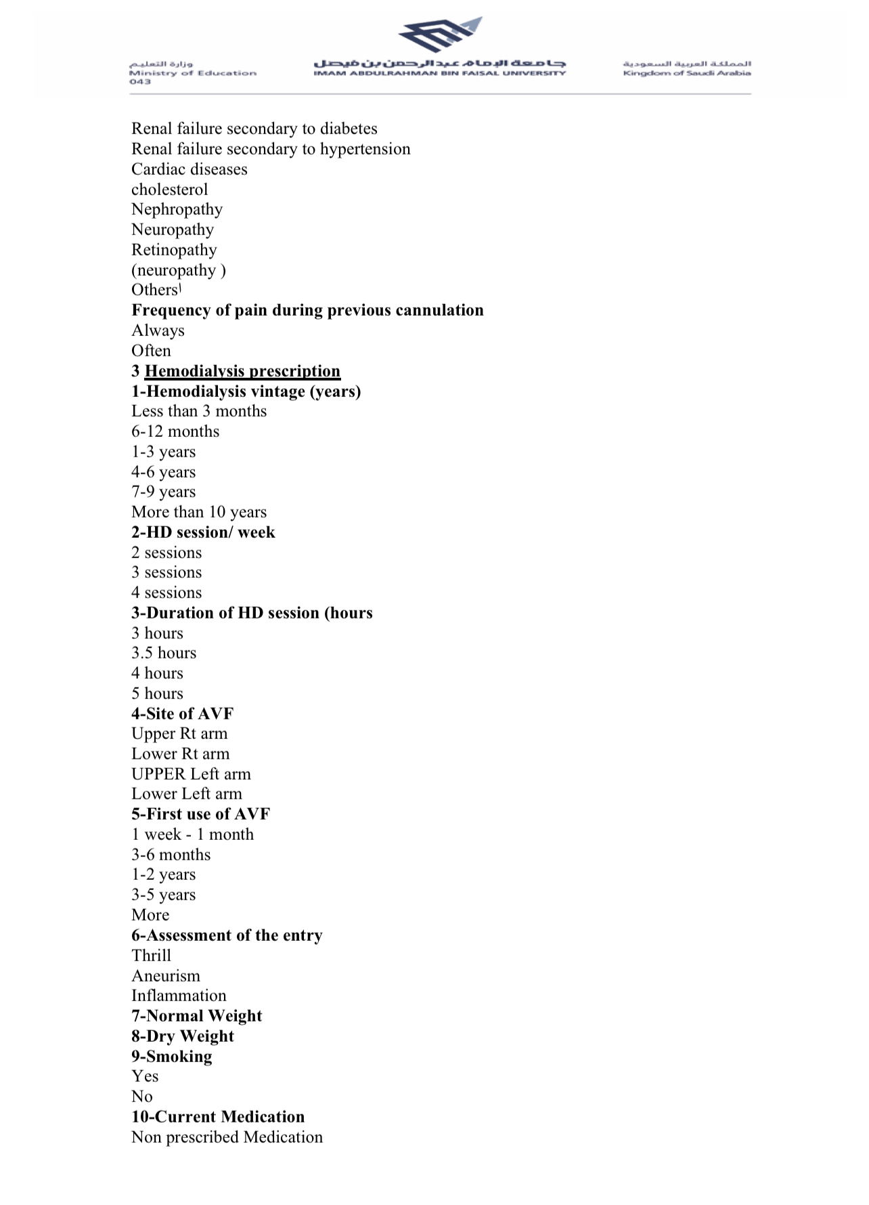

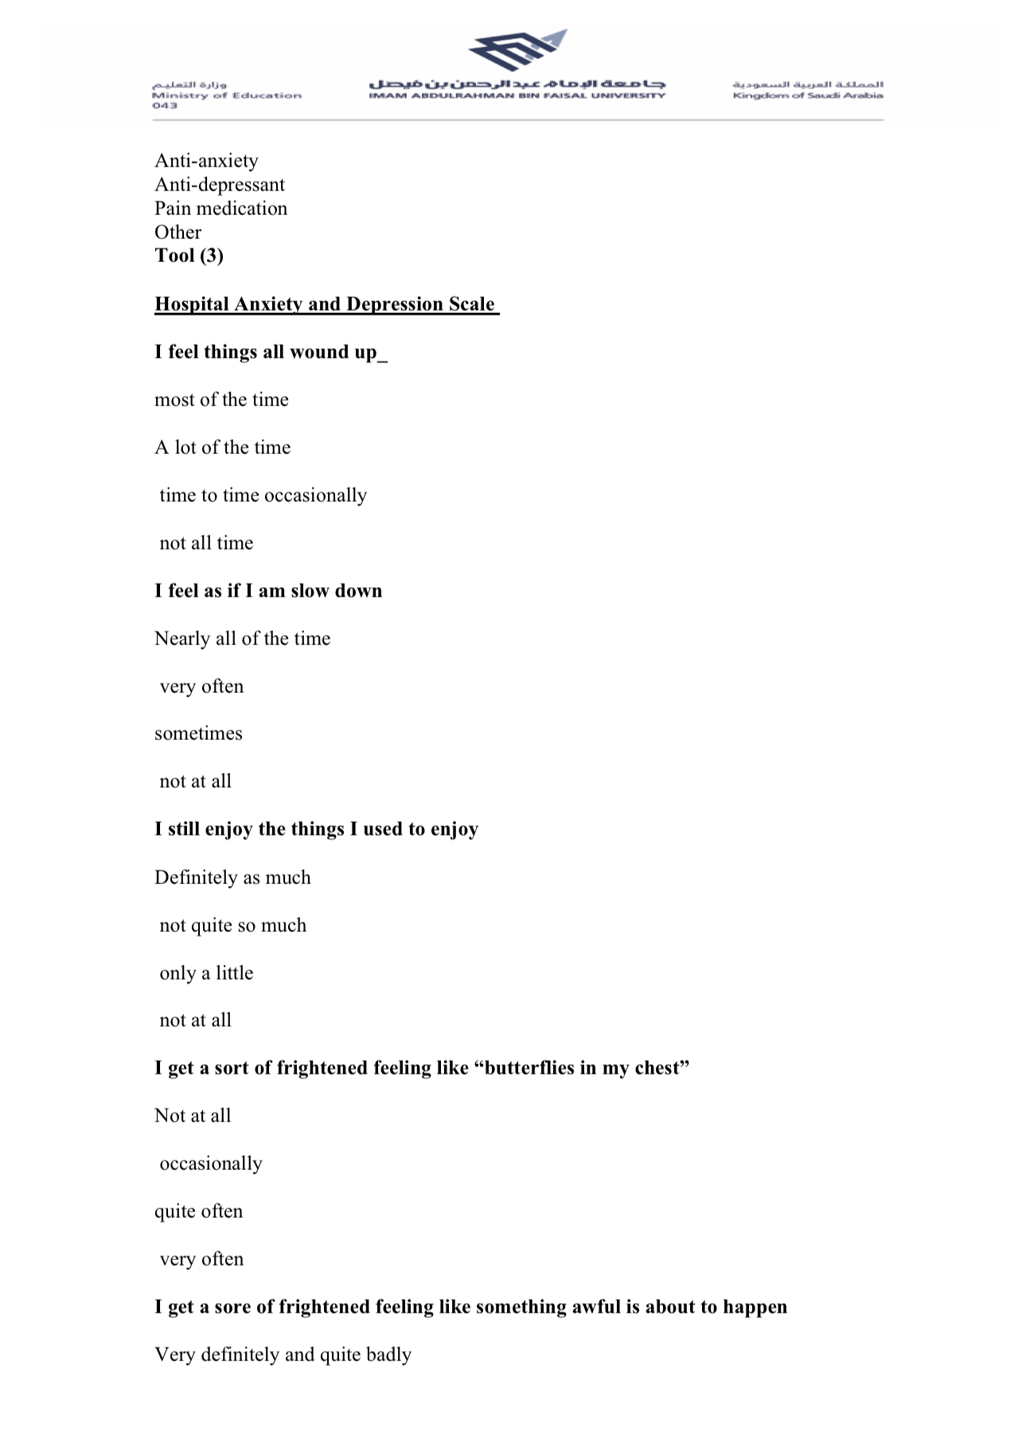

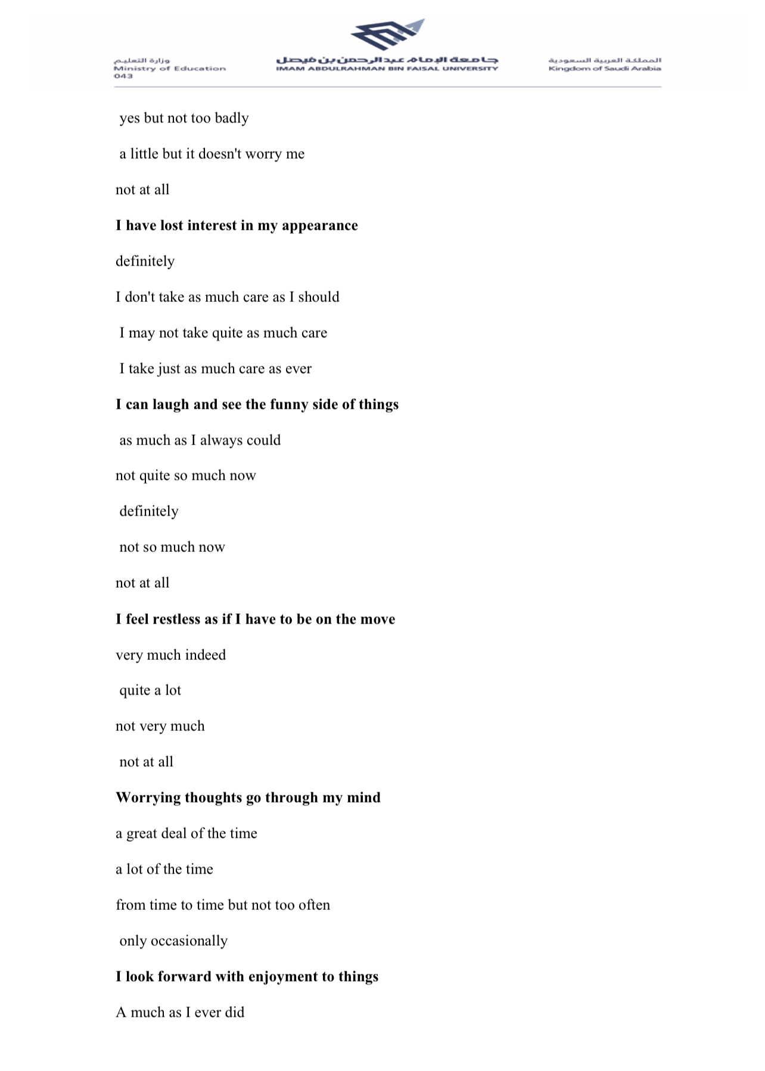

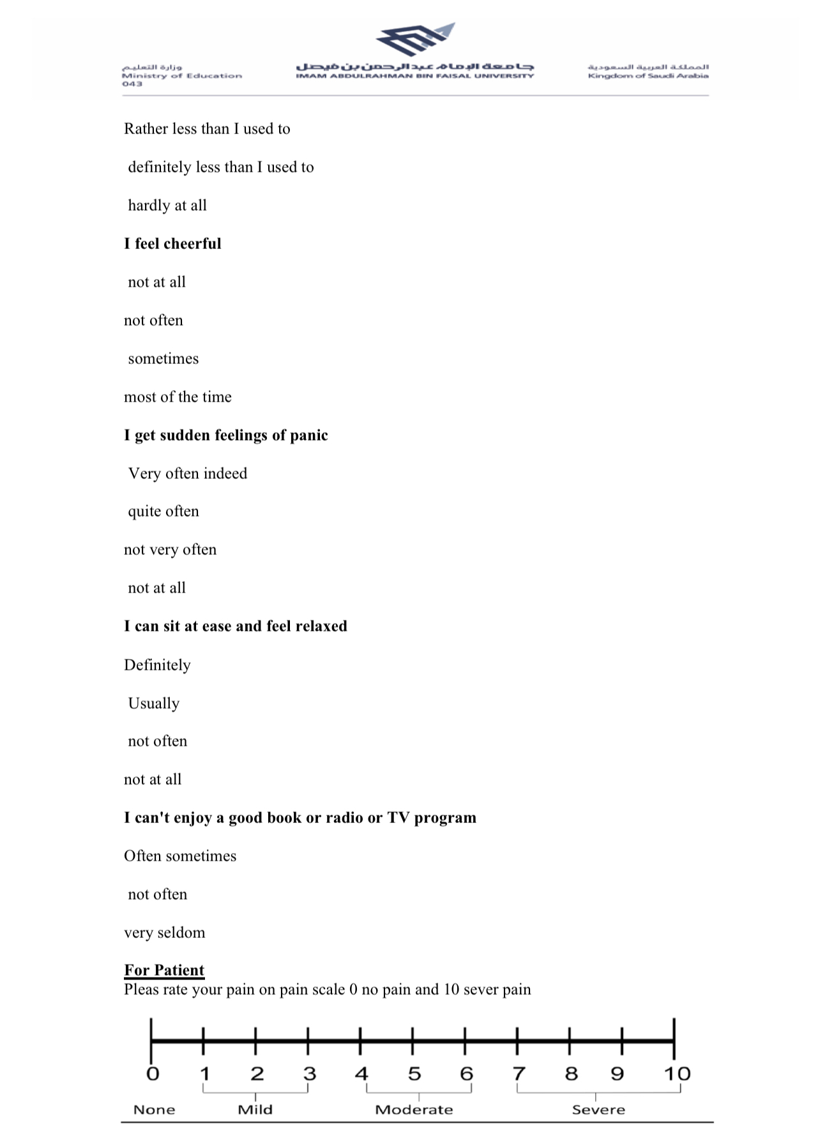

Notes: The Hospital Anxiety and Depression Scale reprinted with permission from: Zigmond AS, Snaith RP. The Hospital Anxiety and Depression Scale. Acta Psychiatr Scand. 1983;67(6):361-370. doi:10.1111/j.1600-0447.1983.tb09716.x. © John Wiley & Sons A/S. Published by John Wiley & Sons Ltd.

