Supplementary Figure 1: Hip abduction strength. (a) Knee only or Hip only exercise programs compared with Controls. (b) Hip only or Hip&Knee exercise programs compared with Knee only exercise programs.
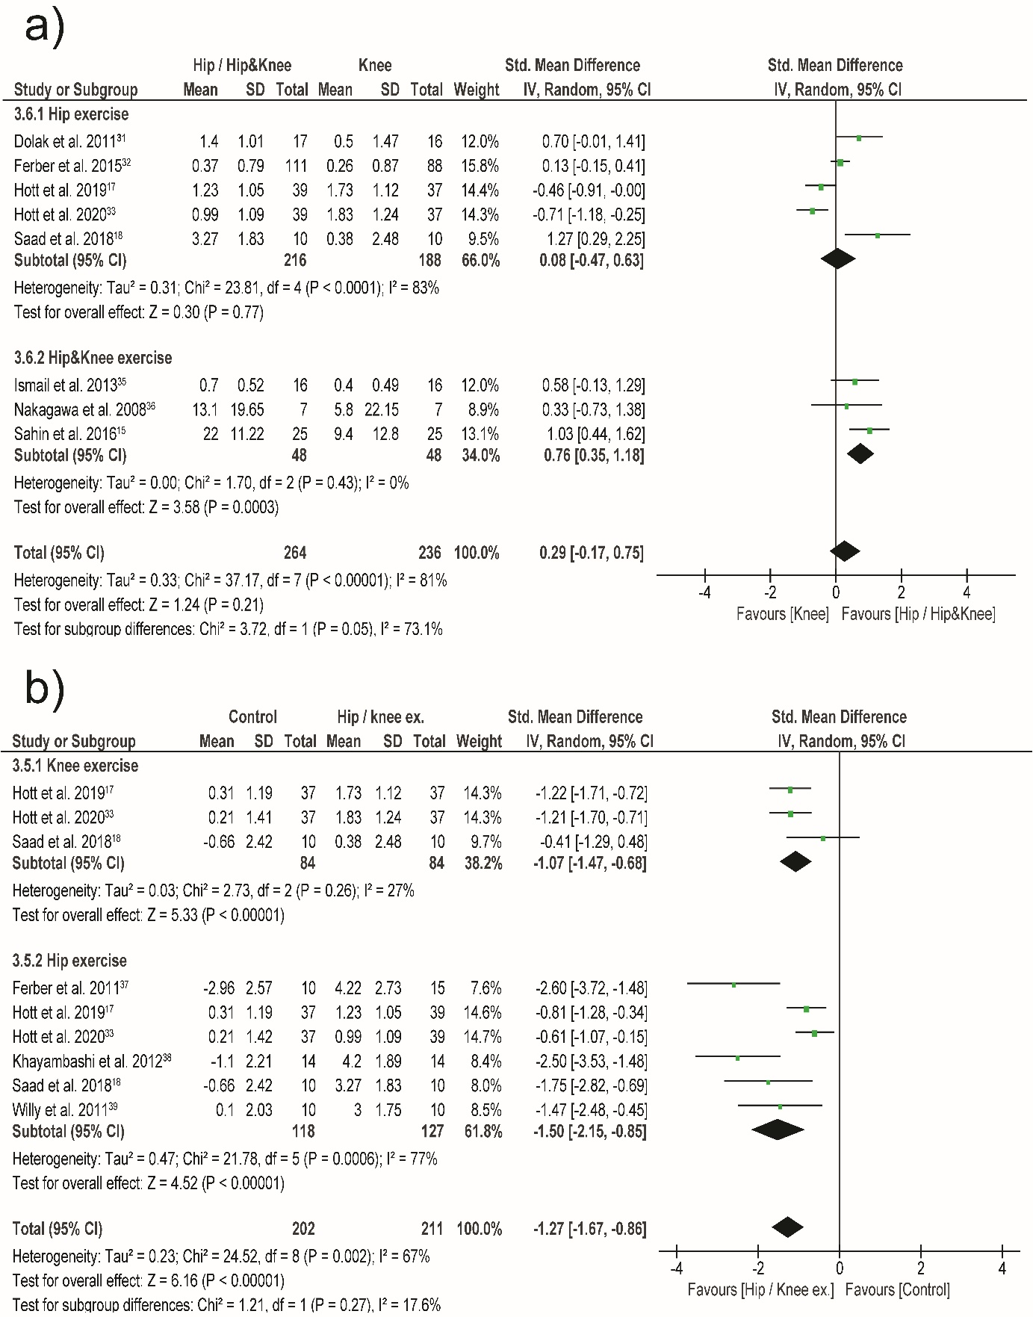

Supplementary Figure 2: Hip external rotation strength. (a) Hip only or Knee only exercise programs compared with Controls. (b) Hip only or Hip&Knee exercise programs compared with Knee only exercise programs.
