Supplementary Material

Supplementary Figures
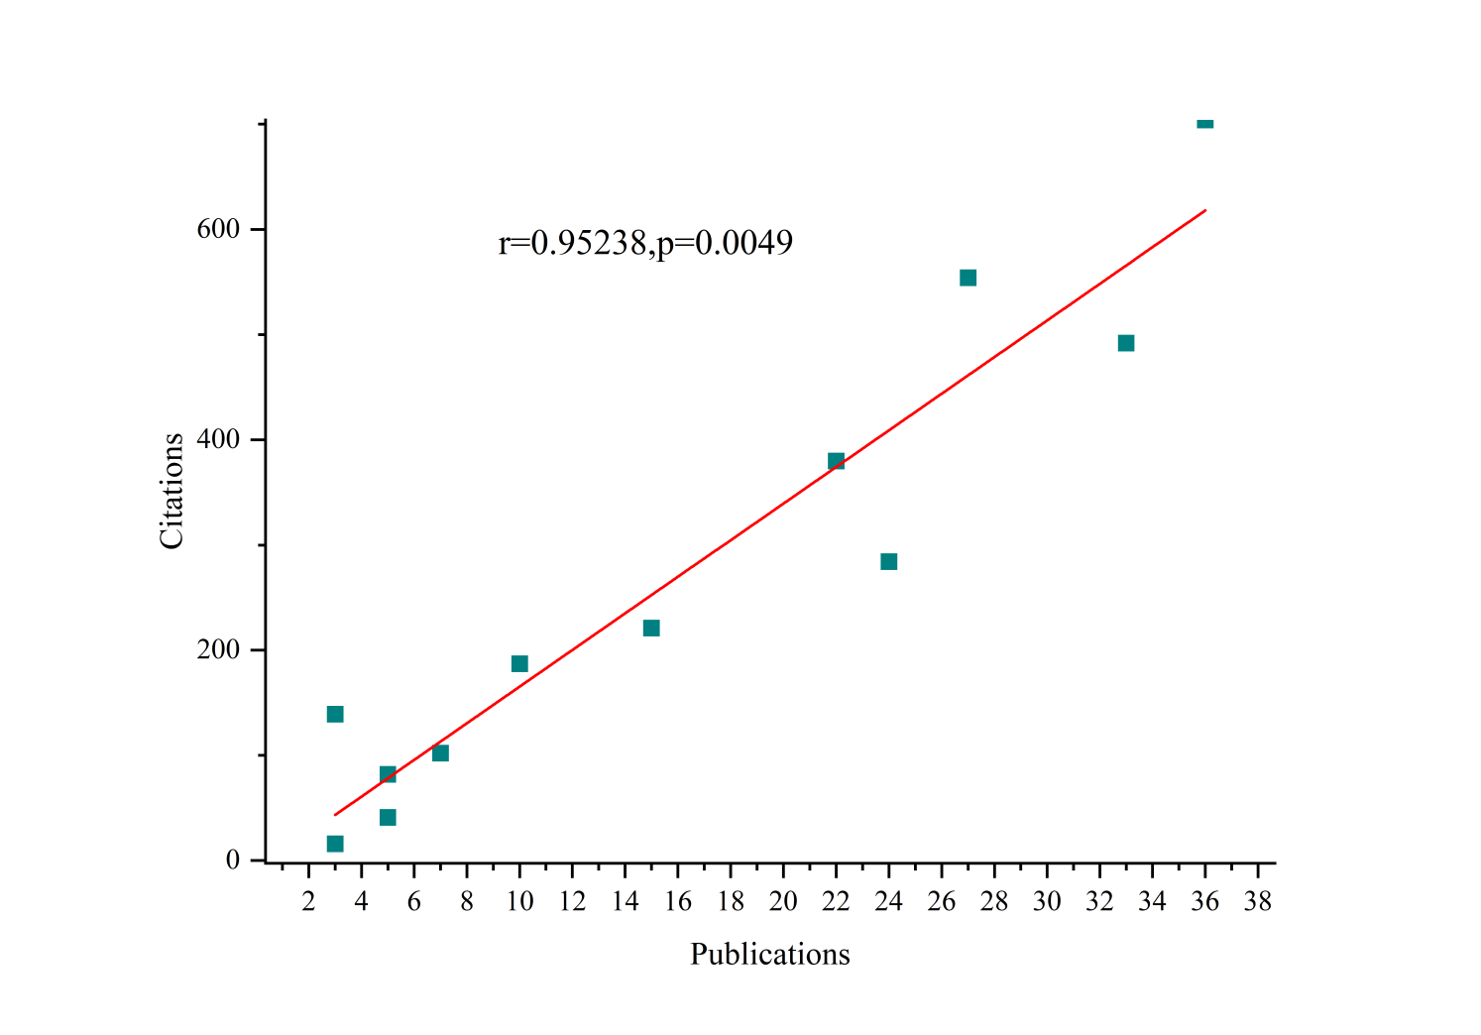
Supplementary Figure 1. Curve fitting of annual growth trend of publications from 2000 to 2024.

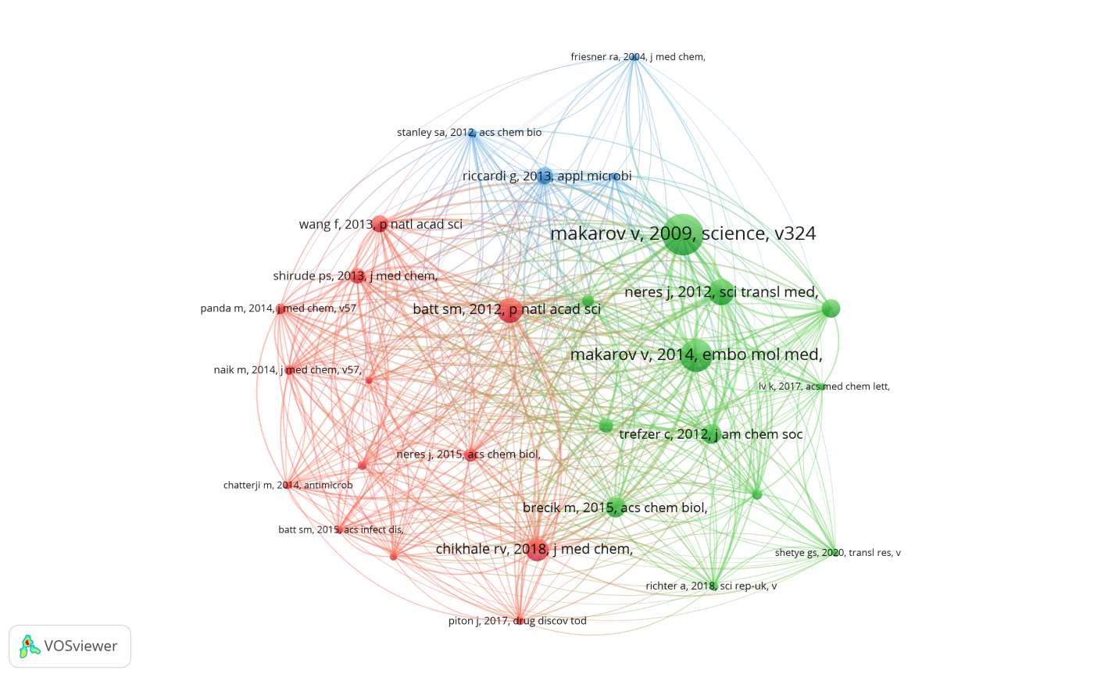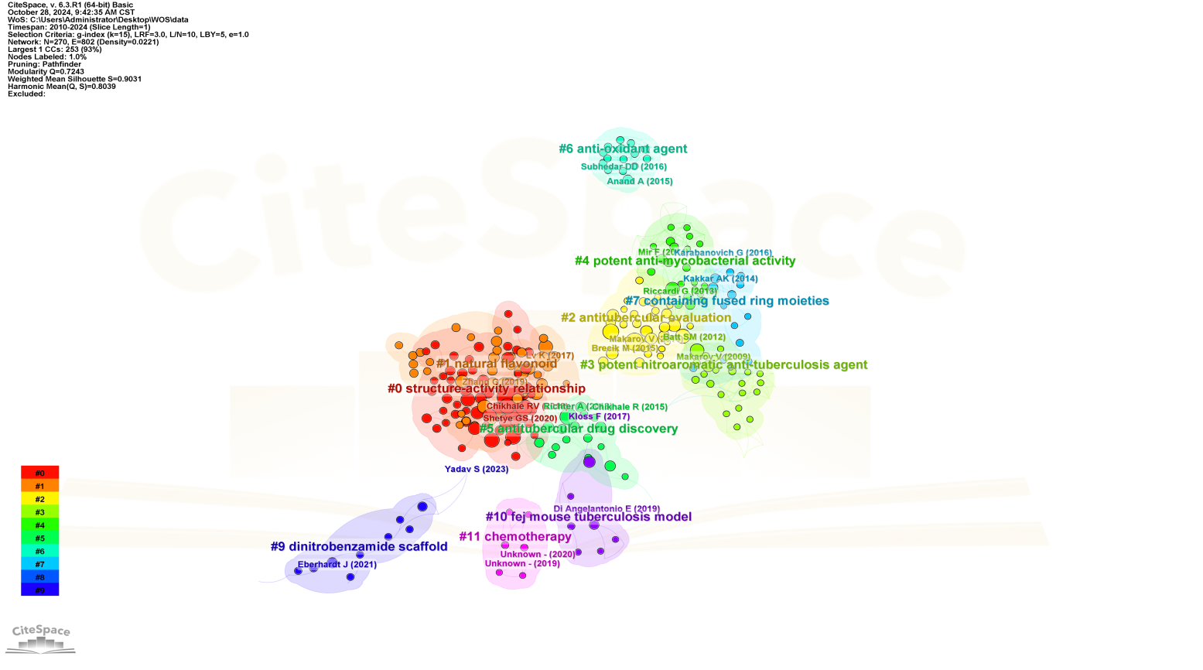
Supplementary Figure 2. Network visualization map of reference co-citation analysis generated by the CiteSpace. All the references are clustered into 11 clusters. From 2000 to 2022, the color changed from deep to light yellow.

Supplementary Table 1 Top 17 Institutions with the Strongest Citation Bursts
Institutions | Year | Strength | Begin | End | 2010 - 2024
Swiss Federal Institutes of Technology Domain | 2010 | 2.75 | 2010 | 2016 | ▃▃▃▃▃▃▃▂▂▂▂▂▂▂▂
Ecole Polytechnique Federale de Lausanne | 2010 | 2.6 | 2010 | 2016 | ▃▃▃▃▃▃▃▂▂▂▂▂▂▂▂
AstraZeneca | 2013 | 3.14 | 2013 | 2016 | ▂▂▂▃▃▃▃▂▂▂▂▂▂▂▂
University of Notre Dame | 2013 | 2.63 | 2013 | 2017 | ▂▂▂▃▃▃▃▃▂▂▂▂▂▂▂
University of Illinois System | 2014 | 1.7 | 2014 | 2016 | ▂▂▂▂▃▃▃▂▂▂▂▂▂▂▂
University of Illinois Chicago Hospital | 2014 | 1.7 | 2014 | 2016 | ▂▂▂▂▃▃▃▂▂▂▂▂▂▂▂
University of Illinois Chicago | 2014 | 1.7 | 2014 | 2016 | ▂▂▂▂▃▃▃▂▂▂▂▂▂▂▂
CSIR - National Chemical Laboratory (NCL) | 2015 | 2.78 | 2015 | 2019 | ▂▂▂▂▂▃▃▃▃▃▂▂▂▂▂
Dr. Babasaheb Ambedkar Marathwada University (BAMU) | 2016 | 1.86 | 2016 | 2019 | ▂▂▂▂▂▂▃▃▃▃▂▂▂▂▂
Peking Union Medical College | 2017 | 3.85 | 2017 | 2020 | ▂▂▂▂▂▂▂▃▃▃▃▂▂▂▂
Institute of Medicinal Biotechnology - CAMS | 2017 | 2.77 | 2017 | 2020 | ▂▂▂▂▂▂▂▃▃▃▃▂▂▂▂
Chinese Academy of Medical Sciences - Peking Union Medical College | 2017 | 2.4 | 2017 | 2020 | ▂▂▂▂▂▂▂▃▃▃▃▂▂▂▂
University of Cape Town | 2018 | 1.69 | 2020 | 2021 | ▂▂▂▂▂▂▂▂▂▂▃▃▂▂▂
Academy of Scientific & Innovative Research (AcSIR) | 2017 | 1.56 | 2021 | 2022 | ▂▂▂▂▂▂▂▂▂▂▂▃▃▂▂
Max Planck Society | 2022 | 1.72 | 2022 | 2024 | ▂▂▂▂▂▂▂▂▂▂▂▂▃▃▃
Martin Luther University Halle Wittenberg | 2022 | 1.7 | 2022 | 2022 | ▂▂▂▂▂▂▂▂▂▂▂▂▃▂▂
Charles University Prague | 2016 | 1.41 | 2023 | 2024 | ▂▂▂▂▂▂▂▂▂▂▂▂▂▃▃

