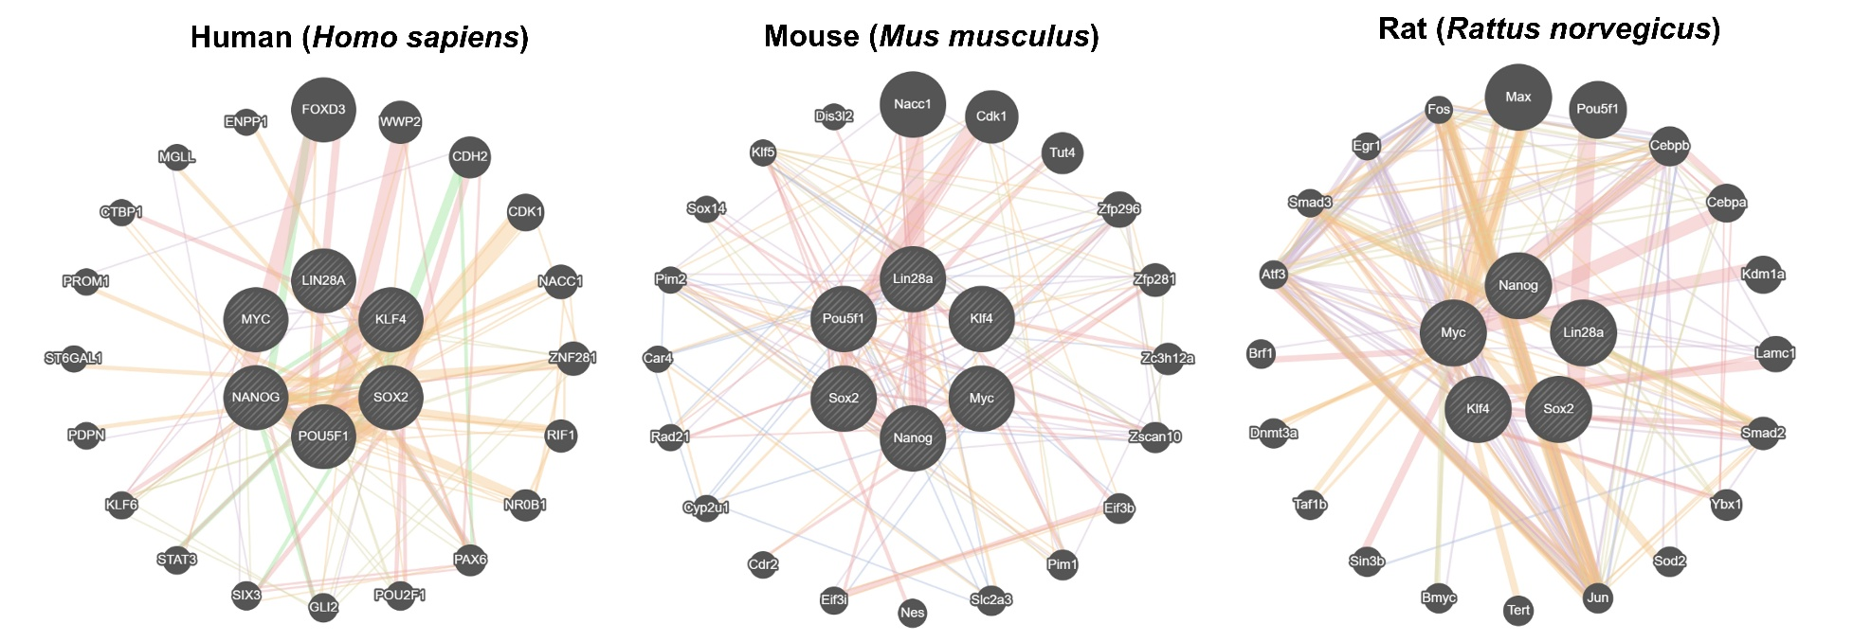
Supplementary Figure 1. The main differences between the pluripotency factors networks in different animals.

