Supplementary information

Different properties of the erector spinae and multifidus muscles on physical performance in patients with chronic obstructive pulmonary disease

Kyosuke Imashiro^{1,2}, Masanori Nakanishi³, Yuta Minoshima^{1,2}, Ken Kouda², Seigo Sasaki⁴, Koichiro Takahashi⁵, Kazuhisa Asai⁶, Tsunahiko Hirano⁷, Kazuto Matsunaga⁷, Yoshiaki Minakata⁴

Supplementary Figures
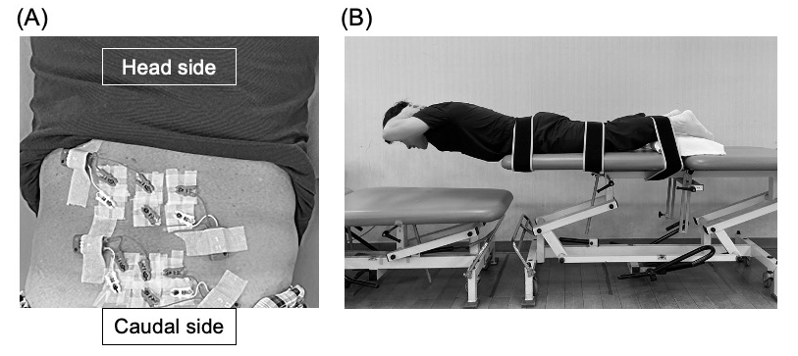
Figure S1. Trunk holding test.
(A) Attaching the electrodes, (B) Implementation of the trunk holding test.

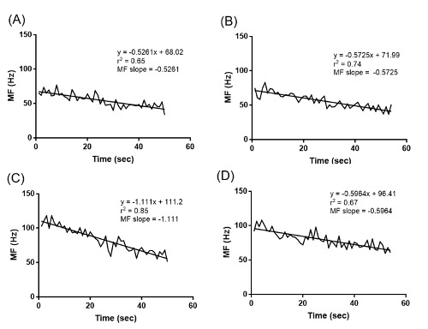
Figure S2. Typical example of MF slope
(A) Erector spinae muscle in patients with COPD, (B) erector spinae muscle in healthy subjects, (C) multifidus muscle in patients with COPD, (D) multifidus muscle in healthy subjects. Abbreviation: MF slope, median frequency slope.

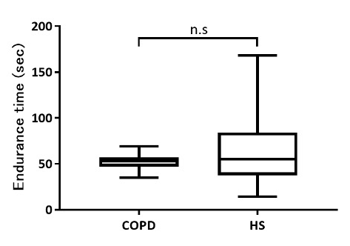
Figure S3. A comparison of the endurance time in the trunk holding test.
Abbreviations: HS, healthy subjects. n.s., not significant.

