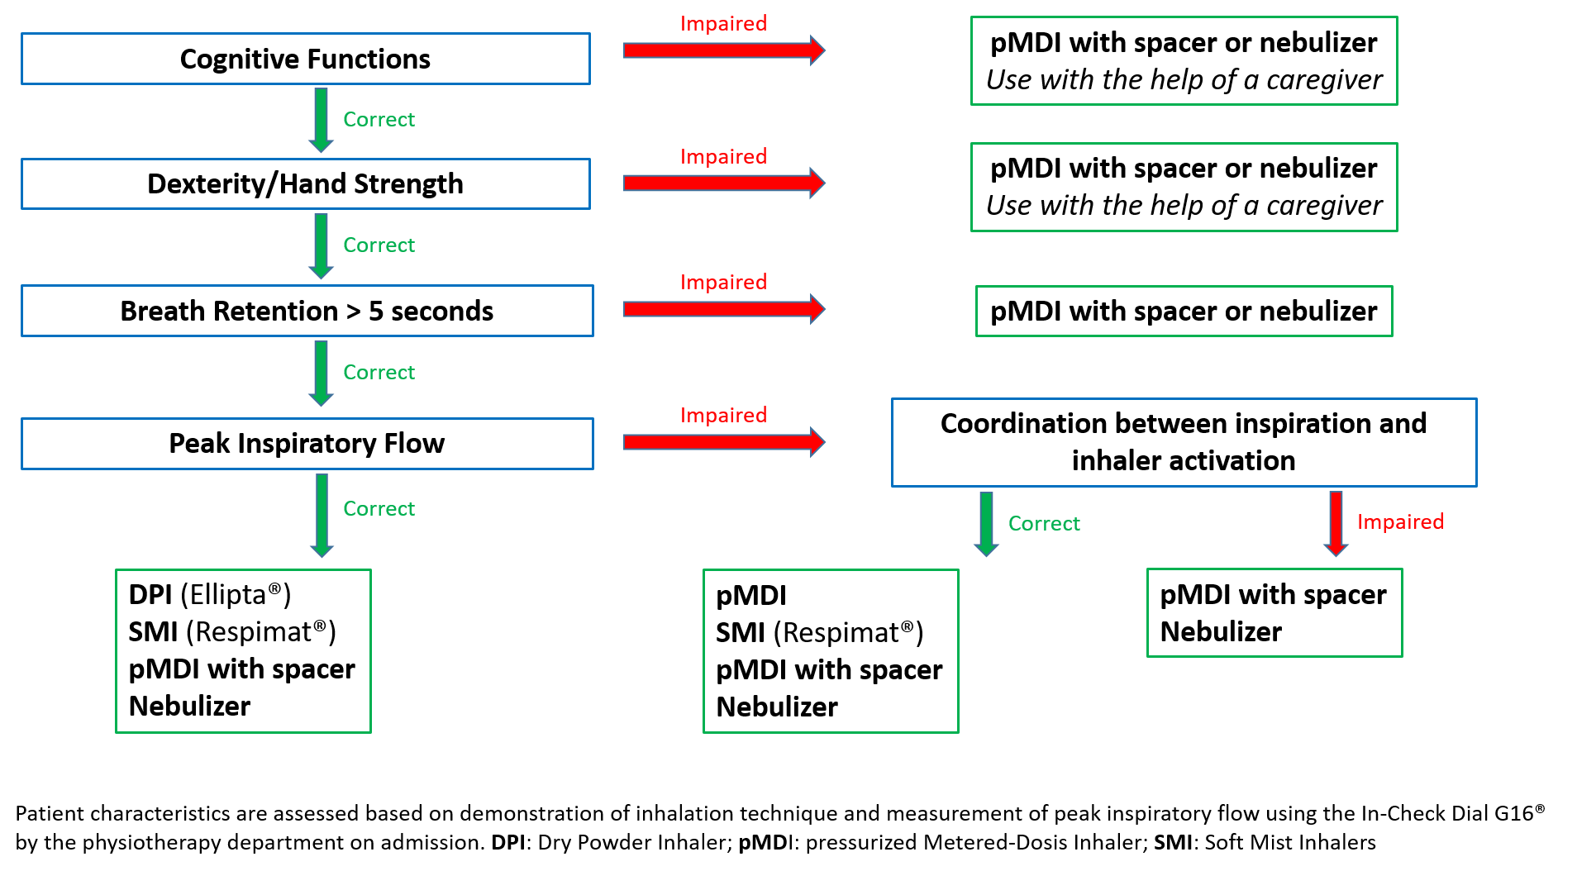
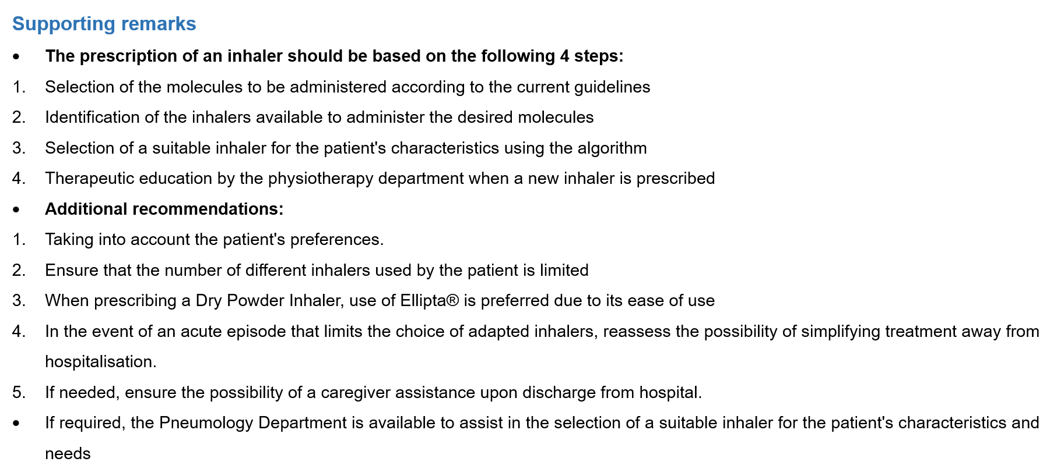

Figure S1. Written guide to assist in the selection of an adapted inhaler according to patient characteristics.
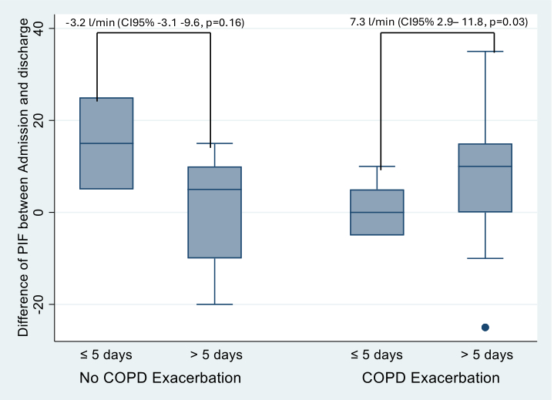
Figure S2. Evolution of PIF in patients with AECOPD and without AECOPD, analyses of stays longer or shorter than 5 days
AECOPD: acute exacerbation of chronic obstructive pulmonary disease, CI: confidence interval, COPD: chronic obstructive pulmonary disease, PIF: peak inspiratory flow

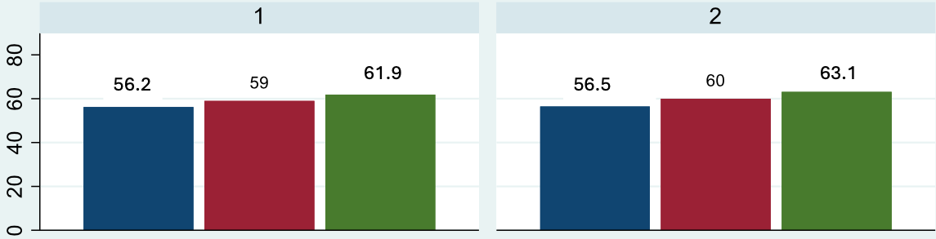
Figure S3a. Evolution of intra-assessment PIF based on median age at admission
1 = measurement at admission in group older than medium age
2 = measurement at admission in group younger than medium age
PIF = peak inspiratory flow
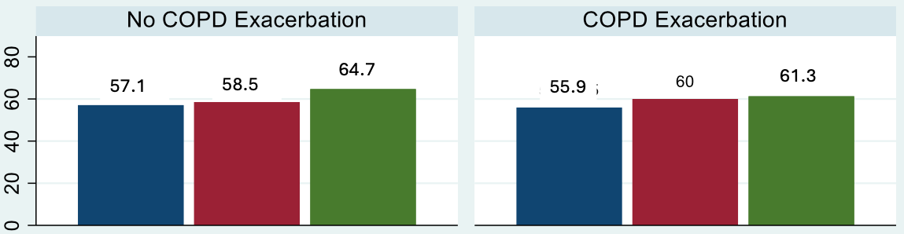
Figure S3b. Evolution of intra-assessment PIF based on presence or not of AECOPD at admission
AECOPD = acute exacerbation of chronic obstructive pulmonary disease, COPD : chronic obstructive pulmonary disease, PFI= peak inspiratory flow

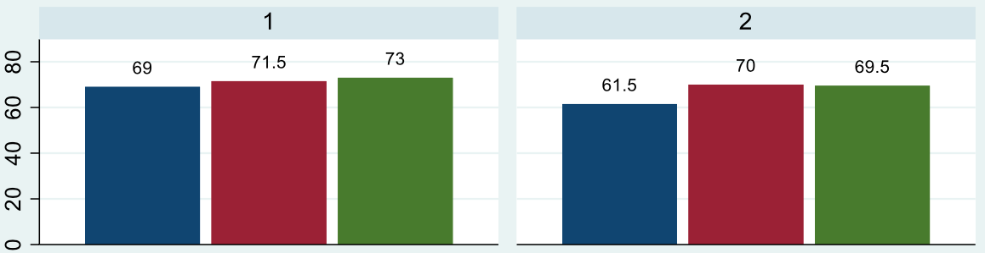
Figure S3c. Evolution of intra-assessment PIF based on median age at discharge
1 = measurement at discharge in group younger than medium age
2 = measurement at admission in group older than medium age
PIF = peak inspiratory flow

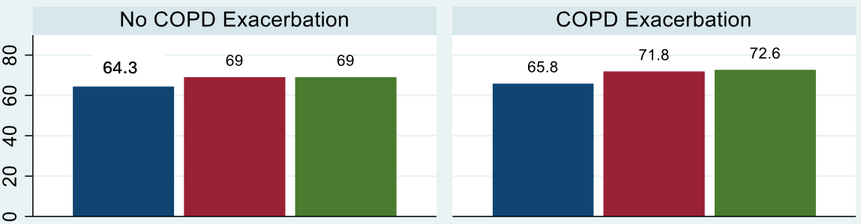
Figure S3d. Evolution of intra-assessment PIF based on presence or not of AECOPD at discharge
AECOPD = acute exacerbation of chronic obstructive pulmonary disease, COPD : chronic obstructive pulmonary disease, PFI= peak inspiratory flow

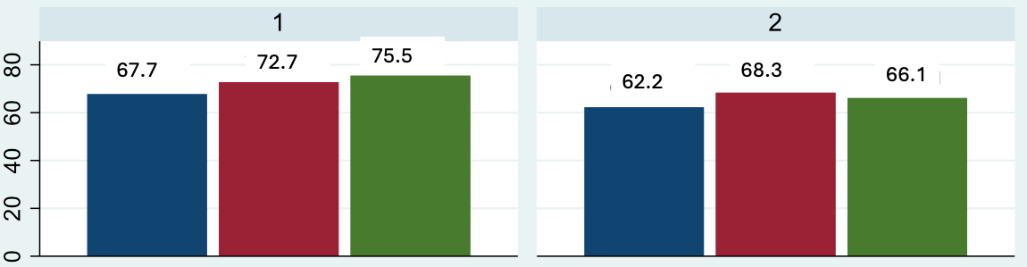
Figure S3e. Evolution of intra-assessment PIF based on median length of hospital stay at discharge
1 = measurement at discharge in group with shorter than median LHS
2 = measurement at discharge in group with longer than median LHS
LHS = length of hospital stay, PIF = peak inspiratory flow

