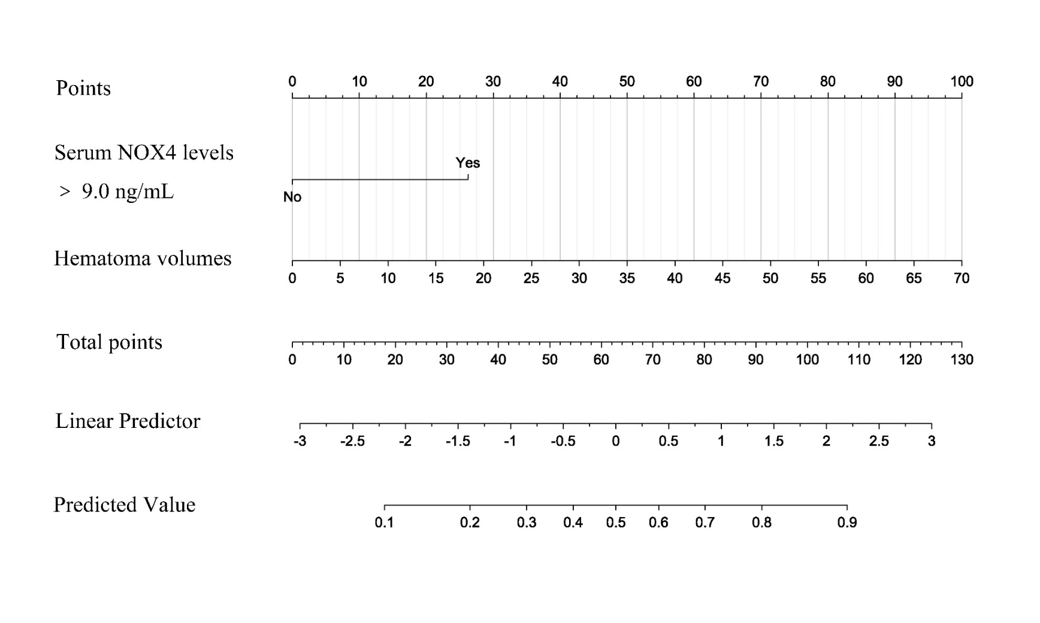
Supplemental Figure 1
Nomogram assessing risk of early neurological deterioration after spontaneous intracerebral hemorrhage.
NOX4 means NADPH oxidase 4.

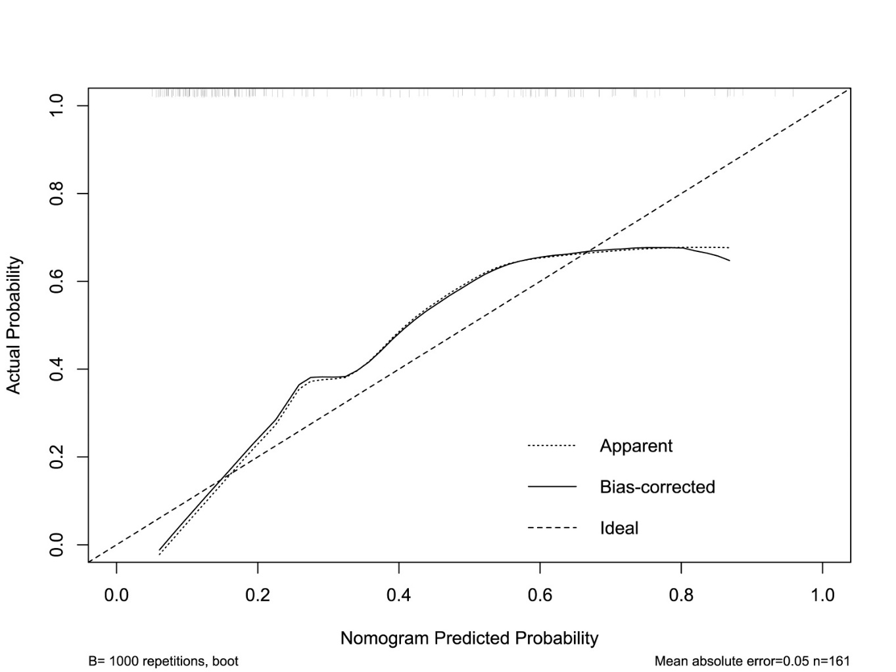
Supplemental Figure 2
Calibration curve assessing reliability of early neurological deterioration after spontaneous intracerebral hemorrhage.
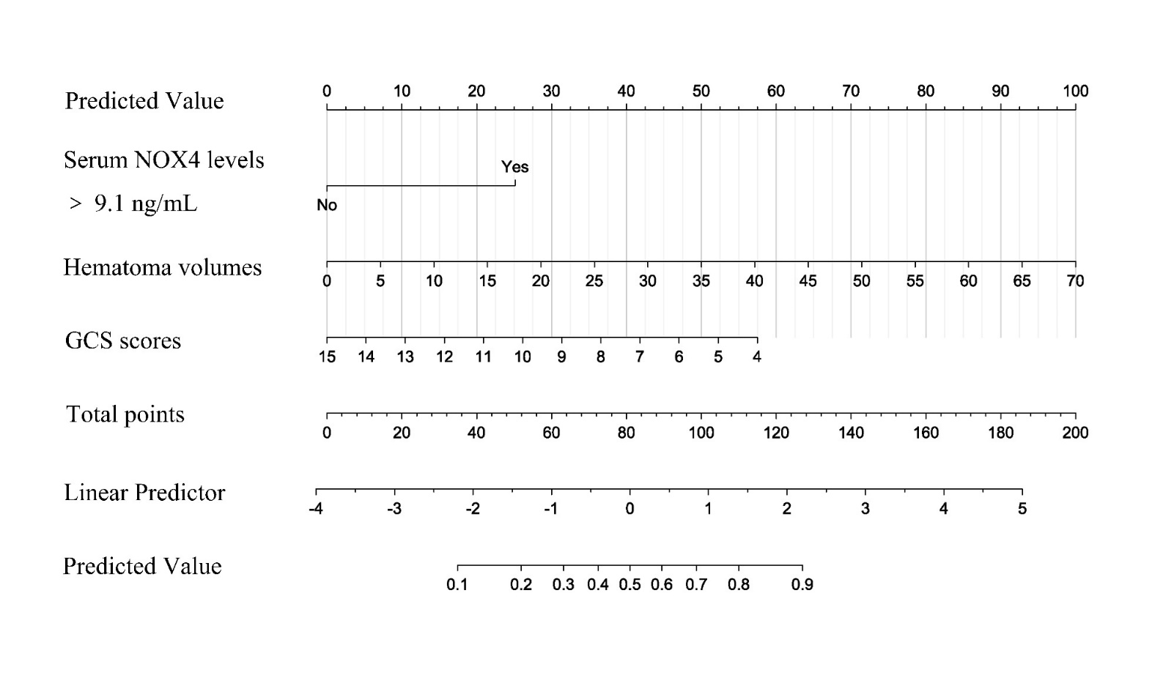
Supplemental Figure 3
Nomogram assessing risk of 90-day poor outcomes after spontaneous intracerebral hemorrhage.
NOX4 means NADPH oxidase 4

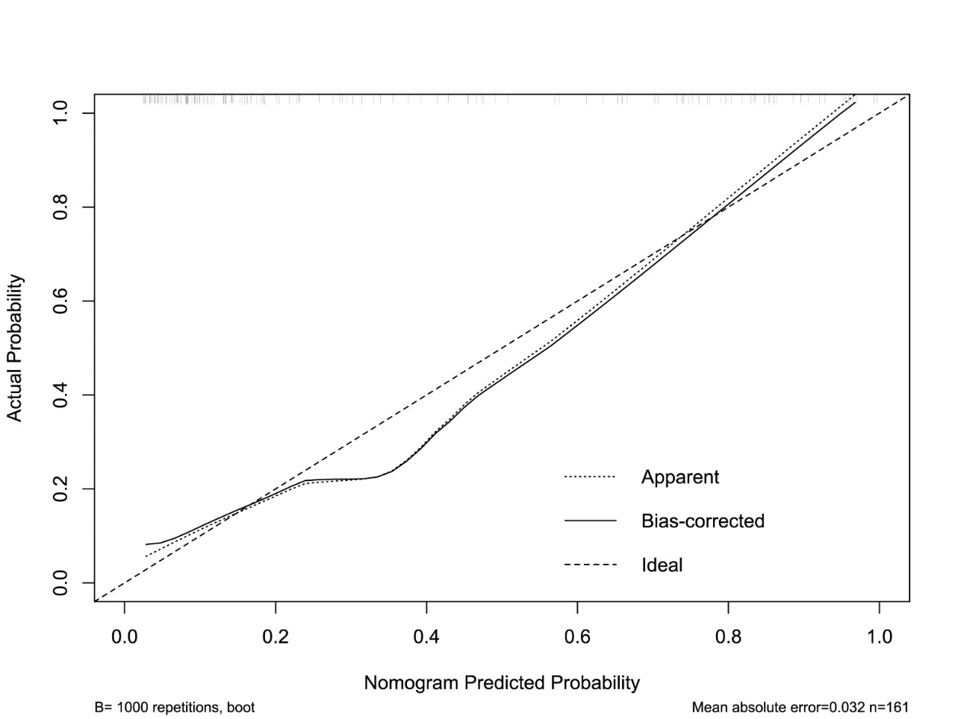
Supplemental Figure 4
Calibration curve assessing reliability of 90-day poor outcomes after spontaneous intracerebral hemorrhage.

Supplemental Table1 Differences of demographic data and vascular risk factors between patients and controls.
Variable | Initially Enrolled Patients (n=214) | Finally Eligible Patients (n=161) | P1 value | Controls (n=161) | P2 value
Gander (male/female) | 123/91 | 91/70 | 0.853 | 97/64 | 0.934
Age (years) | 63.4 ± 11.1 | 64.2 ± 11.4 | 0.654 | 60.7 ± 10.9 | 0.822
Cigarette smoking | 53 (24.7%) | 34 (21.1%) | 0.468 | 27 (16.7%) | 0.394
Alcohol consumption | 64 (29.9%) | 41 (25.5%) | 0.343 | 30 (18.9%) | 0.179
Hypertension | 135 (63.1%) | 104 (64.6%) | 0.763 | - | -
Diabetes mellitus | 47 (22.0 %) | 31 (19.3%) | 0.522 | - | -
Hyperlipidemia | 59 (27.6%) | 43 (26.7%) | 0.853 | - | -
Admission time (h) | 7.5 (5.0-12.3) | 7.0 (5.0-12.0) | 0.534 | - | -
Blood-collection time (h) | 8.4 (5.6-13.6) | 7.6 (5.2-12.8) | 0.557 | - | -
Systolic arterial pressure (mmHg) | 158 (144-170) | 158 (143-172) | 0.905 | - | -
Diastolic arterial pressure (mmHg) | 89.0 ± 14.4 | 89.5 ± 14.8 | 0.685 | - | -
Basal ganglia hemorrhage | 48 (22.4%) | 34 (21.1%) | 0.761 | - | -
Lobar hemorrhage | 137 (61.7%) | 101 (62.7%) | 0.836 | - | -
Infratentorial hemorrhage | 33 (15.4%) | 26 (16.1%) | 0.848 | - | -
Intraventricular hemorrhage | 33 (15.4%) | 22 (13.7%) | 0.634 | - | -
GCS scores | 12 (9-13) | 12 (8-13) | 0.841 | - | -
Hematoma volumes (mL) | 21.8 (14.6-30.2) | 21.1 (14.2-30.6) | 0.969 | - | -
Blood leucocyte count (×10⁹/L) | 8.9 ± 2.7 | 9.3 ± 2.7 | 0.719 | - | -
Blood CRP levels (mg/L) | 7.2 (3.0-13.6) | 8.0 (3.0-16.1) | 0.519 | - | -
Blood potassium levels (mmol/L) | 3.66 ± 0.41 | 3.69 ± 0.42 | 0.686 | - | -
Blood glucose levels (mmol/L) | 7.6 (6.2-9.7) | 7.4 (6.1-9.4) | 0.518 | - | -
Note: Quantitative data were reported as medians with upper and lower quartiles or the mean ± standard deviation as appropriate. Qualitative data were presented as counts (proportions). Intergroup comparisons were performed using the χ2 test or Fisher’s exact test for qualitative data, and the Mann-Whitney U-test or t test for quantitative data. CRP indicates C-reactive protein; GCS, Glasgow coma scale. P1 was calculated from initially enrolled patients versus finally eligible patients; P2, from finally eligible patients versus controls.

Supplemental Table 2 Factors associated with early neurological deterioration in spontaneous intracerebral hemorrhage
Variables |  | END Presence (n=51) | END Absence (n=110) | Z/t/χ² | P value
Age (years) |  | 67.0±9.6 | 62.9±12.0 | -2.149 | *0.033
Gender (male/female) |  | 27/24 | 64/46 | 0.389 | 0.533
Hypertension |  | 32 (62.7%) | 72 (65.5%) | 0.112 | 0.738
Diabetes mellitus |  | 11 (21.6%) | 20 (18.2%) | 0.257 | 0.612
Hyperlipidemia |  | 14 (27.5) | 29 (26.4%) | 0.021 | 0.885
Current smoking |  | 9 (17.6%) | 25 (22.7%) | 0.540 | 0.462
Alcohol consumption |  | 11 (21.6%) | 30 (27.3%) | 0.597 | 0.440
Admission time (h) |  | 6.0 (4.0-12.0) | 7.0 (5.0-12.0) | -0.335 | 0.737
Blood-collection time (h) |  | 7.0 (4.8-13.6) | 7.9 (5.4-12.6) | -0.396 | 0.692
Systolic arterial pressure (mmHg) |  | 158.6±24.4 | 157.0±20.4 | -0.431 | 0.667
Diastolic arterial pressure (mmHg) |  | 87.9±16.1 | 90.3±14.2 | 0.971 | 0.333
Basal ganglia hemorrhage |  | 32 (62.7%) | 69 (62.7%) | 0.000 | 0.998
Lobar hemorrhage |  | 12 (23.5%) | 22 (20.0%) | 0.261 | 0.610
Infratentorial hemorrhage |  | 7 (13.7%) | 19 (17.3%) | 0.324 | 0.569
Intraventricular hemorrhage |  | 15 (29.4%) | 7 (6.4%) | 15.690 | *<0.001
GCS scores |  | 8 (6-11) | 13 (10-14) | -5.632 | *<0.001
Hematoma volumes (mL) |  | 31.0 (24.9-37.5) | 16.4 (10.5-22.8) | -6.726 | *<0.001
Blood leucocyte count (×10⁹/L) |  | 10.0±2.9 | 9.0±2.6 | -2.181 | *0.031
Blood CRP levels (mg/L) |  | 12.5 (6.0-19.2) | 7.0 (2.6-13.0) | -2.868 | *0.004
Blood potassium levels (mmol/L) |  | 3.63±0.46 | 3.71±0.41 | 1.028 | 0.306
Blood glucose levels (mmol/L) |  | 7.5 (6.5-13.4) | 7.5 (5.8-9.1) | -1.990 | *0.047
Serum NOX4 levels (ng/mL) |  | 9.6 (7.9-11.3) | 7.0 (6.0-8.7) | -5.468 | *<0.001
Serum NOX4 levels >9.0 ng/mL |  | 36 (70.6%) | 25 (22.7%) | 33.917 | *<0.001
Notes: Qualitative variables were presented as counts (percentages) and were compared for intergroup difference using chi-square test or Fisher exact test as appropriate. Quantitative variables were summarized as medians (upper - lower quartiles) or the means ± standard deviations as appropriate. Intergroup comparisons were done using unpaired Student t test or Mann-Whitney U test where appropriate. GCS indicates Glasgow Come Scale; NOX4, NADPH oxidase 4; CRP, C-reactive protein. The asterisk indicates statistical significance (*P<0.05).

Supplemental Table 3 Univariate Logistic regression analysis of predictors for early neurological deterioration after spontaneous intracerebral hemorrhage.
Variable | β | SE | Wald | OR | 95% CI | P value
Age (years) | 0.033 | 0.016 | 4.429 | 1.033 | 1.002-1.065 | *0.035
Gender (male/female) | 0.212 | 0.341 | 0.389 | 1.237 | 0.634-2.411 | 0.533
Hypertension | -0.118 | 0.352 | 0.112 | 0.889 | 0.446-1.773 | 0.738
Diabetes mellitus | 0.213 | 0.421 | 0.257 | 1.237 | 0.543-2.823 | 0.613
Hyperlipidemia | 0.055 | 0.381 | 0.021 | 1.057 | 0.501-2.231 | 0.885
Current smoking | -0.317 | 0.432 | 0.537 | 0.729 | 0.312-1.699 | 0.464
Alcohol consumption | -0.310 | 0.420 | 0.595 | 0.733 | 0.333-1.613 | 0.441
Admission time (h) | -0.013 | 0.029 | 0.215 | 0.987 | 0.933-1.044 | 0.643
Blood-collection time (h) | -0.013 | 0.028 | 0.220 | 0.987 | 0.934-1.043 | 0.639
Systolic arterial pressure (mmHg) | 0.003 | 0.008 | 0.187 | 1.003 | 0.988-1.019 | 0.665
Diastolic arterial pressure (mmHg) | -0.011 | 0.012 | 0.944 | 0.989 | 0.967-1.011 | 0.331
Basal ganglia hemorrhage | 0.001 | 0.350 | 0.000 | 1.001 | 0.504-1.989 | 0.998
Lobar hemorrhage | 0.208 | 0.407 | 0.260 | 1.231 | 0.554-2.734 | 0.610
Infratentorial hemorrhage | -0.272 | 0.479 | 0.322 | 0.762 | 0.298-1.947 | 0.570
Intraventricular hemorrhage | 2.070 | 0.517 | 16.025 | 7.924 | 2.876-21.830 | *<0.001
GCS scores | -0.340 | 0.064 | 28.448 | 0.712 | 0.628-0.806 | *<0.001
Hematoma volumes (mL) | 0.098 | 0.018 | 28.553 | 1.103 | 1.064-1.144 | *<0.001
Blood leucocyte count (×10⁹/L) | 0.134 | 0.063 | 4.533 | 1.144 | 1.011-1.294 | *0.033
Blood CRP levels (mg/L) | 0.033 | 0.016 | 4.230 | 1.033 | 1.002-1.066 | *0.040
Blood potassium levels (mmol/L) | -0.423 | 0.412 | 1.054 | 0.655 | 0.292-1.469 | 0.305
Blood glucose levels (mmol/L) | 0.149 | 0.049 | 9.339 | 1.161 | 1.055-1.277 | *0.002
Serum NOX4 levels >9.0 ng/mL | 2.099 | 2.099 | 30.141 | 8.160 | 3.857-17.265 | *<0.001
Note: Results were presented as odds ratio (95% confidence interval) using the univariate logistic regression analysis. CI indicates confidence interval; GCS, Glasgow Come Scale; NOX4, NADPH oxidase 4; CRP, C-reactive protein. The asterisk indicates statistical significance (*P<0.05).

Supplemental Table 4 Factors associated with 90-day function outcomes after spontaneous intracerebral hemorrhage.
Variables |  | Poor outcomes (n=58) | Good outcomes (n=103) |  |  | Z/t/χ² | P value
Age (years) |  | 68.3±11.0 |  | 61.8±11.1 |  | -3.624 | *<0.001
Gender (male/female) |  | 31/27 |  | 60/43 |  | 0.348 | 0.555
Hypertension |  | 40 (69.0%) |  | 64 (62.1%) |  | 0.757 | 0.384
Diabetes mellitus |  | 14 (24.1%) |  | 17 (16.5%) |  | 1.391 | 0.238
Hyperlipidemia |  | 20 (34.5%) |  | 23 (22.3%) |  | 2.800 | 0.094
Current smoking |  | 14 (24.1%) |  | 20 (19.4%) |  | 0.496 | 0.481
Alcohol consumption |  | 14 (24.1%) |  | 27 (26.2%) |  | 0.084 | 0.772
Admission time (h) |  | 6.5 (4.0-12.0) |  | 7.0 (5.0-12.0) |  | -1.246 | 0.213
Blood-collection time (h) |  | 7.1 (4.6-12.6) |  | 8.4 (5.9-13.0) |  | -1.410 | 0.158
Systolic arterial pressure (mmHg) |  | 161.1±24.1 |  | 155.4±20.0 |  | -1.606 | 0.110
Diastolic arterial pressure (mmHg) |  | 90.7±16.2 |  | 88.8±14.0 |  | -0.473 | 0.437
Basal ganglia hemorrhage |  | 34 (58.6%) |  | 67 (65.0%) |  | 0.656 | 0.418
Lobar hemorrhage |  | 15 (25.9%) |  | 19 (18.4%) |  | 1.225 | 0.268
Infratentorial hemorrhage |  | 9 (15.5%) |  | 17 (16.5%) |  | 0.072 | 0.870
Intraventricular hemorrhage |  | 16 (27.6%) |  | 6 (5.8%) |  | 14.894 | *<0.001
GCS scores |  | 8 (6-9) |  | 13 (12-14) |  | -7.518 | *<0.001
Hematoma volumes (mL) |  | 32.5 (24.8-32.5) |  | 16.6 (10.9-21.8) |  | -7.451 | *<0.001
Blood leucocyte count (×10⁹/L) |  | 10.0±2.9 |  | 8.9±2.6 |  | -2.364 | *0.019
Blood CRP levels (mg/L) |  | 11.0 (4.8-19.2) |  | 7.0 (2.7-14.4) |  | -1.999 | *0.046
Blood potassium levels (mmol/L) |  | 3.67 (3.45-3.90) |  | 3.63 (3.43-3.94) |  | -0.919 | 0.360
Blood glucose levels (mmol/L) |  | 8.5 (6.5-12.4) |  | 7.4 (5.6-8.6) |  | -2.883 | *0.004
Serum NOX4 levels (ng/mL) |  | 9.8 (8.0-11.6) |  | 7.0 (6.0-8.5) |  | -5.838 | *<0.001
Serum NOX4 levels >9.1 ng/mL |  | 41 (70.7%) |  | 16 (15.5%) |  | 49.359 | *<0.001
Notes: Qualitative variables were presented as counts (percentages) and were compared for intergroup difference using chi-square test or Fisher exact test as appropriate. Quantitative variables were summarized as medians (upper - lower quartiles) or the means ± standard deviations as appropriate. Intergroup comparisons were done using unpaired Student t test or Mann-Whitney U test where appropriate. GCS indicates Glasgow Come Scale; NOX4, NADPH oxidase 4; CRP, C-reactive protein. The asterisk indicates statistical significance (*P<0.05).

Supplemental Table 5 Univariate Logistic regression analysis of predictors for 90-day poor outcomes after spontaneous intracerebral hemorrhage.
Variable | β | SE | Wald | OR | 95% CI | P value
Age (years) | 0.055 | 0.016 | 11.470 | 1.056 | 1.023-1.090 | *0.001
Gender (male/female) | 0.195 | 0.330 | 0.348 | 1.215 | 0.636-2.323 | 0.555
Hypertension | 0.303 | 0.349 | 0.755 | 1.354 | 0.683-2.684 | 0.385
Diabetes mellitus | 0.476 | 0.406 | 1.376 | 1.610 | 0.727-3.565 | 0.241
Hyperlipidemia | 0.605 | 0.364 | 2.764 | 1.831 | 0.897-3.734 | 0.096
Current smoking | 0.278 | 0.395 | 0.495 | 1.320 | 0.609-2.865 | 0.482
Alcohol consumption | -0.110 | 0.380 | 0.084 | 0.896 | 0.425-1.886 | 0.772
Admission time (h) | -0.023 | 0.028 | 0.710 | 0.977 | 0.925-1.032 | 0.400
Blood-collection time (h) | -0.024 | 0.028 | 0.776 | 0.976 | 0.925-1.030 | 0.378
Systolic arterial pressure (mmHg) | 0.012 | 0.008 | 2.523 | 1.012 | 0.997-1.028 | 0.112
Diastolic arterial pressure (mmHg) | 0.009 | 0.011 | 0.610 | 1.009 | 0.987-1.031 | 0.435
Basal ganglia hemorrhage | -0.273 | 0.337 | 1.035 | 0.654 | 0.761-1.474 | 0.419
Lobar hemorrhage | 0.433 | 0.393 | 1.215 | 1.542 | 0.714-3.332 | 0.270
Infratentorial hemorrhage | -0.073 | 0.449 | 0.027 | 0.929 | 0.385-2.242 | 0.870
Intraventricular hemorrhage | 1.818 | 0.513 | 12.552 | 6.159 | 2.253-16.837 | *<0.001
GCS scores | -0.528 | 0.079 | 44.547 | 0.590 | 0.505-0.689 | *<0.001
Hematoma volumes (mL) | 0.145 | 0.024 | 37.694 | 1.156 | 1.104-1.211 | *<0.001
Blood leucocyte count (×10⁹/L) | 0.142 | 0.062 | 5.277 | 1.153 | 1.021-1.301 | *0.022
Blood CRP levels (mg/L) | 0.021 | 0.016 | 1.895 | 1.022 | 0.991-1.053 | 0.169
Blood potassium levels (mmol/L) | 0.356 | 0.388 | 0.843 | 1.428 | 0.668-3.054 | 0.358
Blood glucose levels (mmol/L) | 0.179 | 0.051 | 12.265 | 1.196 | 1.082-1.323 | *<0.001
Serum NOX4 levels >9.1 ng/mL | 2.574 | 0.396 | 42.134 | 13.114 | 6.029-28.525 | *<0.001
Note: Results were presented as odds ratio (95% confidence interval) using the univariate logistic regression analysis. CI indicates confidence interval; GCS, Glasgow Come Scale; NOX4, NADPH oxidase 4; CRP, C-reactive protein. The asterisk indicates statistical significance (*P<0.05).

