Supplementary Figure 1

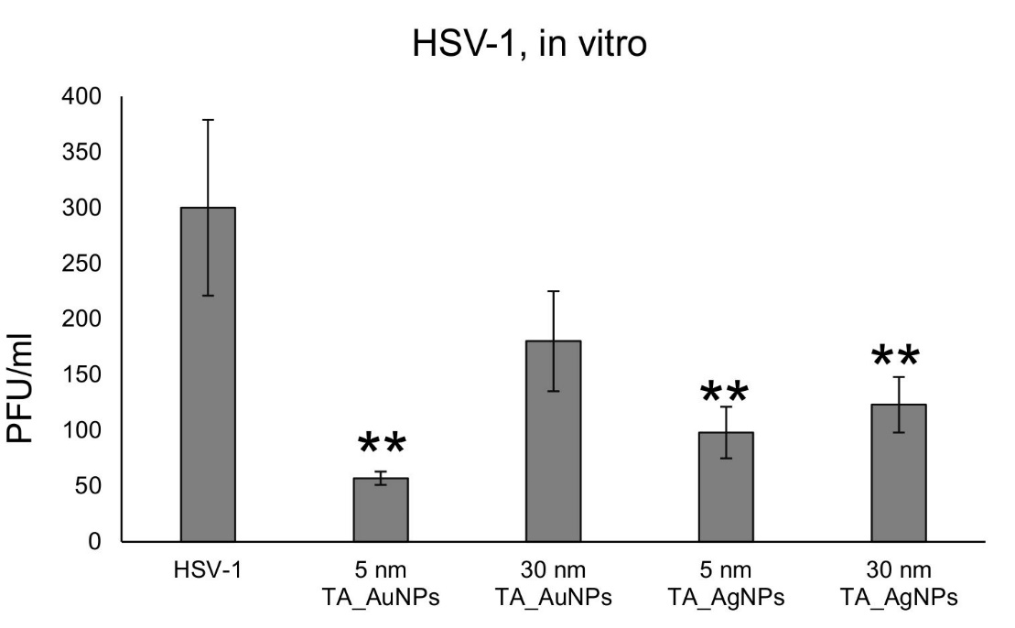
B
A
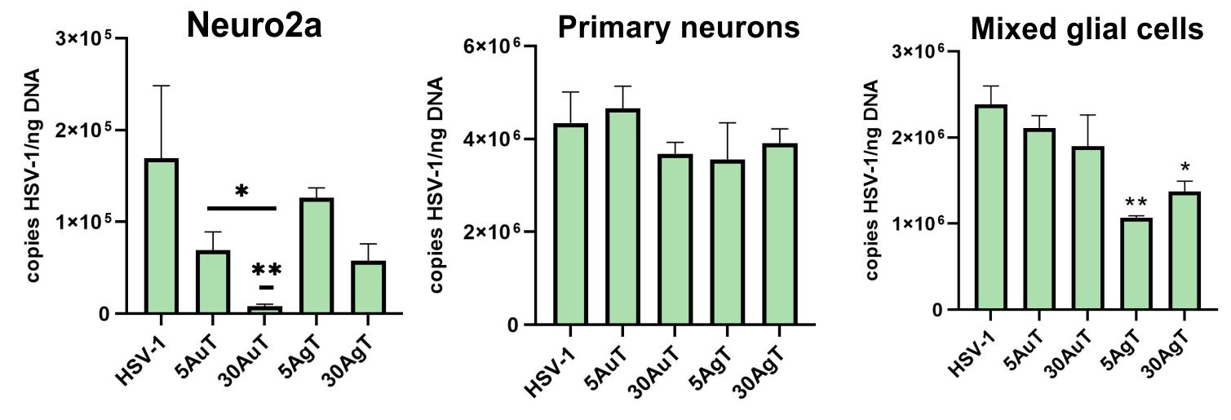

Supplementary Figure 1. Tannic-acid modified Ag/AuNPs (TA-Ag/AuNPs) can inhibit HSV-1 infection. (A) HSV-1 was pre-incubated for 1 h with 7.5 µg/mL of 5 nm TA-AuNPs, 30 nm TA-AuNPs, 5 nm TA-AgNPs and 30nm TA AgNPs, then added to Vero cells and further incubated for 24 h. Next, the cultures were subjected to titration of HSV-1 using PFU method. The data are expressed as means from three independent experiments ± SEM. ** represents significant differences with p ≤ 0.01 in comparison to untreated infected control (two-way ANOVA test). (B) Neuro-2a cell line, primary neurons culture and mixed glial culture were infected for 6 h, then washed and treated with non-toxic concentration of tannic acid-modified AgNPs, or AuNPs sized 5 and 30 nm (2.5 µg/mL for 5 nm AuNPs, 30 AuNPs, 30 AgNPs and 1 µg/mL for 5 nm AgNPs ). At 24 h p.i., cells were subjected to HSV-1 copies titration by qPCR. The data are expressed as means from three independent experiments ± SEM. * represents significant differences with p ≤ 0.05, ** p ≤ 0.01 in comparison to untreated infected control (two-way ANOVA test).
Supplementary Figure 2

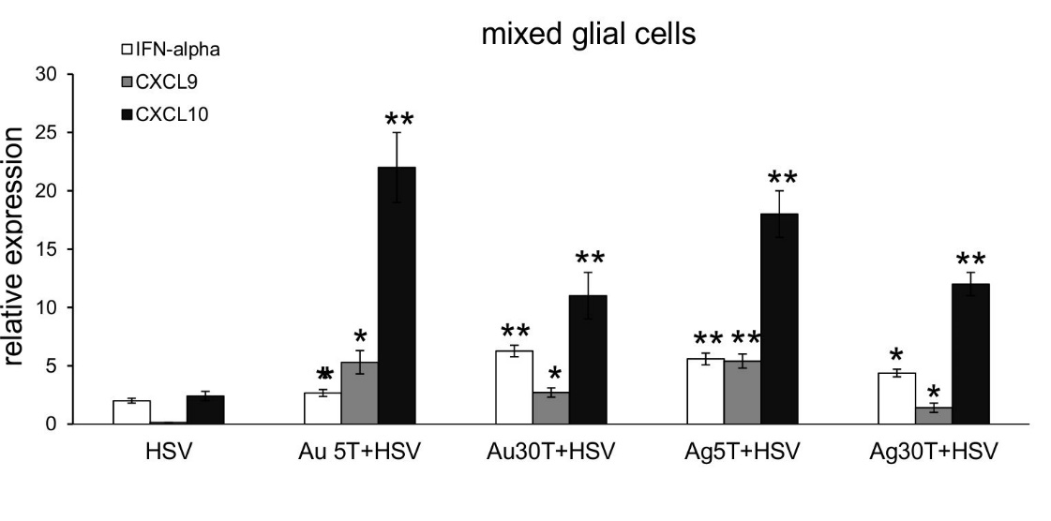
Supplementary Figure 2. The tannic-acid modified Ag/AuNPs upregulate early antiviral response in vitro. The mixed glial culture was infected for 6 h with HSV-1 (PFU 1/ml), then washed and treated with non-toxic concentration of tannic acid-modified AgNPs, or AuNPs sized 5 and 30 nm (2.5 µg/mL for 5 nm AuNPs, 30 AuNPs, 30 AgNPs and 1 µg/mL for 5 nm AgNPs ). At 24 h p.i., cells were subjected to RNA isolation and qPCR measurements. Levels of IFN-α, CXCL9 and CXCL10 mRNAs are shown as expression relative to control based on the 2-∆∆Ct method. N = 3. The data are expressed as means from three independent experiments ± SEM. * represents significant differences with p ≤ 0.05, ** p ≤ 0.01 in comparison to untreated infected control (two-way ANOVA test).

Supplementary Figure 3
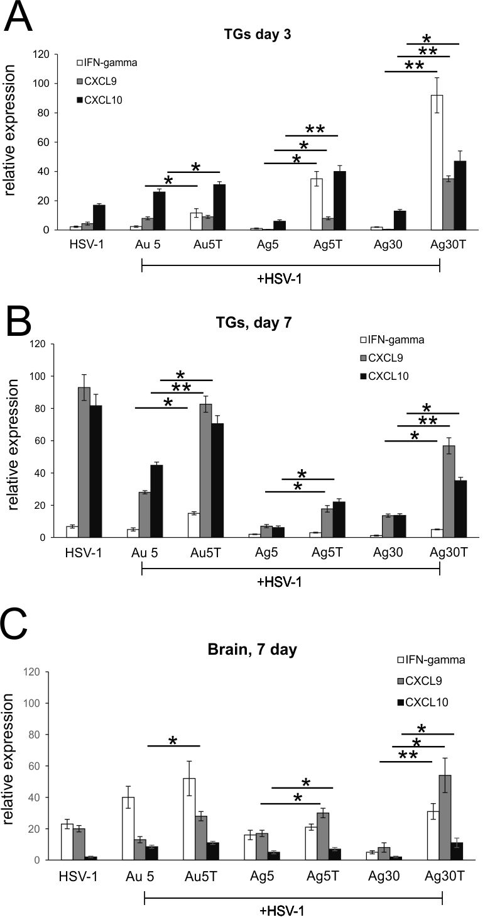
Supplementary Figure 3. Tannic acid-modified Ag/AuNPs of both 5 and 30 nm induce anti-viral response in HSV-1 infection better than unmodified NPs. Cytokine and chemokine expression in the TGs (A, B) and brains (C) at 3 and 7 days p.i. after treatment with tannic acid-modified or unmodified 5 nm AgNPs, 30 nm AgNPs, 5 nm AuNPs or 0.9% NaCl. Levels of IFN-γ, CXCL9 and CXCL10 mRNAs are shown as expression relative to control based on the 2-∆∆Ct method. N = 7. * Represents significant differences with p ≤ 0.05, ** p ≤ 0.01 in comparison to uninfected tissues.

Supplementary Figure 4

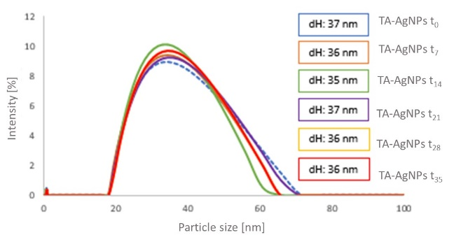 | 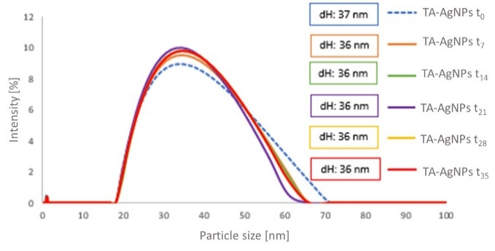
(a) | (b)
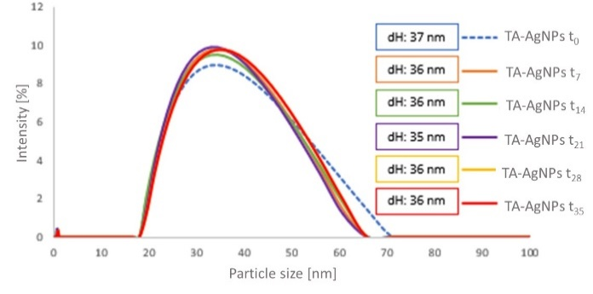 | 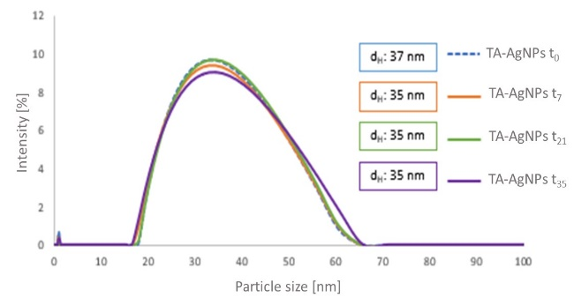
(c) | (d)
Supplementary Figure 4. DLS size distribution histogram of TA-AgNPs colloid stored at different conditions: colloid stored in transparent vial at sunlight (a); colloid stored in dark vial at sunlight (b); colloid stored in darkness (c); colloid stored with access of oxygen from the air (d); tests carried directly after TA-AgNPs colloid preparation (t_{o}) and after 7 (t₇), 14 (t₁₄), 21 (t₂₁), 28 (t₂₈), and after 35 days (t₃₅) of storage in specific conditions.

The stability of nanoparticles under different storage conditions depends mainly on the type of modifier present on the surface of the nanoparticles. Our studies clearly indicate that the use of tannic acid provides AgNPs long-term colloidal stability.

Supplementary Figure 5

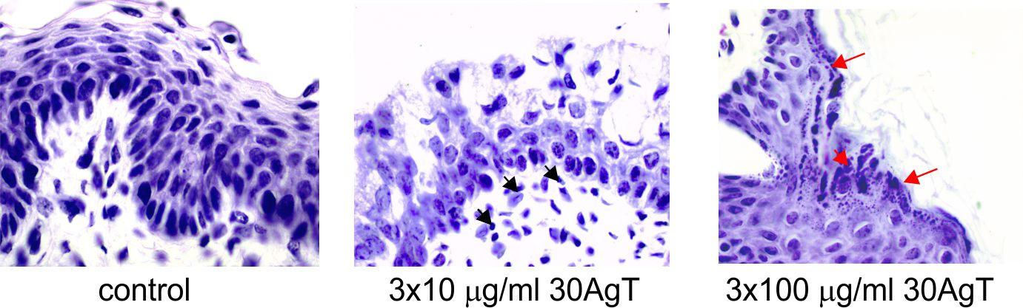
Supplementary Figure 5. Mucosal tissue upon treatment with different doses of 30 nm TA-AgNPs. The vaginal mucosal tissue was treated 3 times every 24h with 100 ul of NaCl (control), 100 ul of 10 μg/ml (middle photo), and 100 ul of 100 μg/ml TA-AgNPs (right photo). After 24 hours from the last treatment tissues were subjected to paraffin processing, followed by classical histopathological procedures. Slides were stained with haematoxylin-eosin (HE) and subjected to histological analysis. Application of the lower dose (10 μg/ml) led to increased infiltration of monocytes with no other signs of local toxicity (black arrows), while the higher dose (100 μg/ml) cause increased inflammatory reaction accompanied by acanthosis of the epithelial tissue (red arrows), which strongly influenced functionality of the mucosal tissue.

Supplementary Table S1
The list of antibodies used in the study

Antigen | Clone | Manufacturer
anti-CD3-FITC | 145-2C11 | ThermoFisher Scientific
anti-CD8-PE or BV421 | 53-6.7 | BD Biosciences
anti- NK1.1-APC | PK136 | BD Biosciences
anti-CD11b-PE | RB6-8C5 | BD Biosciences
anti-CD192-BV421 | 475301 | BD Biosciences
anti-Ly6C-APC-Cy7 | AL-21 | BD Biosciences
anti-IBA-1-FITC | EPR16588 | Abcam
anti-CD86-PE | GL1 | BD Biosciences
anti-CD206-APC | MMR | ThermoFisher Scientific
anti-CD69-APC | H1.2F3 | eBioscience™
anti- CD207 (Langerin)-PE | eBioL31) | eBioscience™

