Supplementary Table 1 The results of collinear diagnosis between each covariate in the models of SII
Variable | Tol | VIF
(constant )
age | 0.657 | 1.522
sex | 0.785 | 1.275
heart rate | 0.588 | 1.702
GCS score | 0.723 | 1.383
creatinine | 0.585 | 1.710
white blood cell | 0.709 | 1.411
hemoglobin | 0.772 | 1.296
SII | 0.535 | 1.871

The results showed that the VIF value of all independent variables is less than 5(all VIF ＜ 5), revealing that collinearity problems can be ignored.

Supplementary Table 2 The results of collinear diagnosis between each covariate in the models of PLR
Variable | Tol | VIF
(constant )
age | 0.672 | 1.488
sex | 0.786 | 1.272
heart rate | 0.606 | 1.650
GCS score | 0.711 | 1.407
creatinine | 0.627 | 1.594
white blood cell | 0.879 | 1.137
hemoglobin | 0.775 | 1.290
PLR | 0.688 | 1.453

The results showed that the VIF value of all independent variables is less than 5(all VIF ＜ 5), revealing that collinearity problems can be ignored.

Supplementary Table 3 Adjusted ORs and 95% CIs for SII levels and coagulopathy risk among TBI patients with antibiotics (n=108)
 | SII level(median[range])
 | Q1(Lowest)  (545.92  [≤966.60]) | Q2  (1387.21[966.61 - 2011.89]) | Q3  (2340.01[2011.90 - 3096.15]) | Q4 (Highest)  (5378.72  [≥3096.16]) | P for trend
No. Of Coagulopathy (n,%) | 23  (82.1%) | 17  (63.0%) | 13  (48.1%) | 11  (42.3%)
Unadjusted | 1 | 0.370  (0.107,1.281) | 0.202  (0.059,0.688) | 0.159  (0.046,0.552) | 0.007
Model 1 | 1 | 0.313  (0.086,1.140) | 0.193  (0.056,0.666) | 0.145  (0.041,0.520) | 0.006
Model 2 | 1 | 0.435  (0.111,1.709) | 0.243  (0.064,0.913) | 0.224  (0.058,0.863) | 0.049
Model 3 | 1 | 0.493  (0.111,2.182) | 0.259  (0.053,1.264) | 0.095  (0.016,0.562) | 0.009
Model 1 adjusted for age and sex. Model 2 additionally adjusted for heart rate, GCS sore, and covariates included in model 1. Model 3 additionally adjusted for WBC, Creatinine, Hemoglobin , and covariates included in model 1 and 2.

Supplementary Table 4 Adjusted ORs and 95% CIs for PLR levels and coagulopathy risk among TBI patients with antibiotics (n=108)
 | PLR level(median[range])
 | Q1 (Lowest)  (67.95 [≤97.99]) | Q2  (131.18 [98.00 - 164.62]) | Q3  (205.77 [164.63 - 255.38]) | Q4 (Highest)  (314.66 [≥255.39]) | P for trend
No. Of Coagulopathy (n,%) | 23  (82.1%) | 20  (69.0%) | 12  (50.0%) | 9  (33.3%)
Unadjusted | 1 | 0.483  (0.139,1.681) | 0.217  (0.062,0.763) | 0.109  (0.031,0.381) | ＜0.001
Model 1 | 1 | 0.491  (0.140,1.718) | 0.213  (0.060,0.752) | 0.110  (0.031,0.388) | ＜0.001
Model 2 | 1 | 0.728  (0.192,2.761) | 0.345  (0.091,1.310) | 0.186  (0.049,0.705) | 0.005
Model 3 | 1 | 0.861  (0.203,3.654) | 0.456  (0.103,2.012) | 0.207  (0.047,0.912) | 0.013
Model 1 adjusted for age and sex. Model 2 additionally adjusted for heart rate, GCS sore, and covariates included in model 1. Model 3 additionally adjusted for WBC, Creatinine, Hemoglobin , and covariates included in model 1 and 2.

Supplementary Table 5 Adjusted ORs and 95% CIs for SII levels and coagulopathy risk among TBI patients without lower limb venous thrombosis on admission (n=74)
 | SII level(median[range])
 | Q1(Lowest)  (545.92  [≤966.60]) | Q2  (1387.21[966.61 - 2011.89]) | Q3  (2340.01[2011.90 - 3096.15]) | Q4 (Highest)  (5378.72  [≥3096.16]) | P for trend
No. Of Coagulopathy (n,%) | 14  (77.8%) | 14  (70.0%) | 9  (52.9%) | 8  (42.1%)
Unadjusted | 1 | 0.348  (0.100,1.213) | 0.201  (0.058,0.697) | 0.149  (0.043,0.514) | 0.005
Model 1 | 1 | 0.300  (0.081,1.106) | 0.191  (0.054,0.673) | 0.136  (0.038,0.488) | 0.005
Model 2 | 1 | 0.874  (0.181,4.218) | 0.440  (0.092,2.106) | 0.316  (0.064,1.549) | 0.099
Model 3 | 1 | 1.133  (0.198,6.487) | 0.306  (0.047,2.000) | 0.148  (0.019,1.171) | 0.031
Model 1 adjusted for age and sex. Model 2 additionally adjusted for heart rate, GCS sore, and covariates included in model 1. Model 3 additionally adjusted for WBC, Creatinine, Hemoglobin , and covariates included in model 1 and 2.

Supplementary Table 6 Adjusted ORs and 95% CIs for PLR levels and coagulopathy risk among TBI patients without lower limb venous thrombosis on admission (n=74)
 | PLR level(median[range])
 | Q1 (Lowest)  (67.95 [≤97.99]) | Q2  (131.18 [98.00 - 164.62]) | Q3  (205.77 [164.63 - 255.38]) | Q4 (Highest)  (314.66 [≥255.39]) | P for trend
No. Of Coagulopathy (n,%) | 17  (85.0%) | 11  (61.1%) | 11  (61.1%) | 6  (33.3%)
Unadjusted | 1 | 0.404  (0.107,1.519) | 0.154  (0.041,0.584) | 0.091  (0.024,0.345) | ＜0.001
Model 1 | 1 | 0.409  (0.108,1.541) | 0.151  (0.040,0.577) | 0.091  (0.024,0.347) | ＜0.001
Model 2 | 1 | 0.290  (0.055,1.522) | 0.348  (0.067,1.803) | 0.118  (0.022,0.619) | 0.016
Model 3 | 1 | 0.275  (0.044,1.722) | 0.363  (0.061,2.167) | 0.124  (0.020,0.776) | 0.039
Model 1 adjusted for age and sex. Model 2 additionally adjusted for heart rate, GCS sore, and covariates included in model 1. Model 3 additionally adjusted for WBC, Creatinine, Hemoglobin , and covariates included in model 1 and 2.

Supplementary Table 7 Adjusted ORs and 95% CIs for SII levels and coagulopathy risk among TBI patients without anticoagulants (n=64)
 | SII level(median[range])
 | Q1(Lowest)  (545.92  [≤966.60]) | Q2  (1387.21[966.61 - 2011.89]) | Q3  (2340.01[2011.90 - 3096.15]) | Q4 (Highest)  (5378.72  [≥3096.16]) | P for trend
No. Of Coagulopathy (n,%) | 17  (77.3%) | 7  (53.8%) | 5  (35.7%) | 7  (46.7%)
Unadjusted | 1 | 0.343  (0.078,1.504) | 0.163  (0.037,0.718) | 0.257  (0.062,1.067) | 0.099
Model 1 | 1 | 0.303  (0.060,1.523) | 0.172  (0.038,0.781) | 0.273  (0.063,1.189) | 0.149
Model 2 | 1 | 0.407  (0.069,2.420) | 0.160  (0.027,0.926) | 0.434  (0.086,2.184) | 0.488
Model 3 | 1 | 0.444  (0.062,3.157) | 0.292  (0.036,2.351) | 0.088  (0.007,1.033) | 0.059
Model 1 adjusted for age and sex. Model 2 additionally adjusted for heart rate, GCS sore, and covariates included in model 1. Model 3 additionally adjusted for WBC, Creatinine, Hemoglobin , and covariates included in model 1 and 2.

Supplementary Table 8 Adjusted ORs and 95% CIs for PLR levels and coagulopathy risk among TBI patients without anticoagulants (n=64)
 | PLR level(median[range])
 | Q1 (Lowest)  (67.95 [≤97.99]) | Q2  (131.18 [98.00 - 164.62]) | Q3  (205.77 [164.63 - 255.38]) | Q4 (Highest)  (314.66 [≥255.39]) | P for trend
No. Of Coagulopathy (n,%) | 14  (73.7%) | 12  (75.0%) | 4  (36.4%) | 6  (33.3%)
Unadjusted | 1 | 1.071  (0.233,4.919) | 0.204  (0.041,1.008) | 0.179  (0.043,0.735) | 0.005
Model 1 | 1 | 1.163  (0.249,5.438) | 0.199  (0.039,1.012) | 0.206  (0.049,0.874) | 0.009
Model 2 | 1 | 1.453  (0.279,7.553) | 0.451  (0.075,2.723) | 0.324  (0.068,1.539) | 0.073
Model 3 | 1 | 1.641  (0.269,9.990) | 0.681  (0.082,5.631) | 0.227  (0.032,1.619) | 0.077
Model 1 adjusted for age and sex. Model 2 additionally adjusted for heart rate, GCS sore, and covariates included in model 1. Model 3 additionally adjusted for WBC, Creatinine, Hemoglobin , and covariates included in model 1 and 2.

Supplementary Table 9 Adjusted ORs and 95% CIs for SII levels and coagulopathy risk among patients with isolated TBI (n=61)
 | SII level(median[range])
 | Q1(Lowest)  (545.92  [≤966.60]) | Q2  (1387.21[966.61 - 2011.89]) | Q3  (2340.01[2011.90 - 3096.15]) | Q4 (Highest)  (5378.72  [≥3096.16]) | P for trend
No. Of Coagulopathy (n,%) | 15  (46.9%) | 5  (15.6%) | 5  (15.6%) | 7  (21.9%)
Unadjusted | 1 | 0.125  (0.024,0.663) | 0.091  (0.018,0.464) | 0.200  (0.039,1.014) | 0.026
Model 1 | 1 | 0.113  (0.019,0.668) | 0.095  (0.018,0.513) | 0.199  (0.036,1.104) | 0.036
Model 2 | 1 | 0.125  (0.017,0.901) | 0.129  (0.020,0.825) | 0.303  (0.048,1.917) | 0.117
Model 3 | 1 | 0.061  (0.006,0.665) | 0.104  (0.011,1.012) | 0.063  (0.004,0.941) | 0.116
Model 1 adjusted for age and sex. Model 2 additionally adjusted for heart rate, GCS sore, and covariates included in model 1. Model 3 additionally adjusted for WBC, Creatinine, Hemoglobin , and covariates included in model 1 and 2.

Supplementary Table 10 Adjusted ORs and 95% CIs for PLR levels and coagulopathy risk among patients with isolated TBI(n=61)
 | PLR level(median[range])
 | Q1 (Lowest)  (67.95 [≤97.99]) | Q2  (131.18 [98.00 - 164.62]) | Q3  (205.77 [164.63 - 255.38]) | Q4 (Highest)  (314.66 [≥255.39]) | P for trend
No. Of Coagulopathy (n,%) | 13  (40.6%) | 8  (25.0%) | 4  (12.5%) | 7  (21.9%)
Unadjusted | 1 | 0.615  (0.099,3.823) | 0.084  (0.015,0.459) | 0.135  (0.028,0.643) | 0.009
Model 1 | 1 | 0.639  (0.101,4.038) | 0.081  (0.015,0.454) | 0.157  (0.032,0.775) | 0.011
Model 2 | 1 | 0.767  (0.094,6.274) | 0.163  (0.024,1.132) | 0.249  (0.041,1.510) | 0.170
Model 3 | 1 | 1.196  (0.123,11.618) | 0.202  (0.023,1.777) | 0.287  (0.036,2.283) | 0.253
Model 1 adjusted for age and sex. Model 2 additionally adjusted for heart rate, GCS sore, and covariates included in model 1. Model 3 additionally adjusted for WBC, Creatinine, Hemoglobin , and covariates included in model 1 and 2.

Supplementary Table 11 Adjusted ORs and 95% CIs for SII levels and coagulopathy risk among TBI patients with multi-trauma(n=52)
 | SII level(median[range])
 | Q1(Lowest)  (545.92  [≤966.60]) | Q2  (1387.21[966.61 - 2011.89]) | Q3  (2340.01[2011.90 - 3096.15]) | Q4 (Highest)  (5378.72  [≥3096.16]) | P for trend
No. Of Coagulopathy (n,%) | 8  (25.0%) | 12  (37.5%) | 8  (25.0%) | 4  (12.5%)
Unadjusted | 1 | 2.250  (0.304,16.632) | 0.600  (0.106,3.400) | 0.150  (0.026,0.874) | 0.029
Model 1 | 1 | 2.187  (0.281,17.019) | 0.686  (0.103,4.586) | 0.155  (0.025,0.959) | 0.039
Model 2 | 1 | 2.831  (0.288,27.790) | 0.691  (0.078,6.104) | 0.178  (0.019,1.652) | 0.071
Model 3 | 1 | 6.633  (0.245,179.685) | 0.149  (0.003,6.750) | 0.001  (0.000,0.333) | 0.055
Model 1 adjusted for age and sex. Model 2 additionally adjusted for heart rate, GCS sore, and covariates included in model 1. Model 3 additionally adjusted for WBC, Creatinine, Hemoglobin , and covariates included in model 1 and 2.

Supplementary Table 12 Adjusted ORs and 95% CIs for PLR levels and coagulopathy risk among TBI patients with multi-trauma (n=52)
 | PLR level(median[range])
 | Q1 (Lowest)  (67.95 [≤97.99]) | Q2  (131.18 [98.00 - 164.62]) | Q3  (205.77 [164.63 - 255.38]) | Q4 (Highest)  (314.66 [≥255.39]) | P for trend
No. Of Coagulopathy (n,%) | 10  (31.3%) | 12  (37.5%) | 8  (25.0%) | 2  (6.3%)
Unadjusted | 1 | 0.400  (0.066,2.437) | 0.400  (0.058,2.770) | 0.050  (0.006,0.438) | 0.046
Model 1 | 1 | 0.442  (0.064,3.070) | 0.436  (0.057,3.351) | 0.045  (0.005,0.443) | 0.043
Model 2 | 1 | 0.646  (0.081,5.144) | 0.534  (0.062,4.632) | 0.055  (0.004,0.664) | 0.086
Model 3 | 1 | 0.611  (0.066,5.656) | 0.475  (0.037,6.091) | 0.00  (0.000,0.458) | 0.110
Model 1 adjusted for age and sex. Model 2 additionally adjusted for heart rate, GCS sore, and covariates included in model 1. Model 3 additionally adjusted for WBC, Creatinine, Hemoglobin , and covariates included in model 1 and 2.

Supplementary Table 13 Baseline characteristics of 98 patients according to GOS score(n=98)
Variable | ALL patients  (N=113) | GOS≤3  (N=52) | GOS＞3  (N=46) | P-value
Age (years,mean±SD) | 49.12±18.86 | 52.98±18.79 | 44.78±17.66 | 0.029
Sex(males,n,%) | 75(76.5%) | 38(73.1%) | 37(80.4%) | 0.391
Heart rate [M(IQR)] | 90.60±20.83 | 98.02±22.52 | 85.02±16.56 | 0.002
Blood pressure (mmHg) [M(IQR)]
Systolic pressure | 126.21±26.33 | 126.02±28.83 | 124.024±18.40 | 0.786
Diastolic pressure | 78.13±19.99 | 77.14±22.03 | 77.36±14.67 | 0.817
Temperature(℃) [M(IQR)] | 36.79±0.80 | 36.67±0.79 | 36.95±0.83 | 0.140
Time to hospital after injury (h) [M(IQR)] | 5.00  (2.00,22.00) | 7.50  (2.00,24.00) | 5.000  (2.75,24.00) | 0.834
AIS score  [M(IQR)] | 4.00  (3.00,5.00) | 5.00  (4.00,5.00) | 3.00  (3.00,4.00) | ＜0.001
GCS score  [M(IQR)] | 7.50  (4.00,12.00) | 4.00  (3.00,7.00) | 11.00  (8.00,12.00) | ＜0.001
Abnormal Pupillary reflex (n,%) | 60(61.22%) | 41(78.8%) | 19(41.3%) | ＜0.001
Blunt injury(n,%) | 96(98.0%) | 52(100.0%) | 44(95.7%) | 0.422
Mortality in hospital (n,%) | 22(22.4%) | 22(42.3%) | 0(0.0%) | ＜0.001
Coagulation (n,%) | 55(56.1%) | 38(73.1%) | 17(37.0%) | ＜0.001
ICU/EICU LOS  (d) [M(IQR)] | 10.00  (4.00,19.50) | 14.50  (7.75,24.25) | 8.50  (4.75,15.25) | 0.013
Respirator LOS  (d) [M(IQR)] | 3.00  (0.00,9.00) | 9.00  (4.00,18.00) | 0.00  (0.00,5.00) | ＜0.001
Total LOS(d,mean±SD) | 18.00  (10.00,30.00) | 19.00  (8.00,30.50) | 21.00  (15.75,34.00) | 0.115
Antibiotic usage(n,%) | 94(95.9%) | 52(100.0%) | 42(91.3%) | 0.097
Anticoagulant usage(n,%) | 44(44.9%) | 26(50.0%) | 18(39.1%) | 0.280
Laboratory findings
Creatinine [M(IQR)] | 78.50  (64.25,100.75) | 87.00  (64.75,120.75) | 73.50  (64.50,86.00) | 0.029
Hemoglobin (mean±SD) | 104.68±26.04 | 91.21±26.051 | 116.76±20.78 | ＜0.001
C-reactive protein [M(IQR)] | 29.20  (5.74,88.35) | 31.74  (7.61,113.88) | 31.57  (4.66,85.57) | 0.726
Neutrophile [M(IQR)] | 10.66  (8.14,14.00) | 10.66  (8.62,12.82) | 10.64  (8.23,15.34) | 0.576
White blood cell [M(IQR)] | 12.74  (9.77,16.72) | 12.82  (9.79,15.62) | 12.72  (10.04,16.82) | 0.550
SII[M(IQR)] | 1799.65  (858.90,3317.91) | 1116.73  (486.53,2342.04) | 2060.24  (1185.02,4125.97) | 0.008
PLR[M(IQR)] | 177.46  (90.62,271.52) | 113.14  (55.01,212.64) | 217.91  (120.06,278.50) | 0.001
Abbreviations: AIS score = head acute injury scale score , GCS score=Glasgow Coma Scale score, GOS score = Glasgow Outcome Scale score, IQR = interquartile range, LOS = length of stay, SII= platelet count×neutrophil count / lymphocyte count) , PLR = platelet-to-lymphocyte ratio.

Supplementary Table 14 Adjusted ORs and 95% CIs for SII levels and prognosis at 6 months after discharge (n = 98)
 | SII level(median[range])
 | Q1 (Lowest)  (545.92  [≤966.60]) | Q2  (1387.21[966.61 - 2011.89]) | Q3  (2340.01[2011.90 - 3096.15]) | Q4 (Highest)  (5378.72  [≥3096.16]) | P for trend
No. of  GOS ≤ 3(n,%) | 20(74.1%) | 11(45.8%) | 14(60.9%) | 7(29.2%)
Unadjusted | 1 | 3.377  (1.041,10.957) | 1.837  (0.553,6.103) | 6.939  (2.026,23.765) | 0.014
Model 1 | 1 | 2.604  (0.765,8.864) | 1.890  (0.556,6.425) | 7.132  (1.981,25.677) | 0.024
Model 2 | 1 | 0.805  (0.135,4.801) | 0.406  (0.067,2.466) | 2.545  (0.438,14.778) | 0.297
Model 3 | 1 | 0.612  (0.077,4.855) | 0.164  (0.016,1.632) | 1.506  (0.184,12.337) | 0.208
Model 1 adjusted for age and sex. Model 2 additionally adjusted for heart rate, GCS sore, and covariates included in model 1. Model 3 additionally adjusted for WBC, Creatinine, Hemoglobin , and covariates included in model 1 and 2.

Supplementary Table 15 Adjusted ORs and 95% CIs for PLR levels and prognosis at 6 months after discharge (n = 98)
 | PLR level(median[range])
 | Q1 (Lowest)  (67.95 [≤97.99]) | Q2  (131.18 [98.00 - 164.62]) |  | Q3  (205.77 [164.63 - 255.38]) | Q4 (Highest)  (314.66 [≥255.39]) | P for trend
No. of  GOS ≤ 3(n,%) | 19(73.1%) |  | 16(66.7%) | 10(41.7%) | 7(29.2%)
Unadjusted | 1 |  | 1.357  (0.404,4.565) | 3.800  (1.159,12.456) | 6.592  (1.917,22.670) | 0.008
Model 1 | 1 |  | 1.528  (0.433,5.388) | 4.205  (1.215,14.552) | 9.012  (2.353,34.514) | 0.005
Model 2 | 1 |  | 0.346  (0.049,2.430) | 0.597  (0.099,3.578) | 1.834  (0.281,11.969) | 0.420
Model 3 | 1 |  | 0.223  (0.024,2.064) | 0.343  (0.045,2.627) | 1.449  (0.213,9.875) | 0.335
Model 1 adjusted for age and sex. Model 2 additionally adjusted for heart rate, GCS sore, and covariates included in model 1. Model 3 additionally adjusted for WBC, Creatinine, Hemoglobin , and covariates included in model 1 and 2.

Supplementary Figure 1 ROC curves of SII for predicting coagulopathy risk in isolated TBI patients(A). ROC curves of PLR for predicting coagulopathy risk in isolated TBI patients(B). ROC curves of SII for predicting poor prognosis at 6 months after discharge in isolated TBI patients(C). ROC curves of PLR for predicting poor prognosis at 6 months after discharge in isolated TBI patients(D).
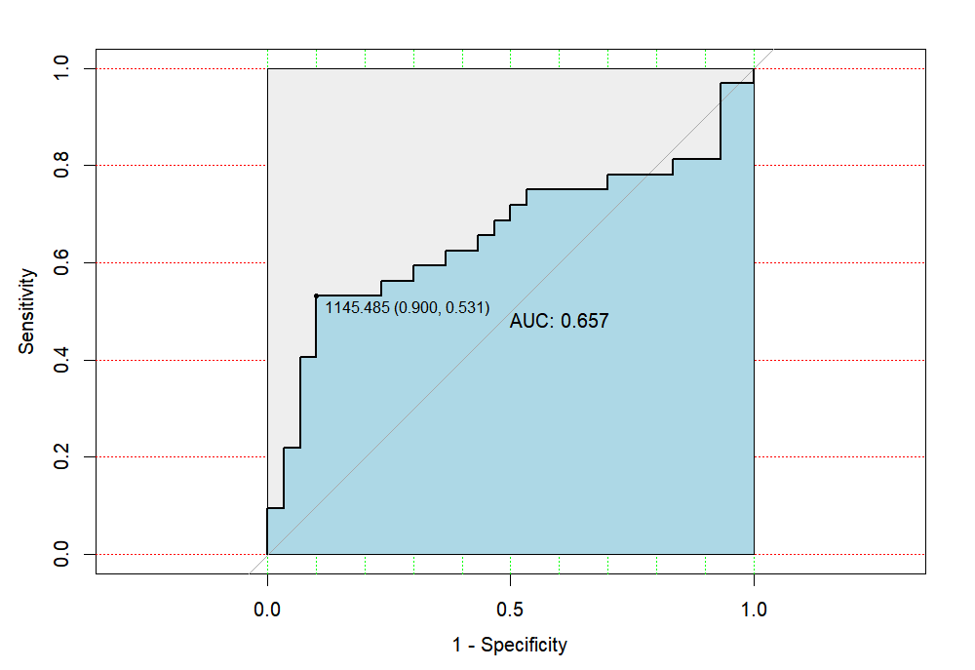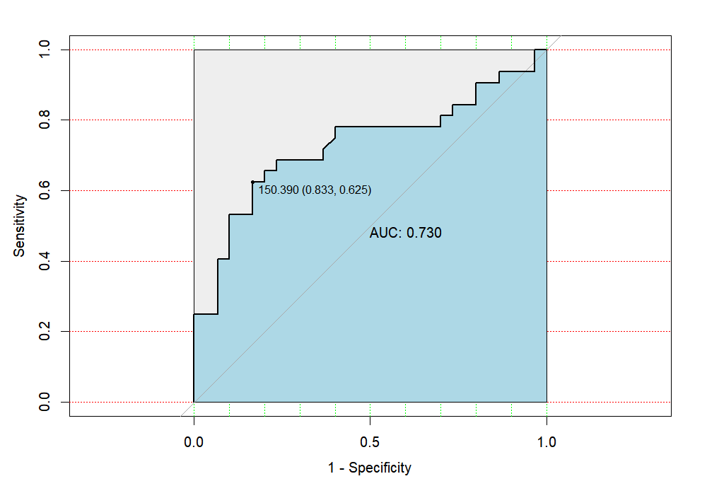
B
A

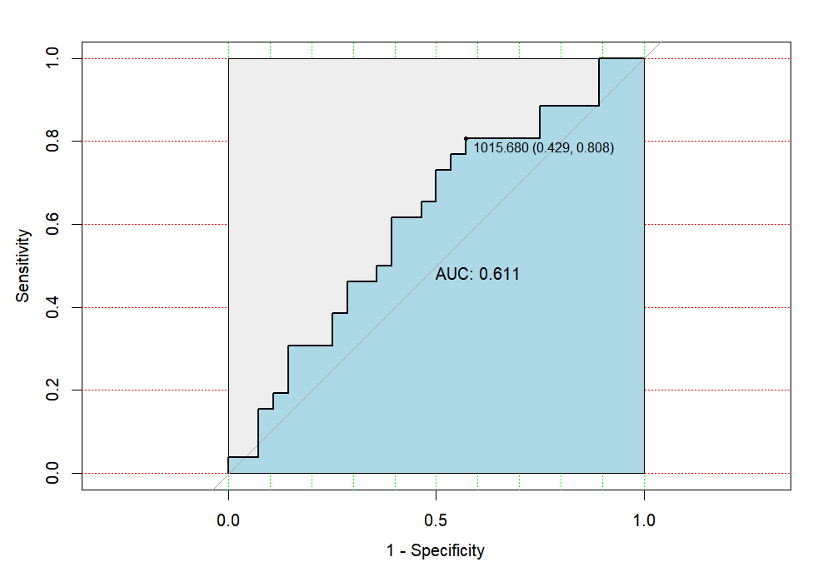
C
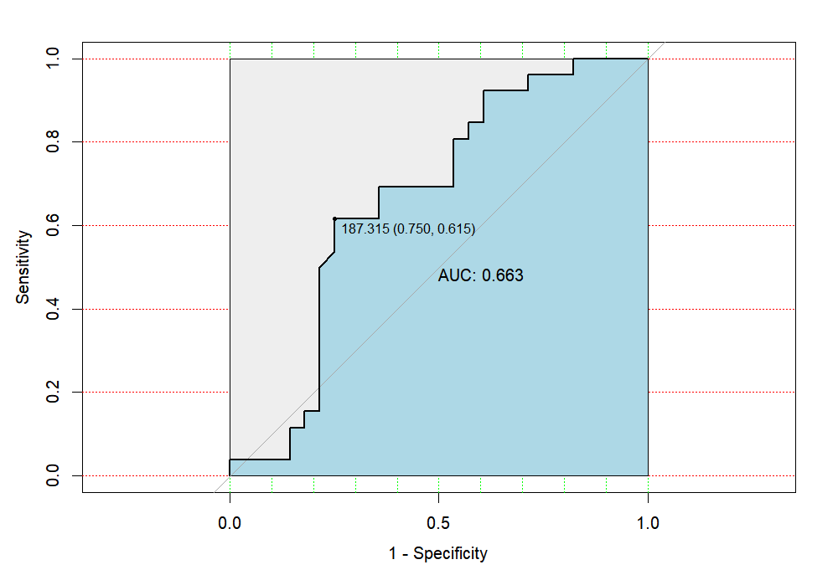
D

Supplementary Figure 2 ROC curves of SII for predicting coagulopathy risk in TBI patients with multi-trauma(A). ROC curves of PLR for predicting coagulopathy risk in TBI patients with multi-trauma(B). ROC curves of SII for predicting poor prognosis at 6 months after discharge in TBI patients with multi-trauma(C). ROC curves of PLR for predicting poor prognosis at 6 months after discharge in TBI patients with multi-trauma(D).
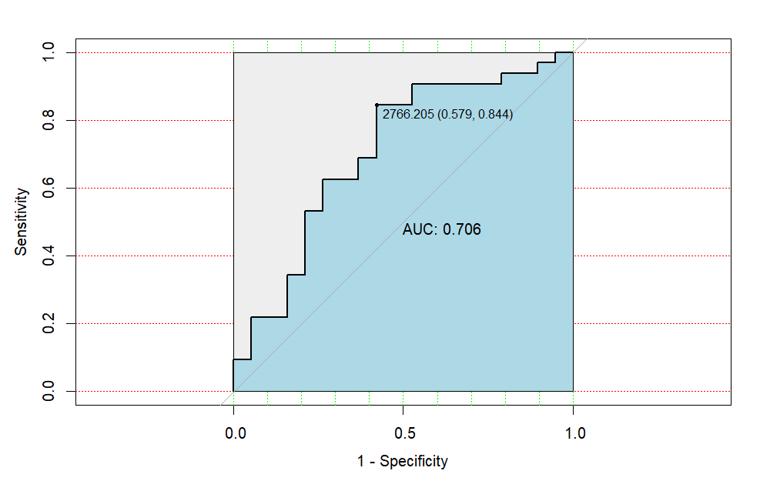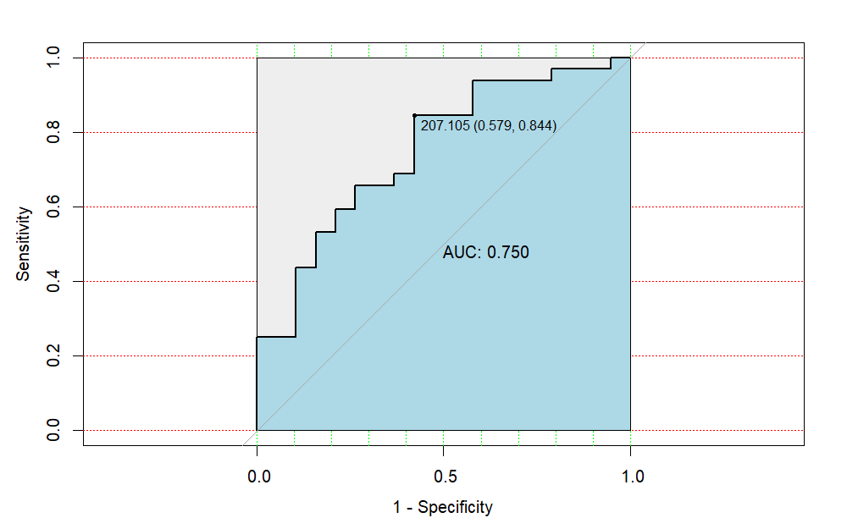
B
A

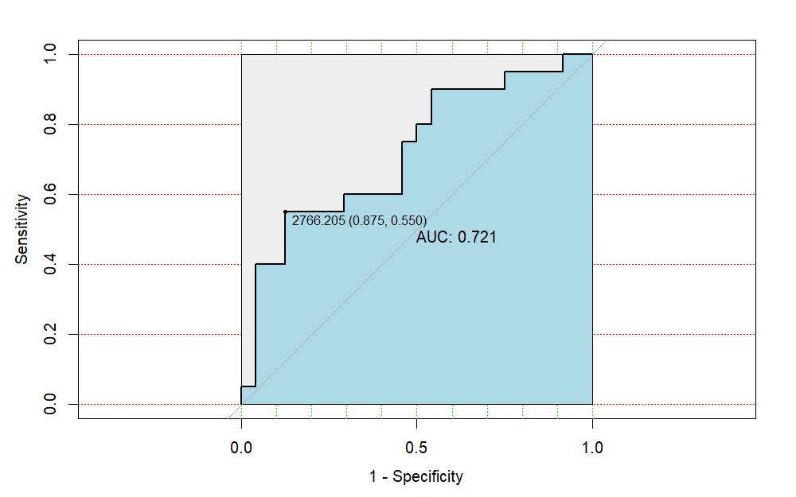
C

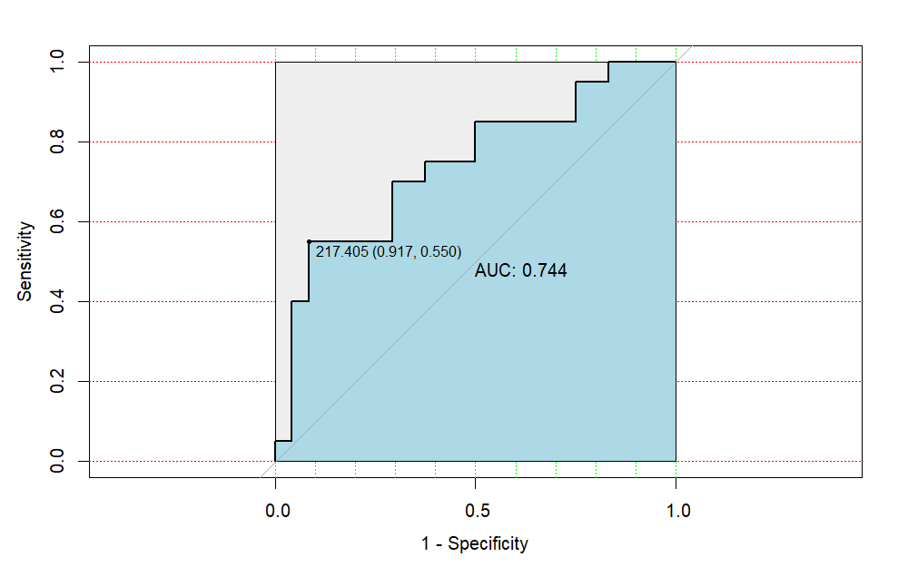
D

