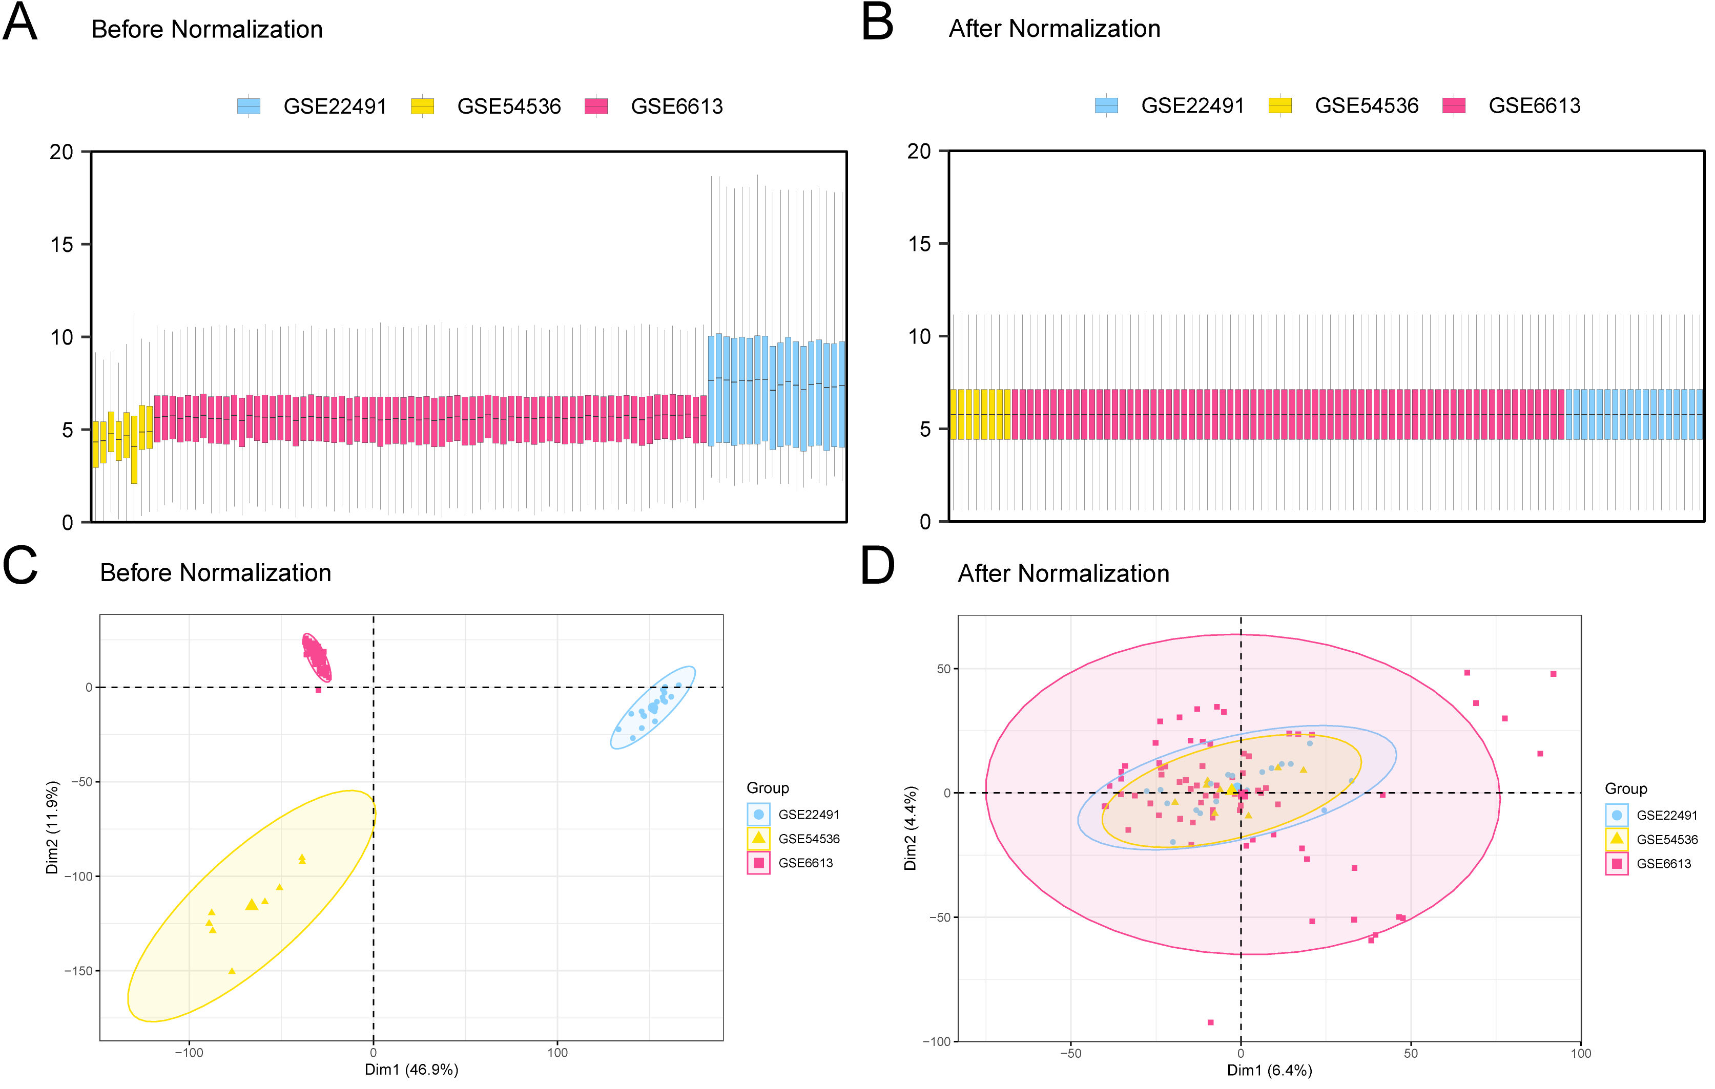
Supplementary Fig.1
The expression matrices of the GSE6613, GSE54536, and GSE22491 datasets were normalized. (A) Box plot of three datasets before batch correction; (B) Box plot of three datasets after batch correction. (C) PCA of three datasets before batch correction; (D) PCA of three datasets after batch correction.

Table S1 Iron metabolism-related genes
Iron metabolism-related genes
PRNP | GABARAPL2 | SQSTM1 | CYBRD1 | CEBPG | EPO
VDAC3 | GABARAPL1 | NQO1 | FBXL5 | SNORA16A | BCS1L
CYBB | ATG16L1 | EIF2S1 | FLVCR1 | RGS4 | ERFE
PCBP1 | WIPI1 | MUC1 | FTL | BLOC1S5-TXNDC5 | CRP
PCBP2 | WIPI2 | MT1G | NEDD8 | KIM-1 | HBB
ACSL1 | SNX4 | CISD1 | GLRX3 | IL6 | MT-CYB
ACSL5 | ATG13 | FANCD2 | HEPH | CXCL2 | FXN
ACSL6 | ULK2 | ELAVL1 | FTMT | RELA | PLA2G6
ACSF2 | SAT1 | HSPA5 | HMOX2 | HSD17B11 | BMP2
GCLM | EGFR | HELLS | LCN2 | AGPAT3 | HP
GSS | MAPK3 | SCD | MCOLN1 | SETD1B | SETX
MAP1LC3B | MAPK1 | FADS2 | RPS27A | HSPB1 | UNC13A
MAP1LC3C | BID | SRC | SKP1 | IREB2 | SURF1
SAT2 | ZEB1 | STAT3 | SLC22A17 | MAPK14 | PRKCG
SLC11A2 | DPP4 | PML | SLC46A1 | MAFG | DNM1
SLC39A14 | CDKN2A | MTOR | STEAP2 | IL33 | GRM1
SLC39A8 | PEBP1 | NFS1 | GPX4 | NFE2L2 | NPC1
ALOX12 | SOCS1 | TP63 | TCIRG1 | RPL8 | SCN8A
ALOX15 | CDO1 | CDKN1A | UBA52 | HAMP | STXBP1
CS | MYB | MIR137 | UBB | SESN2 | CACNA1A
EMC2 | MAPK8 | ENPP2 | PTGS2 | SLC3A2 | MFN2
ALOX5 | MAPK9 | FH | DUSP1 | DRD5 | SYNGAP1
NOX1 | ATP5MC3 | CISD2 | NOS2 | DRD4 | PMM2
NOX3 | GOT1 | MIR9-1 | NCF2 | MAP3K5 | AFG3L2
NOX4 | PRKAA2 | MIR9-2 | MT3 | SLC2A1 | KCNJ10
NOX5 | PRKAA1 | MIR9-3 | ALB | SLC2A3 | FLNC
DUOX1 | BAP1 | FTH1 | TXNRD1 | SLC2A6 | HARS1
DUOX2 | ABCC1 | ISCU | SRXN1 | SLC2A8 | SATB2
G6PD | MIR6852 | ACSL3 | GPX2 | SLC2A12 | TDP2
PGD | ACVR1B | OTUB1 | BNIP3 | SLC2A14 | COQ8A
VDAC2 | TGFBR1 | CD44 | OXSR1 | EIF2AK4 | PNPLA6
PIK3CA | EPAS1 | BRD4 | SELENOS | SLC40A1 | PTRH2
FLT3 | HILPDA | PRDX6 | ANGPTL7 | SLC7A11 | SEPSECS
SCP2 | IFNG | MIR17 | HFE | STEAP3 | ATP6V0A1
TP53 | ANO6 | NF2 | DDIT4 | TF | FGF14
LPCAT3 | LPIN1 | ARNTL | ASNS | TFRC | KCNN2
NRAS | CBS | HIF1A | TSC22D3 | UBC | MLC1
KRAS | TNFAIP3 | JUN | DDIT3 | TFAP2C | SPTBN2
HRAS | TLR4 | CA9 | JDP2 | SP1 | KIF1C
TFR2 | ATM | TMBIM4 | SLC1A4 | HBA1 | PEX6
SLC38A1 | YY1AP1 | PLIN2 | PCK2 | NNMT | RNF14
SLC1A5 | EGLN2 | MIR212 | TXNIP | PLIN4 | COQ4
CARS1 | MIOX | Fer1HCH | VLDLR | HIC1 | PCDH12
KEAP1 | TAZ | AIFM2 | GPT2 | STMN1 | SYNE1
ATF3 | MTDH | LAMP2 | PSAT1 | RRM2 | SPART
ATG5 | IDH1 | ZFP36 | LURAP1L | CAPG | CEP104
ATG7 | SIRT1 | PROM2 | SLC7A5 | HNF4A | KCNA6
NCOA4 | FBXW7 | CHMP5 | HERPUD1 | NGB | KIF7
ATF4 | PANX1 | CHMP6 | XBP1 | YWHAE | NCDN
ALOX12B | DNAJB6 | AKR1C1 | HMGB1 | GABPB1 | CIZ1
ALOX15B | BACH1 | CAV1 | HMOX1 | AURKA | CSMD1
ALOXE3 | ACSL4 | GCH1 | ZNF419 | MIR4715 | SNX14
PHKG2 | LONP1 | HPX | KLHL24 | RIPK1 | MTCL1
ACO1 | CHAC1 | LTF | TRIB3 | PRDX1 | MT-ATP6
GLS2 | AKR1C2 | MT2A | ZFP69B | MIR30B | LRCH2
ULK1 | AKR1C3 | MYC | ATP6V1G2 | HJV | C11orf65
ATG3 | RB1 | SRI | VEGFA | TMPRSS6 | HERC2
ATG4D | CP | ABCG2 | GDF15 | BMP6 | ALAS2
BECN1 | HSF1 | CAND1 | TUBE1 | SLC11A1 | PCSK7
MAP1LC3A | GCLC | CUL1 | ARRDC3 | PANK2 | UQCRFS1
MB | COASY | C19orf12

Table S2 All primer sequences used for RT-qPCR validation
Primer name | Primer sequence (5’ to 3’)
GAPDH-F (Internal reference) | 5-GGAGCGAGATCCCTCCAAAAT-3
GAPDH-R (Internal reference) | 5-GGCTGTTGTCATACTTCTCATGG-3
ACTB-F (Internal reference) | 5-CATGTACGTTGCTATCCAGGC-3
ACTB-R (Internal reference) | 5-CTCCTTAATGTCACGCACGAT-3
HNF4A-F | 5-CACGGGCAAACACTACGGT-3
HNF4A-R | 5-TTGACCTTCGAGTGCTGATCC-3
CHAC1-F | 5-GAACCCTGGTTACCTGGGC-3
CHAC1-R | 5-CGCAGCAAGTATTCAAGGTTGT-3
CDO1-F | 5-ATGGAACAGACCGAAGTGCTG-3
CDO1-R | 5-CTTGGCGTACATTGCCCAC-3
PNPLA6-F | 5-ACCTGGCTAACTCCCATCTG-3
PNPLA6-R | 5-GGAAGAGTGGCTTCTCGAAGT-3
SKP1-F | 5-GCCATTGTTTCCAGCTTCCC-3
SKP1-R | 5-CAAGGGATGATCTGAGCCTGA-3
ALAS2-F | 5-TGTCCGTCTGGTGTAGTAATGA-3
ALAS2-R | 5-GCTCAAGCTCCACATGAAACT-3

