Appendix
Table S1 Model performance comparison among the original dataset.

Table S2 Model performance comparison among the random over-sampling dataset.

Table S3 Model performance comparison among the random under-sampling dataset.

Table S4 Model performance comparison among the ADASYN dataset.

Table S5 Model performance comparison among the SMOTE dataset.

Table S6 Model performance comparison among the borderline SMOTE dataset.

Table S7 Model performance comparison among the SVM-SMOTE dataset.

Table S8 Model performance comparison among the SMOTE-NC dataset.

Table S9 Hyperparameter of the proposed ML algorithms.
Method | Hyperparameters
Elastic Net | loss='log_loss', penalty='elasticnet', l1_ratio=0.5, alpha=0.0001, max_iter=10000, tol=1e-3
Logistic Regression | max_iter=10000
XGBoost | Default setting in xgboost
LightGBM | Default setting in lightgbm
Gradient Boosting | Default setting in scikit-learn
AdaBoost | Default setting in scikit-learn
SVM | probability=True
Random Forest | criterion='gini',max_depth=5,max_features='sqrt'  min_samples_leaf=2,n_estimators=50
MLP | hidden_layer_sizes=(20,15,10), max_iter=1000,batch_size=256,solver='adam'

Figure S1 ROC plot of the model performance in the random under-sampling dataset.
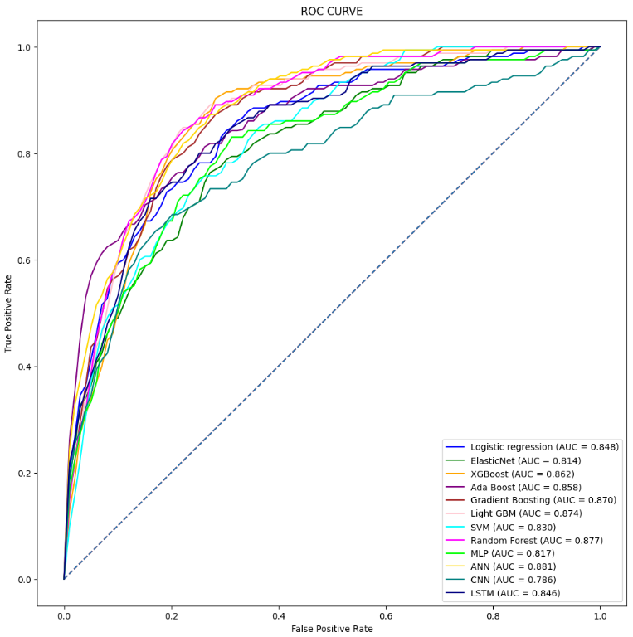

Figure S2 ROC plot of the model performance in the ADASYN dataset.
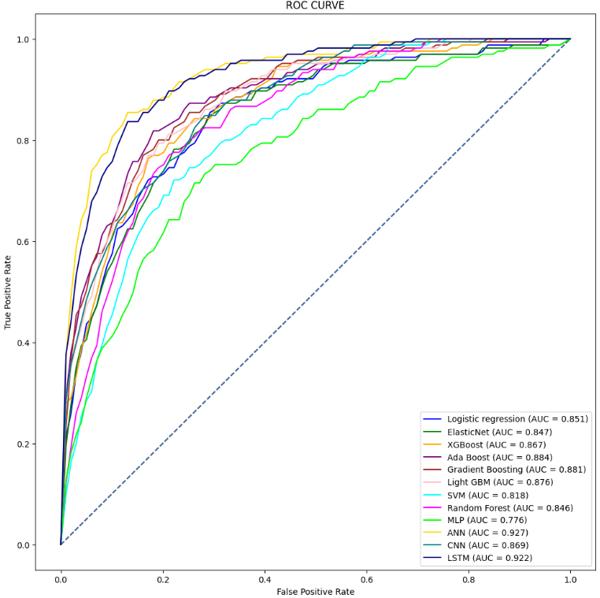

Figure S3 ROC plot of the model performance in the SMOTE dataset.
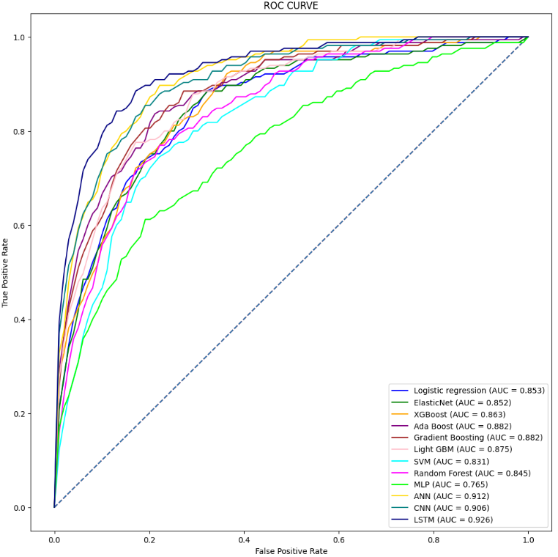

Figure S4 ROC plot of the model performance in the borderline-SMOTE dataset.
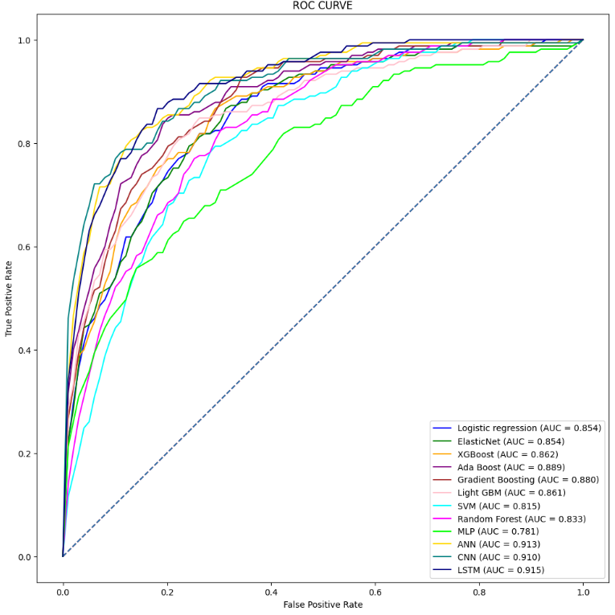

Figure S5 ROC plot of the model performance in the SVM-SMOTE dataset.
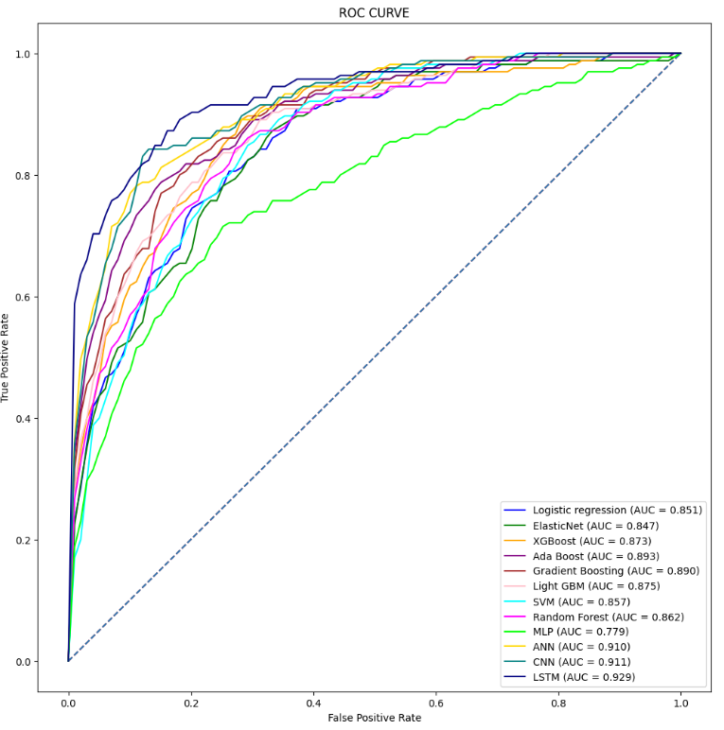

Figure S6 ROC plot of the model performance in the SMOTE-NC dataset.
