Supplementary Tables

Table S1. Physical appearance of RMP formulations after 6 months of accelerated storage.
Formulation | Physical appearance
Formulation | Zero time | Accelerated (6 m)
Liquid SNEDDS | Brown liquid | Brown liquid
RMP/THQ loaded Single-SNEPs | Free-flowing pellets | Pellet adherence
THQ loaded Single-SNEPs  (no-RMP) | Free-flowing pellets | Free-flowing pellets
3L-SNEPs | Free-flowing pellets | Free-flowing pellets
4L-SNEPs | Free-flowing pellets | Pellet adherence
5L-SNEPs | Free-flowing pellets | Free-flowing pellets

Supplementary figures legend

Figure S1. UPLC MS‒MS chromatograms of prednisolone, Ramiprilat and ramipril.
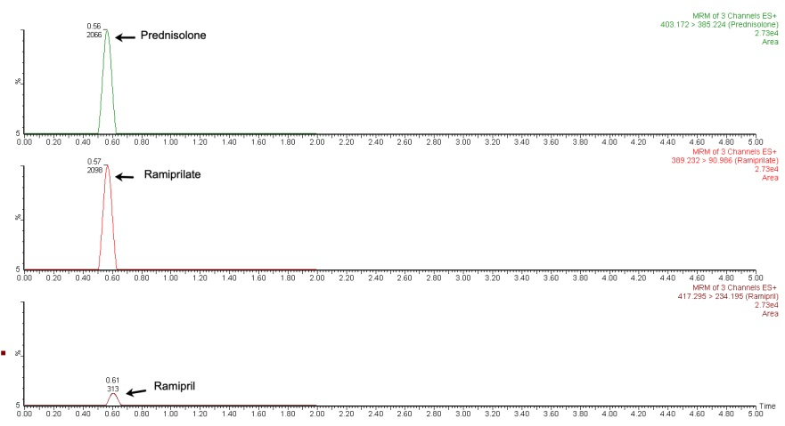

Figure S2. Calibration curves of ramipril in plasma (range = 10--500 ng/ml) [TOP] and ramiprilat in plasma (range = 20--1000 ng/ml) [BOTTOM].
