Supplementary Figures
Figure S1. Comparison of gADNPs and rADNPs optimisation schemes. (A) Four groups of different extraction protocols were used as a comparison, where G stands for gel, R for rind, G1/R1 and G2/R2 were extracted according to the description of existing articles, and G3/R3 and G4/R4 were modified protocols. The G3/R3 scheme with high final yield and stable ζ-potential was chosen. (B) Statistical charts of program results for each group. Data are presented as mean ± SD. n = 3, *P < 0.05, **P < 0.01, ***P < 0.001, ****P < 0.0001, ns: no significant difference.

Figure S2. The identification images of DFs. (A) General procedure for the extraction of gADNPs/rADNPs. (B) Immunofluorescence identification images of CK-10, Vimentin, and α-SMA labeled DF cells (Scale bar: 100 μm).

Figure S3. (A) Scratch assay of DFs (scale bar: 200 μm). (B) CCK-8 assay for the proliferative viability of DFs after UVA irradiation.

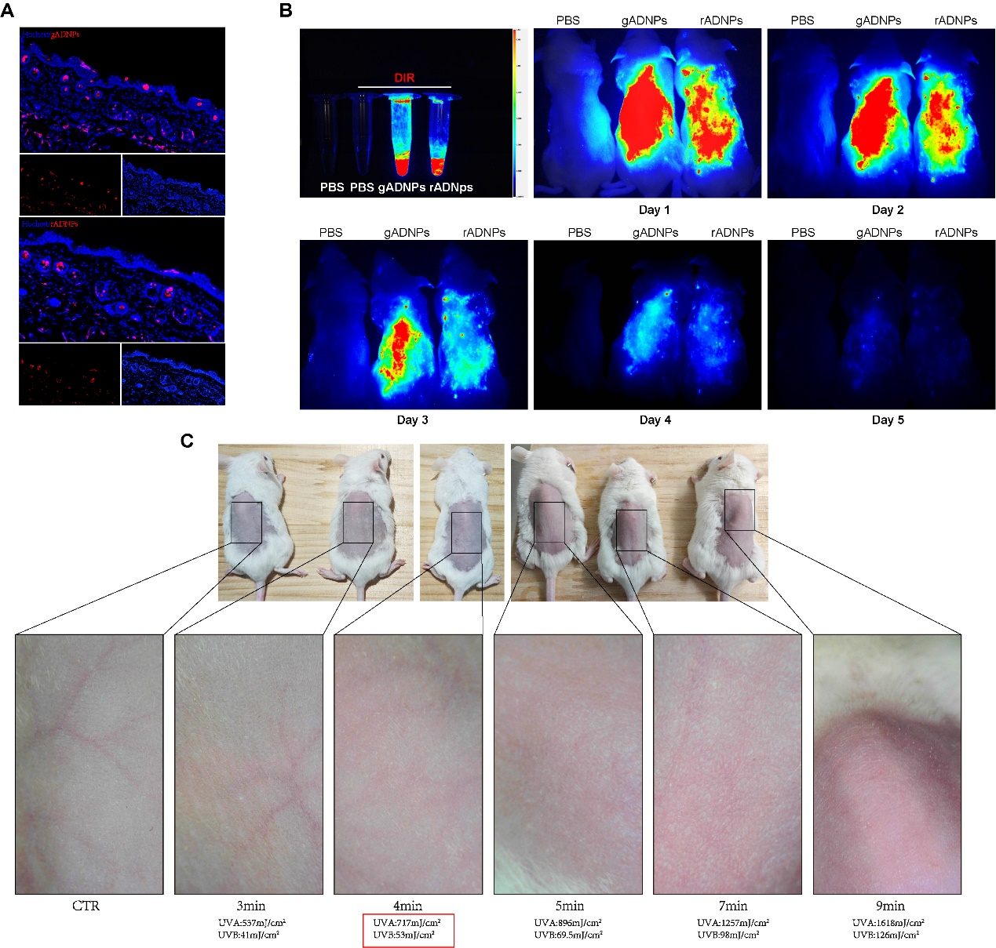
Figure S4. (A) Cutaneous uptake of DiL-gADNPs/rADNPs in mice. (B) Skin metabolism in mice after application of gADNPs/rADNPs assisted by a microneedle roller. (C) Minimum erythema dose (MED) testing on the backs of 7-week-old ICR mice, with UVA = 717 mJ/cm² and UVB = 53 mJ/cm² as the final doses.

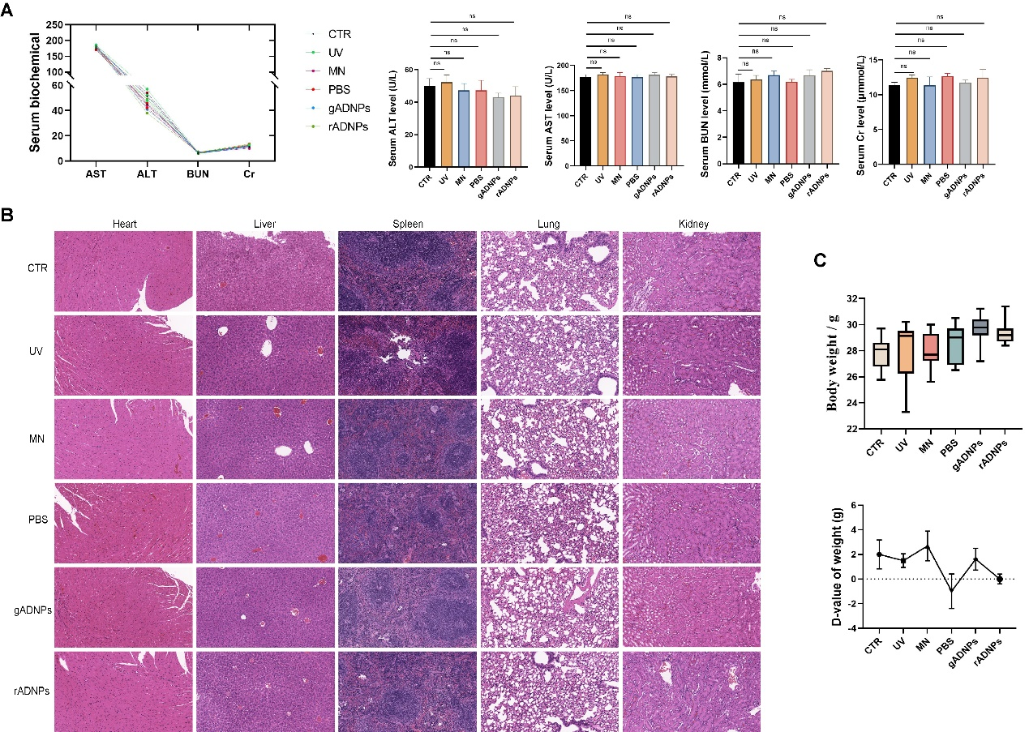
Figure S5. In vivo safety assessment. (A) Determination of ALT, AST, Cr, and BUN levels in mouse serum after UV irradiation. (B) Histological analysis of pathological changes in the heart, liver, spleen, lungs, and kidneys of mice. (C) Body weight changes in mice during UV irradiation.

Supplementary Tables
Table S1. Primer sequences for RT-qPCR
Genes | Forward Primers（5’-3’） | Reverse Primers（5’-3’）
Rattus norvegicus
Il-6 | ACTTCCAGCCAGTTGCCTTCTTG | TGGTCTGTTGTGGGTGGTATCCTC
p16 | TCCTTGGCTTCACTTCTGGCAAC | ACTCTGTCCCTCCCTCCCTCTG
Cxcl1 | GCAGACAGTGGCAGGGATTCAC | AGTGTGGCTATGACTTCGGTTTGG
col1α1 | TGTTGGTCCTGCTGGCAAGAATG | GTCACCTTGTTCGCCTGTCTCAC
actin | TCAGGTCATCACTATCGGCAAT | AAAGAAAGGGTGTAAAACGCA
Mus musculus
IL-6 | CTTCTTGGGACTGATGCTGGTGAC | AGGTCTGTTGGGAGTGGTATCCTC
col1α1 | TCAGAGGCGAAGGCAACAGTC | GCAGGCGGGAGGTCTTGG
Tgf-beta | ACCGCAACAACGCCATCTATGAG | GGCACTGCTTCCCGAATGTCTG
P53 | ACCGCCGACCTATCCTTACCATC | GGCACAAACACGAACCTCAAAGC

