Supplementary information

Table S1 The proportion of IHD burden attribute to all risk factors in 2021
Location | Deaths (95% CI) | DALYs (95% CI)
Global | 91.67(88.44 to 93.36) | 92.27(88.88 to 93.95)
High SDI | 89.13(85.3 to 91.53) | 90.37(87.69 to 92.95)
High-middle SDI | 91.55(89.08 to 92.77) | 92.53(89.49 to 93.77)
Middle SDI | 91.92(90.15 to 92.95) | 91.81(89.44 to 92.96)
Low-middle SDI | 93.17(90.59 to 93.84) | 93.03(90.35 to 93.96)
Low SDI | 92.37(90.05 to 93.2) | 92.34(89.12 to 93.51)
DALYs:disability-adjusted life years; SDI: sociodemographic index; CI: confidence interval.

Table S2 IHD-related deaths (absolute numbers and percentages) associated with risk factors and their clusters in 2021
 | Global |  |  | High SDI |  |  | High-middle SDI |  |  | Middle SDI |  |  | Low-middle SDI |  |  | Low SDI
 | Absolute number(thousands) | Percentage |  | Absolute number(thousands) | Percentage |  | Absolute number(thousands) | Percentage |  | Absolute number(thousands) | Percentage |  | Absolute number(thousands) | Percentage |  | Absolute number(thousands) | Percentage
Environmental risks
Ambient particulate matter pollution | 1729.55(1212.5 to 2286.98) | 20.98%(16.59 to 25.7) |  | 155.16(102.51 to 209.32) | 12.5%(9.87 to 15.36) |  | 495.57(344.04 to 651.79) | 22.09%(17.41 to 26.54) |  | 699.85(464.57 to 923.95) | 27.08%(20.09 to 32.88) |  | 329.36(201.05 to 462.86) | 19.27%(13.06 to 25.11) |  | 48.07(30.17 to 70.77) | 10.55%(7.48 to 13.98)
Household air pollution from solid fuels | 762.84(412.88 to 1370.92) | 9.26%(5.65 to 15.41) |  | 0.83(0 to 8.01) | 0.07%(0 to 0.59) |  | 37.82(2.72 to 185.46) | 1.69%(0.14 to 7.55) |  | 180.18(42.03 to 459.34) | 6.97%(1.82 to 16.35) |  | 372.39(222.16 to 544.44) | 21.79%(14.43 to 29.54) |  | 171.06(131.69 to 211.46) | 37.53%(32.63 to 41.78)
High temperature | 112.39(17.05 to 256.43) | 1.36%(0.23 to 2.88) |  | 9.19(-0.48 to 28.53) | 0.74%(-0.05 to 2.09) |  | 13.44(-3.34 to 46.86) | 0.6%(-0.17 to 1.91) |  | 36.66(6.11 to 82.78) | 1.42%(0.26 to 2.95) |  | 45.83(12.53 to 86.44) | 2.68%(0.81 to 4.69) |  | 7.22(1.08 to 14.34) | 1.58%(0.27 to 2.83)
Low temperature | 505.3(432.02 to 619.92) | 6.13%(5.91 to 6.97) |  | 91.34(74.99 to 109.64) | 7.36%(7.22 to 8.04) |  | 161.78(138.03 to 198.11) | 7.21%(6.98 to 8.07) |  | 150.11(127.84 to 178.55) | 5.81%(5.53 to 6.35) |  | 81.16(61.93 to 104.9) | 4.75%(4.02 to 5.69) |  | 20.46(16 to 25.36) | 4.49%(3.96 to 5.01)
Lead exposure | 590.37(-83.78 to 1233.63) | 7.16%(-1.15 to 13.86) |  | 49.29(-6.96 to 107.58) | 3.97%(-0.67 to 7.89) |  | 118.37(-16.28 to 251.98) | 5.28%(-0.82 to 10.26) |  | 204.07(-28.95 to 424.99) | 7.9%(-1.25 to 15.12) |  | 169.23(-24.37 to 361.48) | 9.9%(-1.58 to 19.61) |  | 48.88(-7.14 to 102.01) | 10.72%(-1.77 to 20.15)
Behavioral risks
Low physical activity | 232.25(103.52 to 371.37) | 2.82%(1.42 to 4.17) |  | 35.92(14.37 to 58.94) | 2.89%(1.38 to 4.32) |  | 66.68(28.94 to 111.39) | 2.97%(1.46 to 4.54) |  | 79.47(35.67 to 125.59) | 3.08%(1.54 to 4.47) |  | 43.06(19.11 to 68.47) | 2.52%(1.24 to 3.71) |  | 6.87(2.97 to 11.06) | 1.51%(0.74 to 2.19)
Secondhand smoke | 414.64(307.78 to 528.09) | 5.03%(4.21 to 5.93) |  | 37.16(26.6 to 49.16) | 2.99%(2.56 to 3.61) |  | 130.37(93.19 to 168.8) | 5.81%(4.71 to 6.87) |  | 148.71(108.1 to 194) | 5.75%(4.68 to 6.9) |  | 82.28(60.68 to 105.21) | 4.81%(3.94 to 5.71) |  | 15.74(11.32 to 20.94) | 3.45%(2.81 to 4.14)
Smoking | 1346.29(1143.83 to 1571.73) | 16.33%(15.65 to 17.66) |  | 183.8(150.04 to 217.95) | 14.81%(14.45 to 15.99) |  | 378.97(313.32 to 448.55) | 16.89%(15.85 to 18.26) |  | 435.7(361.54 to 512.59) | 16.86%(15.64 to 18.24) |  | 290.37(243.27 to 338.39) | 16.99%(15.8 to 18.36) |  | 56.16(46.13 to 67.49) | 12.32%(11.43 to 13.33)
Dietary risks
Diet low in fruits | 601.9(126.53 to 1003.68) | 7.3%(1.73 to 11.28) |  | 55.65(11.34 to 97.88) | 4.48%(1.09 to 7.18) |  | 108.99(22.49 to 190.61) | 4.86%(1.14 to 7.76) |  | 183.18(38.21 to 306) | 7.09%(1.65 to 10.89) |  | 197.79(41.52 to 321.82) | 11.57%(2.7 to 17.46) |  | 55.9(11.96 to 91.96) | 12.26%(2.96 to 18.17)
Diet low in vegetables | 239.77(112 to 379.25) | 2.91%(1.53 to 4.26) |  | 32.43(13.98 to 53.38) | 2.61%(1.35 to 3.92) |  | 34.41(14.73 to 58.05) | 1.53%(0.75 to 2.36) |  | 68.97(31.97 to 110.87) | 2.67%(1.38 to 3.95) |  | 72.42(35.03 to 109.75) | 4.24%(2.28 to 5.95) |  | 31.27(15.16 to 46.66) | 6.86%(3.76 to 9.22)
Diet low in whole grains | 1125.89(680.98 to 1546.74) | 13.66%(9.32 to 17.38) |  | 155.75(90.86 to 218.84) | 12.55%(8.75 to 16.06) |  | 338.44(201.84 to 474.83) | 15.09%(10.21 to 19.33) |  | 329.93(200.26 to 456.97) | 12.77%(8.66 to 16.26) |  | 229.41(139.5 to 311.22) | 13.42%(9.06 to 16.89) |  | 71.14(43.63 to 97.07) | 15.61%(10.81 to 19.18)
Diet high in red meat | 181.39(-8.72 to 370.17) | 2.2%(-0.12 to 4.16) |  | 48.81(-2.39 to 102.02) | 3.93%(-0.23 to 7.49) |  | 71.19(-3.48 to 146.37) | 3.17%(-0.18 to 5.96) |  | 54.57(-2.55 to 115.01) | 2.11%(-0.11 to 4.09) |  | 6.05(-0.27 to 12.67) | 0.35%(-0.02 to 0.69) |  | 0.56(-0.02 to 1.21) | 0.12%(0 to 0.24)
Diet high in processed meat | 77.84(31.4 to 121.59) | 0.94%(0.43 to 1.37) |  | 45.64(18.32 to 70.9) | 3.68%(1.76 to 5.2) |  | 24.97(9.43 to 39.04) | 1.11%(0.48 to 1.59) |  | 3.04(1.18 to 4.9) | 0.12%(0.05 to 0.17) |  | 3.07(1.13 to 4.95) | 0.18%(0.07 to 0.27) |  | 1.06(0.4 to 1.76) | 0.23%(0.1 to 0.35)
Diet high in sugar-sweetened beverages | 6.87(-1.64 to 14.79) | 0.08%(-0.02 to 0.17) |  | 1.95(-0.44 to 4.24) | 0.16%(-0.04 to 0.31) |  | 1.58(-0.38 to 3.42) | 0.07%(-0.02 to 0.14) |  | 2.05(-0.49 to 4.4) | 0.08%(-0.02 to 0.16) |  | 1.11(-0.27 to 2.43) | 0.07%(-0.02 to 0.13) |  | 0.17(-0.04 to 0.38) | 0.04%(-0.01 to 0.08)
Diet low in fiber | 458.82(240.4 to 666.58) | 5.57%(3.29 to 7.49) |  | 69.09(34.65 to 104.87) | 5.57%(3.34 to 7.69) |  | 89.77(43.8 to 134.06) | 4%(2.22 to 5.46) |  | 141.11(72.84 to 201.15) | 5.46%(3.15 to 7.16) |  | 128.03(67.56 to 182.8) | 7.49%(4.39 to 9.92) |  | 30.36(16.2 to 44.29) | 6.66%(4.01 to 8.75)
Diet low in polyunsaturated fatty acids | 737.12(-2119.61 to 2766.91) | 8.94%(-29 to 31.1) |  | 66.59(-171.24 to 257.49) | 5.37%(-16.49 to 18.89) |  | 196.95(-536.8 to 749.36) | 8.78%(-27.16 to 30.51) |  | 243.89(-705.49 to 910.11) | 9.44%(-30.51 to 32.39) |  | 178.39(-547.57 to 658.07) | 10.44%(-35.57 to 35.7) |  | 50.59(-157.56 to 184.77) | 11.1%(-39.04 to 36.5)
Diet high in sodium | 658.81(116.24 to 1564.79) | 7.99%(1.59 to 17.59) |  | 83.95(9.26 to 223.99) | 6.76%(0.89 to 16.44) |  | 209.16(45.97 to 464.88) | 9.32%(2.33 to 18.93) |  | 243.56(51.32 to 543.38) | 9.43%(2.22 to 19.34) |  | 99.97(9.06 to 276.25) | 5.85%(0.59 to 14.99) |  | 21.23(0.69 to 65.22) | 4.66%(0.17 to 12.89)
Diet low in legumes | 389.33(-313.42 to 1011.1) | 4.72%(-4.29 to 11.36) |  | 68.34(-55.43 to 183.7) | 5.51%(-5.34 to 13.48) |  | 111.45(-91.89 to 290.94) | 4.97%(-4.65 to 11.85) |  | 112.39(-88.3 to 286.13) | 4.35%(-3.82 to 10.18) |  | 74.09(-59.71 to 187.17) | 4.33%(-3.88 to 10.15) |  | 22.62(-18.52 to 57.44) | 4.96%(-4.59 to 11.35)
Diet low in nuts and seeds | 658.25(184.91 to 1086.13) | 7.99%(2.53 to 12.21) |  | 65.57(17.74 to 110.48) | 5.28%(1.71 to 8.11) |  | 174.86(48.28 to 298.31) | 7.79%(2.44 to 12.15) |  | 191.17(53.09 to 315.38) | 7.4%(2.3 to 11.22) |  | 180.95(52.35 to 290) | 10.59%(3.4 to 15.73) |  | 45.07(13.04 to 71.31) | 9.89%(3.23 to 14.09)
Diet low in seafood omega-3 fatty acids | 627.34(119.54 to 1082.74) | 7.61%(1.64 to 12.17) |  | 70.16(12.96 to 127.78) | 5.65%(1.25 to 9.38) |  | 118.54(22.45 to 213) | 5.28%(1.14 to 8.67) |  | 194.45(36.79 to 338.12) | 7.52%(1.59 to 12.03) |  | 178.27(34.9 to 297.39) | 10.43%(2.27 to 16.13) |  | 65.21(13.45 to 109.24) | 14.31%(3.33 to 21.58)
Metabolic risks
High fasting plasma glucose | 1345.84(1161.32 to 1549.27) | 16.33%(15.89 to 17.41) |  | 250.4(210.21 to 289.79) | 20.18%(20.25 to 21.26) |  | 333.66(281.19 to 386.44) | 14.87%(14.23 to 15.73) |  | 414.44(354.17 to 477.88) | 16.04%(15.32 to 17) |  | 280.75(241.09 to 322.86) | 16.43%(15.66 to 17.52) |  | 64.96(54.6 to 76.37) | 14.25%(13.53 to 15.09)
High LDL cholesterol | 2709.81(1803.8 to 3683.8) | 32.88%(24.68 to 41.4) |  | 409.28(269.22 to 567.36) | 32.98%(25.93 to 41.63) |  | 757.2(504 to 1028.02) | 33.75%(25.5 to 41.86) |  | 851.45(568.35 to 1154.79) | 32.95%(24.58 to 41.09) |  | 549.71(373.3 to 737.13) | 32.16%(24.25 to 39.99) |  | 139.14(94.59 to 189.87) | 30.53%(23.44 to 37.51)
High systolic blood pressure | 4692.86(3799.89 to 5515.76) | 56.94%(51.99 to 61.99) |  | 696.92(538.08 to 838.24) | 56.15%(51.83 to 61.5) |  | 1356.64(1101.52 to 1600.03) | 60.48%(55.73 to 65.15) |  | 1455.32(1169.45 to 1723.45) | 56.32%(50.58 to 61.33) |  | 942.43(761.33 to 1111.84) | 55.14%(49.45 to 60.32) |  | 236.39(183.76 to 285.82) | 51.86%(45.54 to 56.47)
High body-mass index | 985.92(378.3 to 1610.22) | 11.96%(5.18 to 18.1) |  | 192.54(76.13 to 318.34) | 15.51%(7.33 to 23.36) |  | 306.64(118 to 511.49) | 13.67%(5.97 to 20.83) |  | 277.54(108.45 to 453.73) | 10.74%(4.69 to 16.15) |  | 173.42(67.96 to 277.13) | 10.15%(4.41 to 15.04) |  | 34.49(12.7 to 56.37) | 7.57%(3.15 to 11.14)
Kidney dysfunction | 1398.57(976.44 to 1778.4) | 16.97%(13.36 to 19.99) |  | 247.96(174.44 to 319.42) | 19.98%(16.8 to 23.44) |  | 369.62(252.99 to 480.88) | 16.48%(12.8 to 19.58) |  | 427.8(297.23 to 550.31) | 16.55%(12.86 to 19.58) |  | 281.11(201.82 to 360.78) | 16.45%(13.11 to 19.57) |  | 70.68(49.14 to 91.61) | 15.51%(12.18 to 18.1)

Table S3 IHD-related DALYs (absolute numbers and percentages) associated with risk factors and their clusters in 2021
 | Global |  |  | High SDI |  |  | High-middle SDI |  |  | Middle SDI |  |  | Low-middle SDI |  |  | Low SDI
 | Absolute number(millions) | Percentage |  | Absolute number(millions) | Percentage |  | Absolute number(millions) | Percentage |  | Absolute number(millions) | Percentage |  | Absolute number(millions) | Percentage |  | Absolute number(millions) | Percentage
Environmental risks
Ambient particulate matter pollution | 36.52(25.54 to 48.13) | 21.01%(16.23 to 25.85) |  | 2.78(1.91 to 3.7) | 13.06%(10.18 to 16.09) |  | 9.04(6.36 to 11.81) | 21.93%(17.28 to 26.22) |  | 15.16(9.94 to 19.95) | 26.81%(19.59 to 32.55) |  | 8.27(5.06 to 11.59) | 19.31%(13.11 to 24.92) |  | 1.23(0.77 to 1.82) | 10.51%(7.47 to 13.83)
Household air pollution from solid fuels | 18.15(10.27 to 31.39) | 10.44%(6.53 to 16.86) |  | 0.01(0 to 0.13) | 0.06%(0 to 0.56) |  | 0.68(0.05 to 3.32) | 1.64%(0.13 to 7.36) |  | 3.83(0.92 to 9.68) | 6.77%(1.81 to 15.8) |  | 9.27(5.53 to 13.6) | 21.63%(14.33 to 29.26) |  | 4.35(3.34 to 5.41) | 37.08%(32.28 to 41.2)
High temperature | 2.62(0.47 to 5.73) | 1.51%(0.3 to 3.08) |  | 0.21(0.01 to 0.57) | 0.97%(0.05 to 2.48) |  | 0.24(-0.06 to 0.83) | 0.59%(-0.16 to 1.84) |  | 0.82(0.16 to 1.79) | 1.45%(0.31 to 2.91) |  | 1.17(0.31 to 2.21) | 2.73%(0.82 to 4.76) |  | 0.18(0.03 to 0.37) | 1.55%(0.25 to 2.8)
Low temperature | 9.96(8.58 to 12.29) | 5.73%(5.45 to 6.6) |  | 1.49(1.29 to 1.8) | 7.01%(6.85 to 7.81) |  | 2.83(2.47 to 3.45) | 6.88%(6.71 to 7.67) |  | 3.06(2.62 to 3.65) | 5.41%(5.16 to 5.96) |  | 2.04(1.54 to 2.66) | 4.76%(3.98 to 5.72) |  | 0.53(0.41 to 0.65) | 4.48%(3.98 to 4.97)
Lead exposure | 11.85(-1.67 to 24.79) | 6.82%(-1.06 to 13.32) |  | 0.79(-0.11 to 1.69) | 3.7%(-0.59 to 7.34) |  | 2.03(-0.28 to 4.33) | 4.92%(-0.75 to 9.61) |  | 4.01(-0.56 to 8.4) | 7.1%(-1.11 to 13.7) |  | 3.87(-0.55 to 8.3) | 9.04%(-1.43 to 17.84) |  | 1.14(-0.17 to 2.42) | 9.75%(-1.6 to 18.41)
Behavioral risks
Low physical activity | 3.9(1.77 to 6.12) | 2.24%(1.12 to 3.29) |  | 0.5(0.21 to 0.81) | 2.36%(1.13 to 3.5) |  | 0.96(0.42 to 1.55) | 2.33%(1.13 to 3.43) |  | 1.42(0.65 to 2.23) | 2.51%(1.27 to 3.64) |  | 0.87(0.4 to 1.34) | 2.03%(1.04 to 2.89) |  | 0.14(0.06 to 0.22) | 1.22%(0.62 to 1.7)
Secondhand smoke | 9.7(7.26 to 12.13) | 5.58%(4.62 to 6.52) |  | 0.83(0.61 to 1.07) | 3.89%(3.26 to 4.66) |  | 2.65(1.96 to 3.35) | 6.42%(5.31 to 7.43) |  | 3.44(2.56 to 4.38) | 6.09%(5.05 to 7.14) |  | 2.32(1.69 to 2.94) | 5.41%(4.38 to 6.31) |  | 0.46(0.34 to 0.61) | 3.95%(3.24 to 4.63)
Smoking | 35.48(30.53 to 40.7) | 20.42%(19.4 to 21.86) |  | 4.32(3.64 to 5.02) | 20.28%(19.34 to 21.82) |  | 9.39(8.01 to 10.82) | 22.79%(21.76 to 24.02) |  | 11.55(9.73 to 13.38) | 20.42%(19.16 to 21.84) |  | 8.49(7.19 to 9.8) | 19.82%(18.65 to 21.09) |  | 1.7(1.4 to 2.01) | 14.5%(13.53 to 15.34)
Dietary risks
Diet low in fruits | 15.93(3.49 to 25.8) | 9.16%(2.22 to 13.86) |  | 1.11(0.23 to 1.9) | 5.22%(1.25 to 8.28) |  | 2.32(0.51 to 3.93) | 5.62%(1.4 to 8.73) |  | 4.97(1.11 to 8.1) | 8.78%(2.18 to 13.22) |  | 5.85(1.27 to 9.45) | 13.65%(3.28 to 20.33) |  | 1.68(0.37 to 2.72) | 14.3%(3.55 to 20.75)
Diet low in vegetables | 6.12(3.03 to 9.49) | 3.52%(1.92 to 5.1) |  | 0.61(0.28 to 0.97) | 2.89%(1.49 to 4.23) |  | 0.7(0.32 to 1.15) | 1.7%(0.86 to 2.56) |  | 1.82(0.9 to 2.85) | 3.22%(1.76 to 4.65) |  | 2.05(1.04 to 3.1) | 4.79%(2.69 to 6.67) |  | 0.92(0.46 to 1.36) | 7.86%(4.46 to 10.37)
Diet low in whole grains | 27.13(16.85 to 36.7) | 15.61%(10.71 to 19.71) |  | 3.09(1.9 to 4.24) | 14.52%(10.11 to 18.45) |  | 7.05(4.28 to 9.58) | 17.11%(11.63 to 21.27) |  | 8.25(5.05 to 11.27) | 14.59%(9.95 to 18.39) |  | 6.59(4.07 to 8.91) | 15.38%(10.55 to 19.17) |  | 2.12(1.32 to 2.86) | 18.07%(12.71 to 21.81)
Diet high in red meat | 4.41(-0.22 to 8.96) | 2.54%(-0.14 to 4.81) |  | 1.04(-0.05 to 2.12) | 4.9%(-0.29 to 9.23) |  | 1.67(-0.09 to 3.4) | 4.05%(-0.23 to 7.55) |  | 1.47(-0.07 to 3.06) | 2.6%(-0.15 to 5) |  | 0.2(-0.01 to 0.42) | 0.47%(-0.02 to 0.91) |  | 0.02(0 to 0.05) | 0.2%(-0.01 to 0.4)
Diet high in processed meat | 1.9(0.76 to 2.95) | 1.09%(0.49 to 1.59) |  | 1.09(0.44 to 1.7) | 5.13%(2.35 to 7.4) |  | 0.57(0.23 to 0.9) | 1.39%(0.61 to 2) |  | 0.09(0.03 to 0.15) | 0.16%(0.07 to 0.24) |  | 0.11(0.04 to 0.17) | 0.25%(0.1 to 0.37) |  | 0.04(0.01 to 0.06) | 0.31%(0.14 to 0.46)
Diet high in sugar-sweetened beverages | 0.2(-0.05 to 0.44) | 0.12%(-0.03 to 0.23) |  | 0.05(-0.01 to 0.11) | 0.25%(-0.06 to 0.5) |  | 0.04(-0.01 to 0.09) | 0.1%(-0.03 to 0.19) |  | 0.06(-0.02 to 0.14) | 0.11%(-0.03 to 0.23) |  | 0.04(-0.01 to 0.08) | 0.09%(-0.02 to 0.17) |  | 0.01(0 to 0.01) | 0.05%(-0.01 to 0.1)
Diet low in fiber | 11.54(6.16 to 16.41) | 6.64%(3.91 to 8.81) |  | 1.25(0.66 to 1.87) | 5.86%(3.51 to 8.14) |  | 1.89(0.96 to 2.81) | 4.58%(2.61 to 6.23) |  | 3.76(1.98 to 5.3) | 6.65%(3.9 to 8.65) |  | 3.72(1.99 to 5.29) | 8.69%(5.17 to 11.39) |  | 0.92(0.49 to 1.32) | 7.81%(4.76 to 10.05)
Diet low in polyunsaturated fatty acids | 17.85(-56.02 to 65.94) | 10.27%(-35.6 to 35.42) |  | 1.24(-3.42 to 4.67) | 5.84%(-18.17 to 20.33) |  | 4.04(-11.96 to 15.18) | 9.79%(-32.49 to 33.7) |  | 6.05(-19.24 to 22.33) | 10.71%(-37.9 to 36.44) |  | 5.04(-16.78 to 18.54) | 11.77%(-43.5 to 39.87) |  | 1.46(-4.83 to 5.31) | 12.43%(-46.63 to 40.42)
Diet high in sodium | 14.08(2.84 to 32.53) | 8.1%(1.81 to 17.47) |  | 1.47(0.18 to 3.87) | 6.89%(0.97 to 16.81) |  | 4.19(1.1 to 8.87) | 10.17%(3 to 19.68) |  | 5.4(1.31 to 11.84) | 9.54%(2.57 to 19.32) |  | 2.49(0.26 to 6.63) | 5.81%(0.66 to 14.25) |  | 0.52(0.02 to 1.56) | 4.41%(0.18 to 11.85)
Diet low in legumes | 9.16(-7.64 to 22.95) | 5.27%(-4.85 to 12.33) |  | 1.28(-1.05 to 3.31) | 6%(-5.58 to 14.4) |  | 2.27(-1.97 to 5.77) | 5.5%(-5.34 to 12.8) |  | 2.85(-2.32 to 7.06) | 5.04%(-4.57 to 11.53) |  | 2.09(-1.74 to 5.22) | 4.88%(-4.51 to 11.22) |  | 0.67(-0.56 to 1.66) | 5.69%(-5.43 to 12.63)
Diet low in nuts and seeds | 16.26(4.81 to 26.19) | 9.36%(3.06 to 14.07) |  | 1.18(0.33 to 1.93) | 5.54%(1.78 to 8.41) |  | 3.54(1.03 to 5.91) | 8.59%(2.79 to 13.12) |  | 4.88(1.42 to 7.92) | 8.63%(2.8 to 12.92) |  | 5.28(1.59 to 8.3) | 12.32%(4.14 to 17.84) |  | 1.37(0.41 to 2.13) | 11.64%(3.97 to 16.19)
Diet low in seafood omega-3 fatty acids | 15.51(3.1 to 25.95) | 8.92%(1.97 to 13.94) |  | 1.36(0.26 to 2.39) | 6.38%(1.4 to 10.38) |  | 2.3(0.46 to 4) | 5.59%(1.25 to 8.88) |  | 4.82(0.96 to 8.04) | 8.53%(1.9 to 13.12) |  | 5.1(1.03 to 8.33) | 11.9%(2.67 to 17.91) |  | 1.91(0.41 to 3.12) | 16.28%(3.96 to 23.73)
Metabolic risks
High fasting plasma glucose | 25.92(22.26 to 29.82) | 14.91%(14.15 to 16.02) |  | 4.12(3.58 to 4.7) | 19.36%(19.05 to 20.45) |  | 5.75(4.87 to 6.68) | 13.96%(13.24 to 14.84) |  | 8.31(7.1 to 9.54) | 14.69%(13.98 to 15.56) |  | 6.24(5.35 to 7.2) | 14.57%(13.86 to 15.48) |  | 1.46(1.21 to 1.72) | 12.46%(11.74 to 13.13)
High LDL cholesterol | 66.75(47.51 to 86.99) | 38.4%(30.19 to 46.72) |  | 8.14(5.59 to 10.77) | 38.24%(29.72 to 46.82) |  | 16.11(11.35 to 21.09) | 39.1%(30.84 to 46.81) |  | 22.05(15.42 to 28.69) | 38.98%(30.38 to 46.82) |  | 16.16(11.41 to 21.27) | 37.71%(29.58 to 45.74) |  | 4.22(2.94 to 5.6) | 35.98%(28.45 to 42.67)
High systolic blood pressure | 93.96(75.57 to 110.79) | 54.06%(48.03 to 59.51) |  | 11.34(8.94 to 13.53) | 53.3%(47.52 to 58.82) |  | 24.16(19.69 to 28.54) | 58.61%(53.5 to 63.35) |  | 30.26(24.16 to 36.09) | 53.52%(47.58 to 58.89) |  | 22.33(17.78 to 26.54) | 52.1%(46.1 to 57.07) |  | 5.77(4.49 to 7) | 49.22%(43.4 to 53.35)
High body-mass index | 23.91(9.47 to 38.33) | 13.76%(6.02 to 20.59) |  | 3.99(1.63 to 6.34) | 18.75%(8.67 to 27.59) |  | 6.54(2.6 to 10.88) | 15.86%(7.07 to 24.14) |  | 7.26(2.92 to 11.76) | 12.84%(5.74 to 19.19) |  | 5.04(2.02 to 7.91) | 11.75%(5.23 to 17.01) |  | 1.06(0.4 to 1.73) | 9.06%(3.87 to 13.16)
Kidney dysfunction | 26.13(18.9 to 33.38) | 15.04%(12.01 to 17.93) |  | 3.56(2.55 to 4.53) | 16.71%(13.54 to 19.72) |  | 6(4.22 to 7.81) | 14.56%(11.46 to 17.34) |  | 8.5(6.11 to 11.01) | 15.04%(12.04 to 17.96) |  | 6.39(4.61 to 8.2) | 14.91%(11.94 to 17.64) |  | 1.66(1.15 to 2.14) | 14.12%(11.1 to 16.27)

Data in parentheses are 95% uncertainty intervals and confidence intervals. IHD: ischemic heart disease; SDI: sociodemographic index.

Figure S1 Leading Level 4 risks by attributable deaths and DALYs in High SDI region, 1990–2021. (A) deaths. (B) DALYs. Abbreviations: DALYs, disability-adjusted life years.
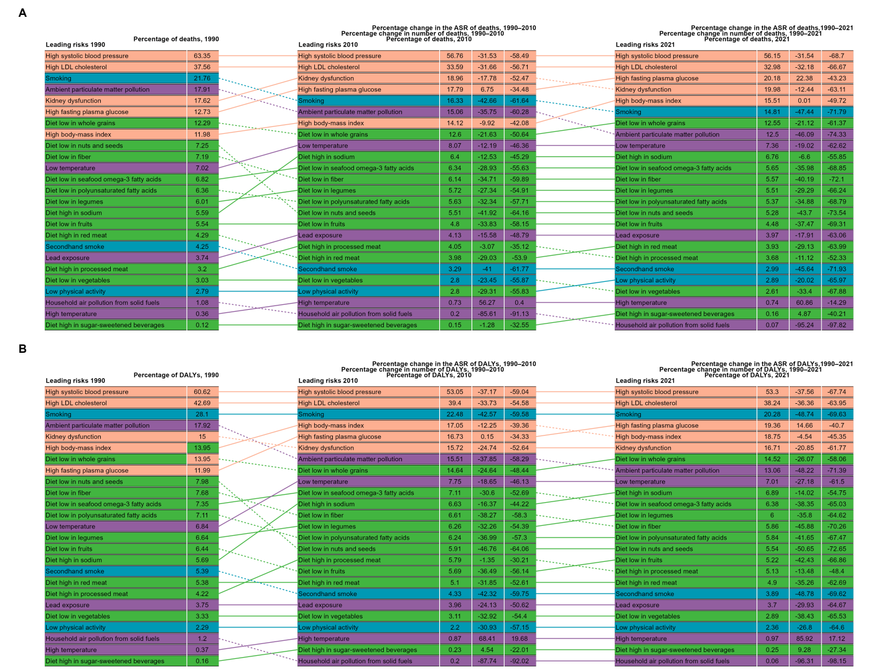

Figure S2 Leading Level 4 risks by attributable deaths and DALYs in High-middle SDI region, 1990–2021. (A) deaths. (B) DALYs. Abbreviations: DALYs, disability-adjusted life years.
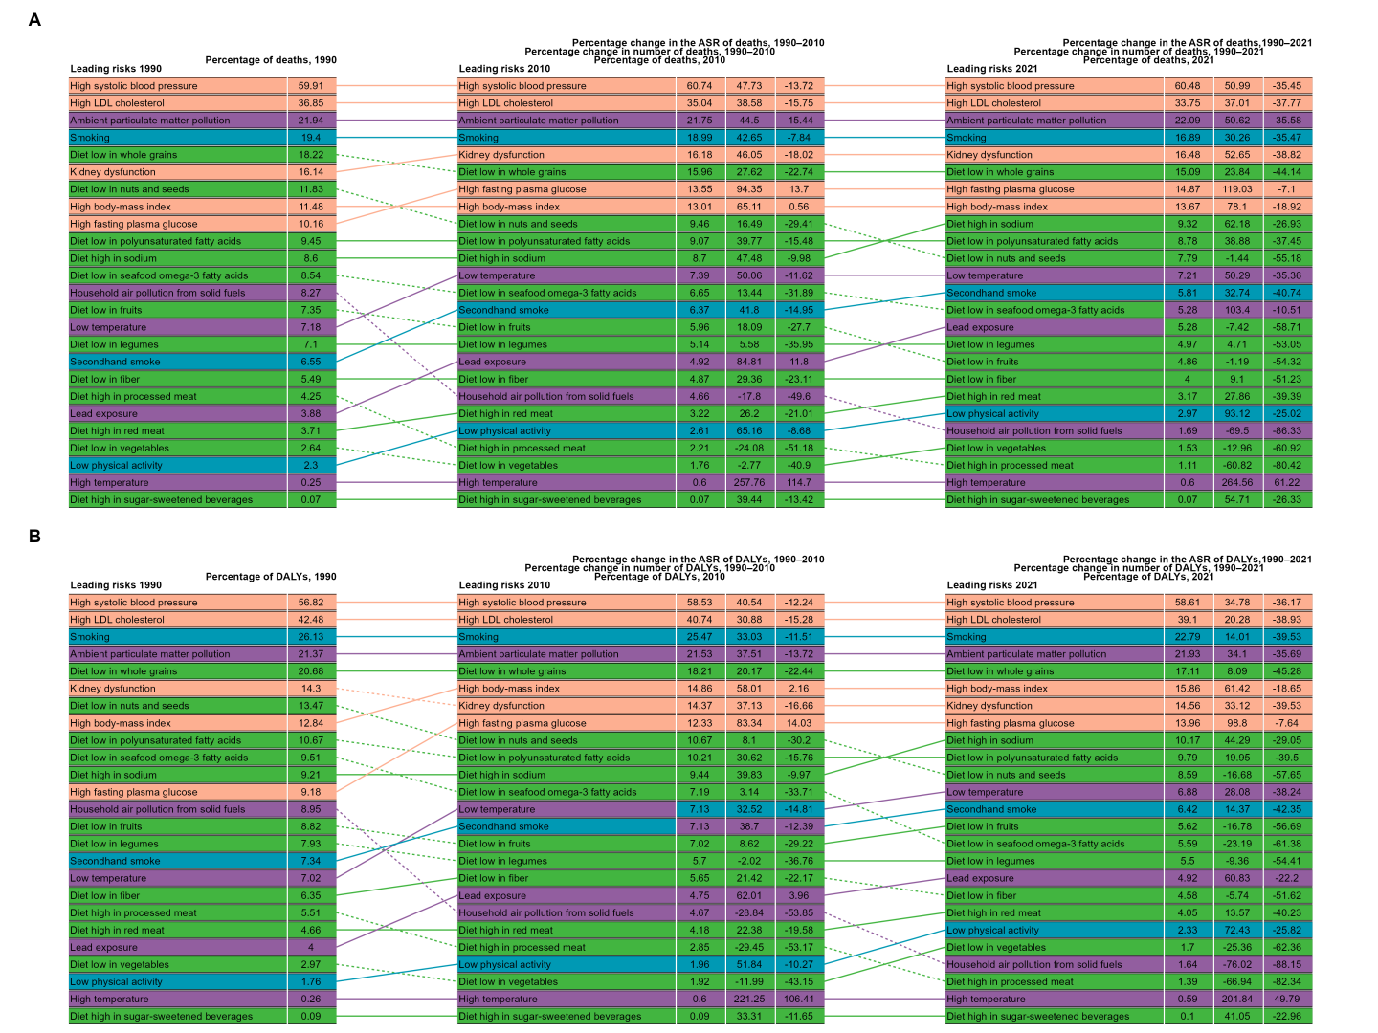

Figure S3 Leading Level 4 risks by attributable deaths and DALYs in Middle SDI region, 1990–2021. (A) deaths. (B) DALYs. Abbreviations: DALYs, disability-adjusted life years.
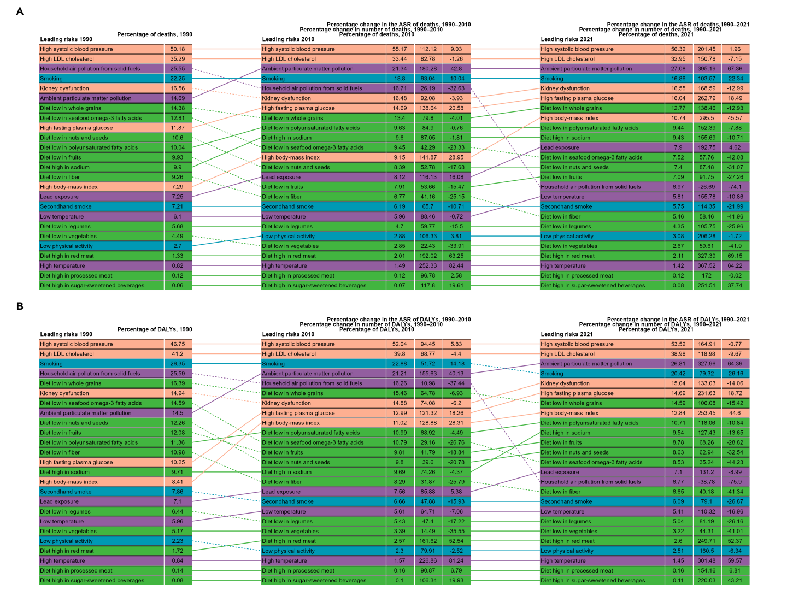

Figure S4 Leading Level 4 risks by attributable deaths and DALYs in Low-middle SDI region, 1990–2021. (A) deaths. (B) DALYs. Abbreviations: DALYs, disability-adjusted life years.
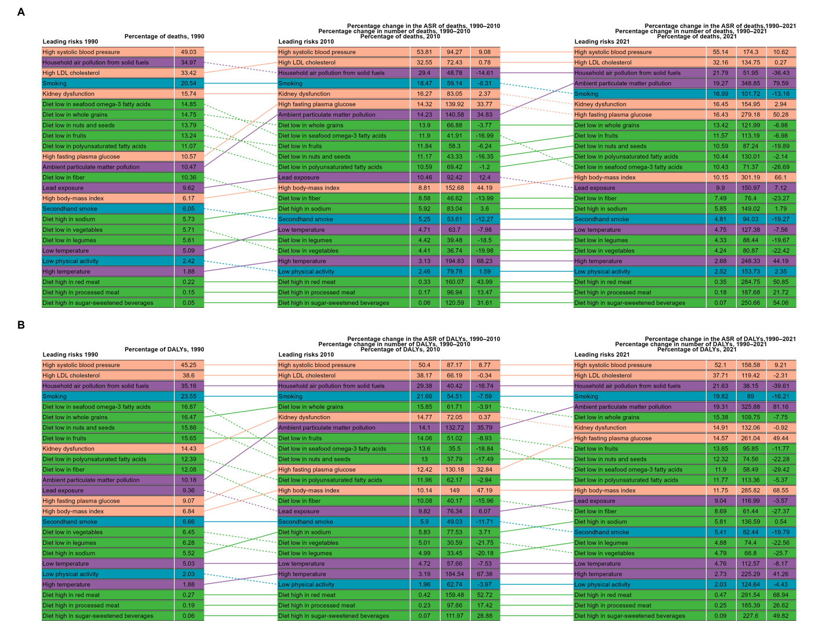

Figure S5 Leading Level 4 risks by attributable deaths and DALYs in Low SDI region, 1990–2021. (A) deaths. (B) DALYs. Abbreviations: DALYs, disability-adjusted life years.
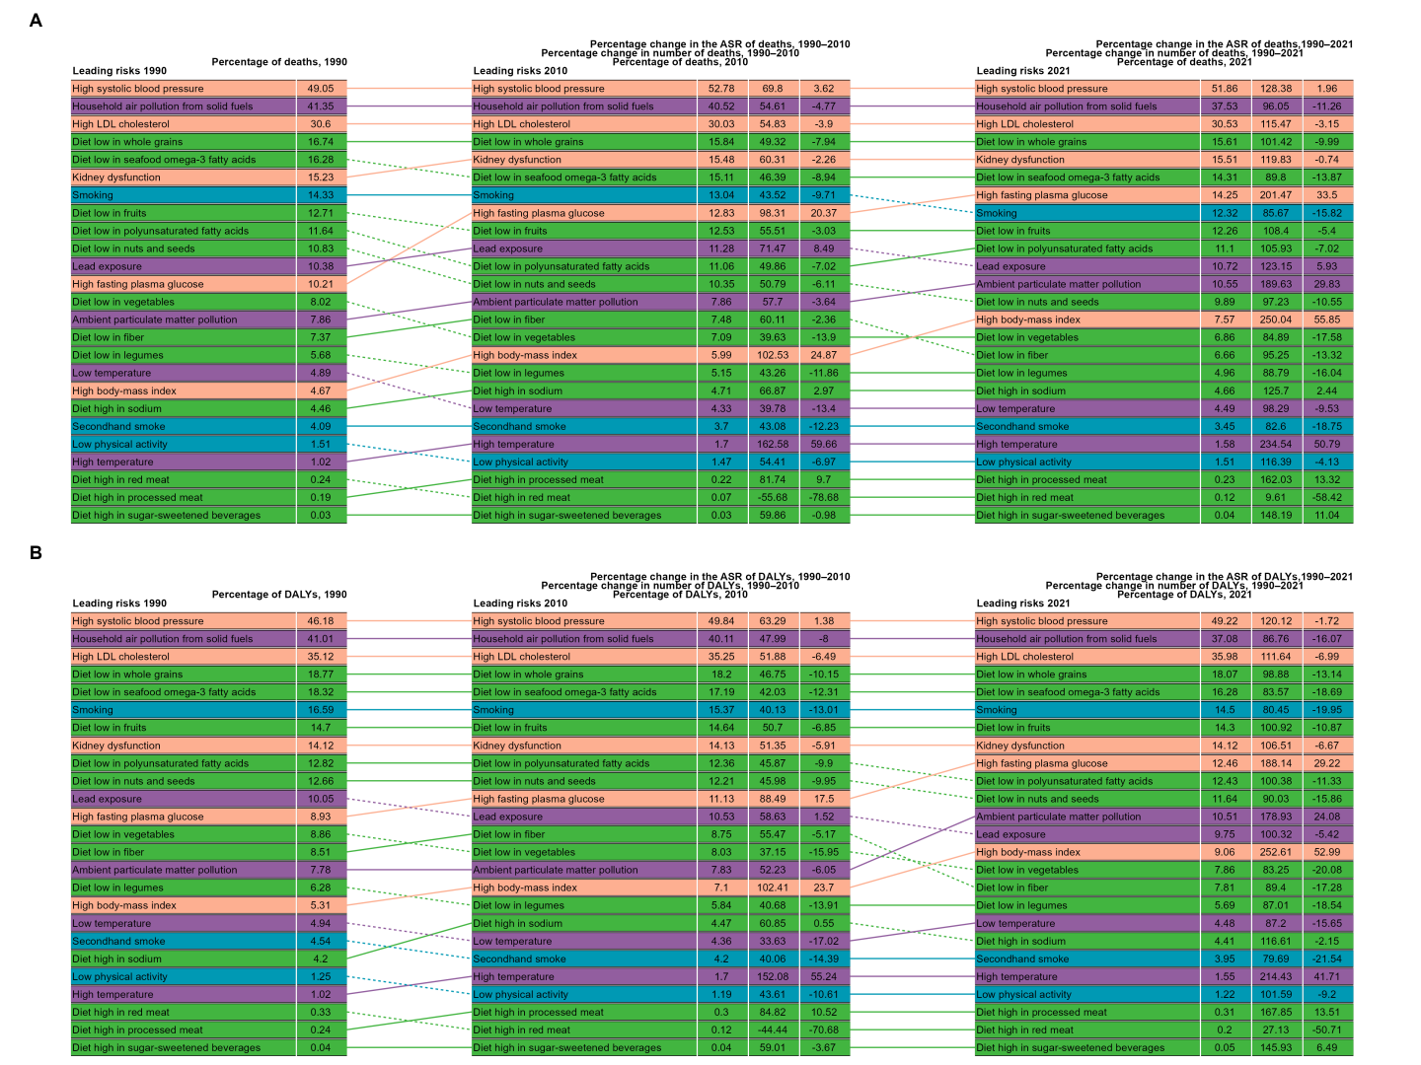

Figure S6 Summary of analysis results for household air pollution from solid fuels. (A) The joinpoint regression analysis on SEV. (B) The joinpoint regression analysis on the ASR of deaths. (C) The joinpoint regression analysis on the ASR of DALYs. (D) Changes in deaths according to aging, population growth and epidemiological change from 1990 to 2021. (E) Changes in DALYs according to aging, population growth and epidemiological change from 1990 to 2021. (F) The correspondence between different regions and fixed effects quintiles of stroke related deaths. (G) The correspondence between different regions and fixed effects quintiles of stroke related DALYs. (H) The fixed-effects of deaths of 204 countries and territories. (I) The fixed-effects of DALYs of 204 countries and territories. Abbreviations: SEV, summary exposure value; ASR, age-standardized rate; DALYs, disability-adjusted life years.
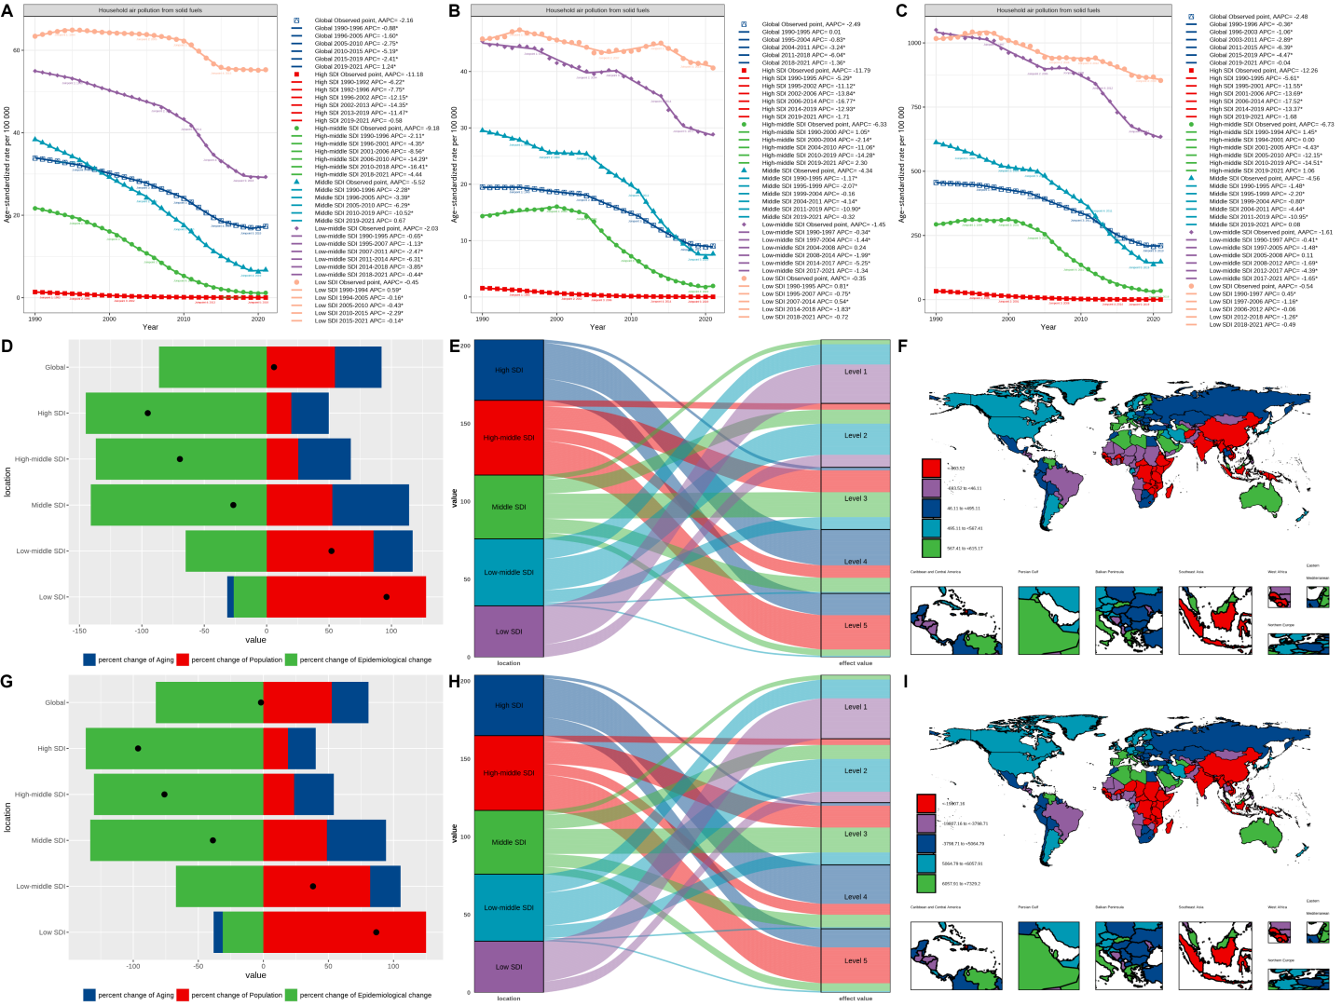

Figure S7 Summary of analysis results for high temperature. (A) The joinpoint regression analysis on SEV. (B) The joinpoint regression analysis on the ASR of deaths. (C) The joinpoint regression analysis on the ASR of DALYs. (D) Changes in deaths according to aging, population growth and epidemiological change from 1990 to 2021. (E) Changes in DALYs according to aging, population growth and epidemiological change from 1990 to 2021. (F) The correspondence between different regions and fixed effects quintiles of stroke related deaths. (G) The correspondence between different regions and fixed effects quintiles of stroke related DALYs. (H) The fixed-effects of deaths of 204 countries and territories. (I) The fixed-effects of DALYs of 204 countries and territories. Abbreviations: SEV, summary exposure value; ASR, age-standardized rate; DALYs, disability-adjusted life years.
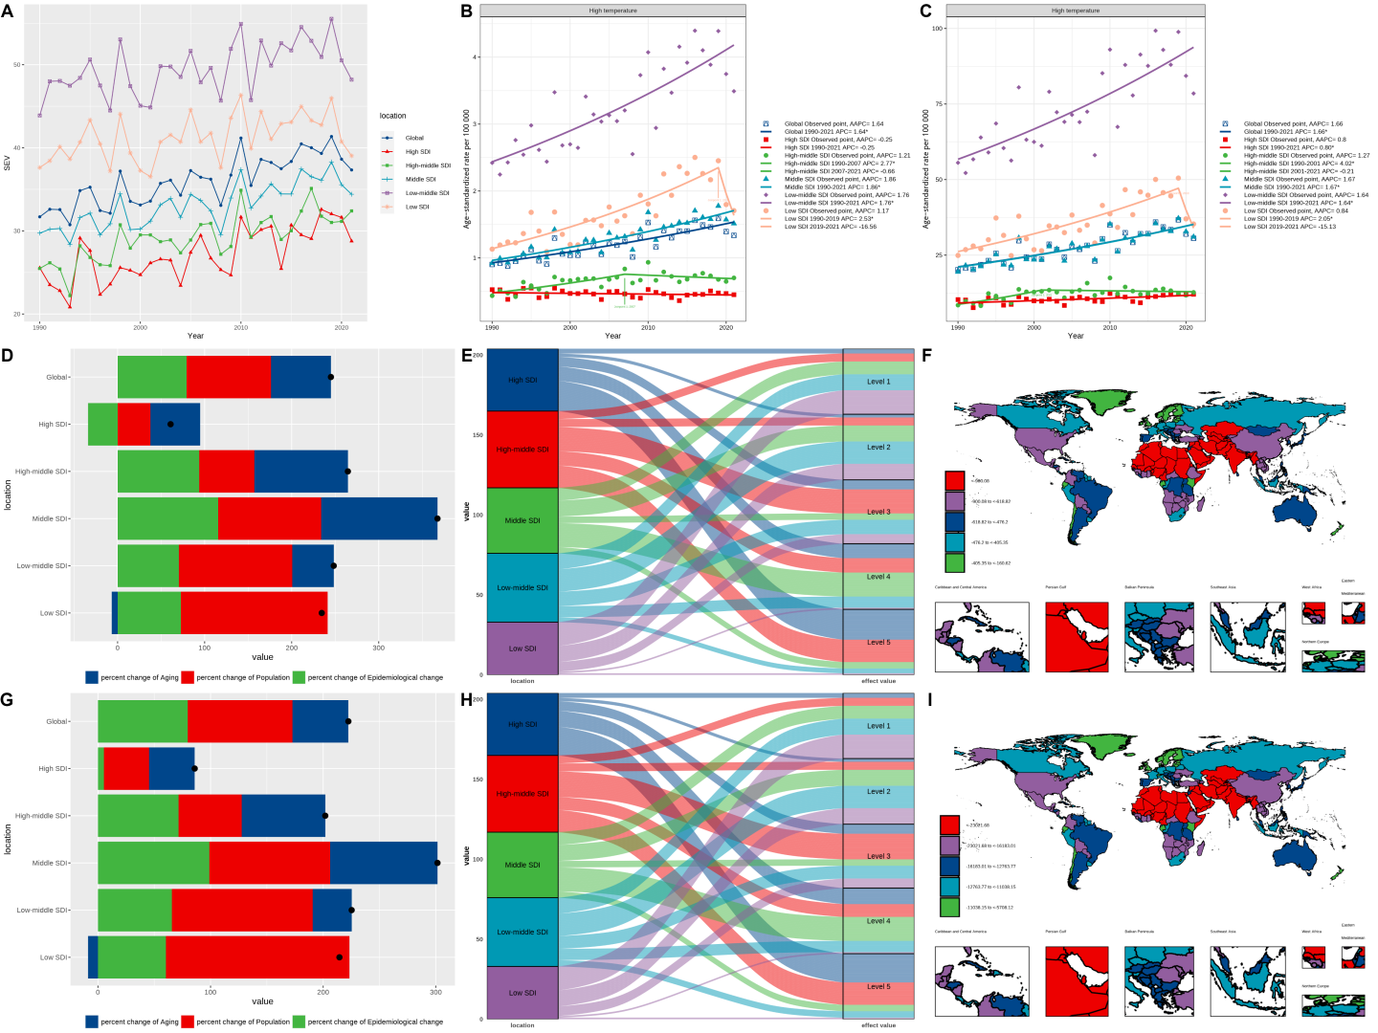

Figure S8 Summary of analysis results for low temperature. (A) The joinpoint regression analysis on SEV. (B) The joinpoint regression analysis on the ASR of deaths. (C) The joinpoint regression analysis on the ASR of DALYs. (D) Changes in deaths according to aging, population growth and epidemiological change from 1990 to 2021. (E) Changes in DALYs according to aging, population growth and epidemiological change from 1990 to 2021. (F) The correspondence between different regions and fixed effects quintiles of stroke related deaths. (G) The correspondence between different regions and fixed effects quintiles of stroke related DALYs. (H) The fixed-effects of deaths of 204 countries and territories. (I) The fixed-effects of DALYs of 204 countries and territories. Abbreviations: SEV, summary exposure value; ASR, age-standardized rate; DALYs, disability-adjusted life years.
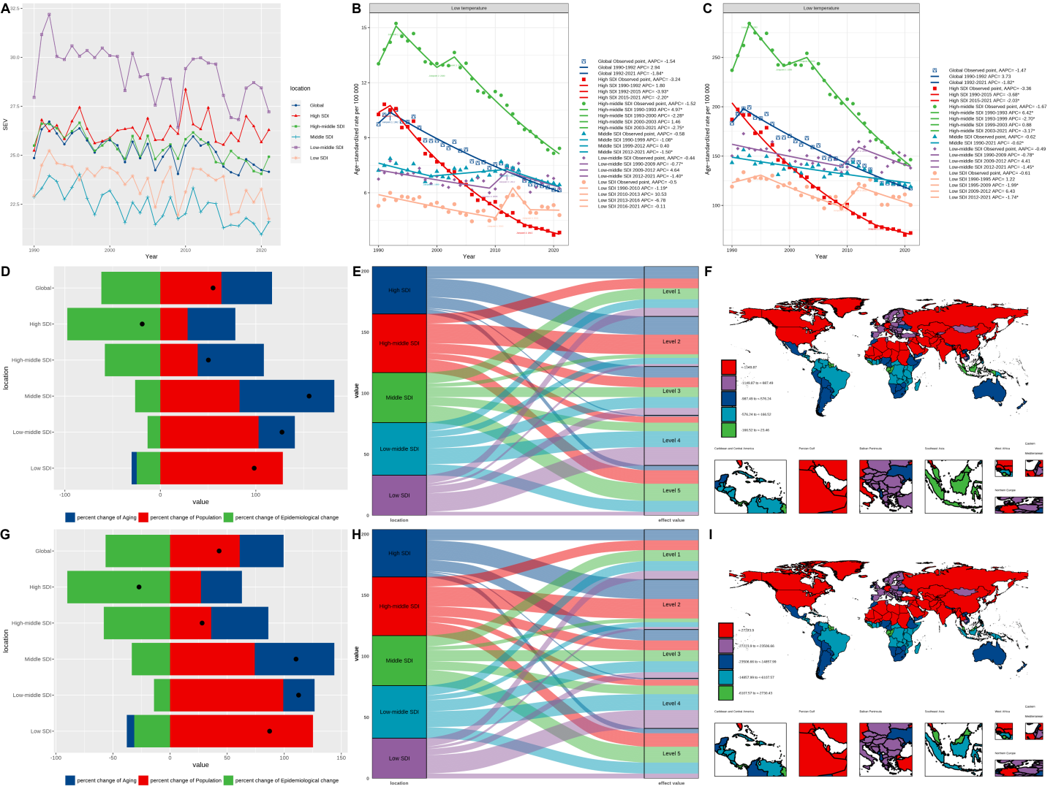

Figure S9 Summary of analysis results for lead exposure. (A) The joinpoint regression analysis on SEV. (B) The joinpoint regression analysis on the ASR of deaths. (C) The joinpoint regression analysis on the ASR of DALYs. (D) Changes in deaths according to aging, population growth and epidemiological change from 1990 to 2021. (E) Changes in DALYs according to aging, population growth and epidemiological change from 1990 to 2021. (F) The correspondence between different regions and fixed effects quintiles of stroke related deaths. (G) The correspondence between different regions and fixed effects quintiles of stroke related DALYs. (H) The fixed-effects of deaths of 204 countries and territories. (I) The fixed-effects of DALYs of 204 countries and territories. Abbreviations: SEV, summary exposure value; ASR, age-standardized rate; DALYs, disability-adjusted life years.
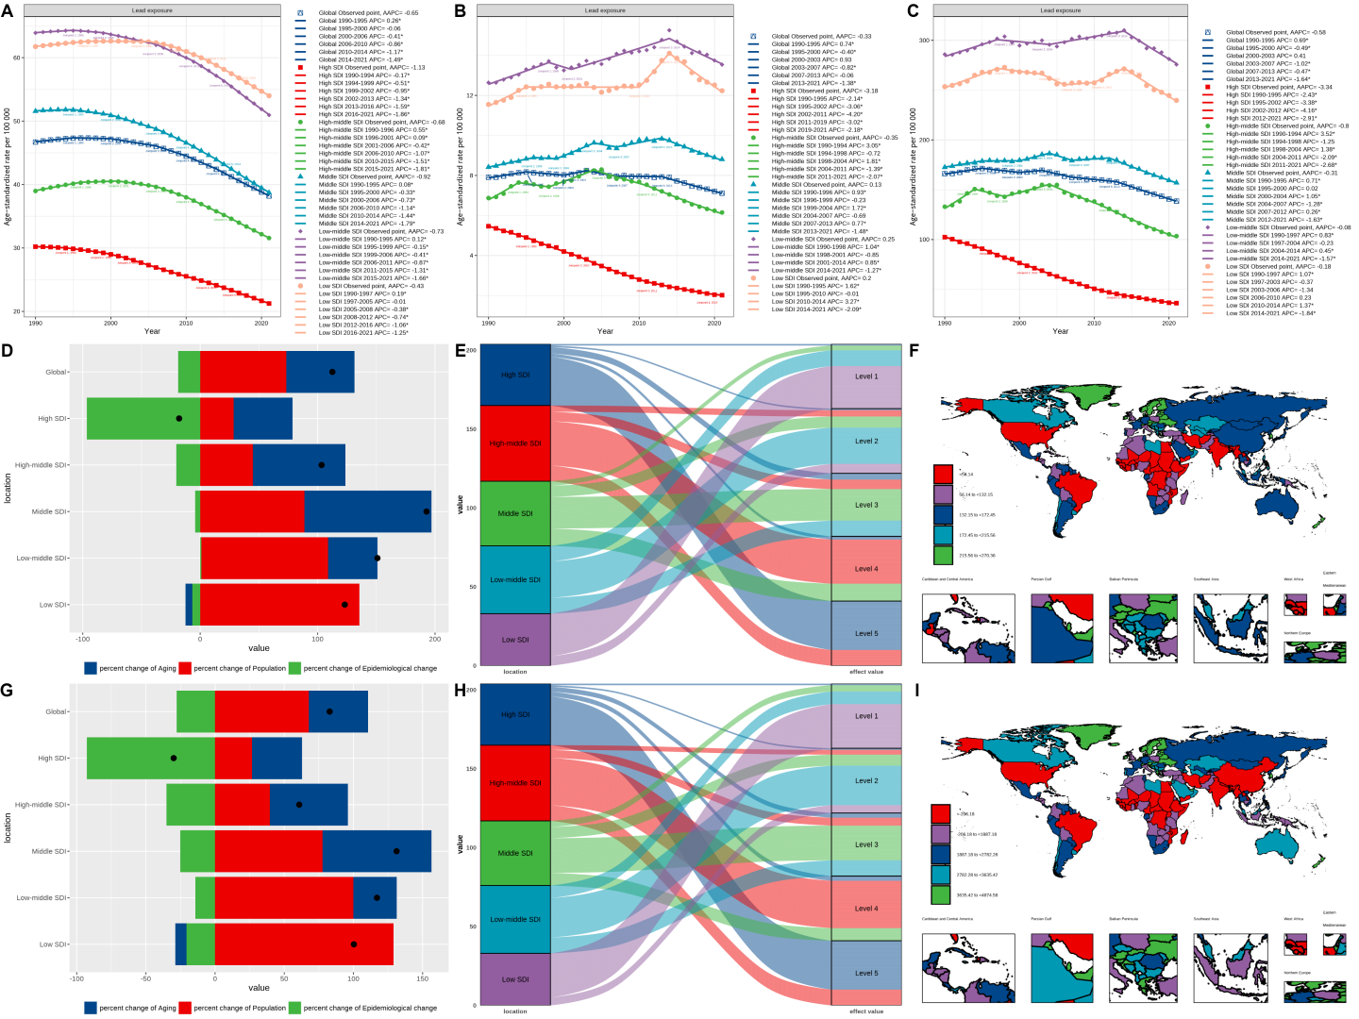

Figure S10 Summary of analysis results for low physical activity. (A) The joinpoint regression analysis on SEV. (B) The joinpoint regression analysis on the ASR of deaths. (C) The joinpoint regression analysis on the ASR of DALYs. (D) Changes in deaths according to aging, population growth and epidemiological change from 1990 to 2021. (E) Changes in DALYs according to aging, population growth and epidemiological change from 1990 to 2021. (F) The correspondence between different regions and fixed effects quintiles of stroke related deaths. (G) The correspondence between different regions and fixed effects quintiles of stroke related DALYs. (H) The fixed-effects of deaths of 204 countries and territories. (I) The fixed-effects of DALYs of 204 countries and territories. Abbreviations: SEV, summary exposure value; ASR, age-standardized rate; DALYs, disability-adjusted life years.
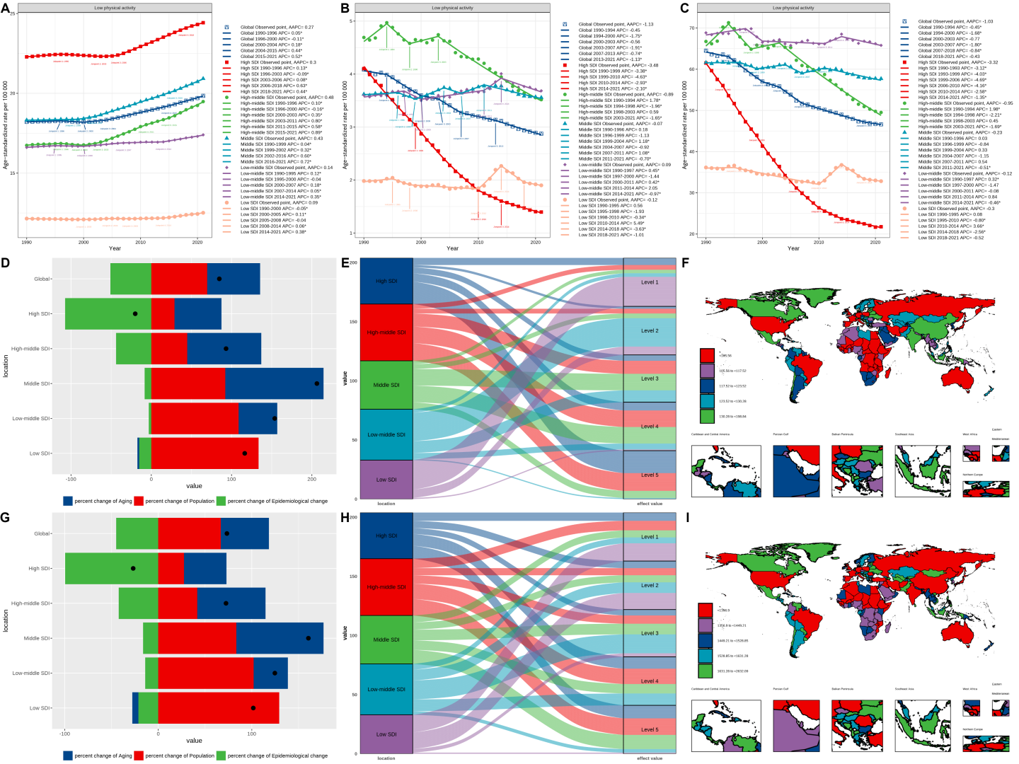

Figure S11 Summary of analysis results for secondhand smoke. (A) The joinpoint regression analysis on SEV. (B) The joinpoint regression analysis on the ASR of deaths. (C) The joinpoint regression analysis on the ASR of DALYs. (D) Changes in deaths according to aging, population growth and epidemiological change from 1990 to 2021. (E) Changes in DALYs according to aging, population growth and epidemiological change from 1990 to 2021. (F) The correspondence between different regions and fixed effects quintiles of stroke related deaths. (G) The correspondence between different regions and fixed effects quintiles of stroke related DALYs. (H) The fixed-effects of deaths of 204 countries and territories. (I) The fixed-effects of DALYs of 204 countries and territories. Abbreviations: SEV, summary exposure value; ASR, age-standardized rate; DALYs, disability-adjusted life years.
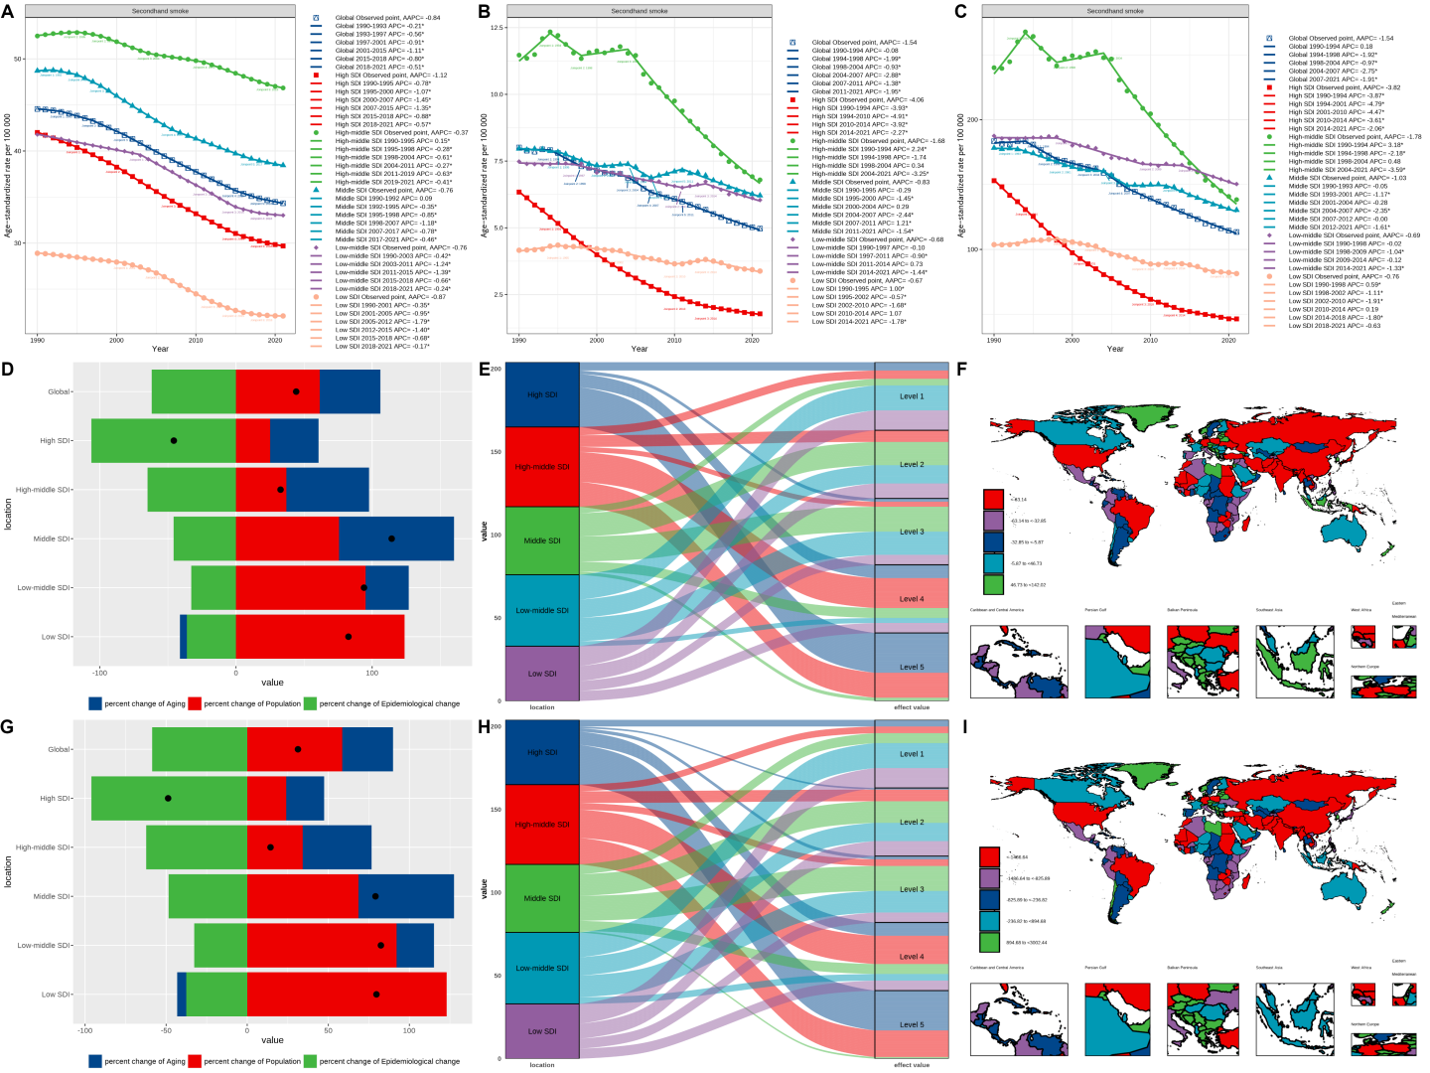

Figure S12 Summary of analysis results for diet low in fruits. (A) The joinpoint regression analysis on SEV. (B) The joinpoint regression analysis on the ASR of deaths. (C) The joinpoint regression analysis on the ASR of DALYs. (D) Changes in deaths according to aging, population growth and epidemiological change from 1990 to 2021. (E) Changes in DALYs according to aging, population growth and epidemiological change from 1990 to 2021. (F) The correspondence between different regions and fixed effects quintiles of stroke related deaths. (G) The correspondence between different regions and fixed effects quintiles of stroke related DALYs. (H) The fixed-effects of deaths of 204 countries and territories. (I) The fixed-effects of DALYs of 204 countries and territories. Abbreviations: SEV, summary exposure value; ASR, age-standardized rate; DALYs, disability-adjusted life years.
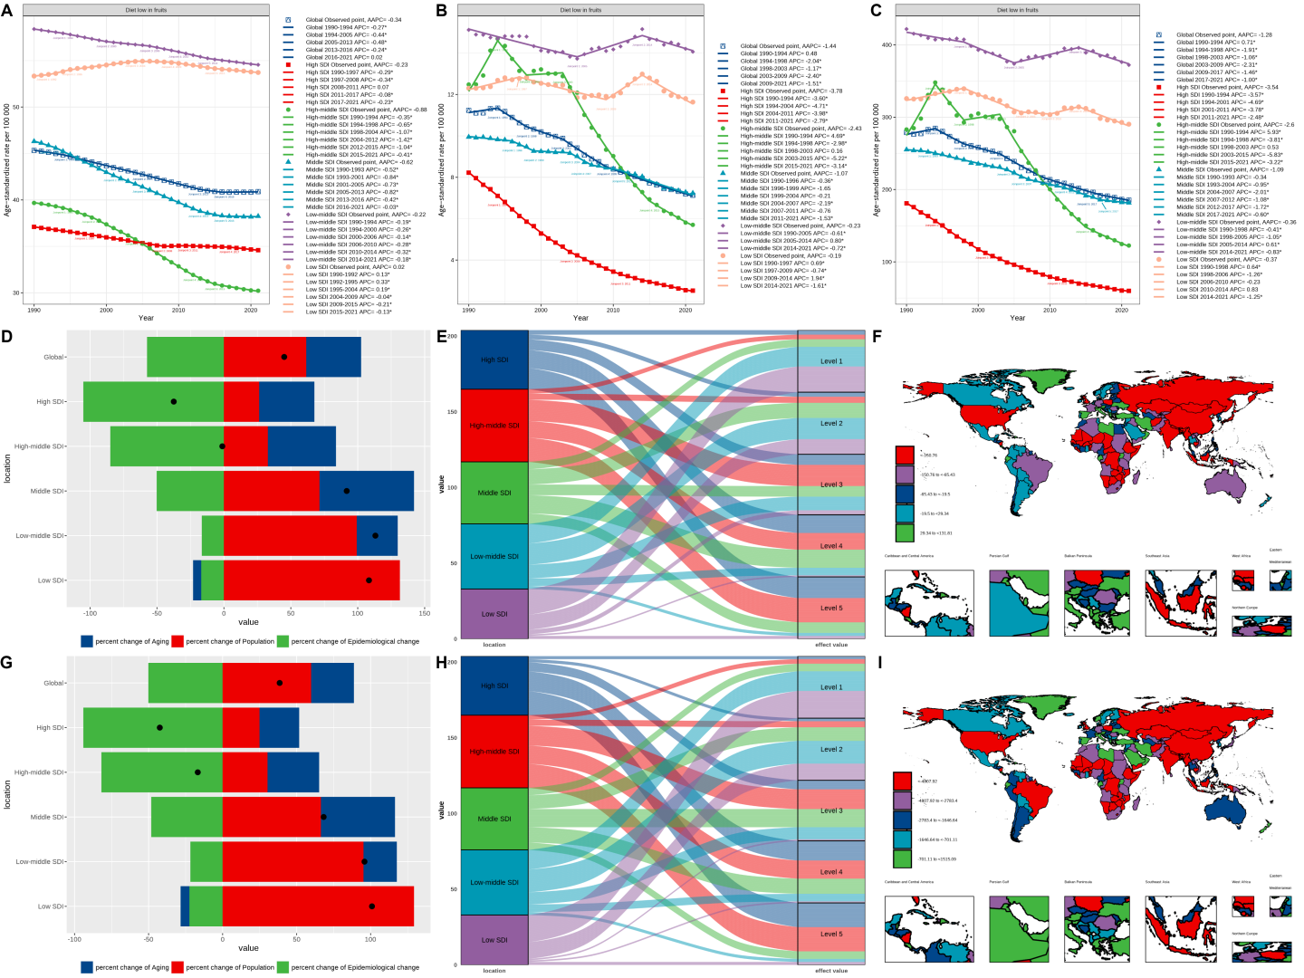

Figure S13 Summary of analysis results for diet low in vegetables. (A) The joinpoint regression analysis on SEV. (B) The joinpoint regression analysis on the ASR of deaths. (C) The joinpoint regression analysis on the ASR of DALYs. (D) Changes in deaths according to aging, population growth and epidemiological change from 1990 to 2021. (E) Changes in DALYs according to aging, population growth and epidemiological change from 1990 to 2021. (F) The correspondence between different regions and fixed effects quintiles of stroke related deaths. (G) The correspondence between different regions and fixed effects quintiles of stroke related DALYs. (H) The fixed-effects of deaths of 204 countries and territories. (I) The fixed-effects of DALYs of 204 countries and territories. Abbreviations: SEV, summary exposure value; ASR, age-standardized rate; DALYs, disability-adjusted life years.
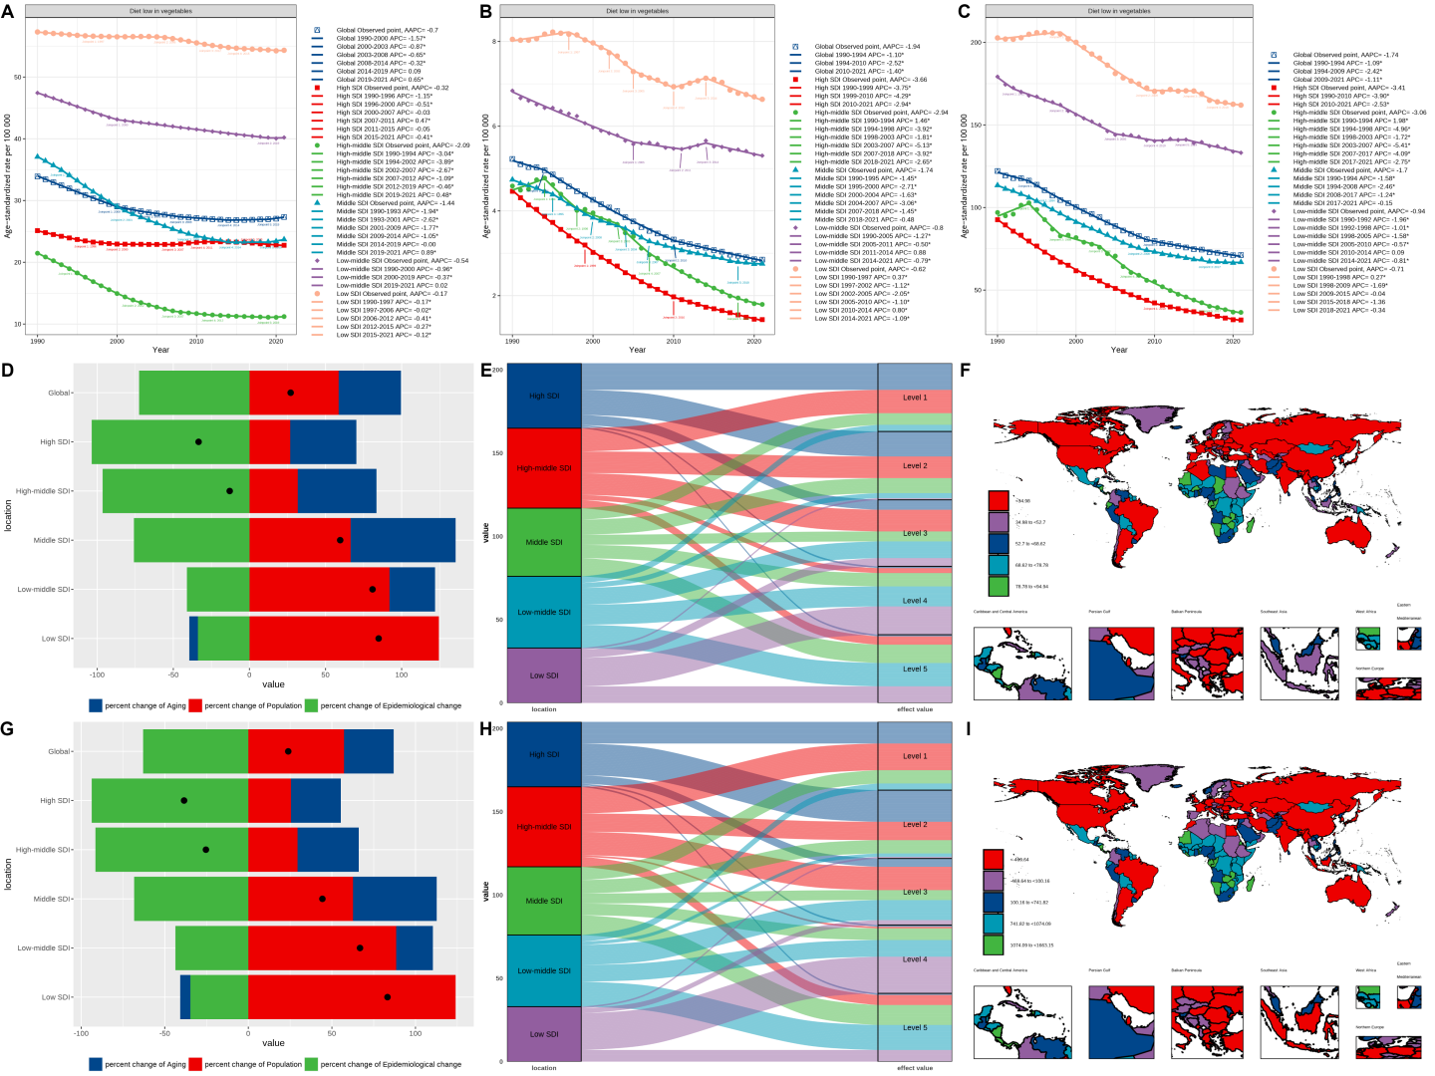

Figure S14 Summary of analysis results for diet high in red meat. (A) The joinpoint regression analysis on SEV. (B) The joinpoint regression analysis on the ASR of deaths. (C) The joinpoint regression analysis on the ASR of DALYs. (D) Changes in deaths according to aging, population growth and epidemiological change from 1990 to 2021. (E) Changes in DALYs according to aging, population growth and epidemiological change from 1990 to 2021. (F) The correspondence between different regions and fixed effects quintiles of stroke related deaths. (G) The correspondence between different regions and fixed effects quintiles of stroke related DALYs. (H) The fixed-effects of deaths of 204 countries and territories. (I) The fixed-effects of DALYs of 204 countries and territories. Abbreviations: SEV, summary exposure value; ASR, age-standardized rate; DALYs, disability-adjusted life years.
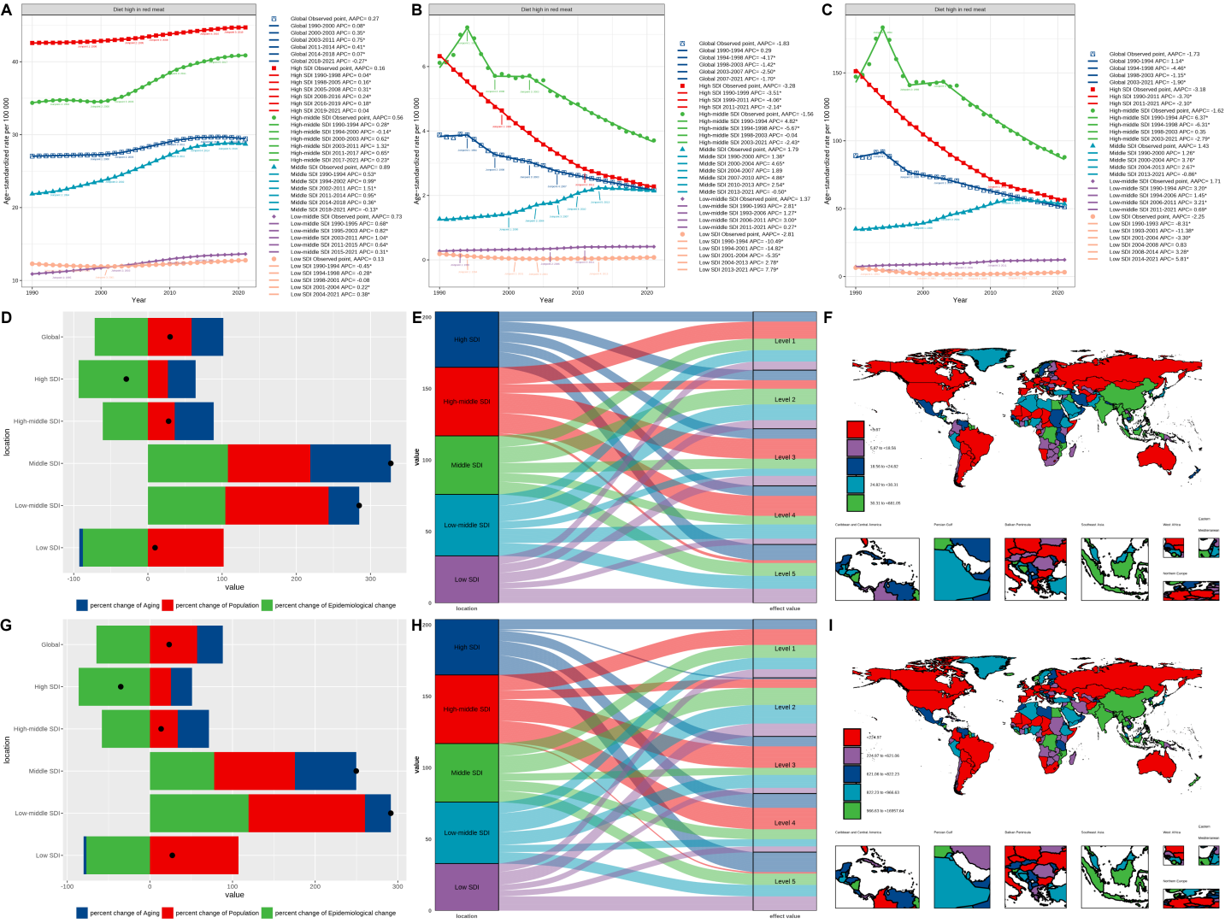

Figure S15 Summary of analysis results for diet high in processed meat. (A) The joinpoint regression analysis on SEV. (B) The joinpoint regression analysis on the ASR of deaths. (C) The joinpoint regression analysis on the ASR of DALYs. (D) Changes in deaths according to aging, population growth and epidemiological change from 1990 to 2021. (E) Changes in DALYs according to aging, population growth and epidemiological change from 1990 to 2021. (F) The correspondence between different regions and fixed effects quintiles of stroke related deaths. (G) The correspondence between different regions and fixed effects quintiles of stroke related DALYs. (H) The fixed-effects of deaths of 204 countries and territories. (I) The fixed-effects of DALYs of 204 countries and territories. Abbreviations: SEV, summary exposure value; ASR, age-standardized rate; DALYs, disability-adjusted life years.
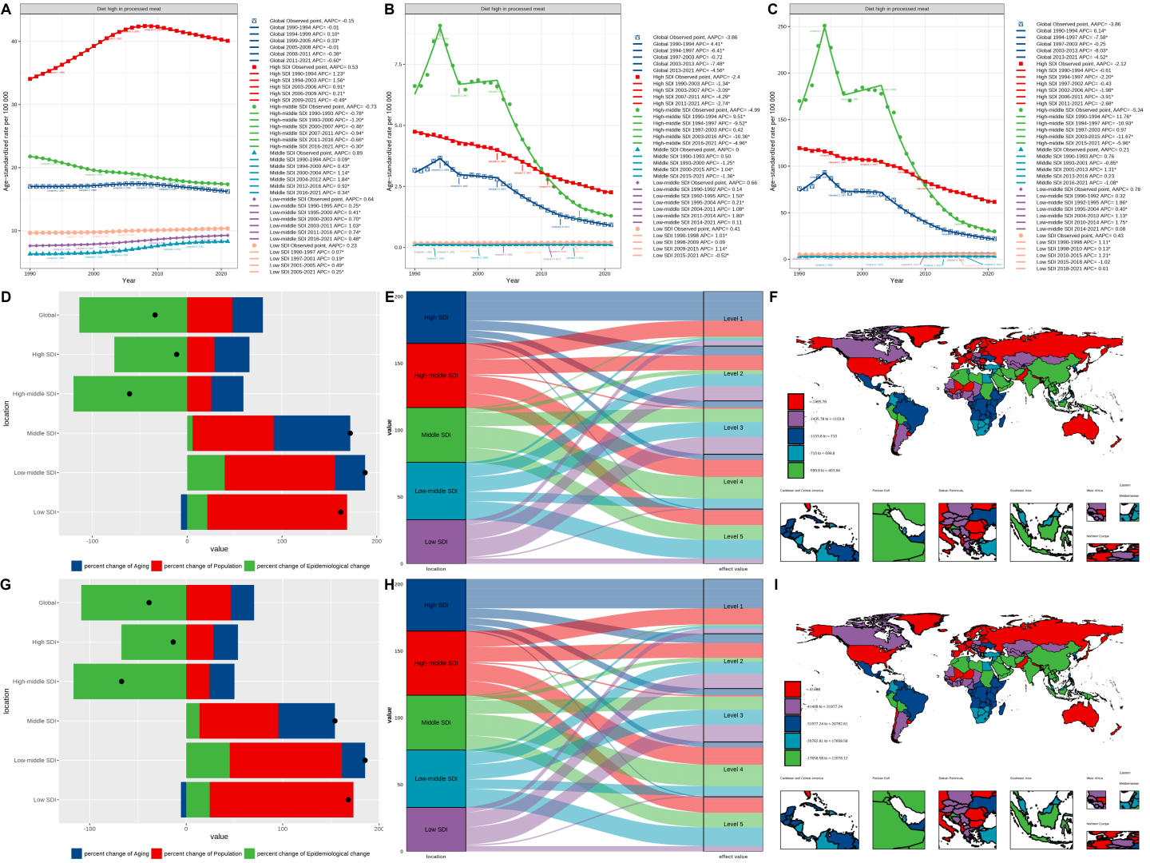

Figure S16 Summary of analysis results for diet high in sugar-sweetened beverages. (A) The joinpoint regression analysis on SEV. (B) The joinpoint regression analysis on the ASR of deaths. (C) The joinpoint regression analysis on the ASR of DALYs. (D) Changes in deaths according to aging, population growth and epidemiological change from 1990 to 2021. (E) Changes in DALYs according to aging, population growth and epidemiological change from 1990 to 2021. (F) The correspondence between different regions and fixed effects quintiles of stroke related deaths. (G) The correspondence between different regions and fixed effects quintiles of stroke related DALYs. (H) The fixed-effects of deaths of 204 countries and territories. (I) The fixed-effects of DALYs of 204 countries and territories. Abbreviations: SEV, summary exposure value; ASR, age-standardized rate; DALYs, disability-adjusted life years.
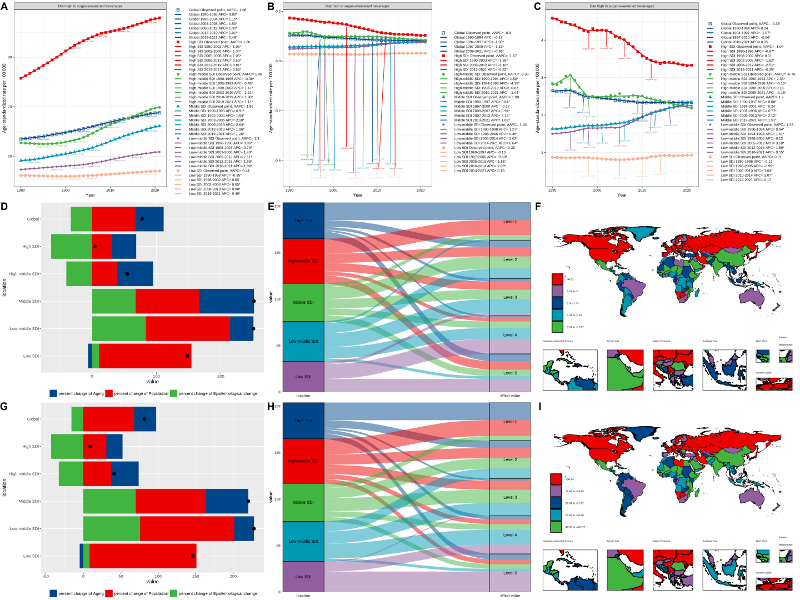

Figure S17 Summary of analysis results for diet low in fiber. (A) The joinpoint regression analysis on SEV. (B) The joinpoint regression analysis on the ASR of deaths. (C) The joinpoint regression analysis on the ASR of DALYs. (D) Changes in deaths according to aging, population growth and epidemiological change from 1990 to 2021. (E) Changes in DALYs according to aging, population growth and epidemiological change from 1990 to 2021. (F) The correspondence between different regions and fixed effects quintiles of stroke related deaths. (G) The correspondence between different regions and fixed effects quintiles of stroke related DALYs. (H) The fixed-effects of deaths of 204 countries and territories. (I) The fixed-effects of DALYs of 204 countries and territories. Abbreviations: SEV, summary exposure value; ASR, age-standardized rate; DALYs, disability-adjusted life years.
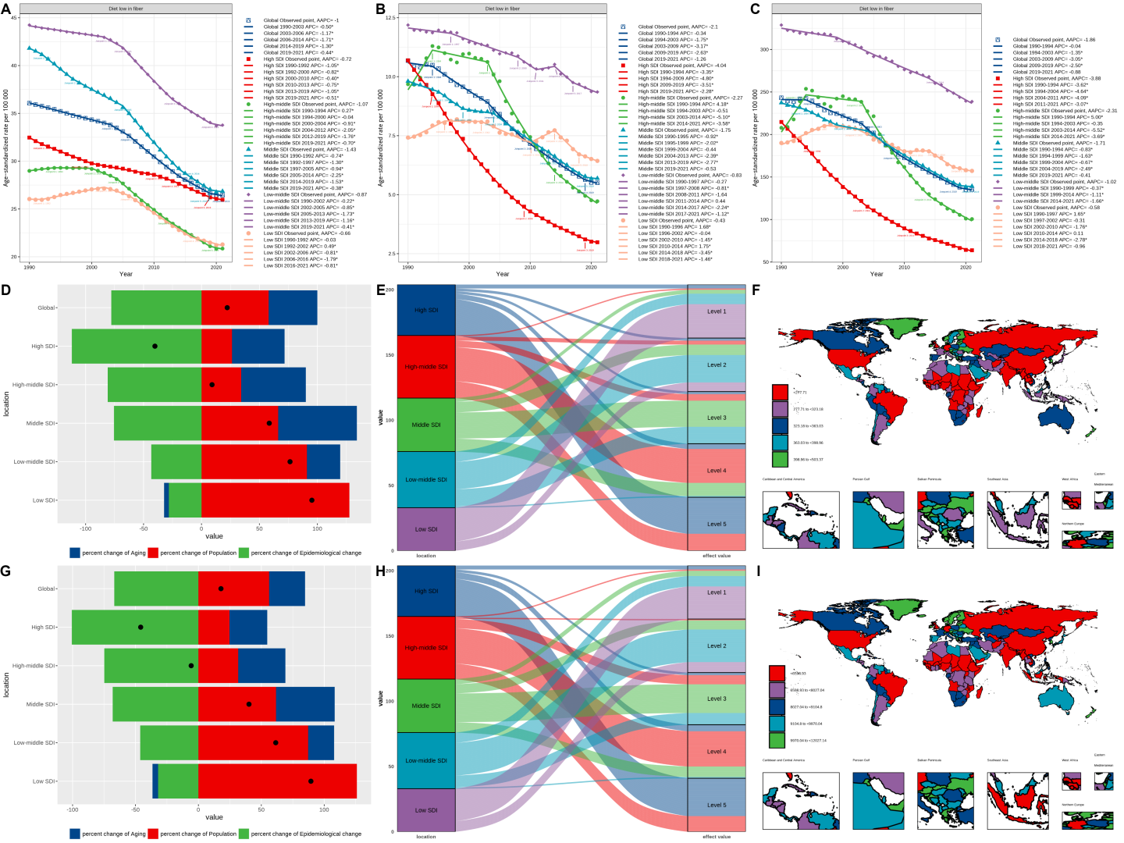

Figure S18 Summary of analysis results for diet low in polyunsaturated fatty acids. (A) The joinpoint regression analysis on SEV. (B) The joinpoint regression analysis on the ASR of deaths. (C) The joinpoint regression analysis on the ASR of DALYs. (D) Changes in deaths according to aging, population growth and epidemiological change from 1990 to 2021. (E) Changes in DALYs according to aging, population growth and epidemiological change from 1990 to 2021. (F) The correspondence between different regions and fixed effects quintiles of stroke related deaths. (G) The correspondence between different regions and fixed effects quintiles of stroke related DALYs. (H) The fixed-effects of deaths of 204 countries and territories. (I) The fixed-effects of DALYs of 204 countries and territories. Abbreviations: SEV, summary exposure value; ASR, age-standardized rate; DALYs, disability-adjusted life years.
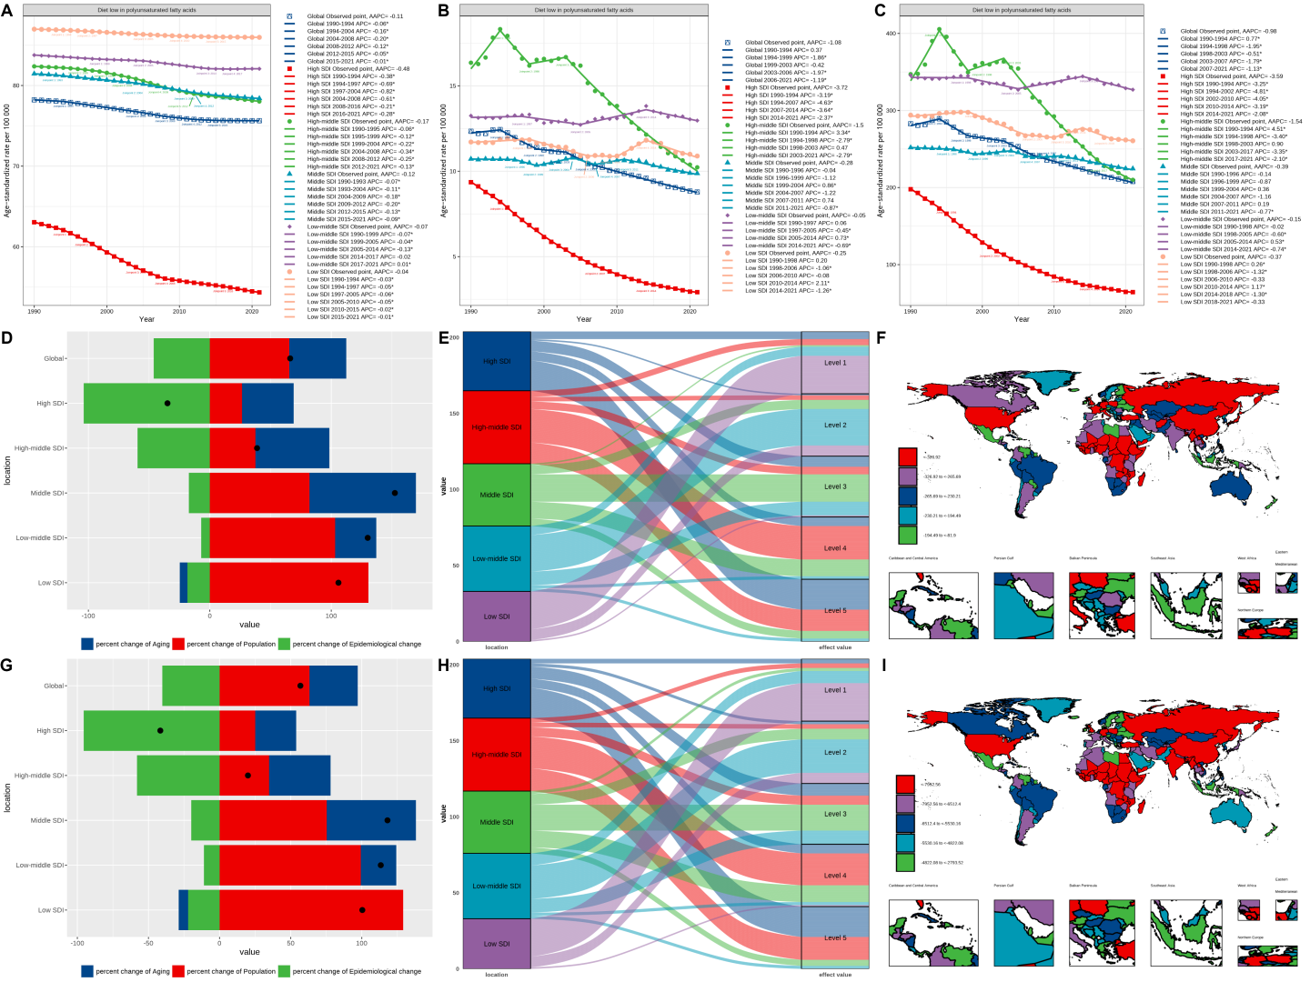

Figure S19 Summary of analysis results for diet high in sodium. (A) The joinpoint regression analysis on SEV. (B) The joinpoint regression analysis on the ASR of deaths. (C) The joinpoint regression analysis on the ASR of DALYs. (D) Changes in deaths according to aging, population growth and epidemiological change from 1990 to 2021. (E) Changes in DALYs according to aging, population growth and epidemiological change from 1990 to 2021. (F) The correspondence between different regions and fixed effects quintiles of stroke related deaths. (G) The correspondence between different regions and fixed effects quintiles of stroke related DALYs. (H) The fixed-effects of deaths of 204 countries and territories. (I) The fixed-effects of DALYs of 204 countries and territories. Abbreviations: SEV, summary exposure value; ASR, age-standardized rate; DALYs, disability-adjusted life years.
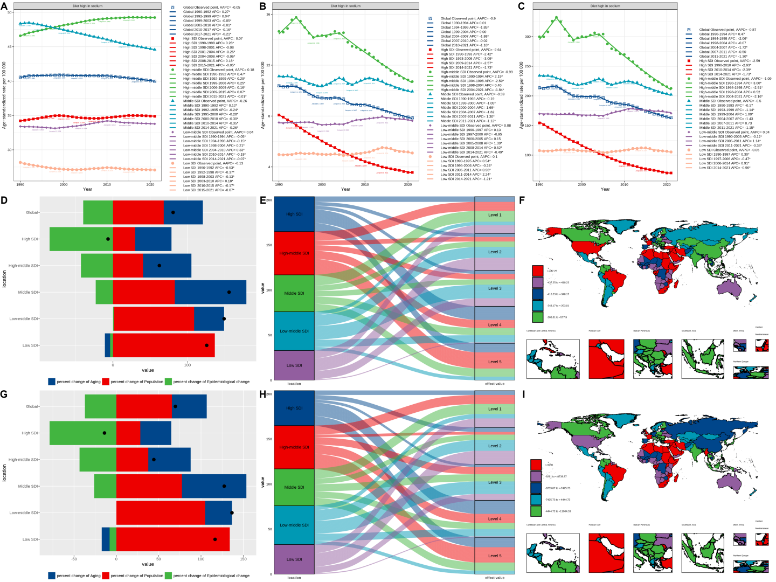

Figure S20 Summary of analysis results for diet low in legumes. (A) The joinpoint regression analysis on SEV. (B) The joinpoint regression analysis on the ASR of deaths. (C) The joinpoint regression analysis on the ASR of DALYs. (D) Changes in deaths according to aging, population growth and epidemiological change from 1990 to 2021. (E) Changes in DALYs according to aging, population growth and epidemiological change from 1990 to 2021. (F) The correspondence between different regions and fixed effects quintiles of stroke related deaths. (G) The correspondence between different regions and fixed effects quintiles of stroke related DALYs. (H) The fixed-effects of deaths of 204 countries and territories. (I) The fixed-effects of DALYs of 204 countries and territories. Abbreviations: SEV, summary exposure value; ASR, age-standardized rate; DALYs, disability-adjusted life years.
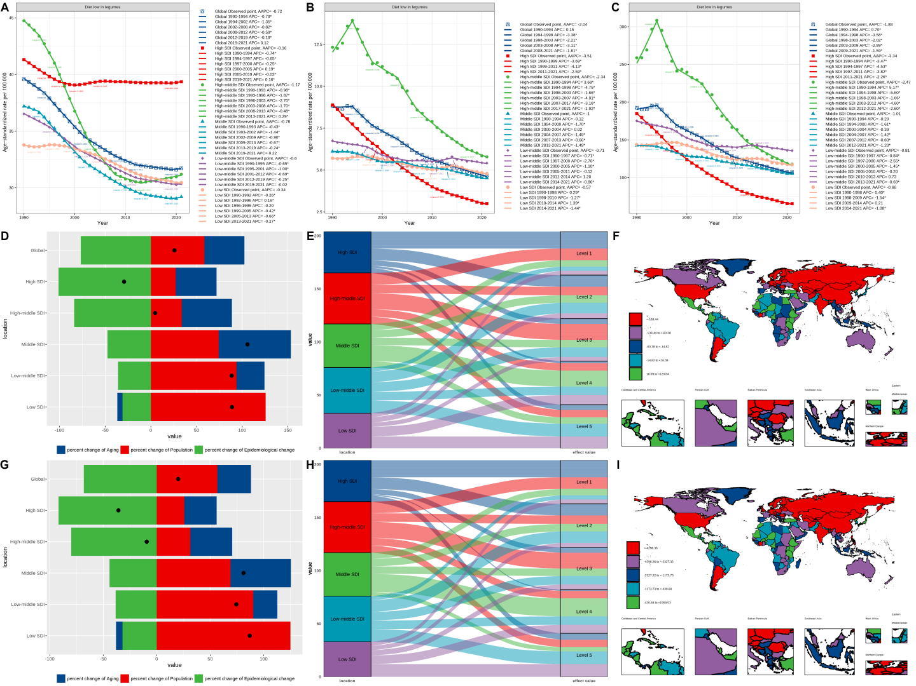

Figure S21 Summary of analysis results for diet low in nuts and seeds. (A) The joinpoint regression analysis on SEV. (B) The joinpoint regression analysis on the ASR of deaths. (C) The joinpoint regression analysis on the ASR of DALYs. (D) Changes in deaths according to aging, population growth and epidemiological change from 1990 to 2021. (E) Changes in DALYs according to aging, population growth and epidemiological change from 1990 to 2021. (F) The correspondence between different regions and fixed effects quintiles of stroke related deaths. (G) The correspondence between different regions and fixed effects quintiles of stroke related DALYs. (H) The fixed-effects of deaths of 204 countries and territories. (I) The fixed-effects of DALYs of 204 countries and territories. Abbreviations: SEV, summary exposure value; ASR, age-standardized rate; DALYs, disability-adjusted life years.
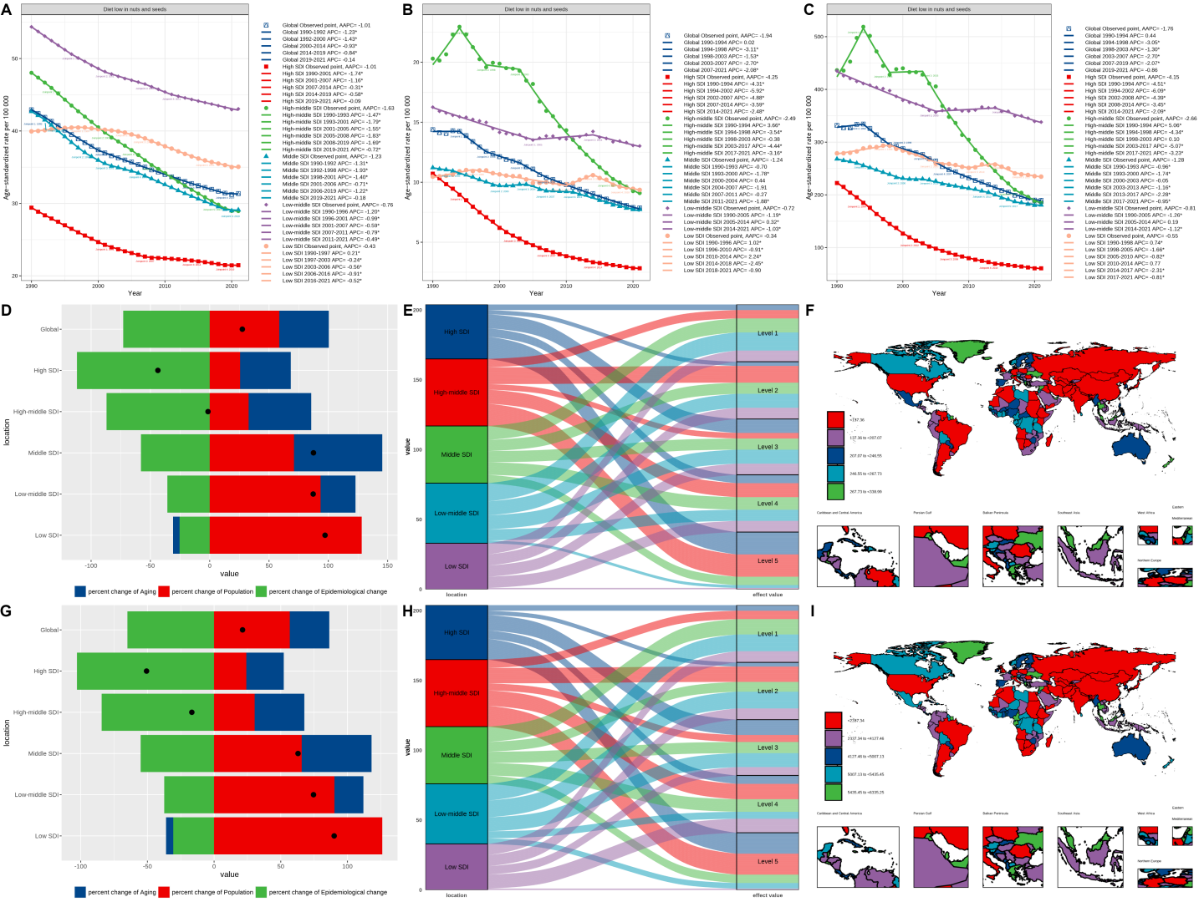

Figure S22 Summary of analysis results for diet low in seafood omega-3 fatty acids. (A) The joinpoint regression analysis on SEV. (B) The joinpoint regression analysis on the ASR of deaths. (C) The joinpoint regression analysis on the ASR of DALYs. (D) Changes in deaths according to aging, population growth and epidemiological change from 1990 to 2021. (E) Changes in DALYs according to aging, population growth and epidemiological change from 1990 to 2021. (F) The correspondence between different regions and fixed effects quintiles of stroke related deaths. (G) The correspondence between different regions and fixed effects quintiles of stroke related DALYs. (H) The fixed-effects of deaths of 204 countries and territories. (I) The fixed-effects of DALYs of 204 countries and territories. Abbreviations: SEV, summary exposure value; ASR, age-standardized rate; DALYs, disability-adjusted life years.
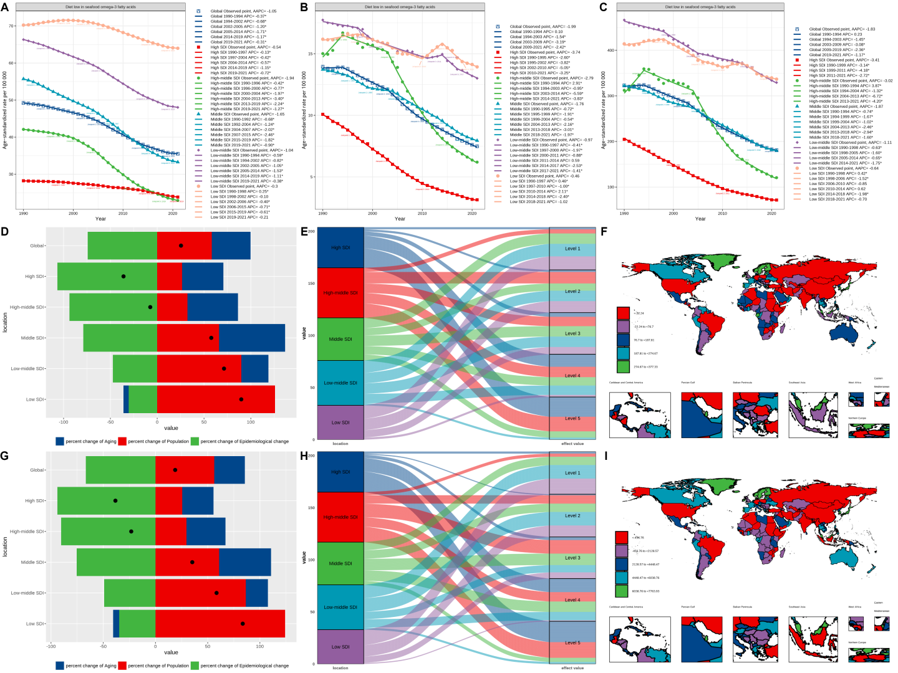

Figure S23 Summary of analysis results for high fasting plasma glucose. (A) The joinpoint regression analysis on SEV. (B) The joinpoint regression analysis on the ASR of deaths. (C) The joinpoint regression analysis on the ASR of DALYs. (D) Changes in deaths according to aging, population growth and epidemiological change from 1990 to 2021. (E) Changes in DALYs according to aging, population growth and epidemiological change from 1990 to 2021. (F) The correspondence between different regions and fixed effects quintiles of stroke related deaths. (G) The correspondence between different regions and fixed effects quintiles of stroke related DALYs. (H) The fixed-effects of deaths of 204 countries and territories. (I) The fixed-effects of DALYs of 204 countries and territories. Abbreviations: SEV, summary exposure value; ASR, age-standardized rate; DALYs, disability-adjusted life years.
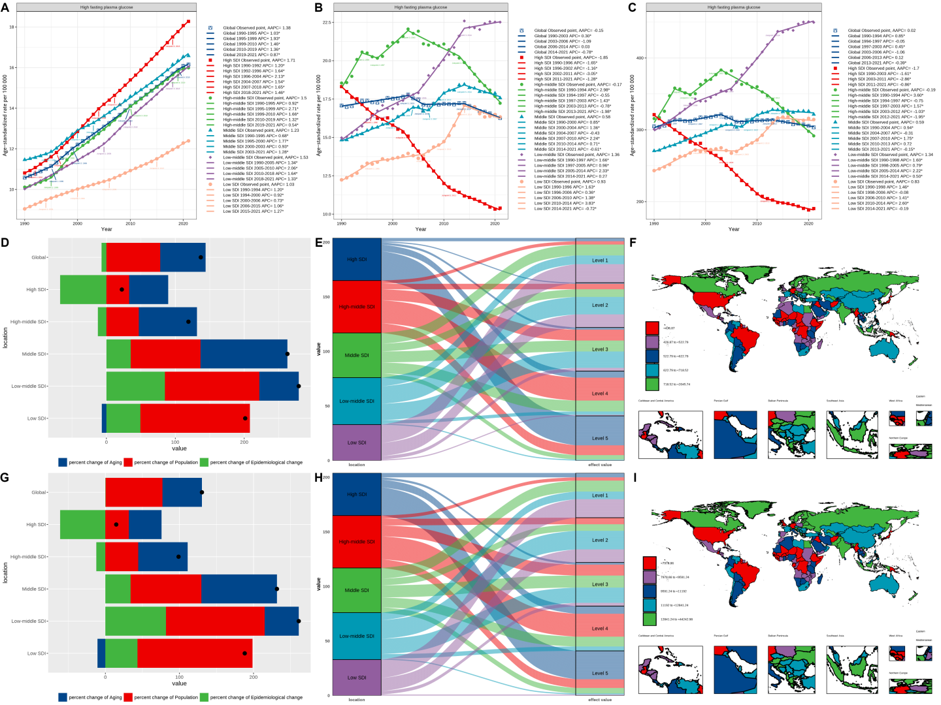

Figure S24 Summary of analysis results for high LDL cholesterol. (A) The joinpoint regression analysis on SEV. (B) The joinpoint regression analysis on the ASR of deaths. (C) The joinpoint regression analysis on the ASR of DALYs. (D) Changes in deaths according to aging, population growth and epidemiological change from 1990 to 2021. (E) Changes in DALYs according to aging, population growth and epidemiological change from 1990 to 2021. (F) The correspondence between different regions and fixed effects quintiles of stroke related deaths. (G) The correspondence between different regions and fixed effects quintiles of stroke related DALYs. (H) The fixed-effects of deaths of 204 countries and territories. (I) The fixed-effects of DALYs of 204 countries and territories. Abbreviations: SEV, summary exposure value; ASR, age-standardized rate; DALYs, disability-adjusted life years.
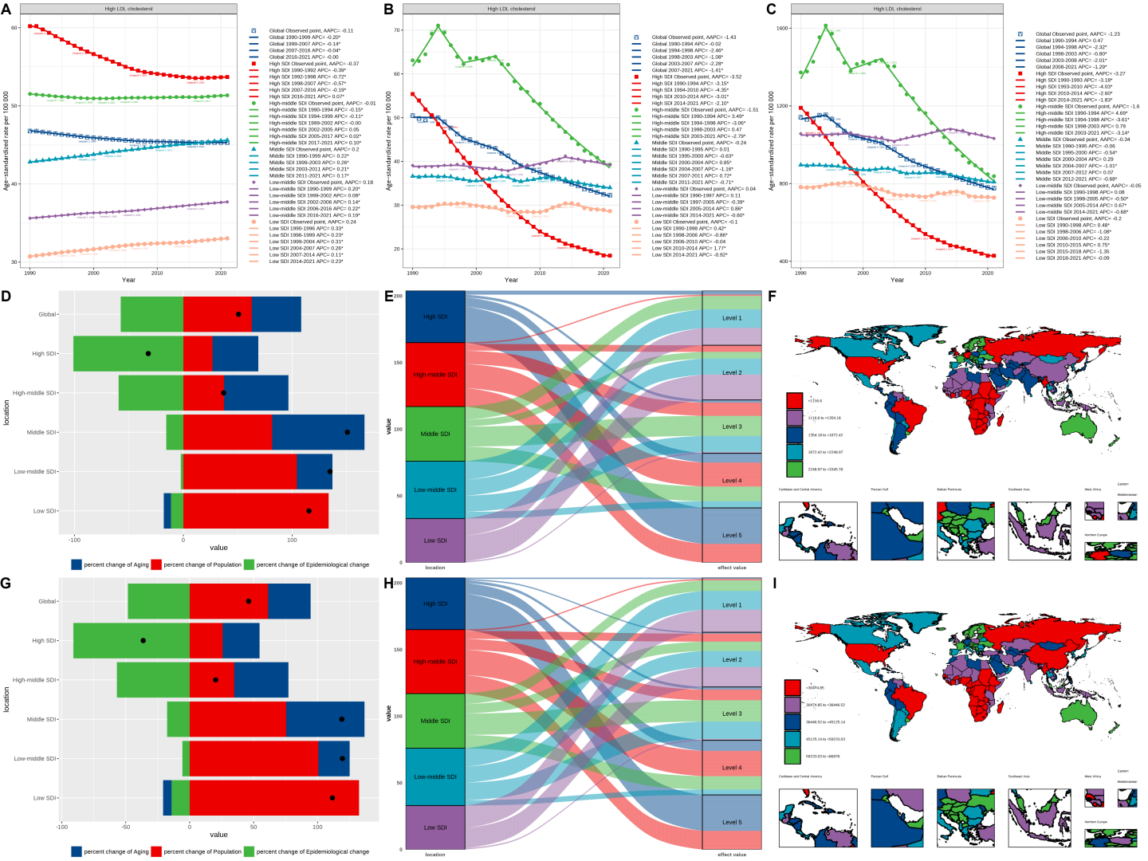

Figure S25 Summary of analysis results for high body-mass index. (A) The joinpoint regression analysis on SEV. (B) The joinpoint regression analysis on the ASR of deaths. (C) The joinpoint regression analysis on the ASR of DALYs. (D) Changes in deaths according to aging, population growth and epidemiological change from 1990 to 2021. (E) Changes in DALYs according to aging, population growth and epidemiological change from 1990 to 2021. (F) The correspondence between different regions and fixed effects quintiles of stroke related deaths. (G) The correspondence between different regions and fixed effects quintiles of stroke related DALYs. (H) The fixed-effects of deaths of 204 countries and territories. (I) The fixed-effects of DALYs of 204 countries and territories. Abbreviations: SEV, summary exposure value; ASR, age-standardized rate; DALYs, disability-adjusted life years.
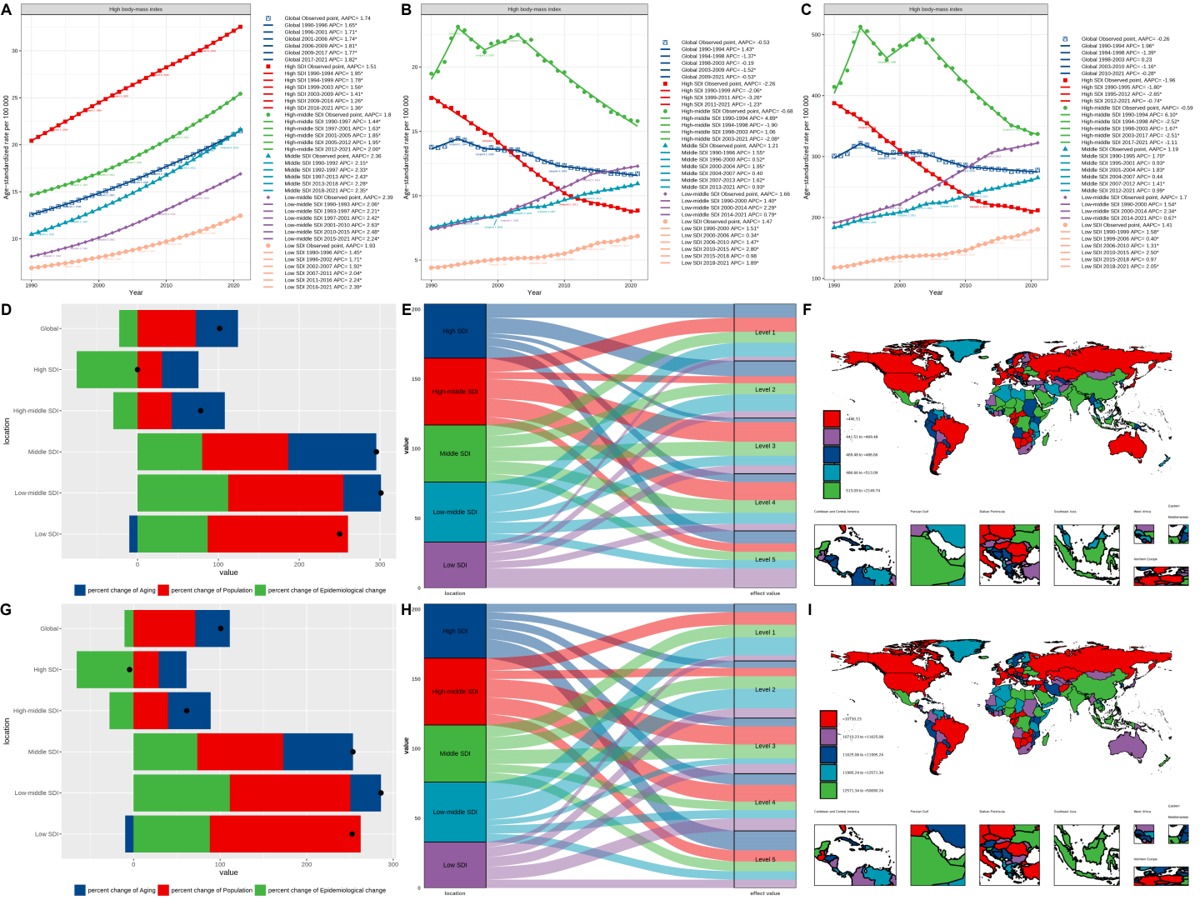

Figure S26 Summary of analysis results for kidney dysfunction. (A) The joinpoint regression analysis on SEV. (B) The joinpoint regression analysis on the ASR of deaths. (C) The joinpoint regression analysis on the ASR of DALYs. (D) Changes in deaths according to aging, population growth and epidemiological change from 1990 to 2021. (E) Changes in DALYs according to aging, population growth and epidemiological change from 1990 to 2021. (F) The correspondence between different regions and fixed effects quintiles of stroke related deaths. (G) The correspondence between different regions and fixed effects quintiles of stroke related DALYs. (H) The fixed-effects of deaths of 204 countries and territories. (I) The fixed-effects of DALYs of 204 countries and territories. Abbreviations: SEV, summary exposure value; ASR, age-standardized rate; DALYs, disability-adjusted life years.
