A Strategy to Design Non-symmetric Compound by Modifying the End-group Functional Atoms for Photothermal and Photodynamic Therapy of Tumor
Xin Xie ^{a, b,1}, Jie Zeng ^{a, b,1}, Miao-Yan Xu ^{a, b}, Xin-Hao Han ª, Bing Fan ^{d},
Xianglong Li ^{e}, Duo-Duo Wei ^{a, b}, Xiao-Jian Han ^{a, c} * and Shaorong Huang ª *

ª Institute of Geriatrics, Jiangxi Provincial People's Hospital, The First Affiliated Hospital of Nanchang Medical College, Nanchang 330006, Jiangxi, People’s Republic of China.
^{b} School of Pharmacy, Jiangxi Medical College, Nanchang University, Nanchang 330006, Jiangxi, People’s Republic of China.
^{c} The Second Department of Neurology, Jiangxi Provincial People’s Hospital, The First Affiliated Hospital of Nanchang Medical College, Nanchang 330006, Jiangxi, People’s Republic of China.
^{d} Department of Radiology, Jiangxi Provincial People's Hospital, The First Affiliated Hospital of Nanchang Medical College, Nanchang, 330006, Jiangxi, People’s Republic of China.
^{e} Jiangxi Key Laboratory of Organic Chemistry, Institute of Organic Chemistry, Jiangxi Science & Technology Normal University, Nanchang 330013.China.

¹ These authors contributed equally to this work.
*Corresponding authors:
E-mail: hanxiaojian@hotmail.com (Xiao-Jian Han)
huangshaorong@ncmc.edu.cn (Shaorong Huang)

Experimental Section

Materials and Instrumentation
The monomers of Y-CHO(CAS: the organic monomer of Y-CHO has not yet been assigned a CAS number), IC-2Cl (CAS: 2197167-50-1) and IC-Br (CAS：507484-47-1) are purchased from Derthon, the molecule of Y-2Cl-Br is synthesized in this work. The other materials are common commercial level and used without further purification.
The ¹H NMR spectra is recorded in deuterated solvents on a Bruker ADVANCE 600 NMR Spectrometer. ¹H NMR chemical shifts is reported in ppm downfield from tetramethylsilane (TMS) reference using the residual protonated solvent as an internal standard. UV-vis absorption spectra are recorded on a Perkin Elmer Lambda 750 spectrophotometer. The photoluminescence spectra (PL) are measured by photoluminescence spectroscopy (Hitachi F-7000). Transmission electron microscopy (TEM) was conducted on a JEM-ARM 200F Atomic Resolution Analytical Microscope operating at an accelerating voltage of 200 kV. Distribution sizes of nanoparticles were performed by dynamic light scattering (DLS) using a PSS Nicomp 380 Z3000. The cellular fluorescence images were carried out using a confocal laser scanning microscope (CLSM, ZEISS-LSM900). In this work, cell counting kit-8 (CCK-8) was purchased from GLPBIO (United States) and the absorbance of each sample was detected at 450 nm with a microplate reader (Multiskan SkyHigh, Thermo Scientific™). The cell apoptosis was analyzed with BD FACSAria SORP fluorescence activated cell sorting (FACS). Phototherapeutic experiments were carried out by an 808 nm infrared semiconductor laser (Changchun radium photoelectric technology). Temperature variation and photothermal images were taken by an E54 camera (FLIR System). Calcein acetoxymethylester and propidium iodide were purchased from Beijing Solarbio Science & Technology. The mitochondrial membrane potential assay kit with JC-1 was purchased from MedChemExpress. DSPE-PEG₂₀₀₀ and DSPE-PEG₂₀₀₀-FITC was obtained from Chongqing Yusi Pharmaceutical Technology Ltd. Fetal bovine serum was purchased from Viva cell biosciences. Annexin-V PE/7-AAD apoptosis detection kit was purchased from BD Biosciences. MitoSOX (M36008) was purchased from Thermo Fisher Scientific Inc.

Synthesis of Y-4Cl
Y-CHO (320 mg, 0.23 mmol) and IC-2Cl (120 mg, 0.46 mmol) were dissolved in chloroform (30 mL) and pyridine (2 mL) was added. The mixture was stirred in nitrogen for 20 min and then reflow at 65 ℃ for 12 hours. After cooling to room temperature, pour the mixture into methanol (200 mL) and filtration. The crude product was purified by silica gel column chromatography using ether/dichloromethane (1:1) as eluent, and the solid Y-4Cl was obtained, yielding a solid (yield 70 %). ¹H NMR (400 MHz, CDCl₃) δ (ppm) = 9.229 (s, 1H), 8.855 (s, 1H), 8.007 (d, 1H), 4.795 (d, 2H), 3.233 (d, 2H), 2.144 (s, 2H), 1.527 (s, 8H), 1.429 ~ 0.836 (m, 61H). MALDI-TOF-MS m/z calcd, for (C₁₀₈H₁₃₈Cl₄N₈O₂S₅): 1881.85. Found: 1881.0478.

Synthesis of Y-2Cl-Br
Y-CHO (345 mg, 0.23 mmol), IC-2Cl (60 mg, 0.23 mmol), IC-Br (63 mg, 0.23 mmol) were dissolved in chloroform (30 mL), and pyridine (2 mL) were added. The mixture was deoxygenated with nitrogen for 20 min and then refluxed for 12 h at 65 ℃. After cooling to room temperature, the mixture was poured into methanol (200 mL) and filtration. The crude product was purified by silica gel column chromatography using ether/dichloromethane (1:1) as eluent, and the solid Y-2Cl-Br was obtained, yielding a solid (yield 40 %). ¹H NMR (400 MHz, CDCl₃) δ (ppm) = 9.233 (s, 2H), 8.858 (s, 1H), 8.621 (d, 1H), 8.084 (s, 1H), 8.007 (s, 1H), 7.914 (d, 1H), 4.94 (d, 4H), 3.236 (s, 4H), 2.146 (s, 4H), 1.431 (s, 11H), 1.379-0.817 (m, 112H). MALDI-TOF-MS m/z calcd, for (C₁₀₈H₁₃₉BrCl₂N₈O₂S₅): 1892.83. Found: 1891.5000.

Synthesis of Y-2Br
Y-CHO (320 mg, 0.23 mmol) and IC-Br (126 mg, 0.46 mmol) were dissolved in chloroform (30 mL) and pyridine (2 mL) was added. The mixture was stirred in nitrogen for 20 min and then reflow at 65 ° C for 12 hours. After cooling to room temperature, pour the mixture into methanol (200 mL) and filtration. The crude product was purified by silica gel column chromatography using ether/dichloromethane (1:1) as eluent, and the solid Y-2Br was obtained, yielding a solid (yield 60 %). ¹H NMR (400 MHz, CDCl₃) δ (ppm) = 9.24 (s, 1H), 8.62 (d, 1H), 8.09 (s, H), 7.91 (d, 1H), 4.80 (d, 2H), 3.24 (d, 2H), 2.15 (s, 2H), 1.53 (s, 1H), 1.44 ~ 0.82 (m, 56H). MALDI-TOF-MS m/z calcd, for (C₁₀₈H₁₄₀Br₂N₈O₂S₅): 1902.82. Found: 1902.0848.

Synthesis of NPs
Y-4Cl, Y-2Cl-Br and Y-2Br (1 mg) was dissolved in 2 mL THF, and DSPE-PEG₂₀₀₀ (5 mg) was completely dissolved in water (9 mL) to obtain DSPE-PEG₂₀₀₀ solution. Then the Y-2Cl-Br solution was added into DSPE-PEG₂₀₀₀ solution under sonication (time: 10 min, power: 220 W). After 10 min sonication, the crude Y-4Cl NPs, Y-2Cl-Br NPs and Y-2Br NPs were filtered through a membrane filter (diameter = 220 nm). Then, it further purified by ultrafiltration device to filter impurities less than 100 μm. Finally, the solvent was removed and the nanoparticle were concentrated by vacuum rotary evaporation to form a liquid stored in dark at 4 °C for further usage.

Determining the concentration of NPs
The final concentration of Y-4Cl NPs, Y-2Cl-Br NPs and Y-2Br NPs was determined by the concentration of Y-4Cl, Y-2Cl-Br and Y-2Br.

Photothermal Performance of NPs
Y-4Cl NPs, Y-2Cl-Br NPs and Y-2Br NPs at different concentrations (13, 26, 39, 52 μg mL⁻¹) in water were respectively exposed under 808 nm laser (1.0 W cm⁻², 300 s). The real-time temperatures and infrared images were recorded using temperature recorder.

Infrared thermal imaging of NPs
The Y-4Cl NPs, Y-2Cl-Br NPs and Y-2Cl-Br NPs of different concentration 13, 26, 39, 52 μg mL⁻¹ in EP tubes were irradiated by 808 nm laser at a power density of 1.0 W cm⁻² for 5 min. The real-time temperatures and infrared images were recorded using an infrared camera (Changchun, China) and analyzed using IR Flash thermal imaging analysis software (Infrared Cameras Inc.).

Calculation of photothermal conversion efficiency of NPs
Y-4Cl NPs, Y-2Cl-Br NPs and Y-2Cl-Br NPs (52 μg mL⁻¹) were exposed to 808 nm laser (1.0 W cm⁻²). After heating, the solution was cooled down to room temperature. The PCE was calculated:
$$PCE=\frac{hS \left(T_{max}-T_{surr}\right)-Q_{dis}}{I(1-{10}^{-A_{λ}})}$$
Where, h and S are heat transfer coefficient and surface area of the container, respectively; Q_{dis} is the heat dissipation from the laser mediated by the solvent and container; I and A are the laser power and absorption at 808 nm.
$$hS=\frac{mC_{water}}{τ_{s}}$$
Where m is the mass of the NPs solution, C is the specific heat capacity of the solution (C_{water} = 4.2 J/g∙ ºC), and τ_{s} is the associated time constant.
t=−$τ_{s}ln (θ)$
Where θ is a dimensionless parameter, deduced from the temperature.
$$θ=\frac{T-T_{surr}}{T_{max}-T_{surr}}$$
T_{max} and T_{surr} denote the maximum steady state temperature and the environmental temperature, respectively.

Photothermal stability
The Y-2Cl-Br NPs with 52 μg mL⁻¹ in EP tubes were irradiated by 808 nm laser at a power density of 1.0 W cm⁻² for 10 min. Subsequently, the NIR laser was turned off, and the solution was naturally cooled to room temperature (laser off). The laser on and laser off cycles were repeated five times, and the change in temperature was monitored.

Reactive Oxygen Species (ROS)
Y-2Cl-Br NPs (2.97 mL, 52 μg mL⁻¹) and Indocyanine green (ICG) aqueous solution (2.97 mL, 52 μg mL⁻¹) in quartz cuvettes were mixed with Detection 1,3-Diphenylisobenzofuran (DPBF) in ethanol (30.0 μL, 10 mM) respectively, which was then irradiated by lasers (808 nm, 1.0 W cm⁻²). The absorbance at 415 nm of the solution was recorded at the preset-time points during 90 s.

Singlet oxygen (¹O₂) detection in aqueous solution
Y-2Cl-Br NPs aqueous solution (52 µg mL⁻¹) was mixed with SOSG (5 µM), which was then irradiated by lasers (808 nm, 1.0 W cm⁻²). The fluorescence intensity at 525 nm of the solution was recorded at the preset-time points during 200 s (Excitation wavelength: 488 nm).

Hydroxyl radical (● OH) detection in aqueous solution
The ● OH generation of Y-2Cl-Br NPs was detected by measuring the fluorescence of HPF. Y-2Cl-Br NPs aqueous solution (52 µg mL⁻¹) in quartz cuvettes were mixed with HPF in DMF (10 µM), which was then irradiated by laser (808 nm, 1.0 W cm⁻²). The fluorescence intensity at 515 nm of the solution was recorded at the preset-time points during 200 s. (Excitation wavelength: 488 nm).

Superoxide anion radical (O₂^{• −}) detection in aqueous solution
The O₂^{• −} generation of Y-2Cl-Br NPs was detected by measuring the fluorescence of dihydroethidium (DHE) in the presence of DNA. Specifically, Y-2Cl-Br NPs aqueous solution (52 µg mL⁻¹) in quartz cuvettes were mixed with DHE in DMSO (10 µM) and DNA in H₂O (250 μg/mL). Then the mixture was irradiated by laser (808 nm, 1.0 W/cm²) and the fluorescence spectrum at 580 nm of the solution was recorded at the preset-time points during 200 s. (Excitation wavelength: 510 nm).

Cell culture
The mouse tumor cell line 4T1 and B16F10 cells were obtained from the American Type Culture Collection (ATCC). The cells were cultured in complete RPMI 1640 medium (containing 10% FBS) at 37 °C in a 5% CO₂ atmosphere.

Cellular uptake of fluorescent Micelles
To study the intracellular internalization behavior of Y-2Cl-Br NPs by CLSM, FITC-labeled Y-2Cl-Br NPs (FITC-Y-2Cl-Br NPs) were prepared through co-assembling DSPE-PEG₂₀₀₀ and DSPE-PEG₂₀₀₀-FITC (mole ratio is 9:1) with Y-2Cl-Br via a nanoprecipitation method. 4T1 cells seeded at a suitable density in glass bottom dish were cultured for 24 h. Then, the cells were incubated with FITC-Y-2Cl-Br NPs in fresh 1640 medium (52 μg mL⁻¹) at different times and washed with PBS. Afterwards, the samples and imaged by fluorescent microscope to observe the subcellular localization of Y-2Cl-Br NPs. The excitation wavelengths are 488 nm for FITC-Y-2Cl-Br NPs. The emission filters are 500~550 nm for FITC-Y-2Cl-Br NPs.

Intracellular ROS generation
4T1 cells seeded in a 6-well plate were cultured for 24 h. Then, the cells were treated with Y-2Cl-Br NPs in fresh 1640 medium (52 μg mL⁻¹) for 4 h, followed by the Y-2Cl-Br NPs was discarded, and washed three times with PBS. Afterwards, the cells incubated with DCFH-DA (10 μM) at 37 °C for 30 min. After washing three times with PBS, the cells were irradiated by 808 nm laser (1.0 W cm⁻²) for 5 min. The cells were imaged by a Nikon Ti2 inverted fluorescence microscope.

Hypoxic tumor environment
To mimic hypoxic tumor environment and therefore detect the intracellular ROS detection under hypoxic condition, the three-gas incubator (1 % O₂, 5 % CO₂) was used to create a hypoxic atmosphere in a sealed transparent chamber. 4T1 cells were inoculated into a 6-well plate with a density of 60 % and incubated under three gas incubator (1 % O₂, 5 % CO₂) conditions for 8 h. Then, the NPs and ROS detection compound (DCFH-DA, SOSG, HPF and DHE) co-incubated with 4T1 cell in the three-gas incubator for 4 h. Subsequently, cells were removed, quickly washed with PBS and re-incubated in the three-gas incubator for 30 min (dark condition). Finally, cells were removed, irradiated with 808 nm laser at a power density of 1.0 W cm⁻² for 5 min (dark condition) and immediately imaged by a Nikon Ti2 inverted fluorescence microscope.

Intracellular ¹O₂ generation
4T1 cells seeded in a 6-well plate were cultured for 24 h. Then, the cells were treated with Y-2Cl-Br NPs in fresh 1640 medium (52 μg mL⁻¹) for 4 h, followed by the Y-2Cl-Br NPs was discarded and washed three times with PBS. Afterwards, the cells incubated with 2 μM SOSG at 37 °C for 15 min. After washing three times with PBS, the cells were irradiated by 808 nm laser (1.0 W cm⁻²) for 5 min. The cells were imaged by a Nikon Ti2 inverted fluorescence microscope.

Intracellular ● OH generation
4T1 cells seeded in a 6-well plate were cultured for 24 h. Then, the cells were treated with Y-2Cl-Br NPs in fresh 1640 medium (52 μg mL⁻¹) for 4 h, followed by the Y-2Cl-Br NPs was discarded, and washed three times with PBS. Afterwards, the cells incubated with 5 μM HPF at 37 °C for 15 min. After washing three times with PBS, the cells were irradiated by 808 nm laser (1.0 W cm⁻²) for 5 min. The cells were imaged by a Nikon Ti2 inverted fluorescence microscope.

Intracellular O₂^{• −} generation
4T1 cells seeded in a 6-well plate were cultured for 24 h. Then, the cells were treated with Y-2Cl-Br NPs in fresh 1640 medium (52 μg mL⁻¹) for 4 h, followed by the Y-2Cl-Br NPs was discarded, and washed three times with PBS. Afterwards, the cells incubated with 5 μM DHE at 37 °C for 15 min. After washing three times with PBS, the cells were irradiated by 808 nm laser (1.0 W cm⁻²) for 5 min. The cells were imaged by a Nikon Ti2 inverted fluorescence microscope.

Mito-SOX
4T1 cells seeded in a 6-well plate were cultured for 24 h. Then, the cells were treated with Y-2Cl-Br NPs in fresh 1640 medium (52 μg mL⁻¹) for 4 h followed by the Y-2Cl-Br NPs was discarded, and washed three times with PBS. Afterwards, the cells incubated with MitoSOX (2 μM) at 37 °C for 15 min. After washing three times with PBS, the cells were irradiated by 808 nm laser (1.0 W cm⁻²) for 5 min. The cells were imaged by a Nikon Ti2 inverted fluorescence microscope.

Measurement of MMP with the JC-1 assay
Mitochondrial membrane potentials (MMPs) were determined by the retention of the JC-1 assays. 4T1 cells were seeded on 35 mm glass dishes at a density of 2 × 10⁵ cells per well for 24 h. Then, the cells were treated with Y-2Cl-Br NPs (52 μg mL⁻¹) for 4 h followed by the Y-2Cl-Br NPs was replaced and washed three times with PBS. Afterwards, the cells incubated with JC-1 relevant probes (5 μM) at 37 °C for 15 min. After washing three times with PBS, the cells were irradiated by 808 nm laser (1.0 W cm⁻²) for 5 min. The cells were imaged by a Nikon Ti2 inverted fluorescence microscope.

Live-dead cell staining
4T1 cells seeded in a 6-well plate were cultured for 24 h. Then, the cells were treated with Y-2Cl-Br NPs in fresh 1640 medium (52 μg mL⁻¹) for 4 h, followed by the Y-2Cl-Br NPs was discarded, and washed three times with PBS. Afterwards, the cells incubated with PI (2 μM) and Calcein-AM (9 μM) for 15 min. After washing three times with PBS, the cells were irradiated by 808 nm laser (1.0 W cm⁻²) for 5 min. The cells were imaged by a Nikon Ti2 inverted fluorescence microscope.

In vitro photo cytotoxicity of Y-2Cl-Br NPs
4T1 and B16F10 cells were seeded in 96-well plate (5 × 10³ cells per well) at an atmosphere of 37 °C and 5% CO₂ for 24 h. Then the medium was replaced with a fresh Y-2Cl-Br NPs at different concentrations and the cells were incubated for 4 h. The cells were washed with PBS for three times, added with fresh medium, and then exposed to the NIR laser (808 nm, 1.0 W cm⁻²) for 5 min. After that, the cells were incubated for additional 24 h and their viability was analyzed using CCK-8 assay.

In Vitro Fluorescence Imaging
Y-2Cl-Br NPs in PBS solutions (0, 13, 26, 39 and 52 μg mL⁻¹, respectively) were subjected to fluorescence imaging. All solutions were put in eppendorf tubes and fluorescence image is by a fluorescence imaging system (PerkinElmer IVIS Lumina) with excitation at 780 nm and emission at 845 nm.

Statements for the animal experiments
All the animals received tender care incompliance with the guidelines outlined in the Guide for the Care and Use of Laboratory Animals. The procedures (including the tumors of the mice were irradiated with 808 nm laser for 5 min at a power density of 1.0 W cm⁻²) were approved by the Ethics Committee of Jiangxi Provincial People’s Hospital (KT016).

Animal tumor model
Female BALB/c mice (4~6 weeks old) were purchased from SPF Biotechnology Co., Ltd (Beijing, China). 4T1 cells (1 × 10⁶ /100 μL for each mouse) were injected into the right thigh of female BALB/c mice to establish a subcutaneous 4T1 tumor model. The tumor-bearing mice used for subsequent experiments, until the tumor volume reached 100-120 mm³. Tumor volume was calculated as (tumor length) × (tumor width)² × 0.5.

In vivo fluorescence imaging
The tumor-bearing mouse was anesthetized with isoflurane to remove fur. Next, the Y-2Cl-Br NPs solution (200 μL, 1 mg mL⁻¹) was intravenously injected into the mouse. After injection, the mouse was imaged with the small animal imaging system (IVIS Lumina Series III, PerkinElmer) at designated time points.

Hemolysis assay
Fresh whole blood (1.0 mL) was extracted by enucleation of BALB/c mice eyes, and the red blood cells (RBCs) were obtained by centrifugation (3000 rpm) for 5 min at 4 °C. The RBCs were further washed by PBS and diluted by PBS. Then, 0.2 mL of the suspension was mixed with 0.8 mL of Y-2Cl-Br NPs in PBS (pH = 7.4) to obtain a different concentration of 0, 0.15, 0.30, 0.45 and 0.60 mg mL⁻¹, respectively. Each sample was prepared by triplicate, and the suspensions were incubated at 37 °C for 2 h under mild shaking (50 rpm/min). Then, the samples were centrifuged at 3000 rpm for 5 min at 4 °C, and the absorbance at 541 nm from hemoglobin was monitored by a UV-Vis spectrometer. To achieve 0% and 100% hemolysis, 0.2 mL of diluted RBCs suspension was treated with PBS (0.8 mL) or water (0.8 mL), respectively. The percent of hemolysis is calculated with the formula: Hemolysis rate (%) = (Abs-Abs0%)/(Abs100%-Abs0%) × 100%. Where Abs, Abs0% and Abs100% were the absorption of samples (with the absorption background of Y-2Cl-Br NPs subtracted), the solution of 0% hemolysis and the solution of 100% hemolysis, respectively.

In vivo photothermal therapeutic efficacy of Y-2Cl-Br NPs
When the tumors reached approximately 100 mm³, 4T1 tumor-bearing mice were randomly divided into four groups (n=6 per group) and were intravenously injected with Y-2Cl-Br NPs (1.0 mg mL⁻¹) or PBS. After injection, the tumors were irradiated by an 808 nm laser at a power density of 1.0 W cm⁻² for 5 min. The tumor sizes were measured by a vernier calipers every three days, and the mice weights were recorded every three days. The detailed grouping is as follows: PBS group were intravenously injected with 200 μL PBS. PBS+NIR group were intravenously injected with 200 μL PBS and irradiated with 808 nm laser for 5 min at a power density of 1.0 W cm⁻². Y-2Cl-Br NPs group were intravenously injected with 1.0 mg mL⁻¹ (200 μL) Y-2Cl-Br NPs. Y-2Cl-Br NPs + NIR group were intravenously injected with 1.0 mg mL⁻¹ (200 μL) Y-2Cl-Br NPs and irradiated with 808 nm laser for 5 min at a power density of 1.0 W cm⁻².

Hematoxylin & Eosin (H&E) staining
At the end of photothermal therapy, the mice were sacrificed and tumors were excised, fixed in 4% paraformaldehyde for 12 h, and embedded in paraffin for histopathological examination. Cell state in tumor tissue was analyzed by hematoxylin-eosin (H&E) staining.

Statistical analysis
All data were expressed as mean ± standard deviation (SD). All experiments were repeated at least 4 times. One-way analysis of variance (ANOVA) and student's t test were used to evaluate the statistical significance. P values < 0.05 were regarded statistically significant. Results were considered statistically significant when P < 0.05. The statistical analysis was performed with Origin 2021 software (OriginLab, Northhampton, MA) or GraphPad Prism (GraphPad Prism 8; GraphPad).

Author Contribution
All authors made a significant contribution to the work reported, whether that is in the conception, study design, execution, acquisition of data, analysis and interpretation, or in all these areas; took part in drafting, revising or critically reviewing the article; gave final approval of the version to be published; have agreed on the journal to which the article has been submitted; and agree to be accountable for all aspects of the work.
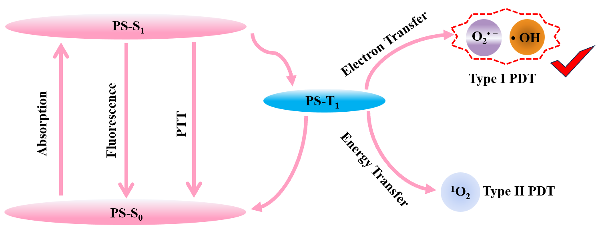
Figure S1 The working principle of photosensitizer for single NIR laser triggered phototherapy using a modified Jablonski diagram.

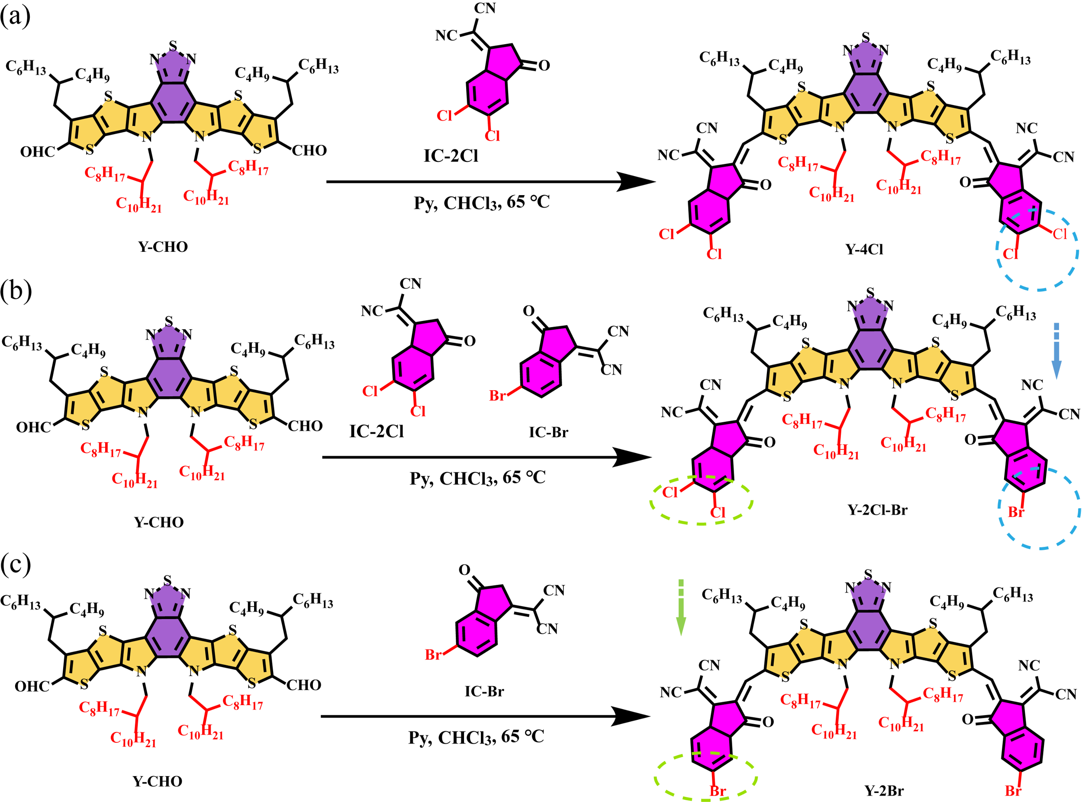
Figure S2 The synthetic route to the Y-4Cl, Y-2Cl-Br and Y-2Br.

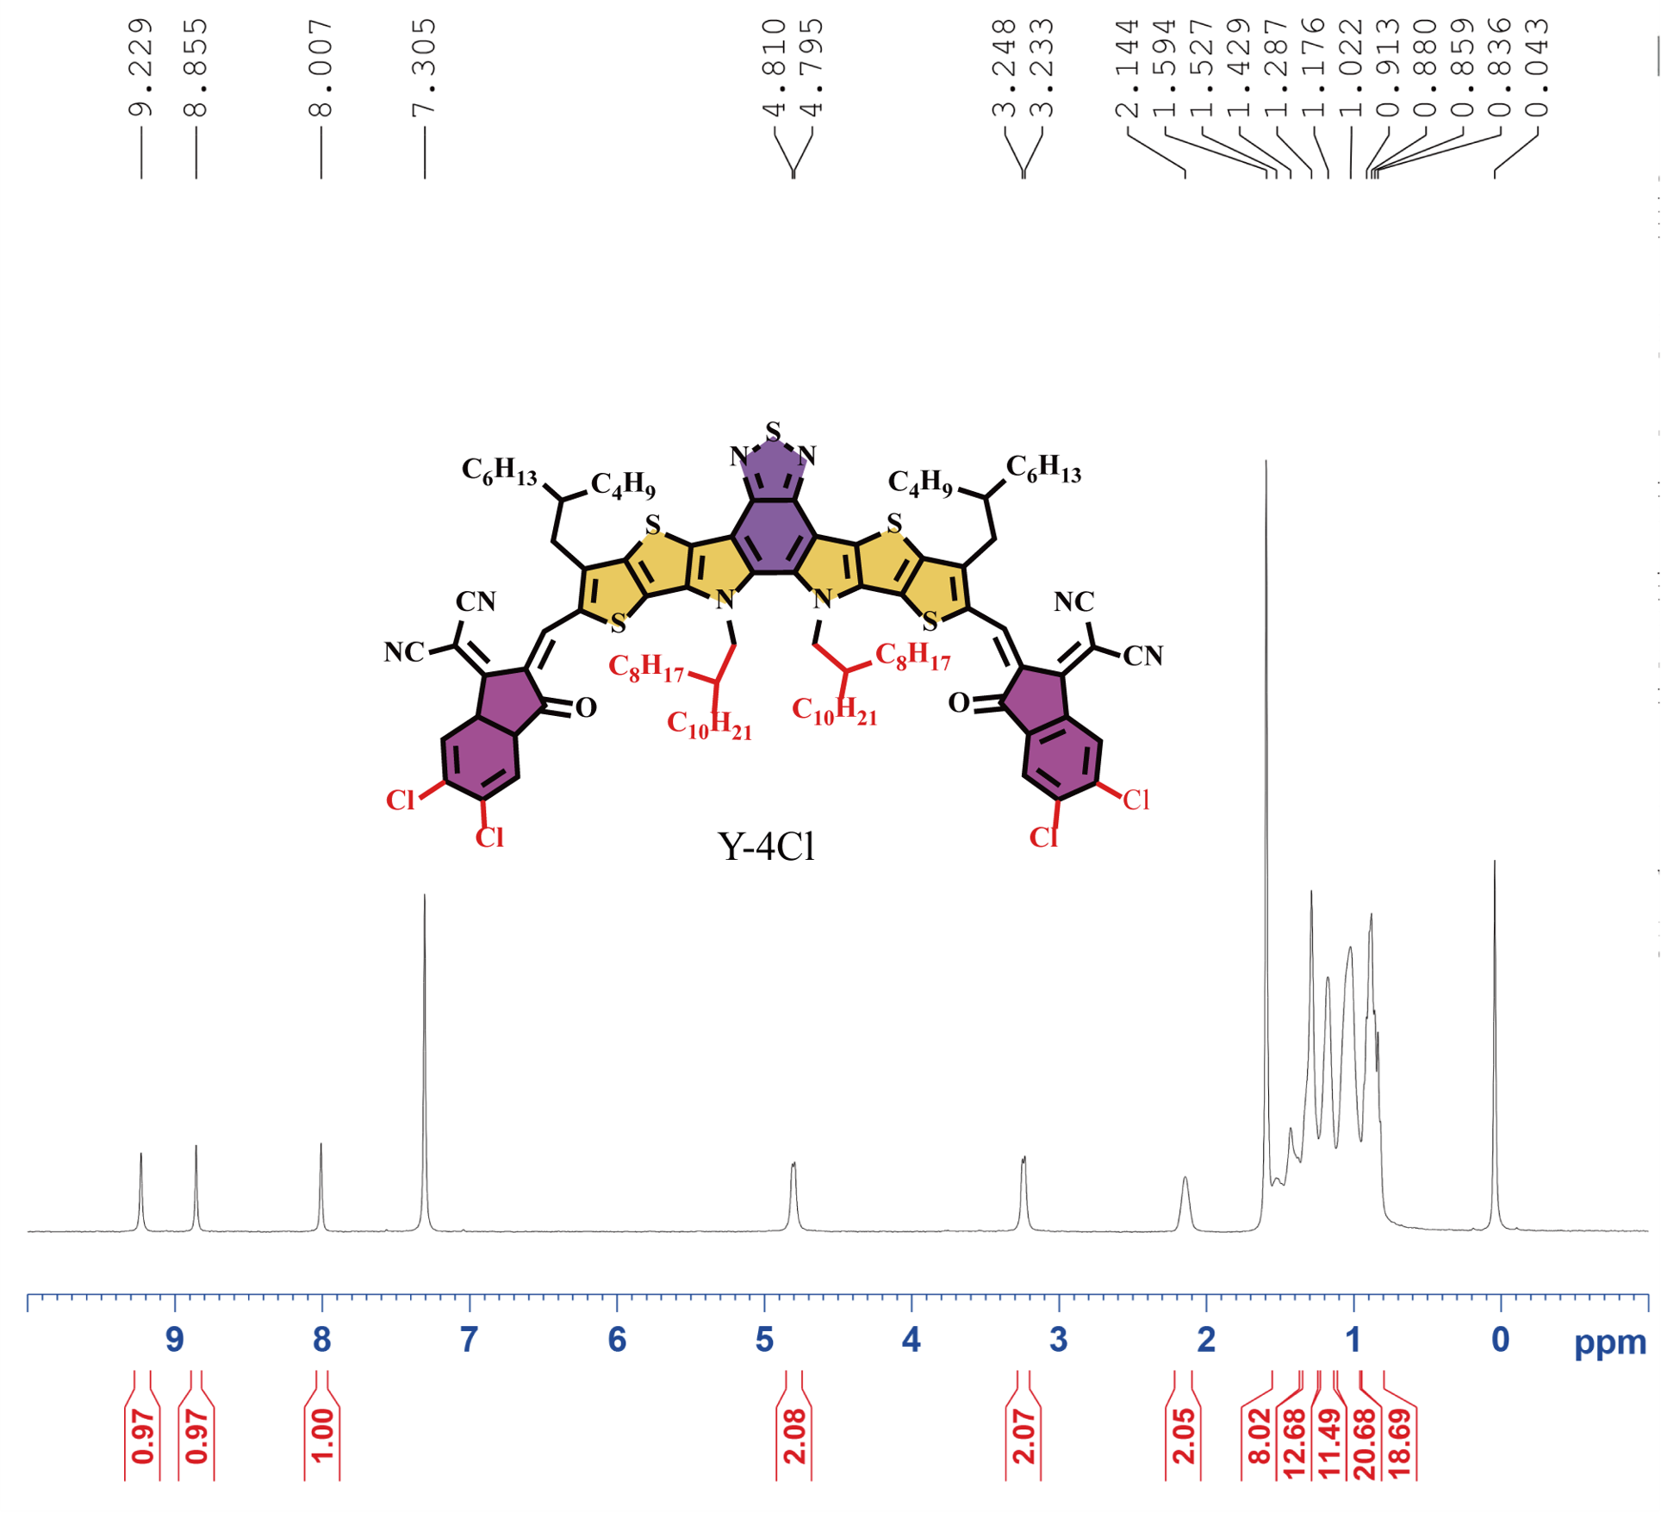
Figure S3 1H NMR spectrum of Y-4Cl in CDCl3.

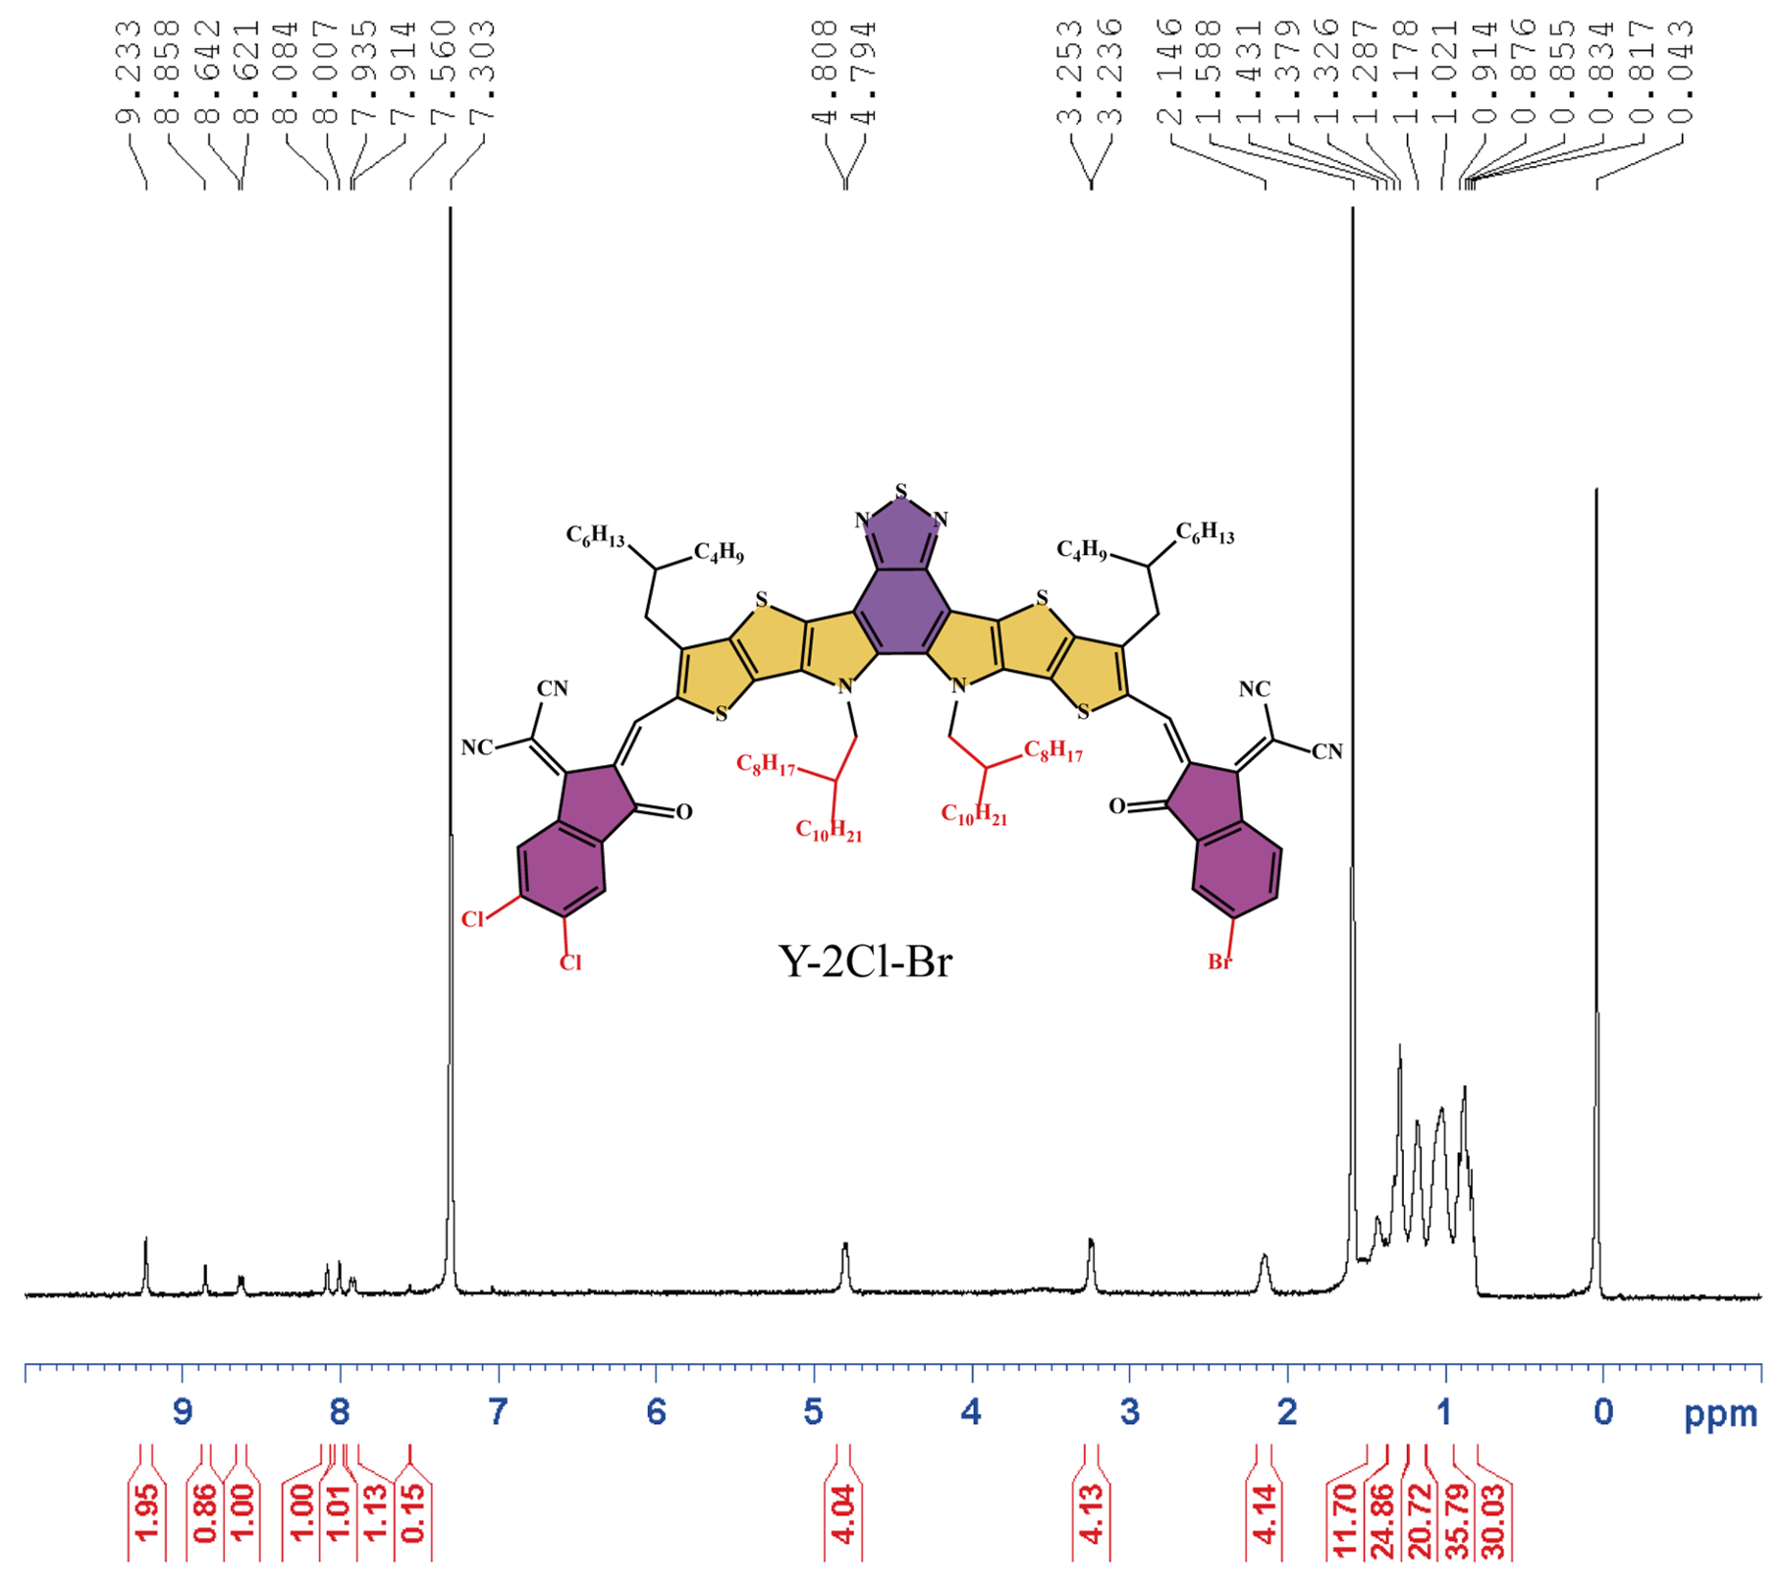
Figure S4 1H NMR spectrum of Y-2Cl-Br in CDCl3.

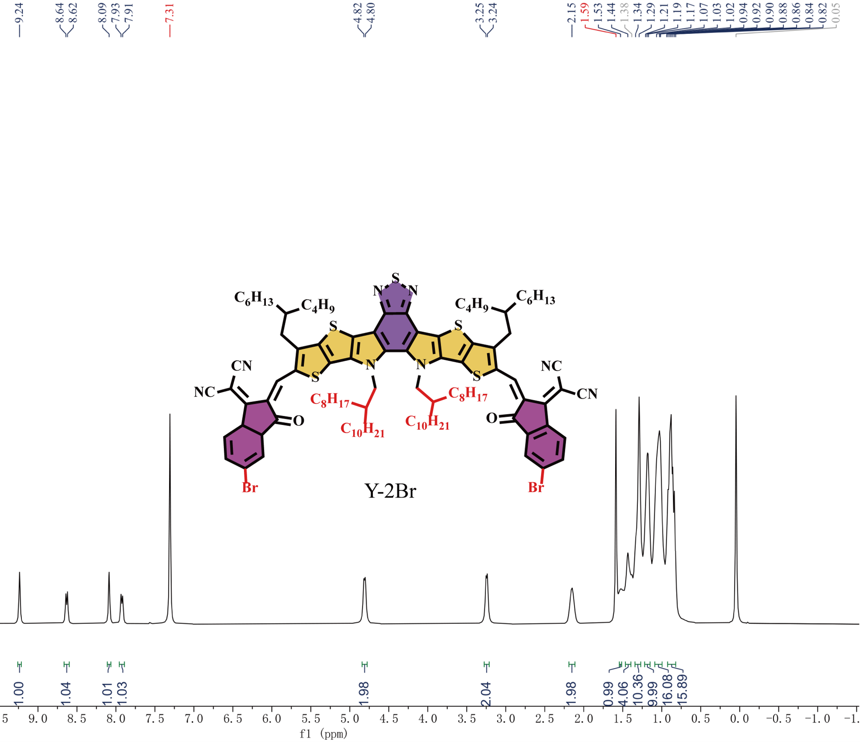
Figure S5 1H NMR spectrum of Y-2Br in CDCl3.

Figure S6 ¹H NMR spectrum of (a) Y-4Cl (b) Y-2Cl-Br and (c) Y-2Br in CDCl₃ including a brief explanation of the characteristic peaks.

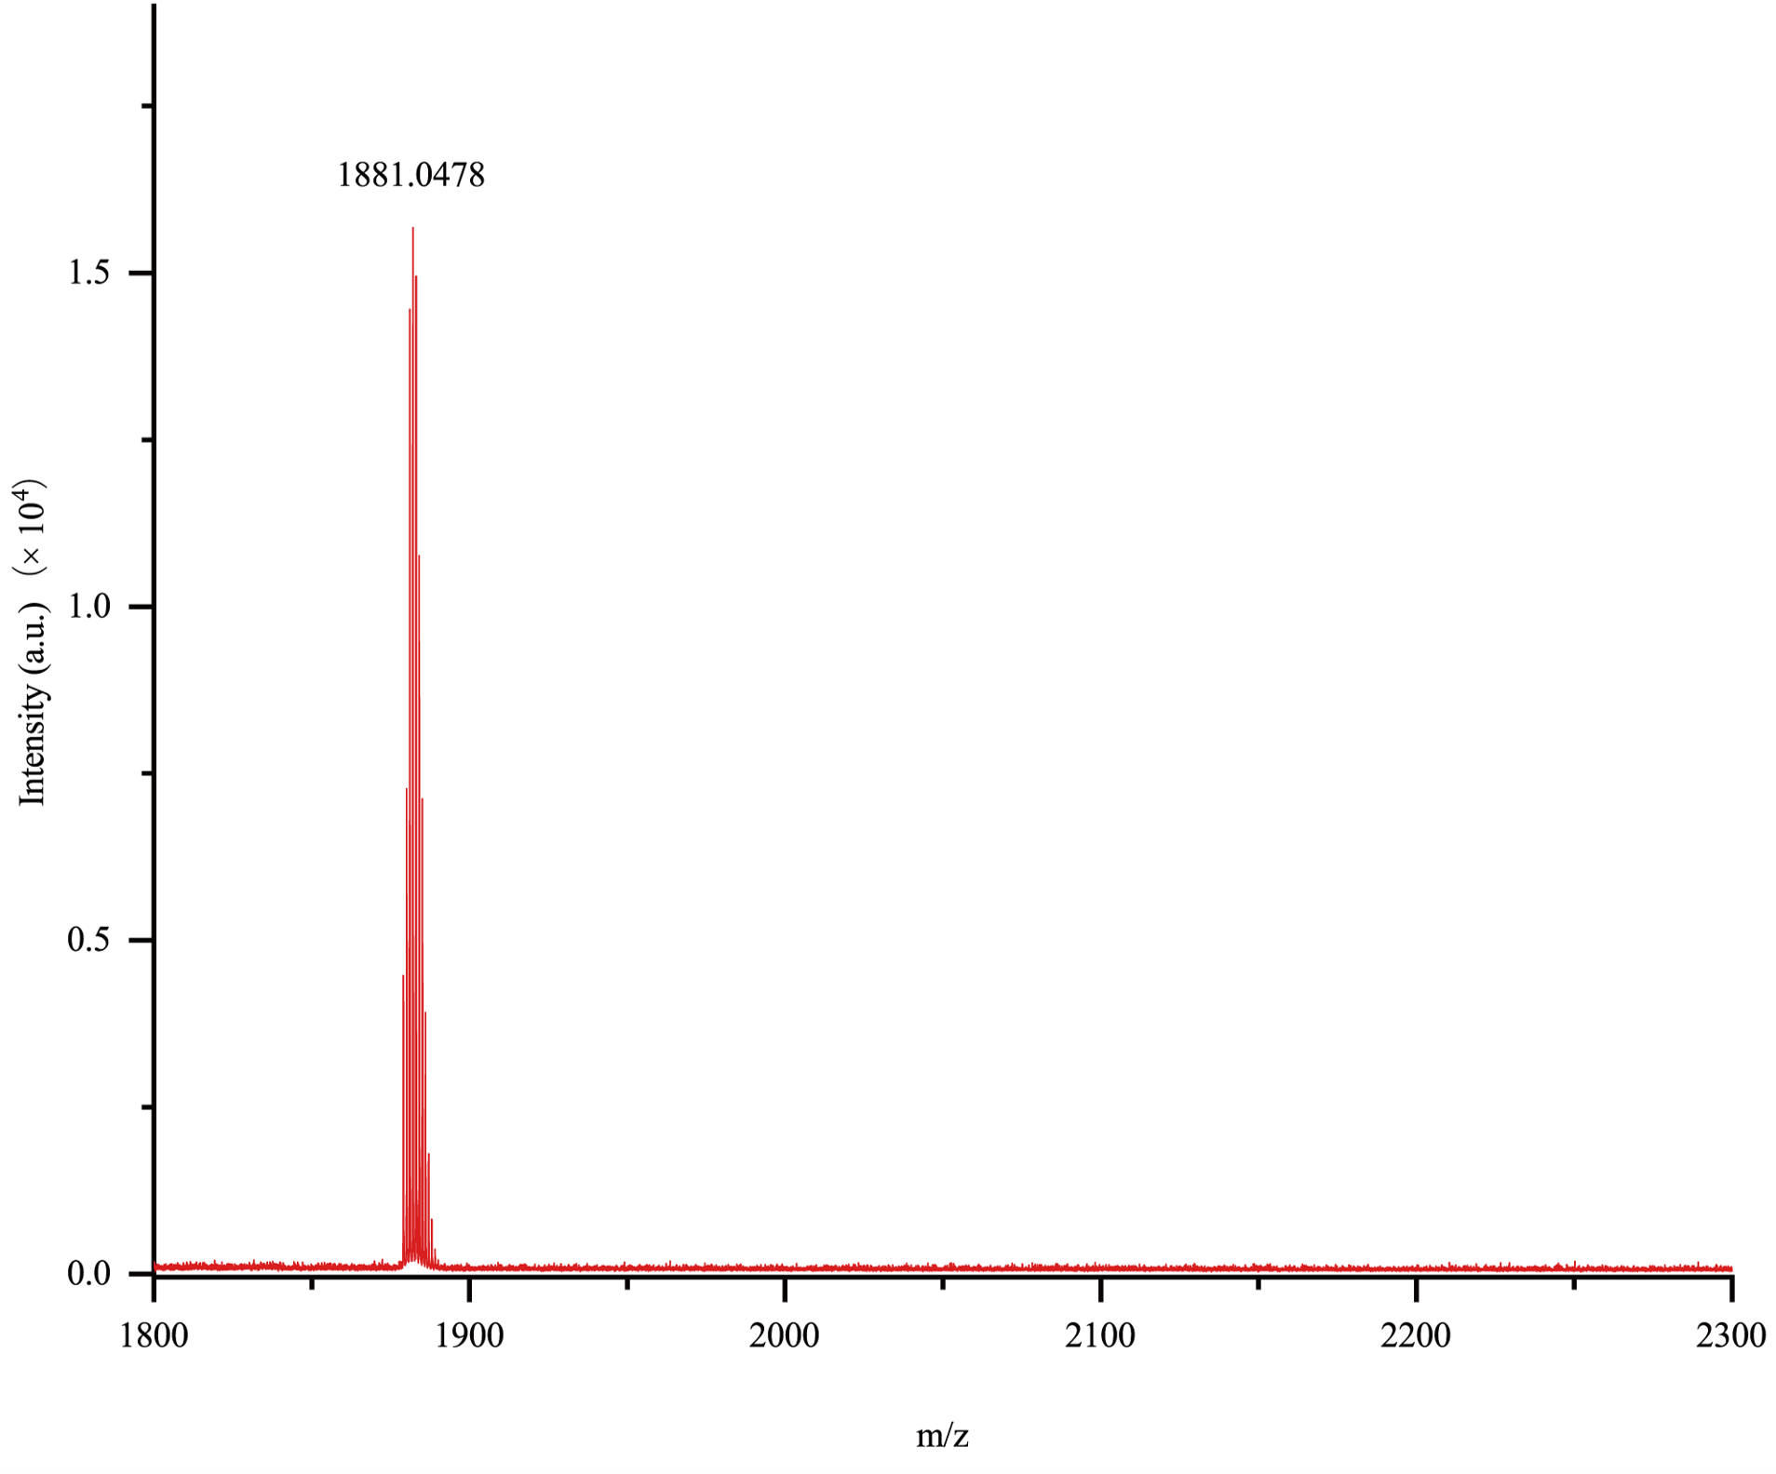
Figure S7 The MALDI-TOF-MS spectrum of Y-4Cl.

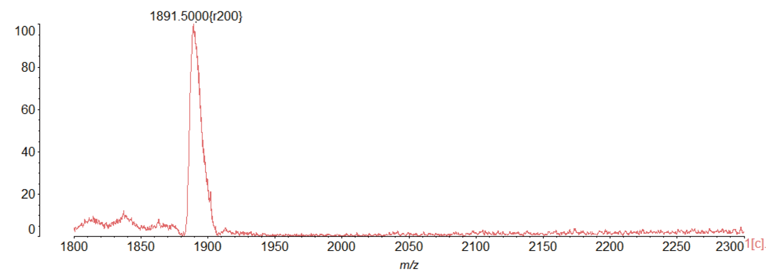
Figure S8 The MALDI-TOF-MS spectrum of Y-2Cl-Br.

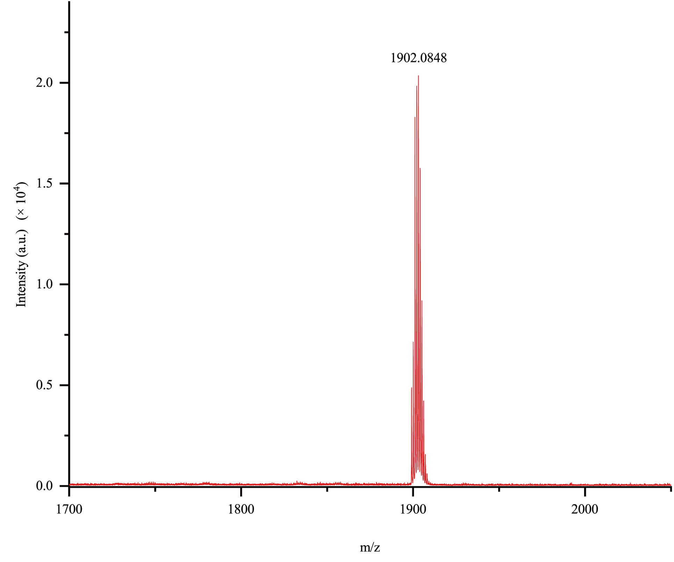
Figure S9 The MALDI-TOF-MS spectrum of Y-2Br.

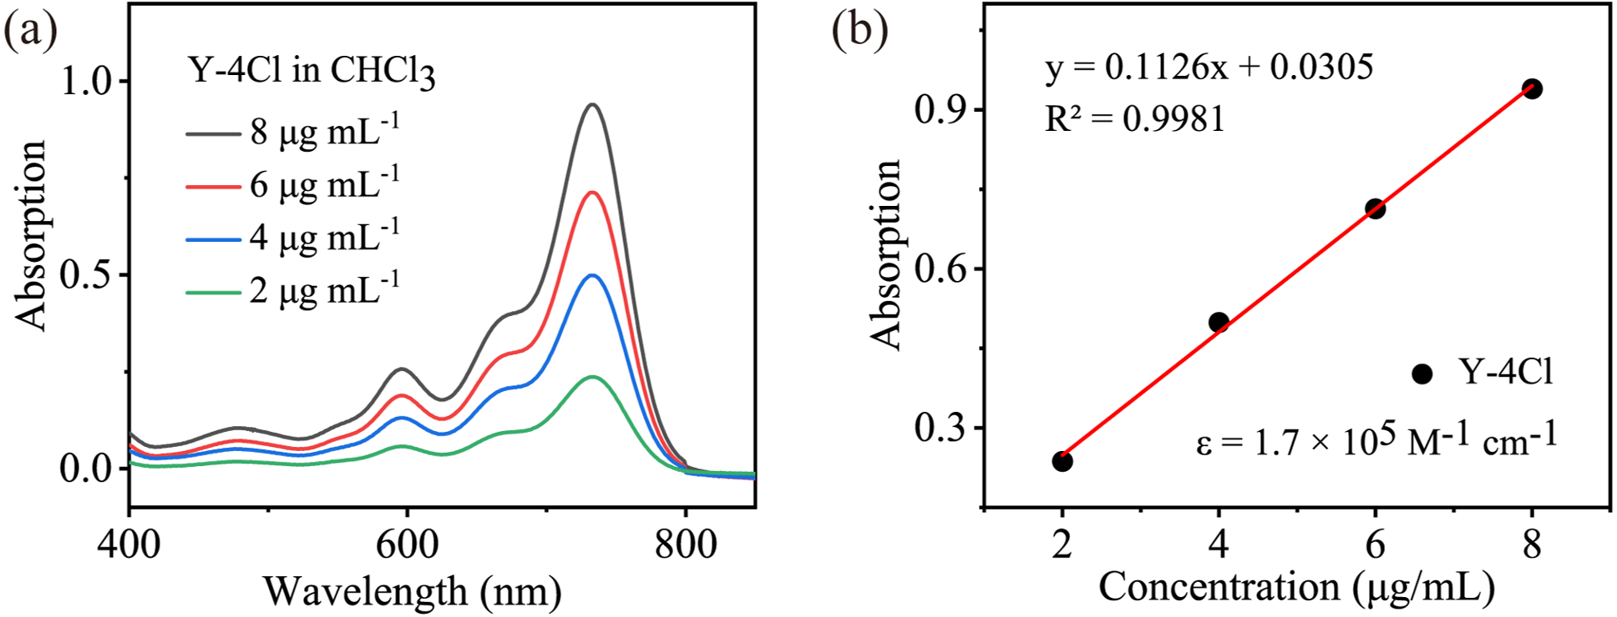
Figure S10 (a) Absorption spectra of Y-4Cl in CHCl₃ at different concentrations. (b) Concentration-absorbance related standard curve of Y-4Cl detected by UV/Vis.

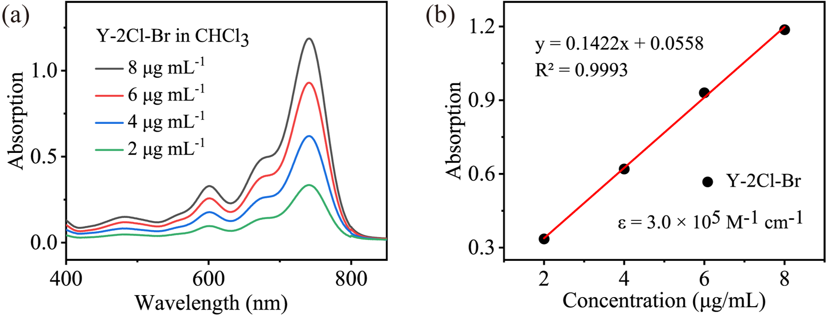
Figure S11 (a) Absorption spectra of Y-2Cl-Br in CHCl₃ at different concentrations. (b) Concentration-absorbance related standard curve of Y-2Cl-Br detected by UV/Vis.

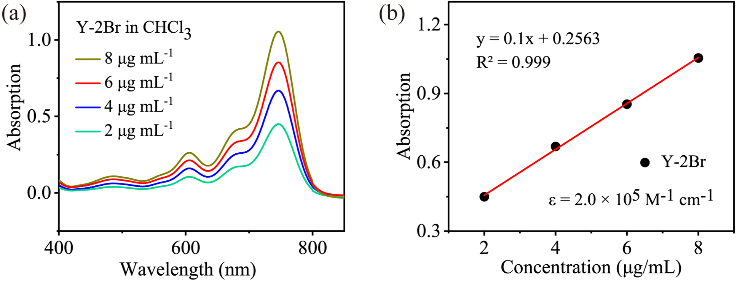
Figure S12 (a) Absorption spectra of Y-2Br in CHCl₃ at different concentrations. (b) Concentration-absorbance related standard curve of Y-2Br detected by UV/Vis.
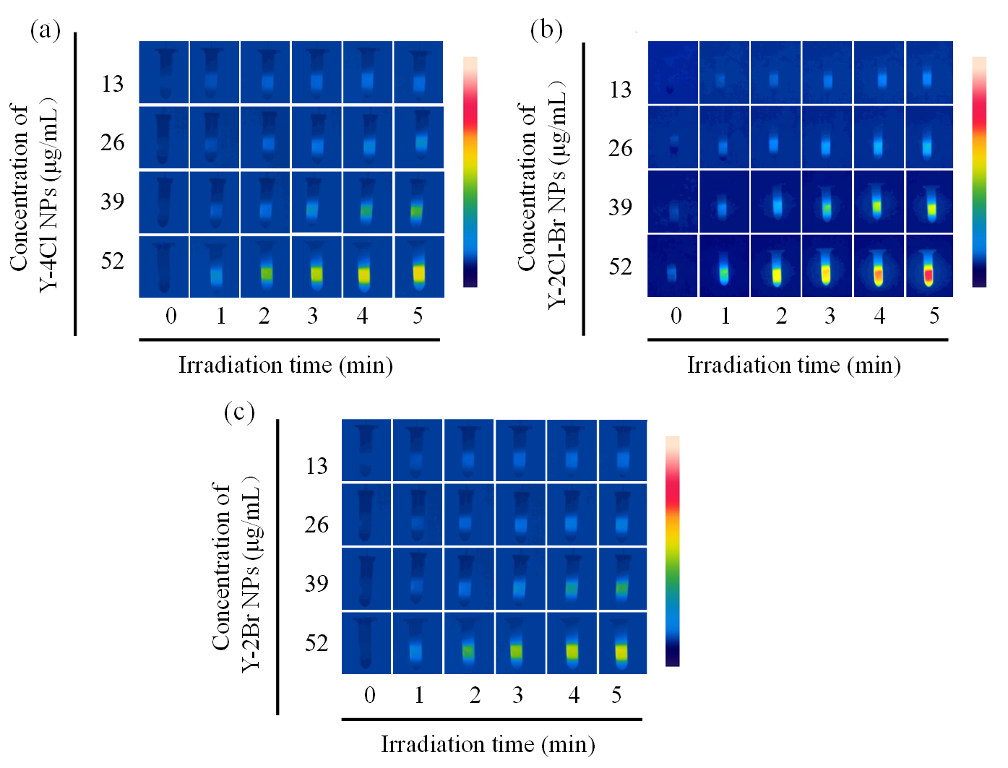
Figure S13 Corresponding infrared thermal images of (a) Y-4Cl NPs (b) Y-2Cl-Br NPs and (c) Y-2Br NPs aqueous dispersions in the laser irradiation.
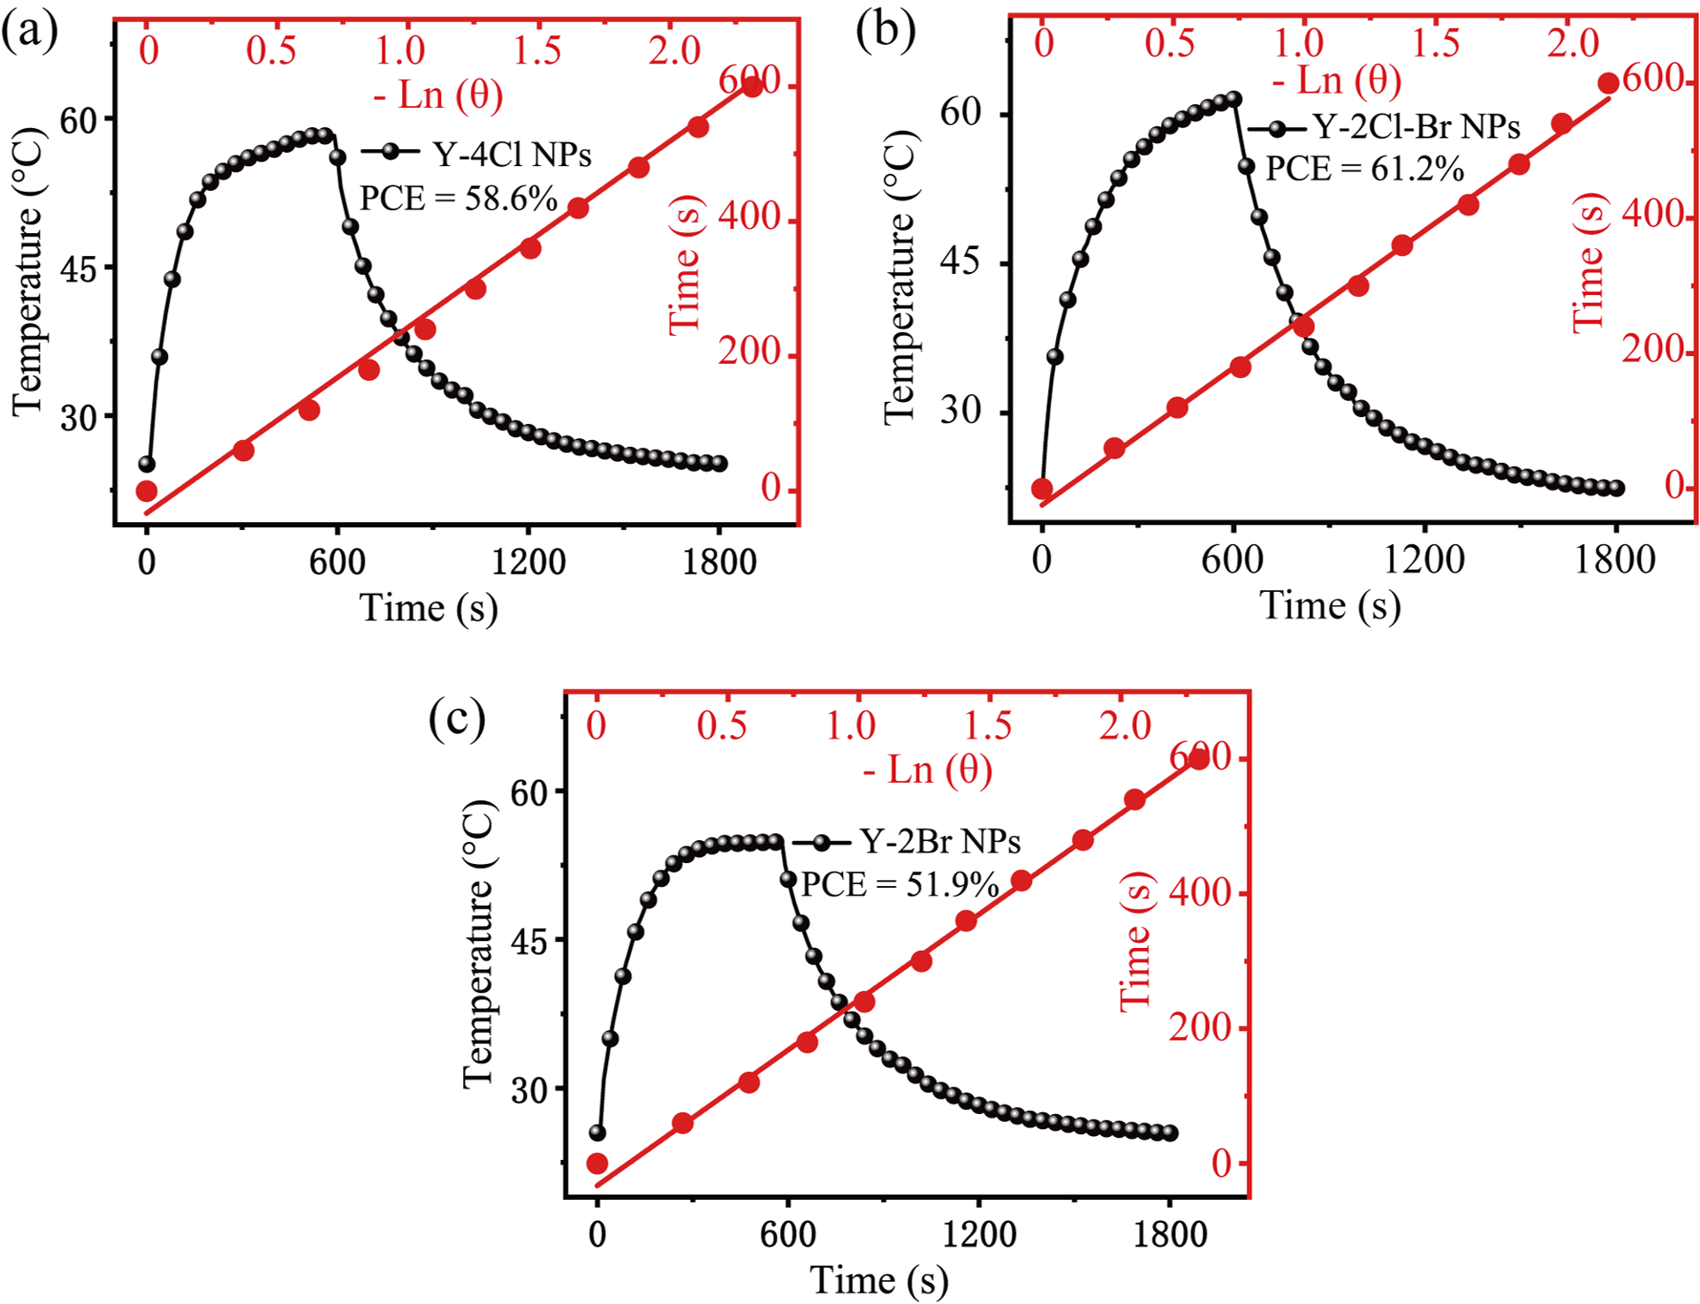
Figure S14 Calculation of PCE of (a) Y-4Cl NPs (b) Y-2Cl-Br NPs and (c) Y-2Br NPs.

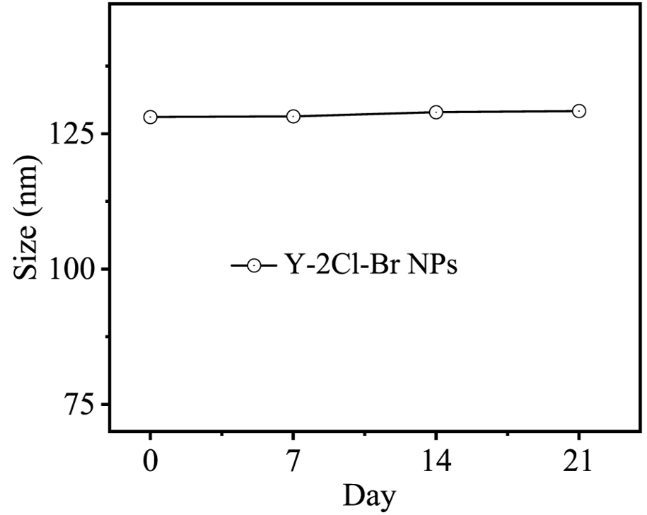
Figure S15 Diameters of Y-2Cl-Br NPs stored in acid solution PBS for 21 days was measured every 7 days.
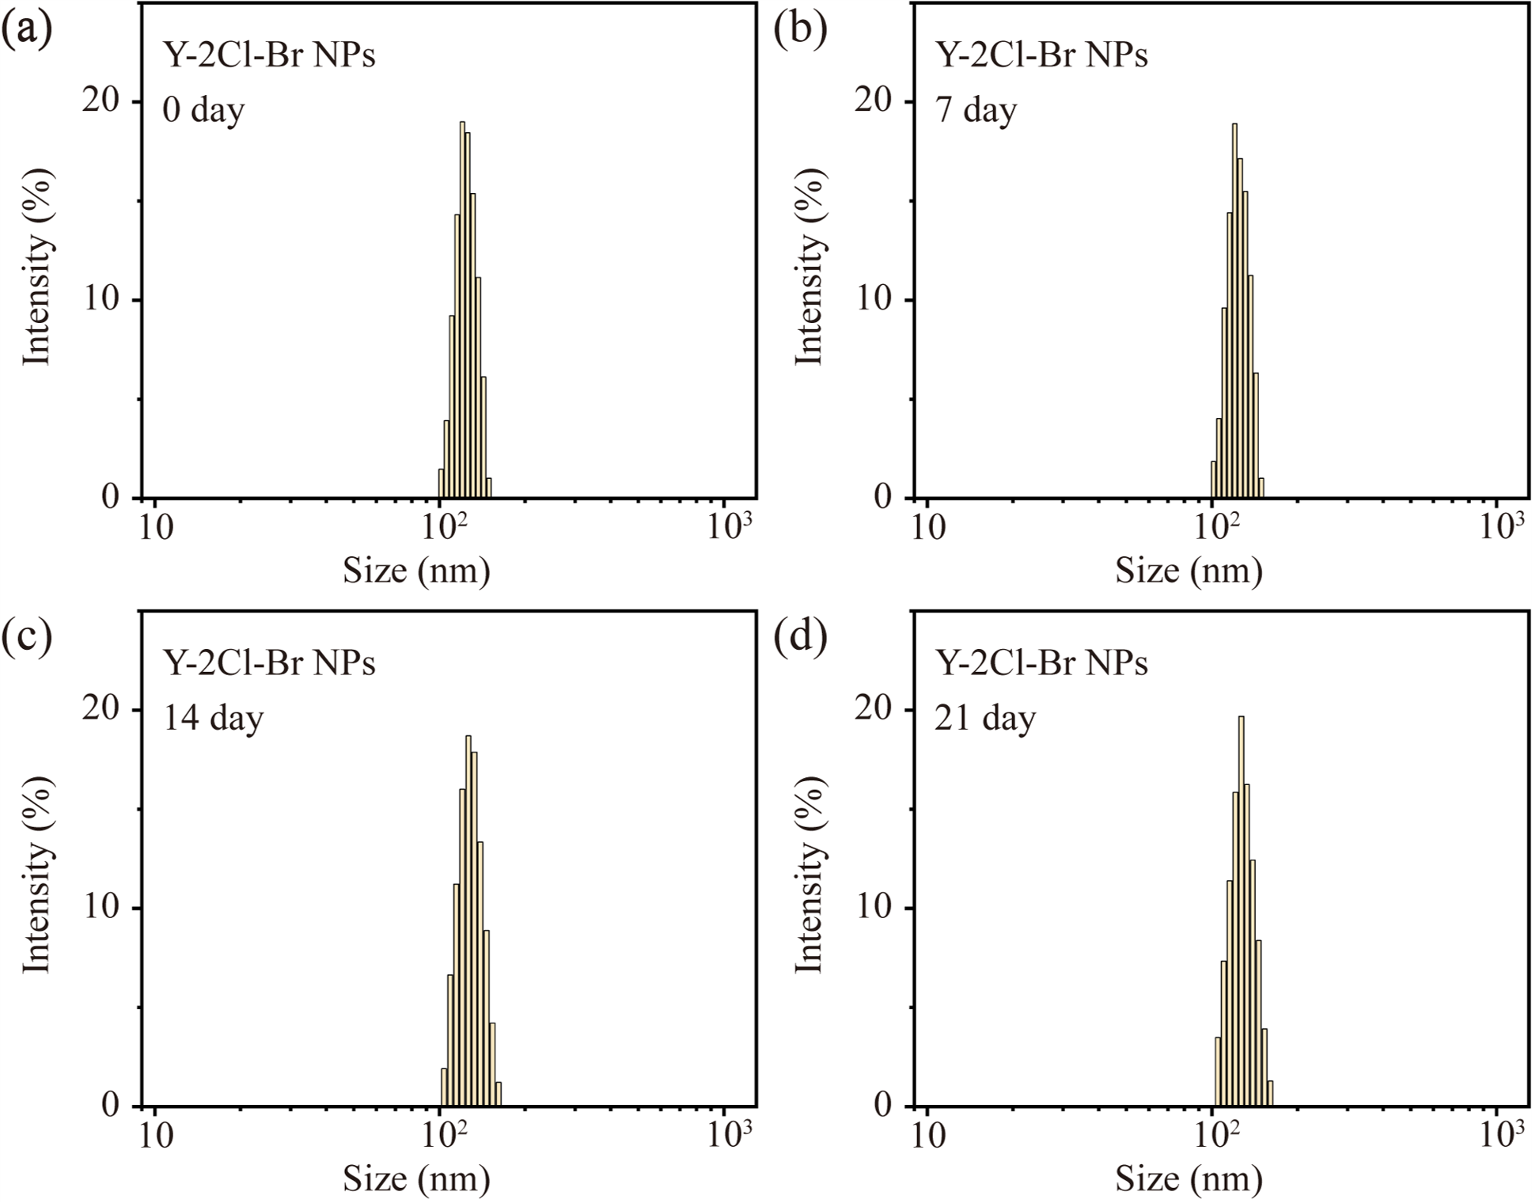
Figure S16 Diameters of Y-2Cl-Br NPs stored in acid solution PBS for (a) 0, (b) 7, (c) 14 and (d) 21 days was measured, respectively.
Figure S17 Diameters of Y-2Cl-Br NPs stored in 1640 medium (10 % FBS) was measured.

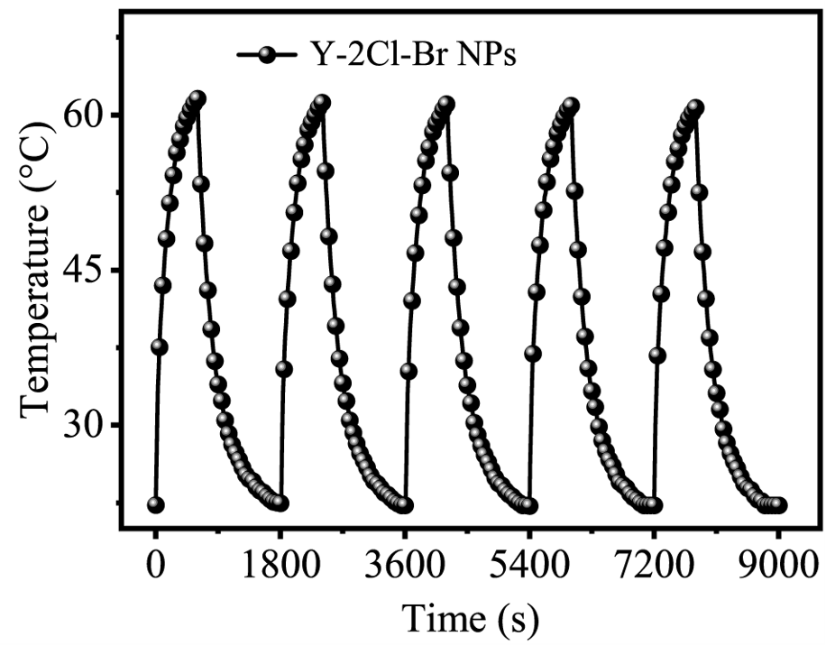
Figure S18 Five heating and cooling cycles of Y-2Cl-Br NPs (52 μg mL⁻¹, 808 nm laser, 1.0 W cm⁻²).
Figure S19 The general principles of DPBF prob to detect ROS generation treated with Y-2Cl-Br NPs and ICG under the NIR irradiation.

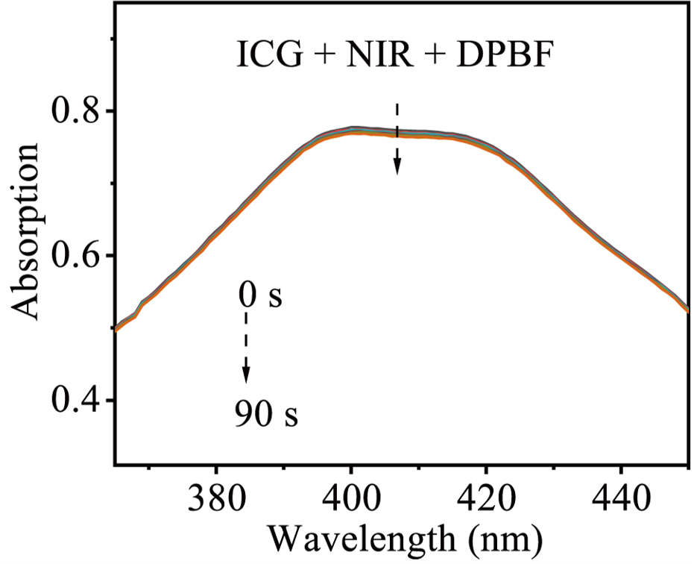
Figure S20 The absorption spectra of DPBF incubated with ICG under 808 nm irradiation of different times.
Figure S21 The absorption spectra of DPBF incubated with (a) Y-2Br NPs and (b) Y-4Cl NPs under 808 nm irradiation of different times. (c) The changes in absorption of DPBF mixed with ICG, Y-2Cl-Br NPs, Y-2Br NPs or Y-4Cl NPs solution at 415 nm.

Figure S22 Fluorescence spectra for ¹O₂ using SOSG as fluorescence probe under 808 nm NIR irradiation for 200 s in water (a) with Y-2Cl-Br NPs + SOSG or (b) SOSG. The fluorescence intensity curve of Y-2Cl-Br NPs + SOSG + Laser or SOSG + Laser.

Figure S23 Fluorescence spectra for ● OH using HPF as fluorescence probe under 808 nm NIR irradiation for 200 s in water (a) with Y-2Cl-Br NPs + HPF or (b) HPF. The fluorescence intensity curve of Y-2Cl-Br NPs + HPF + Laser or HPF + Laser.
Figure S24 Fluorescence spectra for O₂^{• −} using DHE as fluorescence probe under 808 nm NIR irradiation for 200 s in water (a) with Y-2Cl-Br NPs + DHE or (b) DHE. The fluorescence intensity curve of Y-2Cl-Br NPs + DHE+ Laser or DHE + Laser.
Figure S25 Image of a device in the hypoxia environment of cells.

Figure S26 Intracellular ROS in 4T1 cells treated with Y-4Cl NPs + NIR under normoxia or hypoxia conditions. DCFH-DA, SOSG, HPF and DHE were used to detect total ROS, ¹O₂, ●OH and O₂^{•−}, respectively, scale bar: 50 μm.
Figure S27 Intracellular ROS in 4T1 cells treated with Y-2Br NPs + NIR under normoxia or hypoxia conditions. DCFH-DA, SOSG, HPF and DHE were used to detect total ROS, ¹O₂, ●OH and O₂^{•−}, respectively, scale bar: 50 μm.

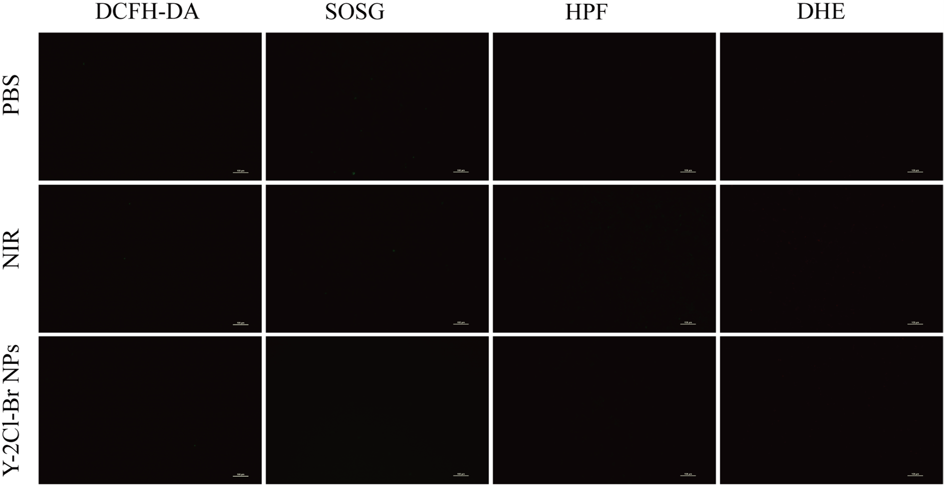
Figure S28 Detection of total ROS, ¹O₂, ● OH and O₂^{• −} in 4T1 cells after different treatments by using DCFH-DA, SOSG, HPF and DHE as probes, respectively, scale bar: 100 μm.

Figure S29 Cell viability of 4T1 and B16F10 cells after treatment with Y-2Cl-Br + NIR without NIR or with NIR (0.5 W/cm²), n=4, “ns” means “no significance”, *p<0.05, **p<0.01, ***p < 0.001, ****p < 0.0001, t-test.
Figure S30 Cell viability of 4T1 cells after treatment with Y-2Cl-Br + NIR (red) and ICG + NIR (green), n=4, “ns” means “no significance”, ****p < 0.0001, t-test.

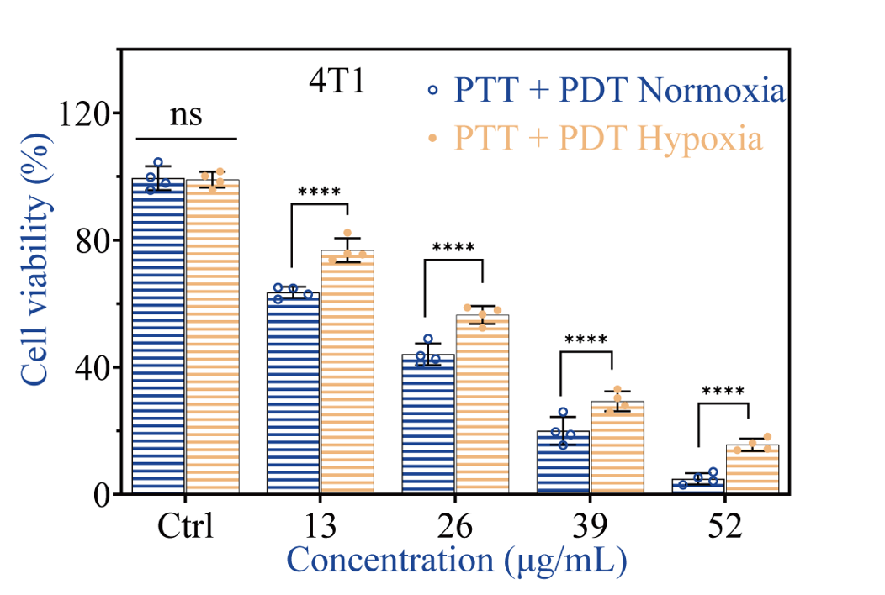
Figure S31 The cell viability of 4T1 cells incubated Y-2Cl-Br NPs under 808 nm laser irradiation under normoxia or hypoxia condition. n = 4, “ns” means “no significance”, ****p < 0.0001, t-test.

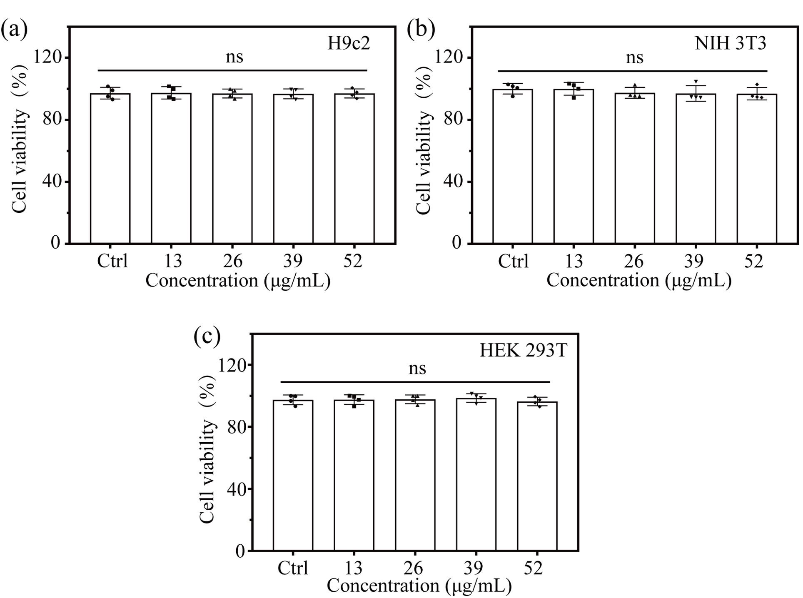
Figure S32 Cell viability of (a) H9c2 (b) NIH 3T3 (c) HEK 293T cells after treatment with various concentrations of Y-2Cl-Br NPs. n=4, “ns” means “no significance”.

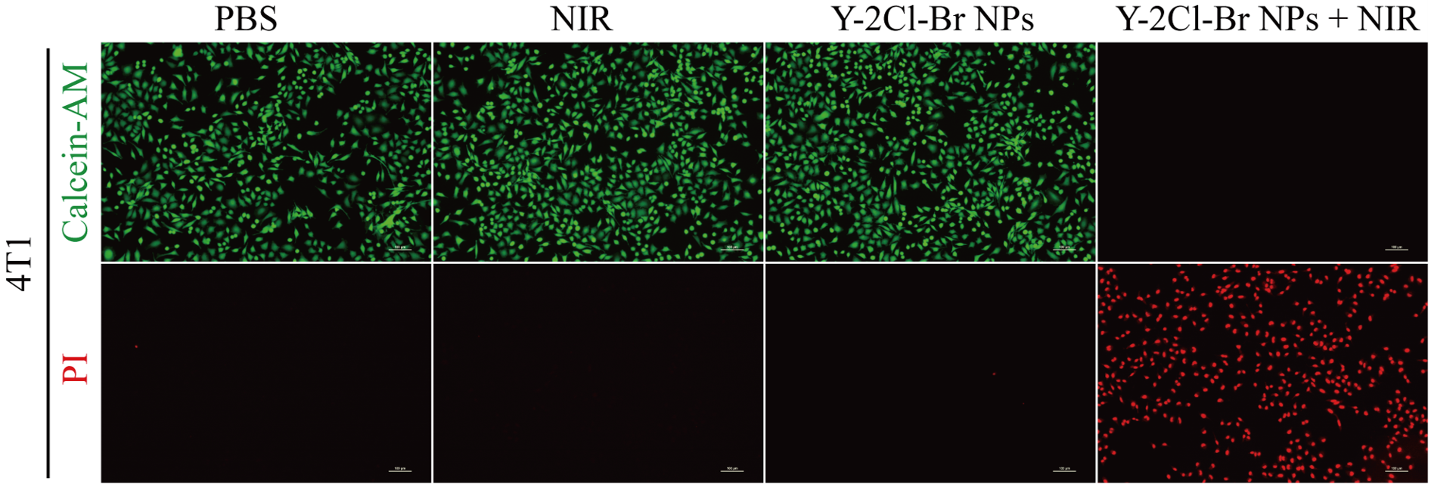
Figure S33 Live/dead staining of 4T1 cells after different treatments, scale bar: 100 μm.
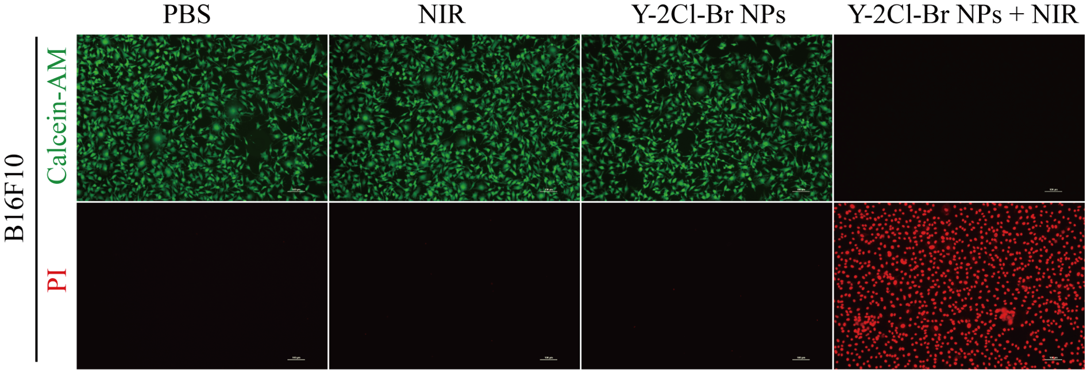
Figure S34 Live/dead staining of B16F10 cells after different treatments, scale bar: 100 μm.

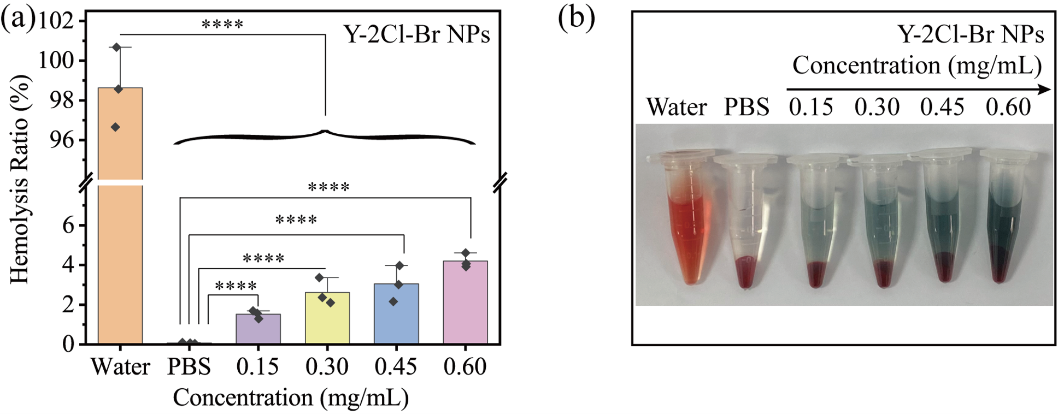
Figure S35 (a) Hemolytic effect of Y-2Cl-Br NPs at different concentrations on RBCs from BALB/c mice, water group was used as the positive control, and slain as the negative control, respectively. (b) Representative photos of hemolysis experiment results. n=3, ***P<0.001, t-test.

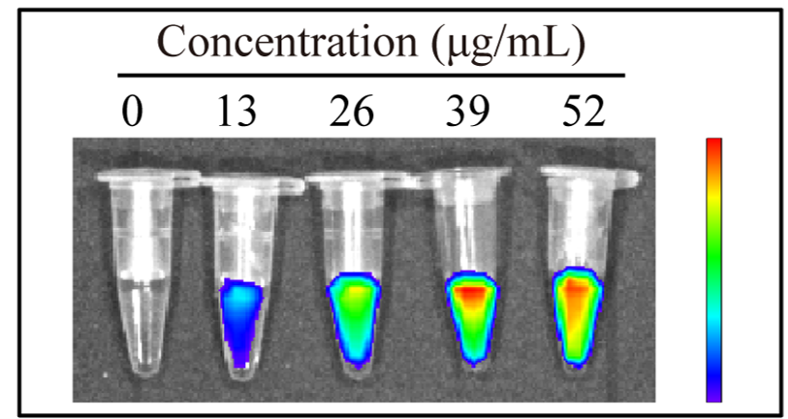
Figure S36 The Y-2Cl−Br NPs concentration-dependent FLI images.
Figure S37 (a) Representative fluorescence images of 4T1 tumor bearing mice after treated with Y-2Cl-Br NPs at different time points. (b) Quantification fluorescence intensity of Y-2Cl-Br NPs in mice tumor (n = 4). (c) Representative ex vivo fluorescence images and (d) average FLI intensities of main organs resected from the mice after 24 h intratumoral injection of Y-2Cl-Br NPs (n = 4). *P < 0.05, ****P < 0.0001.
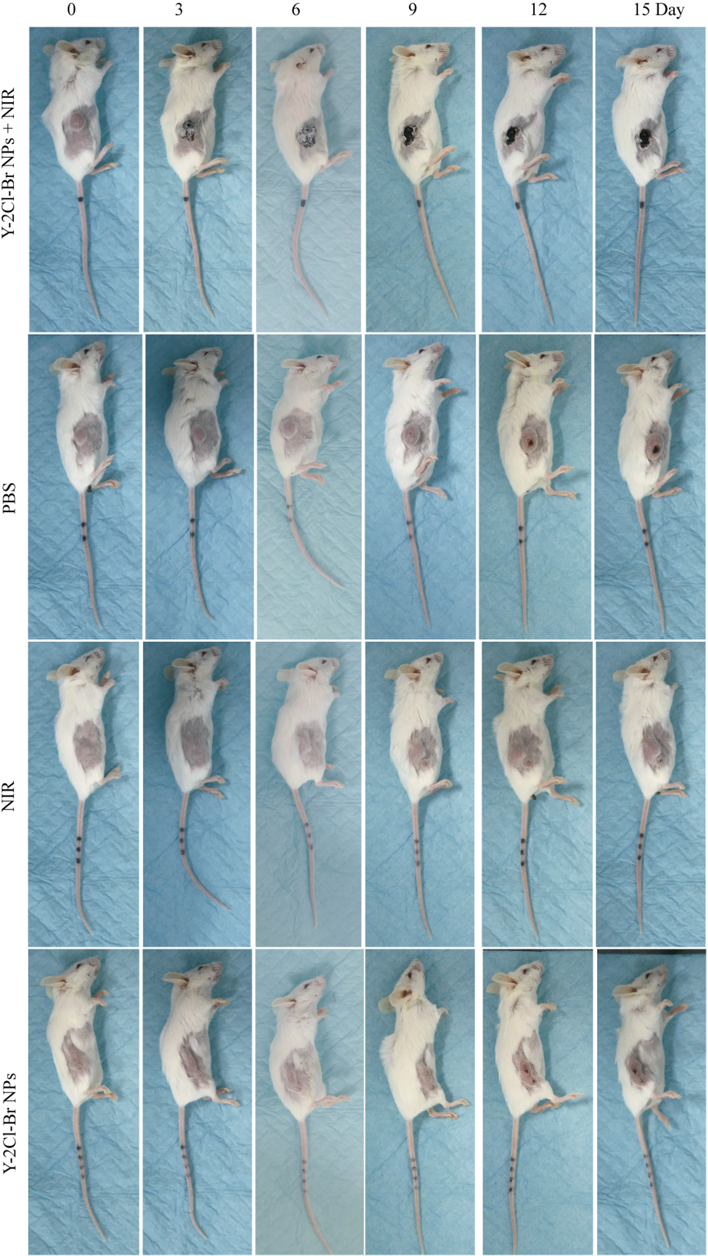
Figure S38 Representative pictures of photothermal therapy for 4T1 tumor bearing mice after different treatments (PBS, NIR, Y-2Cl-Br NPs and Y-2Cl-Br NPs + NIR) in vivo.
Table S1 Explanations or background information on technical terms and acronyms.
Professional terms | Acronyms | Explanation
Photothermal therapy | PTT | Photothermal therapy (PTT) is an emerging approach to cancer treatment that uses light-absorbing nanomaterials to generate localized heat and destroy cancer cells.
Photodynamic therapy | PDT | Photodynamic Therapy (PDT) can cause irreversible oxidative damage and metabolic disorder of biological macromolecules in the lesion site by generating toxic ROS under light stimulation with the photosensitizers (PSs) and O₂, so as to kill tumors to achieve therapeutic effect, with advantages of less trauma and controllability slight side effects. PDT includes Type I and Type II PDT, among which Type I PDT generates superoxide anion radical (O₂^{• −}) and hydroxyl radical (● OH) through electron transfer, and Type II PDT relies on O₂ to generate singlet oxygen (¹O₂) through energy transfer.
Photothermal conversion efficiency | PCE | The photothermal conversion efficiency (PCE) refers to the ratio of the output power to the input power of the photothermal conversion system, which is usually used to evaluate the performance of the photothermal conversion system.
Nanoparticles | NPs | Nanoparticles (NPs) are a class of tiny particles in size in the range of nanometers (nm). They have a wide range of applications and important research value in several fields of science and engineering.
Photosensitizer | PSs | Photosensitizers are a class of substances that can absorb light energy and convert it into chemical energy, and have the properties of absorbing specific wavelengths of light and having excited states.

Table S2 A summary of photosensitizer (PSs) involving molar absorption coefficients, photothermal conversion efficiency and photodynamic therapy.

Table S3 Routine blood indexes of mice at day 15 after treatment.
 | Saline | Y-2Cl-Br NPs + NIR | Reference range
WBC (10⁹/L) | 5.2±0.4 | 5.6±1.2 | 0.8~6.8
NEU (10⁹/L) | 0.9±0.1 | 1.3±0.4 | 0.1~1.8
LYM (10⁹/L) | 3.6±0.7 | 3.4±0.8 | 0.7~5.7
MON (10⁹/L) | 0.1±0.1 | 0.1±0.1 | 0.0~0.3
RBC (10¹²/L) | 8.1±1.3 | 7.6±0.5 | 6.36~9.42
HGB(g/L) | 132.5±7.3 | 125.5±9.3 | 110~143

Table S4 Renal function markers (UREA, CREA and UA) and hepatic function indexes (ALT, AST and ALB) of mice at day 15 after treatment.
 |  | Saline | Y-2Cl-Br NPs | Reference range
UREA | mmol/L | 1.6±0.4 | 1.5±0.2 | 0.6~1.93
UA | μmol/L | 93.2±42.5 | 117.7±50.2 | 44.42~224.77
CREA | μmol/L | 52±20.8 | 30.4±3.5 | 10.91~85.09
ALT | U/L | 48.2±8.6 | 58.4±22.2 | 10.06~96.47
AST | U/L | 107±32.8 | 94.5±74.8 | 36.31~235.48
ALB | U/L | 31±4.8 | 34.5±2.4 | 21.22~39.15

References
- Yoon HJ, Lee HS, Lim JY, Park JH. Liposomal Indocyanine Green for Enhanced Photothermal Therapy. ACS Appl. Mater. Interfaces 2017, 9, 5683-5691.
- Ruan X, Wei M, He X, Wang L, Yang D, Cai Y, Shao J, Dong X. Asymmetric aza-BODIPY photosensitizer for photoacoustic / photothermal imaging - guided synergistic photodynamic / photothermal therapy. Colloids Surf. B Biointerfaces 2023, 231, 113547.
- Wu F, Chen L, Yue L, Wang K, Cheng K, Chen J, Luo X, Zhang T. Small-Molecule Porphyrin-Based Organic Nanoparticles with Remarkable Photothermal Conversion Efficiency for in Vivo Photoacoustic Imaging and Photothermal Therapy. ACS Appl. Mater. Interfaces 2019, 11, 21408-21416.
- Yang S, Jia Q, Ou X, Sun F, Song C, Zhao T, Kwok RTK, Sun J, Zhao Z, Lam JWY, Wang Z, Tang BZ. Integration of Motion and Stillness: A Paradigm Shift in Constructing Nearly Planar NIR-II AIEgen with Ultrahigh Molar Absorptivity and Photothermal Effect for Multimodal Phototheranostics. J. Am. Chem. Soc. 2025, 147, 3570-3583.
- Gu H, Liu W, Zhen S, Long S, Sun W, Cao J, Zhao X, Du J, Fan J, Peng X. "Internal and External Combined" Nonradiative Decay-Based Nanoagents for Photoacoustic Image-Guided Highly Efficient Photothermal Therapy. ACS Appl. Mater. Interfaces 2021, 13, 46353-46360.
- Zhao X, Ma Y, Di J, Qiao Y, Yu J, Yin Y, Xi R, Meng M. Synergetic Pyroptosis with Apoptosis Improving Phototherapy of Mitochondria-Targeted Cyanines with Superior Photostability. ACS Appl. Mater. Interfaces 2024, 16, 12310-12320.
- Li D, Li Y, Wu Q, Xiao P, Wang L, Wang D, Tang BZ. Add the Finishing Touch: Molecular Engineering of Conjugated Small Molecule for High-Performance AIE Luminogen in Multimodal Phototheranostics. Small 2021, 17, e2102044.
- Won M, Koo S, Li H, Sessler JL, Lee JY, Sharma A, Kim JS. An Ethacrynic Acid-Brominated BODIPY Photosensitizer (EA-BPS) Construct Enhances the Lethality of Reactive Oxygen Species in Hypoxic Tumor-Targeted Photodynamic Therapy. Angew. Chem. Int. Ed. Engl. 2021, 60, 3196-3204.
- Zhang H, Xuan X, Wang Y, Qi Z, Cao K, Tian Y, Wang C, Chang J, Zhang Z, Hou L. In situ autophagy regulation in synergy with phototherapy for breast cancer treatment. Acta Pharm. Sin. B 2024, 14, 2317-2332.
- Huang X, Gao M, Xing H, Du Z, Wu Z, Liu J, Li T, Cao J, Yang X, Li R, Wang W, Wang J, Luo S. Rationally Designed Heptamethine Cyanine Photosensitizers that Amplify Tumor-Specific Endoplasmic Reticulum Stress and Boost Antitumor Immunity. Small 2022, 18, e2202728.
- Sun J, Zhao E, Liang J, Li H, Zhao S, Wang G, Gu X, Tang BZ. Diradical-Featured Organic Small-Molecule Photothermal Material with High-Spin State in Dimers for Ultra-Broadband Solar Energy Harvesting. Adv. Mater. 2022, 34, e2108048.
- Cui M, Tang D, Wang B, Zhang H, Liang G, Xiao H. Bioorthogonal Guided Activation of cGAS-STING by AIE Photosensitizer Nanoparticles for Targeted Tumor Therapy and Imaging. Adv. Mater. 2023, 35, e2305668.

