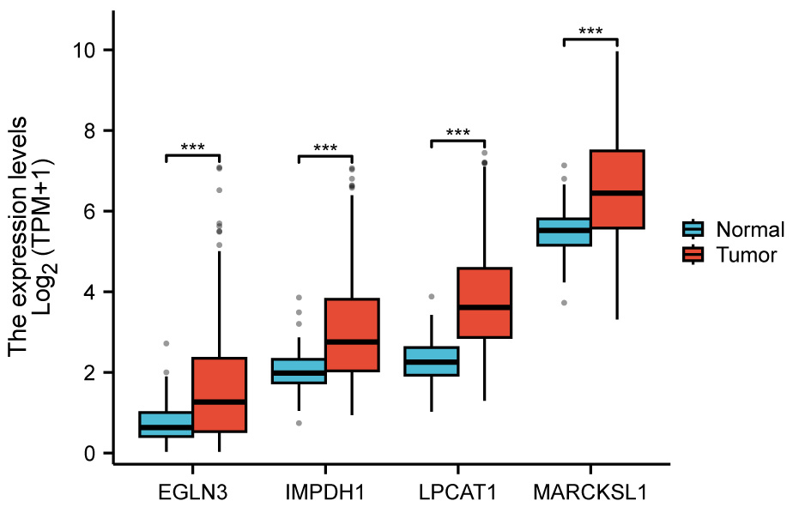
Supplementary figure 1. Box plots showing the differential expression of four genes (EGLN3, IMPDH1, LPCAT1, and MARCKSL1) between liver cancer tissues and adjacent non-tumor tissues, based on data from the TCGA database. ***p < 0.001.

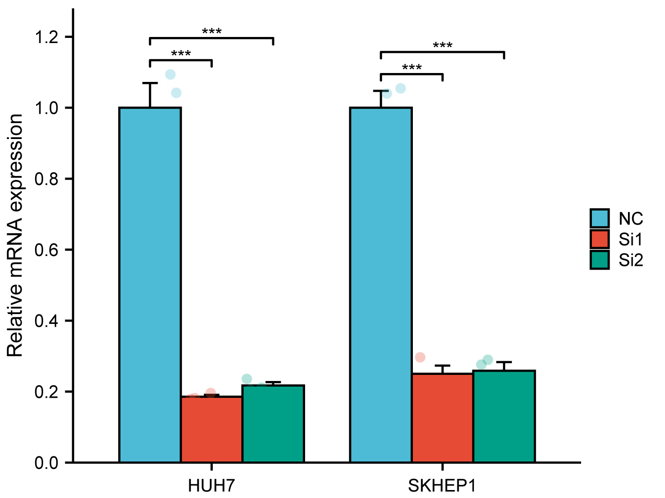
Supplementary figure 2. The native expression and knockdown expression of HOXC9 in HUH7 and SKHEP1 cell lines. ***p < 0.001.

Characteristics | Low expression of HOXC9 | High expression of HOXC9 | P value
N | 187 | 187
Pathologic T stage, n (%) |  |  | 0.02
T1 | 102 (27.5%) | 81 (21.8%)
T2 | 36 (9.7%) | 59 (15.9%)
T3 | 43 (11.6%) | 37 (10%)
T4 | 4 (1.1%) | 9 (2.4%)
Pathologic N stage, n (%) |  |  | 0.66
N0 | 130 (50.4%) | 124 (48.1%)
N1 | 3 (1.2%) | 1 (0.4%)
Pathologic M stage, n (%) |  |  | 0.60
M0 | 136 (50%) | 132 (48.5%)
M1 | 1 (0.4%) | 3 (1.1%)
Pathologic stage, n (%) |  |  | 0.04
Stage I | 97 (27.7%) | 76 (21.7%)
Stage II | 33 (9.4%) | 54 (15.4%)
Stage III | 47 (13.4%) | 38 (10.9%)
Stage IV | 2 (0.6%) | 3 (0.9%)
Tumor status, n (%) |  |  | 0.88
Tumor free | 100 (28.2%) | 102 (28.7%)
With tumor | 77 (21.7%) | 76 (21.4%)
Gender, n (%) |  |  | 0.01
Female | 49 (13.1%) | 72 (19.3%)
Male | 138 (36.9%) | 115 (30.7%)
Age, n (%) |  |  | 0.57
<= 60 | 86 (23.1%) | 91 (24.4%)
> 60 | 101 (27.1%) | 95 (25.5%)
Histologic grade, n (%) |  |  | 0.04
G1 | 34 (9.2%) | 21 (5.7%)
G2 | 93 (25.2%) | 85 (23%)
G3 | 54 (14.6%) | 70 (19%)
G4 | 3 (0.8%) | 9 (2.4%)
AFP(ng/ml), n (%) |  |  | 0.00
<= 400 | 122 (43.6%) | 93 (33.2%)
> 400 | 18 (6.4%) | 47 (16.8%)
Child-Pugh grade, n (%) |  |  | 0.25
A | 111 (46.1%) | 108 (44.8%)
B&C | 14 (5.8%) | 8 (3.3%)
Supplementary table 1. The associations between HOXC9 expression levels and various clinicopathological characteristics, including TNM stage, pathologic stage, tumor status, gender, age, histologic grade, AFP levels, and Child-Pugh grade.

