Supplemental Appendix for:

Suzetrigine, a Non-Opioid Na_{V}1.8 Inhibitor With Broad Applicability for Moderate-to-Severe Acute Pain: A Phase 3 Single Arm Study for Surgical or Non-surgical Acute Pain

Table of Contents

Supplementary Information 1: List of Investigators 3
Supplementary Information 2: Supplemental Methods 4
Supplementary Information 3: Supplemental Figures 10
Supplementary Information 4: Supplemental Tables 12

Supplementary Information 1: List of Investigators
First Name | Last Name | Academic Degree(s) | Site/Institution | Site Location
Nicholas | Brown | M.D. | Cypress Surgery Center | Wichita, KS
Brandon | Broome | M.D. | South Texas Spine & Surgical Hospital | San Antonio, TX
Joseph | Caporusso | D.P.M. | Futuro Clinical Trials, LLC | McAllen, TX
Brian | Chalkin | D.O. | The Orthopaedic Center | Tulsa, OK
Benjamin | Cilento | M.D. | Renovatio Clinical | Houston, TX
J. Richard Lee | Evanson | D.O. | Legent Orthopedic Hospital | Carrollton, TX
Clark | Larsen | D.P.M. | Wasatch Clinical Research, LLC | Salt Lake City, UT
Jessica | McCoun | M.D. | Atlanta Center for Medical Research | Atlanta, GA
Gonzalo | Quesada | M.D. | Mart Medical Research Group, LLC | Miami, FL
Anthony | Romeo | M.D. | Duly Health | Westmont, IL
Nebojsa | Skrepnik | M.D. | Tucson Orthopaedic Institute Research Center | Tucson, AZ
Daneshvari | Solanki | M.D. | First Surgical Hospital | Bellaire, TX
Joshua | Urban | M.D. | OrthoNebraska Hospital | Omaha, NE
Peter | Winkle | M.D. | Anaheim Clinical Trials | Anaheim, CA
John | Zimmerman | D.P.M. | Trovare Clinical Research | Bakersfield, CA

Supplementary Information 2: Supplemental Methods
Study Eligibility Criteria
Participants who met all the inclusion criteria and none of the exclusion criteria were eligible for study participation.
Inclusion Criteria
All Participants (Before Surgery, If Applicable)
- Sign and date an informed consent form.
- Willing and able to comply with scheduled visits, treatment plan, study restrictions, laboratory tests, contraceptive guidelines, and other study procedures.
- Between the ages of 18 and 80 years, inclusive.
- Body mass index (BMI) of ≥18.0 to <40.0 kg/m².
- Surgical Participants: Scheduled to undergo an ambulatory orthopedic, plastic, breast, otorhinolaryngologic, colorectal, gynecologic, urologic, or general surgical procedure with pain that is expected to last for at least 72 hours and that is expected to require no more than short-term (i.e., <24-hour) admission.
Non-surgical Participants: Present to medical facility with pain of new origin (not related to a prior known condition) that is moderate or severe on the verbal categorical rating scale (VRS) and ≥4 on the numeric pain rating scale (NPRS), has been ongoing for ≤48 hours, is expected to last for at least 72 hours, and is expected to require no more than short-term (i.e., <24-hour) admission, if any. Representative conditions include traumatic and atraumatic acute musculoskeletal pain, orofacial pain, burns, and cutaneous and soft tissue pain.
After Surgery (Surgical Participants Only)
- Participant reported pain at the surgical site that is moderate or severe on the VRS and ≥4 on the NPRS within the following procedure-specific time periods:
- Procedures performed with regional anesthesia: within 12 hours after surgery completion
- All other procedures: within 4 hours after surgery completion
- Participant is lucid, able to follow commands, and able to swallow oral medications.
- All analgesic guidelines were followed during and after the procedure.
Exclusion Criteria
All Participants (Before Surgery, If Applicable)
- Surgical Participants Only: History of previous surgery due to the same condition, except for procedures for which a previous surgery on the contra-lateral limb or organ is allowed.
- Surgical Participants Only: History of a prior surgical procedure in the same region of the body that resulted in any perioperative complications or that, in the opinion of the investigator or medical monitor, would preclude participation in the study.
- History of any illness or any clinical condition that, in the opinion of the investigator, might confound the results of the study or pose an additional risk in administering study drug to the participant. This may include, but is not limited to, history of relevant drug or food allergies; history of significant respiratory, cardiovascular, metabolic, hematologic, neurologic, or psychiatric disease; history or presence of clinically significant pathology; and history of cancer. Note that this criterion does not apply to squamous cell skin cancer, basal cell skin cancer, and Stage 0 cervical carcinoma in situ (i.e., no adjudication by the investigator is needed), so long as there has been no recurrence for the last 5 years.
- Cardiac dysrhythmias requiring anti-arrhythmic treatment(s) within the last 2 years; history or evidence of abnormal study ECGs that in the opinion of the investigator or medical monitor would preclude the participant’s participation in the study; or history of QT prolongation or standard 12-lead ECG (performed in triplicate) demonstrating median QTcF >450 msec at screening.
- Presence of an automated implantable cardioverter defibrillator, cardiac resynchronization therapy device, or pacemaker.
- History of significant hepatic disease, including but not limited to hepatic cirrhosis, portal hypertension, or moderate or severe hepatic impairment (Child Pugh Class B or C).
- Alanine transaminase or aspartate transaminase values >2.5 × upper limit of normal.
- History of severe renal impairment defined as estimated glomerular filtration rate (eGFR) <30 mL/min/1.73m² calculated using the subject’s measured serum creatinine; the suggested calculation method for eGFR is the Chronic Kidney Disease Epidemiology Collaboration (CKD-EPI) equation
- Any other abnormal laboratory results indicative of significant medical disease that, in the opinion of the investigator, would preclude the participant’s participation in the study.
- History of any sensory abnormality that, in the opinion of the investigator, may confound the ability of the participant to assess pain.
- Participants who have a painful physical condition that, in the opinion of the investigator, may confound the assessments of pain.
- A known or clinically suspected active infection with human immunodeficiency virus or hepatitis B or C viruses. (Note: Testing in the absence of suspected active infection is required for surgical participants only.)
- Any surgery (except the protocol surgery for surgical participants) within 1 month before the first study drug dose, unless approved by the medical monitor.
- American Society of Anesthesiologists physical status classification of ≥3.
- Chronic use of opioids (pure agonists, agonist/antagonists, partial agonists, antagonists) or NSAIDs with dose escalation within 30 days before first dose of study drug.
- Unwilling or unable to stop analgesics at least 5 half-lives or 2 days (whichever is longer) before first dose of study drug, with the following exception: for non-surgical subjects, use of a limited amount of pain medications before presentation at the medical facility and/or single use of any medication in the medical facility within the past 4 hours is not exclusionary.
- Participant who started any non-analgesic new medications that have not been at a stable dose for at least 14 days before first dose of study drug.
- Willing to receive any protocol-related medicine (e.g., ibuprofen, acetaminophen, fentanyl).
- History of allergy or significant adverse event (AE) to any opioid and/or NSAID that, in the opinion of the investigator, would significantly increase the chance of AEs from medicines used in the study.
- Sleep apnea and/or on a home positive airway pressure device.
- History of peptic ulcer disease or gastrointestinal bleeding that, in the opinion of the investigator or medical monitor, would preclude the participant’s participation in the study.
- For female participant: Pregnant, nursing, or planning to become pregnant during the study or within 30 days after the last study drug dose.
For male participant: Male participant with a female partner who is pregnant, nursing, or planning to become pregnant during the study or within 30 days after the last study drug dose.
- Participation in a previous study investigating suzetrigine.
- Participated in another investigational study within 30 days of the first dose of study drug.
- Evidence of misuse, aberrant use, or addiction to alcohol or an illicitly used drug of abuse in the past 3 years, or a positive test for drugs of abuse.
- A positive drug screen for a known prescribed concomitant medication that is not otherwise exclusionary (e.g., benzodiazepines) will not disqualify subjects.
- Use of the substances, activities, or devices during the specified times.
- Participant, or close relative of the participant, is the investigator or a sub-investigator, research assistant, pharmacist, study coordinator, or other staff directly involved with the conduct of the study at that site.
After Surgery (Surgical Participants Only)
- Any surgical complications during the procedure.
- Medical complication during the procedure that, in the opinion of the investigator, should preclude assignment to treatment.
- Standard 12-lead ECG (performed in triplicate) demonstrating median QTcF >450 msec at baseline (Day 1 predose).
Statistical Analysis
A descriptive ad hoc subgroup analysis of the proportion of participants reporting good, very good, or excellent on the patient global assessment was conducted for participants who took any rescue medication and participants who did not take any rescue medication. No statistical testing was performed.

Supplementary Information 3: Supplemental Figures
Supplementary Figure 1. Study Design

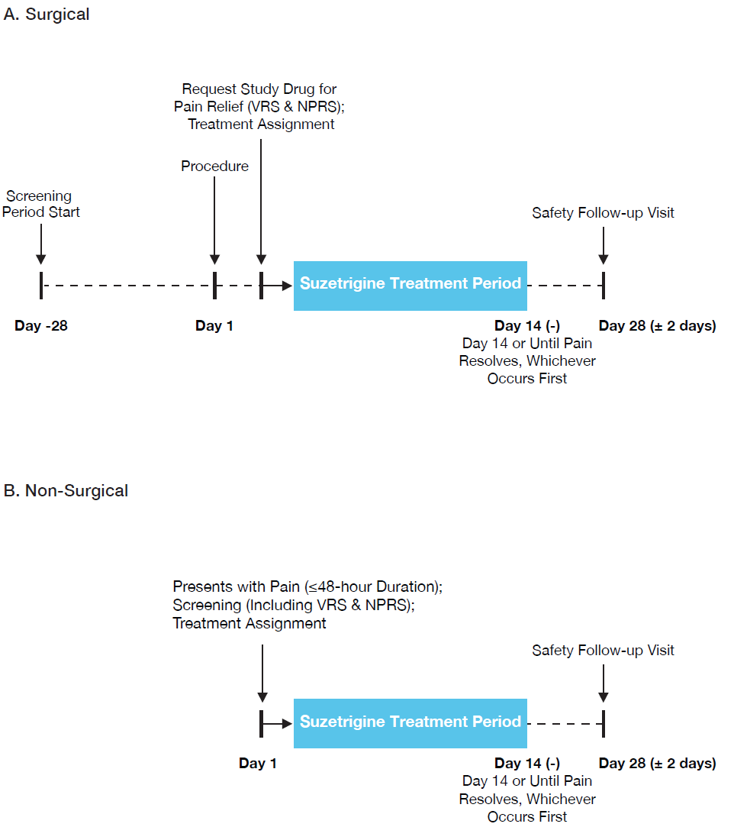
NPRS: numeric pain rating scale; VRS: verbal categorical rating scale

Notes: Panel A shows study design for surgical participants and Panel B shows study design for non-surgical participants. Suzetrigine was administered orally (100-mg first dose, then 50-mg every 12 hours).

Supplementary Figure 2. Flow of Participants in the Trial

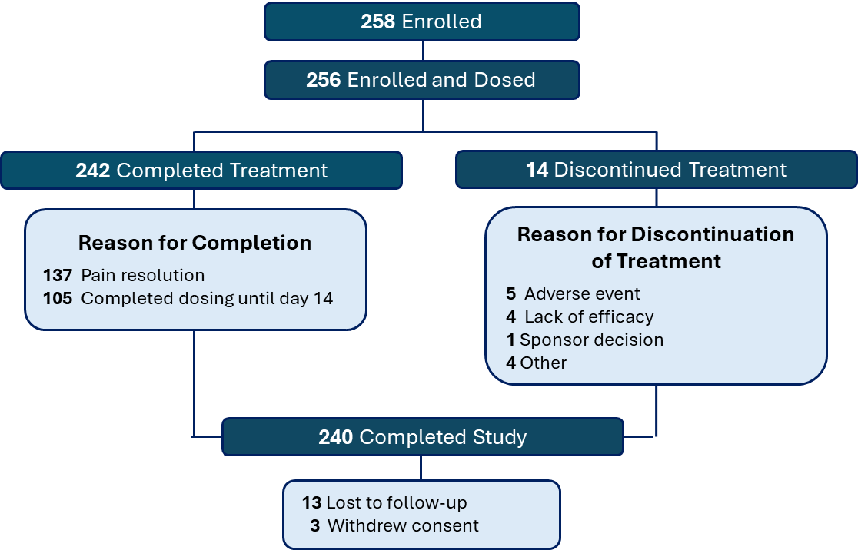

Supplementary Information 4: Supplemental Tables

Supplementary Table 1. Patient Global Assessment
PGA | Suzetrigine  N = 256
Participants reporting good, very good, or excellent on the PGA at end of treatment, n (%) | 213 (83.2)
PGA at the end of treatment, n (%)
Excellent | 70 (27.3)
Very good | 92 (35.9)
Good | 51 (19.9)
Fair | 26 (10.2)
Poor | 11 (4.3)
Missing | 6 (2.3)
N: number of participants in the analysis set; n: number of participants; PGA: patient global assessment

Note: Table includes participants who received at least one dose of suzetrigine.

Supplementary Table 2. Ad hoc Subgroup Analysis of Patient Global Assessment by Rescue Medication Use
 | Participants taking any rescue medication  N=187 | Participants taking no rescue medication  N=69
Proportion of participants reporting good, very good, or excellent on PGA, n (%) | 154 (82.4) | 59 (85.5)
N: number of participants in the analysis set; PGA: patient global assessment

