Supplementary materials

Figure S1: Comparison of PSQI total scores for age between potential classes of sleep patterns in patients with CHF
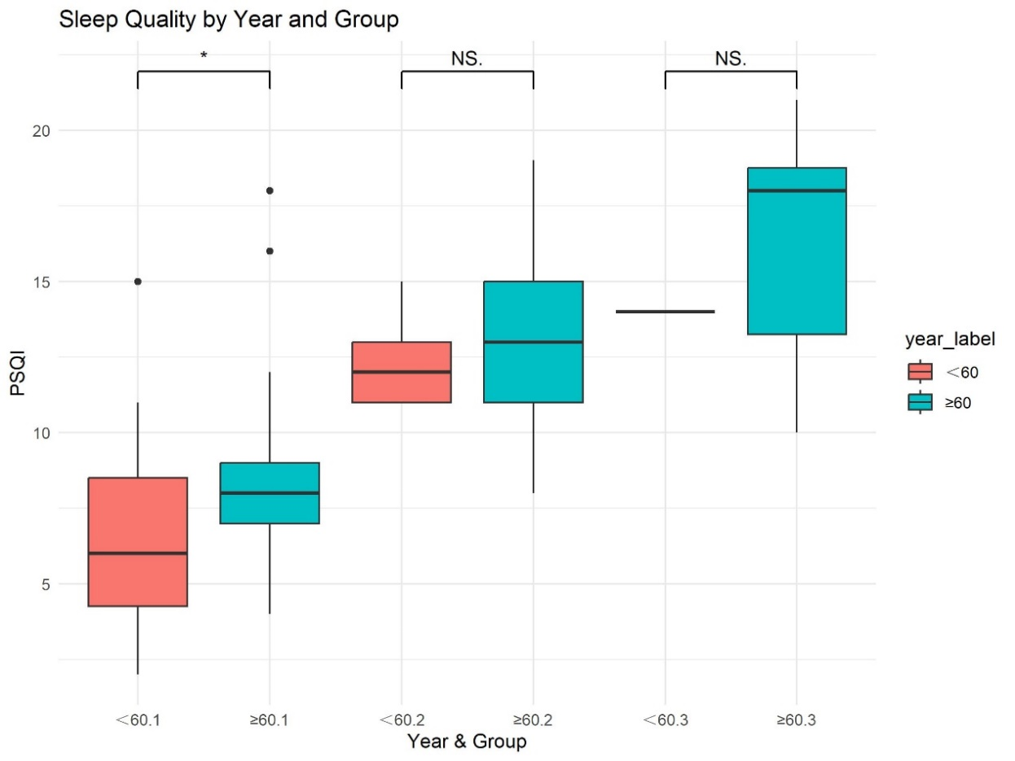
Figure S1: *, P < 0.05; NS, Not Significant

Figure S2: Comparison of PSQI total scores for gender between potential classes of sleep patterns in patients with CHF
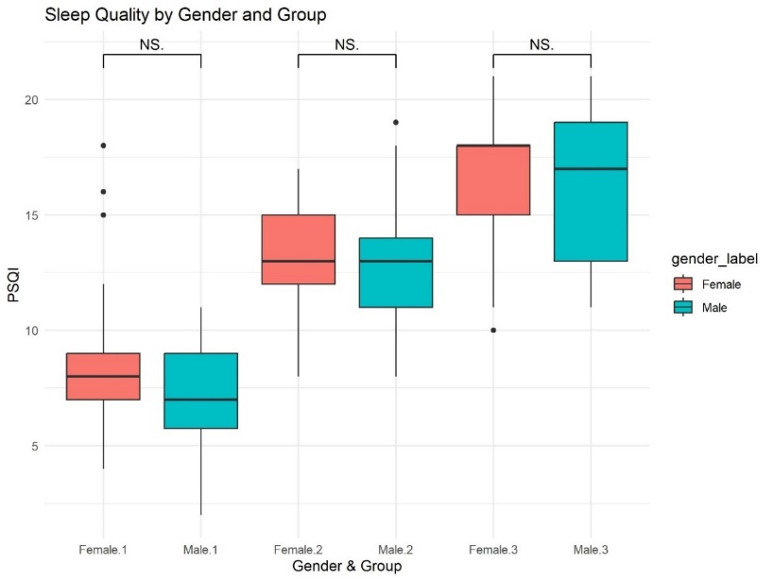
Figure S2: NS, Not Significant
Figure S3: Comparison of PSQI total scores for education level between potential classes of sleep patterns in patients with CHF
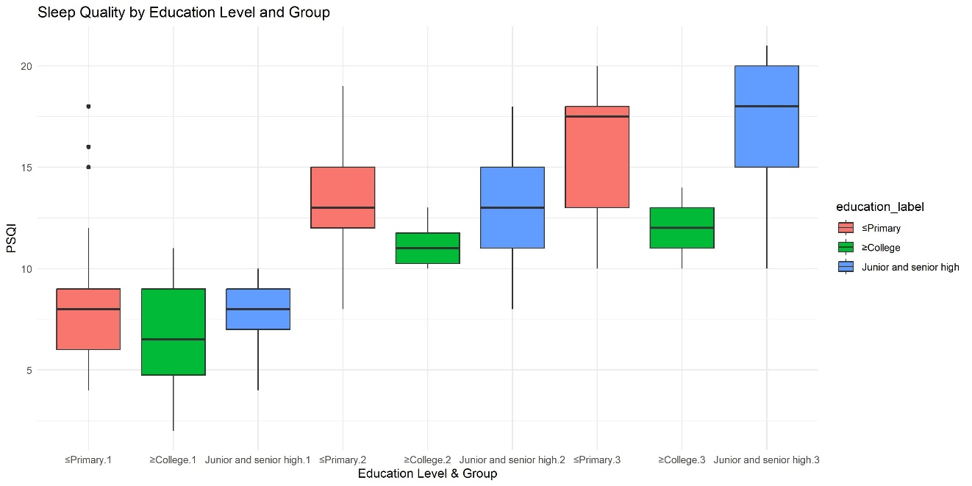

Figure S4: Comparison of PSQI total scores for occupation between potential classes of sleep patterns in patients with CHF
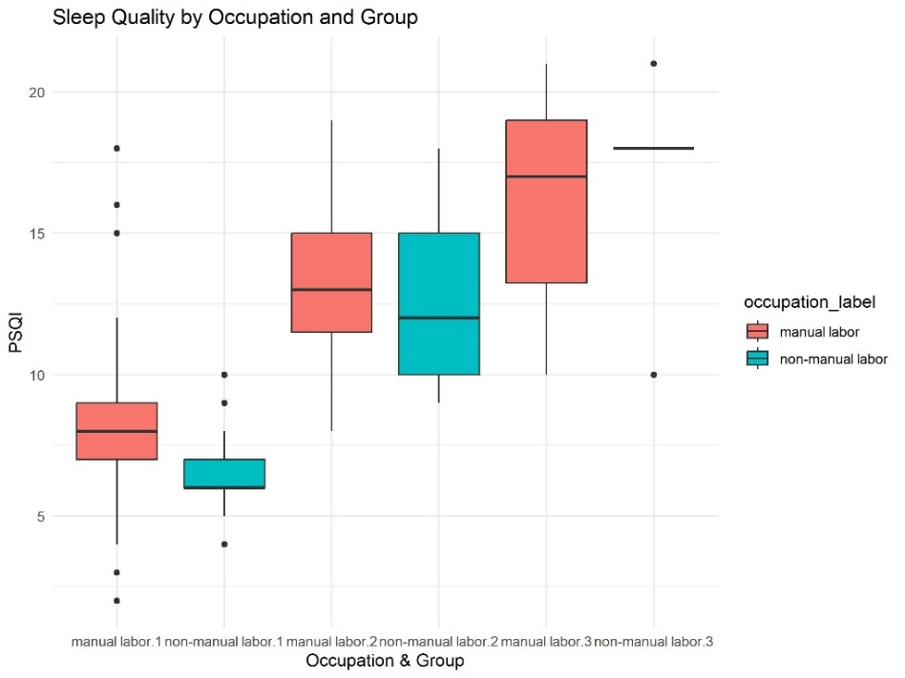

Figure S5: Comparison of PSQI total scores for monthly income between potential classes of sleep patterns in patients with CHF
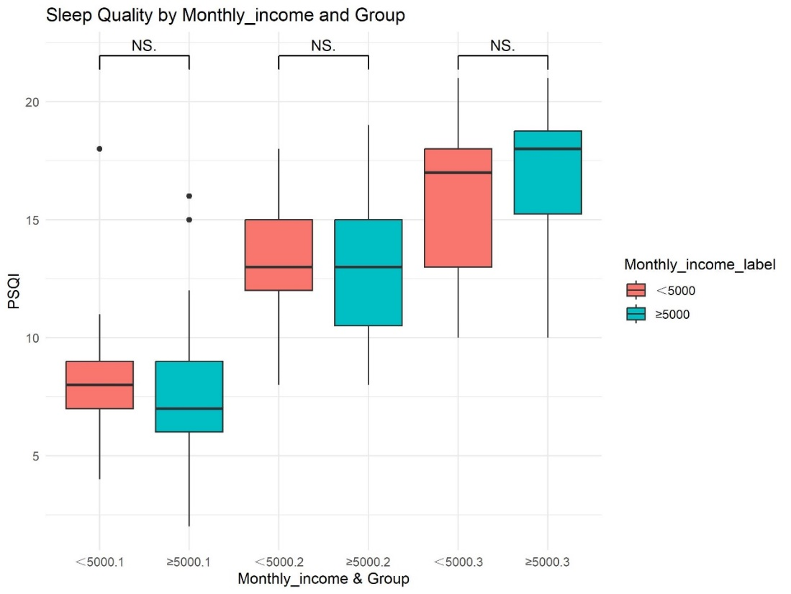
Figure S5: NS, Not Significant

Figure S6: Comparison of PSQI total scores for caregiver between potential classes of sleep patterns in patients with CHF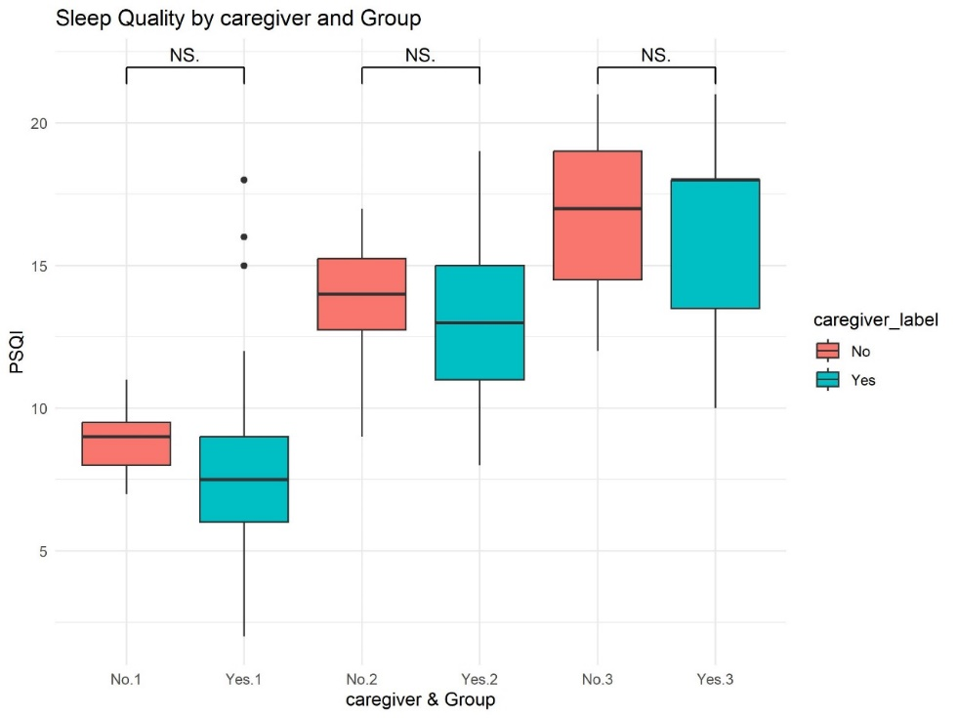
Figure S6: NS, Not Significant
Figure S7: Comparison of PSQI total scores for the number of comorbidities between potential classes of sleep patterns in patients with CHF
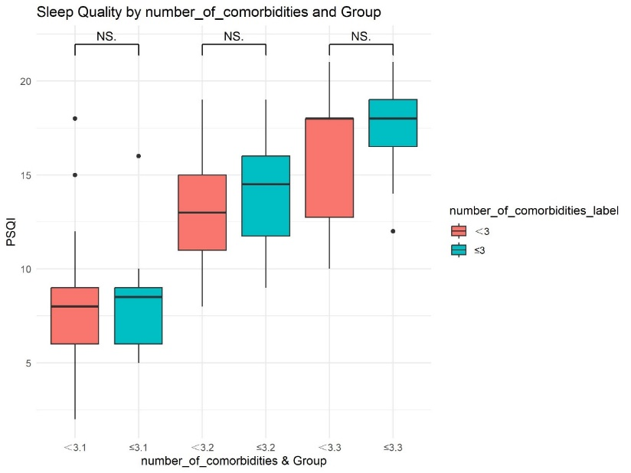
Figure S7: NS, Not Significant

Figure S8: Comparison of PSQI total scores for HF hospitalizations in the last year between potential classes of sleep patterns in patients with CHF
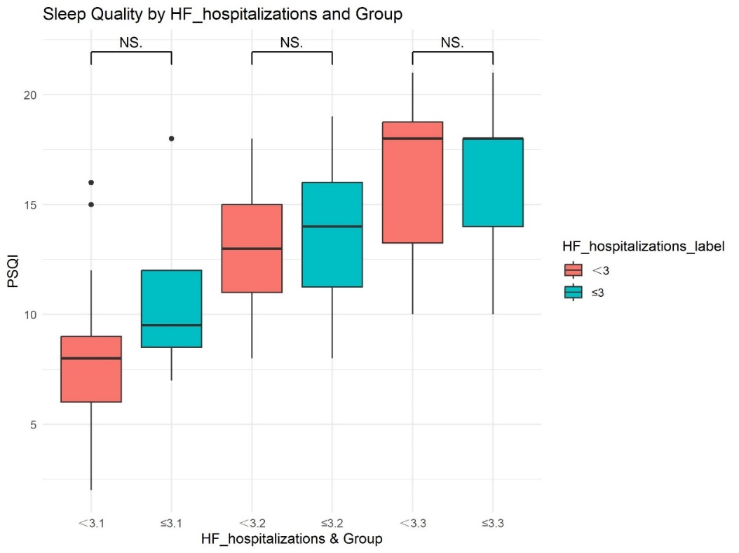
Figure S8: NS, Not Significant

Figure S9: Comparison of PSQI total scores for the number of medications between potential classes of sleep patterns in patients with CHF
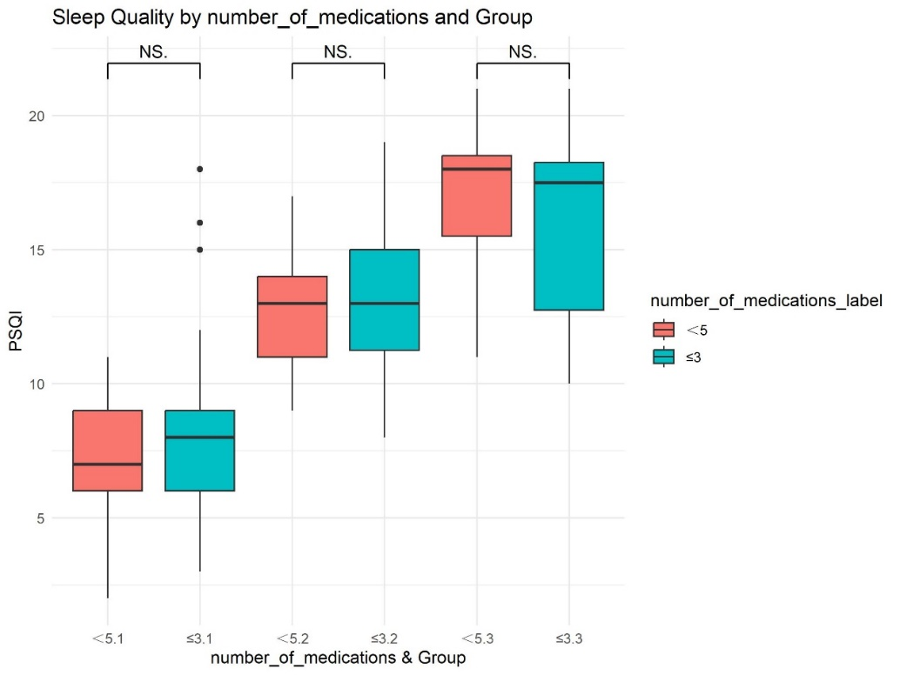
Figure S9: NS, Not Significant

Figure S10: Comparison of PSQI total scores for duration of HF between potential classes of sleep patterns in patients with CHF
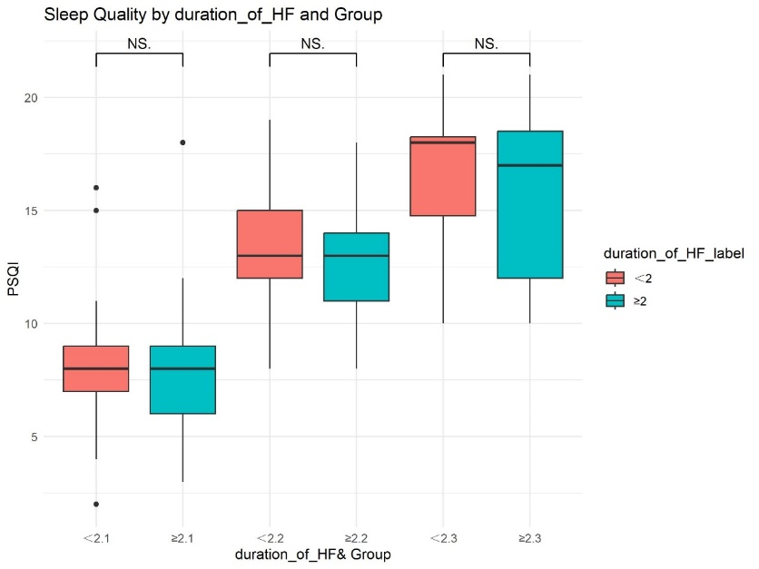
Figure S10: NS, Not Significant

Figure S11: Comparison of PSQI total scores for mean hospital duration between potential classes of sleep patterns in patients with CHF
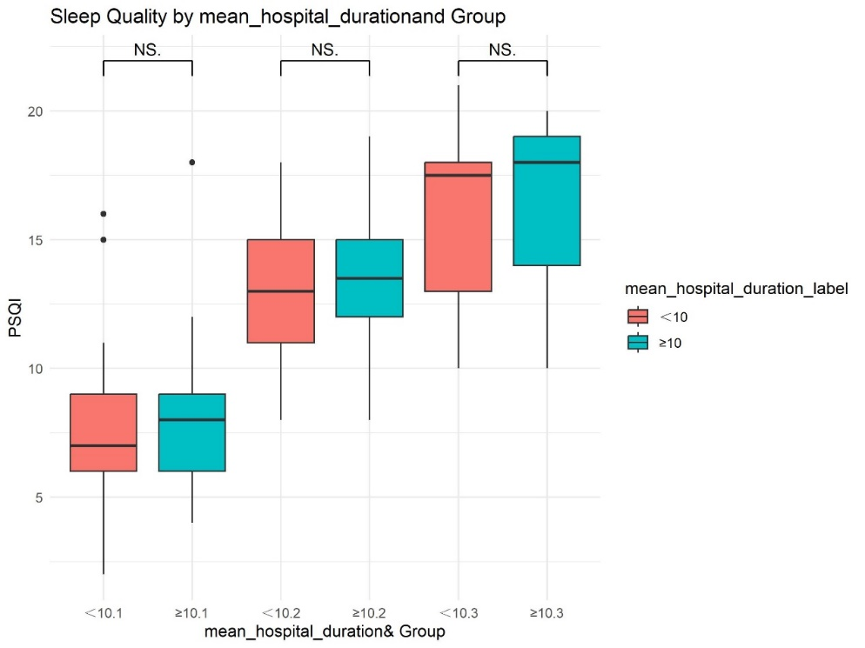
Figure S11: NS, Not Significant

Figure S12: Comparison of PSQI total scores for NYHA class between potential classes of sleep patterns in patients with CHF
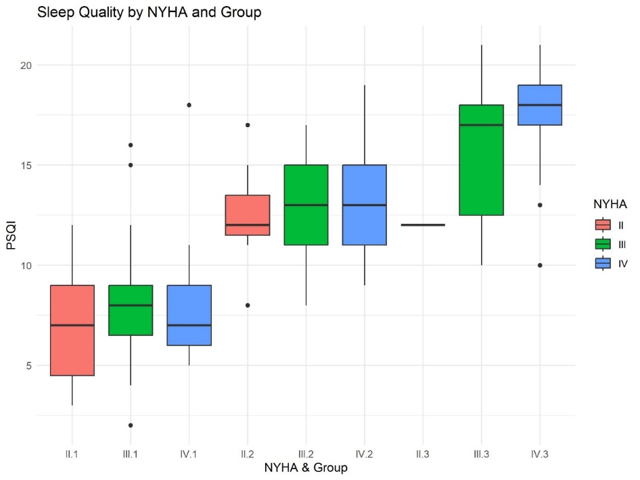

Figure S13: Comparison of PSQI total scores for FoP-Q-SF between potential classes of sleep patterns in patients with CHF
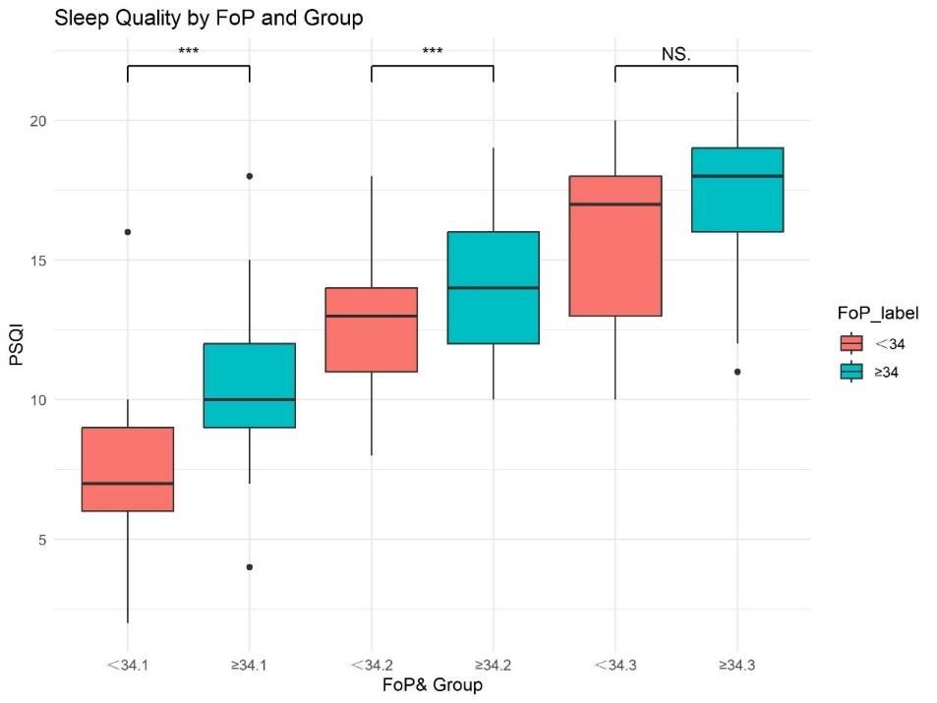
Figure S13: ***, P < 0.001; NS, Not Significant

