Evaluation of Anti-inflammatory and Antibacterial Properties of Photo-thermal Hydrogel as Dual Functional Platform for management of Periodontitis
Zhisong Mai¹, Yuying Mai¹, Xianxian Huang¹, Shipeng Ning³, Hongbing Liao²

¹ Department of Prosthodontics, School of Stomatology, Guangxi Medical University, Nanning, Guangxi, 530021, China
² Guangxi Key Laboratory of Oral and Maxillofacial Rehabilitation and Reconstruction, College of Stomatology, Guangxi Medical University, No.10 Shuangyong Road Nanning, Guangxi 530021, China
³ Research Center of Nanomedicine Technology, the Second Affiliated Hospital of Guangxi Medical University, Nanning, 530000, China

Correspondence: Hongbing Liao (hongbing_liao@gxmu.edu.cn)

Experimental Section
- Cell cytotoxicity assessment
Murine macrophage cell line RAW 264.7 was purchased from Procell (China). Cells were cultured in DMEM supplemented with 10% FBS in 95% humidified environment with 5% CO2. RAW 264.7 cells were seeded in 96-well plates at a density of 2×103 cells/well. After 24 h, medium was replaced by DMEM containing different concentrations of PtCuSe. Then 10 μL of CCK-8 was added in each well after 24 h, 48 h and 72 h respectively, followed by OD values measurement at 450 nm using a Microplate reader.

- Statistical analysis
All data were represented as Mean ± SD. The GraphPad Prism 8 was employed for data analysis. Data were analyzed using the t-test and one-way analysis of variance (ANOVA). All experiments were performed in at least three replicates. A p-value of < 0.05 was considered statistically significant (*p < 0.05, **p < 0.01, ***p < 0.001).

Supporting figures
Figure S1. XPS spectrum of PtCuSe nanozyme.
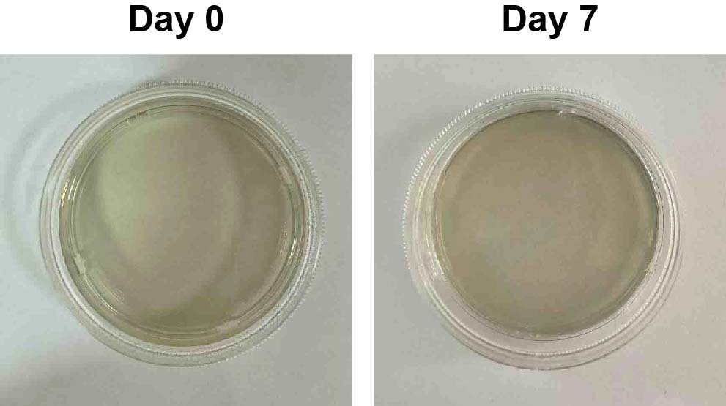
Figure S2. Images of PtCuSe hydrogel on day 0 and day 7.
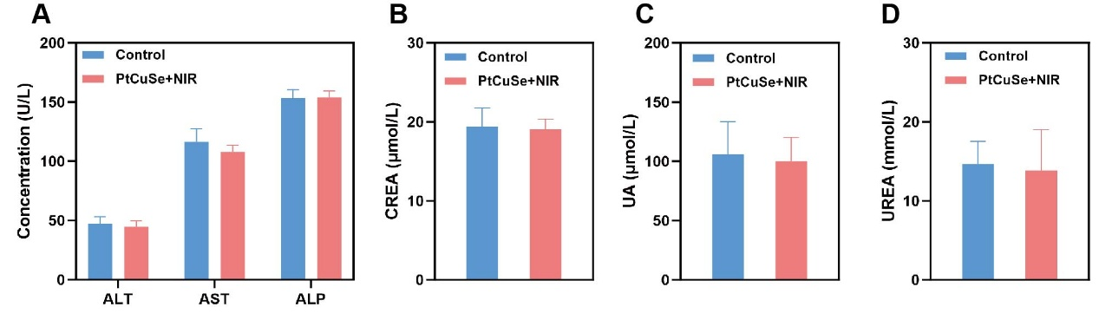
Figure S3. Biosafety analysis. (A) Liver function. (B)-(D) Kidney function.

