A B
T1-T2 T2-T3
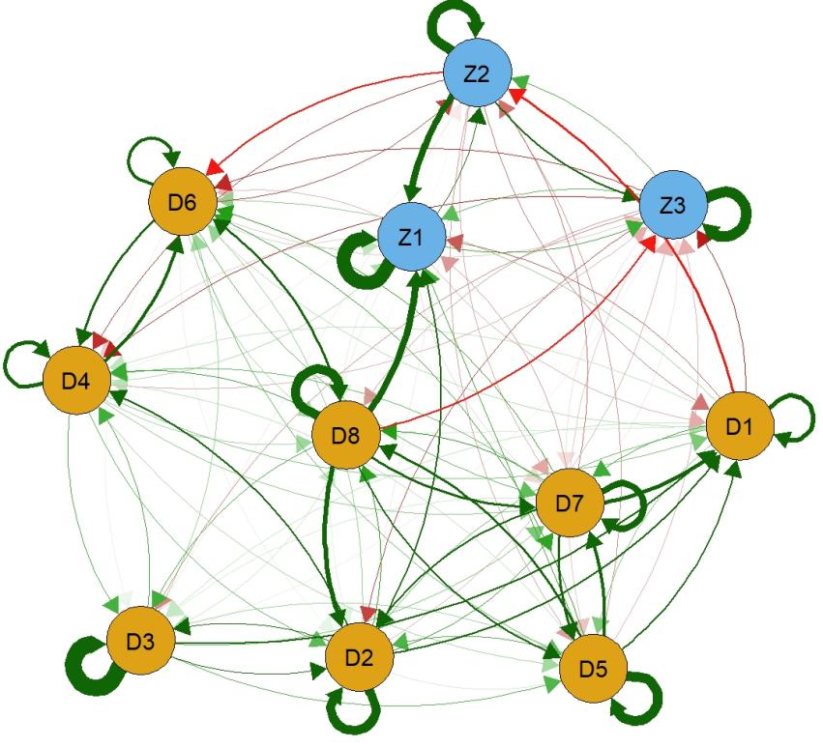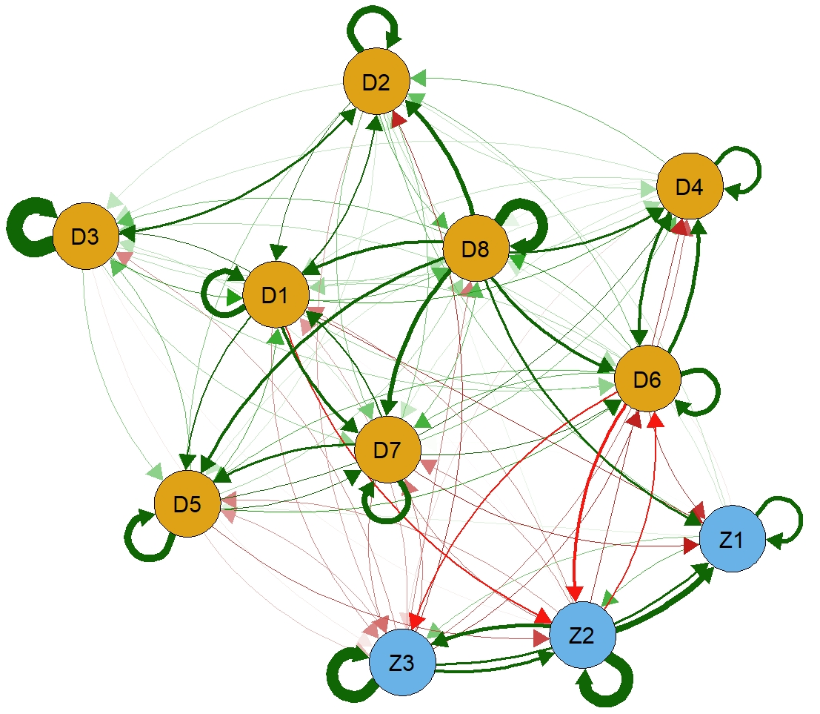
Figure S1 Cross-Lagged Networks Analysis of Subjective Well-Being and Depression from T1 — T2 (A) and T2 — T3 (B) (including all cross-lagged edges)
Note: Z1=Perceived social status; Z2= Life satisfaction; Z3=Confidence in the future; D1=Feeling down; D2=Everything feels like an effort; D3= Restless sleep; D4=Feeling unhappy; D5=Feeling lonely; D6=Not enjoying life; D7=Feeling sad; D8=Feeling life is not worth living.

