Supplementary Table S1 Sequences of the gene-specific primers
Gene | Sequences | Species
β-Actin | Forward, TGTCCACCTTCCAGCAGATGT | Rat
β-Actin | Reverse, AGCTCAGTAACAGTCCGCCTAGA | Rat
IFN-γ | Forward, CAGGCCATCAGCAACAACAT | Rat
IFN-γ | Reverse, TCTGGTGACAGCTGGTGAAT | Rat
IL-10 | Forward, AGTGGAGCAGGTGAAGAATGA | Rat
IL-10 | Reverse, ATTTGCTGGTTCCCACACTC | Rat
IL-17A | Forward, AGTTCAGTGTGTCCAAACGC | Rat
IL-17A | Reverse, GAGTCCAGGGTGAAGTGGAA | Rat
FOXP3 | Forward,TATTTATGGCGGAGACACGGG | Rat
FOXP3 | Reverse,GTGCAGGGTCCGAGGTATTC | Rat
ROR-γT | Forward, AGTAGGCCACATTACACTGCT | Rat
ROR-γT | Reverse, GACCCACACCTCACAAATTGA | Rat

Supplementary Figure S1 Raw WB bands
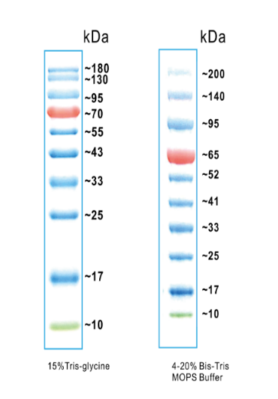
Supplier：Biosharp Item No：BL713A

p-STAT3
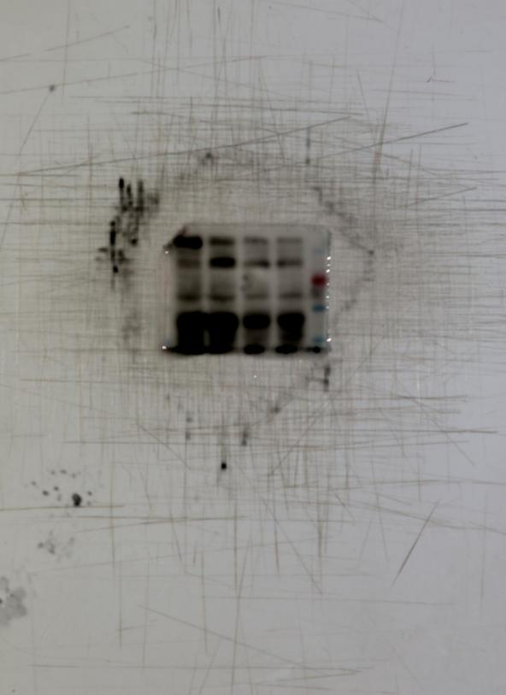
95kDa
70kDa
55kDa
43kDa

STAT3
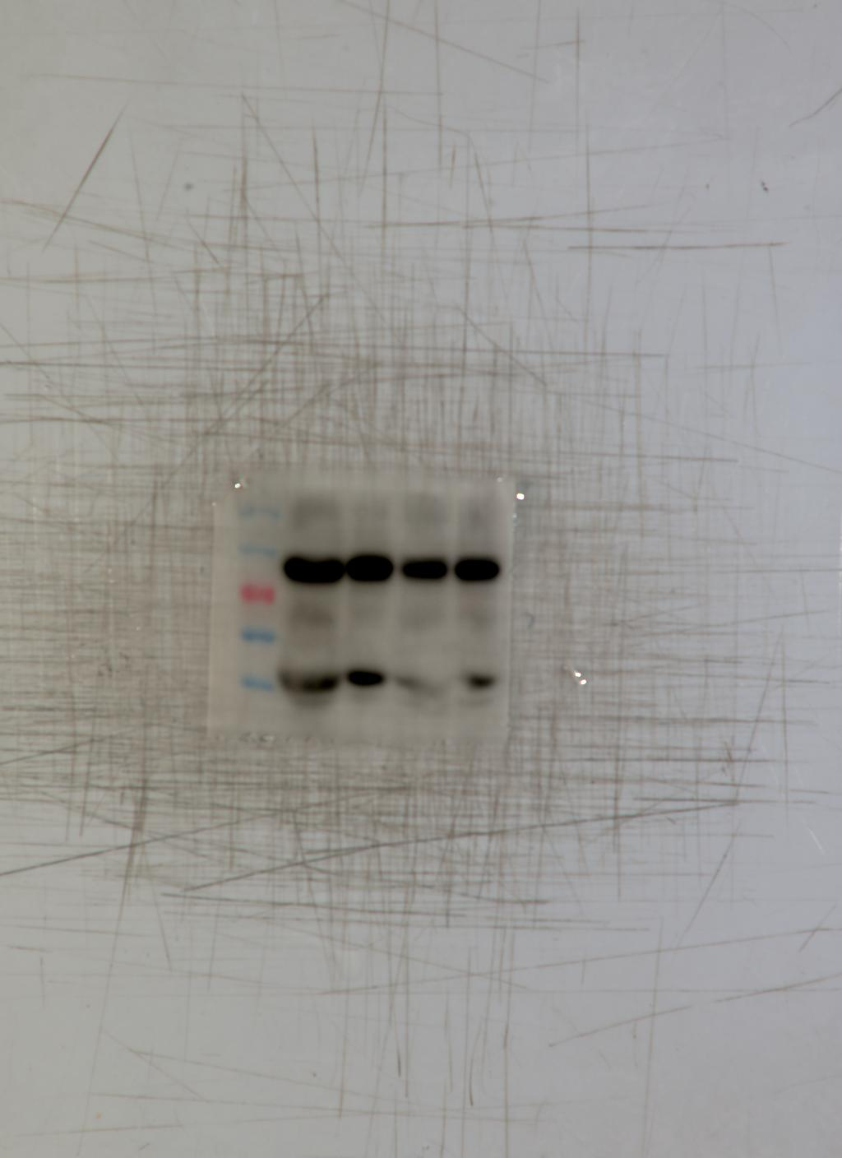
130kDa
95kDa
70kDa
55kDa
43kDa

P-JNK
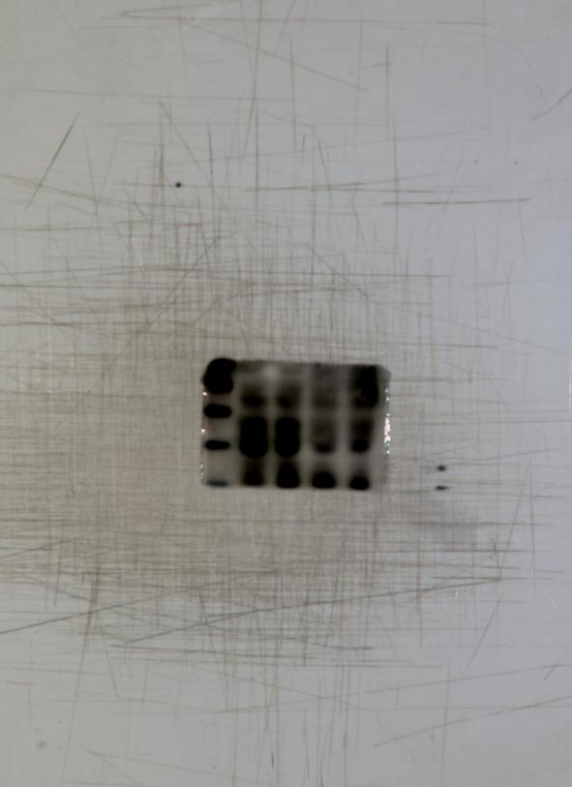
70kDa
55kDa
43kDa

JNK
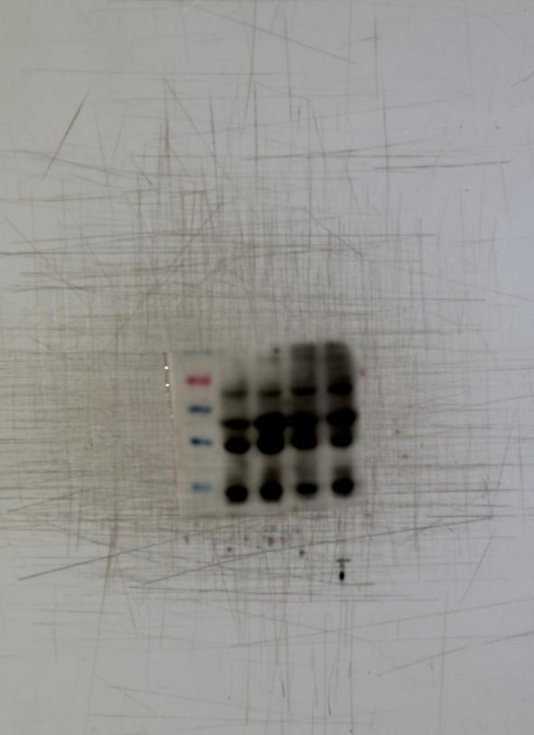
70kDa
55kDa
43kDa

33kDa

TLR4
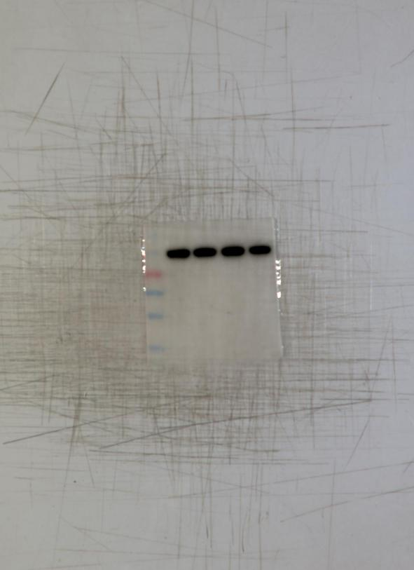
95kDa
70kDa
55kDa
43kDa

33kDa

CPT1A
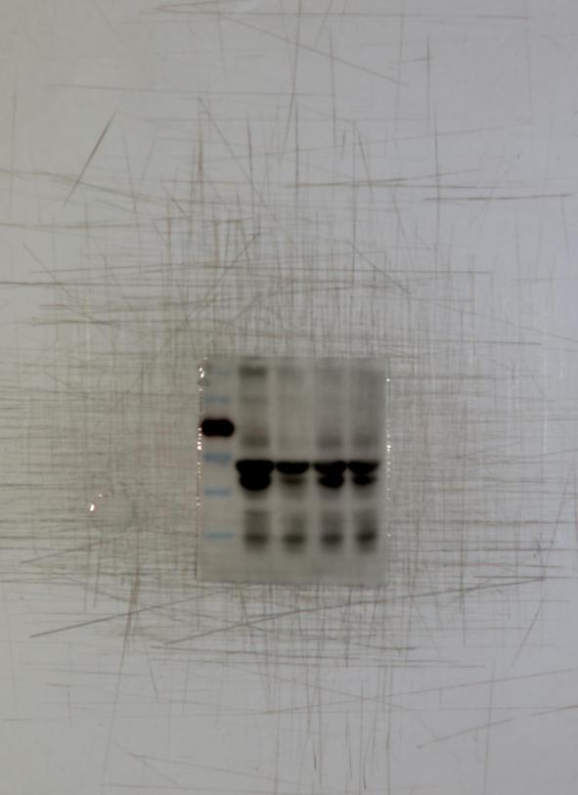
95kDa
70kDa
55kDa
43kDa

33kDa

CD36
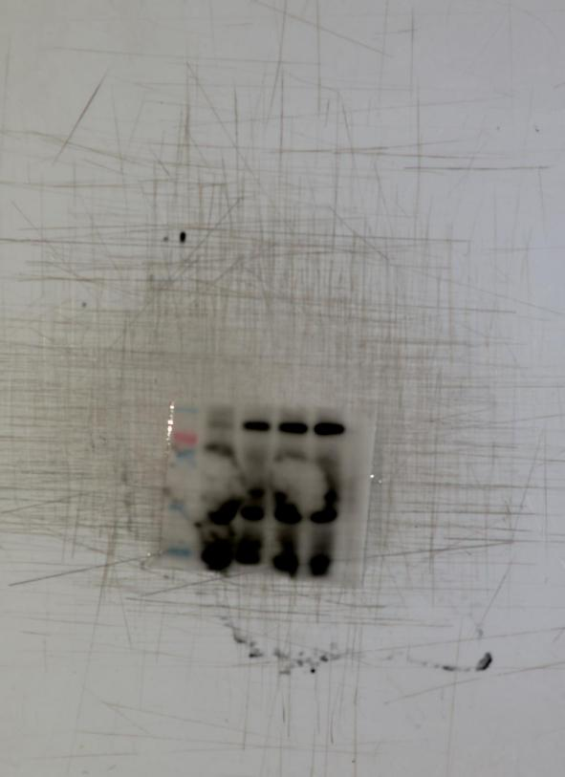
95kDa
70kDa
55kDa
43kDa

33kDa

FABP1
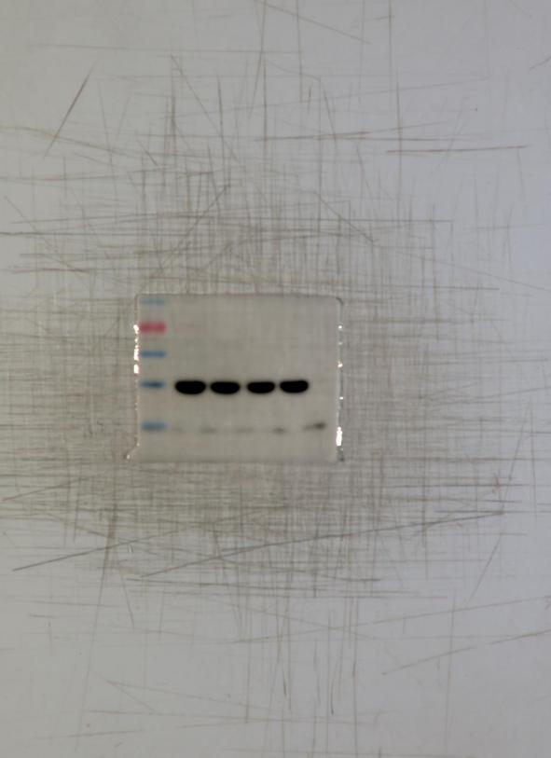
95kDa
70kDa
55kDa
43kDa

33kDa

ATGL
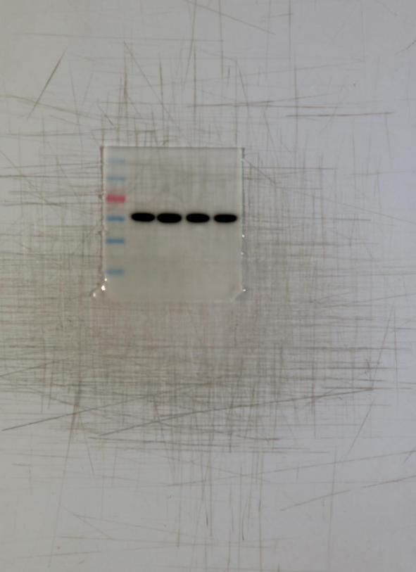
130kDa
95kDa
70kDa
55kDa
43kDa
33kDa

PPARγ
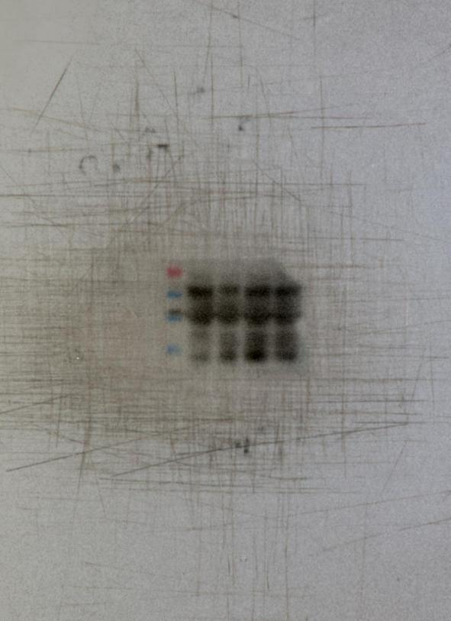
70kDa
55kDa
43kDa

33kDa

GAPDH
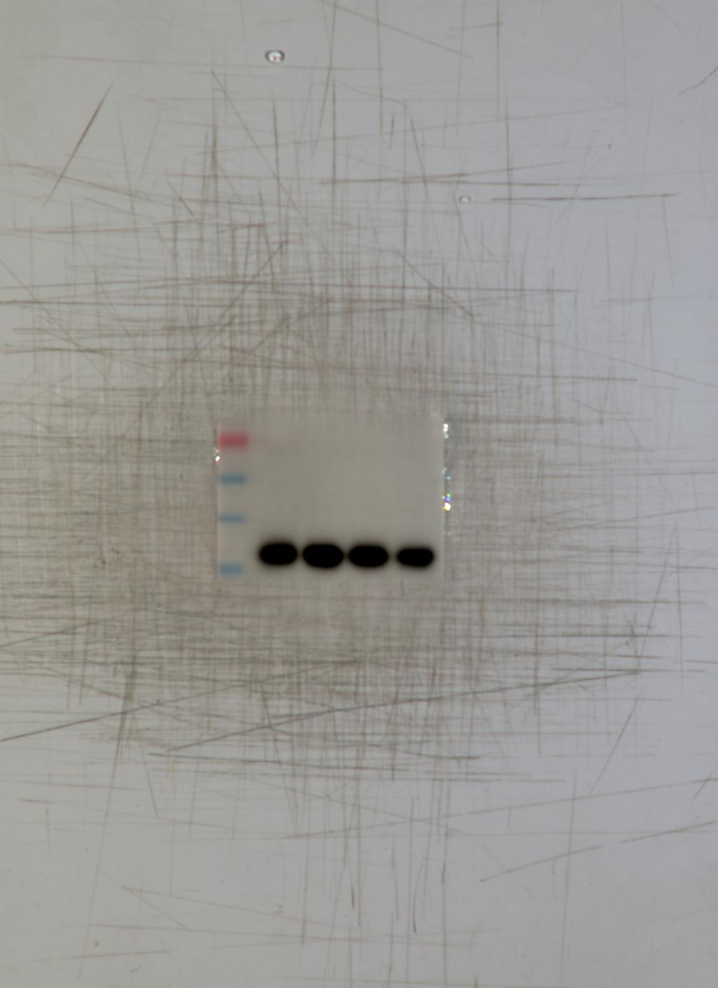
70kDa
55kDa
43kDa
33kDa

PPARγ
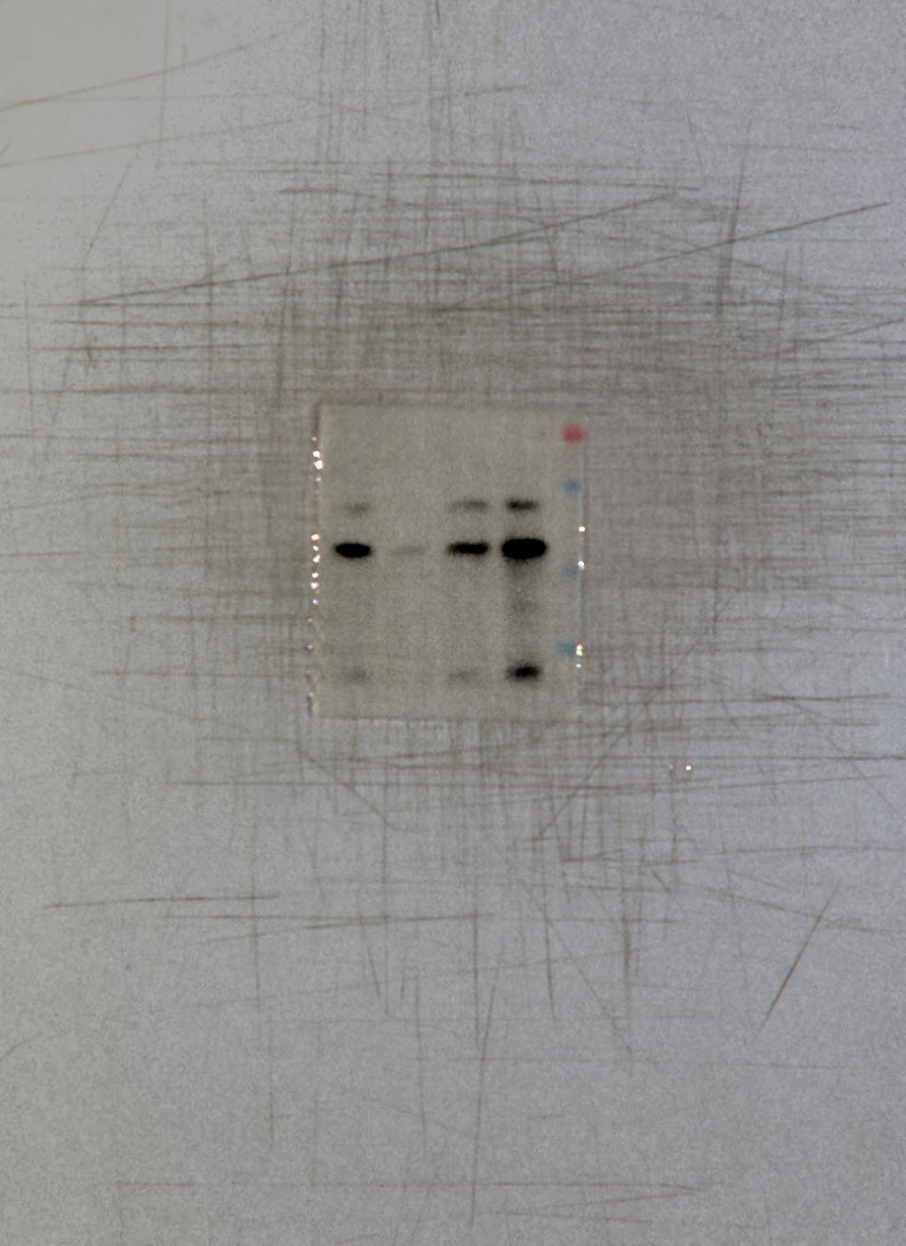
70kDa
55kDa

43kDa
33kDa

β-Actin
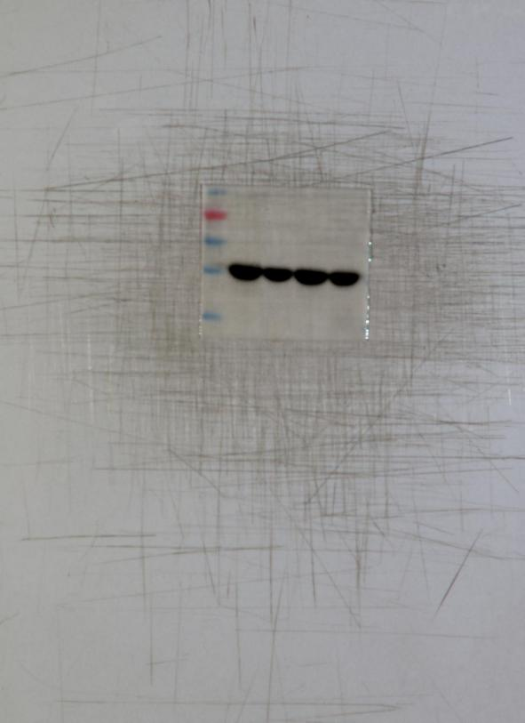
95kDa
70kDa
55kDa
43kDa
33kDa

The uncropped WB bands were used in Figure 2G and 4I. Their molecular weights were annotated with a protein ladder with the provided information.

Supplementary Figure S2 T cells distribution in healthy recipients
The data were generated by a FCM analysis.

