Supplementary Table1 MR analyses of BMD at different sites and in different age groups on RA.
Exposure | Outcome | No.of Ivs | Heterogeneity tests |  | Directional horizontal pleiotropy test | MR results
 |  |  | Methods | Cochran’sQ (P) | MR-Egger intercept (P) | Method | P
TB-BMD | RA | 82 | MR Egger | 89.40（0.22） | -6.71E-03(0.19) | Inverse variance weighted | 0.009
 |  | 82 | IVW | 91.35（0.20） |  | MR Egger | 0.032
 |  | 82 |  |  |  | Weighted median | 0.126
 |  | 82 |  |  |  | Weighted mode | 0.744
FA-BMD | RA | 3 | MR Egger | 0.01（0.92） | -2.78E-02(0.46) | Inverse variance weighted | 0.025
 |  | 3 | IVW | 1.27（0.53） |  | MR Egger | 0.323
 |  | 3 |  |  |  | Weighted median | 0.045
 |  | 3 |  |  |  | Weighted mode | 0.124
LS-BMD | RA | 23 | MR Egger | 23.71（0.31） | -1.30E-02(0.39) | Inverse variance weighted | 0.001
 |  | 23 | IVW | 24.60（0.32） |  | MR Egger | 0.115
 |  | 23 |  |  |  | Weighted median | 0.108
 |  | 23 |  |  |  | Weighted mode | 0.489
FN-BMD | RA | 21 | MR Egger | 20.79（0.35） | 1.68E-02(0.73) | Inverse variance weighted | 0.120
 |  | 21 | IVW | 20.93（0.40） |  | MR Egger | 0.967
 |  | 21 |  |  |  | Weighted median | 0.512
 |  | 21 |  |  |  | Weighted mode | 0.796
Heel-BMD | RA | 52 | MR Egger | 56.23（0.25） | 8.10E-03(0.16) | Inverse variance weighted | 0.006
 |  | 52 | IVW | 58.48（0.22） |  | MR Egger | 0.858
 |  | 52 |  |  |  | Weighted median | 0.128
 |  | 52 |  |  |  | Weighted mode | 0.292
*15 or less | RA | 8 | MR Egger | 16.24（0.01） | -3.03E-02(0.51) | Inverse variance weighted | 0.030
 |  | 8 | IVW | 17.56（0.01） |  | MR Egger | 0.317
 |  | 8 |  |  |  | Weighted median | 0.072
 |  | 8 |  |  |  | Weighted mode | 0.794
15-30 | RA | 1 |  |  |  | Wald ratio | 0.456
30-45 | RA | 9 | MR Egger | 10.48（0.16） | -2.49E-02(0.42) | Inverse variance weighted | 0.070
 |  | 9 | IVW | 11.57（0.17） |  | MR Egger | 0.269
 |  | 9 |  |  |  | Weighted median | 0.312
 |  | 9 |  |  |  | Weighted mode | 0.714
45-60 | RA | 20 | MR Egger | 15.73（0.61） | -2.18E-02(0.12) | Inverse variance weighted | 0.009
 |  | 20 | IVW | 18.46（0.49） |  | MR Egger | 0.035
 |  | 20 |  |  |  | Weighted median | 0.150
 |  | 20 |  |  |  | Weighted mode | 0.349
60 or more | RA | 21 | MR Egger | 26.29（0.12） | 1.36E-02(0.43) | Inverse variance weighted | 0.079
 |  | 21 | IVW | 27.20（0.13） |  | MR Egger | 0.738
 |  | 21 |  |  |  | Weighted median | 0.374
 |  | 21 |  |  |  | Weighted mode | 0.770
Note. *15 or less:MR-PRESSO for further testing, finding no significant outliers for 15 or less
The bold font is used to highlight the result of Inverse Variance Weighted.

Supplementary Table2 MR analyses of RA on BMD at different sites and in different age groups
Exposure | Outcome | No.of Ivs | Heterogeneity tests |  | Directional horizontal pleiotropy test | MR results
 |  |  | Methods | Cochran’sQ (P) | MR-Egger intercept (P) | Method | P
RA | TB-BMD | 23 | MR Egger | 42.00（4.20E-03） | 6.74E-04(0.86) | Inverse variance weighted | 0.465
 |  |  | IVW | 42.07（6.13E-03） |  | MR Egger | 0.570
 |  |  |  |  |  | Weighted median | 0.293
 |  |  |  |  |  | Weighted mode | 0.425
RA | FA-BMD | 24 | MR Egger | 21.20（0.51） | -4.65E-03(0.52) | Inverse variance weighted | 0.799
 |  |  | IVW | 21.63（0.54） |  | MR Egger | 0.732
 |  |  |  |  |  | Weighted median | 0.777
 |  |  |  |  |  | Weighted mode | 0.902
RA | LS-BMD | 24 | MR Egger | 38.18（0.02） | 2.08E-03(0.70) | Inverse variance weighted | 0.732
 |  |  | IVW | 38.45（0.02） |  | MR Egger | 0.928
 |  |  |  |  |  | Weighted median | 0.344
 |  |  |  |  |  | Weighted mode | 0.385
*RA | LS-BMD | 23 | MR Egger | 27.08（0.17） | 3.34E-03(0.48) | Inverse variance weighted | 0.641
 |  |  | IVW | 27.76（0.18） |  | MR Egger | 0.403
 |  |  |  |  |  | Weighted median | 0.327
 |  |  |  |  |  | Weighted mode | 0.398
RA | FN-BMD | 24 | MR Egger | 26.94（0.21） | 1.48E-03(0.71) | Inverse variance weighted | 0.988
 |  |  | IVW | 27.11（0.25） |  | MR Egger | 0.762
 |  |  |  |  |  | Weighted median | 0.150
 |  |  |  |  |  | Weighted mode | 0.223
RA | Heel-BMD | 21 | MR Egger | 50.20（1.22e-4） | 1.23E-03(0.81) | Inverse variance weighted | 0.857
 |  |  | IVW | 50.36（1.97e-4） |  | MR Egger | 0.942
 |  |  |  |  |  | Weighted median | 0.488
 |  |  |  |  |  | Weighted mode | 0.683
*RA | Heel-BMD | 20 | MR Egger | 34.82（9.96e-3） | 1.65E-03(0.72) | Inverse variance weighted | 0.832
 |  |  | IVW | 35.08（1.37e-2） |  | MR Egger | 0.883
 |  |  |  |  |  | Weighted median | 0.487
 |  |  |  |  |  | Weighted mode | 0.737
RA | 15 or less | 24 | MR Egger | 29.25（0.14） | -3.72E-03(0.60) | Inverse variance weighted | 0.976
 |  |  | IVW | 29.63（0.16） |  | MR Egger | 0.664
 |  |  |  |  |  | Weighted median | 0.873
 |  |  |  |  |  | Weighted mode | 0.999
RA | 15-30 | 24 | MR Egger | 23.24（0.39） | -3.55E-03(0.76) | Inverse variance weighted | 0.708
 |  |  | IVW | 23.33（0.44） |  | MR Egger | 0.984
 |  |  |  |  |  | Weighted median | 0.692
 |  |  |  |  |  | Weighted mode | 0.643
RA | 30-45 | 24 | MR Egger | 36.87（0.02） | -5.03E-03(0.57) | Inverse variance weighted | 0.751
 |  |  | IVW | 37.42（0.03） |  | MR Egger | 0.527
 |  |  |  |  |  | Weighted median | 0.949
 |  |  |  |  |  | Weighted mode | 0.840
*RA | 30-45 | 23 | MR Egger | 27.99（0.14） | -1.81E-05(1.00) | Inverse variance weighted | 0.408
 |  |  | IVW | 27.99（0.18） |  | MR Egger | 0.615
 |  |  |  |  |  | Weighted median | 0.945
 |  |  |  |  |  | Weighted mode | 0.871
RA | 45-60 | 24 | MR Egger | 42.00（6.25E-3） | 1.05E-02(0.15) | Inverse variance weighted | 0.675
 |  |  | IVW | 46.37（2.70E-3） |  | MR Egger | 0.365
 |  |  |  |  |  | Weighted median | 0.154
 |  |  |  |  |  | Weighted mode | 0.253
*RA | 45-60 | 21 | MR Egger | 19.69（0.41） | 1.04E-02(0.18) | Inverse variance weighted | 0.148
 |  |  | IVW | 21.62（0.36） |  | MR Egger | 0.562
 |  |  |  |  |  | Weighted median | 0.319
 |  |  |  |  |  | Weighted mode | 0.456
RA | 60 or more | 24 | MR Egger | 26.67（0.22） | -8.31E-03(0.13) | Inverse variance weighted | 0.450
 |  |  | IVW | 29.69（0.16） |  | MR Egger | 0.098
 |  |  |  |  |  | Weighted median | 0.863
 |  |  |  |  |  | Weighted mode | 0.861
*RA | 60 or more | 23 | MR Egger | 15.16（0.82） | -5.95E-03(0.23) | Inverse variance weighted | 0.748
 | rs6679677，p 0.000213698 |  | IVW | 16.67（0.78） |  | MR Egger | 0.440
 |  |  |  |  |  | Weighted median | 0.842
 |  |  |  |  |  | Weighted mode | 0.862

RA on TB-BMD:MR-PRESSO detection results indicated no significant outliers
*RA on LS-BMD:MR-PRESSO results: Global Test P-value=0.04166667, excluding rs6679677.Continue with MR analysis
*RA on Heel-BMD:MR-PRESSO results: Global Test P-value=0.001333333, excluding rs2618444.Continue with MR analysis
*RA on age 30-45:MR-PRESSO results: Global Test P-value=0.04133333, excluding rs3757387.Continue with MR analysis
*RA on age 45-60:MR-PRESSO results: Global Test P-value=0.006666667, excluding rs35139284,rs6679677,rs9494894.Continue with MR analysis
*RA on age 60 or more: rs6679677 (pval.outcome 2.14E-4) may interfere with the causal relationship between BMD and RA risk in those over 60, so it was excluded.Continue with MR analysis
The bold font is used to highlight the result of Cochran’s Q (P) < 0.05.

Supplementary Table 3

Supplementary Table 3. RA SNPs from the GWAS used as genetic instruments in the MR study,and the reported traits of selected instrumental variables of RA searched in GWAS Catalog.
SNP | Chr | Pos | Gene | EA | OA | EAF | Beta | Se | P | R2 | F | Trait | Excluded from MR analysis
rs6679677 | 1 | 114303808 | PHTF1 | A | C | 0.112873 | 0.3051 | 0.0254 | 2.54E-33 | 3.46E-04 | 144.2829125 | rheumatoid arthritis,type 1 diabetes mellitus, autoantibody measurement | No
rs10797431 | 1 | 2501222 | PRXL2B | T | G | 0.403594 | -0.074 | 0.0129 | 1.06E-08 | 7.89E-05 | 32.90651855 | rheumatoid arthritis,autoimmune disease,multiple sclerosis | No
rs11889341 | 2 | 191943742 | STAT4 | T | C | 0.249601 | 0.1232 | 0.0146 | 2.71E-17 | 1.71E-04 | 71.20551345 | rheumatoid arthritis,systemic lupus erythematosus ,Sjogren syndrome | No
rs7731626 | 5 | 55444683 | ANKRD55 | A | G | 0.278947 | -0.1343 | 0.0157 | 9.77E-18 | 1.75E-04 | 73.17296258 | rheumatoid arthritis,Multiple sclerosis,Pediatric autoimmune diseases | No
rs62395272 | 6 | 31394424 | CPNE1 | T | C | 0.110971 | 0.3146 | 0.0206 | 6.60E-53 | 5.59E-04 | 233.2281214 | None | No
rs142144003 | 6 | 32433702 | PDE6B | A | G | 0.111153 | 0.4134 | 0.0207 | 1.09E-88 | 9.55E-04 | 398.8395081 | None | No
rs9277814 | 6 | 33101675 | HLA-DPB1 | G | A | 0.510227 | 0.1322 | 0.0145 | 6.12E-20 | 1.99E-04 | 83.12369194 | None | No
rs9469053 | 6 | 31755776 | VARS1 | G | A | 0.0454311 | -0.2907 | 0.0312 | 1.22E-20 | 2.08E-04 | 86.81180652 | blood protein measurement | No
rs35139284 | 6 | 32561370 | HLA-DRB1 | T | C | 0.319092 | 0.5387 | 0.0149 | 1.00E-200 | 3.12E-03 | 1307.131656 | BMI-adjusted waist-hip ratio | Yes
rs9494894 | 6 | 138228520 | SIMALR | C | T | 0.0417083 | 0.1726 | 0.031 | 2.48E-08 | 7.43E-05 | 30.99960167 | rheumatoid arthritis,systemic lupus erythematosus | No
rs362531 | 6 | 29530455 | MAPT | A | G | 0.0614836 | -0.2121 | 0.0252 | 3.47E-17 | 1.70E-04 | 70.83993822 | None | No
rs28362859 | 6 | 44228815 | NFKBIE | C | A | 0.100049 | 0.1465 | 0.0205 | 9.90E-13 | 1.22E-04 | 51.06995152 | rheumatoid arthritis | No
rs1611318 | 6 | 29902240 | SHANK3 | C | A | 0.76162 | 0.1259 | 0.0185 | 1.07E-11 | 1.11E-04 | 46.31332074 | None | No
rs35511257 | 6 | 32545392 | HLA-DRB1 | C | G | 0.074625 | 0.6889 | 0.0408 | 4.38E-64 | 6.83E-04 | 285.0952369 | grip strength measurement | No
rs3093017 | 6 | 167541258 | CCR6 | G | C | 0.545899 | -0.1179 | 0.0128 | 4.34E-20 | 2.03E-04 | 84.84096297 | rheumatoid arthritis | No
rs3757387 | 7 | 128576086 | IRF5 | C | T | 0.34443 | 0.1086 | 0.0147 | 1.47E-13 | 1.31E-04 | 54.57866384 | rheumatoid arthritis,Sjogren syndrome,eosinophil count | No
rs10261758 | 7 | 50353192 | IKZF1 | A | G | 0.710671 | -0.081 | 0.0143 | 1.47E-08 | 7.69E-05 | 32.08454473 | rheumatoid arthritis | No
rs2618444 | 8 | 11338370 | BLK | C | A | 0.387409 | 0.1005 | 0.0146 | 6.71E-12 | 1.14E-04 | 47.38319379 | rheumatoid arthritis,systemic lupus erythematosus | No
rs1776616 | 10 | 31350494 | LINC02664 | G | A | 0.664992 | 0.0832 | 0.0139 | 2.41E-09 | 8.59E-05 | 35.82737343 | rheumatoid arthritis | No
rs71508903 | 10 | 63779871 | ARID5B | T | C | 0.210869 | 0.0872 | 0.0157 | 2.54E-08 | 7.39E-05 | 30.84832469 | autoimmune thyroid disease,Vitiligo | No
rs2156698 | 11 | 128488322 | ETS1 | A | G | 0.4561 | -0.0745 | 0.0131 | 1.44E-08 | 7.75E-05 | 32.34207445 | rheumatoid arthritis | No
rs56376587 | 18 | 77160235 | NFATC1 | C | A | 0.429311 | 0.0785 | 0.0133 | 3.77E-09 | 8.35E-05 | 34.83645465 | heel bone mineral density | No
rs34536443 | 19 | 10463118 | TYK2 | C | G | 0.0427749 | -0.2367 | 0.0427 | 3.03E-08 | 7.36E-05 | 30.72831061 | sarcoidosis,type 1 diabetes mellitus,multiple sclerosis | No
rs5754100 | 22 | 21916166 | UBE2L3 | C | T | 0.244139 | 0.086 | 0.015 | 9.20E-09 | 7.88E-05 | 32.87095355 | autoimmune disease,lymphocyte count | No
rs5757628 | 22 | 39749981 | SYNGR1 | A | G | 0.427512 | 0.0966 | 0.0157 | 7.58E-10 | 9.07E-05 | 37.85758153 | rheumatoid arthritis | No
EA, effect allele. OA, other allele. EAF, effect allele frequency. SE, standard error.
R2 were calculated using the following formula: (2×EAF×(1-EAF)×beta2 )/[(2×EAF×(1-EAF)×beta2 ) + (2×EAF×(1-EAF)×N×SE2 )], where EAF is the effect allele frequency, beta is the estimated effect on RA, N is the sample size of the GWAS for the SNP-RA association and SE is the standard error of the estimated effect.
F-statistic were calculated using the following formula: R2 (N-2)/(1-R2 ), where R2 is the proportion of variance in RA explained by each instrument and N is the sample size of the GWAS for the RA association.
The red font is used to indicate that this SNP has been excluded as a confounding factor.

Supplementary Table 4

Supplementary Table 4. Characteristics of the BMD-associated genetic instrumental variables included in the MR study,and the reported traits of selected genetic instrumental variables of BMD searched in GWAS Catalog.
SNP | chr | pos | Gene | EA | OA | EAF | Beta | SE | P | R2 | F | Trait | Excluded from MR analysis
Instrumental variables of TB-BMD
rs10048745 | 2 | 68962137 | ARHGAP25 | A | G | 0.2477 | -0.0389 | 0.0067 | 6.44E-09 | 0.000598556 | 33.70809155 | lymphocyte percentage of leukocytes,neutrophil count,platelet count | No
rs1037011 | 12 | 107302778 | RPL30P12 | C | T | 0.5208 | 0.0404 | 0.0057 | 1.54E-12 | 0.000891745 | 50.23397977 | bone density | No
rs10490046 | 2 | 40630678 | SLC8A1 | C | A | 0.2391 | -0.0429 | 0.0067 | 1.43E-10 | 0.000727887 | 40.99676103 | bone density | No
rs10493013 | 1 | 22703035 | ZBTB40 | C | T | 0.1811 | 0.1013 | 0.0074 | 4.07E-43 | 0.003318386 | 187.3872418 | bone density | No
rs10735851 | 12 | 53743064 | SP7 | A | G | 0.7083 | -0.0541 | 0.0063 | 5.84E-18 | 0.001308458 | 73.73912821 | bone density | No
rs10777212 | 12 | 90334829 | BRWD1P2 | T | G | 0.3455 | 0.0452 | 0.006 | 5.05E-14 | 0.001007284 | 56.74909451 | bone density | No
rs10788264 | 10 | 124015986 | BTBD16 | A | G | 0.4815 | -0.0338 | 0.0057 | 2.61E-09 | 0.000624349 | 35.16156985 | bone density | No
rs10832520 | 11 | 15816918 | CRYBA2 | A | T | 0.0394 | 0.1123 | 0.0158 | 1.00E-12 | 0.000896749 | 50.51611068 | None | No
rs10901216 | 9 | 133471891 | FUBP3 | A | G | 0.3438 | -0.0474 | 0.0061 | 5.53E-15 | 0.001071634 | 60.3783973 | body height | No
rs10931982 | 2 | 202832130 | RNU6-440P | C | T | 0.7903 | 0.0508 | 0.009 | 1.59E-08 | 0.000565733 | 31.85862098 | heel bone mineral density | No
rs11228240 | 11 | 68218290 | SOX5 | T | C | 0.2574 | -0.083 | 0.0067 | 1.72E-35 | 0.002719187 | 153.45857 | None | No
rs1159798 | 10 | 54412493 | LNCAROD | C | A | 0.7598 | -0.0429 | 0.007 | 1.01E-09 | 0.000666874 | 37.55805312 | bone density | No
rs11745493 | 5 | 122847622 | CSNK1G3 | G | A | 0.2537 | -0.0445 | 0.0065 | 7.74E-12 | 0.000832045 | 46.86815701 | bone density | No
rs117557198 | 12 | 49655948 | TUBA1C | G | A | 0.0676 | 0.0769 | 0.012 | 1.58E-10 | 0.000729102 | 41.06527684 | bone density | No
rs118115924 | 12 | 49379537 | DDN | T | G | 0.0139 | -0.2822 | 0.0301 | 6.99E-21 | 0.001559259 | 87.89528833 | body height | No
rs11898505 | 2 | 54684557 | SPTBN1 | G | A | 0.6674 | -0.0342 | 0.006 | 1.28E-08 | 0.000576918 | 32.4888455 | bone density | No
rs11904127 | 2 | 85484818 | TCF7L1 | A | G | 0.5512 | -0.0324 | 0.0057 | 1.18E-08 | 0.000573728 | 32.30910119 | bone density | No
rs11910328 | 21 | 40350744 | LINC02940 | A | G | 0.8351 | -0.0429 | 0.0077 | 2.99E-08 | 0.000551199 | 31.03971332 | bone density | No
rs11934731 | 4 | 88831249 | HSP90AB3P | A | G | 0.6738 | -0.0674 | 0.0061 | 8.39E-29 | 0.002164383 | 122.0800478 | bone density | No
rs11995824 | 8 | 120012700 | COLEC10 | G | C | 0.5681 | -0.0675 | 0.0058 | 1.06E-31 | 0.002400616 | 135.436626 | bone density | No
rs12044944 | 1 | 240581653 | FMN2 | T | C | 0.1916 | 0.0553 | 0.0074 | 7.54E-14 | 0.000991223 | 55.84334064 | bone density | No
rs12258451 | 10 | 54423853 | LNCAROD | G | C | 0.1307 | -0.0702 | 0.0089 | 2.41E-15 | 0.001104154 | 62.21266111 | bone density | No
rs12442242 | 15 | 38340874 | LINC02345 | G | A | 0.1499 | 0.0509 | 0.0082 | 4.94E-10 | 0.00068411 | 38.52941609 | bone density | No
rs12534510 | 7 | 120730944 | C5orf66 | C | A | 0.5545 | 0.0395 | 0.0057 | 3.15E-12 | 0.00085249 | 48.02076202 | None | No
rs12612325 | 2 | 119632252 | KCNIP4 | A | G | 0.2122 | -0.0548 | 0.0078 | 1.98E-12 | 0.000876206 | 49.35787787 | None | No
rs1286150 | 14 | 91464890 | EN1 | C | T | 0.1955 | 0.0549 | 0.0072 | 2.44E-14 | 0.001031921 | 58.13855903 | bone density | No
rs13204965 | 6 | 127167072 | RPS6KA5 | C | A | 0.229 | -0.0619 | 0.007 | 1.02E-18 | 0.001387386 | 78.19334382 | bone density | No
rs143187557 | 11 | 47284279 | CDH13 | T | C | 0.0223 | -0.1237 | 0.0203 | 1.15E-09 | 0.000659289 | 37.13059348 | None | No
rs144279715 | 2 | 119548256 | LINC01956 | G | A | 0.0147 | 0.2295 | 0.0294 | 6.18E-15 | 0.001081473 | 60.9333824 | bone fracture | No
rs144691710 | 17 | 41819562 | WHSC1L2P | G | A | 0.0751 | 0.1017 | 0.0113 | 2.24E-19 | 0.001437062 | 80.99712174 | bone density | No
rs1452102 | 21 | 28773868 | EIF4A1P1 | G | T | 0.4129 | 0.0345 | 0.0057 | 1.74E-09 | 0.000650461 | 36.63304726 | bone density | No
rs1548607 | 7 | 50901491 | COBL | G | A | 0.313 | -0.0363 | 0.0066 | 4.18E-08 | 0.000537164 | 30.24892509 | bone density | No
rs2252865 | 1 | 8422676 | RERE | C | T | 0.6759 | 0.0328 | 0.006 | 4.72E-08 | 0.000530676 | 29.88338253 | attention deficit hyperactivity disorder, unipolar depression, bipolar disorder, autism spectrum disorder, schizophrenia | No
rs2289410 | 2 | 42284110 | PKDCC | T | A | 0.132 | -0.0494 | 0.0088 | 2.00E-08 | 0.000559578 | 31.51179344 | body height | No
rs2350085 | 2 | 202799604 | RNU6-440P | C | T | 0.1274 | 0.0643 | 0.0085 | 3.79E-14 | 0.001015682 | 57.22274166 | bone density | No
rs2414098 | 15 | 51537806 | MIR4713HG | C | T | 0.6102 | 0.0329 | 0.0059 | 1.99E-08 | 0.000552157 | 31.09369542 | endometrial endometrioid carcinoma,alkaline phosphatase measurement | No
rs2553773 | 11 | 35089085 | PDHX | G | C | 0.5863 | 0.037 | 0.0058 | 1.49E-10 | 0.000722518 | 40.6941544 | uterine fibroid | No
rs2566751 | 1 | 68664913 | EFCAB5 | A | T | 0.8727 | -0.0567 | 0.01 | 1.32E-08 | 0.000570865 | 32.14775762 | None | No
rs2566752 | 1 | 68656697 | GNG12-AS1 | C | T | 0.3897 | 0.0721 | 0.0059 | 1.88E-34 | 0.002646249 | 149.3313783 | bone density | No
rs2873195 | 17 | 2064702 | SMG6 | T | A | 0.6873 | 0.0406 | 0.0062 | 4.31E-11 | 0.000761295 | 42.87984982 | osteoarthritis | No
rs34102936 | 7 | 38142840 | STARD3NL | A | G | 0.5897 | 0.0471 | 0.0057 | 1.87E-16 | 0.00121166 | 68.27735213 | bone density | No
rs34670419 | 7 | 99130834 | ZKSCAN5 | T | G | 0.0394 | -0.088 | 0.0154 | 1.09E-08 | 0.000579812 | 32.65190093 | bone density | No
rs35125553 | 12 | 1639249 | WNT5B | G | A | 0.2855 | 0.0383 | 0.0066 | 5.20E-09 | 0.00059795 | 33.67396408 | bone density | No
rs35199438 | 11 | 16630779 | SOX6 | T | G | 0.3035 | -0.0489 | 0.0062 | 2.36E-15 | 0.001104001 | 62.20408508 | reticulocyte count | No
rs3743347 | 15 | 67547301 | AAGAB | A | C | 0.2351 | 0.0519 | 0.0068 | 1.75E-14 | 0.00103391 | 58.25074146 | risk-taking behaviour | No
rs3801387 | 7 | 120974765 | WNT16 | G | A | 0.2721 | 0.1347 | 0.0063 | 1.15E-100 | 0.008056678 | 457.1288805 | bone density | No
rs447911 | 3 | 41127046 | RPS27P4 | C | G | 0.5348 | 0.0708 | 0.0057 | 6.29E-36 | 0.002733651 | 154.2770662 | bone density | No
rs4757350 | 11 | 15703674 | PTGER4 | T | C | 0.7852 | -0.0564 | 0.0069 | 3.75E-16 | 0.001185659 | 66.81048031 | None | No
rs4846580 | 1 | 219897941 | SLC30A10 | A | G | 0.5329 | 0.0345 | 0.0058 | 3.21E-09 | 0.000628238 | 35.38072847 | smoking status measurement, chronic obstructive pulmonary disease | Yes
rs55781332 | 11 | 242859 | PSMD13 | G | A | 0.2169 | 0.0552 | 0.0069 | 8.07E-16 | 0.001135799 | 63.99772582 | mean platelet volume | No
rs56104760 | 1 | 22486029 | ZBTB7A | G | A | 0.1905 | -0.0747 | 0.0074 | 7.38E-24 | 0.001807204 | 101.8972191 | None | No
rs6029130 | 20 | 39103882 | LINC01370 | T | C | 0.2874 | 0.0348 | 0.0063 | 3.50E-08 | 0.000541823 | 30.51138742 | bone density | No
rs6040063 | 20 | 10640877 | JAG1 | G | A | 0.4993 | -0.0359 | 0.0056 | 1.78E-10 | 0.000729644 | 41.0957973 | bone density | No
rs61884327 | 11 | 46766890 | CKAP5 | C | T | 0.0978 | 0.0801 | 0.0099 | 4.63E-16 | 0.001161729 | 65.46048376 | bone density | No
rs633995 | 1 | 172186729 | DNM3 | A | G | 0.4251 | 0.0351 | 0.0058 | 1.61E-09 | 0.000650266 | 36.62206366 | BMI-adjusted waist-hip ratio | Yes
rs634277 | 11 | 86887931 | TMEM135 | G | A | 0.3322 | -0.0607 | 0.0061 | 2.15E-23 | 0.001756181 | 99.01529361 | bone density | No
rs6465511 | 7 | 96134115 | SEM1 | G | C | 0.6752 | 0.0738 | 0.006 | 1.03E-34 | 0.002680769 | 151.284624 | bone density | No
rs6557155 | 6 | 151910126 | CCDC170 | G | T | 0.5682 | 0.0751 | 0.0059 | 2.56E-37 | 0.002870401 | 162.0169373 | bone density | No
rs6960249 | 7 | 96660132 | SDHAF3 | G | T | 0.4091 | -0.0325 | 0.0057 | 1.45E-08 | 0.000577273 | 32.50884786 | bone density | No
rs7105860 | 11 | 27306364 | CCDC34 | C | G | 0.6025 | -0.0468 | 0.0059 | 2.36E-15 | 0.001116651 | 62.91761482 | bone density | No
rs71390846 | 16 | 86714715 | FOXL1 | C | G | 0.1836 | -0.0484 | 0.0075 | 1.38E-10 | 0.00073937 | 41.64403128 | bone density | No
rs725670 | 11 | 121913230 | MIR100HG | A | G | 0.383 | -0.0322 | 0.0059 | 3.61E-08 | 0.000528924 | 29.78463536 | bone density | No
rs73169678 | 7 | 150953205 | SMARCD3 | A | C | 0.1117 | 0.0619 | 0.0091 | 1.05E-11 | 0.000821404 | 46.26825078 | erythrocyte count | No
rs73305797 | 7 | 30997087 | LOC1 | T | A | 0.2431 | -0.0422 | 0.0067 | 2.40E-10 | 0.000704343 | 39.66978658 | None | No
rs73349318 | 10 | 112245400 | DUSP5-DT | T | A | 0.1262 | 0.0472 | 0.0085 | 2.68E-08 | 0.000547549 | 30.83406001 | bone density | No
rs73719807 | 7 | 121191251 | CYCSP19 | C | A | 0.0871 | 0.0925 | 0.0112 | 1.14E-16 | 0.001210421 | 68.20747737 | bone density | No
rs74394007 | 3 | 156692207 | LEKR1 | C | A | 0.138 | -0.0608 | 0.0083 | 2.46E-13 | 0.000952472 | 53.65813098 | bone density | No
rs7548588 | 1 | 110475971 | AHCYL1 | C | T | 0.391 | 0.0367 | 0.0058 | 2.21E-10 | 0.000710857 | 40.03692448 | bone density | No
rs757138 | 7 | 27989403 | JAZF1 | G | T | 0.3111 | 0.0348 | 0.0063 | 3.33E-08 | 0.000541823 | 30.51138742 | prostate carcinoma | No
rs7586085 | 2 | 166577489 | CSRNP3 | G | A | 0.4663 | -0.0532 | 0.0057 | 8.64E-21 | 0.001545315 | 87.1080157 | bone density | No
rs76051363 | 4 | 1006987 | FGFRL1 | T | C | 0.1491 | -0.0794 | 0.0085 | 1.39E-20 | 0.001547909 | 87.25447724 | bone density | No
rs7728694 | 5 | 88288341 | MEF2C-AS1 | T | G | 0.461 | -0.0503 | 0.0059 | 1.30E-17 | 0.001289694 | 72.68026704 | bone density | No
rs7740042 | 6 | 151971720 | ESR1 | A | T | 0.2024 | -0.0494 | 0.0071 | 2.71E-12 | 0.000859367 | 48.40851585 | bone density | No
rs7741085 | 6 | 44636919 | SUPT3H | T | C | 0.5874 | 0.0423 | 0.0057 | 1.51E-13 | 0.00097751 | 55.07006523 | bone density | No
rs780096 | 2 | 27741072 | GCKR | G | C | 0.5594 | 0.0311 | 0.0057 | 4.58E-08 | 0.000528636 | 29.7684097 | triglycerides:total lipids ratio, very low density lipoprotein cholesterol measurement | No
rs78667121 | 13 | 43200103 | FAM216B | A | G | 0.0325 | 0.1326 | 0.018 | 1.70E-13 | 0.000963249 | 54.26584942 | alkaline phosphatase measurement | No
rs8047501 | 16 | 392318 | AXIN1 | G | A | 0.5077 | -0.0524 | 0.0059 | 1.13E-18 | 0.001399476 | 78.87568032 | bone density | No
rs8070128 | 17 | 17804725 | TOM1L2 | T | C | 0.5763 | -0.0394 | 0.0059 | 1.98E-11 | 0.000791698 | 44.5936466 | bone density | No
rs818427 | 5 | 112221869 | REEP5 | T | C | 0.3118 | 0.0342 | 0.0061 | 2.37E-08 | 0.000558168 | 31.43236866 | bone density | No
rs838721 | 2 | 234303405 | DGKD | G | A | 0.563 | 0.0314 | 0.0057 | 4.48E-08 | 0.000538878 | 30.34548984 | bone density | No
rs884205 | 18 | 60054857 | TNFRSF11A | C | A | 0.7579 | 0.0531 | 0.0068 | 4.39E-15 | 0.001082221 | 60.97555813 | bone density | No
rs9594738 | 13 | 42952145 | LINC02341 | T | C | 0.4592 | -0.0614 | 0.0057 | 3.84E-27 | 0.002057348 | 116.030349 | bone density | No
rs9910055 | 17 | 42283037 | ATXN7L3-AS1 | T | C | 0.2624 | 0.0442 | 0.0067 | 3.12E-11 | 0.000772635 | 43.51905946 | appendicular lean mass | No
rs9972944 | 17 | 63771079 | CEP112 | G | A | 0.5951 | -0.0363 | 0.0059 | 6.87E-10 | 0.000672098 | 37.85243255 | bone density | No
rs9976876 | 21 | 36970350 | RUNX1 | T | G | 0.447 | -0.0375 | 0.0058 | 8.01E-11 | 0.000742163 | 41.80142777 | bone density | No
Instrumental variables of Forearm-BMD
rs13423976 | 2 | 38745624 | LINC02613 | G | A | 0.714002 | 0.097978 | 0.017179 | 2.30E-08 | 0.00300145 | 32.52228008 | body height | No
rs6894139 | 5 | 88327782 | MEF2C-AS1 | G | T | 0.513206 | -0.088937 | 0.015638 | 2.52E-08 | 0.002984555 | 32.33866884 | body height | No
rs7776725 | 7 | 121033121 | FAM3C | C | T | 0.259348 | 0.186109 | 0.017421 | 1.21E-25 | 0.010452031 | 114.1059246 | bone density | No
Instrumental variables of LS-BMD
rs1023940 | 6 | 151932778 | CCDC170 | G | A | 0.534845 | -0.064541 | 0.00876 | 6.47E-13 | 0.00121207 | 54.28048874 | bone density | No
rs11002249 | 10 | 79447228 | RNU6-1266P | T | C | 0.235402 | 0.069743 | 0.011142 | 1.01E-09 | 0.000875157 | 39.17919627 | bone density | No
rs11024028 | 11 | 16756873 | SOX6 | G | C | 0.147176 | 0.065776 | 0.011325 | 1.44E-08 | 0.000753568 | 33.73176601 | bone density | No
rs11680288 | 2 | 166603281 | CSRNP3 | A | G | 0.428958 | -0.054235 | 0.008933 | 3.12E-09 | 0.000823376 | 36.85914038 | bone density | No
rs11692564 | 2 | 119545994 | LINC01956 | T | C | 0.0127287 | 0.23782 | 0.039471 | 4.10E-09 | 0.000810923 | 36.30120757 | bone density | No
rs13046645 | 21 | 36818136 | UBAC2 | A | T | 0.276293 | -0.055863 | 0.009829 | 2.92E-08 | 0.000721619 | 32.30058746 | None | No
rs1357651 | 7 | 38097862 | STARD3NL | G | T | 0.645187 | 0.068117 | 0.009151 | 3.75E-13 | 0.001237165 | 55.40570635 | bone density | No
rs2220189 | 8 | 120007708 | GPR26 | G | C | 0.610183 | -0.082756 | 0.008797 | 4.25E-20 | 0.001974526 | 88.49329771 | None | No
rs2235811 | 20 | 10644158 | JAG1 | G | A | 0.537709 | -0.054301 | 0.009045 | 4.66E-09 | 0.000805082 | 36.03952798 | urate measurement | No
rs2291467 | 11 | 68216756 | LRP5 | T | C | 0.228162 | -0.077421 | 0.010148 | 9.64E-14 | 0.001299521 | 58.20190738 | mathematical ability | No
rs2566752 | 1 | 68656697 | GNG12-AS1 | C | T | 0.41074 | 0.082922 | 0.008947 | 1.49E-19 | 0.00191665 | 85.89447775 | bone density | No
rs35681117 | 7 | 37959021 | ZCCHC24 | T | C | 0.237947 | 0.055162 | 0.009645 | 2.39E-08 | 0.000730717 | 32.70816089 | None | No
rs401680 | 3 | 41127094 | ZNF429 | T | A | 0.503898 | 0.056521 | 0.008802 | 3.70E-10 | 0.000920976 | 41.23229677 | None | No
rs6965122 | 7 | 96133319 | SEM1 | G | A | 0.265712 | -0.061835 | 0.009266 | 7.40E-11 | 0.000994588 | 44.53123298 | bone density | No
rs71390846 | 16 | 86714715 | FOXL1 | C | G | 0.173667 | -0.064092 | 0.011373 | 3.80E-08 | 0.000709481 | 31.75690364 | bone density | No
rs73326583 | 14 | 91465976 | LOC1 | A | C | 0.160382 | 0.072363 | 0.011887 | 2.83E-09 | 0.00082779 | 37.05690831 | None | No
rs7524102 | 1 | 22698447 | ZBTB40 | G | A | 0.198329 | 0.089822 | 0.011494 | 2.41E-14 | 0.001363396 | 61.06658556 | ulcerative colitis | Yes
rs7807953 | 7 | 121000718 | FAM3C | T | C | 0.263325 | 0.075102 | 0.009698 | 4.11E-14 | 0.0013389 | 59.96795337 | cortical thickness | No
rs78667121 | 13 | 43200103 | FAM216B | A | G | 0.0221957 | 0.149862 | 0.025668 | 1.21E-08 | 0.000761482 | 34.08627698 | alkaline phosphatase measurement | No
rs884205 | 18 | 60054857 | TNFRSF11A | C | A | 0.786794 | 0.062204 | 0.010212 | 2.77E-09 | 0.000828793 | 37.10185251 | bone density | No
rs894738 | 12 | 54417525 | HOXC4 | A | G | 0.333492 | -0.062783 | 0.009136 | 2.00E-11 | 0.001054642 | 47.22288628 | Drugs affecting bone structure and mineralization use measurement | No
rs9533094 | 13 | 42965837 | LINC02341 | G | A | 0.404296 | -0.082629 | 0.008741 | 2.80E-20 | 0.001993735 | 89.35592084 | alkaline phosphatase measurement | No
rs9749364 | 19 | 33525713 | IGDCC4 | G | T | 0.133492 | 0.11438 | 0.018078 | 6.64E-10 | 0.000894133 | 40.02948492 | None | No
rs9921222 | 16 | 375782 | AXIN1 | T | C | 0.461177 | -0.053345 | 0.008789 | 3.16E-09 | 0.000822891 | 36.83741031 | ferritin measurement | No
Instrumental variables of FN-BMD
rs10170839 | 2 | 166572906 | ANKRD35 | C | A | 0.431424 | -0.059358 | 0.007521 | 1.20E-14 | 0.001244517 | 62.28593171 | None | No
rs10794639 | 16 | 377367 | AXIN1 | G | A | 0.458313 | -0.051188 | 0.007546 | 3.30E-11 | 0.000919681 | 46.013508 | brain measurement | No
rs10946458 | 6 | 21391282 | LINC00581 | C | T | 0.338425 | -0.044918 | 0.007974 | 3.63E-08 | 0.000634376 | 31.73006653 | non-high density lipoprotein cholesterol measurement | No
rs11024028 | 11 | 16756873 | SOX6 | G | C | 0.147176 | 0.05552 | 0.009698 | 2.18E-08 | 0.000655215 | 32.77307403 | bone density | No
rs11652763 | 17 | 42208172 | TTC28 | A | G | 0.147574 | 0.083568 | 0.012659 | 1.09E-10 | 0.000871038 | 43.57765346 | None | No
rs13194508 | 6 | 127144683 | RSPO3 | C | T | 0.195465 | -0.051843 | 0.008915 | 1.30E-08 | 0.000676049 | 33.81583989 | cortical surface area measurement | No
rs1366594 | 5 | 88376061 | MEF2C-AS1 | C | A | 0.522593 | -0.079453 | 0.007525 | 5.44E-25 | 0.002225227 | 111.4782687 | bone density | No
rs1485307 | 8 | 120007395 | RNU6-12P | C | T | 0.582657 | -0.061597 | 0.00761 | 2.49E-15 | 0.001308926 | 65.51374592 | eye morphology measurement | No
rs1785493 | 11 | 68208345 | NDRG1 | T | C | 0.365235 | -0.045109 | 0.008037 | 4.06E-08 | 0.000629795 | 31.50076393 | None | No
rs2566752 | 1 | 68656697 | GNG12-AS1 | C | T | 0.41074 | 0.061943 | 0.007699 | 3.65E-15 | 0.001293267 | 64.72893398 | bone density | No
rs2741856 | 17 | 41826839 | WHSC1L2P | C | G | 0.0573588 | 0.087631 | 0.014131 | 1.34E-09 | 0.000768723 | 38.4549602 | lysophosphatidylethanolamine 20:4 measurement | No
rs3779381 | 7 | 120966790 | WNT16 | G | A | 0.252188 | 0.057989 | 0.008522 | 2.87E-11 | 0.000925423 | 46.30104607 | ischemic cardiomyopathy | No
rs4281029 | 7 | 38153650 | STARD3NL | A | C | 0.187749 | 0.056816 | 0.009361 | 2.96E-09 | 0.000736396 | 36.83659194 | bone density | No
rs436448 | 3 | 41121251 | HLA-DQA1 | C | T | 0.519809 | 0.063845 | 0.007565 | 1.56E-16 | 0.001422826 | 71.22271774 | None | No
rs4448201 | 7 | 96154912 | SEM1 | C | G | 0.700398 | 0.065631 | 0.007895 | 4.37E-16 | 0.001380537 | 69.10291981 | bone density | No
rs4759320 | 12 | 54433011 | HOXC4 | C | G | 0.334049 | -0.044812 | 0.007933 | 3.33E-08 | 0.000637927 | 31.90776389 | systolic blood pressure, alcohol drinking | No
rs7108738 | 11 | 15710084 | LINC02751 | G | T | 0.192681 | 0.082771 | 0.009715 | 8.07E-17 | 0.001450023 | 72.58609256 | reticulocyte measurement | No
rs71390846 | 16 | 86714715 | FOXL1 | C | G | 0.173667 | -0.059106 | 0.009756 | 3.16E-09 | 0.000733728 | 36.70305203 | bone density | No
rs7209460 | 17 | 2048713 | SMG6 | T | C | 0.705251 | 0.050829 | 0.008199 | 1.35E-09 | 0.000768249 | 38.43120324 | coronary artery disease | No
rs7524102 | 1 | 22698447 | ZBTB40 | G | A | 0.198329 | 0.083798 | 0.009823 | 7.36E-17 | 0.001453722 | 72.7715529 | ulcerative colitis | Yes
rs9478217 | 6 | 151874122 | CCDC170 | G | A | 0.482657 | 0.052736 | 0.007608 | 1.23E-11 | 0.000960263 | 48.04586174 | bone density | No
Instrumental variables of Heel-BMD
rs10047482 | 11 | 68231843 | PPP6R3 | T | C | 0.259569 | -0.0522975 | 0.00771874 | 1.20E-11 | 0.00112905 | 45.90369498 | bone density | No
rs10221370 | 18 | 13709576 | RASA1 | T | C | 0.361998 | -0.053743 | 0.00702036 | 1.90E-14 | 0.0014409 | 58.60081521 | None | No
rs10450588 | 11 | 27308664 | CCDC34 | T | C | 0.638908 | -0.0470044 | 0.00704084 | 2.50E-11 | 0.001096192 | 44.56631122 | C-reactive protein measurement | No
rs10838658 | 11 | 47130778 | PCSK1 | A | G | 0.229709 | 0.0518874 | 0.00802132 | 9.90E-11 | 0.001029248 | 41.84183733 | None | No
rs10931982 | 2 | 202832130 | RNU6-440P | C | T | 0.76691 | 0.0625069 | 0.00796982 | 4.40E-15 | 0.001512295 | 61.50883599 | heel bone mineral density | No
rs11003038 | 10 | 54433560 | SH2D2A | C | T | 0.107064 | -0.131854 | 0.0108975 | 1.10E-33 | 0.003591742 | 146.3900219 | None | No
rs11088458 | 21 | 40350120 | LINC02940 | G | A | 0.711547 | -0.0417982 | 0.00751851 | 2.70E-08 | 0.000760425 | 30.90510394 | bone density | No
rs113308638 | 6 | 45392296 | RUNX2 | T | G | 0.047831 | -0.117934 | 0.0158904 | 1.20E-13 | 0.001354424 | 55.0791223 | bone density | No
rs1133400 | 10 | 134459388 | INPP5A | G | A | 0.217416 | 0.0446459 | 0.00817534 | 4.70E-08 | 0.000733783 | 29.82154434 | triglyceride measurement | No
rs115134980 | 4 | 996768 | IDUA | C | T | 0.148673 | -0.0650236 | 0.00949927 | 7.60E-12 | 0.00115238 | 46.85329833 | bone density | No
rs1159798 | 10 | 54412493 | LNCAROD | C | A | 0.775713 | -0.0685661 | 0.00806131 | 1.80E-17 | 0.001778155 | 72.34129239 | heel bone mineral density | No
rs117481343 | 12 | 13328208 | FAM234B | T | C | 0.02861 | 0.120261 | 0.0207742 | 7.10E-09 | 0.000824475 | 33.51040042 | heel bone mineral density | No
rs117645784 | 13 | 93845208 | LOC1 | A | G | 0.011891 | -0.210421 | 0.0325619 | 1.00E-10 | 0.001027182 | 41.75776986 | None | No
rs118115924 | 12 | 49379537 | DDN | T | G | 0.012423 | -0.170974 | 0.0305121 | 2.10E-08 | 0.00077253 | 31.39746312 | body height | No
rs11812238 | 10 | 31041315 | ZNF438 | A | G | 0.497897 | 0.0460171 | 0.00675283 | 9.50E-12 | 0.001142104 | 46.43500226 | bone density | No
rs11840862 | 13 | 42956463 | LINC02341 | G | A | 0.710417 | -0.0445302 | 0.00743382 | 2.10E-09 | 0.000882748 | 35.88094081 | heel bone mineral density | No
rs11934731 | 4 | 88831249 | HSP90AB3P | A | G | 0.682352 | -0.0420385 | 0.00730733 | 8.80E-09 | 0.000814251 | 33.09448247 | bone density | No
rs11972702 | 7 | 38147661 | STARD3NL | T | C | 0.358177 | -0.0612742 | 0.00703276 | 3.00E-18 | 0.001865639 | 75.90708576 | alkaline phosphatase measurement | No
rs12424790 | 12 | 1638069 | ZNF3 | C | T | 0.073173 | -0.0882635 | 0.0130254 | 1.20E-11 | 0.001129339 | 45.91544147 | None | No
rs13222180 | 7 | 30970989 | AQP1 | T | C | 0.264802 | -0.0428949 | 0.00771158 | 2.70E-08 | 0.000761253 | 30.93878078 | gut microbiome measurement | No
rs1414660 | 1 | 240586695 | FMN2 | T | C | 0.19523 | 0.0823696 | 0.00852311 | 4.30E-22 | 0.002294431 | 93.39343294 | bone density | No
rs1878526 | 2 | 119038598 | THORLNC | A | G | 0.220958 | 0.0732097 | 0.00817663 | 3.40E-19 | 0.001970004 | 80.16174729 | bone density | No
rs1891002 | 6 | 151900047 | CCDC170 | A | T | 0.291176 | -0.103079 | 0.00742785 | 8.70E-44 | 0.004719485 | 192.5718294 | bone density | No
rs212417 | 7 | 105494963 | ATXN7L1 | A | G | 0.6667 | -0.041277 | 0.00720101 | 9.90E-09 | 0.000808375 | 32.85549656 | heel bone mineral density | No
rs2195682 | 1 | 68635743 | HLA-B | T | C | 0.404321 | -0.0421893 | 0.00689674 | 9.50E-10 | 0.00092056 | 37.41929011 | None | No
rs2273368 | 1 | 113063771 | WNT2B | T | C | 0.198288 | 0.0470017 | 0.00850523 | 3.30E-08 | 0.000751387 | 30.53750985 | body fat distribution | No
rs2647468 | 1 | 220168633 | CRISP3 | G | A | 0.762455 | -0.0462996 | 0.00797422 | 6.40E-09 | 0.000829378 | 33.7098379 | None | No
rs2732098 | 8 | 71920997 | LOC1 | G | C | 0.594474 | -0.0511907 | 0.00687952 | 1.00E-13 | 0.001361473 | 55.36616899 | None | No
rs2737252 | 8 | 116663898 | TRPS1 | A | G | 0.276371 | 0.0416503 | 0.00755719 | 3.60E-08 | 0.000747353 | 30.37345513 | total cholesterol measurement | No
rs2741856 | 17 | 41826839 | WHSC1L2P | C | G | 0.07956 | 0.0781979 | 0.012546 | 4.60E-10 | 0.000955651 | 38.84706629 | lysophosphatidylethanolamine 20:4 measurement | No
rs2908007 | 7 | 120962164 | CPED1 | G | A | 0.401332 | 0.171209 | 0.00690498 | 1.00E-135 | 0.014912081 | 614.7618995 | bone fracture | No
rs2929308 | 8 | 9084121 | PPP1R3B-DT | A | T | 0.517174 | -0.0411139 | 0.00679474 | 1.40E-09 | 0.00090069 | 36.61088916 | heel bone mineral density | No
rs2941584 | 2 | 54881621 | SPTBN1 | C | T | 0.670923 | 0.0499772 | 0.0071923 | 3.70E-12 | 0.001187482 | 48.28217948 | body fat percentage | Yes
rs2982573 | 6 | 152010534 | ESR1 | C | T | 0.416642 | 0.0804004 | 0.00687404 | 1.30E-31 | 0.00335712 | 136.7952197 | heel bone mineral density | No
rs34920465 | 1 | 22700351 | ZBTB40 | G | A | 0.179636 | 0.071738 | 0.00876011 | 2.60E-16 | 0.001648534 | 67.05914667 | hemoglobin measurement | No
rs35107139 | 14 | 54419106 | BMP4 | C | A | 0.403987 | 0.063162 | 0.00712721 | 7.90E-19 | 0.00193005 | 78.53283012 | colorectal cancer, colorectal adenoma | No
rs35681117 | 7 | 37959021 | SNCA | T | C | 0.298599 | 0.0517586 | 0.00739986 | 2.70E-12 | 0.001203179 | 48.92114886 | None | No
rs3802858 | 11 | 115078492 | CADM1 | C | T | 0.42784 | 0.0397671 | 0.00681054 | 5.20E-09 | 0.000838794 | 34.09285405 | fat body mass | Yes
rs419918 | 3 | 41118898 | RPS27P4 | C | G | 0.551635 | 0.058397 | 0.00677694 | 6.90E-18 | 0.001824969 | 74.24930709 | bone fracture | No
rs4233949 | 2 | 54659707 | SPTBN1 | G | C | 0.607912 | -0.0791344 | 0.00693117 | 3.40E-30 | 0.003199343 | 130.3455289 | alkaline phosphatase measurement | No
rs4729260 | 7 | 96117918 | SEM1 | C | G | 0.663948 | 0.0537074 | 0.00714701 | 5.70E-14 | 0.001388516 | 56.46743882 | reticulocyte measurement | No
rs4790881 | 17 | 2068932 | SMG6 | A | C | 0.697809 | 0.0574381 | 0.00737518 | 6.80E-15 | 0.00149122 | 60.65037561 | coronary artery disease,myocardial infarction | No
rs4906321 | 14 | 103878882 | HPCAL1 | C | T | 0.667392 | 0.0498633 | 0.00720049 | 4.40E-12 | 0.001179398 | 47.95308405 | None | No
rs552521 | 11 | 86882599 | HLA-DQA1 | A | C | 0.314373 | -0.0673254 | 0.00727876 | 2.30E-20 | 0.002102152 | 85.55033169 | None | No
rs56104760 | 1 | 22486029 | STING1 | G | A | 0.181533 | -0.0491984 | 0.00873835 | 1.80E-08 | 0.0007799 | 31.69725834 | None | No
rs6538224 | 12 | 90473496 | PCDHB2 | G | A | 0.409858 | 0.0492433 | 0.00685866 | 7.00E-13 | 0.001267651 | 51.5459279 | None | No
rs6903443 | 6 | 133575048 | EYA4 | G | A | 0.547539 | -0.0479913 | 0.00680635 | 1.80E-12 | 0.001222644 | 49.71358533 | heel bone mineral density | No
rs7045925 | 9 | 96475306 | PHF2 | T | C | 0.263331 | 0.0430887 | 0.00769758 | 2.20E-08 | 0.000770936 | 31.33263887 | body mass index | Yes
rs7121746 | 11 | 112437007 | LINC02763 | G | A | 0.589214 | -0.0461639 | 0.00691121 | 2.40E-11 | 0.001097375 | 44.614437 | bone density | No
rs71378512 | 16 | 410178 | MRPL28 | A | G | 0.048688 | -0.107915 | 0.017364 | 5.10E-10 | 0.000950137 | 38.62270512 | heel bone mineral density | No
rs7250288 | 19 | 33562464 | HRH4 | A | G | 0.093513 | 0.109286 | 0.011645 | 6.30E-21 | 0.002163935 | 88.07014023 | None | No
rs755760 | 11 | 68827175 | TPCN2 | A | T | 0.355126 | 0.0405961 | 0.00718001 | 1.60E-08 | 0.000786524 | 31.96665114 | bone fracture | No
rs76946110 | 2 | 119571670 | LINC01956 | A | G | 0.02879 | 0.140779 | 0.0202965 | 4.00E-12 | 0.001183189 | 48.1074191 | bone density | No
rs7741021 | 6 | 127468274 | RSPO3 | C | A | 0.473613 | 0.0793191 | 0.00676511 | 9.50E-32 | 0.003373442 | 137.4625649 | bone density | No
rs9309078 | 2 | 42249890 | SLC44A1 | G | C | 0.217341 | 0.0668912 | 0.00820995 | 3.70E-16 | 0.001631859 | 66.37974233 | None | No
rs9606138 | 22 | 19676393 | LINC00895 | A | G | 0.10537 | -0.117932 | 0.0112091 | 6.90E-26 | 0.002718158 | 110.6879777 | bone density | No
Instrumental variables of 15 or less
rs10896329 | 11 | 68250029 | PPP6R3 | G | A | 0.2497 | -0.0851 | 0.0149 | 1.18E-08 | 0.002755173 | 32.61467172 | bone density | No
rs11934731 | 4 | 88831249 | HSP90AB3P | A | G | 0.6716 | -0.0777 | 0.0137 | 1.52E-08 | 0.002716938 | 32.16083615 | bone density | No
rs2566752 | 1 | 68656697 | GNG12-AS1 | C | T | 0.3806 | 0.0763 | 0.0134 | 1.33E-08 | 0.002738476 | 32.41648395 | bone density | No
rs34824550 | 1 | 22592191 | ZNF3 | A | C | 0.2204 | -0.0952 | 0.0156 | 1.14E-09 | 0.003144253 | 37.23498029 | None | No
rs35969972 | 2 | 166573776 | CSRNP3 | T | C | 0.5148 | 0.0771 | 0.0129 | 2.01E-09 | 0.003016323 | 35.71542017 | bone density | No
rs72699866 | 14 | 93114787 | RIN3 | A | G | 0.1753 | -0.0994 | 0.0173 | 1.01E-08 | 0.002788229 | 33.00707125 | neutrophil count, eosinophil count,appendicular lean mass | No
rs917726 | 7 | 121018857 | FAM3C | T | A | 0.2731 | 0.137 | 0.0146 | 5.07E-21 | 0.007402341 | 88.03631403 | bone density | No
rs9525638 | 13 | 43128577 | LINC02341 | C | T | 0.4174 | 0.0844 | 0.0132 | 1.90E-10 | 0.003450613 | 40.87553585 | bone density, lean body mass | No
Instrumental variables of 15-30
Instrumental variables of 30-45
rs10005067 | 4 | 88852643 | SPP1 | C | T | 0.4788 | -0.0883 | 0.0148 | 2.16E-09 | 0.003525169 | 35.58866066 | bone density | No
rs11228240 | 11 | 68218290 | SERPINE1 | T | C | 0.2576 | -0.0974 | 0.0175 | 2.58E-08 | 0.003069181 | 30.97101825 | None | No
rs12534510 | 7 | 120730944 | NR4A1 | C | A | 0.5628 | 0.083 | 0.0148 | 2.20E-08 | 0.003115969 | 31.44462514 | None | No
rs12742784 | 1 | 22682366 | ZBTB40 | T | C | 0.2193 | 0.1126 | 0.0182 | 6.64E-10 | 0.003789664 | 38.26904925 | None | No
rs3801387 | 7 | 120974765 | WNT16 | G | A | 0.2725 | 0.1617 | 0.0162 | 1.42E-23 | 0.009804527 | 99.61016935 | bone density | No
rs55781332 | 11 | 242859 | PSMD13 | G | A | 0.2177 | 0.1088 | 0.0177 | 6.98E-10 | 0.003741099 | 37.77677902 | mean platelet volume | No
rs62259232 | 3 | 41112656 | RPS27P4 | A | G | 0.4885 | 0.0899 | 0.0148 | 1.21E-09 | 0.003653608 | 36.89008198 | Hypermetropia, Myopia | No
rs7761420 | 6 | 151872567 | ZFHX3 | T | C | 0.5592 | 0.1195 | 0.0148 | 7.95E-16 | 0.006437589 | 65.1817547 | None | No
rs8001611 | 13 | 42965694 | LINC02341 | T | C | 0.5404 | 0.0947 | 0.0148 | 1.54E-10 | 0.004052552 | 40.93456644 | collagen alpha-1(I) chain measurement | No
Instrumental variables of 45-60
rs118115924 | 12 | 49379537 | DDN | T | G | 0.0143 | -0.3132 | 0.0506 | 6.10E-10 | 0.002033224 | 38.30860005 | body height | No
rs12410251 | 1 | 22482629 | RASA1 | T | G | 0.2234 | -0.0829 | 0.0136 | 9.85E-10 | 0.001971972 | 37.1522442 | None | No
rs13130558 | 4 | 88848608 | SPP1 | A | G | 0.5776 | -0.0698 | 0.0109 | 1.47E-10 | 0.002175898 | 41.00262466 | bone density | No
rs1968294 | 2 | 166618262 | GALNT3 | T | C | 0.4895 | -0.0632 | 0.0108 | 4.41E-09 | 0.001817704 | 34.24052807 | bone density | No
rs2566752 | 1 | 68656697 | GNG12-AS1 | C | T | 0.3944 | 0.075 | 0.0111 | 1.42E-11 | 0.002421866 | 45.64890638 | bone density | No
rs3801387 | 7 | 120974765 | WNT16 | G | A | 0.2652 | 0.1359 | 0.0119 | 3.49E-30 | 0.006887634 | 130.4063679 | bone density | No
rs444561 | 3 | 41127606 | RPS27P4 | C | G | 0.5642 | 0.0831 | 0.0107 | 1.02E-14 | 0.003197204 | 60.30985724 | bone density | No
rs476597 | 11 | 86884018 | SLC44A1 | T | C | 0.3338 | -0.0706 | 0.0115 | 8.33E-10 | 0.002000188 | 37.6849141 | None | No
rs6465510 | 7 | 96133871 | SEM1 | A | C | 0.6498 | 0.0787 | 0.0112 | 1.79E-12 | 0.002618794 | 49.37046614 | bone density | No
rs6510186 | 19 | 31654615 | TSHZ3 | C | T | 0.7398 | -0.0677 | 0.0122 | 3.11E-08 | 0.001634834 | 30.79012729 | bone density | No
rs6557155 | 6 | 151910126 | CCDC170 | G | T | 0.5745 | 0.0968 | 0.011 | 1.42E-18 | 0.004101165 | 77.43176389 | bone density | No
rs6679981 | 1 | 22697860 | ZBTB40 | A | G | 0.1811 | 0.1162 | 0.0138 | 4.81E-17 | 0.00375618 | 70.89374056 | bone density | No
rs6827815 | 4 | 999445 | FGFRL1 | G | C | 0.1575 | -0.12 | 0.016 | 6.19E-14 | 0.002982305 | 56.24401755 | bone density | No
rs6894139 | 5 | 88327782 | MEF2C-AS1 | G | T | 0.4801 | -0.0618 | 0.0108 | 9.74E-09 | 0.001738203 | 32.7403447 | body height | No
rs7010267 | 8 | 119946656 | TNFRSF11B | A | C | 0.4438 | 0.0838 | 0.0106 | 3.34E-15 | 0.003312546 | 62.49281889 | bone density | No
rs7105218 | 11 | 68222461 | CCR2 | A | C | 0.1712 | -0.1086 | 0.0147 | 1.79E-13 | 0.002893963 | 54.57312072 | None | No
rs7398996 | 12 | 53659448 | ESPL1 | T | C | 0.6855 | -0.0762 | 0.0113 | 1.56E-11 | 0.002412297 | 45.46810602 | bone density | No
rs7740042 | 6 | 151971720 | ESR1 | A | T | 0.2004 | -0.0773 | 0.0134 | 6.99E-09 | 0.001766478 | 33.2738611 | bone density | No
rs78667121 | 13 | 43200103 | FAM216B | A | G | 0.0309 | 0.1885 | 0.0332 | 1.30E-08 | 0.001711313 | 32.23297193 | alkaline phosphatase measurement | No
rs884205 | 18 | 60054857 | TNFRSF11A | C | A | 0.7521 | 0.072 | 0.0126 | 9.97E-09 | 0.001733393 | 32.64958842 | bone density | No
rs9594738 | 13 | 42952145 | LINC02341 | T | C | 0.4644 | -0.0912 | 0.0106 | 9.95E-18 | 0.003921014 | 74.017047 | bone density | No
Instrumental variables of 60 or more
rs10824760 | 10 | 54425325 | LNCAROD | T | C | 0.8217 | 0.0886 | 0.0149 | 3.05E-09 | 0.001568749 | 35.35544502 | bone density | No
rs11228240 | 11 | 68218290 | LRP5 | T | C | 0.254 | -0.0848 | 0.0114 | 1.12E-13 | 0.002452764 | 55.32780017 | bone density | No
rs11995824 | 8 | 120012700 | COLEC10 | G | C | 0.5711 | -0.0806 | 0.0098 | 2.80E-16 | 0.002996779 | 67.63622083 | blood protein measurement | No
rs1936792 | 6 | 127423055 | RSPO3 | A | G | 0.2652 | 0.0607 | 0.011 | 3.72E-08 | 0.001351279 | 30.44762436 | BMI-adjusted hip circumference | Yes
rs2371447 | 3 | 41171177 | RPS27P4 | G | T | 0.5154 | 0.0711 | 0.0099 | 6.58E-13 | 0.00228673 | 51.57392845 | bone density | No
rs2566752 | 1 | 68656697 | GNG12-AS1 | C | T | 0.3881 | 0.0776 | 0.0101 | 1.55E-14 | 0.002616274 | 59.02582911 | bone density | No
rs2741856 | 17 | 41826839 | WHSC1L2P | C | G | 0.0764 | 0.1391 | 0.0194 | 7.03E-13 | 0.002279293 | 51.40580936 | lysophosphatidylethanolamine 20:4 measurement | No
rs34670419 | 7 | 99130834 | ZKSCAN5 | T | G | 0.0387 | -0.1603 | 0.0265 | 1.40E-09 | 0.001623342 | 36.58783383 | bone density | No
rs34920465 | 1 | 22700351 | ZBTB40 | G | A | 0.2032 | 0.1008 | 0.0126 | 9.41E-16 | 0.002835874 | 63.99431212 | hematocrit,hemoglobin measurement | No
rs3801387 | 7 | 120974765 | WNT16 | G | A | 0.2734 | 0.1337 | 0.0108 | 2.82E-35 | 0.006764069 | 153.2416095 | bone density | No
rs55983207 | 2 | 119529829 | LINC01956 | C | T | 0.0526 | 0.1409 | 0.0255 | 3.37E-08 | 0.001354856 | 30.52832852 | bone density | No
rs56104760 | 1 | 22486029 | STING1 | G | A | 0.1957 | -0.0715 | 0.0127 | 2.00E-08 | 0.00140648 | 31.69319647 | None | No
rs61884328 | 11 | 46783435 | CKAP5 | C | T | 0.0987 | 0.1063 | 0.0168 | 2.46E-10 | 0.001775891 | 40.03219162 | bone density | No
rs6557155 | 6 | 151910126 | CCDC170 | G | T | 0.572 | 0.0981 | 0.0102 | 5.18E-22 | 0.004093516 | 92.49091426 | bone density | No
rs6942191 | 6 | 44623887 | LOC1 | A | G | 0.3356 | -0.0645 | 0.0103 | 4.23E-10 | 0.001739519 | 39.21086121 | None | No
rs6978070 | 7 | 38152923 | SFRP4 | A | G | 0.3505 | 0.0641 | 0.0103 | 4.72E-10 | 0.001718047 | 38.72603297 | bone density | No
rs7131442 | 11 | 16348061 | SOX6 | T | A | 0.2082 | 0.0762 | 0.0119 | 1.81E-10 | 0.001818719 | 40.99939244 | mean arterial pressure | No
rs7548588 | 1 | 110475971 | AHCYL1 | C | T | 0.3925 | 0.0617 | 0.0099 | 3.80E-10 | 0.001723024 | 38.83840088 | bone density | No
rs7740042 | 6 | 151971720 | ESR1 | A | T | 0.2025 | -0.0741 | 0.0121 | 9.05E-10 | 0.00166373 | 37.4996381 | bone density | No
rs7787512 | 7 | 96131103 | SEM1 | T | C | 0.6398 | 0.0849 | 0.0101 | 3.56E-17 | 0.003130051 | 70.65355751 | bone density | No
rs8073650 | 17 | 42066678 | IKZF1 | T | C | 0.8573 | -0.0958 | 0.0174 | 3.59E-08 | 0.001345204 | 30.31055739 | None | No
rs9533094 | 13 | 42965837 | LINC02341 | G | A | 0.4592 | -0.0688 | 0.0097 | 1.30E-12 | 0.002230509 | 50.30310686 | alkaline phosphatase measurement | No
EA, effect allele. OA, other allele. EAF, effect allele frequency. SE, standard error.
R2 were calculated using the following formula: (2×EAF×(1-EAF)×beta2 )/[(2×EAF×(1-EAF)×beta2 ) + (2×EAF×(1-EAF)×N×SE2 )], where EAF is the effect allele frequency, beta is the estimated effect on BMD, N is the sample size of the GWAS for the SNP-BMD association and SE is the standard error of the estimated effect.
F-statistic were calculated using the following formula: R2 (N-2)/(1-R2 ), where R2 is the proportion of variance in BMD explained by each instrument and N is the sample size of the GWAS for the BMD association.
The red font is used to indicate that this SNP has been excluded as a confounding factor.

Supplementary Figure 1-1 depicts scatter plots, funnel plots, and leave-one-out analyses of Bone Mineral Density at Different Sites on RA.
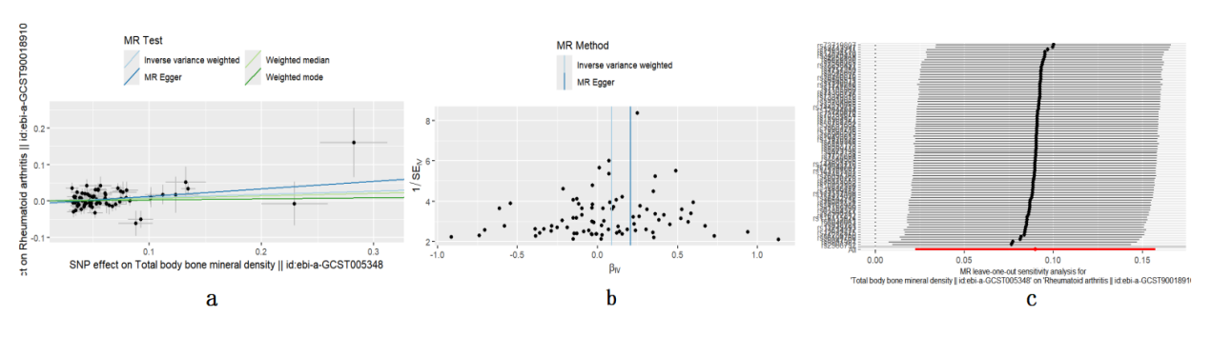
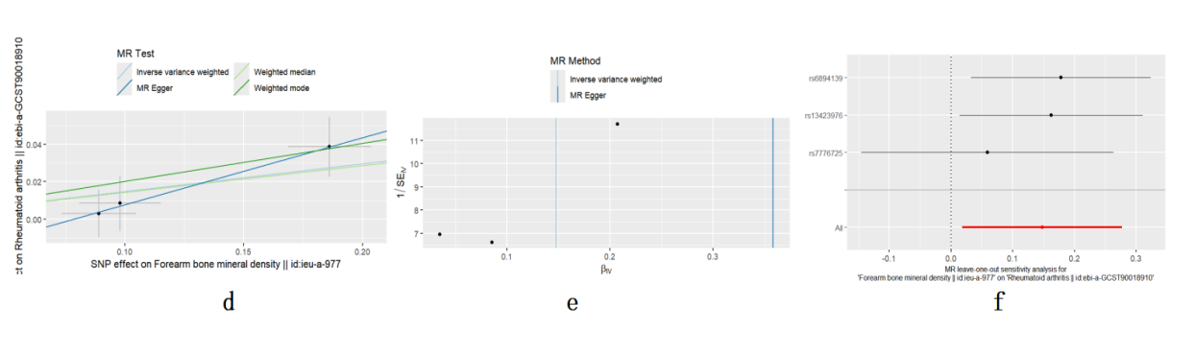
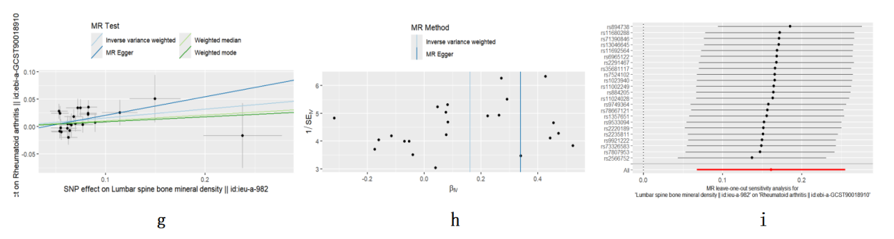
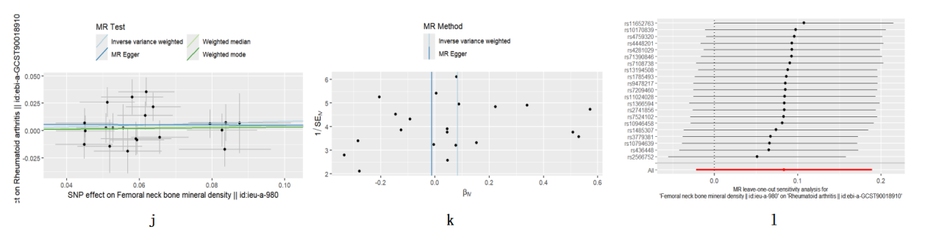
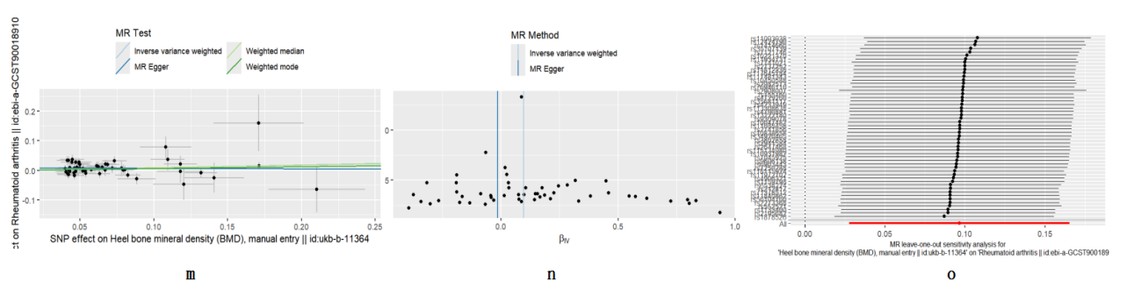

TB-BMD on RA:（a）scatter plots, (b) funnel plots, (c) leave-one-out plots
FA-BMD on RA:（d）scatter plots, (e) funnel plots, (f) leave-one-out plots
LS-BMD on RA:（g）scatter plots, (h) funnel plots, (i) leave-one-out plots
FN-BMD on RA:（j）scatter plots, (k) funnel plots, (l) leave-one-out plots
Heel-BMD on RA:（m）scatter plots, (n) funnel plots, (o) leave-one-out plots

Supplementary Figure 1-2 depicts scatter plots, funnel plots, and leave-one-out analyses of Bone Mineral Density at Different Ages on RA.
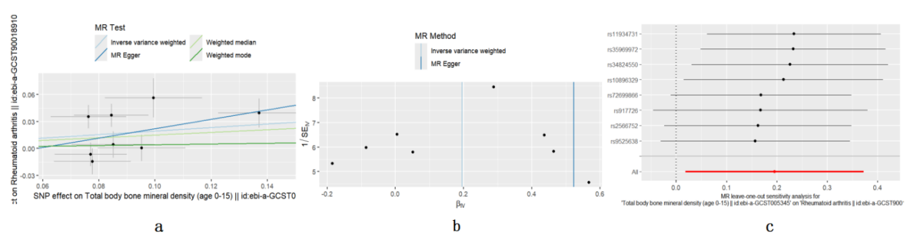
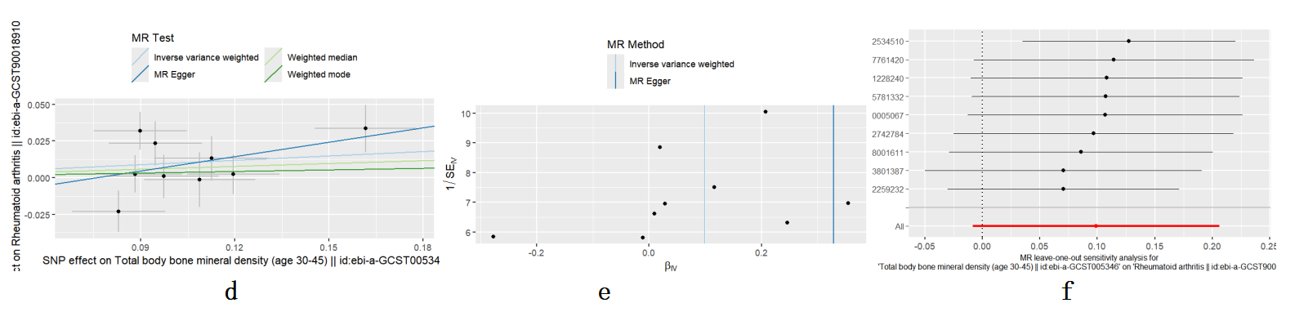
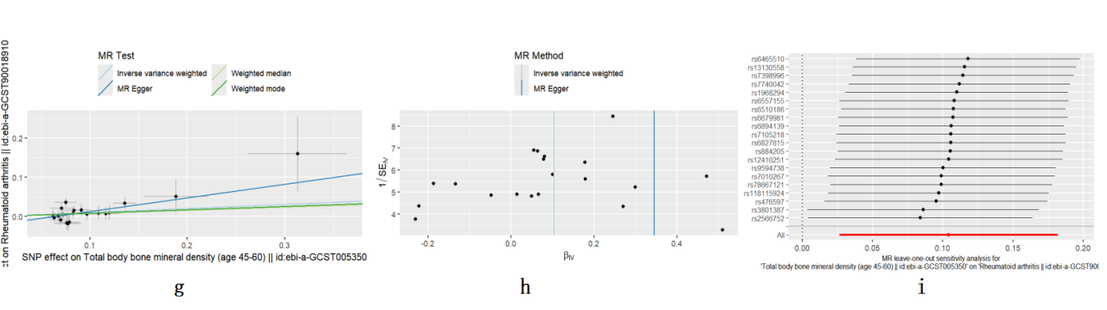
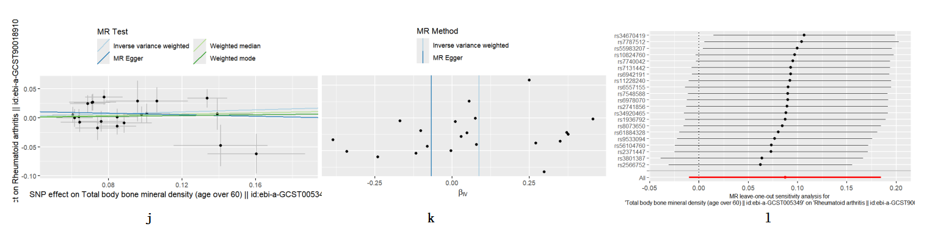

Age 0-15-BMD on RA:（a）scatter plots, (b) funnel plots, (c) leave-one-out plots
Age 30-15-BMD on RA:（d）scatter plots, (e) funnel plots, (f) leave-one-out plots
Age 45-60-BMD on RA:（g）scatter plots, (h) funnel plots, (i) leave-one-out plots
Age ＞60-BMD on RA:（j）scatter plots, (k) funnel plots, (l) leave-one-out plots

Supplementary Figure 2-1 depicts scatter plots, funnel plots, and leave-one-out analyses of RA on Bone Mineral Density at Different Sites.
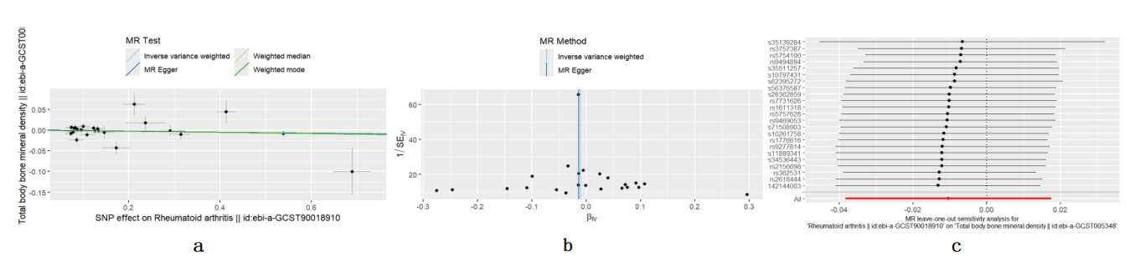
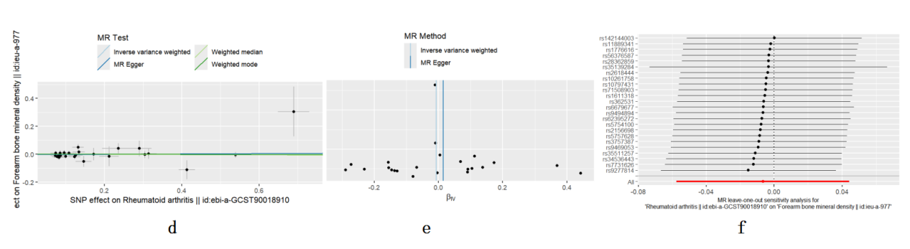
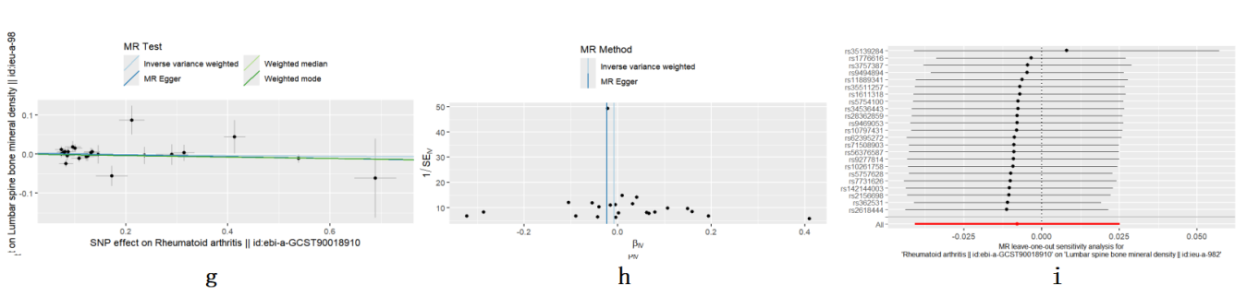
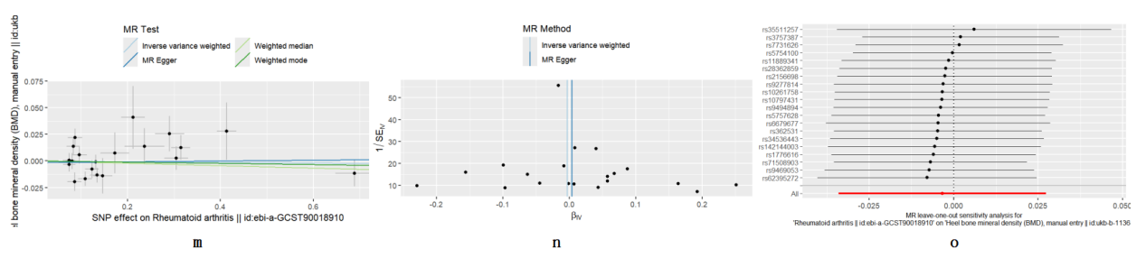
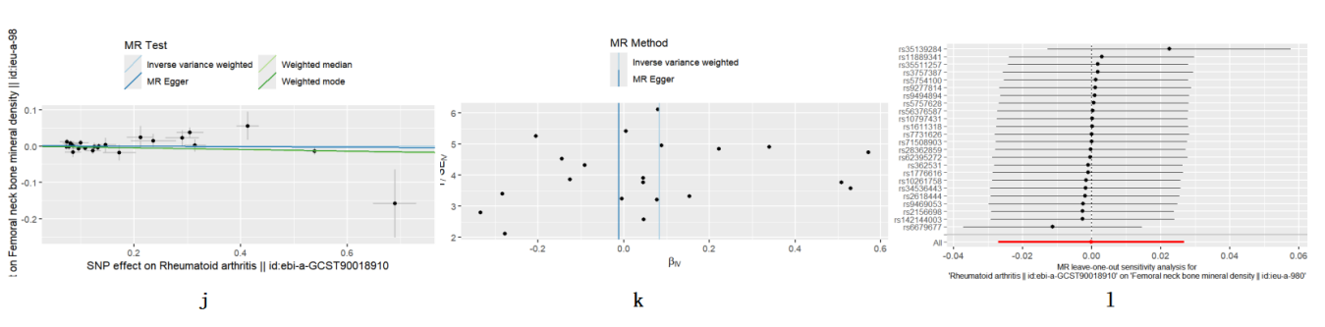

RA on TB-BMD（a）scatter plots, (b) funnel plots, (c) leave-one-out plots
RA on FA-BMD（d）scatter plots, (e) funnel plots, (f) leave-one-out plots
RA on LS-BMD（g）scatter plots, (h) funnel plots, (i) leave-one-out plots.MR-PRESSO results: Global Test P-value=0.04166667, excluding rs6679677.Continue with MR analysis
RA on FN-BMD（j）scatter plots, (k) funnel plots, (l) leave-one-out plots
RA on Heel-BMD（m）scatter plots, (n) funnel plots, (o) leave-one-out plots.Global Test P-value=0.001333333, excluding rs2618444.Continue with MR analysis
Supplementary Figure 2-2 depicts scatter plots, funnel plots, and leave-one-out analyses of RA on Bone Mineral Density at Different Ages.
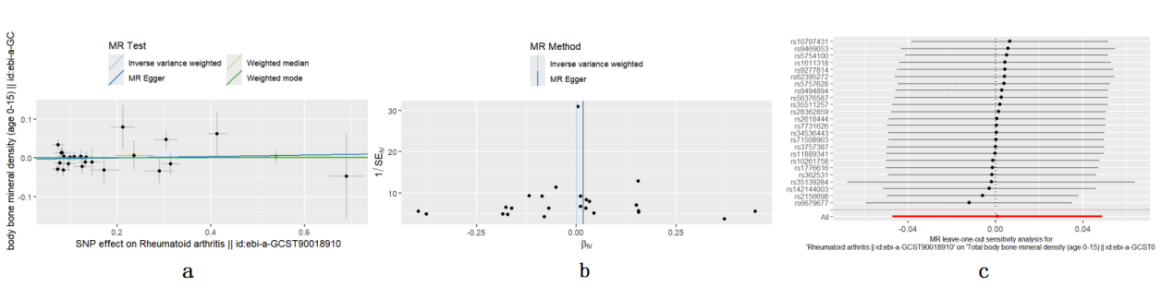
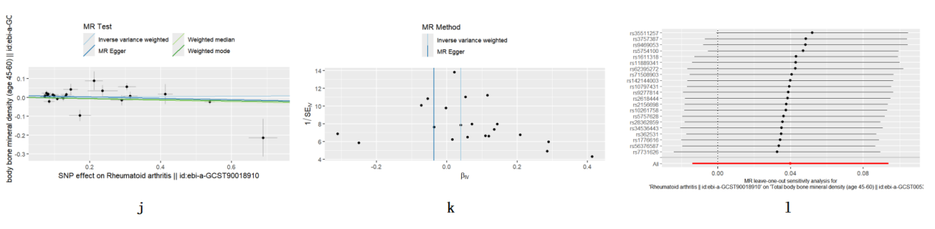
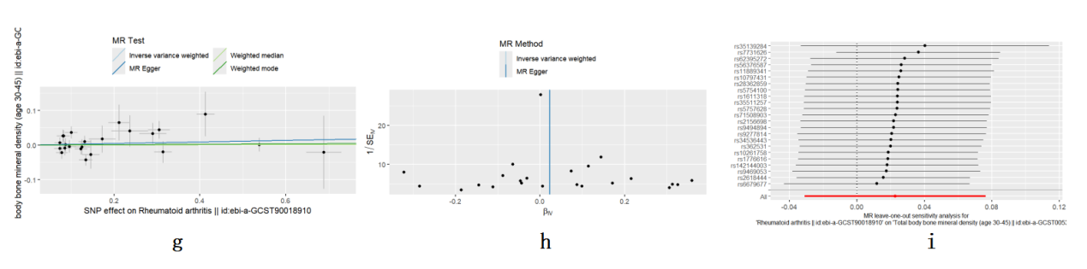
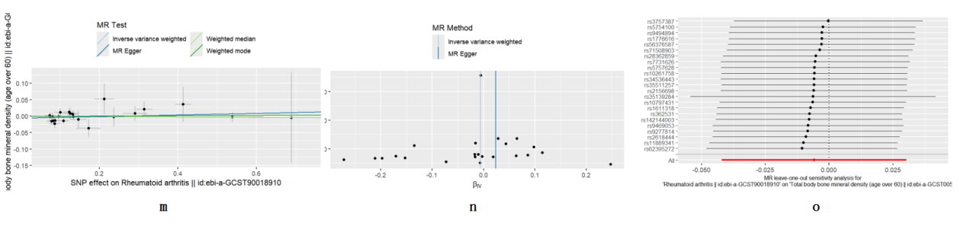
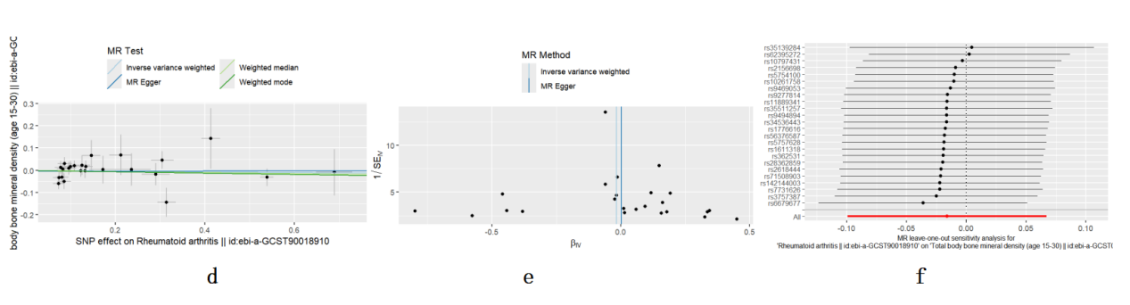

RA on Age 0-15-BMD（a）scatter plots, (b) funnel plots, (c) leave-one-out plots.
RA on Age 15-30-BMD（d）scatter plots, (e) funnel plots, (f) leave-one-out plots.
RA on Age 30-45-BMD（g）scatter plots, (h) funnel plots, (i) leave-one-out plots.MR-PRESSO results: Global Test P-value=0.04133333, excluding rs3757387.Continue with MR analysis
RA on Age 45-60-BMD（j）scatter plots, (k) funnel plots, (l) leave-one-out plots.MR-PRESSO results: Global Test P-value=0.006666667, excluding rs35139284,rs6679677,rs9494894.Continue with MR analysis
RA on Age ＞60-BMD（m）scatter plots, (n) funnel plots, (o) leave-one-out plots. rs6679677 (pval.outcome 2.14E-4) may interfere with the causal relationship between BMD and RA risk in those over 60, so it was excluded.Continue with MR analysis

Supplementary Figure 3-1. Mendelian randomization analysis results for the effects of BMD at different sites on RA after removal of potentially pleiotropic SNPs.
RA, Rheumatoid arthritis; FN-BMD, femoral neck bone mineral density; LS-BMD, lumbar spine bone mineral density; TB-BMD, total body bone mineral density; FA-BMD, forearm bone mineral density; Heel-BMD, heel bone mineral density; CI, confidence interval, inverse-variance-weighted; OR, Odds ratios; CI, confidence interval.
The bold font is used to highlight the result of P < 0.05.

Supplementary Figure 3-2. Mendelian randomization analysis results for the effects of BMD at different Ages on RA after removal of potentially pleiotropic SNPs.
RA, Rheumatoid arthritis;CI, confidence interval, inverse-variance-weighted; OR, Odds ratios; CI, confidence interval.
The bold font is used to highlight the result of P < 0.05.

Supplementary Figure 4-1. Causal effects of RA on BMD at different sites after removal of potentially pleiotropic SNPs.
RA, Rheumatoid arthritis; FN-BMD, femoral neck bone mineral density; LS-BMD, lumbar spine bone mineral density; TB-BMD, total body bone mineral density; FA-BMD, forearm bone mineral density; Heel-BMD, heel bone mineral density; CI, confidence interval, inverse-variance-weighted; OR, Odds ratios; CI, confidence interval.

Supplementary Figure 4-2. Causal effects of RA on BMD at different Ages after removal of potentially pleiotropic SNPs.
RA, Rheumatoid arthritis;IVW, inverse-variance-weighted; OR, Odds ratios; CI, confidence interval.

