Supplementary Figures

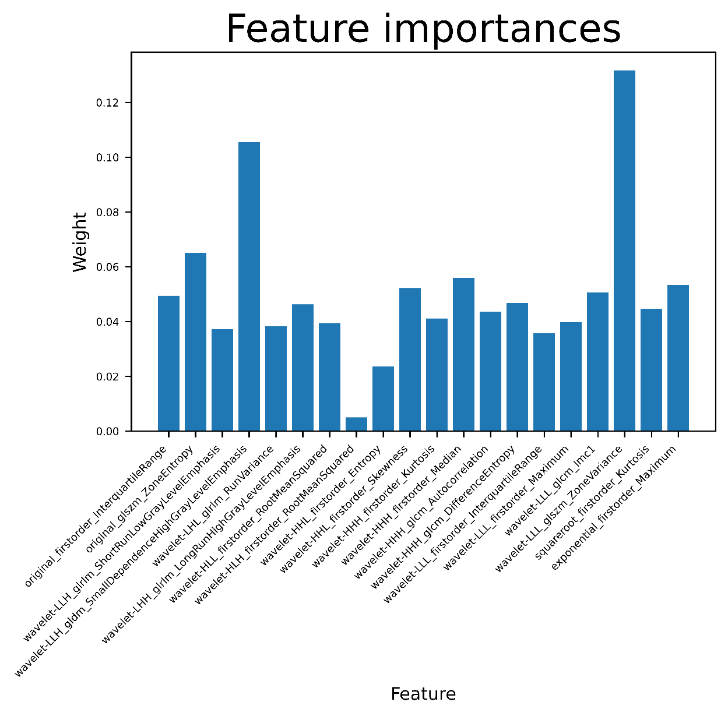
Supplementary Figure 1. The feature significance graph shows 20 important radiomics signatures and their corresponding feature coefficients.

20 corresponding feature coefficients:

0.04943341, 0.0650934 , 0.03715707, 0.10543799, 0.03823163,
0.0462575 , 0.03942079, 0.00001 , 0.02353024, 0.05219965,
0.04114265, 0.05598072, 0.04353325, 0.04680411, 0.03569015,
0.03983657, 0.05059297, 0.13172768, 0.04463004, 0.05330012

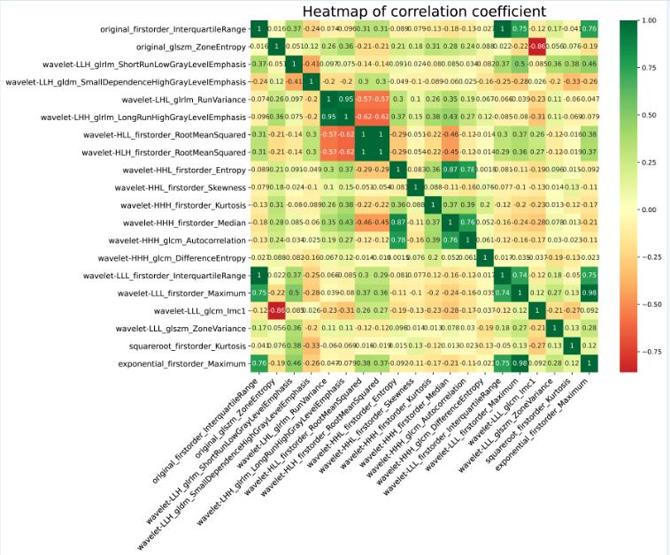

Supplementary Figure 2. The feature heatmap displays the correlation between 20 important radiomics signatures extracted from the training data set by color. The greener the color, the higher the correlation. Conversely, the redder the color, the lower the correlation.

