Supporting information
Macrophage Membrane Coated Manganese Dioxide Nanoparticles loaded with Rapamycin Alleviate Intestinal Ischemia-Reperfusion Injury by Reducing Oxidative Stress and Enhancing Autophagy
Ruxiang Sheng,^{1#} Wei Wang, ^{2#} Weian Zeng, ³ Bin Li,⁴ Haoyuan Yu,⁵ Xuan Li,¹ Yanqiu Liang,¹ Ying Wang,¹ Yuhui Liao,² Dezhao Liu¹
1. Department of Anesthesiology, The Fifth Affiliated Hospital of Sun Yat-Sen University, Zhuhai 519000, China.
2. Molecular Diagnosis and Treatment Center for Infectious Diseases Dermatology Hospital of Southern Medical University, Guangzhou 510091, China.
3. Department of Anesthesiology, State Key Laboratory of Oncology in South China. Guangdong Provincial Clinical Research Center for Cancer, Sun Yat-sen University Cancer Center, Guangzhou 510060, China.
4. School of Inspection, Ningxia Medical University, Yinchuan 750004, China.
5. Department of Hepatic Surgery and Liver Transplantation Center, The Third Affiliated Hospital of Sun Yat-Sen University, Guangzhou 510630, China.
#These authors contributed equally to this work.
Corresponding authors: Yuhui Liao (liaoyh8@mail.sysu.edu.cn), and Dezhao Liu (sumsldz@126.com)

Figure S1. UV-vis absorption spectra of KMnO₄, RAPA, MnO₂, and Ma@(MnO₂+RAPA).
Figure S2. EDS analysis of MnO2 nanoparticles.
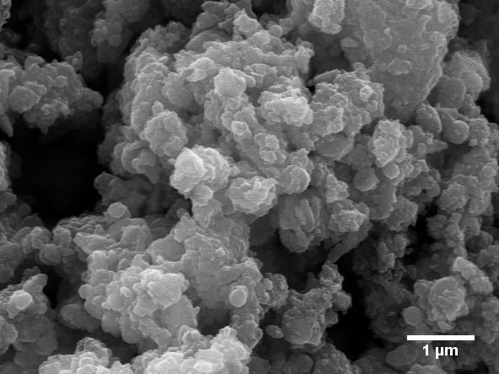
Figure S3. SEM image of honeycomb MnO₂ nanoparticles.
Figure S4. XRD pattern of MnO₂ nanoparticles.
Figure S5. Nitrogen sorption isotherms of MnO₂ nanoparticles.
Figure S6. Pore distribution of MnO₂ nanoparticles.
A
B
Figure S7. H₂O₂ scavenging behaviour of A) Ma@MnO₂ and B) MnO₂+RAPA nanoparticles with multiple concentrations over 4 hours.

Figure S8. Viability of IEC-6 cells subsequent to incubation with diverse concentrations of RAPA, Ma@MnO₂, and MnO₂+RAPA nanoparticles for 24 hours. *P < 0.05, **P < 0.01.

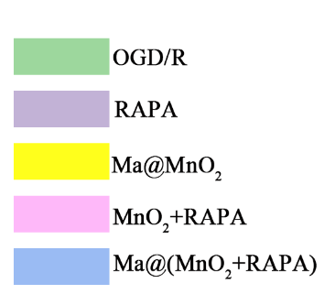
2 h

4 h
6 h

8 h
10 h

12 h
Figure S9. Viability of IEC-6 cells after incubation with RAPA (0.94 μg mL⁻¹), Ma@MnO₂, MnO₂+RAPA, and Ma@(MnO₂+RAPA) (with equal dose of MnO₂ at 1.88 μg mL⁻¹) nanoparticles over different durations of OGD.

