Supplementary Information
Title: Core-Shell Magnetic Nanocarriers: Fe₃O₄-Hydroxyapatite/Polysuccinimide Hybrids for Enhanced Oral Bioavailability of Fluorouracil
Author: Wenhui Zhang ¹, Qiang Wang ², Fengguo Zhai ¹, Xingjun Fan ³, Fanqin Meng ¹, Guangzhi Shen ¹, Ying Zhu ¹, Jingdan Cao ¹, Fengbo Yu ^{1*}
Author affiliations: ¹ School of Pharmacy, Mudanjiang Medical University, Mudanjiang 157011, People’s Republic of China; ² Hongqi People Hospital, Mudanjiang Medical University, Mudanjiang 157011, People’s Republic of China; ³ School of Public Health, Mudanjiang Medical University, Mudanjiang 157011, People’s Republic of China
Correspondence: Fengbo Yu
School of Pharmacy, Mudanjiang Medical University, Mudanjiang 157011, People’s Republic of China
Email: yfb526@126.com

File List:
- Ultraviolet scanning spectra of Fluorouracil (5-FU)
- Standard curve of Fluorouracil (5-FU)
- FT-IR spectra of different 5-FU@DC and 5-FU@FeDC
- Hemolytic test results of different 5-@DC and 5-FU@FeDC
- BET and pore size analysis

- Ultraviolet scanning spectra of Fluorouracil (5-FU)

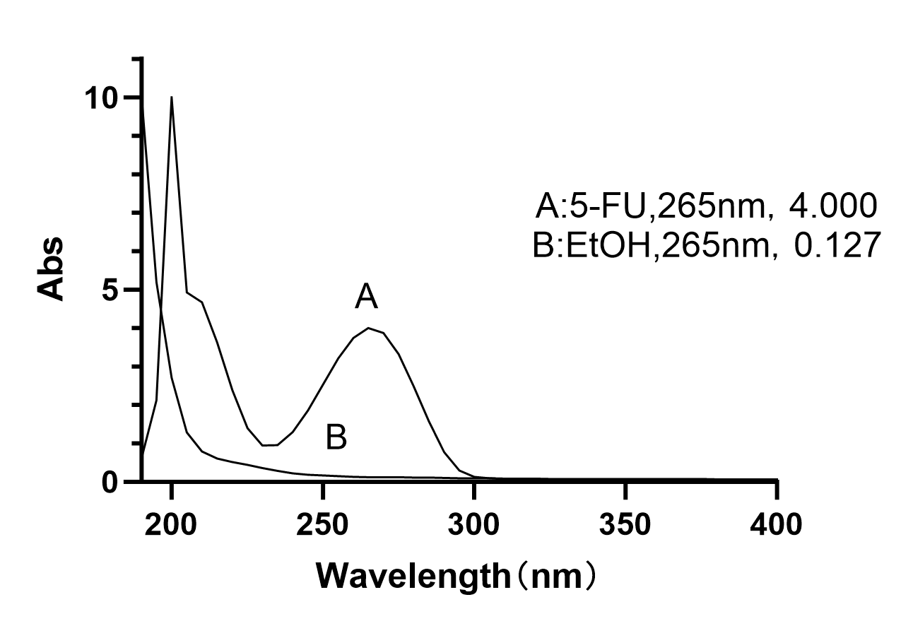
Fig. S1. Ultraviolet scanning spectra of Fluorouracil (5-FU)
As Fig. S1 shown, 265 nm was selected as the detection wavelength of 5-FU.
- Standard curve of 5-FU
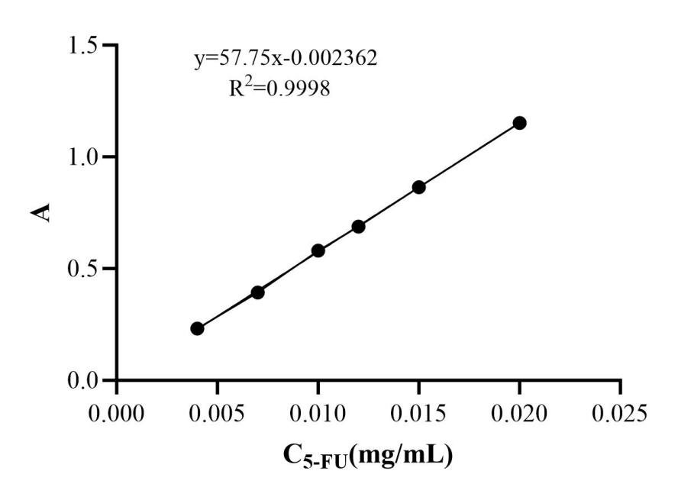
Fig. S2. Standard curve of Fluorouracil (5-FU)
As Fig. S2 shown, standard curve of 5-FU was A=57.75 C- 0.002362, R²=0.9998, the linearity was good in the concentration range of 0.004 mg/mL~0.02 mg/mL.
- FT-IR spectra of different 5-FU@DC and5-FU@FeDC

Fig. S3. FT-IR spectra of different 5-FU@DC and 5-FU@FeDC
As illustrated in the Fig. S3, the infrared characteristic peaks of all formulations closely resemble those of PSI, indicating that the chemical structure of PSI dominates the surface properties of the composite materials. This alignment suggests that PSI forms a uniform coating on the surface of the nanoparticles, effectively masking the characteristic peaks of the underlying HAP and Fe/HAP components. The strong presence of PSI-related peaks further confirms the successful integration of PSI into the composite structure, which is consistent with the observed improvements in dispersibility and stability.
- Hemolytic test results of different 5-FU@DC and 5-FU@FeDC

Fig. S4. Results of Hemolytic A: 5-FU@DC; B: 5-FU@FeDC20; C: 5-FU@FeDC30; D: 5-FU@FeDC40
The test sample was injected if there was no aggregation or hemolysis within 3 hours after hemolysis occurred in the positive control tube but not in the negative control group. However, if hemolysis or aggregation occurred in the solution of the sample to be tested within 3 h, the sample was not injected. No hemolysis was in any preparation group, as shown in Fig. S4.
Table S1 Hemolysis rate results of 5-FU@DC and Fe@FeDC
Tested drug | 5-FU@DC |  | 5-FU@FeDC20 |  | 5-FU@FeDC30 |  | 5-FU@FeDC40
Tested drug | A | Hemolysis rate/% | A | Hemolysis rate/% | A | Hemolysis rate/% | A | Hemolysis rate/%
Deionized water | 2.210 | 100 | 2.210 | 100 | 2.210 | 100 | 2.210 | 100
0.9% Sodium Chloride | 0.138 | 0.05 | 0.138 | 0.05 | 0.138 | 0.05 | 0.138 | 0.05
1 | 0.142 | 0.19 | 0.150 | 0.58 | 0.147 | 0.43 | 0.162 | 1.16
2 | 0.144 | 0.29 | 0.153 | 0.72 | 0.156 | 0.87 | 0.170 | 1.54
3 | 0.145 | 0.34 | 0.163 | 1.30 | 0.155 | 0.82 | 0.164 | 1.25
4 | 0.148 | 0.48 | 0.167 | 1.40 | 0.154 | 0.87 | 0.153 | 0.72
5 | 0.152 | 0.68 | 0.174 | 1.74 | 0.157 | 0.92 | 0.170 | 1.54
The low hemolysis rates observed across all tested concentrations of 5-FU-DC, 5-FU@FeDC20, 5-FU@FeDC30, and 5-FU@FeDC40 (Table S1) demonstrate the excellent biocompatibility of these formulations. This is a critical finding, as hemolysis is a key indicator of material toxicity and compatibility with biological systems. The hemolysis rate threshold for biomaterials is typically set at 5%, and the fact that all formulations remained well below this limit (≤2.0%) strongly supports their safety profile. These results suggest that the encapsulation of 5-FU within the FeDC carriers does not induce significant damage to red blood cell membranes, which is crucial for intravenous administration. The low hemolytic potential can be attributed to the stable and biocompatible nature of the FeDC carriers, which effectively shield the drug from direct interaction with blood components. This property is particularly important for reducing the risk of adverse effects such as anemia, thrombosis, or immune responses during in vivo applications. Furthermore, the consistency of the hemolysis rates across different concentrations (Table S1) indicates that the formulations maintain their safety even at higher doses. This dose-independent safety profile is advantageous for therapeutic applications, as it allows for flexibility in dosing regimens without compromising biocompatibility.

5 Specific Surface Area and Pore Structure Determination (BET)
The high drug-loading capacity of nano-carriers represents a critical parameter for optimizing drug delivery systems, as it allows therapeutic efficacy to be achieved at reduced dosages while enhancing delivery efficiency. To systematically investigate this property, we employed Quantachrome Instruments (version 2.01) to characterize the specific surface area and pore size distribution of four materials: HAP, Fe/HAP, DC, and FeDC30. These analyses were performed via nitrogen adsorption-desorption isotherms at 77 K using silica-based substrates, a standardized methodology to evaluate their structural characteristics and assess their potential for facilitating optimal drug adsorption kinetics and controlled release profiles. The derived porosity data provide essential insights into the relationship between nanomaterial architecture and pharmaceutical payload capacity.

Fig. S5. BET (A) and aperture maps (B) of HAP, Fe/HAP20, Fe/HAP30, Fe/HAP40, DC, FeDC30
According to the IUPAC classification of adsorption-desorption isotherms, the N₂ adsorption-desorption isotherms of HAP, Fe/HAPs, DC, and FeDC30 correspond to type IV isotherms (S5. A). In the low-pressure region, the adsorption increased gradually as N₂ molecules adsorb in single to multiple layers on the mesopore surfaces. At p/p₀ values around 0.5–0.8, a sudden increase in adsorption was observed, followed by a third increase at higher p/p₀ values. Here, the desorption isotherm did align with the adsorption isotherm, and the desorption isotherm was positioned above it, forming an H3-type hysteresis loop. This hysteresis loop suggests that the material has an accumulation of mesopores with an irregular pore structure. The pore size distribution peaks ranged from 2 to 20 nm (S5. B).
Table S2 BET Results of HAP, Fe/HAP20, Fe/HAP30, Fe/HAP40, DC, FeDC30
Samples | SinglePoint BET (m²/g) | MultiPoint BET (m²/g) | Total pore volume for pores with Diameter  (cm³/g) | Average pore Diameter  (nm)
HAP | 29.02 | 47.34 | 0.0965 | 8.15
Fe/HAP20 | 36.19 | 51.45 | 0.1192 | 9.66
Fe/HAP30 | 49.02 | 73.73 | 0.1428 | 7.75
Fe/HAP40 | 66.13 | 102.50 | 0.2121 | 8.28
DC | 163.69 | 166.84 | 0.3980 | 9.54
FeDC30 | 564.00 | 681.70 | 2.1530 | 12.63
Table S2 shows that the average pore size of HAP, Fe/HAP20, Fe/HAP30, Fe/HAP40, DC, FeDC30 ranged from 7 to 13 nm, all within the 2–50 nm range, indicating mesopore formation. Compared with HAP and Fe/HAP alone, the specific surface area and pore volume of DC and FeDC30, with an outer PSI coating, were significantly increased. This suggested enhanced adsorption capacity and indicated that the PSI coating disrupted the aggregation of HAP and Fe/HAP, resulting in nanoparticles with smaller particle sizes. The increase in specific surface area was particularly notable for FeDC30. The enhanced specific surface area and pore volume of DC and FeDC30 are particularly advantageous for applications requiring high adsorption capacity, such as drug delivery or catalytic processes. The PSI coating not only stabilizes the nanoparticles but also contributes to their dispersibility, which is critical for achieving uniform performance in practical applications. Furthermore, the mesoporous structure of these materials facilitates efficient mass transfer and accessibility of active sites, which is essential for optimizing their functional performance.

