Supporting information

Preparation and characterization of Mitochondrial-targeted nitronyl nitroxide loaded PLGA nanoparticles for brain injury induced by hypobaric hypixia in mice
Qingyue Da^{1,2}, Min Xu^{3,4}, Yiting Tian², Huiping Ma², Haibo Wang^{3*}, Linlin Jing^{1,2*}

¹ Department of Pharmacy, The First Affiliated Hospital of Xi’an Jiaotong University, Xi’an 710061, China
² Department of Pharmacy, The 940th Hospital of Joint Logistics Support force of PLA, Lanzhou, Gansu, 730050, China.
³ Department of Chemistry, School of Pharmacy, The Air Force Medical University, Xi’an 710032, China
⁴ The Third Stationed Outpatient Department, General Hospital of Central Theater Command, Wuhan 430070, China

Correspondence
Linlin Jing, Department of Pharmacy, The First Affiliated Hospital of Xi'an Jiaotong University, NO.277 Yanta West Road, Yanta District, Xi’an, Shaanxi, 710061, People’s Republic of China. Tel +86-029-85323537, E-mail address: jinglinlin@xjtufh.edu.cn
Haibo Wang, Department of Chemistry, School of Pharmacy, The Air Force Medical University, No.169, Changle West Road, Xi'an, Shaanxi, 710032, People’s Republic of China. Tel +86-029-84774473, E-mail address: haibo7691@fmmu.edu.cn.

1. Material and method

1.1 Chemical Materials
Polyvinyl alcohol (PVA) was purchased from Chengdu Kelong Chemical Co.,Ltd.(Chengdu, China). D-α-Tocopherol polyethylene glycol succinate (TPGS) was purchased from Beijing Solarbio Science & Technology Co., Ltd. (Beijing, China)

1.2 Single-Factor Experiments of TPP-C₆-HPN@PLGA-NPs

Test for stabilizer
The organic phase was composed of PLGA (10 mg/mL), TPP-C₆-HPN (1 mg/mL) and CH₂Cl₂, which was added dropwise into the water phase included stabilizer (as shown in Table S1), then the mixture was emulsified using ultraprobe sonicator at 200 W for 5 min in an ice bath. The the ratio of the aqueous phase to the oil phase was 10:1. Other processes were same as the method described in the manuscript. The experimental responses measured included particle size, PDI and zeta Potential.

Test for the contents of stabilizer
The organic phase was composed of PLGA (10 mg/mL), TPP-C₆-HPN (1 mg/mL) and CH₂Cl₂, which was added dropwise into the water phase included different concentration of P188 (as shown in Table S2) and 0.1% SC, then the mixture was emulsified using ultraprobe sonicator at 200 W for 5 min in an ice bath. The the ratio of the aqueous phase to the oil phase was 10:1. Other processes were same as the method described in the manuscript. The experimental responses measured included particle size, PDI, zeta potential, encapsulation efficiency (EE), and drug loading (DL).

Test for the drug-load ratios
The organic phase was composed of different ratio of PLGA and TPP-C₆-HPN in CH₂Cl₂ (as shown in Table S3), which was added dropwise into the water phase included 0.5% P188 and 0.1%SC, then the mixture was emulsified using ultraprobe sonicator at 200 W for 5 min in an ice bath. The the ratio of the aqueous phase to the oil phase was 10:1. Other processes were same as the method described in the manuscript. The experimental responses measured included particle size, PDI, zeta potential, EE, and DL.

Test for the oil-water ratios
The organic phase was composed of PLGA (10 mg/mL), TPP-C₆-HPN (1 mg/mL) and CH₂Cl₂, which was added dropwise into the water phase included 0.5% P188 and 0.1% SC, then the mixture was emulsified using ultraprobe sonicator at 200 W for 90 s in an ice bath. The the ratio of the aqueous phase to the oil phase was set as shown in Table S4) Other processes were same as the method described in the manuscript. The experimental responses measured included particle size, PDI, zeta potential, EE, and DL.

Test for the ultrasonic power
The organic phase was composed of PLGA (10 mg/mL), TPP-C₆-HPN (1 mg/mL) and CH₂Cl₂, which was added dropwise into the water phase included 0.5% P188 and 0.1% SC, then the mixture was emulsified using ultraprobe sonicator at 150, 200, 250, and 300 W, respectively, for 90 s in an ice bath. The the ratio of the aqueous phase to the oil phase was set as 10:1 Other processes were same as the method described in the manuscript. The experimental responses measured included particle size, PDI, zeta Potential, EE, and DL.

Test for the ultrasonic time
The organic phase was composed of PLGA (10 mg/mL), TPP-C₆-HPN (1 mg/mL) and CH₂Cl₂, which was added dropwise into the water phase included 0.5% P188 and 0.1% SC, then the mixture was emulsified using ultraprobe sonicator at 200 for 3,5,7, and 10 min, respectively, in an ice bath. The the ratio of the aqueous phase to the oil phase was set as 10:1. Other processes were same as the method described in the manuscript. The experimental responses measured included particle size, PDI, zeta potential, EE, and DL.

1.3 Preparation of CY5.5@PLGA-NPs
The organic phase was composed of PLGA (10 mg/mL), CY5.5 (0.2 mg/mL) in 1 ml CH₂Cl₂, which was added dropwise into the water phase included 0.3% P188 and 0.1% SC, then the mixture was emulsified using ultraprobe sonicator at 200 for 5 min in an ice bath. The the ratio of the aqueous phase to the oil phase was set as 10:1. Other processes were same as the the method described in the manuscript. The particle size, PDI and zeta potential were detected.

2. Results

2.1 Characterization of TPP-C₆-HPN
Figure S1 FTIR Spectra of TPP-C₆-HPN
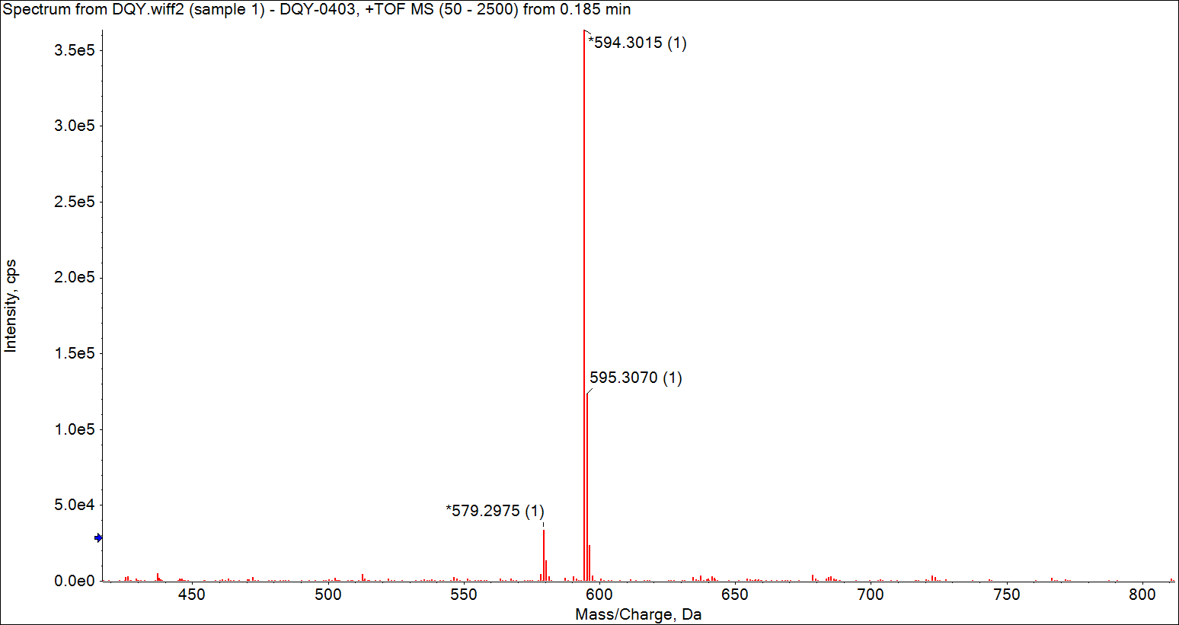
Figure S2 HRMS of TPP-C₆-HPN
Figure S3 ESR of TPP-C₆-HPN
2.2 Determination of the TPP-C₆-HPN content
Specificity of the TPP-C₆-HPN
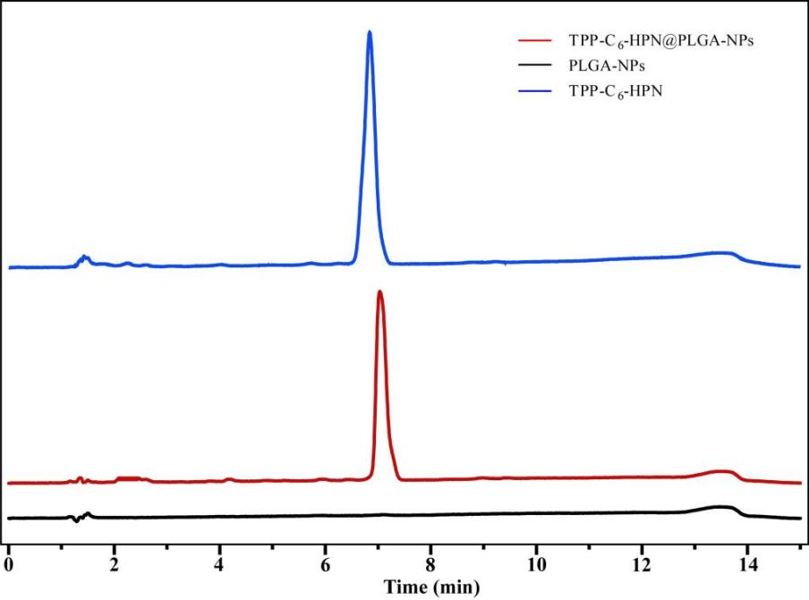
Figure S4 Displays the chromatography of of TPP-C₆-HPN, TPP-C₆-HPN@PLGA-NPs, and PLGA-NPs
Effect of stabilizer on the characteristics of TPP-C₆-HPN@PLGA-NPs
As shown in Table S1, P188 contributes more to the reduction of potential and PDI, while SC contributes to the reduction of particle size. The effect is more balanced when the two are mixed.

Table S1 Effect of stabilizer on the characteristics of TPP-C₆-HPN@PLGA-NPs (± s, n=3)
Stabilizer | Particle Size (nm) | PDI | Zeta Potential (mV)
1% PVA | 367.75 ± 9.62 | 0.276 ± 0.10 | -4.31 ± 0.12
0.5% P188 | 213.59 ± 5.48 | 0.094 ± 0.10 | -18.99 ± 0.21
0.5% TPGS | 258.68 ± 0.05 | 0.221 ± 0.01 | 3.39 ± 2.02
0.5% SC | 35.11 ± 6.35 | 0.480 ± 0.04 | -5.36 ± 2.98
1% PVA+0.1% TPGS | 370.30 ± 3.23 | 0.192 ± 0.03 | -4.27 ± 1.06
1% PVA+0.1% SC | 328.39 ± 12.11 | 0.143 ± 0.06 | -3.64 ± 2.96
0.5% P188+0.1% TPGS | 256.29 ± 1.06 | 0.175 ± 0.10 | 2.10 ± 3.12
0.5% P188+0.1% SC | 140.29 ± 4.32 | 0.197 ± 0.03 | -22.37 ± 2.44
Effect of concentration of P188 on the characteristics of TPP-C₆-HPN@PLGA-NPs
As shown in Table S2, the concentration of P188 had little effect on particle size, PDI and ζ-potential, but the EE and DL increased with the increase of concentration.
Table S2 Effect of the concentration of P188 on the characteristics of TPP-C₆-HPN@PLGA-NPs (± s, n=3)
The contents of P188 (%) | Particle Size (nm) | PDI | Zeta Potential (mV) | EE (%) | DL (%)
0.1 | 117.44 ± 0.56 | 0.293 ± 0.01 | -22.95 ± 2.04 | 81.20 ± 0.49 | 6.90 ± 0.05
0.2 | 121.45 ± 4.05 | 0.300 ± 0.01 | -25.39 ± 0.49 | 85.45 ± 1.81 | 6.51 ± 0.43
0.3 | 123.28 ± 1.81 | 0.310 ± 0.01 | -30.59 ± 2.66 | 89.32 ± 0.33 | 6.82 ± 0.26
0.4 | 127.62 ± 0.68 | 0.301 ± 0.01 | -38.31 ± 5.44 | 91.14 ± 0.97 | 7.11 ± 0.50
0.5 | 126.26 ± 3.37 | 0.301 ± 0.01 | -30.77 ± 6.93 | 91.80 ± 0.94 | 7.60 ± 0.47
Effect of Drug-load ratios on the characteristics of TPP-C₆-HPN@PLGA-NPs
As shown in Table S3, Drug-load ratios can significantly affect the EE and DL. With the increase of drug loading ratio, the EE gradually increased, but the DL gradually decreased.
Table S3 Effect of Drug-load ratios on the characteristics of TPP-C₆-HPN@PLGA-NPs (± s, n=3)
Drug-load ratios | Particle Size (nm) | PDI | Zeta Potential (mV) | EE (%) | DL (%)
1:5 | 135.6±6.31 | 0.100±0.04 | -19.20±3.02 | 62.3±4.48 | 8.8±1.11
1:8 | 135.1±8.14 | 0.300±0.07 | -24.30±6.94 | 83.0±5.54 | 8.4±0.77
1:10 | 126.3±3.37 | 0.300±0.01 | -30.8±6.93 | 91.8±0.94 | 7.6±0.47
1:15 | 152.5±3.38 | 0.200±0.05 | -43.8±12.65 | 95.1±0.10 | 5.3±0.45
Effect of oil/water ratios on the characteristics of TPP-C₆-HPN@PLGA-NPs
As shown in Table S4, the oil/water ratio could significantly affect the particle size and DL. With the increase of the oil/water ratio, the particle size became smaller and the DL increased.
Table S4 Effect of oil-water ratios on the characteristics of TPP-C₆-HPN@PLGA-NPs (± s, n=3)
oil/water ratios | Particle Size (nm) | PDI | Zeta Potential (mV) | EE (%) | DL (%)
1:6 | 162.60±8.29 | 0.199±0.03 | -37.52±4.59 | 79.22±0.56 | 6.38±0.07
1:8 | 157.54±9.01 | 0.212±0.02 | -30.71±3.86 | 88.95±2.32 | 6.67±0.49
1:10 | 123.28±1.81 | 0.310±0.01 | -30.59±2.66 | 92.69±2.25 | 6.91±0.24
Effect of Ultrasonic power on the characteristics of TPP-C₆-HPN@PLGA-NPs
As shown in Table S5, the ultrasonic power had little effect on the properties of the NPs. When the ultrasonic power was set at 200 W, each index of the nanoparticles was better.
Table S5 Effect of ultrasonic power on the characteristics of TPP-C₆-HPN@PLGA-NPs (± s, n=3)
Ultrasonic power(W) | Particle Size (nm) | PDI | Zeta Potential (mV) | EE (%) | DL (%)
150 | 125.6±4.68 | 0.222±0.044 | -27.72±2.30 | 74.80±4.46 | 6.38±0.26
200 | 108.00±2.24 | 0.194±0.010 | -25.08±3.01 | 73.92±3.33 | 6.75±0.13
250 | 113.87±3.67 | 0.195±0.004 | -27.48±1.83 | 70.53±4.67 | 6.39±0.60
300 | 119.73±4.12 | 0.192±0.019 | -27.17±1.22 | 68.59±2.73 | 5.98±0.49
Effect of Ultrasonic time on the characteristics of TPP-C₆-HPN@PLGA-NPs
As shown in Table S6, with the increase of sonication time, the EE first increased and then decreased, and the particle size gradually decreased. When the ultrasound time was set as 5 min, the indexes of NPs were the best.
Table S6 Effect of Ultrasonic time on the characteristics of TPP-C₆-HPN@PLGA-NPs (± s, n=3)
Ultrasonic time(min) | Particle Size (nm) | PDI | Zeta Potential (mV) | EE (%) | DL (%)
3 | 140.37±25.58 | 0.193±0.07 | -29.85±5.82 | 82.06±3.21 | 6.48±0.35
5 | 113.87±10.16 | 0.199±0.02 | -29.63±2.78 | 87.41±0.95 | 7.17±0.12
7 | 104.55±5.98 | 0.215±0.01 | -25.31±1.00 | 74.09±1.91 | 5.98±0.11
10 | 108.00±3.65 | 0.247±0.05 | -24.95±2.17 | 76.40±2.23 | 6.08±0.13
Limit of detection (LOD) and limit of quantitation (LOQ) of TPP-C₆-HPN
As shown in Table S7, the corresponding LOD and LOQ values of TPP-C₆-HPN are 0.3 μg/mL and 1.0 μg/mL, respectively.
Table S7 LOD and LOQ of TPP-C₆-HPN (n = 6)
Concentration (μg/mL) | Peak area (mAU*s) | S/N
0.30 | 2.96 | 2.71
0.30 | 3.17 | 2.73
0.30 | 2.98 | 2.98
1.00 | 9.86 | 9.03
1.00 | 10.56 | 9.11
1.00 | 9.93 | 9.93
The calibration curve of TPP-C₆-HPN
Figure S5 TPP-C₆-HPN calibration curve
Accuracy and precision
Table S8 Accuracy and precision of TPP-C₆-HPN (n = 6)
Concentration (μg/mL) | Intra-day |  | Inter-day
Concentration (μg/mL) | Precision (RSD %) | Accuracy  (EE (%) | Precision (RSD %) | Accuracy  (EE (%)
6.25 | 1.94 | 0.49 | 0.42 | 0.30
25 | 0.99 | 0.80 | 1.43 | 1.07
100 | 0.82 | 0.86 | 2.01 | 1.18
Stability
Table S9 The stability of TPP-C₆-HPN (n=6)
Concentration (μg/mL) | 24 h at RT
Concentration (μg/mL) | Precision (RSD %) | Accuracy (EE %)
6.25 | 1.94 | 0.49
25 | 1.33 | 0.80
100 | 0.82 | 0.86
2.3 Single-Factor Experiments of TPP-C₆-HPN@PLGA-NPs
ANOVA for the Quadratic Model
Table S10 ANOVA for the Quadratic Model for the particle size (Y₁)
Source | Sum of squares | df | Mean square | F-value | p-value
Model | 5602.22 | 9 | 622.47 | 5.56 | 0.0171 | significant
X₁-W_{PLGA}:W_{TPP-C6-HPN} | 302.58 | 1 | 302.58 | 2.70 | 0.1443
X₂-V_{water}:V_{oil} | 1004.17 | 1 | 1004.17 | 8.96 | 0.0201
X₃-C_{P188} | 97.20 | 1 | 97.20 | 0.8674 | 0.3827
X₁X₂ | 0.4298 | 1 | 0.4298 | 0.0038 | 0.9524
X₁X₃ | 87.53 | 1 | 87.53 | 0.7811 | 0.4061
X₂X₃ | 32.43 | 1 | 32.43 | 0.2894 | 0.6073
X₁² | 2910.39 | 1 | 2910.39 | 25.97 | 0.0014
X₁² | 1082.85 | 1 | 1082.85 | 9.66 | 0.0171
X₁² | 51.19 | 1 | 51.19 | 0.4568 | 0.5208
Residual | 784.38 | 7 | 112.05
Lack of Fit | 607.90 | 3 | 202.63 | 4.59 | 0.0875 | not significant
Pure Error | 176.48 | 4 | 44.12
Cor Total | 6386.60 | 16

Table S11 ANOVA for the Quadratic Model for the EE (Y₂)
Source | Sum of squares | df | Mean square | F-value | p-value
Source | 434.14 | 9 | 48.24 | 5.19 | 0.0206 | significant
Model | 198.80 | 1 | 198.80 | 21.38 | 0.0024
X₁-W_{PLGA}:W_{TPP-C6-HPN} | 68.95 | 1 | 68.95 | 7.41 | 0.0296
X₂-V_{water}:V_{oil} | 0.8243 | 1 | 0.8243 | 0.0886 | 0.7746
X₃-C_{P188} | 7.97 | 1 | 7.97 | 0.8568 | 0.3854
X₁X₂ | 17.75 | 1 | 17.75 | 1.91 | 0.2096
X₁X₃ | 17.51 | 1 | 17.51 | 1.88 | 0.2123
X₂X₃ | 104.10 | 1 | 104.10 | 11.19 | 0.0123
X₁² | 49.20 | 1 | 49.20 | 5.29 | 0.0550
X₁² | 1.58 | 1 | 1.58 | 0.1703 | 0.6922
X₁² | 65.10 | 7 | 9.30
Residual | 38.32 | 3 | 12.77 | 1.91 | 0.2697 | not significant
Lack of Fit | 26.78 | 4 | 6.69
Pure Error | 499.24 | 16

Table S12 ANOVA for the Quadratic Model for the DL (Y₃)
Source | Sum of squares | df | Mean square | F-value | p-value
Source | 10.21 | 9 | 1.13 | 10.58 | 0.0026 | significant
Model | 6.48 | 1 | 6.48 | 60.39 | 0.0001
X₁-W_{PLGA}:W_{TPP-C6-HPN} | 0.7111 | 1 | 0.7111 | 6.63 | 0.0368
X₂-V_{water}:V_{oil} | 0.0951 | 1 | 0.0951 | 0.8867 | 0.3777
X₃-C_{P188} | 0.0000 | 1 | 0.0000 | 0.0002 | 0.9904
X₁X₂ | 0.3305 | 1 | 0.3305 | 3.08 | 0.1227
X₁X₃ | 0.1892 | 1 | 0.1892 | 1.76 | 0.2259
X₂X₃ | 0.3054 | 1 | 0.3054 | 2.85 | 0.1355
X₁² | 0.1178 | 1 | 0.1178 | 1.10 | 0.3296
X₁² | 0.1996 | 1 | 0.1996 | 1.86 | 0.2148
X₁² | 0.7511 | 7 | 0.1073
Residual | 0.3568 | 3 | 0.1189 | 1.21 | 0.4147 | not significant
Lack of Fit | 0.3943 | 4 | 0.0986
Pure Error | 10.96 | 16
Drug release model of TPP-C₆-HPN and TPP-C₆-HPN@PLGA-NPs
Table S13 Fitting results of drug release kinetics equations for TPP-C₆-HPN
 | Release model | Fitting equation | R²
TPP-HPN | Zero-order | Q = 31.27+3.72 * t | 0.5164
TPP-HPN | First-order | Q = 89.60585*(1-exp (-0.4502*t)) | 0.99383
TPP-HPN | Higuchi | Q = 22.25164*(t^{^0.5}) + 11.33737 | 0.78166
TPP-HPN | Ritger-Peppas | Q = 39.13173*(t^{^0.32219}) | 0.85783

Table S14 Fitting results of drug release kinetics equations for TPP-C₆-HPN@PLGA-NPs
 | Release model | Fitting equation | R²
TPP-C₆-HPN@PLGA-NPs | Zero-order | Q = 9.56+0.50*t | 0.69581
TPP-C₆-HPN@PLGA-NPs | First-order | Q = 42.53283*(1-exp(-0.1047*t)) | 0.99581
TPP-C₆-HPN@PLGA-NPs | Higuchi | Q = 5.54337*(t^{^0.5}) + 0.3242 | 0.89142
TPP-C₆-HPN@PLGA-NPs | Ritger-Peppas | Q = 6.07776*(t^{^0.4687}) | 0.97667
2.4 Characterization of CY5.5@PLGA-NPs
The measured particle size was 169.50 nm, the Zeta potential was -11.39 mV, and the PDI was 0.108.

