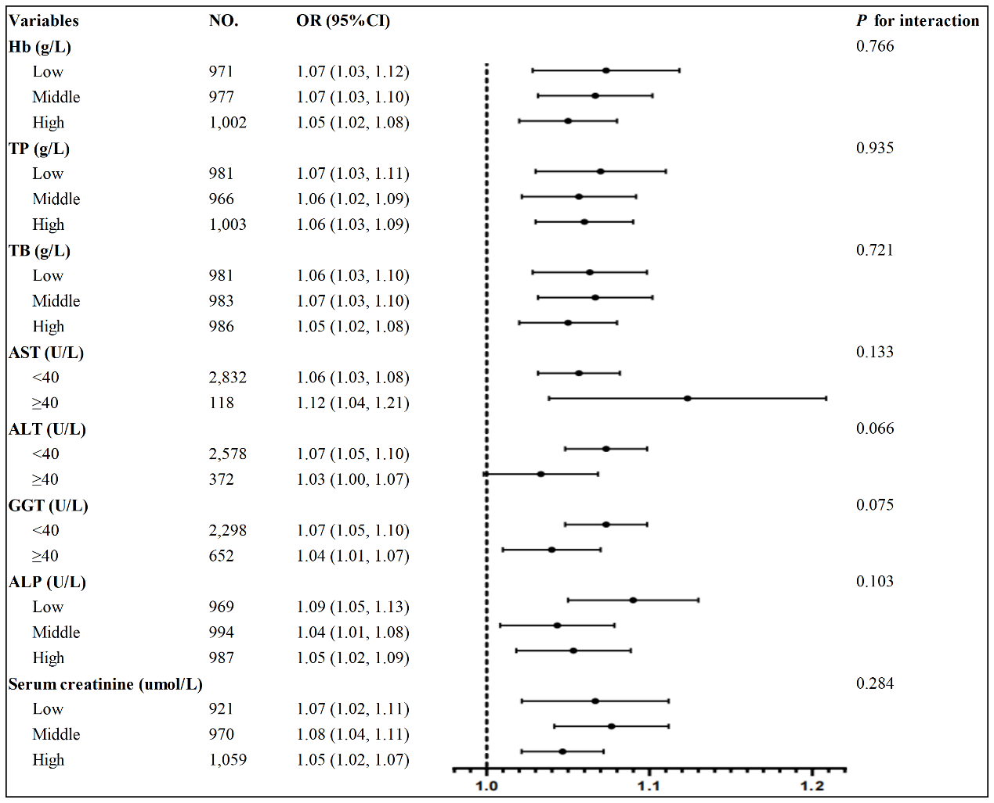

Supplementary Figure. 1 The relationship between LFC and hyperuricemia in different subgroups of prediabetic populations. Hb, hemoglobin; TP, total protein; TB, total bilirubin; AST, aspartate aminotransferase; ALT, alanine aminotransferase; GGT, glutamyl transpeptidase; ALP, alkaline phosphatase.

