Supplementary Table 1 : Real-time Polymerase Chain Reaction (PCR) Primers
Genes | Forward primer (5′ to 3′) | Reverse Primer (5′ to 3′)
NLRP3 | CGGGTTTCAACGCCGACTA | TTGGCACTAGAGACGGACAGA
IL-1β | GAAATGCCACCTTTTGACAGTG | TGGATGCTCTCATCAGGACAG
IL-18 | ATATCGACCGAACAGCCAAC | TTCCATCCTTCACAGATAGGG
β-actin | TGTTACCAACTGGGACGACGACA | CTGGGTCATCTTTTCACGGT

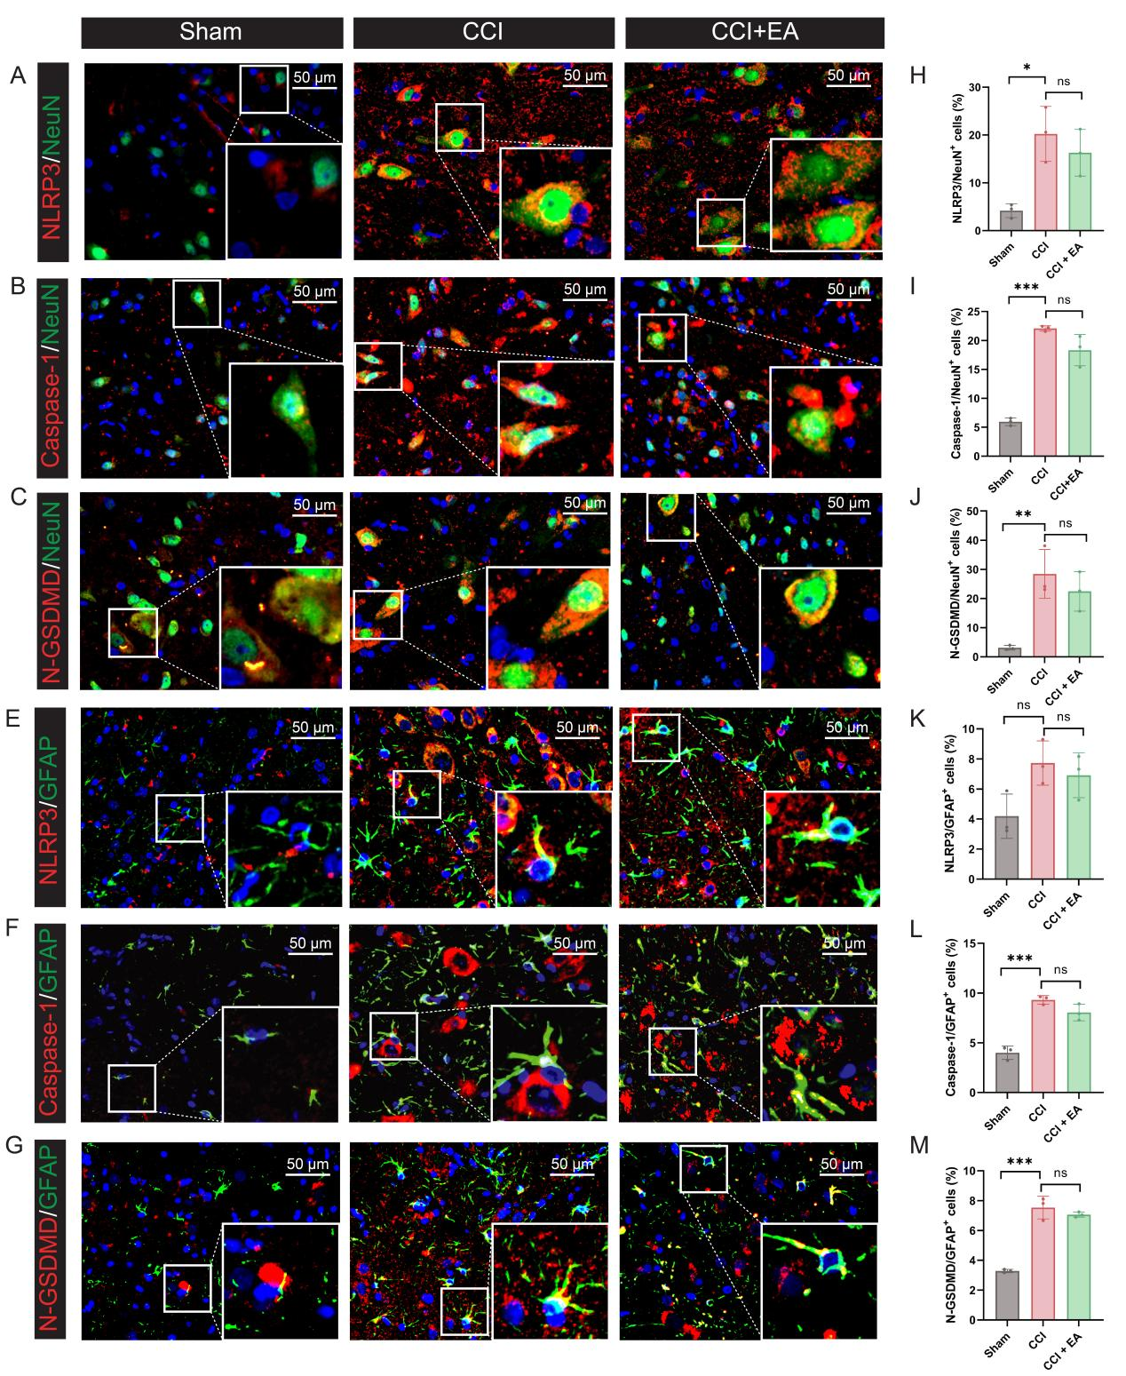
Supplementary Figure 1 EA failed to inhibit the pyroptosis in neurons and astrocyte following CCI operation. (A) Representative images of immunofluorescent analysis of NeuN⁺ (green), NLRP3⁺ (red) maker, and DAPI (blue) staining of nuclei in the spinal cord dorsal horn among groups. Scale bars, 50 μm. (B) Representative images of immunofluorescent analysis of NeuN⁺ (green), Caspase-1⁺ (red) maker, and DAPI (blue) staining of nuclei in the spinal cord dorsal horn among groups. Scale bars, 50 μm. (C) Representative images of immunofluorescent analysis of NeuN⁺ (green), N-GSDMD⁺ (red) maker, and DAPI (blue) staining of nuclei in the spinal cord dorsal horn among groups. Scale bars, 50 μm. (D)Representative images of immunofluorescent analysis of GFAP⁺ (green), NLRP3⁺ (red) maker, and DAPI (blue) staining of nuclei in the spinal cord dorsal horn among groups. Scale bars, 50 μm. (E) Representative images of immunofluorescent analysis of GFAP⁺ (green), Caspase-1⁺ (red) maker, and DAPI (blue) staining of nuclei in the spinal cord dorsal horn among groups. Scale bars, 50 μm. (F) Representative images of immunofluorescent analysis of GFAP⁺ (green), N-GSDMD⁺ (red) maker, and DAPI (blue) staining of nuclei in the spinal cord dorsal horn among groups. Scale bars, 50 μm. Quantification analysis the number of NLRP3/NeuN⁺ (G), Caspase-1/NeuN⁺ (H), N-GSDMD/NeuN⁺ (I), NLRP3/GFAP⁺ (J), Caspase-1/GFAP⁺ (K) and N-GSDMD/GFAP⁺ (L) in the spinal cord dorsal horn. Data presented as means ± s.d. *P < 0.05, **P < 0.01, ***P < 0.001, n = 3.

