Figure S1: Enlargement of the 800-2000 cm⁻¹ region of the FTIR spectra of bare M55 NPs (blue line), o-carboxymethyl chitosan (red line) and CM55 (pink line).
Figure S2: Zeta potential measurements of GM55 (red), CM55 (green), and PM55 (blue).
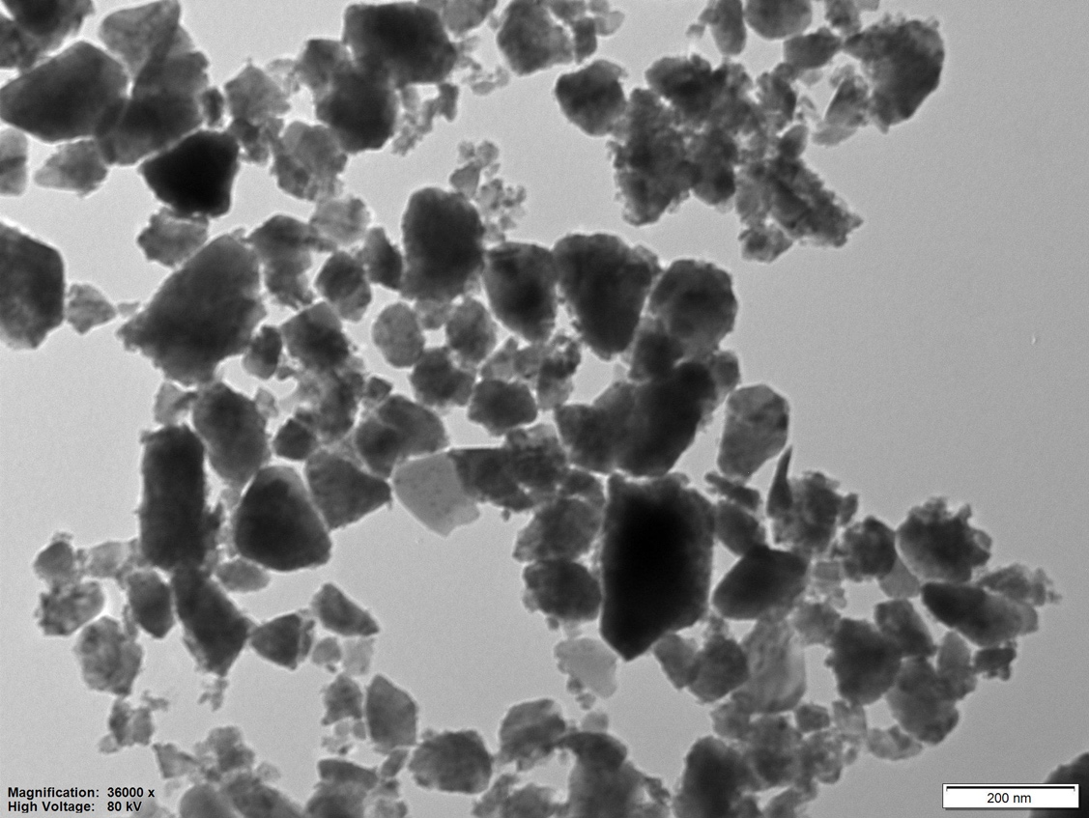
Figure S3: TEM image of M55, with scale bar = 200 nm.
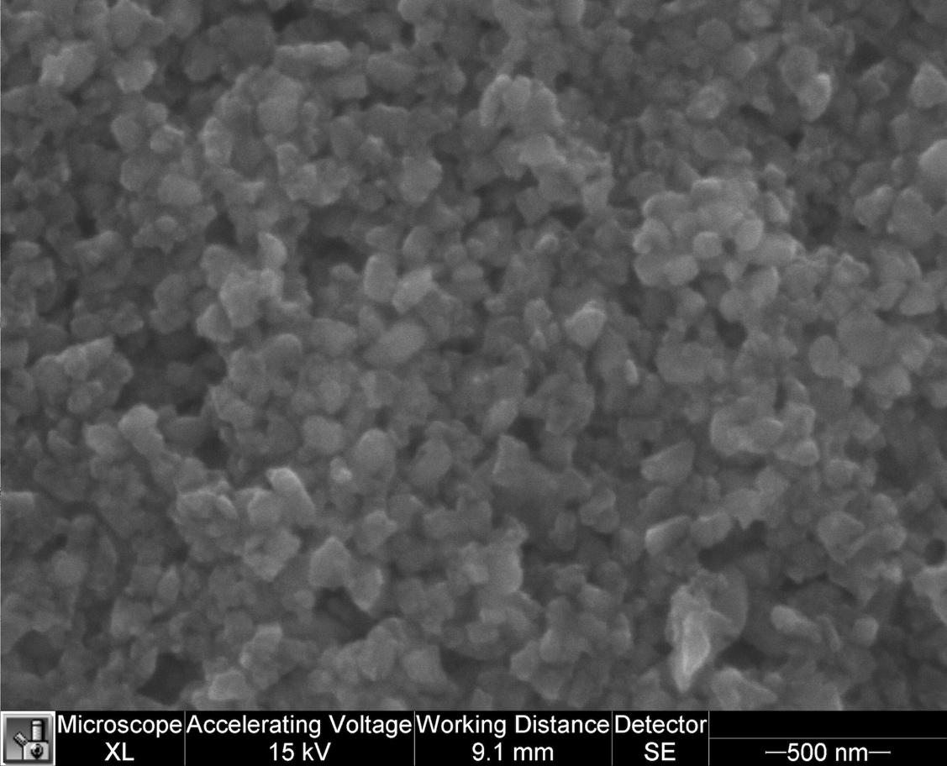
Figure S4: SEM image of M55, with scale bar = 500 nm.
Figure S5: Thermograms of water-dispersed GM55, CM55, PM55, and Ferucarbotran under AMF application.
Figure S6: Cell viability assessed on WI-26 Human Fibroblast after 24 hours and 48 hours of incubation with GM55 NPs at different concentrations.

