Supplementary files
Increment of Skeletal Muscle Mass Predicts Survival Benefit for Hepatocellular Carcinoma Treated with Transarterial Chemoembolization Combining Molecular Targeted Agents and Immune Checkpoint Inhibitors
Supplementary Table 1. Predictive Factor Analysis for Overall Survival in muscle maintian group and muscle down group.
Variables | Univariate |  | Multivariate
Variables | HR (95% CI) | P | HR (95% CI) | P
Age | 1.00 (0.97–1.03) | 0.910
BCLC (C) | 1.86 (0.96–3.59) | 0.066 | 1.52 (0.78–2.97) | 0.218
Child-Pugh Class (B) | 1.61 (0.73–3.58) | 0.240
ECOG score (1) | 1.24 (0.65–2.38) | 0.517
AFP (≥ 400 ng/ml) | 1.74 (0.89–3.41) | 0.105
Albumin | 0.98 (0.92–1.04) | 0.516
SMI | 0.99 (0.95–1.03) | 0.466
SFA | 0.99 (0.96–1.00) | 0.098 | 0.99 (0.99–1.00) | 0.019
Muscle maintain | 0.42 (0.21–0.82) | 0.011 | 0.31 (0.14–0.66) | 0.002
Abbreviations: BCLC, Barcelona Clinic Liver Cancer; ECOG, Eastern Cooperative Oncology Group; AFP, α‐fetoprotein. SMI, skeletal muscle index; SFA, subcutaneous fat area.
Supplementary Table 2. Tumor Response on Modified Response Evaluation Criteria in Solid Tumors
 | Muscle gain  (n=23) | Non muscle gain  (n=69) | P valve | Muscle maintain  (n=41) | Muscle down  (n=28) | P valve
CR | 2 (8.7%) | 2 (2.9%) | 0.259 | 1 (2.4%) | 1 (3.6%) | 1.000
PR | 14 (60.9%) | 38 (55.1%) | 0.809 | 21 (51.2%) | 17 (60.7%) | 0.470
SD | 2 (8.7%) | 8 (11.6%) | 1.000 | 5 (12.2%) | 3 (10.7%) | 1.000
PD | 5 (21.7%) | 21 (30.4%) | 0.594 | 14 (34.1%) | 7 (25.0%) | 0.441
ORR | 16 (69.6%) | 40 (58.0%) | 0.460 | 22 (53.7%) | 18 (64.3%) | 0.460
DCR | 18 (78.3%) | 48 (69.6%) | 0.594 | 27 (65.9%) | 21 (75.0%) | 0.441
Abbreviations: CR, complete response; PR, partial response; SD, stable response; ORR, objective response rate; PD, progressive disease; DCR, disease control rate.

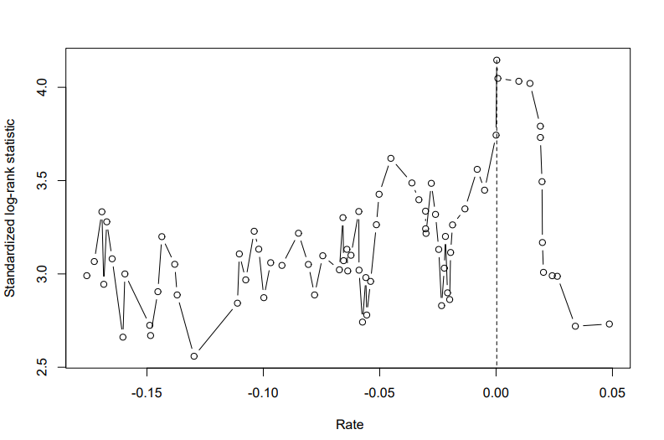
Supplementary Figure 1. Cutoff point of SMI defined via maximally selected log rank statistics. The cutoff value for ΔSMI was 0.03%.

Supplementary Figure 2. Graphs after triple therapy in patients with muscle maintain group show time-course changes of (a) skeletal muscle area (SMA), (b) skeletal muscle index (SMI), (c) subcutaneous fat area (SFA). Graphs after triple therapy in patients with muscle down group show time-course changes of (d) mean skeletal muscle area (SMA), (e) skeletal muscle index (SMI), (f) subcutaneous fat area (SFA).

