Supplementary material

Explainable Prediction of Long-Term Glycated Hemoglobin Response in Finnish Patients with Type 2 Diabetes Mellitus Following Drug Initiation Using Evidence-Based Machine Learning Approaches

Gunjan Chandra¹, Piia Lavikainen², Pekka Siirtola¹, Satu Tamminen¹, Anusha Ihalapathirana¹, Tiina Laatikainen^{3,4,5}, Janne Martikainen², Juha Röning¹

¹Biomimetics and Intelligent Systems Group, Faculty of Information Technology and Electrical Engineering, University of Oulu, Oulu, Finland; ²School of Pharmacy, University of Eastern Finland, Kuopio, Finland; ³ North Karelia Wellbeing Services County (Siun Sote), Joensuu, Finland; ⁴Department of Public Health and Social Welfare, Finnish Institute for Health and Welfare, Helsinki, Finland; ⁵Institute of Public Health and Clinical Nutrition, University of Eastern Finland, Kuopio, Finland

Table of contents:

Appendix 1. Data pre-processing

Supplementary figure S1. Individual SHAP decision plots for four randomly selected samples (a–d) from the MLP model, showing feature values used to predict the change in HbA1c before antidiabetic drug initiation (base model). The legend indicates the actual change, while the x-axis represents the predicted change.

Supplementary figure S2. Individual SHAP decision plots for four randomly selected samples (a–d) from the MLP model, showing feature values used to predict the change in HbA1c before antidiabetic drug initiation (follow-up model). The legend indicates the actual change, while the x-axis represents the predicted change.

Supplementary figure S3. Comparison of baseline and change in (a) HbA1c and (b) BMI across drug classes in baseline model (N=1309). Note: The presented data reflects a smaller subset as not all patients had their BMI measured around response time.
Supplementary table S1. Definitions of predictors.

Supplementary table S2. Efficacy of antidiabetic drugs utilized in this study as obtained from randomized controlled trials among patients with and without metformin as a background therapy.

Appendix 1.

Data pre-processing

The inclusion criteria for treatment episodes ensured that only patients who initiated antidiabetic medications between 2012 and 2018 were included. Patients were excluded if there was no HbA1c data before 2011 or if they had medication data extending beyond 2019, requiring at least 365 days of continuous use. Additionally, only "new users" were considered, meaning no prior purchases of the drug between 1995 and 2011. To ensure clarity, episodes with the initiation of more than one antidiabetic drug at the same time were excluded. These criteria resulted in a refined dataset comprising 10,139 instances, i.e. new antidiabetic drug use periods lasting at least 12 months, with HbA1c change observations across 242 variables. After removing instances with missing records and response value (i.e., no HbA1c measurement within 365 days after the drug initiation), and restricting data to HbA1c response measurement in 80 to 365 days from the baseline (i.e., antidiabetic drug initiation) resulted in dataset of 1,698 instances. The mean time between the drug initiation and the follow-up measurement closest to the 12-month date was 264.5 days with a median of 280 days. Exclusion reduced the variables to 202 while maintaining the instance count. No outliers were identified at this stage, preserving the dataset’s shape at (1698, 202). Further refinement involved eliminating columns with consistent single values, resulting in a dataset of (1698, 185). Columns with 40% or more missing values were then excluded, yielding a dataset of (1698, 169). The samples with missing values of RCT-derived expected change were removed, resulting in a final dataset comprising 1,693 instances and 169 variables. For the follow-up model, one extra feature named First HbA1c post-drug start, a marker indicating the initial drug response, was added to the dataset. Finally, samples without follow-up HbA1c values taken before the 12-month response were dropped resulting in the final dataset for follow-up model having 1,157 instances with 170 variables.

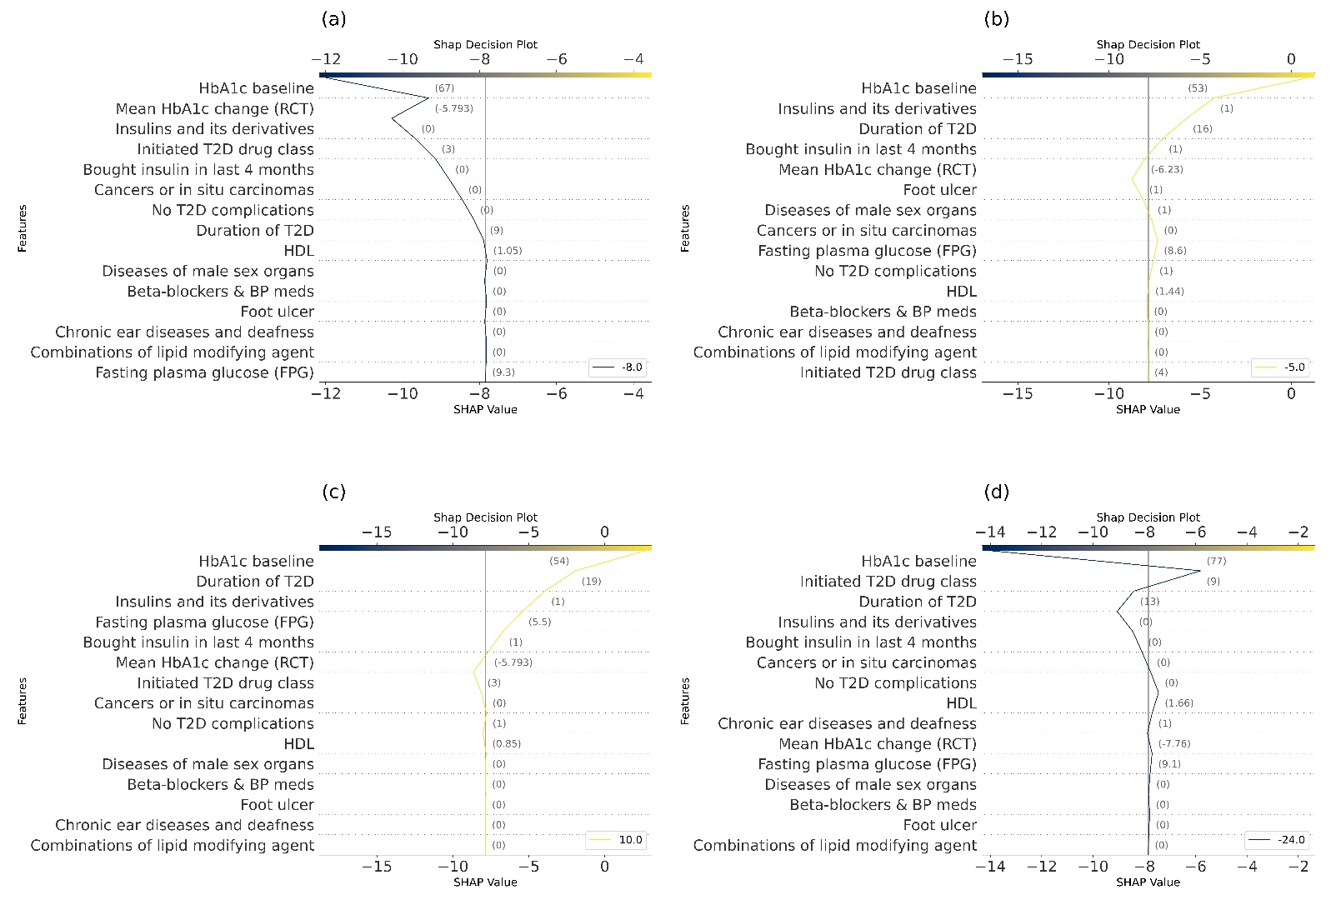
Supplementary figure S1. Individual SHAP decision plots for four randomly selected samples (a–d) from the MLP model, showing feature values used to predict the change in HbA1c before antidiabetic drug initiation (base model). The legend indicates the actual change, while the x-axis represents the predicted change.

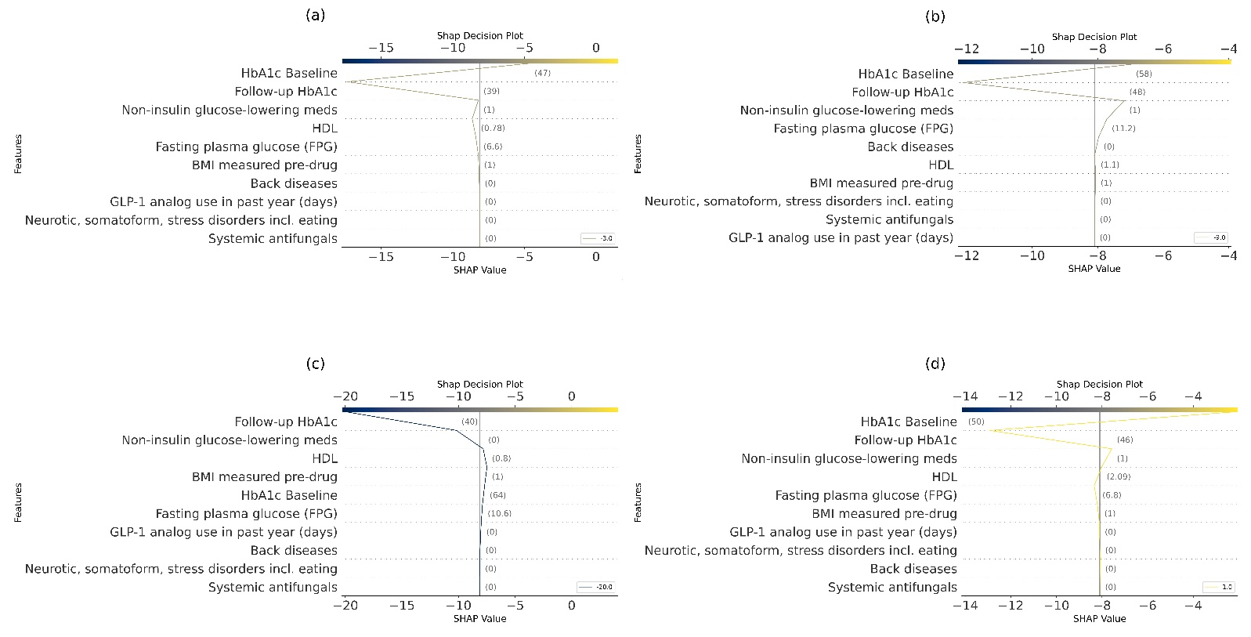
Supplementary figure S2. Individual SHAP decision plots for four randomly selected samples (a–d) from the MLP model, showing feature values used to predict the change in HbA1c before antidiabetic drug initiation (follow-up model). The legend indicates the actual change, while the x-axis represents the predicted change.

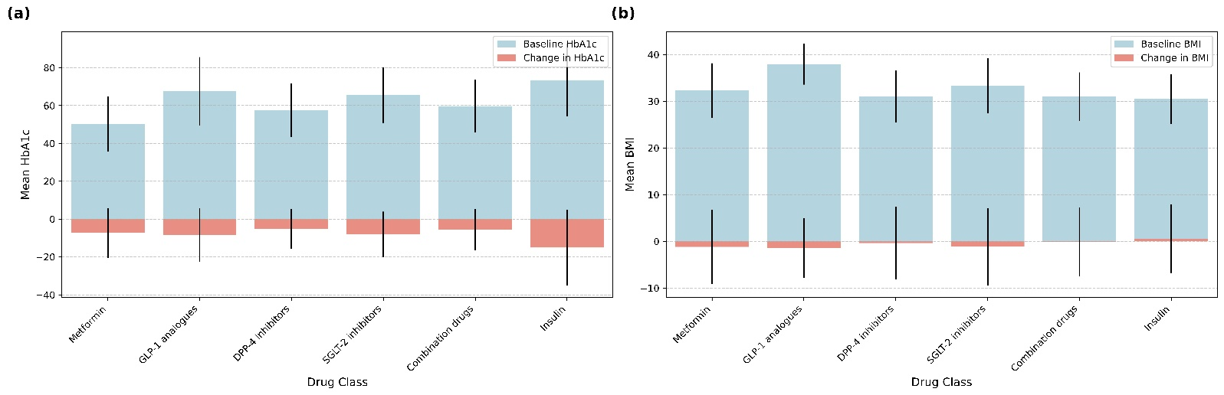
Supplementary figure S3. Comparison of baseline and change in (a) HbA1c and (b) BMI across drug classes in baseline model (N=1309). Note: The presented data reflects a smaller subset as not all patients had their BMI measured around response time.

Supplementary table S1. Definitions of potential predictors.
Definition | ICD-10 code | ATC code | Other specification | Data source | Time of measurement
CLINICAL FACTORS
Gender |  |  |  | EHR | At the time of drug initiation
Male
Female
Age, years |  |  |  | EHR | At the time of drug initiation
Age, classified, years |  |  | 1= ≤50,  2=51–60,  3=61–70,  4=71–80,  5=≥81 | EHR | At the time of drug initiation
Time since T2D diagnosis, years | E11 | A10 | Entitlement to a special refund for antidiabetic medications | EHR | At the time of drug initiation
TREATMENT-RELATED FACTORS
Initiated antidiabetic medication |  | metformin (ATC code A10BA02)  GLP-1 analogues (A10BJ)  DPP-4 inhibitors (A10BH)  SGLT2 inhibitors (A10BK)  combinations of oral blood glucose lowering drugs (A10BG)  insulin (A10A) |  | FPR | At the time of drug initiation
Use of metformin (yes/no) |  | A10BA02 |  | FPR | At least one purchase within the year before the drug initiation
Use of glitazones (yes/no) |  | A10BG |  | FPR | At least one purchase within the year before the drug initiation
Use of sulfonylureas (yes/no) |  | A10BB |  | FPR | At least one purchase within the year before the drug initiation
Use of glinides (yes/no) |  | A10BX02 |  | FPR | At least one purchase within the year before the drug initiation
Use of combinations of oral blood glucose lowering drugs (yes/no) |  | A10BG |  | FPR | At least one purchase within the year before the drug initiation
Table continues

Supplementary table S1. Continued
Definition | ICD-10 code | ATC code | Other specification | Data source | Time of measurement
Use of DPP-4 inhibitors (yes/no) |  | A10BH |  | FPR | At least one purchase within the year before the drug initiation
Use of SGLT2 inhibitors (yes/no) |  | A10BK |  | FPR | At least one purchase within the year before the drug initiation
Use of GLP-1 analogues (yes/no) |  | A10BJ |  | FPR | At least one purchase within the year before the drug initiation
Use of insulin (yes/no) |  | A10A |  | FPR | At least one purchase within the year before the drug initiation
Use of metformin only (yes/no) |  | A10BA02 only |  | FPR | Within the year before the drug initiation
Use of metformin and other oral antidiabetic medications (yes/no) |  | A10BA02 + other A10B |  | FPR | Within the year before the drug initiation
Use of only other diabetes medications than insulin or metformin (yes/no) |  | A10B excluding A10BA02 and A10A |  | FPR | Within the year before the drug initiation
Use of insulin and oral antidiabetic medication (including metformin) (yes/no) |  | A10A + A10B |  | FPR | Within the year before the drug initiation
Use of insulin only (yes/no) |  | A10A only |  | FPR | Within the year before the drug initiation
Number of antidiabetic medications |  | Sum of different ATC codes within A10 |  |  | Within the year before the drug initiation
Use of other than antidiabetic drugs (Total of 130 different drug classes) (yes/no) |  | Third level of ATC code |  | FPR | Within the year before the drug initiation
Total number of medications in use |  | Sum of different ATC codes |  | FPR | Within the year before the drug initiation
FACTORS DESCRIBING PERSISTENCE TO ANTIDIABETIC MEDICATION WITHIN THE PREVIOUS YEAR
Number of days of continuous use of metformin during the previous 12 months |  | A10BA02 |  | FPR | Within the year before the drug initiation
Number of days of continuous use of GLP-1 analogues during the previous 12 months |  | A10BJ |  | FPR | Within the year before the drug initiation
Number of days of continuous use of DPP-4 inhibitors during the previous 12 months |  | A10BH |  | FPR | Within the year before the drug initiation
Table continues
Supplementary table S1. Continued
Definition | ICD-10 code | ATC code | Other specification | Data source | Time of measurement
Number of days of continuous use of SGLT2 inhibitors during the previous 12 months |  | A10BK |  | FPR | Within the year before the drug initiation
Number of days of continuous use of combinations of oral blood glucose lowering drugs during the previous 12 months |  | A10BG |  | FPR | Within the year before the drug initiation
Number of days of continuous use of glitazones during the previous 12 months |  | A10BG |  | FPR | Within the year before the drug initiation
Number of days of continuous use of sulfonylureas during the previous 12 months |  | A10BB |  | FPR | Within the year before the drug initiation
Number of days of continuous use of glinides during the previous 12 months |  | A10BX02 |  | FPR | Within the year before the drug initiation
Number of days of continuous use of insulin during the previous 12 months |  | A10A |  | FPR | Within the year before the drug initiation
LABORATORY VALUES
HbA1c at baseline, mmol/mol |  |  | B -HbA1c | EHR | 4 months before drug initiation until the date of drug initiation
HbA1c 12 months before, mmol/mol |  |  | B -HbA1c | EHR | The latest measured HbA1c value during 12-months to 4-months prior to the drug initiation
HbA1c follow-up measurement, mmol/mol |  |  | B -HbA1c | EHR | First HbA1c measurement after drug initiation
Fasting plasma glucose, mmol/l |  |  | fP-Gluk | EHR | Latest value until the drug initiation
Body mass index (BMI), kg/m² |  |  |  | EHR | Latest value until the drug initiation
Total cholesterol, mmol/l |  |  | fP-Kol | EHR | Latest value until the drug initiation
Low-density lipoprotein cholesterol (LDL), mmol/l |  |  | fP-Kol-LDL | EHR | Latest value until the drug initiation
High-density lipoprotein cholesterol (HDL), mmol/l |  |  | fP-Kol-HDL | EHR | Latest value until the drug initiation
Triglycerids, mmol/l |  |  | fP-Trigly | EHR | Latest value until the drug initiation
Creatinine, µmol/l |  |  | P-Krea | EHR | Latest value until the drug initiation
Table continues
Supplementary table S1. Continued
Definition | ICD-10 code | ATC code | Other specification | Data source | Time of measurement
Classified creatinine, µmol/l |  |  | Creatinine out of the sex-specific reference values (1=yes/0=no) | EHR | Latest value until the drug initiation
eGFR, mL/min/1.73m² |  |  | Estimated glomerular filtration rate based on age and sex (CKD-EPI equation) | EHR | Latest value until the drug initiation
Categorized eGFR, mL/min/1.73m² |  |  | 1= eGFR ≥ 90  2= 60 ≤ eGFR < 90  3= 30 ≤ eGFR < 60  4= eGFR <30 | EHR | Latest value until the drug initiation
COMORBIDITIES
T2D with ketoacidosis (yes/no) | E11.1 |  |  | EHR | At the time of drug initiation
T2D with kidney complications (yes/no) | E11.2 |  |  | EHR | At the time of drug initiation
T2D with ophthalmic complications (yes/no) | E11.3 |  |  | EHR | At the time of drug initiation
T2D with neurological complications (yes/no) | E11.4 |  |  | EHR | At the time of drug initiation
T2D with circulatory complications (yes/no) | E11.5 |  |  | EHR | At the time of drug initiation
T2D with other specified complications (yes/no) | E11.6 |  |  | EHR | At the time of drug initiation
T2D with several complications (yes/no) | E11.7 |  |  | EHR | At the time of drug initiation
T2D with unspecified complications (yes/no) | E11.8 |  |  | EHR | At the time of drug initiation
T2D without complications (yes/no) | E11.9 |  |  | EHR | At the time of drug initiation
Hypertension (yes/no) | I10 |  |  | EHR | At the time of drug initiation
Coronary heart disease (yes/no) | I20–I25 |  |  | EHR | At the time of drug initiation
Atrial fibrillation (yes/no) | I48 |  |  | EHR | At the time of drug initiation
Heart failure (yes/no) | I50, I11.0, I13.0, I13.2 |  |  | EHR | At the time of drug initiation
Peripheral arterial diseases (yes/no) | I70.2, I73.9 |  |  | EHR | At the time of drug initiation
Table continues

Supplementary table S1. Continued
Definition | ICD-10 code | ATC code | Other specification | Data source | Time of measurement
Stroke (incl. Sah) (yes/no) | I60, I61, I63 (excluding I63.6), I64 |  |  | EHR | At the time of drug initiation
Chronic kidney disease (yes/no) | N18, N19 |  |  | EHR | At the time of drug initiation
Neuropathies (yes/no) | G59, G63, G73, G99 |  |  | EHR | At the time of drug initiation
Blindness (yes/no) | H54 |  |  | EHR | At the time of drug initiation
Cancers (yes/no) | C00–C43, C45–C97 |  |  | EHR | At the time of drug initiation
Asthma (yes/no) | J45, J46 |  |  | EHR | At the time of drug initiation
Gout (yes/no) | M10 |  |  | EHR | At the time of drug initiation
Glaucoma (yes/no) | H40–H42 |  |  | EHR | At the time of drug initiation
Depression (yes/no) | F32, F33 |  |  | EHR | At the time of drug initiation
Dementia (yes/no) | F00–F03, G30 |  |  | EHR | At the time of drug initiation
Mental diseases (yes/no) | F20–F48 |  |  | EHR | At the time of drug initiation
Chronic obstructive pulmonary disease (yes/no) | J43–J44 |  |  | EHR | At the time of drug initiation
Rheumatoid and other arthritis (yes/no) | M05–M13, M32, M33, M45 |  |  | EHR | At the time of drug initiation
Osteoporosis (yes/no) | M80–M85 |  |  | EHR | At the time of drug initiation
Neuromuscular diseases (yes/no) | G70–G72 |  |  | EHR | At the time of drug initiation
Liver diseases excluding cancers (yes/no) | K70–K77 |  |  | EHR | At the time of drug initiation
Obesity (yes/no) | E66 |  | BMI≥30 | EHR | At the time of drug initiation
Dysfunctions of lipid metabolism (yes/no) | E78 |  |  | EHR | At the time of drug initiation
Cancers and in situ carcinomas (yes/no) | C00–C97, D00-D07, D09 |  |  | EHR | At the time of drug initiation
Diseases of blood and blood forming organs (yes/no) | D50-D53, D55-D77, D80-D84, D86, D89 |  |  | EHR | At the time of drug initiation
Diseases of endocrine glands (yes/no) | E00-E07, E15-E16, E20-E32, E34-E35 |  |  | EHR | At the time of drug initiation
Obesity and other metabolic diseases (yes/no) | E65-E68, E70-E80, E83-E85, E87-E90 |  |  | EHR | At the time of drug initiation
Dementia and organic psychical disorders (yes/no) | F00-F07, F09, G30-G32 |  |  | EHR | At the time of drug initiation
Psychical and behavioral disorders caused by drugs or psychoactive substances (yes/no) | F10-F16, F18-F19 |  |  | EHR | At the time of drug initiation
Table continues
Supplementary table S1. Continued
Definition | ICD-10 code | ATC code | Other specification | Data source | Time of measurement
Schizophrenia and delusional disorders (yes/no) | F20-F25, F28-F29 |  |  | EHR | At the time of drug initiation
Mood disorders (yes/no) | F30-F34, F38-F39 |  |  | EHR | At the time of drug initiation
Neurotic, somatoformic and stress related disorders (incl. eating disorders) (yes/no) | F40-F45, F48, F50, F52-F55, F59-F66, F68-F69 |  |  | EHR | At the time of drug initiation
Sleep disorders (yes/no) | F51, G47 |  |  | EHR | At the time of drug initiation
Other neurological disorders (yes/no) | G10-G13, G20-G26, G36-G37 |  |  | EHR | At the time of drug initiation
Epilepsy and migraine (yes/no) | G40-G44 |  |  | EHR | At the time of drug initiation
Diseases of nerves and nerve-muscle junction (yes/no) | G50-G64, G70-G73 |  |  | EHR | At the time of drug initiation
Chronic eye diseases and blindness (yes/no) | H15-H22, H25-H28, H30-H36, H40, H42, H46-H48, H53-H54 |  |  | EHR | At the time of drug initiation
Chronic ear diseases and deafness (yes/no) | H80-H83, H90-H91, H93-H95 |  |  | EHR | At the time of drug initiation
Hypertensive diseases (yes/no) | I10-I13, I15, I95, I97-I99 |  |  | EHR | At the time of drug initiation
Ischemic heart diseases (yes/no) | I20-I25 |  |  | EHR | At the time of drug initiation
Other diseases of heart and pulmonary circulation (yes/no) | I26-I28, I30-I52 |  |  | EHR | At the time of drug initiation
Cerebrovascular diseases (yes/no) | I60-I69 |  |  | EHR | At the time of drug initiation
Diseases or arteries and veins (yes/no) | I70-I74, I77-I89 |  |  | EHR | At the time of drug initiation
Chronic diseases of upper respiratory tract (yes/no) | J30-J39 |  |  | EHR | At the time of drug initiation
Chronic diseases of lower  respiratory tract (yes/no) | J40-J47, J60-J70, J80-J82, J84, J95-J96, J98-J99 |  |  | EHR | At the time of drug initiation
Parodontal diseases (yes/no) | K05 |  |  | EHR | At the time of drug initiation
Diseases of esophagus, stomach and duodenum (yes/no) | K21-K23, K25-K31 |  |  | EHR | At the time of drug initiation
Table continues

Supplementary table S1. Continued
Definition | ICD-10 code | ATC code | Other specification | Data source | Time of measurement
Inflammatory and other bowel diseases (yes/no) | K50-K52, K55-K63, K90 |  |  | EHR | At the time of drug initiation
Diseases of liver, pancreas, and biliary tract (yes/no) | K70-K77, K80-K83, K85-K87 |  |  | EHR | At the time of drug initiation
Chronic diseases of skin (yes/no) | L10-L14, L20-L21, L23-L28, L40-L45 |  |  | EHR | At the time of drug initiation
Inflammatory diseases of joints and connective tissue (yes/no) | M05-M14, M30-M36 |  |  | EHR | At the time of drug initiation
Arthrosis (yes/no) | M15-M19 |  |  | EHR | At the time of drug initiation
Other musculoskeletal diseases (yes/no) | M20-M25, M70-M73, M75-M77, M79-M85, M91-M94 |  |  | EHR | At the time of drug initiation
Back diseases (yes/no) | M40-M43, M45-M51, M53-M54 |  |  | EHR | At the time of drug initiation
Chronic diseases of kidneys and urinary tract (yes/no) | N00-N08, N17-N23 |  |  | EHR | At the time of drug initiation
Diseases of male sex organs (yes/no) | N40-N44, N48, N50-N51 |  |  | EHR | At the time of drug initiation
Diseases of female sex organs (yes/no) | N80-N81, N88 |  |  | EHR | At the time of drug initiation
Number of diseases | sum of the diseases above (cancers – diseases of female sex organs) |  |  | EHR | At the time of drug initiation
DIABETES-RELATED COMPLICATIONS
Microvascular complications (yes/no) |  |  |  | EHR | At the time of drug initiation
Eye complications
Retinopathy or other diabetic eye complication | E11.3, H28.0, H36 (excluding H36.8), H40.5, H42.0, H43.1, H45.0
Blindness in one or two eyes | H54
Renal complications
Renal insufficiency | E11.2, N08.3, N18
End-stage renal disease (with or without dialysis) | Z49, Z94.0
Table continues

Supplementary table S1. Continued
Definition | ICD-10 code | ATC code | Other specification | Data source | Time of measurement
Neuropathic complications
Diabetic neuropathy, Charcot foot or other diabetic foot complication | E11.4, E11.5, E11.6, G59.0, G63.2, G73.0, G99.0, I70.2, I73.9, I79.2, L97, M14.2, M14.6, N48.4
Amputation of lower extremities |  |  | NFQ10, NFQ20, NGQ10, NGQ20, NHQ10, NHQ20, NFQ48, NGQ48, NHQ30, NHQ40, NHQ60
Macrovascular complications (yes/no) |  |  |  | EHR | At the time of drug initiation
Cardiovascular complications
Angina pectoris | I20
Chronic heart failure | I11.0, I13.0, I13.2, I50
Incident myocardial infarction/cardiac arrest | I21, I46
Other ischemic heart disease | I22–I25
Cerebrovascular complications
Ischemic stroke | I63–I66 (excluding I63.6)
EFFICACY OF ANTIDIABETIC DRUGS OBTAINED FROM RCT*
Mean difference from RCTs* |  |  |  | RCT
Lower limit of 95% Confidence Interval for the Mean difference |  |  |  | RCT
Upper limit of 95% Confidence Interval for the Mean difference |  |  |  | RCT
Abbreviations: eGFR, estimated glomerular filtration rate; EHR, electronic health records; FPR, Finnish Prescription Register; T2D, type 2 diabetes.
* See supplementary table S2 for more detailed specifications.

Supplementary table S2. Efficacy of antidiabetic drugs utilized in this study as obtained from randomized controlled trials among patients with and without metformin as a background therapy.
ATC | Mean Difference (%) |  | Lower 95% CI | Upper 95% CI |  | Reference
METFORMIN AS A BACKGROUND THERAPY
A10AB01 | -0.67 | -0.86 |  |  | -0.47 | ¹
A10AB04 | -0.67 | -0.86 |  |  | -0.47 | ¹
A10AB05 | -0.67 | -0.86 |  |  | -0.47 | ¹
A10AB06 | -0.67 | -0.86 |  |  | -0.47 | ¹
A10AC01 | -0.71 | -0.82 |  |  | -0.60 | ¹
A10AD05 | -0.67 | -0.86 |  |  | -0.47 | ¹
A10AE04 | -0.71 | -0.82 |  |  | -0.60 | ¹
A10AE05 | -0.71 | -0.82 |  |  | -0.60 | ¹
A10AE06 | -0.71 | -0.82 |  |  | -0.60 | ¹
A10BB07 | -0.57 | -0.66 |  |  | -0.48 | ¹
A10BB12 | -0.57 | -0.66 |  |  | -0.48 | ¹
A10BD05 | -0.83 | NA |  |  | NA | ²
A10BD07 | -0.44 | -0.57 |  |  | -0.31 | ³
A10BD08 | -0.44 | -0.57 |  |  | -0.31 | ³
A10BD09 | -1.40 | -1.45 |  |  | -1.35 | ⁴
A10BD11 | -0.44 | -0.57 |  |  | -0.31 | ³
A10BD13 | -0.44 | -0.57 |  |  | -0.31 | ³
A10BD15 | -0.47 | -0.58 |  |  | -0.37 | ³
A10BD20 | -0.47 | -0.58 |  |  | -0.37 | ³
A10BD21 | -1.47 | -1.62 |  |  | -1.31 | ⁵
A10BG03 | -0.60 | -0.71 |  |  | -0.50 | ¹
A10BH01 | -0.53 | -0.58 |  |  | -0.47 | ¹
A10BH02 | -0.53 | -0.58 |  |  | -0.47 | ¹
A10BH03 | -0.53 | -0.58 |  |  | -0.47 | ¹
A10BH04 | -0.53 | -0.58 |  |  | -0.47 | ¹
A10BH05 | -0.53 | -0.58 |  |  | -0.47 | ¹
A10BJ01 | -0.60 | -0.73 |  |  | -0.47 | ¹
A10BJ02 | -0.80 | -0.89 |  |  | -0.70 | ¹
A10BJ03 | -0.43 | -0.57 |  |  | -0.29 | ¹
A10BJ05 | -0.89 | -1.05 |  |  | -0.73 | ¹
A10BJ06 | -1.33 | -1.50 |  |  | -1.16 | ¹
A10BK01 | -0.51 | -0.63 |  |  | -0.40 | ¹
A10BK03 | -0.57 | -0.71 |  |  | -0.42 | ¹
A10BK02 | -0.63 | -0.78 |  |  | -0.47 | ¹
A10BX02 | -0.64 | -0.85 |  |  | -0.43 | ¹
A10BX04 | -0.60 | -0.73 |  |  | -0.47 | ¹
A10BX07 | -0.80 | -0.89 |  |  | -0.70 | ¹
A10BX09 | -0.51 | -0.63 |  |  | -0.40 | ¹
A10BX12 | -0.57 | -0.71 |  |  | -0.42 | ¹
Table continues

Supplementary table S2. Continued
ATC | Mean Difference (%) | Lower 95% CI | Upper 95% CI | Reference
WITHOUT METFORMIN AS A BACKGROUND THERAPY (DRUG-NAIVE PATIENTS)
A10AB01 | -1.12 | -1.74 | -0.50 | ¹
A10AB04 |  |  |  | ¹
A10AB05 | -1.12 | -1.74 | -0.50 | ¹
A10AB06 |  |  |  | ¹
A10AC01 | -1.12 | -1.74 | -0.50 | ¹
A10AD05 |  |  |  | ¹
A10AE04 | -1.12 | -1.74 | -0.50 | ¹
A10AE05 | -1.12 | -1.74 | -0.50 | ¹
A10AE06 | -1.12 | -1.74 | -0.50 | ¹
A10BA02 500 mg | -0.99 | -1.22 | -0.75 | ⁶
A10BA02 1000 mg | -1.30 | -1.53 | -1.06 | ⁶
A10BB12 | -0.86 | -1.05 | -0.66 | ¹
A10BD07  (metformin and sitagliptin, 500/50 mg) | -1.57 | -1.80 | -1.34 | ⁶
A10BD07  (metformin and sitagliptin, 1000/50 mg) | -2.07 | -2.30 | -1.84 | ⁶
A10BD08 |  |  |  | No results without metformin at baseline
A10BD11 |  |  |  | No results without metformin at baseline
A10BD15 |  |  |  | No results without metformin at baseline
A10BD09  (A12.5/P30) | -1.56 | -1.64 | -1.48 | ⁷
A10BD09  (A25/P30) | -1.71 | -1.79 | -1.63 | ⁷
A10BD20 | -2.03 | NA | NA | ⁸
A10BD21 |  |  |  | No results without metformin at baseline
A10BG03 | -0.89 | -1.10 | -0.68 | ¹
A10BH01 100 mg | -0.60 | -0.75 | -0.46 | ¹
A10BH02 | -0.60 | -0.75 | -0.46 | ¹
A10BH03 | -0.60 | -0.75 | -0.46 | ¹
A10BH04 | -0.60 | -0.75 | -0.46 | ¹
A10BH05 | -0.60 | -0.75 | -0.46 | ¹
A10BJ01 | -0.98 | -1.42 | -0.55 | ¹
A10BJ02 | -1.45 | -2.18 | -0.72 | ¹
A10BJ05 | -1.29 | -1.96 | -0.62 | ¹
A10BJ06 | -1.48 | -2.15 | -0.81 | ¹
A10BK01 | -0.83 | -1.11 | -0.54 | ¹
A10BK02 | -1.02 | -1.68 | -0.36 | ¹
A10BK03 | -0.81 | -1.18 | -0.45 | ¹
A10BX02 | -0.77 | -1.07 | -0.47 | ¹
A10BX04 | -0.98 | -1.42 | -0.55 | ¹
A10BX07 | -1.45 | -2.18 | -0.72 | ¹
A10BX09 | -0.83 | -1.11 | -0.54 | ¹
A10BX12 | -0.81 | -1.18 | -0.45 | ¹

List of abbreviations:
1. Tsapas A, Avgerinos I, Karagiannis T, Malandris K, Manolopoulos A, Andreadis P, Liakos A, Matthews DR, Bekiari E. Comparative effectiveness of glucose-lowering drugs for type 2 diabetes: A systematic review and network meta-analysis. Ann Intern Med. 2020;173:278–287. https://doi.org/10.7326/M20-0864
2. Einhorn D, Rendell M, Rosenzweig J, Egaq JW, Mathisen AL, Schneider RL. Pioglitazone Hydrochloride in Combination with Metformin in the Treatment of Qpe 2 Diabetes Mellitus: A Randomized, Placebo-Controlled Study for The Pioglitazone 027 Study Group*. Clin Ther. 2000;22:1395–1409.
3. Cai X, Gao X, Yang W, Han X, Ji L. Efficacy and Safety of Initial Combination Therapy in Treatment-Naïve Type 2 Diabetes Patients: A Systematic Review and Meta-analysis. Diabetes Ther. 2018;9:1995–2014. https://doi.org/10.1007/s13300-018-0493-2
4. De Fronzo RA, Burant CF, Fleck P, Wilson C, Mekki Q, Pratley RE. Efficacy and tolerability of the DPP-4 inhibitor alogliptin combined with pioglitazone, in metformin-treated patients with type 2 diabetes. J Clin Endocrinol Metab. 2012;97:1615–1622. https://doi.org/10.1210/jc.2011-2243
5. Rosenstock J, Hansen L, Zee P, Li Y, Cook W, Hirshberg B, Iqbal N. Dual add-on therapy in type 2 diabetes poorly controlled with metformin monotherapy: A Randomized double-blind trial of saxagliptin plus dapagliflozin addition versus single addition of saxagliptin or dapaglif lozin to metformin. Diabetes Care. 2015;38:376–383. https://doi.org/10.2337/dc14-1142
6. Goldstein B, Feinglos MN, Lunceford JK, Johnson J, Williams-Herman DE, for the Sitagliptin 036 Study Group. Effect of Initial Combination Therapy With Sitagliptin, a Dipeptidyl Peptidase-4 Control in Patients With Type 2 Diabetes. Diabetes Care. 2007;30:1979–1987. https://doi.org/10.2337/dc07-0627
7.Rosenstock J, Inzucchi SE, Seufert J, Fleck PR, Wilson CA, Mekki Q. Initial combination therapy with alogliptin and pioglitazone in drug-naïve patients with type 2 diabetes. Diabetes Care. 2010;33:2406–2408. https://doi.org/10.2337/dc10-0159
8. Hadjadj S, Rosenstock J, Meinicke T, Woerle HJ, Broedl UC. Initial Combination of Empagliflozin and Metformin in Patients With Type 2 Diabetes. Diabetes Care. 2016;39:1718–1728. https://doi.org/10.2337/dc16-0522

