Serum lipidomic analysis of T2DM patients: a potential biomarker study
Wenwen Qi¹, Chunjing Yang^{2,3}, Jingfeng Li^{2,3}, Li Bao^{2,3,*}
¹ Department of Geriatrics, Beijing Shijitan Hospital, Capital Medical University, No.10 Tieyi-Road, Haidian District, Beijing, China;
² Department of Pharmacy, Beijing Shijitan Hospital, Capital Medical University, No.10 Tieyi-Road, Haidian District, Beijing, China;
³ Beijing Key Laboratory of Bio-characteristic Profiling for Evaluation of Rational Drug Use, No.10 Tieyi-Road, Haidian District, Beijing, China;
Correspondence:
Dr, Li Bao
Department of Pharmacy, Beijing Shijitan Hospital, Capital Medical University, No.10 Tieyi-Road, Haidian District, 10038, Beijing, China
Tel: +86-10-63926405
Email: baoli3712@bjsjth.cn

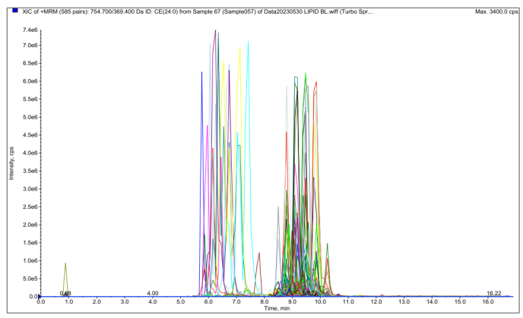
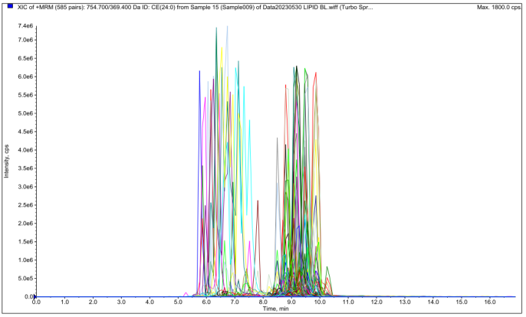
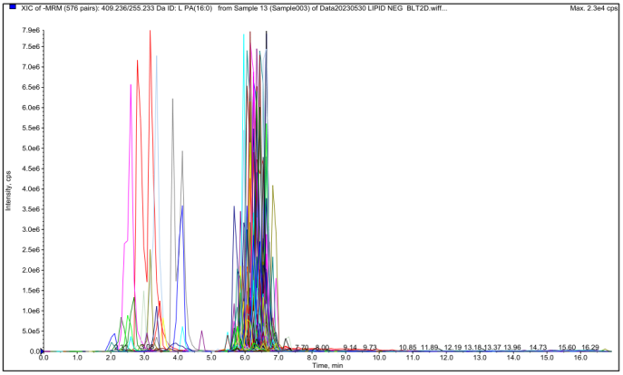
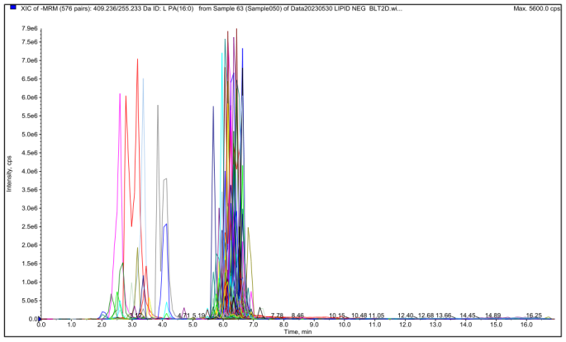
A
D
B
C

Figure S1 Representive MRM chromatogram. (healthy group (A) and T2DM group (B) in positive mode, healthy group (C) and T2DM group (D) in negtive mode)

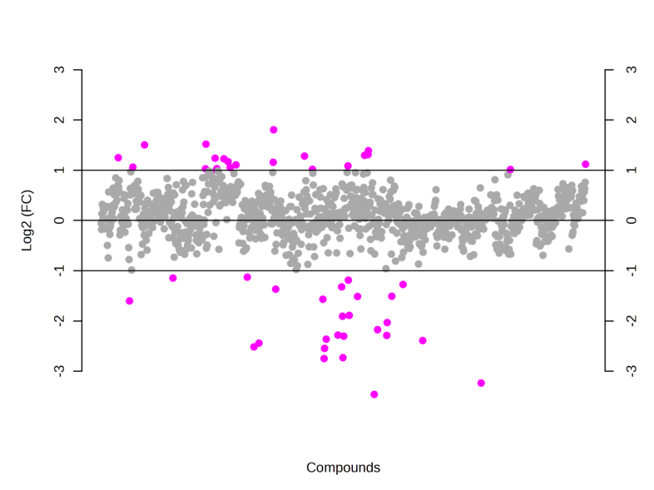
Figure S2 Fold change (FC) of the significantly changed lipids in T2DM

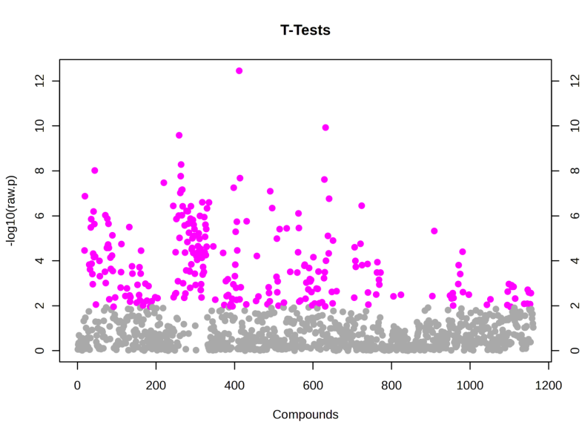
Figure S3 T-tests analysis of lipid metabolites in plasma sample

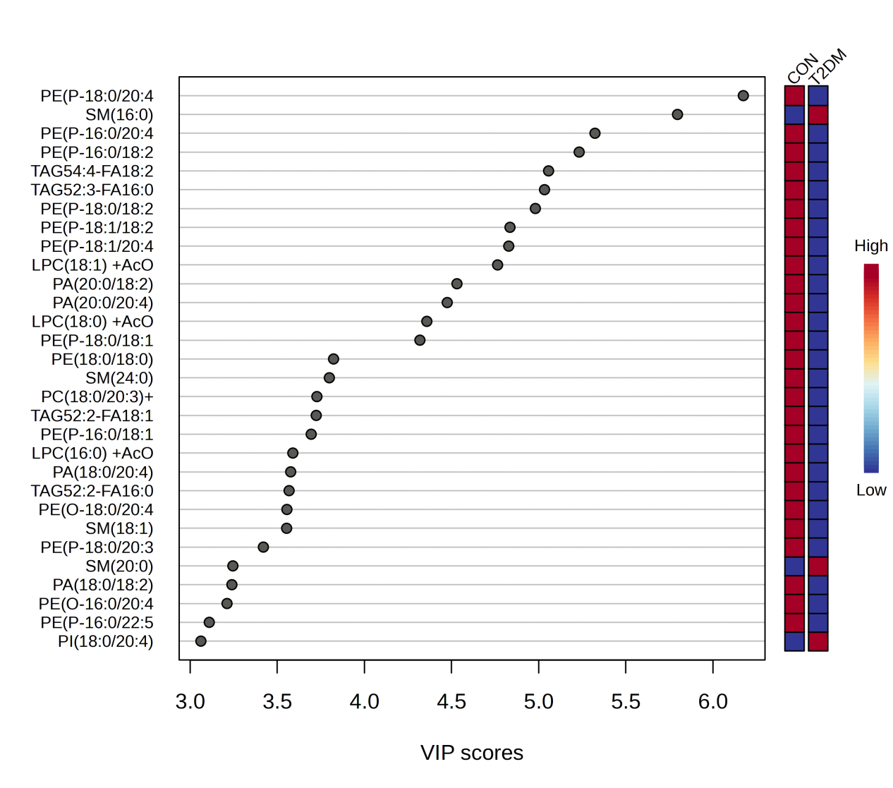
Figure S4 VIP scores represent the most contributing metabolites involved in the separation between Healthy volunteers and T2DM patients (the top of 30).

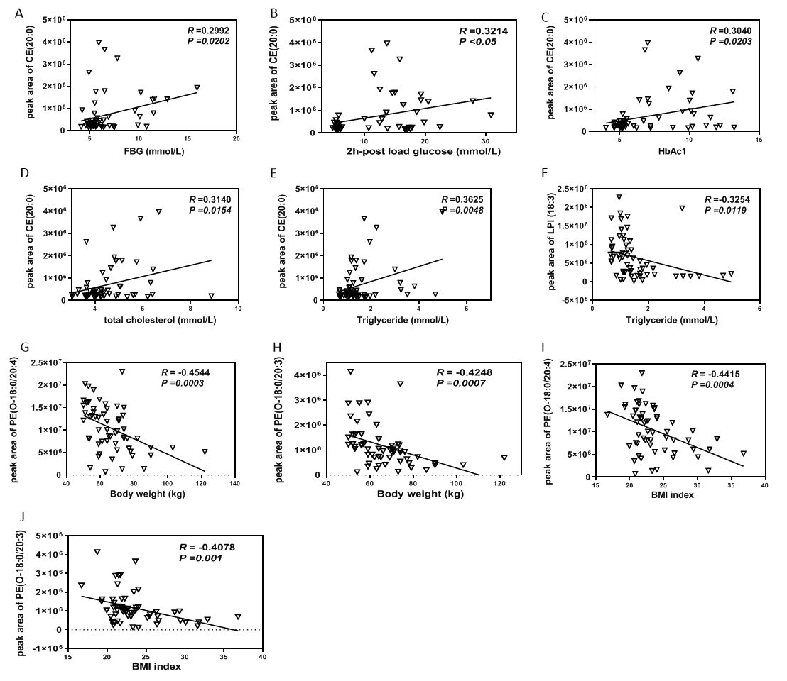Figure S5 Linear regression of the significantly changed lipids with the physiological parameters. Linear regression of CE (20:0) with FBG (A), 2h-post load BG (B), HbAc1 (C), TC (D) and TG (E); linear regression of LPI (18:3) with TG (F),
linear regression of PE(O-18:0/20:4) (G) and PE (O-18:0/20:3) (H) with body weight, and linear regression of PE(O-18:0/20:4) (I) and PE (O-18:0/20:3) (J) with BMI index.

Table S1 MS parameters of lipid metabolites in Positive mode
 | Name | Q1 | Q3 | DP | CE |  | Name | Q1 | Q3 | DP | CE
1 | CE(24:0) | 754.7 | 369.4 | 150 | 25 | 294 | TAG51:2-FA16:0 | 862.8 | 589.5 | 150 | 38
2 | CE(22:6) | 714.6 | 369.4 | 150 | 25 | 295 | TAG51:2-FA16:1 | 862.8 | 591.5 | 150 | 38
3 | CE(20:0) | 698.7 | 369.4 | 150 | 25 | 296 | TAG51:2-FA17:0 | 862.8 | 575.5 | 150 | 38
4 | CE(20:1) | 696.7 | 369.4 | 150 | 25 | 297 | TAG51:2-FA18:1 | 862.8 | 563.5 | 150 | 38
5 | CE(22:5) | 716.6 | 369.4 | 150 | 25 | 298 | TAG51:2-FA18:2 | 862.8 | 565.5 | 150 | 38
6 | CE(14:0) | 614.6 | 369.4 | 150 | 25 | 299 | TAG51:3-FA16:1 | 860.8 | 589.5 | 150 | 38
7 | CE(16:0) | 642.6 | 369.4 | 150 | 25 | 300 | TAG51:3-FA17:0 | 860.8 | 573.5 | 150 | 38
8 | CE(16:1) | 640.6 | 369.4 | 150 | 25 | 301 | TAG51:3-FA18:2 | 860.8 | 563.5 | 150 | 38
9 | CE(18:0) | 670.6 | 369.4 | 150 | 25 | 302 | TAG51:3-FA18:3 | 860.8 | 565.5 | 150 | 38
10 | CE(18:1) | 668.6 | 369.4 | 150 | 25 | 303 | TAG51:4-FA16:1 | 858.8 | 587.5 | 150 | 38
11 | CE(18:2) | 666.6 | 369.4 | 150 | 25 | 304 | TAG51:4-FA18:2 | 858.8 | 561.5 | 150 | 38
12 | CE(18:3) | 664.6 | 369.4 | 150 | 25 | 305 | TAG51:4-FA18:3 | 858.8 | 563.5 | 150 | 38
13 | CE(20:2) | 694.6 | 369.4 | 150 | 25 | 306 | TAG51:4-FA20:4 | 858.8 | 537.5 | 150 | 38
14 | CE(20:3) | 692.6 | 369.4 | 150 | 25 | 307 | TAG51:5-FA18:2 | 856.8 | 559.5 | 150 | 38
15 | CE(20:4) | 690.6 | 369.4 | 150 | 25 | 308 | TAG51:5-FA18:3 | 856.8 | 561.5 | 150 | 38
16 | CE(20:5) | 688.6 | 369.4 | 150 | 25 | 309 | TAG52:0-FA16:0 | 880.8 | 607.5 | 150 | 38
17 | CE(22:0) | 726.7 | 369.4 | 150 | 25 | 310 | TAG52:0-FA18:0 | 880.8 | 579.5 | 150 | 38
18 | CE(22:1) | 724.7 | 369.4 | 150 | 25 | 311 | TAG52:0-FA20:0 | 880.8 | 551.503 | 150 | 38
19 | CE(22:2) | 722.7 | 369.4 | 150 | 25 | 312 | TAG52:1-FA16:0 | 878.8 | 605.5 | 150 | 38
20 | CE(22:4) | 718.6 | 369.4 | 150 | 25 | 313 | TAG52:1-FA16:1 | 878.8 | 607.5 | 150 | 38
21 | CE(24:1) | 752.7 | 369.4 | 150 | 43 | 314 | TAG52:1-FA18:0 | 878.8 | 577.5 | 150 | 38
22 | CER(14:0) | 510.6 | 264.4 | 150 | 43 | 315 | TAG52:1-FA18:1 | 878.8 | 579.5 | 150 | 38
23 | CER(16:0) | 538.6 | 264.4 | 150 | 43 | 316 | TAG52:1-FA20:0 | 878.8 | 549.5 | 150 | 38
24 | CER(18:0) | 566.7 | 264.4 | 150 | 43 | 317 | TAG52:1-FA20:1 | 878.8 | 551.503 | 150 | 38
25 | CER(18:1) | 564.8 | 264.4 | 150 | 43 | 318 | TAG52:2-FA14:0 | 876.8 | 631.6 | 150 | 38
26 | CER(20:0) | 594.6 | 264.4 | 150 | 43 | 319 | TAG52:2-FA16:0 | 876.8 | 603.5 | 150 | 38
27 | CER(20:1) | 592.6 | 264.4 | 150 | 43 | 320 | TAG52:2-FA16:1 | 876.8 | 605.5 | 150 | 38
28 | CER(22:0) | 622.7 | 264.4 | 150 | 43 | 321 | TAG52:2-FA18:0 | 876.8 | 575.5 | 150 | 38
29 | CER(22:1) | 620.7 | 264.4 | 150 | 43 | 322 | TAG52:2-FA18:1 | 876.8 | 577.5 | 150 | 38
30 | CER(24:0) | 650.8 | 264.4 | 150 | 43 | 323 | TAG52:2-FA18:2 | 876.8 | 579.5 | 150 | 38
31 | CER(24:1) | 648.8 | 264.4 | 150 | 43 | 324 | TAG52:2-FA20:0 | 876.8 | 547.5 | 150 | 38
32 | CER(26:0) | 678.9 | 264.4 | 150 | 43 | 325 | TAG52:2-FA20:1 | 876.8 | 549.5 | 150 | 38
33 | CER(26:1) | 676.9 | 264.4 | 150 | 43 | 326 | TAG52:2-FA20:2 | 876.8 | 551.503 | 150 | 38
34 | DCER(14:0) | 512.6 | 266.4 | 150 | 43 | 327 | TAG52:3-FA14:0 | 874.8 | 629.6 | 150 | 38
35 | DCER(16:0) | 540.6 | 266.4 | 150 | 43 | 328 | TAG52:3-FA16:0 | 874.8 | 601.5 | 150 | 38
36 | DCER(18:0) | 568.7 | 266.4 | 150 | 43 | 329 | TAG52:3-FA16:1 | 874.8 | 603.5 | 150 | 38
37 | DCER(18:1) | 566.8 | 266.4 | 150 | 43 | 330 | TAG52:3-FA18:0 | 874.8 | 573.5 | 150 | 38
38 | DCER(20:0) | 596.7 | 266.4 | 150 | 43 | 331 | TAG52:3-FA18:1 | 874.8 | 575.5 | 150 | 38
39 | DCER(20:1) | 594.4 | 266.4 | 150 | 43 | 332 | TAG52:3-FA18:2 | 874.8 | 577.5 | 150 | 38
40 | DCER(22:0) | 624.8 | 266.4 | 150 | 43 | 333 | TAG52:3-FA18:3 | 874.8 | 579.5 | 150 | 38
41 | DCER(22:1) | 620.4 | 266.4 | 150 | 43 | 334 | TAG52:3-FA20:0 | 874.8 | 545.5 | 150 | 38
42 | DCER(24:0) | 652.9 | 266.4 | 150 | 43 | 335 | TAG52:3-FA20:1 | 874.8 | 547.5 | 150 | 38
43 | DCER(24:1) | 650.9 | 266.4 | 150 | 43 | 336 | TAG52:3-FA20:2 | 874.8 | 549.5 | 150 | 38
44 | DCER(26:0) | 680.5 | 266.4 | 150 | 43 | 337 | TAG52:3-FA20:3 | 874.8 | 551.503 | 150 | 38
45 | DCER(26:1) | 678.5 | 266.4 | 150 | 43 | 338 | TAG52:4-FA14:0 | 872.8 | 627.6 | 150 | 38
46 | HCER(14:0) | 672.5 | 264.4 | 150 | 43 | 339 | TAG52:4-FA16:0 | 872.8 | 599.5 | 150 | 38
47 | HCER(16:0) | 700.7 | 264.4 | 150 | 43 | 340 | TAG52:4-FA16:1 | 872.8 | 601.5 | 150 | 38
48 | HCER(18:0) | 728.8 | 264.4 | 150 | 43 | 341 | TAG52:4-FA18:0 | 872.8 | 571.5 | 150 | 38
49 | HCER(18:1) | 726.7 | 264.4 | 150 | 43 | 342 | TAG52:4-FA18:1 | 872.8 | 573.5 | 150 | 38
50 | HCER(20:0) | 756.7 | 264.4 | 150 | 43 | 343 | TAG52:4-FA18:2 | 872.8 | 575.5 | 150 | 38
51 | HCER(20:1) | 754.7 | 264.4 | 150 | 43 | 344 | TAG52:4-FA18:3 | 872.8 | 577.5 | 150 | 38
52 | HCER(22:0) | 784.9 | 264.4 | 150 | 43 | 345 | TAG52:4-FA20:0 | 872.8 | 543.5 | 150 | 38
53 | HCER(22:1) | 782.8 | 264.4 | 150 | 43 | 346 | TAG52:4-FA20:2 | 872.8 | 547.5 | 150 | 38
54 | HCER(24:0) | 812.9 | 264.4 | 150 | 43 | 347 | TAG52:4-FA20:3 | 872.8 | 549.5 | 150 | 38
55 | HCER(24:1) | 810.9 | 264.4 | 150 | 43 | 348 | TAG52:4-FA20:4 | 872.8 | 551.503 | 150 | 38
56 | HCER(26:0) | 840.9 | 264.4 | 150 | 43 | 349 | TAG52:4-FA22:4 | 872.8 | 523.472 | 150 | 38
57 | HCER(26:1) | 838.9 | 264.4 | 150 | 43 | 350 | TAG52:5-FA14:0 | 870.8 | 625.6 | 150 | 38
58 | HexCer d18:1/12:0 | 644.5 | 264.4 | 150 | 43 | 351 | TAG52:5-FA16:0 | 870.8 | 597.5 | 150 | 38
59 | LacCer d18:1/12:0 | 806.6 | 264.4 | 150 | 43 | 352 | TAG52:5-FA16:1 | 870.8 | 599.5 | 150 | 38
60 | LCER(14:0) | 834.9 | 264.4 | 150 | 43 | 353 | TAG52:5-FA18:1 | 870.8 | 571.5 | 150 | 38
61 | LCER(16:0) | 862.9 | 264.4 | 150 | 43 | 354 | TAG52:5-FA18:2 | 870.8 | 573.5 | 150 | 38
62 | LCER(18:0) | 890.2 | 264.4 | 150 | 43 | 355 | TAG52:5-FA18:3 | 870.8 | 575.5 | 150 | 38
63 | LCER(18:1) | 888.2 | 264.4 | 150 | 43 | 356 | TAG52:5-FA20:3 | 870.8 | 547.5 | 150 | 38
64 | LCER(20:0) | 918.2 | 264.4 | 150 | 43 | 357 | TAG52:5-FA20:4 | 870.8 | 549.5 | 150 | 38
65 | LCER(20:1) | 916.2 | 264.4 | 150 | 43 | 358 | TAG52:5-FA20:5 | 870.8 | 551.503 | 150 | 38
66 | LCER(22:0) | 946.2 | 264.4 | 150 | 43 | 359 | TAG52:5-FA22:5 | 870.8 | 523.472 | 150 | 38
67 | LCER(22:1) | 944.2 | 264.4 | 150 | 43 | 360 | TAG52:6-FA14:0 | 868.8 | 623.6 | 150 | 38
68 | LCER(24:0) | 974.8 | 264.4 | 150 | 43 | 361 | TAG52:6-FA16:0 | 868.8 | 595.5 | 150 | 38
69 | LCER(24:1) | 972.9 | 264.4 | 150 | 43 | 362 | TAG52:6-FA16:1 | 868.8 | 597.5 | 150 | 38
70 | LCER(26:0) | 1002.4 | 264.4 | 150 | 43 | 363 | TAG52:6-FA18:1 | 868.8 | 569.5 | 150 | 38
71 | LCER(26:1) | 1000.4 | 264.4 | 150 | 38 | 364 | TAG52:6-FA18:2 | 868.8 | 571.5 | 150 | 38
72 | GluCer d18:0/18:0 | 730.7 | 266.4 | 150 | 43 | 365 | TAG52:6-FA18:3 | 868.8 | 573.5 | 150 | 38
73 | GluCer d18:0/20:0 | 758.7 | 266.4 | 150 | 43 | 366 | TAG52:6-FA20:4 | 868.8 | 547.5 | 150 | 38
74 | GluCer d18:0/22:0 | 786.8 | 266.4 | 150 | 43 | 367 | TAG52:6-FA20:5 | 868.8 | 549.5 | 150 | 38
75 | GluCer d18:0/24:0 | 814.9 | 266.4 | 150 | 43 | 368 | TAG52:6-FA22:6 | 868.8 | 523.472 | 150 | 38
76 | GluCer d18:0/24:1 | 812.9 | 266.4 | 150 | 43 | 369 | TAG52:7-FA16:0 | 866.7 | 593.4 | 150 | 38
77 | GluCer d18:0/26:0 | 842.9 | 266.4 | 150 | 43 | 370 | TAG52:7-FA18:1 | 866.7 | 567.4 | 150 | 38
78 | GluCer d18:0/26:1 | 840.9 | 266.4 | 150 | 43 | 371 | TAG52:7-FA20:5 | 866.7 | 547.4 | 150 | 38
79 | DAG(14:0/14:0) | 530.4 | 285.2 | 150 | 26 | 372 | TAG52:7-FA22:6 | 866.7 | 521.4 | 150 | 38
80 | DAG(14:0/16:1) | 556.5 | 285.2 | 150 | 26 | 373 | TAG52:8-FA16:1 | 864.8 | 593.5 | 150 | 38
81 | DAG(16:0/16:0) | 586.5 | 313.3 | 150 | 26 | 374 | TAG52:8-FA18:2 | 864.8 | 567.5 | 150 | 38
82 | DAG(16:0/16:1) | 584.4 | 313.2 | 150 | 26 | 375 | TAG53:0-FA16:0 | 894.8 | 621.5 | 150 | 38
83 | DAG(14:0/18:1) | 584.4 | 285.2 | 150 | 26 | 376 | TAG53:1-FA16:0 | 892.8 | 619.5 | 150 | 38
84 | DAG(16:1/16:1) | 582.4 | 311.2 | 150 | 26 | 377 | TAG53:1-FA17:0 | 892.8 | 605.5 | 150 | 38
85 | DAG(14:0/18:2) | 582.4 | 285.2 | 150 | 26 | 378 | TAG53:1-FA18:0 | 892.8 | 591.5 | 150 | 38
86 | DAG(14:0/18:3) | 580.4 | 285.2 | 150 | 26 | 379 | TAG53:1-FA18:1 | 892.8 | 593.5 | 150 | 38
87 | DAG(14:0/20:0) | 614.6 | 285.2 | 150 | 26 | 380 | TAG53:2-FA16:0 | 890.8 | 617.5 | 150 | 38
88 | DAG(16:0/18:0) | 614.4 | 313.2 | 150 | 26 | 381 | TAG53:2-FA17:0 | 890.8 | 603.5 | 150 | 38
89 | DAG(16:1/18:0) | 612.6 | 311.3 | 150 | 26 | 382 | TAG53:2-FA18:1 | 890.8 | 591.5 | 150 | 38
90 | DAG(16:0/18:1) | 612.6 | 313.2 | 150 | 26 | 383 | TAG53:2-FA18:2 | 890.8 | 593.5 | 150 | 38
91 | DAG(16:1/18:1) | 610.4 | 311.2 | 150 | 26 | 384 | TAG53:3-FA16:0 | 888.8 | 615.5 | 150 | 38
92 | DAG(16:0/18:2) | 610.4 | 313.2 | 150 | 26 | 385 | TAG53:3-FA17:0 | 888.8 | 601.5 | 150 | 38
93 | DAG(16:1/18:2) | 608.5 | 311.2 | 150 | 26 | 386 | TAG53:3-FA18:2 | 888.8 | 591.5 | 150 | 38
94 | DAG(16:0/18:3) | 608.5 | 313.2 | 150 | 26 | 387 | TAG53:4-FA16:0 | 886.8 | 613.5 | 150 | 38
95 | DAG(16:1/18:3) | 606.4 | 311.2 | 150 | 26 | 388 | TAG53:4-FA17:0 | 886.8 | 599.5 | 150 | 38
96 | DAG(14:0/20:4) | 606.4 | 285.2 | 150 | 26 | 389 | TAG53:4-FA18:2 | 886.8 | 589.5 | 150 | 38
97 | DAG(16:1/20:0) | 640.6 | 283.2 | 150 | 26 | 390 | TAG53:4-FA18:3 | 886.8 | 591.5 | 150 | 38
98 | DAG(18:0/18:1) | 640.4 | 341.3 | 150 | 26 | 391 | TAG53:4-FA20:4 | 886.8 | 565.5 | 150 | 38
99 | DAG(18:1/18:1) | 638.4 | 339.3 | 150 | 26 | 392 | TAG53:5-FA20:4 | 884.8 | 563.5 | 150 | 38
100 | DAG(18:0/18:2) | 638.4 | 341.3 | 150 | 26 | 393 | TAG53:6-FA20:4 | 882.8 | 561.5 | 150 | 38
101 | DAG(18:1/18:2) | 636.5 | 339.3 | 150 | 26 | 394 | TAG54:0-FA16:0 | 908.8 | 635.5 | 150 | 38
102 | DAG(18:0/18:3) | 636.5 | 341.3 | 150 | 26 | 395 | TAG54:0-FA18:0 | 908.8 | 607.5 | 150 | 38
103 | DAG(16:1/20:2) | 636.6 | 311.3 | 150 | 26 | 396 | TAG54:1-FA16:0 | 906.8 | 633.5 | 150 | 38
104 | DAG(16:0/20:3) | 636.5 | 313.3 | 150 | 26 | 397 | TAG54:1-FA18:0 | 906.8 | 605.5 | 150 | 38
105 | DAG(16:0/20:4) | 634.5 | 313.3 | 150 | 26 | 398 | TAG54:1-FA18:1 | 906.8 | 607.5 | 150 | 38
106 | DAG(18:2/18:3) | 632.4 | 337.3 | 150 | 26 | 399 | TAG54:1-FA20:0 | 906.8 | 577.5 | 150 | 38
107 | DAG(16:1/20:4) | 632.4 | 311.3 | 150 | 26 | 400 | TAG54:1-FA20:1 | 906.8 | 579.5 | 150 | 38
108 | DAG(16:0/20:5) | 632.4 | 313.3 | 150 | 26 | 401 | TAG54:2-FA16:0 | 904.8 | 631.5 | 150 | 38
109 | DAG(14:0/22:6) | 630.5 | 285.3 | 150 | 26 | 402 | TAG54:2-FA18:0 | 904.8 | 603.5 | 150 | 38
110 | DAG(18:1/20:1) | 666.6 | 339.3 | 150 | 26 | 403 | TAG54:2-FA18:1 | 904.8 | 605.5 | 150 | 38
111 | DAG(18:1/20:2) | 664.6 | 339.3 | 150 | 26 | 404 | TAG54:2-FA18:2 | 904.8 | 607.5 | 150 | 38
112 | DAG(18:1/20:3) | 662.6 | 339.3 | 150 | 26 | 405 | TAG54:2-FA20:0 | 904.8 | 575.5 | 150 | 38
113 | DAG(18:2/20:3) | 660.5 | 337.3 | 150 | 26 | 406 | TAG54:2-FA20:1 | 904.8 | 577.5 | 150 | 38
114 | DAG(18:1/20:4) | 660.5 | 339.3 | 150 | 26 | 407 | TAG54:2-FA20:2 | 904.8 | 579.5 | 150 | 38
115 | DAG(16:0/22:5) | 660.5 | 313.3 | 150 | 26 | 408 | TAG54:3-FA16:0 | 902.8 | 629.5 | 150 | 38
116 | DAG(18:2/20:4) | 658.5 | 337.3 | 150 | 26 | 409 | TAG54:3-FA16:1 | 902.8 | 631.5 | 150 | 38
117 | DAG(18:1/20:5) | 658.5 | 339.3 | 150 | 26 | 410 | TAG54:3-FA18:0 | 902.8 | 601.5 | 150 | 38
118 | DAG(16:0/22:6) | 658.5 | 313.3 | 150 | 26 | 411 | TAG54:3-FA18:1 | 902.8 | 603.5 | 150 | 38
119 | DAG(18:2/20:5) | 656.5 | 337.3 | 150 | 26 | 412 | TAG54:3-FA18:2 | 902.8 | 605.5 | 150 | 38
120 | DAG(16:1/22:6) | 656.5 | 311.3 | 150 | 26 | 413 | TAG54:3-FA18:3 | 902.8 | 607.5 | 150 | 38
121 | DAG(20:0/20:0) | 698.6 | 369.3 | 150 | 26 | 414 | TAG54:3-FA20:1 | 902.8 | 575.5 | 150 | 38
122 | DAG(18:1/22:4) | 688.6 | 339.3 | 150 | 26 | 415 | TAG54:3-FA20:2 | 902.8 | 577.5 | 150 | 38
123 | DAG(18:2/22:4) | 686.6 | 337.3 | 150 | 26 | 416 | TAG54:3-FA20:3 | 902.8 | 579.5 | 150 | 38
124 | DAG(18:1/22:5) | 686.6 | 339.3 | 150 | 26 | 417 | TAG54:4-FA16:0 | 900.8 | 627.5 | 150 | 38
125 | DAG(18:0/22:6) | 686.6 | 341.3 | 150 | 26 | 418 | TAG54:4-FA16:1 | 900.8 | 629.5 | 150 | 38
126 | DAG(18:2/22:5) | 684.6 | 337.3 | 150 | 26 | 419 | TAG54:4-FA18:0 | 900.8 | 599.5 | 150 | 38
127 | DAG(18:1/22:6) | 684.6 | 339.3 | 150 | 26 | 420 | TAG54:4-FA18:1 | 900.8 | 601.5 | 150 | 38
128 | DAG(18:2/22:6) | 682.5 | 337.3 | 150 | 26 | 421 | TAG54:4-FA18:2 | 900.8 | 603.5 | 150 | 38
129 | SM(14:0) | 675.5 | 184.1 | 150 | 43 | 422 | TAG54:4-FA18:3 | 900.8 | 605.5 | 150 | 38
130 | SM(16:0) | 703.6 | 184.1 | 150 | 43 | 423 | TAG54:4-FA20:1 | 900.8 | 573.5 | 150 | 38
131 | SM(18:0) | 731.6 | 184.1 | 150 | 43 | 424 | TAG54:4-FA20:2 | 900.8 | 575.5 | 150 | 38
132 | SM(18:1) | 729.6 | 184.1 | 150 | 43 | 425 | TAG54:4-FA20:3 | 900.8 | 577.5 | 150 | 38
133 | SM(20:0) | 759.6 | 184.1 | 150 | 43 | 426 | TAG54:4-FA20:4 | 900.8 | 579.5 | 150 | 38
134 | SM(20:1) | 757.6 | 184.1 | 150 | 43 | 427 | TAG54:4-FA22:4 | 900.8 | 551.503 | 150 | 38
135 | SM(22:0) | 787.7 | 184.1 | 150 | 43 | 428 | TAG54:5-FA16:0 | 898.8 | 625.5 | 150 | 38
136 | SM(22:1) | 785.7 | 184.1 | 150 | 43 | 429 | TAG54:5-FA16:1 | 898.8 | 627.5 | 150 | 38
137 | SM(24:0) | 815.7 | 184.1 | 150 | 43 | 430 | TAG54:5-FA18:0 | 898.8 | 597.5 | 150 | 38
138 | SM(24:1) | 813.7 | 184.1 | 150 | 43 | 431 | TAG54:5-FA18:1 | 898.8 | 599.5 | 150 | 38
139 | SM(26:0) | 843.7 | 184.1 | 150 | 43 | 432 | TAG54:5-FA18:2 | 898.8 | 601.5 | 150 | 38
140 | SM(26:1) | 841.7 | 184.1 | 150 | 25 | 433 | TAG54:5-FA18:3 | 898.8 | 603.5 | 150 | 38
141 | TAG40:0-FA14:0 | 712.645 | 467.409 | 150 | 38 | 434 | TAG54:5-FA20:2 | 898.8 | 573.5 | 150 | 38
142 | TAG40:0-FA16:0 | 712.645 | 439.378 | 150 | 38 | 435 | TAG54:5-FA20:3 | 898.8 | 575.5 | 150 | 38
143 | TAG42:0-FA14:0 | 740.676 | 495.441 | 150 | 38 | 436 | TAG54:5-FA20:4 | 898.8 | 577.5 | 150 | 38
144 | TAG42:0-FA16:0 | 740.676 | 467.409 | 150 | 38 | 437 | TAG54:5-FA20:5 | 898.8 | 579.5 | 150 | 38
145 | TAG42:1-FA14:0 | 738.661 | 493.425 | 150 | 38 | 438 | TAG54:5-FA22:4 | 898.8 | 549.5 | 150 | 38
146 | TAG42:1-FA16:0 | 738.661 | 465.394 | 150 | 38 | 439 | TAG54:5-FA22:5 | 898.8 | 551.503 | 150 | 38
147 | TAG42:1-FA16:1 | 738.661 | 467.409 | 150 | 38 | 440 | TAG54:6-FA16:0 | 896.8 | 623.5 | 150 | 38
148 | TAG42:1-FA18:1 | 738.661 | 439.378 | 150 | 38 | 441 | TAG54:6-FA16:1 | 896.8 | 625.5 | 150 | 38
149 | TAG42:2-FA18:2 | 736.645 | 439.378 | 150 | 38 | 442 | TAG54:6-FA18:1 | 896.8 | 597.5 | 150 | 38
150 | TAG44:0-FA14:0 | 768.708 | 523.472 | 150 | 38 | 443 | TAG54:6-FA18:2 | 896.8 | 599.5 | 150 | 38
151 | TAG44:0-FA16:0 | 768.708 | 495.441 | 150 | 38 | 444 | TAG54:6-FA18:3 | 896.8 | 601.5 | 150 | 38
152 | TAG44:0-FA18:0 | 768.708 | 467.409 | 150 | 38 | 445 | TAG54:6-FA20:3 | 896.8 | 573.5 | 150 | 38
153 | TAG44:1-FA14:0 | 766.692 | 521.456 | 150 | 38 | 446 | TAG54:6-FA20:4 | 896.8 | 575.5 | 150 | 38
154 | TAG44:1-FA16:0 | 766.692 | 493.425 | 150 | 38 | 447 | TAG54:6-FA20:5 | 896.8 | 577.5 | 150 | 38
155 | TAG44:1-FA16:1 | 766.692 | 495.441 | 150 | 38 | 448 | TAG54:6-FA22:5 | 896.8 | 549.5 | 150 | 38
156 | TAG44:1-FA18:1 | 766.692 | 467.409 | 150 | 38 | 449 | TAG54:6-FA22:6 | 896.8 | 551.503 | 150 | 38
157 | TAG44:2-FA14:0 | 764.676 | 519.441 | 150 | 38 | 450 | TAG54:7-FA16:1 | 894.8 | 623.5 | 150 | 38
158 | TAG44:2-FA16:0 | 764.676 | 491.409 | 150 | 38 | 451 | TAG54:7-FA18:1 | 894.8 | 595.5 | 150 | 38
159 | TAG44:2-FA16:1 | 764.676 | 493.425 | 150 | 38 | 452 | TAG54:7-FA18:2 | 894.8 | 597.5 | 150 | 38
160 | TAG44:2-FA18:1 | 764.676 | 465.394 | 150 | 38 | 453 | TAG54:7-FA18:3 | 894.8 | 599.5 | 150 | 38
161 | TAG44:2-FA18:2 | 764.676 | 467.409 | 150 | 38 | 454 | TAG54:7-FA20:4 | 894.8 | 573.5 | 150 | 38
162 | TAG44:3-FA18:2 | 762.661 | 465.394 | 150 | 38 | 455 | TAG54:7-FA20:5 | 894.8 | 575.5 | 150 | 38
163 | TAG45:0-FA14:0 | 782.723 | 537.488 | 150 | 38 | 456 | TAG54:7-FA22:5 | 894.8 | 547.5 | 150 | 38
164 | TAG45:0-FA16:0 | 782.723 | 509.456 | 150 | 38 | 457 | TAG54:7-FA22:6 | 894.8 | 549.5 | 150 | 38
165 | TAG45:1-FA16:0 | 780.708 | 507.4 | 150 | 38 | 458 | TAG54:8-FA18:2 | 892.8 | 595.5 | 150 | 38
166 | TAG45:1-FA18:1 | 780.708 | 481.4 | 150 | 38 | 459 | TAG54:8-FA18:3 | 892.8 | 597.5 | 150 | 38
167 | TAG46:0-FA14:0 | 796.7 | 551.503 | 150 | 38 | 460 | TAG54:8-FA20:4 | 892.8 | 571.5 | 150 | 38
168 | TAG46:0-FA16:0 | 796.7 | 523.472 | 150 | 38 | 461 | TAG54:8-FA20:5 | 892.8 | 573.5 | 150 | 38
169 | TAG46:0-FA18:0 | 796.7 | 495.441 | 150 | 38 | 462 | TAG54:8-FA22:6 | 892.8 | 547.5 | 150 | 38
170 | TAG46:1-FA14:0 | 794.7 | 549.5 | 150 | 38 | 463 | TAG55:1-FA16:0 | 920.9 | 647.6 | 150 | 38
171 | TAG46:1-FA16:0 | 794.7 | 521.4 | 150 | 38 | 464 | TAG55:1-FA18:1 | 920.9 | 621.6 | 150 | 38
172 | TAG46:1-FA16:1 | 794.7 | 523.472 | 150 | 38 | 465 | TAG55:2-FA18:1 | 918.8 | 619.5 | 150 | 38
173 | TAG46:1-FA18:0 | 794.7 | 493.425 | 150 | 38 | 466 | TAG55:2-FA18:2 | 918.8 | 621.5 | 150 | 38
174 | TAG46:1-FA18:1 | 794.7 | 495.441 | 150 | 38 | 467 | TAG55:3-FA18:1 | 916.8 | 617.5 | 150 | 38
175 | TAG46:2-FA14:0 | 792.7 | 547.5 | 150 | 38 | 468 | TAG55:3-FA18:2 | 916.8 | 619.5 | 150 | 38
176 | TAG46:2-FA16:0 | 792.7 | 519.441 | 150 | 38 | 469 | TAG55:4-FA18:1 | 914.8 | 615.5 | 150 | 38
177 | TAG46:2-FA16:1 | 792.7 | 521.4 | 150 | 38 | 470 | TAG55:4-FA18:2 | 914.8 | 617.5 | 150 | 38
178 | TAG46:2-FA18:1 | 792.7 | 493.425 | 150 | 38 | 471 | TAG55:5-FA18:1 | 912.8 | 613.5 | 150 | 38
179 | TAG46:2-FA18:2 | 792.7 | 495.441 | 150 | 38 | 472 | TAG55:5-FA18:2 | 912.8 | 615.5 | 150 | 38
180 | TAG46:3-FA14:0 | 790.7 | 545.5 | 150 | 38 | 473 | TAG55:5-FA20:4 | 912.8 | 591.5 | 150 | 38
181 | TAG46:3-FA16:0 | 790.7 | 517.4 | 150 | 38 | 474 | TAG55:7-FA22:6 | 908.8 | 563.5 | 150 | 38
182 | TAG46:3-FA16:1 | 790.7 | 519.441 | 150 | 38 | 475 | TAG56:10-FA18:2 | 916.7 | 619.4 | 150 | 38
183 | TAG46:3-FA18:1 | 790.7 | 491.409 | 150 | 38 | 476 | TAG56:1-FA16:0 | 934.9 | 661.6 | 150 | 38
184 | TAG46:3-FA18:2 | 790.7 | 493.425 | 150 | 38 | 477 | TAG56:1-FA18:1 | 934.9 | 635.6 | 150 | 38
185 | TAG46:3-FA18:3 | 790.7 | 495.441 | 150 | 38 | 478 | TAG56:2-FA16:0 | 932.9 | 659.6 | 150 | 38
186 | TAG46:4-FA18:2 | 788.7 | 491.409 | 150 | 38 | 479 | TAG56:2-FA18:0 | 932.9 | 631.6 | 150 | 38
187 | TAG47:0-FA14:0 | 810.7 | 565.5 | 150 | 38 | 480 | TAG56:2-FA20:0 | 932.9 | 603.6 | 150 | 38
188 | TAG47:0-FA16:0 | 810.7 | 537.4 | 150 | 38 | 481 | TAG56:2-FA20:1 | 932.9 | 605.6 | 150 | 38
189 | TAG47:0-FA17:0 | 810.7 | 523.472 | 150 | 38 | 482 | TAG56:3-FA16:0 | 930.8 | 657.5 | 150 | 38
190 | TAG47:1-FA14:0 | 808.7 | 563.5 | 150 | 38 | 483 | TAG56:3-FA18:0 | 930.8 | 629.5 | 150 | 38
191 | TAG47:1-FA16:0 | 808.7 | 535.4 | 150 | 38 | 484 | TAG56:3-FA18:1 | 930.8 | 631.5 | 150 | 38
192 | TAG47:1-FA16:1 | 808.7 | 537.4 | 150 | 38 | 485 | TAG56:3-FA18:2 | 930.8 | 633.5 | 150 | 38
193 | TAG47:1-FA17:0 | 808.7 | 521.4 | 150 | 38 | 486 | TAG56:3-FA20:0 | 930.8 | 601.5 | 150 | 38
194 | TAG47:1-FA18:1 | 808.7 | 509.4 | 150 | 38 | 487 | TAG56:3-FA20:1 | 930.8 | 603.5 | 150 | 38
195 | TAG47:2-FA14:0 | 806.7 | 561.5 | 150 | 38 | 488 | TAG56:3-FA20:2 | 930.8 | 605.5 | 150 | 38
196 | TAG47:2-FA16:1 | 806.7 | 535.4 | 150 | 38 | 489 | TAG56:4-FA16:0 | 928.8 | 655.5 | 150 | 38
197 | TAG47:2-FA18:1 | 806.7 | 507.4 | 150 | 38 | 490 | TAG56:4-FA18:0 | 928.8 | 627.5 | 150 | 38
198 | TAG47:2-FA18:2 | 806.7 | 509.4 | 150 | 38 | 491 | TAG56:4-FA18:1 | 928.8 | 629.5 | 150 | 38
199 | TAG48:0-FA14:0 | 824.7 | 579.5 | 150 | 38 | 492 | TAG56:4-FA18:2 | 928.8 | 631.5 | 150 | 38
200 | TAG48:0-FA16:0 | 824.7 | 551.4 | 150 | 38 | 493 | TAG56:4-FA20:1 | 928.8 | 601.5 | 150 | 38
201 | TAG48:0-FA18:0 | 824.7 | 523.472 | 150 | 38 | 494 | TAG56:4-FA20:2 | 928.8 | 603.5 | 150 | 38
202 | TAG48:1-FA14:0 | 822.7 | 577.5 | 150 | 38 | 495 | TAG56:4-FA20:3 | 928.8 | 605.5 | 150 | 38
203 | TAG48:1-FA16:0 | 822.7 | 549.4 | 150 | 38 | 496 | TAG56:4-FA20:4 | 928.8 | 607.5 | 150 | 38
204 | TAG48:1-FA16:1 | 822.7 | 551.4 | 150 | 38 | 497 | TAG56:4-FA22:4 | 928.8 | 579.5 | 150 | 38
205 | TAG48:1-FA18:0 | 822.7 | 521.4 | 150 | 38 | 498 | TAG56:5-FA16:0 | 926.8 | 653.5 | 150 | 38
206 | TAG48:1-FA18:1 | 822.7 | 523.472 | 150 | 38 | 499 | TAG56:5-FA18:0 | 926.8 | 625.5 | 150 | 38
207 | TAG48:2-FA14:0 | 820.7 | 575.5 | 150 | 38 | 500 | TAG56:5-FA18:1 | 926.8 | 627.5 | 150 | 38
208 | TAG48:2-FA16:0 | 820.7 | 547.4 | 150 | 38 | 501 | TAG56:5-FA18:2 | 926.8 | 629.5 | 150 | 38
209 | TAG48:2-FA16:1 | 820.7 | 549.4 | 150 | 38 | 502 | TAG56:5-FA20:1 | 926.8 | 599.5 | 150 | 38
210 | TAG48:2-FA18:0 | 820.7 | 519.441 | 150 | 38 | 503 | TAG56:5-FA20:2 | 926.8 | 601.5 | 150 | 38
211 | TAG48:2-FA18:1 | 820.7 | 521.4 | 150 | 38 | 504 | TAG56:5-FA20:3 | 926.8 | 603.5 | 150 | 38
212 | TAG48:2-FA18:2 | 820.7 | 523.472 | 150 | 38 | 505 | TAG56:5-FA20:4 | 926.8 | 605.5 | 150 | 38
213 | TAG48:3-FA14:0 | 818.7 | 573.5 | 150 | 38 | 506 | TAG56:5-FA22:4 | 926.8 | 577.5 | 150 | 38
214 | TAG48:3-FA16:0 | 818.7 | 545.4 | 150 | 38 | 507 | TAG56:5-FA22:5 | 926.8 | 579.5 | 150 | 38
215 | TAG48:3-FA16:1 | 818.7 | 547.4 | 150 | 38 | 508 | TAG56:6-FA16:0 | 924.8 | 651.5 | 150 | 38
216 | TAG48:3-FA18:1 | 818.7 | 519.441 | 150 | 38 | 509 | TAG56:6-FA18:0 | 924.8 | 623.5 | 150 | 38
217 | TAG48:3-FA18:2 | 818.7 | 521.4 | 150 | 38 | 510 | TAG56:6-FA18:1 | 924.8 | 625.5 | 150 | 38
218 | TAG48:3-FA18:3 | 818.7 | 523.472 | 150 | 38 | 511 | TAG56:6-FA18:2 | 924.8 | 627.5 | 150 | 38
219 | TAG48:4-FA14:0 | 816.7 | 571.5 | 150 | 38 | 512 | TAG56:6-FA18:3 | 924.8 | 629.5 | 150 | 38
220 | TAG48:4-FA16:0 | 816.7 | 543.4 | 150 | 38 | 513 | TAG56:6-FA20:2 | 924.8 | 599.5 | 150 | 38
221 | TAG48:4-FA16:1 | 816.7 | 545.4 | 150 | 38 | 514 | TAG56:6-FA20:3 | 924.8 | 601.5 | 150 | 38
222 | TAG48:4-FA18:1 | 816.7 | 517.4 | 150 | 38 | 515 | TAG56:6-FA20:4 | 924.8 | 603.5 | 150 | 38
223 | TAG48:4-FA18:2 | 816.7 | 519.441 | 150 | 38 | 516 | TAG56:6-FA20:5 | 924.8 | 605.5 | 150 | 38
224 | TAG48:4-FA18:3 | 816.7 | 521.4 | 150 | 38 | 517 | TAG56:6-FA22:4 | 924.8 | 575.5 | 150 | 38
225 | TAG48:4-FA20:4 | 816.7 | 495.441 | 150 | 38 | 518 | TAG56:6-FA22:5 | 924.8 | 577.5 | 150 | 38
226 | TAG48:5-FA18:2 | 814.7 | 517.4 | 150 | 38 | 519 | TAG56:6-FA22:6 | 924.8 | 579.5 | 150 | 38
227 | TAG48:5-FA18:3 | 814.7 | 519.441 | 150 | 38 | 520 | TAG56:7-FA16:0 | 922.8 | 649.5 | 150 | 38
228 | TAG49:0-FA16:0 | 838.8 | 565.5 | 150 | 38 | 521 | TAG56:7-FA16:1 | 922.8 | 651.5 | 150 | 38
229 | TAG49:0-FA17:0 | 838.8 | 551.503 | 150 | 38 | 522 | TAG56:7-FA18:0 | 922.8 | 621.5 | 150 | 38
230 | TAG49:0-FA18:0 | 838.8 | 537.5 | 150 | 38 | 523 | TAG56:7-FA18:1 | 922.8 | 623.5 | 150 | 38
231 | TAG49:1-FA14:0 | 836.8 | 591.6 | 150 | 38 | 524 | TAG56:7-FA18:2 | 922.8 | 625.5 | 150 | 38
232 | TAG49:1-FA16:0 | 836.8 | 563.5 | 150 | 38 | 525 | TAG56:7-FA18:3 | 922.8 | 627.5 | 150 | 38
233 | TAG49:1-FA16:1 | 836.8 | 565.5 | 150 | 38 | 526 | TAG56:7-FA20:3 | 922.8 | 599.5 | 150 | 38
234 | TAG49:1-FA17:0 | 836.8 | 549.5 | 150 | 38 | 527 | TAG56:7-FA20:4 | 922.8 | 601.5 | 150 | 38
235 | TAG49:1-FA18:1 | 836.8 | 537.5 | 150 | 38 | 528 | TAG56:7-FA20:5 | 922.8 | 603.5 | 150 | 38
236 | TAG49:2-FA14:0 | 834.8 | 589.6 | 150 | 38 | 529 | TAG56:7-FA22:4 | 922.8 | 573.5 | 150 | 38
237 | TAG49:2-FA16:0 | 834.8 | 561.5 | 150 | 38 | 530 | TAG56:7-FA22:5 | 922.8 | 575.5 | 150 | 38
238 | TAG49:2-FA16:1 | 834.8 | 563.5 | 150 | 38 | 531 | TAG56:7-FA22:6 | 922.8 | 577.5 | 150 | 38
239 | TAG49:2-FA17:0 | 834.8 | 547.5 | 150 | 38 | 532 | TAG56:8-FA16:0 | 920.8 | 647.5 | 150 | 38
240 | TAG49:2-FA18:1 | 834.8 | 535.5 | 150 | 38 | 533 | TAG56:8-FA16:1 | 920.8 | 649.5 | 150 | 38
241 | TAG49:2-FA18:2 | 834.8 | 537.5 | 150 | 38 | 534 | TAG56:8-FA18:1 | 920.8 | 621.5 | 150 | 38
242 | TAG49:3-FA16:0 | 832.8 | 559.5 | 150 | 38 | 535 | TAG56:8-FA18:2 | 920.8 | 623.5 | 150 | 38
243 | TAG49:3-FA16:1 | 832.8 | 561.5 | 150 | 38 | 536 | TAG56:8-FA18:3 | 920.8 | 625.5 | 150 | 38
244 | TAG49:3-FA18:2 | 832.8 | 535.5 | 150 | 38 | 537 | TAG56:8-FA20:4 | 920.8 | 599.5 | 150 | 38
245 | TAG49:3-FA18:3 | 832.8 | 537.5 | 150 | 38 | 538 | TAG56:8-FA20:5 | 920.8 | 601.5 | 150 | 38
246 | TAG50:0-FA14:0 | 852.8 | 607.6 | 150 | 38 | 539 | TAG56:8-FA22:5 | 920.8 | 573.5 | 150 | 38
247 | TAG50:0-FA16:0 | 852.8 | 579.5 | 150 | 38 | 540 | TAG56:8-FA22:6 | 920.8 | 575.5 | 150 | 38
248 | TAG50:0-FA18:0 | 852.8 | 551.503 | 150 | 38 | 541 | TAG56:9-FA18:3 | 918.8 | 623.5 | 150 | 38
249 | TAG50:1-FA14:0 | 850.8 | 605.6 | 150 | 38 | 542 | TAG56:9-FA20:4 | 918.8 | 597.5 | 150 | 38
250 | TAG50:1-FA16:0 | 850.8 | 577.5 | 150 | 38 | 543 | TAG56:9-FA20:5 | 918.8 | 599.5 | 150 | 38
251 | TAG50:1-FA16:1 | 850.8 | 579.5 | 150 | 38 | 544 | TAG56:9-FA22:6 | 918.8 | 573.5 | 150 | 38
252 | TAG50:1-FA18:0 | 850.8 | 549.5 | 150 | 38 | 545 | TAG57:10-FA22:6 | 928.7 | 583.4 | 150 | 38
253 | TAG50:1-FA18:1 | 850.8 | 551.503 | 150 | 38 | 546 | TAG57:2-FA18:1 | 946.9 | 647.6 | 150 | 38
254 | TAG50:1-FA20:1 | 850.8 | 523.472 | 150 | 38 | 547 | TAG57:3-FA18:2 | 944.9 | 647.6 | 150 | 38
255 | TAG50:2-FA14:0 | 848.8 | 603.6 | 150 | 38 | 548 | TAG58:10-FA18:2 | 944.8 | 647.5 | 150 | 38
256 | TAG50:2-FA16:0 | 848.8 | 575.5 | 150 | 38 | 549 | TAG58:10-FA20:4 | 944.8 | 623.5 | 150 | 38
257 | TAG50:2-FA16:1 | 848.8 | 577.5 | 150 | 38 | 550 | TAG58:10-FA20:5 | 944.8 | 625.5 | 150 | 38
258 | TAG50:2-FA18:0 | 848.8 | 547.5 | 150 | 38 | 551 | TAG58:10-FA22:5 | 944.8 | 597.5 | 150 | 38
259 | TAG50:2-FA18:1 | 848.8 | 549.5 | 150 | 38 | 552 | TAG58:10-FA22:6 | 944.8 | 599.5 | 150 | 38
260 | TAG50:2-FA18:2 | 848.8 | 551.503 | 150 | 38 | 553 | TAG58:2-FA18:1 | 960.9 | 661.6 | 150 | 38
261 | TAG50:2-FA20:2 | 848.8 | 523.472 | 150 | 38 | 554 | TAG58:3-FA18:1 | 958.9 | 659.6 | 150 | 38
262 | TAG50:3-FA14:0 | 846.8 | 601.6 | 150 | 38 | 555 | TAG58:5-FA18:1 | 954.9 | 655.6 | 150 | 38
263 | TAG50:3-FA16:0 | 846.8 | 573.5 | 150 | 38 | 556 | TAG58:6-FA16:0 | 952.8 | 679.5 | 150 | 38
264 | TAG50:3-FA16:1 | 846.8 | 575.5 | 150 | 38 | 557 | TAG58:6-FA18:0 | 952.8 | 651.5 | 150 | 38
265 | TAG50:3-FA18:0 | 846.8 | 545.5 | 150 | 38 | 558 | TAG58:6-FA18:1 | 952.8 | 653.5 | 150 | 38
266 | TAG50:3-FA18:1 | 846.8 | 547.5 | 150 | 38 | 559 | TAG58:6-FA20:4 | 952.8 | 631.5 | 150 | 38
267 | TAG50:3-FA18:2 | 846.8 | 549.5 | 150 | 38 | 560 | TAG58:6-FA22:4 | 952.8 | 603.5 | 150 | 38
268 | TAG50:3-FA18:3 | 846.8 | 551.503 | 150 | 38 | 561 | TAG58:6-FA22:5 | 952.8 | 605.5 | 150 | 38
269 | TAG50:3-FA20:3 | 846.8 | 523.472 | 150 | 38 | 562 | TAG58:7-FA16:0 | 950.8 | 677.5 | 150 | 38
270 | TAG50:4-FA14:0 | 844.6 | 599.4 | 150 | 38 | 563 | TAG58:7-FA18:0 | 950.8 | 649.5 | 150 | 38
271 | TAG50:4-FA16:0 | 844.6 | 571.3 | 150 | 38 | 564 | TAG58:7-FA18:1 | 950.8 | 651.5 | 150 | 38
272 | TAG50:4-FA16:1 | 844.6 | 573.3 | 150 | 38 | 565 | TAG58:7-FA18:2 | 950.8 | 653.5 | 150 | 38
273 | TAG50:4-FA18:1 | 844.6 | 545.3 | 150 | 38 | 566 | TAG58:7-FA20:4 | 950.8 | 629.5 | 150 | 38
274 | TAG50:4-FA18:2 | 844.6 | 547.3 | 150 | 38 | 567 | TAG58:7-FA22:4 | 950.8 | 601.5 | 150 | 38
275 | TAG50:4-FA18:3 | 844.6 | 549.3 | 150 | 38 | 568 | TAG58:7-FA22:5 | 950.8 | 603.5 | 150 | 38
276 | TAG50:4-FA20:3 | 844.6 | 521.3 | 150 | 38 | 569 | TAG58:7-FA22:6 | 950.8 | 605.5 | 150 | 38
277 | TAG50:4-FA20:4 | 844.6 | 523.3 | 150 | 38 | 570 | TAG58:8-FA18:1 | 948.8 | 649.5 | 150 | 38
278 | TAG50:5-FA14:0 | 842.6 | 597.4 | 150 | 38 | 571 | TAG58:8-FA18:2 | 948.8 | 651.5 | 150 | 38
279 | TAG50:5-FA16:0 | 842.6 | 569.3 | 150 | 38 | 572 | TAG58:8-FA20:3 | 948.8 | 625.5 | 150 | 38
280 | TAG50:5-FA16:1 | 842.6 | 571.3 | 150 | 38 | 573 | TAG58:8-FA20:4 | 948.8 | 627.5 | 150 | 38
281 | TAG50:5-FA18:1 | 842.6 | 543.3 | 150 | 38 | 574 | TAG58:8-FA22:5 | 948.8 | 601.5 | 150 | 38
282 | TAG50:5-FA18:2 | 842.6 | 545.3 | 150 | 38 | 575 | TAG58:8-FA22:6 | 948.8 | 603.5 | 150 | 38
283 | TAG50:5-FA18:3 | 842.6 | 547.3 | 150 | 38 | 576 | TAG58:9-FA18:1 | 946.8 | 647.5 | 150 | 38
284 | TAG50:5-FA20:4 | 842.6 | 521.3 | 150 | 38 | 577 | TAG58:9-FA18:2 | 946.8 | 649.5 | 150 | 38
285 | TAG50:5-FA20:5 | 842.6 | 523.3 | 150 | 38 | 578 | TAG58:9-FA20:4 | 946.8 | 625.5 | 150 | 38
286 | TAG50:6-FA20:4 | 840.7 | 519.441 | 150 | 38 | 579 | TAG58:9-FA22:5 | 946.8 | 599.5 | 150 | 38
287 | TAG51:0-FA16:0 | 866.8 | 593.5 | 150 | 38 | 580 | TAG58:9-FA22:6 | 946.8 | 601.5 | 150 | 38
288 | TAG51:0-FA17:0 | 866.8 | 579.5 | 150 | 38 | 581 | TAG60:10-FA22:5 | 972.8 | 625.5 | 150 | 38
289 | TAG51:0-FA18:0 | 866.8 | 565.5 | 150 | 38 | 582 | TAG60:10-FA22:6 | 972.8 | 627.5 | 150 | 38
290 | TAG51:1-FA16:0 | 864.8 | 591.5 | 150 | 38 | 583 | TAG60:11-FA22:5 | 970.8 | 623.5 | 150 | 38
291 | TAG51:1-FA17:0 | 864.8 | 577.5 | 150 | 38 | 584 | TAG60:11-FA22:6 | 970.8 | 625.5 | 150 | 38
292 | TAG51:1-FA18:0 | 864.8 | 563.5 | 150 | 38 | 585 | TAG60:12-FA22:6 | 968.8 | 623.5 | 150 | 38
293 | TAG51:1-FA18:1 | 864.8 | 565.5 | 150 | 38

Table S2 MS parameters of lipid metabolites in Negtive mode
 | Name | Q1 | Q3 | DP | CE |  | Name | Q1 | Q3 | DP | CE
1 | LPA(16:0) | 409.236 | 255.233 | -80 | -50 | 290 | PE(P-16:0/18:2) | 698.5 | 279.233 | -80 | -50
2 | LPA(18:1) | 435.252 | 281.249 | -80 | -50 | 291 | PE(P-16:0/18:3) | 696.5 | 277.217 | -80 | -50
3 | LPA(18:2) | 433.236 | 279.233 | -80 | -50 | 292 | PE(P-16:0/20:1) | 728.6 | 309.28 | -80 | -50
4 | PA(14:0/14:0) | 591.403 | 227.202 | -80 | -50 | 293 | PE(P-16:0/20:2) | 726.5 | 307.264 | -80 | -50
5 | PA(14:0/18:1) | 645.45 | 281.249 | -80 | -50 | 294 | PE(P-16:0/20:3) | 724.5 | 305.249 | -80 | -50
6 | PA(14:0/18:2) | 643.434 | 279.233 | -80 | -50 | 295 | PE(P-16:0/20:4) | 722.5 | 303.233 | -80 | -50
7 | PA(14:0/18:3) | 641.419 | 277.217 | -80 | -50 | 296 | PE(P-16:0/20:5) | 720.5 | 301.217 | -80 | -50
8 | PA(14:0/20:1) | 673.481 | 309.28 | -80 | -50 | 297 | PE(P-16:0/22:4) | 750.5 | 331.264 | -80 | -50
9 | PA(14:0/20:2) | 671.466 | 307.264 | -80 | -50 | 298 | PE(P-16:0/22:5) | 748.5 | 329.249 | -80 | -50
10 | PA(14:0/20:3) | 669.45 | 305.249 | -80 | -50 | 299 | PE(P-16:0/22:6) | 746.5 | 327.233 | -80 | -50
11 | PA(14:0/20:4) | 667.434 | 303.233 | -80 | -50 | 300 | PE(P-16:1/18:1) | 698.5 | 281.249 | -80 | -50
12 | PA(14:0/20:5) | 665.419 | 301.217 | -80 | -50 | 301 | PE(P-18:0/16:0) | 702.5 | 255.233 | -80 | -50
13 | PA(14:0/22:4) | 695.466 | 331.264 | -80 | -50 | 302 | PE(P-18:0/16:1) | 700.5 | 253.217 | -80 | -50
14 | PA(14:0/22:5) | 693.45 | 329.249 | -80 | -50 | 303 | PE(P-18:0/18:0) | 730.6 | 283.264 | -80 | -50
15 | PA(14:0/22:6) | 691.434 | 327.233 | -80 | -50 | 304 | PE(P-18:0/18:1) | 728.6 | 281.249 | -80 | -50
16 | PA(16:0/14:0) | 619.434 | 227.202 | -80 | -50 | 305 | PE(P-18:0/18:2) | 726.5 | 279.233 | -80 | -50
17 | PA(16:0/16:0) | 647.466 | 255.233 | -80 | -50 | 306 | PE(P-18:0/18:3) | 724.5 | 277.217 | -80 | -50
18 | PA(16:0/16:1) | 645.45 | 253.217 | -80 | -50 | 307 | PE(P-18:0/20:1) | 756.6 | 309.28 | -80 | -50
19 | PA(16:0/18:0) | 675.497 | 283.264 | -80 | -50 | 308 | PE(P-18:0/20:2) | 754.6 | 307.264 | -80 | -50
20 | PA(16:0/18:1) | 673.481 | 281.249 | -80 | -50 | 309 | PE(P-18:0/20:3) | 752.6 | 305.249 | -80 | -50
21 | PA(16:0/18:2) | 671.466 | 279.233 | -80 | -50 | 310 | PE(P-18:0/20:4) | 750.5 | 303.233 | -80 | -50
22 | PA(16:0/18:3) | 669.45 | 277.217 | -80 | -50 | 311 | PE(P-18:0/20:5) | 748.5 | 301.217 | -80 | -50
23 | PA(16:0/20:1) | 701.513 | 309.28 | -80 | -50 | 312 | PE(P-18:0/22:4) | 778.6 | 331.264 | -80 | -50
24 | PA(16:0/20:2) | 699.497 | 307.264 | -80 | -50 | 313 | PE(P-18:0/22:5) | 776.6 | 329.249 | -80 | -50
25 | PA(16:0/20:3) | 697.481 | 305.249 | -80 | -50 | 314 | PE(P-18:0/22:6) | 774.5 | 327.233 | -80 | -50
26 | PA(16:0/20:4) | 695.466 | 303.233 | -80 | -50 | 315 | PE(P-18:1/16:0) | 700.5 | 255.233 | -80 | -50
27 | PA(16:0/20:5) | 693.45 | 301.217 | -80 | -50 | 316 | PE(P-18:1/16:1) | 698.5 | 253.217 | -80 | -50
28 | PA(16:0/22:4) | 723.497 | 331.264 | -80 | -50 | 317 | PE(P-18:1/18:0) | 728.6 | 283.2 | -80 | -50
29 | PA(16:0/22:5) | 721.481 | 329.249 | -80 | -50 | 318 | PE(P-18:1/18:1) | 726.5 | 281.249 | -80 | -50
30 | PA(16:0/22:6) | 719.466 | 327.233 | -80 | -50 | 319 | PE(P-18:1/18:2) | 724.5 | 279.233 | -80 | -50
31 | PA(18:0/14:0) | 647.466 | 227.202 | -80 | -50 | 320 | PE(P-18:1/18:3) | 722.5 | 277.217 | -80 | -50
32 | PA(18:0/16:1) | 673.481 | 253.217 | -80 | -50 | 321 | PE(P-18:1/20:1) | 754.6 | 309.28 | -80 | -50
33 | PA(18:0/18:0) | 703.528 | 283.264 | -80 | -50 | 322 | PE(P-18:1/20:2) | 752.6 | 307.264 | -80 | -50
34 | PA(18:0/18:1) | 701.513 | 281.249 | -80 | -50 | 323 | PE(P-18:1/20:3) | 750.5 | 305.249 | -80 | -50
35 | PA(18:0/18:2) | 699.497 | 279.233 | -80 | -50 | 324 | PE(P-18:1/20:4) | 748.5 | 303.233 | -80 | -50
36 | PA(18:0/18:3) | 697.481 | 277.217 | -80 | -50 | 325 | PE(P-18:1/20:5) | 746.5 | 301.217 | -80 | -50
37 | PA(18:0/20:0) | 731.56 | 283.264 | -80 | -50 | 326 | PE(P-18:1/22:4) | 776.6 | 331.264 | -80 | -50
38 | PA(18:0/20:1) | 729.544 | 309.28 | -80 | -50 | 327 | PE(P-18:1/22:5) | 774.5 | 329.249 | -80 | -50
39 | PA(18:0/20:2) | 727.528 | 307.264 | -80 | -50 | 328 | PE(P-18:1/22:6) | 772.5 | 327.233 | -80 | -50
40 | PA(18:0/20:3) | 725.513 | 305.249 | -80 | -50 | 329 | PE(P-18:2/18:2) | 722.5 | 279.233 | -80 | -50
41 | PA(18:0/20:4) | 723.497 | 303.233 | -80 | -50 | 330 | PE(P-18:2/20:4) | 746.5 | 303.233 | -80 | -50
42 | PA(18:0/20:5) | 721.481 | 301.217 | -80 | -50 | 331 | PE(P-18:2/22:6) | 770.5 | 327.233 | -80 | -50
43 | PA(18:0/22:4) | 751.528 | 331.264 | -80 | -50 | 332 | PG(14:0/14:0) | 665.44 | 227.202 | -80 | -50
44 | PA(18:0/22:5) | 749.513 | 329.249 | -80 | -50 | 333 | PG(14:0/18:1) | 719.487 | 281.249 | -80 | -50
45 | PA(18:0/22:6) | 747.497 | 327.233 | -80 | -50 | 334 | PG(14:0/18:2) | 717.471 | 279.233 | -80 | -50
46 | PA(18:1/16:1) | 671.466 | 281.249 | -80 | -50 | 335 | PG(14:0/18:3) | 715.456 | 277.217 | -80 | -50
47 | PA(18:1/18:1) | 699.497 | 281.249 | -80 | -50 | 336 | PG(14:0/20:1) | 747.518 | 309.28 | -80 | -50
48 | PA(18:1/18:2) | 697.481 | 279.233 | -80 | -50 | 337 | PG(14:0/20:2) | 745.503 | 307.264 | -80 | -50
49 | PA(18:1/18:3) | 695.466 | 277.217 | -80 | -50 | 338 | PG(14:0/20:3) | 743.487 | 305.249 | -80 | -50
50 | PA(18:1/20:1) | 727.528 | 309.28 | -80 | -50 | 339 | PG(14:0/20:4) | 741.471 | 303.233 | -80 | -50
51 | PA(18:1/20:2) | 725.513 | 307.264 | -80 | -50 | 340 | PG(14:0/20:5) | 739.456 | 301.217 | -80 | -50
52 | PA(18:1/20:3) | 723.497 | 305.249 | -80 | -50 | 341 | PG(14:0/22:4) | 769.503 | 331.264 | -80 | -50
53 | PA(18:1/20:4) | 721.481 | 303.233 | -80 | -50 | 342 | PG(14:0/22:5) | 767.487 | 329.249 | -80 | -50
54 | PA(18:1/20:5) | 719.466 | 301.217 | -80 | -50 | 343 | PG(14:0/22:6) | 765.471 | 327.233 | -80 | -50
55 | PA(18:1/22:4) | 749.513 | 331.264 | -80 | -50 | 344 | PG(16:0/14:0) | 693.471 | 227.202 | -80 | -50
56 | PA(18:1/22:5) | 747.497 | 329.249 | -80 | -50 | 345 | PG(16:0/16:0) | 721.503 | 255.233 | -80 | -50
57 | PA(18:1/22:6) | 745.481 | 327.233 | -80 | -50 | 346 | PG(16:0/16:1) | 719.487 | 253.217 | -80 | -50
58 | PA(18:2/16:1) | 669.45 | 279.233 | -80 | -50 | 347 | PG(16:0/18:0) | 749.534 | 283.264 | -80 | -50
59 | PA(18:2/18:2) | 695.466 | 279.233 | -80 | -50 | 348 | PG(16:0/18:1) | 747.518 | 281.249 | -80 | -50
60 | PA(18:2/18:3) | 693.45 | 277.217 | -80 | -50 | 349 | PG(16:0/18:2) | 745.503 | 279.233 | -80 | -50
61 | PA(18:2/20:1) | 725.513 | 309.28 | -80 | -50 | 350 | PG(16:0/18:3) | 743.487 | 277.217 | -80 | -50
62 | PA(18:2/20:2) | 723.497 | 307.264 | -80 | -50 | 351 | PG(16:0/20:1) | 775.549 | 309.28 | -80 | -50
63 | PA(18:2/20:3) | 721.481 | 305.249 | -80 | -50 | 352 | PG(16:0/20:2) | 773.534 | 307.264 | -80 | -50
64 | PA(18:2/20:4) | 719.466 | 303.233 | -80 | -50 | 353 | PG(16:0/20:3) | 771.518 | 305.249 | -80 | -50
65 | PA(18:2/20:5) | 717.45 | 301.217 | -80 | -50 | 354 | PG(16:0/20:4) | 769.503 | 303.233 | -80 | -50
66 | PA(18:2/22:4) | 747.497 | 331.264 | -80 | -50 | 355 | PG(16:0/20:5) | 767.487 | 301.217 | -80 | -50
67 | PA(18:2/22:5) | 745.481 | 329.249 | -80 | -50 | 356 | PG(16:0/22:4) | 797.534 | 331.264 | -80 | -50
68 | PA(18:2/22:6) | 743.466 | 327.233 | -80 | -50 | 357 | PG(16:0/22:5) | 795.518 | 329.249 | -80 | -50
69 | PA(20:0/16:1) | 701.513 | 253.217 | -80 | -50 | 358 | PG(16:0/22:6) | 793.503 | 327.233 | -80 | -50
70 | PA(20:0/18:1) | 729.544 | 281.249 | -80 | -50 | 359 | PG(18:0/14:0) | 721.503 | 227.202 | -80 | -50
71 | PA(20:0/18:2) | 727.528 | 279.233 | -80 | -50 | 360 | PG(18:0/16:1) | 747.518 | 253.217 | -80 | -50
72 | PA(20:0/18:3) | 725.513 | 277.217 | -80 | -50 | 361 | PG(18:0/18:0) | 777.565 | 283.264 | -80 | -50
73 | PA(20:0/20:1) | 757.575 | 309.28 | -80 | -50 | 362 | PG(18:0/18:1) | 775.549 | 281.249 | -80 | -50
74 | PA(20:0/20:2) | 755.56 | 307.264 | -80 | -50 | 363 | PG(18:0/18:2) | 773.534 | 279.233 | -80 | -50
75 | PA(20:0/20:3) | 753.544 | 305.249 | -80 | -50 | 364 | PG(18:0/18:3) | 771.518 | 277.217 | -80 | -50
76 | PA(20:0/20:4) | 751.528 | 303.233 | -80 | -50 | 365 | PG(18:0/20:0) | 805.596 | 283.264 | -80 | -50
77 | PA(20:0/20:5) | 749.513 | 301.217 | -80 | -50 | 366 | PG(18:0/20:1) | 803.581 | 309.28 | -80 | -50
78 | PA(20:0/22:4) | 779.56 | 331.264 | -80 | -50 | 367 | PG(18:0/20:2) | 801.565 | 307.264 | -80 | -50
79 | PA(20:0/22:5) | 777.544 | 329.249 | -80 | -50 | 368 | PG(18:0/20:3) | 799.549 | 305.249 | -80 | -50
80 | PA(20:0/22:6) | 775.528 | 327.233 | -80 | -50 | 369 | PG(18:0/20:4) | 797.534 | 303.233 | -80 | -50
81 | LPC(14:0) +AcO | 526.317 | 227.202 | -80 | -43 | 370 | PG(18:0/20:5) | 795.518 | 301.217 | -80 | -50
82 | LPC(16:0) +AcO | 554.346 | 255.233 | -80 | -50 | 371 | PG(18:0/22:4) | 825.565 | 331.264 | -80 | -50
83 | LPC(16:1) +AcO | 552.331 | 253.217 | -80 | -50 | 372 | PG(18:0/22:5) | 823.549 | 329.249 | -80 | -50
84 | LPC(18:0) +AcO | 582.378 | 283.264 | -80 | -50 | 373 | PG(18:0/22:6) | 821.534 | 327.233 | -80 | -50
85 | LPC(18:1) +AcO | 580.362 | 281.249 | -80 | -50 | 374 | PG(18:1/16:1) | 745.503 | 281.249 | -80 | -50
86 | LPC(18:2) +AcO | 578.346 | 279.233 | -80 | -50 | 375 | PG(18:1/18:1) | 773.534 | 281.249 | -80 | -50
87 | LPC(18:3) +AcO | 576.331 | 277.217 | -80 | -50 | 376 | PG(18:1/18:2) | 771.518 | 279.233 | -80 | -50
88 | LPC(20:0) +AcO | 610.409 | 311.3 | -80 | -50 | 377 | PG(18:1/18:3) | 769.503 | 277.217 | -80 | -50
89 | LPC(20:1) +AcO | 608.393 | 309.28 | -80 | -50 | 378 | PG(18:1/20:1) | 801.565 | 309.28 | -80 | -50
90 | LPC(20:2) +AcO | 606.378 | 307.264 | -80 | -50 | 379 | PG(18:1/20:2) | 799.549 | 307.264 | -80 | -50
91 | LPC(20:3) +AcO | 604.362 | 305.249 | -80 | -50 | 380 | PG(18:1/20:3) | 797.534 | 305.249 | -80 | -50
92 | LPC(20:4) +AcO | 602.346 | 303.233 | -80 | -50 | 381 | PG(18:1/20:4) | 795.518 | 303.233 | -80 | -50
93 | LPC(20:5) +AcO | 600.331 | 301.217 | -80 | -50 | 382 | PG(18:1/20:5) | 793.503 | 301.217 | -80 | -50
94 | LPC(22:4) +AcO | 630.364 | 331.264 | -80 | -50 | 383 | PG(18:1/22:4) | 823.549 | 331.264 | -80 | -50
95 | LPC(22:5) +AcO | 628.362 | 329.249 | -80 | -50 | 384 | PG(18:1/22:5) | 821.534 | 329.249 | -80 | -50
96 | LPC(22:6) +AcO | 626.346 | 327.233 | -80 | -50 | 385 | PG(18:1/22:6) | 819.518 | 327.233 | -80 | -50
97 | PC(14:0/14:0)+AcO | 736.513 | 227.202 | -80 | -50 | 386 | PG(18:2/16:1) | 743.487 | 279.233 | -80 | -50
98 | PC(14:0/18:1)+AcO | 790.56 | 281.249 | -80 | -50 | 387 | PG(18:2/18:2) | 769.503 | 279.233 | -80 | -50
99 | PC(14:0/18:2)+AcO | 788.545 | 279.233 | -80 | -50 | 388 | PG(18:2/18:3) | 767.487 | 277.217 | -80 | -50
100 | PC(14:0/18:3)+AcO | 786.529 | 277.217 | -80 | -50 | 389 | PG(18:2/20:1) | 799.549 | 309.28 | -80 | -50
101 | PC(14:0/20:1)+AcO | 818.592 | 309.28 | -80 | -50 | 390 | PG(18:2/20:2) | 797.534 | 307.264 | -80 | -50
102 | PC(14:0/20:2)+AcO | 816.576 | 307.264 | -80 | -50 | 391 | PG(18:2/20:3) | 795.518 | 305.249 | -80 | -50
103 | PC(14:0/20:3)+AcO | 814.56 | 305.249 | -80 | -50 | 392 | PG(18:2/20:4) | 793.503 | 303.233 | -80 | -50
104 | PC(14:0/20:4)+AcO | 812.545 | 303.233 | -80 | -50 | 393 | PG(18:2/20:5) | 791.487 | 301.217 | -80 | -50
105 | PC(14:0/20:5)+AcO | 810.529 | 301.217 | -80 | -50 | 394 | PG(18:2/22:4) | 821.534 | 331.264 | -80 | -50
106 | PC(14:0/22:4)+AcO | 840.576 | 331.264 | -80 | -50 | 395 | PG(18:2/22:5) | 819.518 | 329.249 | -80 | -50
107 | PC(14:0/22:5)+AcO | 838.56 | 329.249 | -80 | -50 | 396 | PG(18:2/22:6) | 817.503 | 327.233 | -80 | -50
108 | PC(14:0/22:6)+AcO | 836.545 | 327.233 | -80 | -50 | 397 | PG(20:0/16:1) | 775.549 | 253.217 | -80 | -50
109 | PC(16:0/14:0)+AcO | 764.545 | 227.202 | -80 | -50 | 398 | PG(20:0/18:1) | 803.581 | 281.249 | -80 | -50
110 | PC(16:0/16:0)+AcO | 792.576 | 255.233 | -80 | -50 | 399 | PG(20:0/18:2) | 801.565 | 279.233 | -80 | -50
111 | PC(16:0/16:1)+AcO | 790.56 | 253.217 | -80 | -50 | 400 | PG(20:0/18:3) | 799.549 | 277.217 | -80 | -50
112 | PC(16:0/18:0)+AcO | 820.607 | 283.264 | -80 | -50 | 401 | PG(20:0/20:1) | 831.612 | 309.28 | -80 | -50
113 | PC(16:0/18:1)+AcO | 818.592 | 281.249 | -80 | -50 | 402 | PG(20:0/20:2) | 829.596 | 307.264 | -80 | -50
114 | PC(16:0/18:2)+AcO | 816.576 | 279.233 | -80 | -50 | 403 | PG(20:0/20:3) | 827.581 | 305.249 | -80 | -50
115 | PC(16:0/18:3)+AcO | 814.56 | 277.217 | -80 | -50 | 404 | PG(20:0/20:4) | 825.565 | 303.233 | -80 | -50
116 | PC(16:0/20:1)+AcO | 846.623 | 309.28 | -80 | -50 | 405 | PG(20:0/20:5) | 823.549 | 301.217 | -80 | -50
117 | PC(16:0/20:2)+AcO | 844.607 | 307.264 | -80 | -50 | 406 | PG(20:0/22:4) | 853.596 | 331.264 | -80 | -50
118 | PC(16:0/20:3)+AcO | 842.592 | 305.249 | -80 | -50 | 407 | PG(20:0/22:5) | 851.581 | 329.249 | -80 | -50
119 | PC(16:0/20:4)+AcO | 840.576 | 303.233 | -80 | -50 | 408 | PG(20:0/22:6) | 849.565 | 327.233 | -80 | -50
120 | PC(16:0/20:5)+AcO | 838.56 | 301.217 | -80 | -50 | 409 | LPI(14:0) | 543.258 | 227.202 | -80 | -50
121 | PC(16:0/22:4)+AcO | 868.607 | 331.264 | -80 | -50 | 410 | LPI(16:0) | 571.289 | 255.233 | -80 | -50
122 | PC(16:0/22:5)+AcO | 866.592 | 329.249 | -80 | -50 | 411 | LPI(16:1) | 569.273 | 253.217 | -80 | -50
123 | PC(16:1/18:1)+AcO | 816.576 | 281.249 | -80 | -50 | 412 | LPI(18:0) | 599.32 | 283.264 | -80 | -50
124 | PC(16:1/18:2)+AcO | 814.56 | 253.217 | -80 | -50 | 413 | LPI(18:1) | 597.305 | 281.249 | -80 | -50
125 | PC(16:0/22:6)+AcO | 864.576 | 327.233 | -80 | -50 | 414 | LPI(18:2) | 595.289 | 279.233 | -80 | -50
126 | PC(18:0/14:0)+AcO | 792.576 | 227.202 | -80 | -50 | 415 | LPI(18:3) | 593.273 | 277.217 | -80 | -50
127 | PC(18:0/16:1)+AcO | 818.592 | 253.217 | -80 | -50 | 416 | LPI(20:0) | 627.352 | 311.3 | -80 | -50
128 | PC(18:0/18:0)+AcO | 848.639 | 283.264 | -80 | -50 | 417 | LPI(20:1) | 625.336 | 309.28 | -80 | -50
129 | PC(18:0/18:1)+AcO | 846.623 | 281.249 | -80 | -50 | 418 | LPI(20:2) | 623.32 | 307.264 | -80 | -50
130 | PC(18:0/18:2)+AcO | 844.607 | 279.233 | -80 | -50 | 419 | LPI(20:3) | 621.305 | 305.249 | -80 | -50
131 | PC(18:0/18:3)+AcO | 842.592 | 277.217 | -80 | -50 | 420 | LPI(20:4) | 619.289 | 303.233 | -80 | -50
132 | PC(18:0/20:0)+AcO | 876.67 | 283.264 | -80 | -50 | 421 | LPI(20:5) | 617.273 | 301.217 | -80 | -50
133 | PC(18:0/20:1)+AcO | 874.654 | 309.28 | -80 | -50 | 422 | LPI(22:4) | 647.32 | 331.264 | -80 | -50
134 | PC(18:0/20:2)+AcO | 872.639 | 307.264 | -80 | -50 | 423 | LPI(22:5) | 645.305 | 329.249 | -80 | -50
135 | PC(18:0/20:3)+AcO | 870.623 | 305.249 | -80 | -50 | 424 | LPI(22:6) | 643.289 | 327.233 | -80 | -50
136 | PC(18:0/20:4)+AcO | 868.607 | 303.233 | -80 | -50 | 425 | PI(14:0/14:0) | 753.456 | 227.202 | -80 | -50
137 | PC(18:0/20:5)+AcO | 866.592 | 301.217 | -80 | -50 | 426 | PI(14:0/18:1) | 807.503 | 281.249 | -80 | -50
138 | PC(18:0/22:4)+AcO | 896.639 | 331.264 | -80 | -50 | 427 | PI(14:0/18:2) | 805.487 | 279.233 | -80 | -50
139 | PC(18:0/22:5)+AcO | 894.623 | 329.249 | -80 | -50 | 428 | PI(14:0/18:3) | 803.472 | 277.217 | -80 | -50
140 | PC(18:0/22:6)+AcO | 892.607 | 327.233 | -80 | -50 | 429 | PI(14:0/20:1) | 835.534 | 309.28 | -80 | -50
141 | PC(18:1/16:1)+AcO | 816.576 | 281.249 | -80 | -50 | 430 | PI(14:0/20:2) | 833.518 | 307.264 | -80 | -50
142 | PC(18:1/18:1)+AcO | 844.607 | 281.249 | -80 | -50 | 431 | PI(14:0/20:3) | 831.503 | 305.249 | -80 | -50
143 | PC(18:1/18:2)+AcO | 842.592 | 279.233 | -80 | -50 | 432 | PI(14:0/20:4) | 829.487 | 303.233 | -80 | -50
144 | PC(18:1/18:3)+AcO | 840.576 | 277.217 | -80 | -50 | 433 | PI(14:0/20:5) | 827.472 | 301.217 | -80 | -50
145 | PC(18:1/20:1)+AcO | 872.639 | 309.28 | -80 | -50 | 434 | PI(14:0/22:4) | 857.518 | 331.264 | -80 | -50
146 | PC(18:1/20:2)+AcO | 870.623 | 307.264 | -80 | -50 | 435 | PI(14:0/22:5) | 855.503 | 329.249 | -80 | -50
147 | PC(18:1/20:3)+AcO | 868.607 | 305.249 | -80 | -50 | 436 | PI(14:0/22:6) | 853.487 | 327.233 | -80 | -50
148 | PC(18:1/20:4)+AcO | 866.592 | 303.233 | -80 | -50 | 437 | PI(16:0/14:0) | 781.487 | 227.202 | -80 | -50
149 | PC(18:1/20:5)+AcO | 864.576 | 301.217 | -80 | -50 | 438 | PI(16:0/16:0) | 809.518 | 255.233 | -80 | -50
150 | PC(18:1/22:4)+AcO | 894.623 | 331.264 | -80 | -50 | 439 | PI(16:0/16:1) | 807.503 | 253.217 | -80 | -50
151 | PC(18:1/22:5)+AcO | 892.607 | 329.249 | -80 | -50 | 440 | PI(16:0/18:0) | 837.55 | 283.264 | -80 | -50
152 | PC(18:1/22:6)+AcO | 890.592 | 327.233 | -80 | -50 | 441 | PI(16:0/18:1) | 835.534 | 281.249 | -80 | -50
153 | PC(18:2/16:1)+AcO | 814.56 | 279.233 | -80 | -50 | 442 | PI(16:0/18:2) | 833.518 | 279.233 | -80 | -50
154 | PC(18:2/18:2)+AcO | 840.576 | 279.233 | -80 | -50 | 443 | PI(16:0/18:3) | 814.561 | 277.218 | -80 | -50
155 | PC(18:2/18:3)+AcO | 838.56 | 277.217 | -80 | -50 | 444 | PI(16:0/20:1) | 863.565 | 309.28 | -80 | -50
156 | PC(18:2/20:1)+AcO | 870.623 | 309.28 | -80 | -50 | 445 | PI(16:0/20:2) | 861.55 | 307.264 | -80 | -50
157 | PC(18:2/20:2)+AcO | 868.607 | 307.264 | -80 | -50 | 446 | PI(16:0/20:3) | 859.534 | 305.249 | -80 | -50
158 | PC(18:2/20:3)+AcO | 866.592 | 305.249 | -80 | -50 | 447 | PI(16:0/20:4) | 857.518 | 303.233 | -80 | -50
159 | PC(18:2/20:4)+AcO | 864.576 | 303.233 | -80 | -50 | 448 | PI(16:0/20:5) | 855.503 | 301.217 | -80 | -50
160 | PC(18:2/20:5)+AcO | 862.56 | 301.217 | -80 | -50 | 449 | PI(16:0/22:4) | 885.55 | 331.264 | -80 | -50
161 | PC(18:2/22:4)+AcO | 892.607 | 331.264 | -80 | -50 | 450 | PI(16:0/22:5) | 883.534 | 329.249 | -80 | -50
162 | PC(18:2/22:5)+AcO | 890.592 | 329.249 | -80 | -50 | 451 | PI(16:0/22:6) | 881.518 | 327.233 | -80 | -50
163 | PC(18:2/22:6)+AcO | 888.576 | 327.233 | -80 | -50 | 452 | PI(18:0/14:0) | 809.518 | 227.202 | -80 | -50
164 | PC(20:0/16:1)+AcO | 846.623 | 253.217 | -80 | -50 | 453 | PI(18:0/16:1) | 835.534 | 253.217 | -80 | -50
165 | PC(20:0/18:1)+AcO | 874.654 | 281.249 | -80 | -50 | 454 | PI(18:0/18:0) | 865.581 | 283.264 | -80 | -50
166 | PC(20:0/18:3)+AcO | 870.623 | 277.217 | -80 | -50 | 455 | PI(18:0/18:1) | 863.565 | 281.249 | -80 | -50
167 | PC(20:0/20:1)+AcO | 902.685 | 309.28 | -80 | -50 | 456 | PI(18:0/18:2) | 861.55 | 279.233 | -80 | -50
168 | PC(20:0/20:2)+AcO | 900.67 | 307.264 | -80 | -50 | 457 | PI(18:0/18:3) | 859.534 | 277.217 | -80 | -50
169 | PC(20:0/20:3)+AcO | 898.654 | 305.249 | -80 | -50 | 458 | PI(18:0/20:0) | 893.612 | 283.264 | -80 | -50
170 | PC(20:0/20:4)+AcO | 896.639 | 303.233 | -80 | -50 | 459 | PI(18:0/20:1) | 891.597 | 309.28 | -80 | -50
171 | PC(20:0/20:5)+AcO | 894.623 | 301.217 | -80 | -50 | 460 | PI(18:0/20:2) | 889.581 | 307.264 | -80 | -50
172 | PC(20:0/22:4)+AcO | 924.67 | 331.264 | -80 | -50 | 461 | PI(18:0/20:3) | 887.565 | 305.249 | -80 | -50
173 | PC(20:0/22:5)+AcO | 922.654 | 329.249 | -80 | -50 | 462 | PI(18:0/20:4) | 885.55 | 303.233 | -80 | -50
174 | PC(20:0/22:6)+AcO | 920.639 | 327.233 | -80 | -50 | 463 | PI(18:0/20:5) | 883.534 | 301.217 | -80 | -50
175 | LPE(14:0) | 424.247 | 227.202 | -80 | -50 | 464 | PI(18:0/22:4) | 913.581 | 331.264 | -80 | -50
176 | LPE(16:0) | 452.278 | 255.233 | -80 | -40 | 465 | PI(18:0/22:5) | 911.565 | 329.249 | -80 | -50
177 | LPE(16:1) | 450.263 | 253.217 | -80 | -40 | 466 | PI(18:0/22:6) | 909.55 | 327.233 | -80 | -50
178 | LPE(18:0) | 480.31 | 283.264 | -80 | -40 | 467 | PI(18:1/16:1) | 833.518 | 281.249 | -80 | -50
179 | LPE(18:1) | 478.293 | 281.249 | -80 | -40 | 468 | PI(18:1/18:1) | 861.55 | 281.249 | -80 | -50
180 | LPE(18:2) | 476.278 | 279.233 | -80 | -40 | 469 | PI(18:1/18:2) | 859.534 | 279.233 | -80 | -50
181 | LPE(18:3) | 474.263 | 277.217 | -80 | -40 | 470 | PI(18:1/18:3) | 857.518 | 277.217 | -80 | -50
182 | LPE(20:0) | 508.341 | 311.3 | -80 | -40 | 471 | PI(18:1/20:1) | 889.581 | 309.28 | -80 | -50
183 | LPE(20:1) | 506.325 | 309.28 | -80 | -40 | 472 | PI(18:1/20:2) | 887.565 | 307.264 | -80 | -50
184 | LPE(20:2) | 504.31 | 307.264 | -80 | -40 | 473 | PI(18:1/20:3) | 885.55 | 305.249 | -80 | -50
185 | LPE(20:3) | 502.294 | 305.249 | -80 | -40 | 474 | PI(18:1/20:4) | 883.534 | 303.233 | -80 | -50
186 | LPE(20:4) | 500.278 | 303.233 | -80 | -40 | 475 | PI(18:1/20:5) | 881.518 | 301.217 | -80 | -50
187 | LPE(20:5) | 498.263 | 301.217 | -80 | -40 | 476 | PI(18:1/22:4) | 911.565 | 331.264 | -80 | -50
188 | LPE(22:4) | 528.31 | 331.264 | -80 | -40 | 477 | PI(18:1/22:5) | 909.55 | 329.249 | -80 | -50
189 | LPE(22:5) | 526.294 | 329.249 | -80 | -40 | 478 | PI(18:1/22:6) | 907.534 | 327.233 | -80 | -50
190 | LPE(22:6) | 524.278 | 327.233 | -80 | -40 | 479 | PI(18:2/16:1) | 831.503 | 279.233 | -80 | -50
191 | PE(14:0/14:0) | 634.445 | 227.202 | -80 | -43 | 480 | PI(18:2/18:2) | 857.518 | 279.233 | -80 | -50
192 | PE(14:0/16:1) | 660.461 | 253.217 | -80 | -43 | 481 | PI(18:2/18:3) | 855.503 | 277.217 | -80 | -50
193 | PE(14:0/18:1) | 688.492 | 281.249 | -80 | -43 | 482 | PI(18:2/20:1) | 887.565 | 309.28 | -80 | -50
194 | PE(14:0/18:2) | 686.477 | 279.233 | -80 | -50 | 483 | PI(18:2/20:2) | 885.55 | 307.264 | -80 | -50
195 | PE(14:0/18:3) | 684.461 | 277.217 | -80 | -50 | 484 | PI(18:2/20:3) | 883.534 | 305.249 | -80 | -50
196 | PE(14:0/20:1) | 716.524 | 309.28 | -80 | -50 | 485 | PI(18:2/20:4) | 881.518 | 303.233 | -80 | -50
197 | PE(14:0/20:2) | 714.508 | 307.264 | -80 | -50 | 486 | PI(18:2/20:5) | 879.503 | 301.217 | -80 | -50
198 | PE(14:0/20:3) | 712.492 | 305.249 | -80 | -50 | 487 | PI(18:2/22:4) | 909.55 | 331.264 | -80 | -50
199 | PE(14:0/20:4) | 710.477 | 303.233 | -80 | -50 | 488 | PI(18:2/22:5) | 907.534 | 329.249 | -80 | -50
200 | PE(14:0/20:5) | 708.461 | 301.217 | -80 | -50 | 489 | PI(18:2/22:6) | 905.518 | 327.233 | -80 | -50
201 | PE(14:0/22:4) | 738.508 | 331.264 | -80 | -50 | 490 | PI(20:0/16:1) | 863.565 | 253.217 | -80 | -50
202 | PE(14:0/22:5) | 736.492 | 329.249 | -80 | -50 | 491 | PI(20:0/18:1) | 891.597 | 281.249 | -80 | -50
203 | PE(14:0/22:6) | 734.477 | 327.233 | -80 | -50 | 492 | PI(20:0/18:2) | 889.581 | 279.233 | -80 | -50
204 | PE(16:0/14:0) | 662.477 | 255.233 | -80 | -50 | 493 | PI(20:0/18:3) | 887.565 | 277.217 | -80 | -50
205 | PE(16:0/16:0) | 690.508 | 255.233 | -80 | -50 | 494 | PI(20:0/20:1) | 919.628 | 309.28 | -80 | -50
206 | PE(16:0/16:1) | 688.492 | 253.217 | -80 | -50 | 495 | PI(20:0/20:2) | 917.612 | 307.264 | -80 | -50
207 | PE(16:0/18:1) | 716.524 | 281.249 | -80 | -50 | 496 | PI(20:0/20:3) | 915.597 | 305.249 | -80 | -50
208 | PE(16:0/18:2) | 714.508 | 279.233 | -80 | -50 | 497 | PI(20:0/20:4) | 913.581 | 303.233 | -80 | -50
209 | PE(16:0/18:3) | 712.492 | 277.217 | -80 | -50 | 498 | PI(20:0/20:5) | 911.565 | 301.217 | -80 | -50
210 | PE(16:0/20:1) | 744.555 | 309.28 | -80 | -50 | 499 | PI(20:0/22:5) | 939.597 | 329.249 | -80 | -50
211 | PE(16:0/20:2) | 742.539 | 307.264 | -80 | -50 | 500 | PI(20:0/22:6) | 937.581 | 327.233 | -80 | -50
212 | PE(16:0/20:3) | 740.524 | 305.249 | -80 | -50 | 501 | PS(14:0/14:0) | 678.435 | 227.202 | -80 | -50
213 | PE(16:0/20:4) | 738.508 | 303.233 | -80 | -50 | 502 | PS(14:0/18:1) | 732.482 | 281.249 | -80 | -50
214 | PE(16:0/20:5) | 736.492 | 301.217 | -80 | -50 | 503 | PS(14:0/18:2) | 730.466 | 279.233 | -80 | -50
215 | PE(16:0/22:4) | 766.539 | 331.264 | -80 | -50 | 504 | PS(14:0/18:3) | 728.451 | 277.217 | -80 | -50
216 | PE(16:0/22:5) | 764.524 | 329.249 | -80 | -50 | 505 | PS(14:0/20:1) | 760.513 | 309.28 | -80 | -50
217 | PE(16:0/22:6) | 762.508 | 327.233 | -80 | -50 | 506 | PS(14:0/20:2) | 758.498 | 307.264 | -80 | -50
218 | PE(18:0/14:0) | 690.508 | 283.264 | -80 | -50 | 507 | PS(14:0/20:3) | 756.482 | 305.249 | -80 | -50
219 | PE(18:0/16:0) | 718.539 | 283.264 | -80 | -50 | 508 | PS(14:0/20:4) | 754.466 | 303.233 | -80 | -50
220 | PE(18:0/16:1) | 716.524 | 283.264 | -80 | -50 | 509 | PS(14:0/20:5) | 752.451 | 301.217 | -80 | -50
221 | PE(18:0/18:0) | 746.57 | 283.264 | -80 | -50 | 510 | PS(14:0/22:4) | 782.498 | 331.264 | -80 | -50
222 | PE(18:0/18:1) | 744.555 | 281.249 | -80 | -50 | 511 | PS(14:0/22:5) | 780.482 | 329.249 | -80 | -50
223 | PE(18:0/18:2) | 742.539 | 279.233 | -80 | -50 | 512 | PS(14:0/22:6) | 778.466 | 327.233 | -80 | -50
224 | PE(18:0/18:3) | 740.524 | 277.217 | -80 | -50 | 513 | PS(16:0/14:0) | 706.466 | 227.202 | -80 | -50
225 | PE(18:0/20:1) | 772.586 | 309.28 | -80 | -50 | 514 | PS(16:0/16:0) | 734.498 | 255.233 | -80 | -50
226 | PE(18:0/20:2) | 770.57 | 307.264 | -80 | -50 | 515 | PS(16:0/16:1) | 732.482 | 253.217 | -80 | -50
227 | PE(18:0/20:3) | 768.555 | 305.249 | -80 | -50 | 516 | PS(16:0/18:0) | 760.513 | 283.264 | -80 | -50
228 | PE(18:0/20:4) | 766.539 | 303.233 | -80 | -50 | 517 | PS(16:0/18:1) | 760.513 | 281.249 | -80 | -50
229 | PE(18:0/20:5) | 764.524 | 301.217 | -80 | -50 | 518 | PS(16:0/18:2) | 758.498 | 279.233 | -80 | -50
230 | PE(18:0/22:4) | 794.57 | 331.264 | -80 | -50 | 519 | PS(16:0/18:3) | 756.482 | 277.217 | -80 | -50
231 | PE(18:0/22:5) | 792.555 | 329.249 | -80 | -50 | 520 | PS(16:0/20:1) | 788.545 | 309.28 | -80 | -50
232 | PE(18:0/22:6) | 790.539 | 327.233 | -80 | -50 | 521 | PS(16:0/20:2) | 786.529 | 307.264 | -80 | -50
233 | PE(18:1/16:1) | 714.508 | 281.249 | -80 | -50 | 522 | PS(16:0/20:3) | 784.513 | 305.249 | -80 | -50
234 | PE(18:1/18:1) | 742.539 | 281.249 | -80 | -50 | 523 | PS(16:0/20:4) | 782.498 | 303.233 | -80 | -50
235 | PE(18:1/18:2) | 740.524 | 279.233 | -80 | -50 | 524 | PS(16:0/20:5) | 780.482 | 301.217 | -80 | -50
236 | PE(18:1/18:3) | 738.508 | 277.217 | -80 | -50 | 525 | PS(16:0/22:4) | 810.529 | 331.264 | -80 | -50
237 | PE(18:1/20:1) | 770.57 | 309.28 | -80 | -50 | 526 | PS(16:0/22:5) | 808.513 | 329.249 | -80 | -50
238 | PE(18:1/20:2) | 768.555 | 307.264 | -80 | -50 | 527 | PS(16:0/22:6) | 806.498 | 327.233 | -80 | -50
239 | PE(18:1/20:3) | 766.539 | 305.249 | -80 | -50 | 528 | PS(18:0/14:0) | 734.498 | 227.202 | -80 | -50
240 | PE(18:1/20:4) | 764.524 | 303.233 | -80 | -50 | 529 | PS(18:0/16:1) | 760.513 | 253.217 | -80 | -50
241 | PE(18:1/20:5) | 762.508 | 301.217 | -80 | -50 | 530 | PS(18:0/18:0) | 790.56 | 283.264 | -80 | -50
242 | PE(18:1/22:4) | 792.555 | 331.264 | -80 | -50 | 531 | PS(18:0/18:1) | 788.545 | 281.249 | -80 | -50
243 | PE(18:1/22:5) | 790.539 | 329.249 | -80 | -50 | 532 | PS(18:0/18:2) | 786.529 | 279.233 | -80 | -50
244 | PE(18:1/22:6) | 788.524 | 327.233 | -80 | -50 | 533 | PS(18:0/18:3) | 784.513 | 277.217 | -80 | -50
245 | PE(18:2/16:1) | 712.492 | 279.233 | -80 | -50 | 534 | PS(18:0/20:0) | 818.592 | 283.264 | -80 | -50
246 | PE(18:2/18:2) | 738.508 | 279.233 | -80 | -50 | 535 | PS(18:0/20:1) | 816.576 | 309.28 | -80 | -50
247 | PE(18:2/18:3) | 736.492 | 277.217 | -80 | -50 | 536 | PS(18:0/20:2) | 814.56 | 307.264 | -80 | -50
248 | PE(18:2/20:1) | 768.555 | 309.28 | -80 | -50 | 537 | PS(18:0/20:3) | 812.545 | 305.249 | -80 | -50
249 | PE(18:2/20:2) | 766.539 | 307.264 | -80 | -50 | 538 | PS(18:0/20:4) | 810.529 | 303.233 | -80 | -50
250 | PE(18:2/20:3) | 764.524 | 305.249 | -80 | -50 | 539 | PS(18:0/20:5) | 808.513 | 301.217 | -80 | -50
251 | PE(18:2/20:4) | 762.508 | 303.233 | -80 | -50 | 540 | PS(18:0/22:4) | 838.56 | 331.264 | -80 | -50
252 | PE(18:2/20:5) | 760.492 | 301.217 | -80 | -50 | 541 | PS(18:0/22:5) | 836.545 | 329.249 | -80 | -50
253 | PE(18:2/22:4) | 790.539 | 331.264 | -80 | -50 | 542 | PS(18:0/22:6) | 834.529 | 327.233 | -80 | -50
254 | PE(18:2/22:5) | 788.524 | 329.249 | -80 | -50 | 543 | PS(18:1/16:1) | 758.498 | 281.249 | -80 | -50
255 | PE(18:2/22:6) | 786.508 | 327.233 | -80 | -50 | 544 | PS(18:1/18:1) | 786.529 | 281.249 | -80 | -50
256 | PE(O-16:0/16:0) | 676.529 | 255.233 | -80 | -50 | 545 | PS(18:1/18:2) | 784.513 | 279.233 | -80 | -50
257 | PE(O-16:0/16:1) | 674.513 | 253.217 | -80 | -50 | 546 | PS(18:1/18:3) | 782.498 | 277.217 | -80 | -50
258 | PE(O-16:0/18:0) | 704.56 | 283.264 | -80 | -50 | 547 | PS(18:1/20:1) | 814.56 | 309.28 | -80 | -50
259 | PE(O-16:0/18:1) | 702.544 | 281.249 | -80 | -50 | 548 | PS(18:1/20:2) | 812.545 | 307.264 | -80 | -50
260 | PE(O-16:0/18:2) | 700.529 | 279.233 | -80 | -50 | 549 | PS(18:1/20:3) | 810.529 | 305.249 | -80 | -50
261 | PE(O-16:0/18:3) | 698.513 | 277.217 | -80 | -50 | 550 | PS(18:1/20:4) | 808.513 | 303.233 | -80 | -50
262 | PE(O-16:0/20:1) | 730.576 | 309.28 | -80 | -50 | 551 | PS(18:1/20:5) | 806.498 | 301.217 | -80 | -50
263 | PE(O-16:0/20:2) | 728.56 | 307.264 | -80 | -50 | 552 | PS(18:1/22:4) | 836.545 | 331.264 | -80 | -50
264 | PE(O-16:0/20:3) | 726.544 | 305.249 | -80 | -50 | 553 | PS(18:1/22:5) | 834.529 | 329.249 | -80 | -50
265 | PE(O-16:0/20:4) | 724.529 | 303.233 | -80 | -50 | 554 | PS(18:1/22:6) | 832.513 | 327.233 | -80 | -50
266 | PE(O-16:0/20:5) | 722.513 | 301.217 | -80 | -50 | 555 | PS(18:2/16:1) | 756.482 | 279.233 | -80 | -50
267 | PE(O-16:0/22:4) | 752.56 | 331.264 | -80 | -50 | 556 | PS(18:2/18:2) | 782.498 | 279.233 | -80 | -50
268 | PE(O-16:0/22:5) | 750.544 | 329.249 | -80 | -50 | 557 | PS(18:2/18:3) | 780.482 | 277.217 | -80 | -50
269 | PE(O-16:0/22:6) | 748.529 | 327.233 | -80 | -50 | 558 | PS(18:2/20:1) | 812.545 | 309.28 | -80 | -50
270 | PE(O-18:0/16:0) | 704.56 | 255.233 | -80 | -50 | 559 | PS(18:2/20:2) | 810.529 | 307.264 | -80 | -50
271 | PE(O-18:0/16:1) | 702.544 | 253.217 | -80 | -50 | 560 | PS(18:2/20:3) | 808.513 | 305.249 | -80 | -50
272 | PE(O-18:0/18:0) | 732.591 | 283.264 | -80 | -50 | 561 | PS(18:2/20:4) | 806.498 | 303.233 | -80 | -50
273 | PE(O-18:0/18:1) | 730.576 | 281.249 | -80 | -50 | 562 | PS(18:2/20:5) | 804.482 | 301.217 | -80 | -50
274 | PE(O-18:0/18:2) | 728.56 | 279.233 | -80 | -50 | 563 | PS(18:2/22:4) | 834.529 | 331.264 | -80 | -50
275 | PE(O-18:0/18:3) | 726.544 | 277.217 | -80 | -50 | 564 | PS(18:2/22:5) | 832.513 | 329.249 | -80 | -50
276 | PE(O-18:0/20:1) | 758.607 | 309.28 | -80 | -50 | 565 | PS(18:2/22:6) | 830.498 | 327.233 | -80 | -50
277 | PE(O-18:0/20:2) | 756.591 | 307.264 | -80 | -50 | 566 | PS(20:0/16:1) | 788.545 | 253.217 | -80 | -50
278 | PE(O-18:0/20:3) | 754.576 | 305.249 | -80 | -50 | 567 | PS(20:0/18:1) | 814.56 | 281.249 | -80 | -50
279 | PE(O-18:0/20:4) | 752.56 | 303.233 | -80 | -50 | 568 | PS(20:0/18:2) | 814.561 | 279.234 | -80 | -50
280 | PE(O-18:0/20:5) | 750.544 | 301.217 | -80 | -50 | 569 | PS(20:0/18:3) | 812.545 | 277.217 | -80 | -50
281 | PE(O-18:0/22:4) | 780.591 | 331.264 | -80 | -50 | 570 | PS(20:0/20:1) | 844.607 | 309.28 | -80 | -50
282 | PE(O-18:0/22:5) | 778.576 | 329.249 | -80 | -50 | 571 | PS(20:0/20:2) | 842.592 | 307.264 | -80 | -50
283 | PE(O-18:0/22:6) | 776.56 | 327.233 | -80 | -50 | 572 | PS(20:0/20:3) | 840.576 | 305.249 | -80 | -50
284 | PE(P-14:0/18:0) | 674.5 | 283.264 | -80 | -50 | 573 | PS(20:0/20:4) | 838.56 | 303.233 | -80 | -50
285 | PE(P-14:0/18:1) | 672.5 | 281.249 | -80 | -50 | 574 | PS(20:0/20:5) | 836.545 | 301.217 | -80 | -50
286 | PE(P-16:0/16:0) | 674.5 | 255.233 | -80 | -50 | 575 | PS(20:0/22:4) | 866.592 | 331.264 | -80 | -50
287 | PE(P-16:0/16:1) | 672.5 | 253.217 | -80 | -50 | 576 | PS(20:0/22:5) | 864.576 | 329.249 | -80 | -50
288 | PE(P-16:0/18:0) | 702.5 | 283.264 | -80 | -50 | 577 | PS(20:0/22:6) | 862.56 | 327.233 | -80 | -50
289 | PE(P-16:0/18:1) | 700.5 | 281.249 | -80 | -50

Table S3 Univariate and multivariate ROC analysis of 11 differential lipids
 | univariate analyse |  |  | multivariate analysis
 | AUC | OR (95% CI) | P value | AUC | OR (95% CI)
CE (20:0) | 0.731 | 0.566-0.848 | 1.49E-4 | 0.929 | 0.842-1
CE(20:5) | 0.814 | 0.704-0.912 | 6.52E-4 | 0.929 | 0.842-1
LPI(18:3) | 0.933 | 0.854-0.988 | 2.10E-8 | 0.95 | 0.819-1
LPI(18:2) | 0.883 | 0.797-0.963 | 0.005 | 0.95 | 0.819-1
PA(20:0/20:5) | 0.833 | 0.719-0.919 | 2.23E-5 | -- | --
PE(P-18:0/18:3) | 0.886 | 0.796-0.954 | 9.04E-5 | 0.903 | 0.702-0.988
PE(P-18:1/20:5) | 0.832 | 0.713-0.832 | 4.14E-5 | 0.903 | 0.702-0.988
PE(P-16:0/20:5) | 0.842 | 0.729-0.922 | 4.48E-5 | 0.903 | 0.702-0.988
PE(P-18:0/20:5) | 0.817 | 0.682-0.907 | 4.42E-5 | 0.903 | 0.702-0.988
PE(O-18:0/20:3) | 0.80 | 0.684-0.899 | 2.68E-4 | 0.903 | 0.702-0.988
PE(O-18:0/20:4) | 0.893 | 0.795-0.954 | 6.05E-7 | 0.903 | 0.702-0.988

