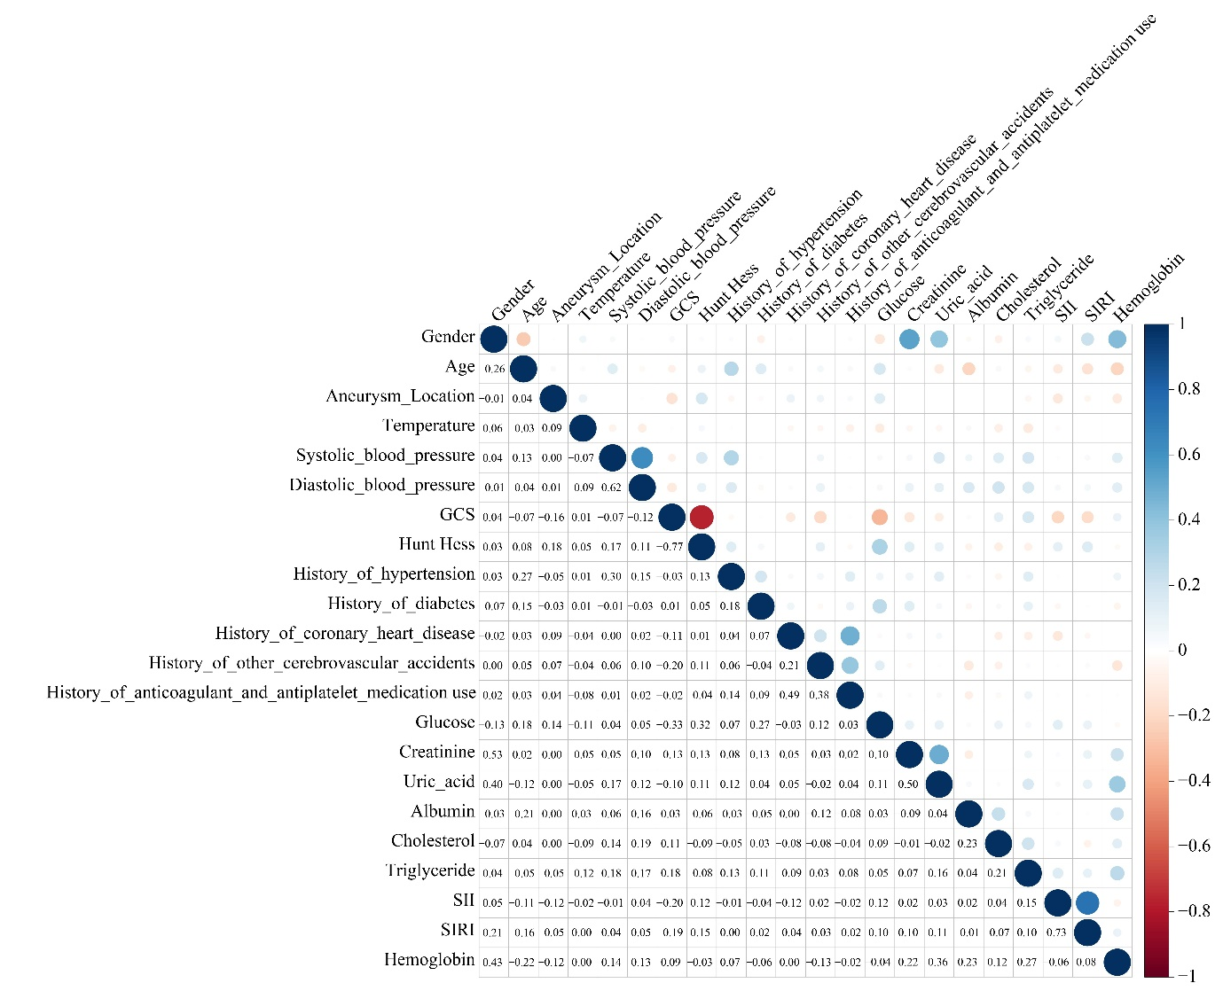
Supplementary Figure 1 Correlations between novel inflammatory indices and covariates.

