Supplementary Figures

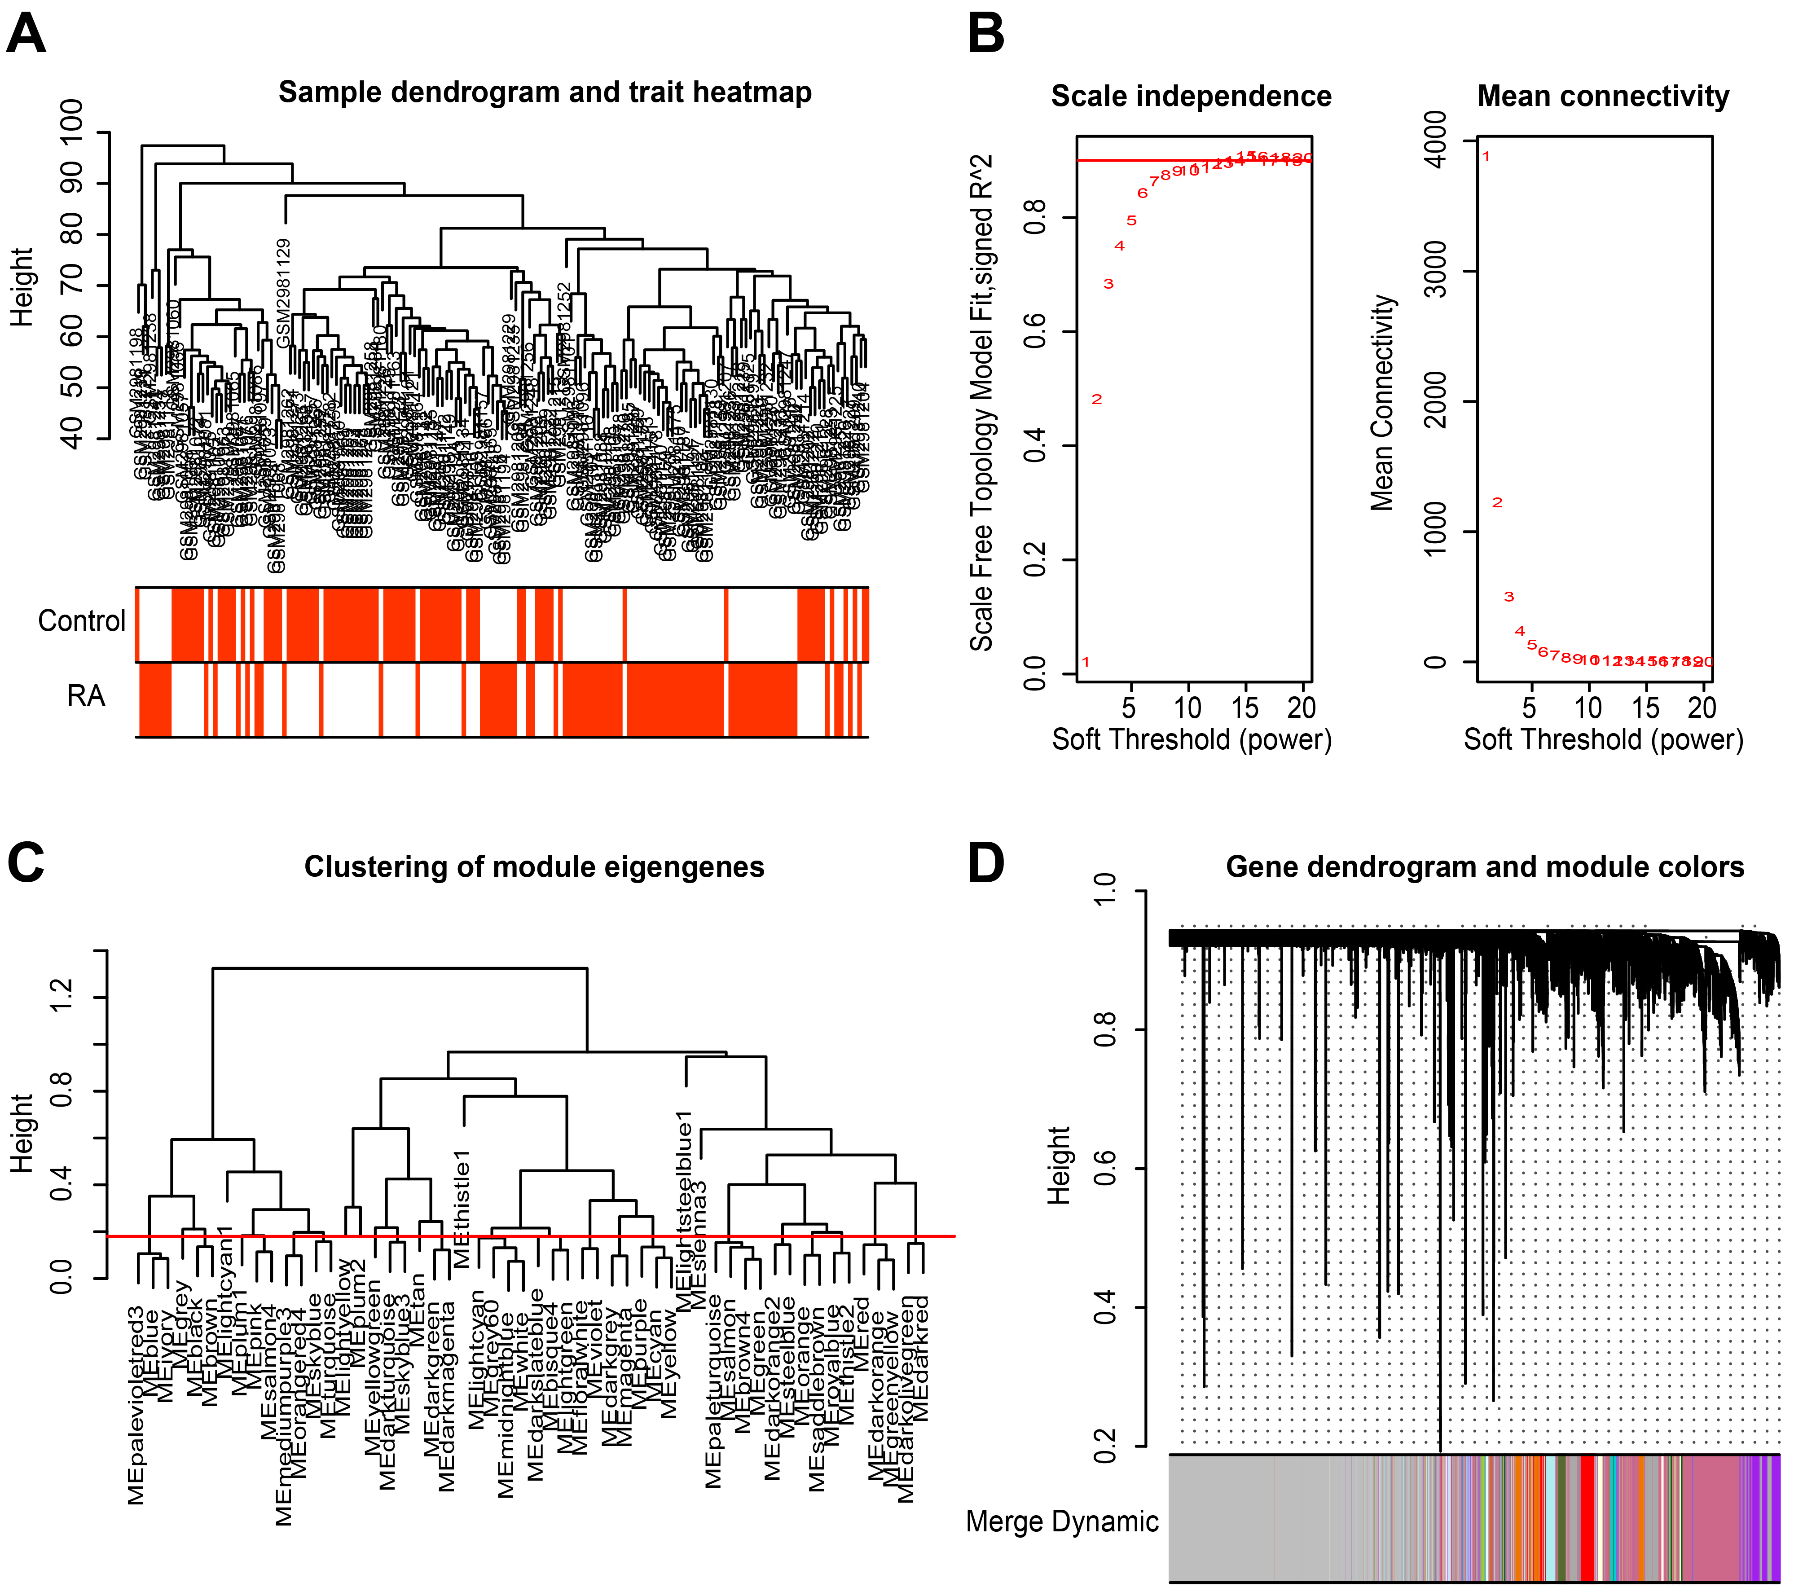
Supplementary Figure 1. Identification of significant module genes in RA. (A) All samples were clustered to detect outliers. (B) Select suitable soft-thresholding power to obtain the scale-free co-expression network. (C) The cutoff value of 0.18 to merge similar gene modules. (D) RA-related genes were clustered to 20 modules. Abbreviations: RA, rheumatoid arthritis.

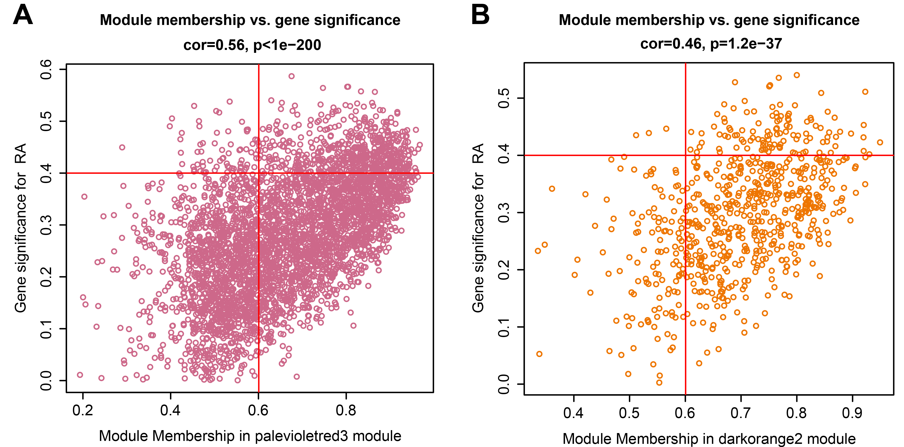
Supplementary Figure 2. The RA important modules analysis. (A) The correlation between module membership in palevioletred3 module and gene significance. (B) The correlation between module membership in darkorange2 module and gene significance. Abbreviations: RA, rheumatoid arthritis.

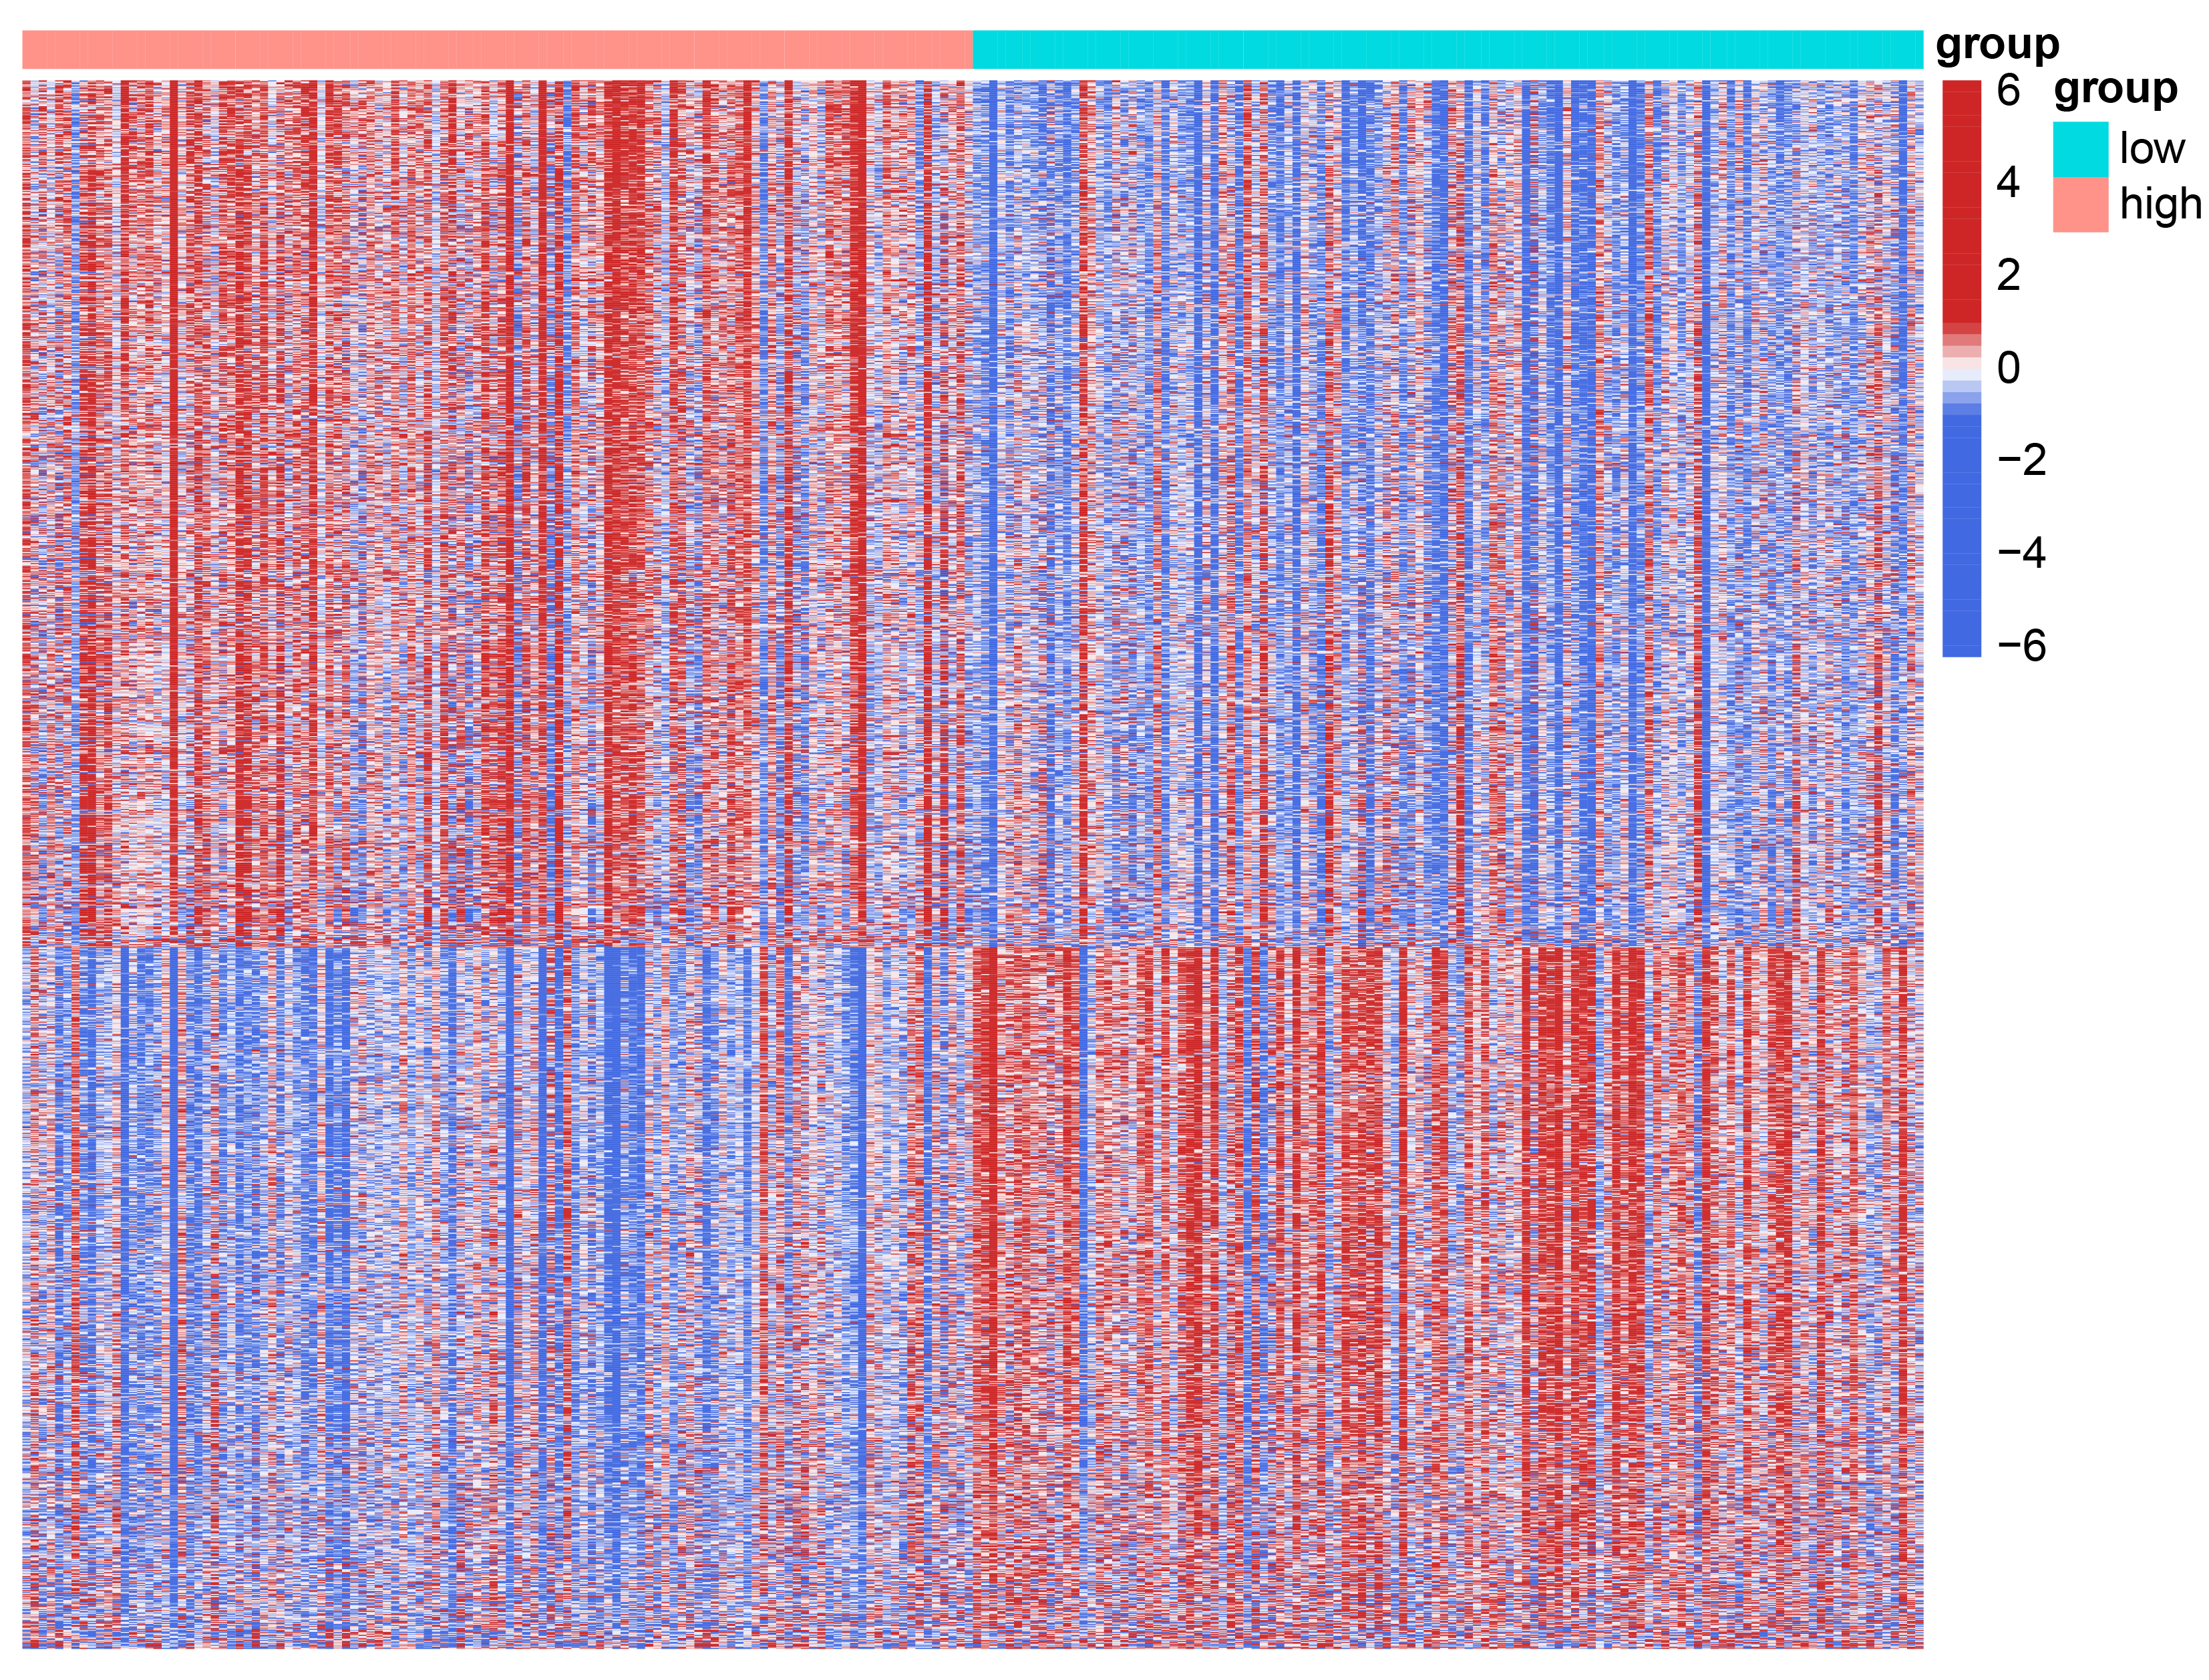
Supplementary Figure 3. The heatmap of 1576 DEGs between high-scoring group and low-scoring group. Abbreviations: DEGs, differentially expressed genes.

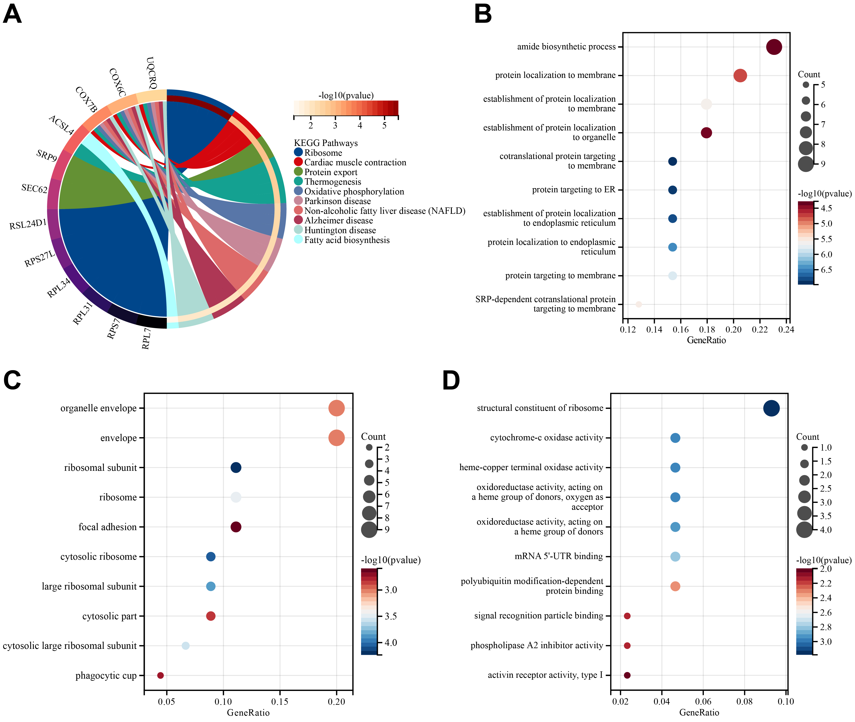
Supplementary Figure 4. Functional enrichment analysis of disulfidptosis-related genes involved in RA. (A) The results of KEGG pathway enrichment analysis for genes related to disulfidptosis involved in RA. (B-D) The results of GO enrichment analysis (BP, CC, MF) for genes related to disulfidptosis involved in RA. Abbreviations: BP, Biological Processes; CC, Cellular Components; GO, Gene Ontology; KEGG, Kyoto Encyclopedia of Genes and Genomes; MF, Molecular Functions; RA, rheumatoid arthritis.

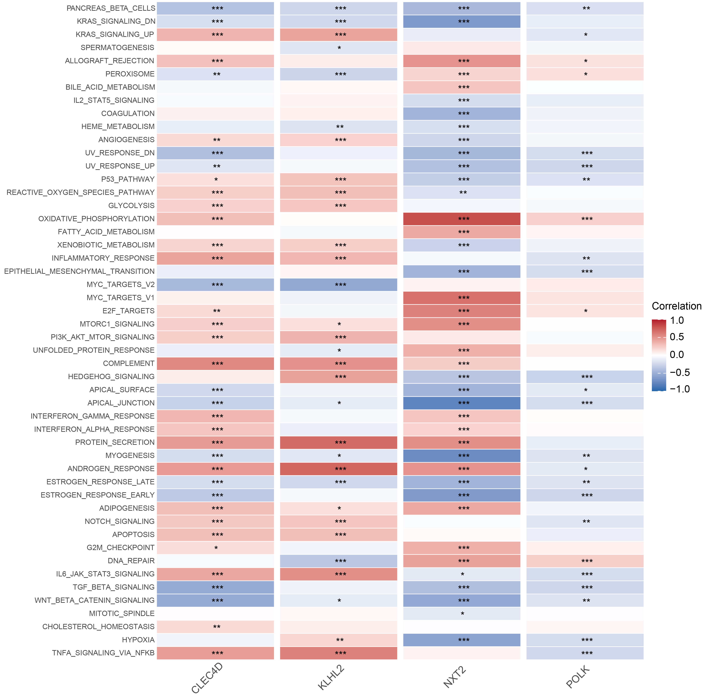
Supplementary Figure 5. The correlation heatmap showed the relationship between hub genes and hallmark gene sets; *: P < 0.05; **: P < 0.01; ***: P < 0.001.

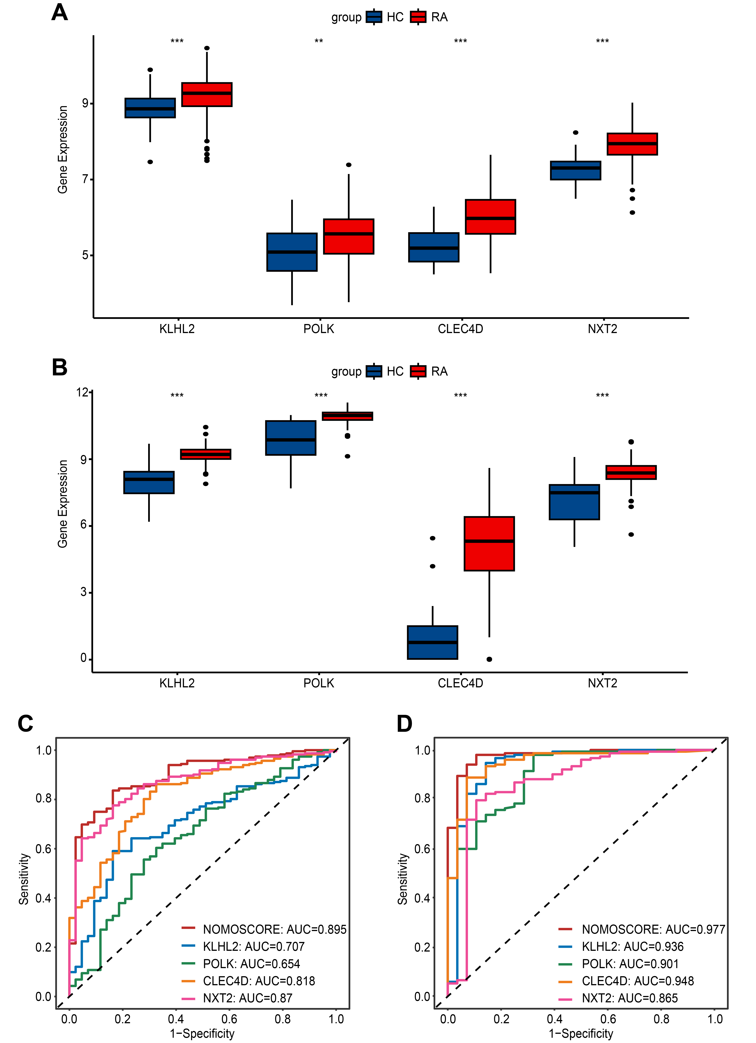
Supplementary Figure 6. External verification in GSE93272 and GSE89408. (A) The different expression of the four genes between RA and HC in GSE93272. (B) The different expression of the four genes between RA and HC in GSE89408; **: P < 0.01; ***: P < 0.001. (C) The diagnostic value of the nomogram and the hub genes using the ROC curve in GSE93272. (D) The diagnostic value of the nomogram and the hub genes using the ROC curve in GSE89408. Abbreviations: AUC, area under the curve; HC, Healthy control; RA, rheumatoid arthritis; ROC, receiver operating characteristic.

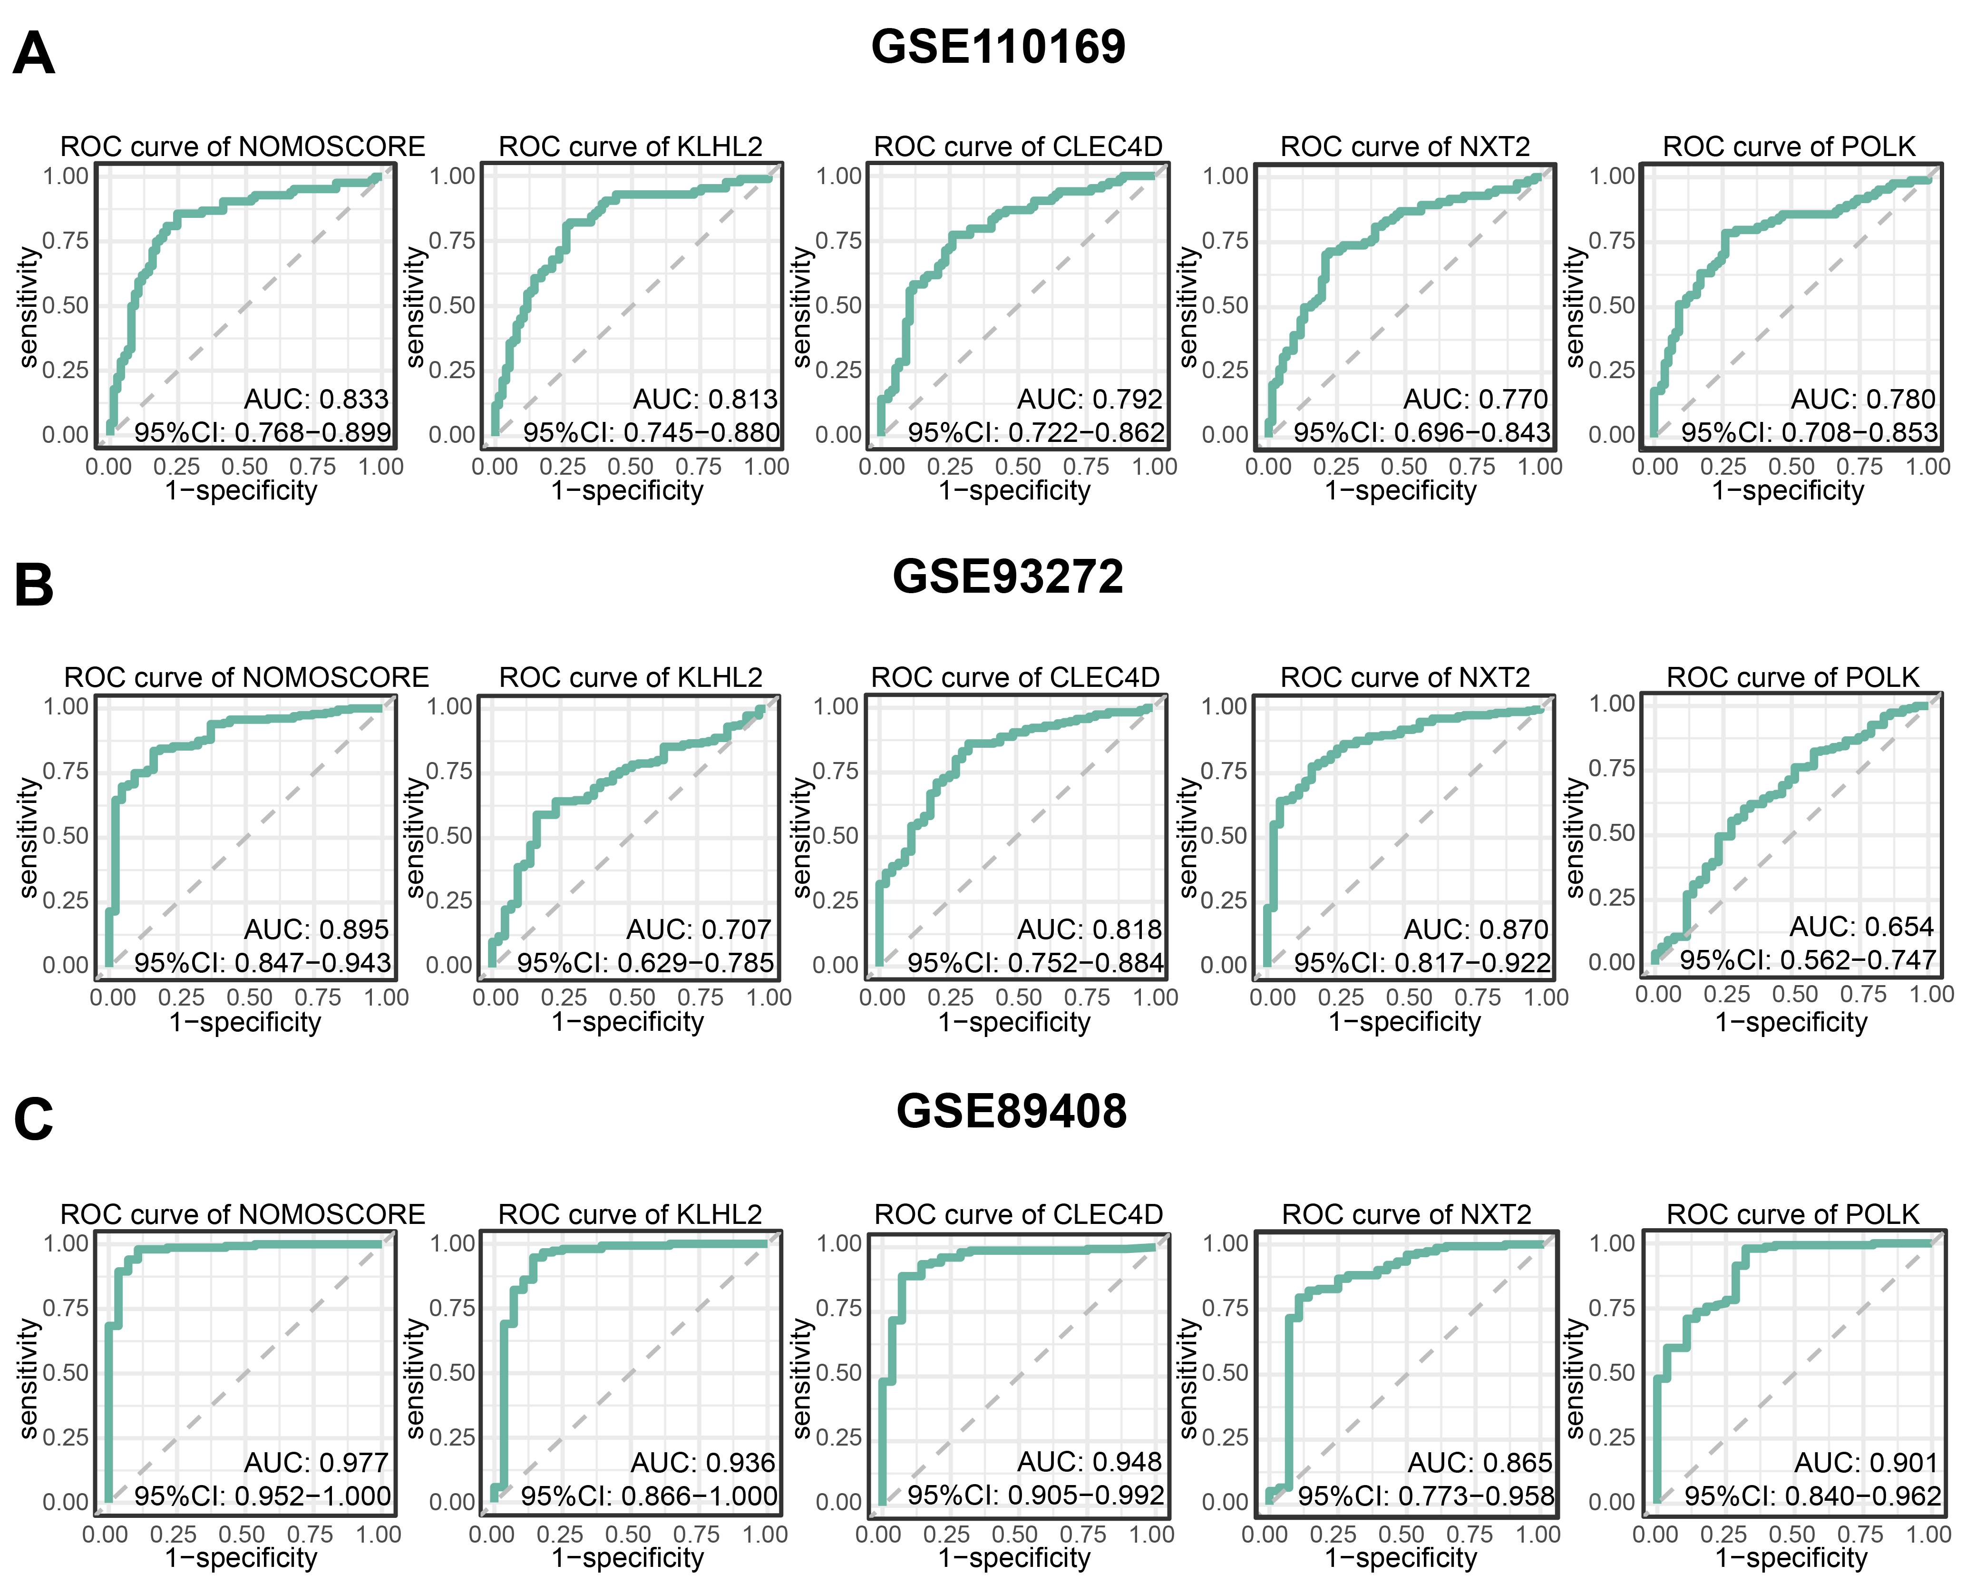
Supplementary Figure 7. ROC curves in validation sets. (A) ROC curves of the GSE110169. (B) ROC curves of the GSE93272. (C) ROC curves of the GSE89408. Abbreviations: AUC, area under the curve; CI, confidence interval; ROC, receiver operating characteristic.

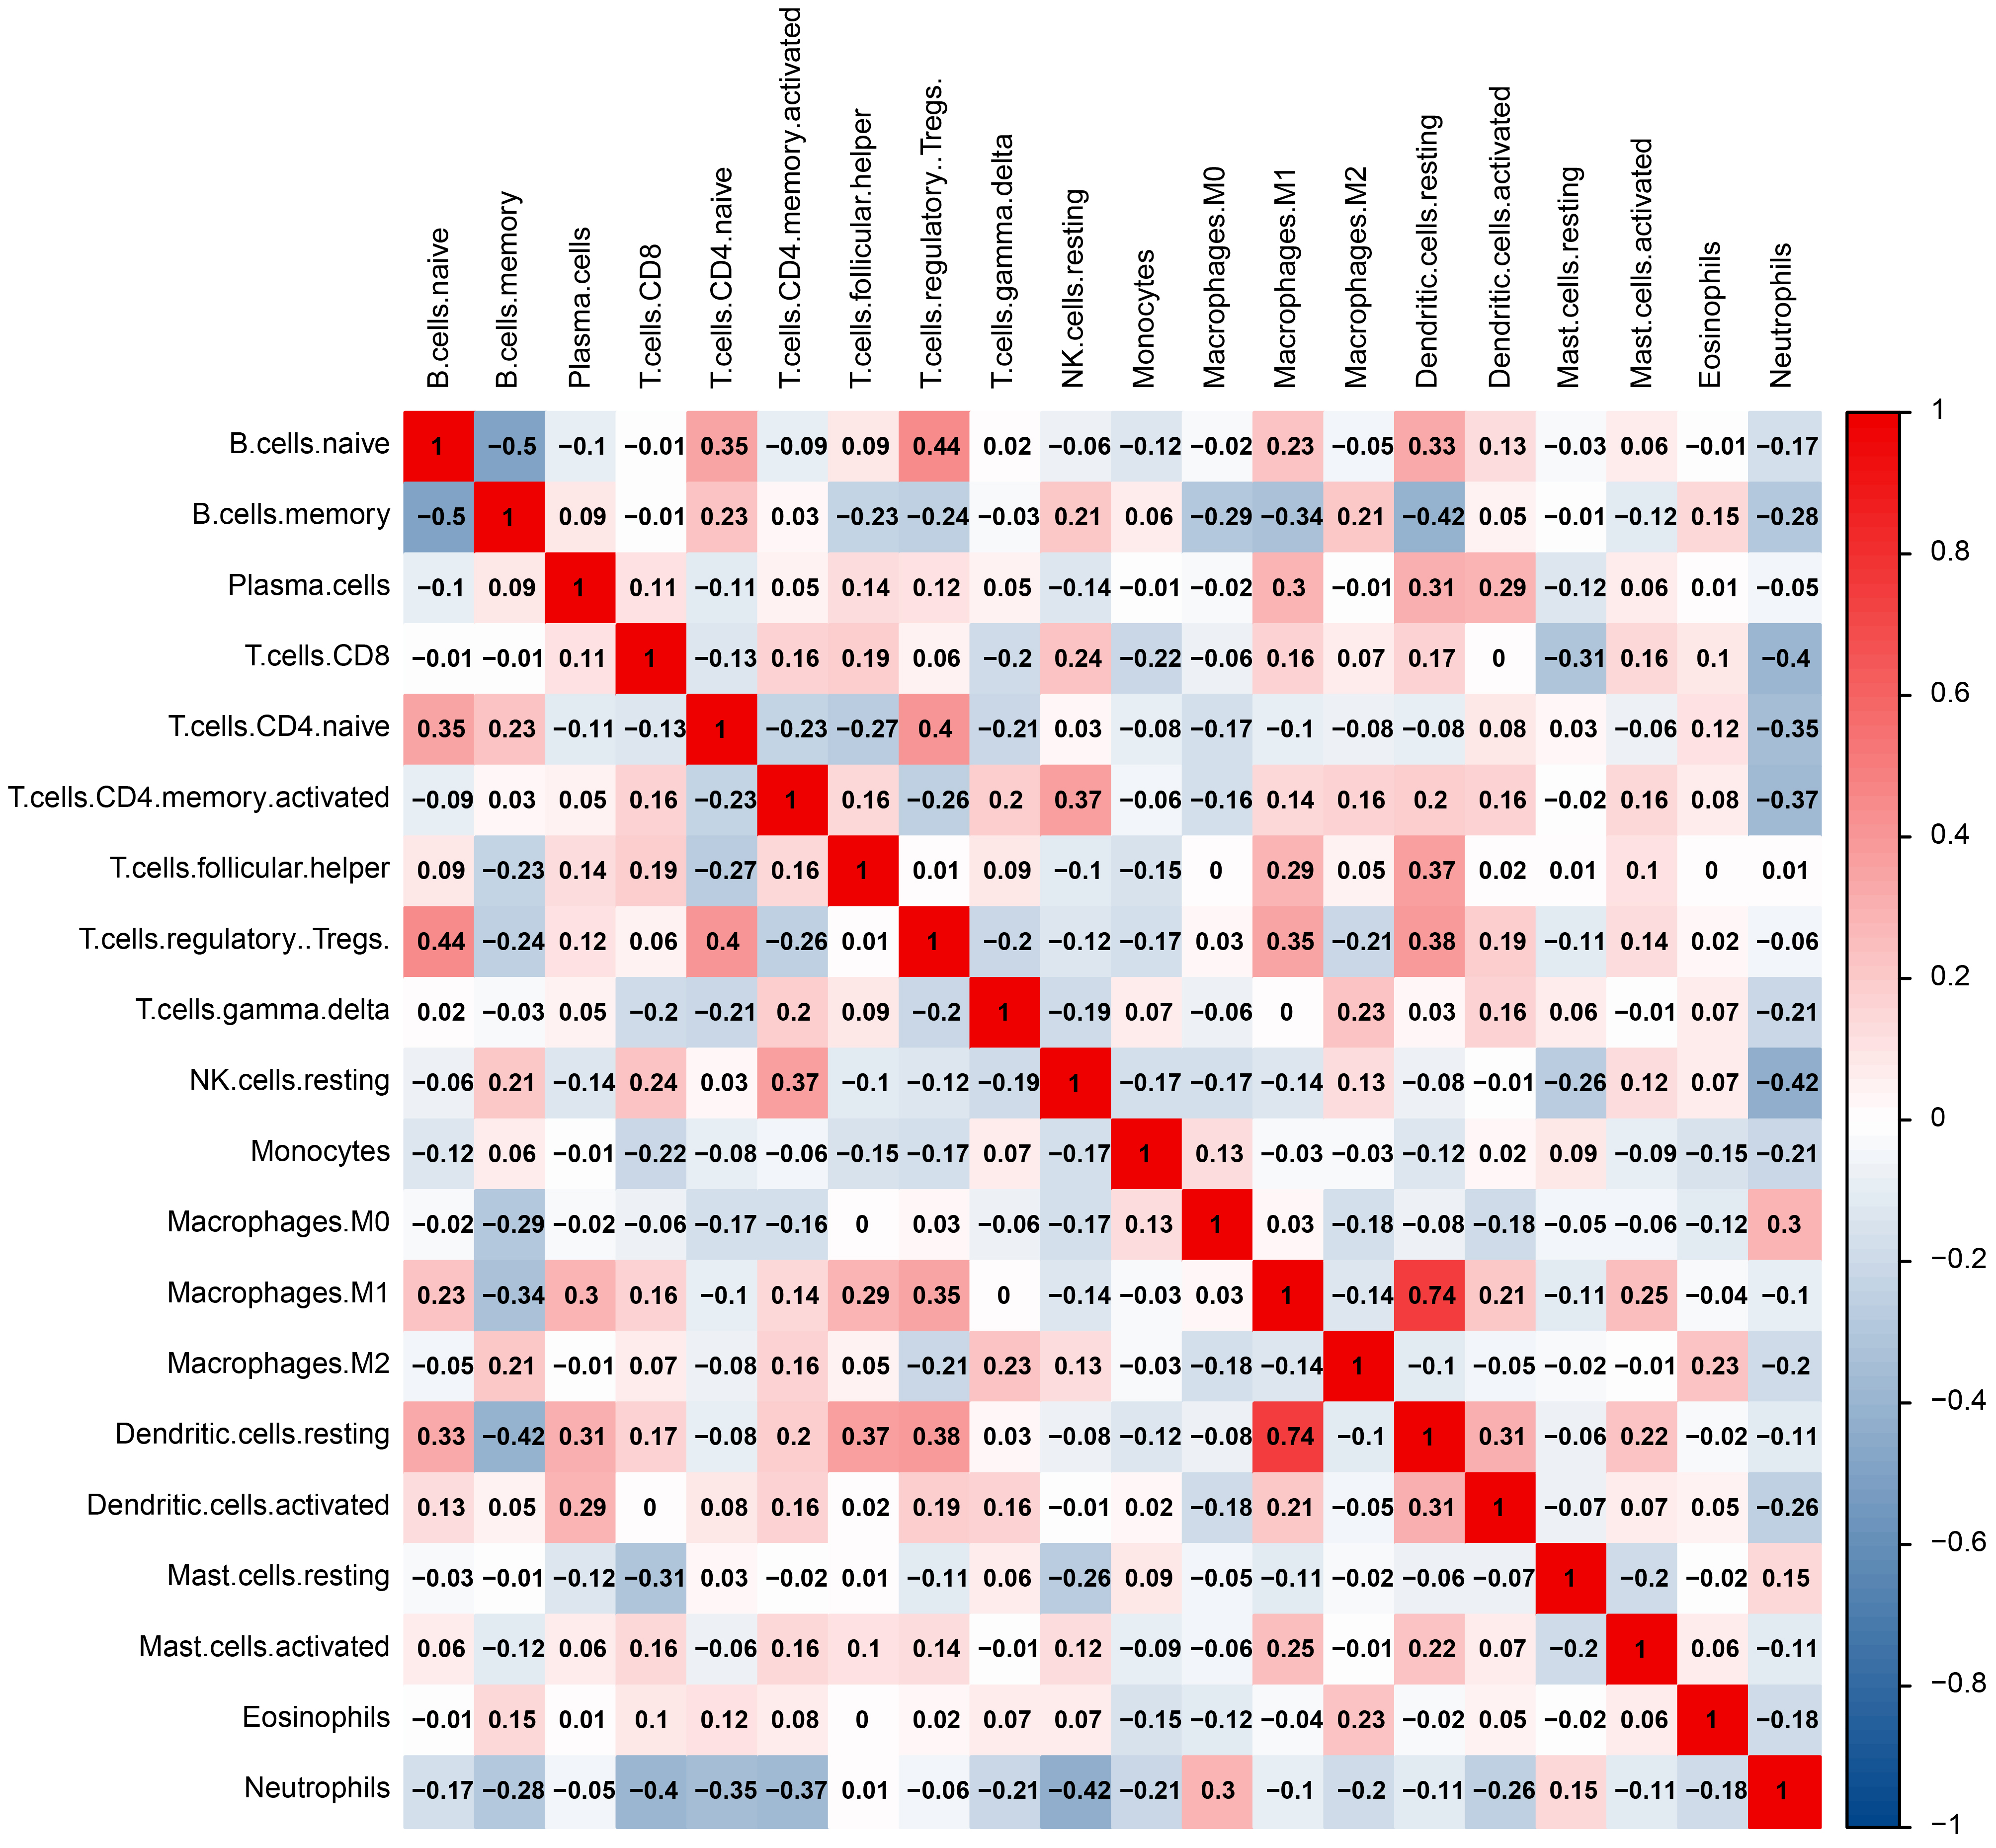
Supplementary Figure 8. The correlation heatmap represented the correlation between different immune cells in RA. Abbreviations: RA, rheumatoid arthritis.

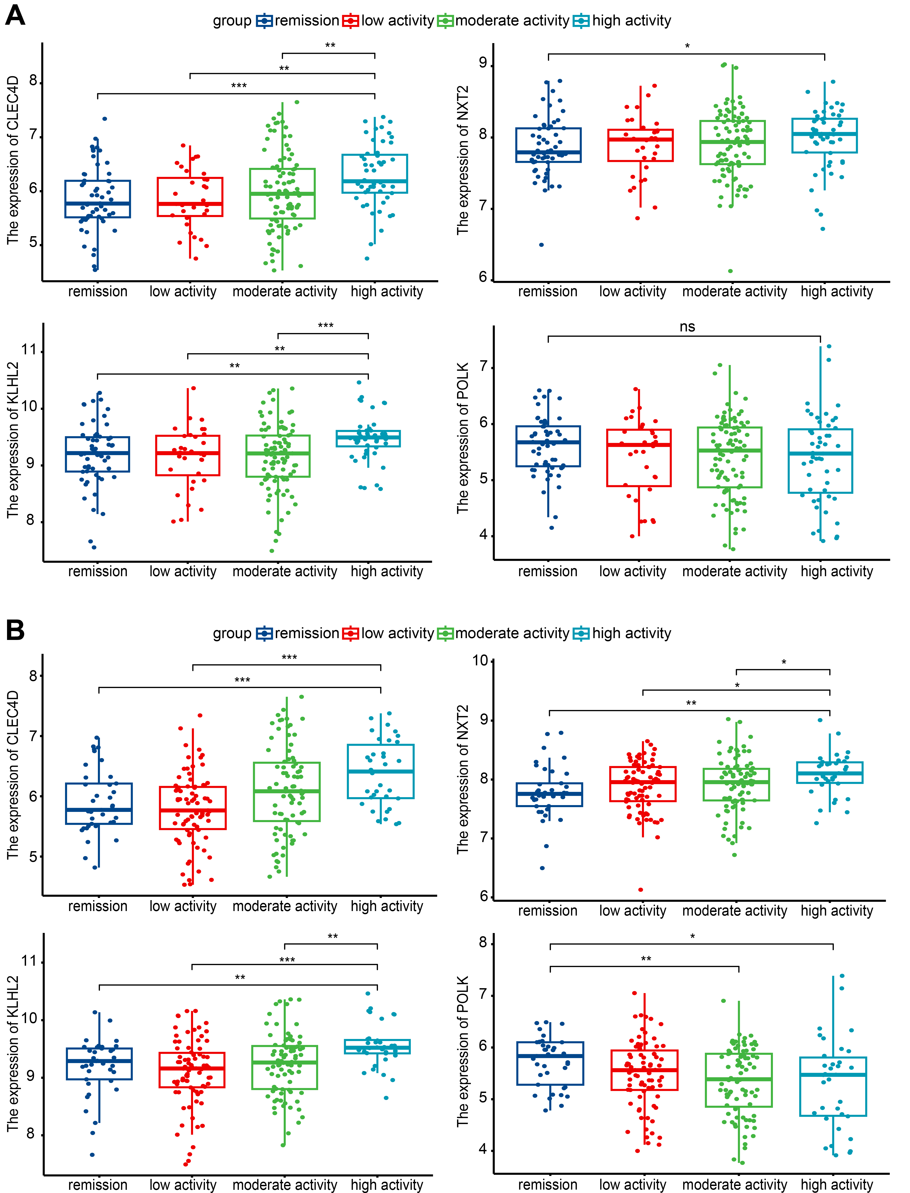
Supplementary Figure 9. The correlation between hub genes expression and RA disease activity. (A) The expression levels of four genes were compared among four different disease activity stages based on DAS28.ESR scores in RA. (B) The expression levels of four genes were compared among four different disease activity stages based on CDAI scores in RA; ns: no significance; *: P < 0.05; **: P < 0.01; ***: P < 0.001. Abbreviations: CDAI, clinical disease activity index; DAS28, disease activity score in 28 joints; RA, rheumatoid arthritis.

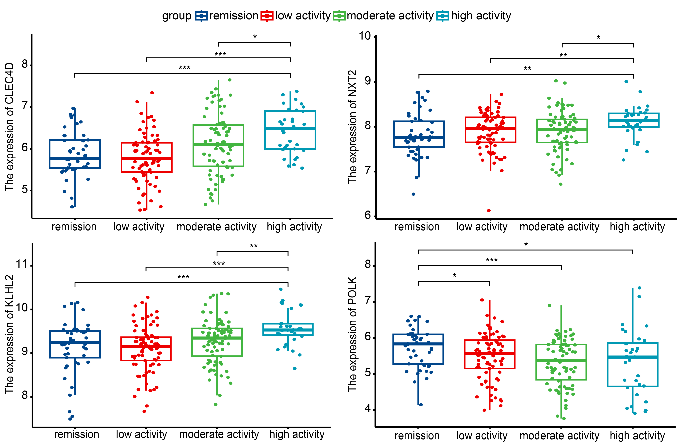Supplementary Figure 10. The expression levels of four genes were compared among four different disease activity stages based on SDAI scores in RA; *: P < 0.05; **: P < 0.01; ***: P < 0.001. Abbreviations: RA, rheumatoid arthritis; SDAI, simplified disease activity index.

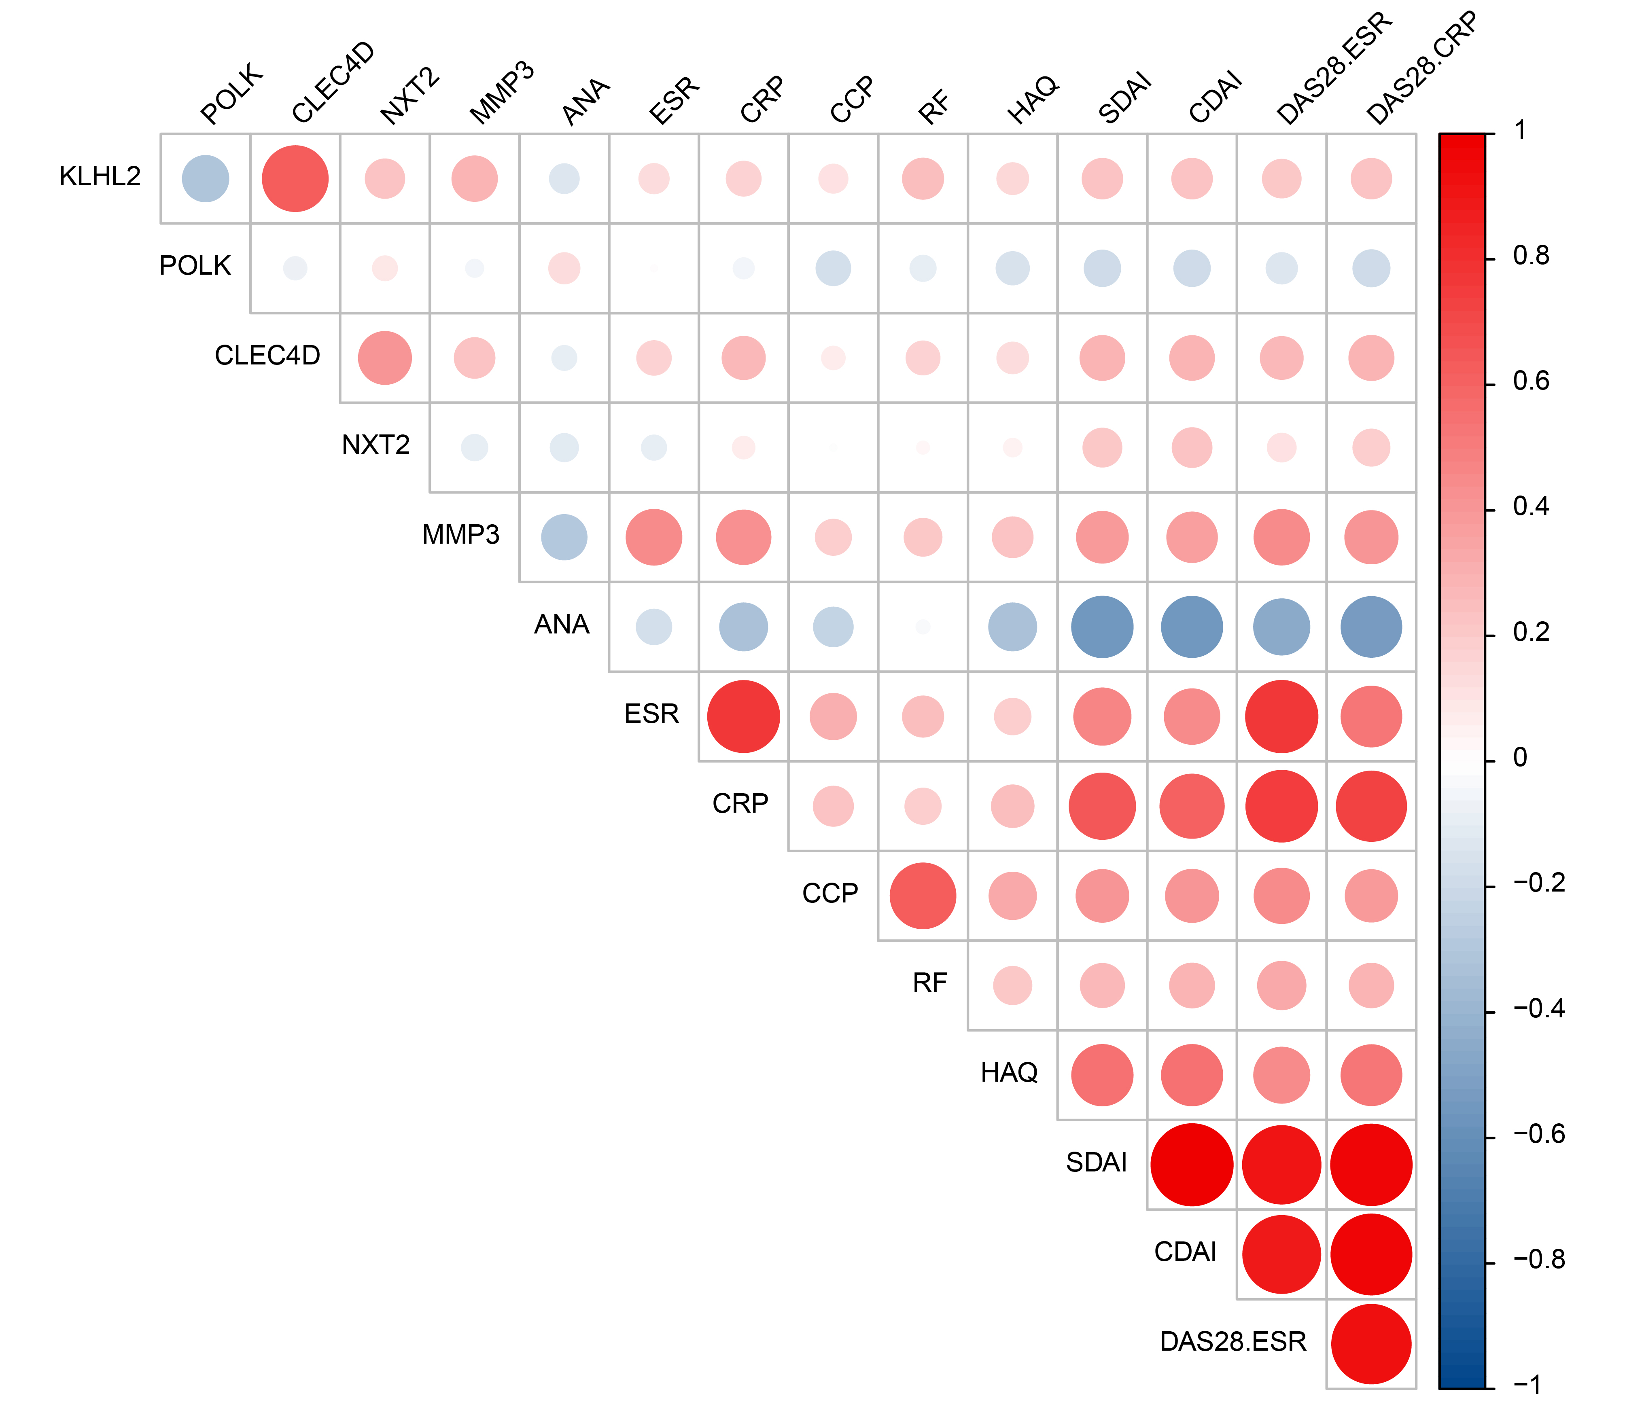
Supplementary Figure 11. The correlation heatmap showed the association between hub genes and clinical markers. Abbreviations: CDAI, clinical disease activity index; DAS28, disease activity score in 28 joints; HAQ, health assessment questionnaire; SDAI, simplified disease activity index.

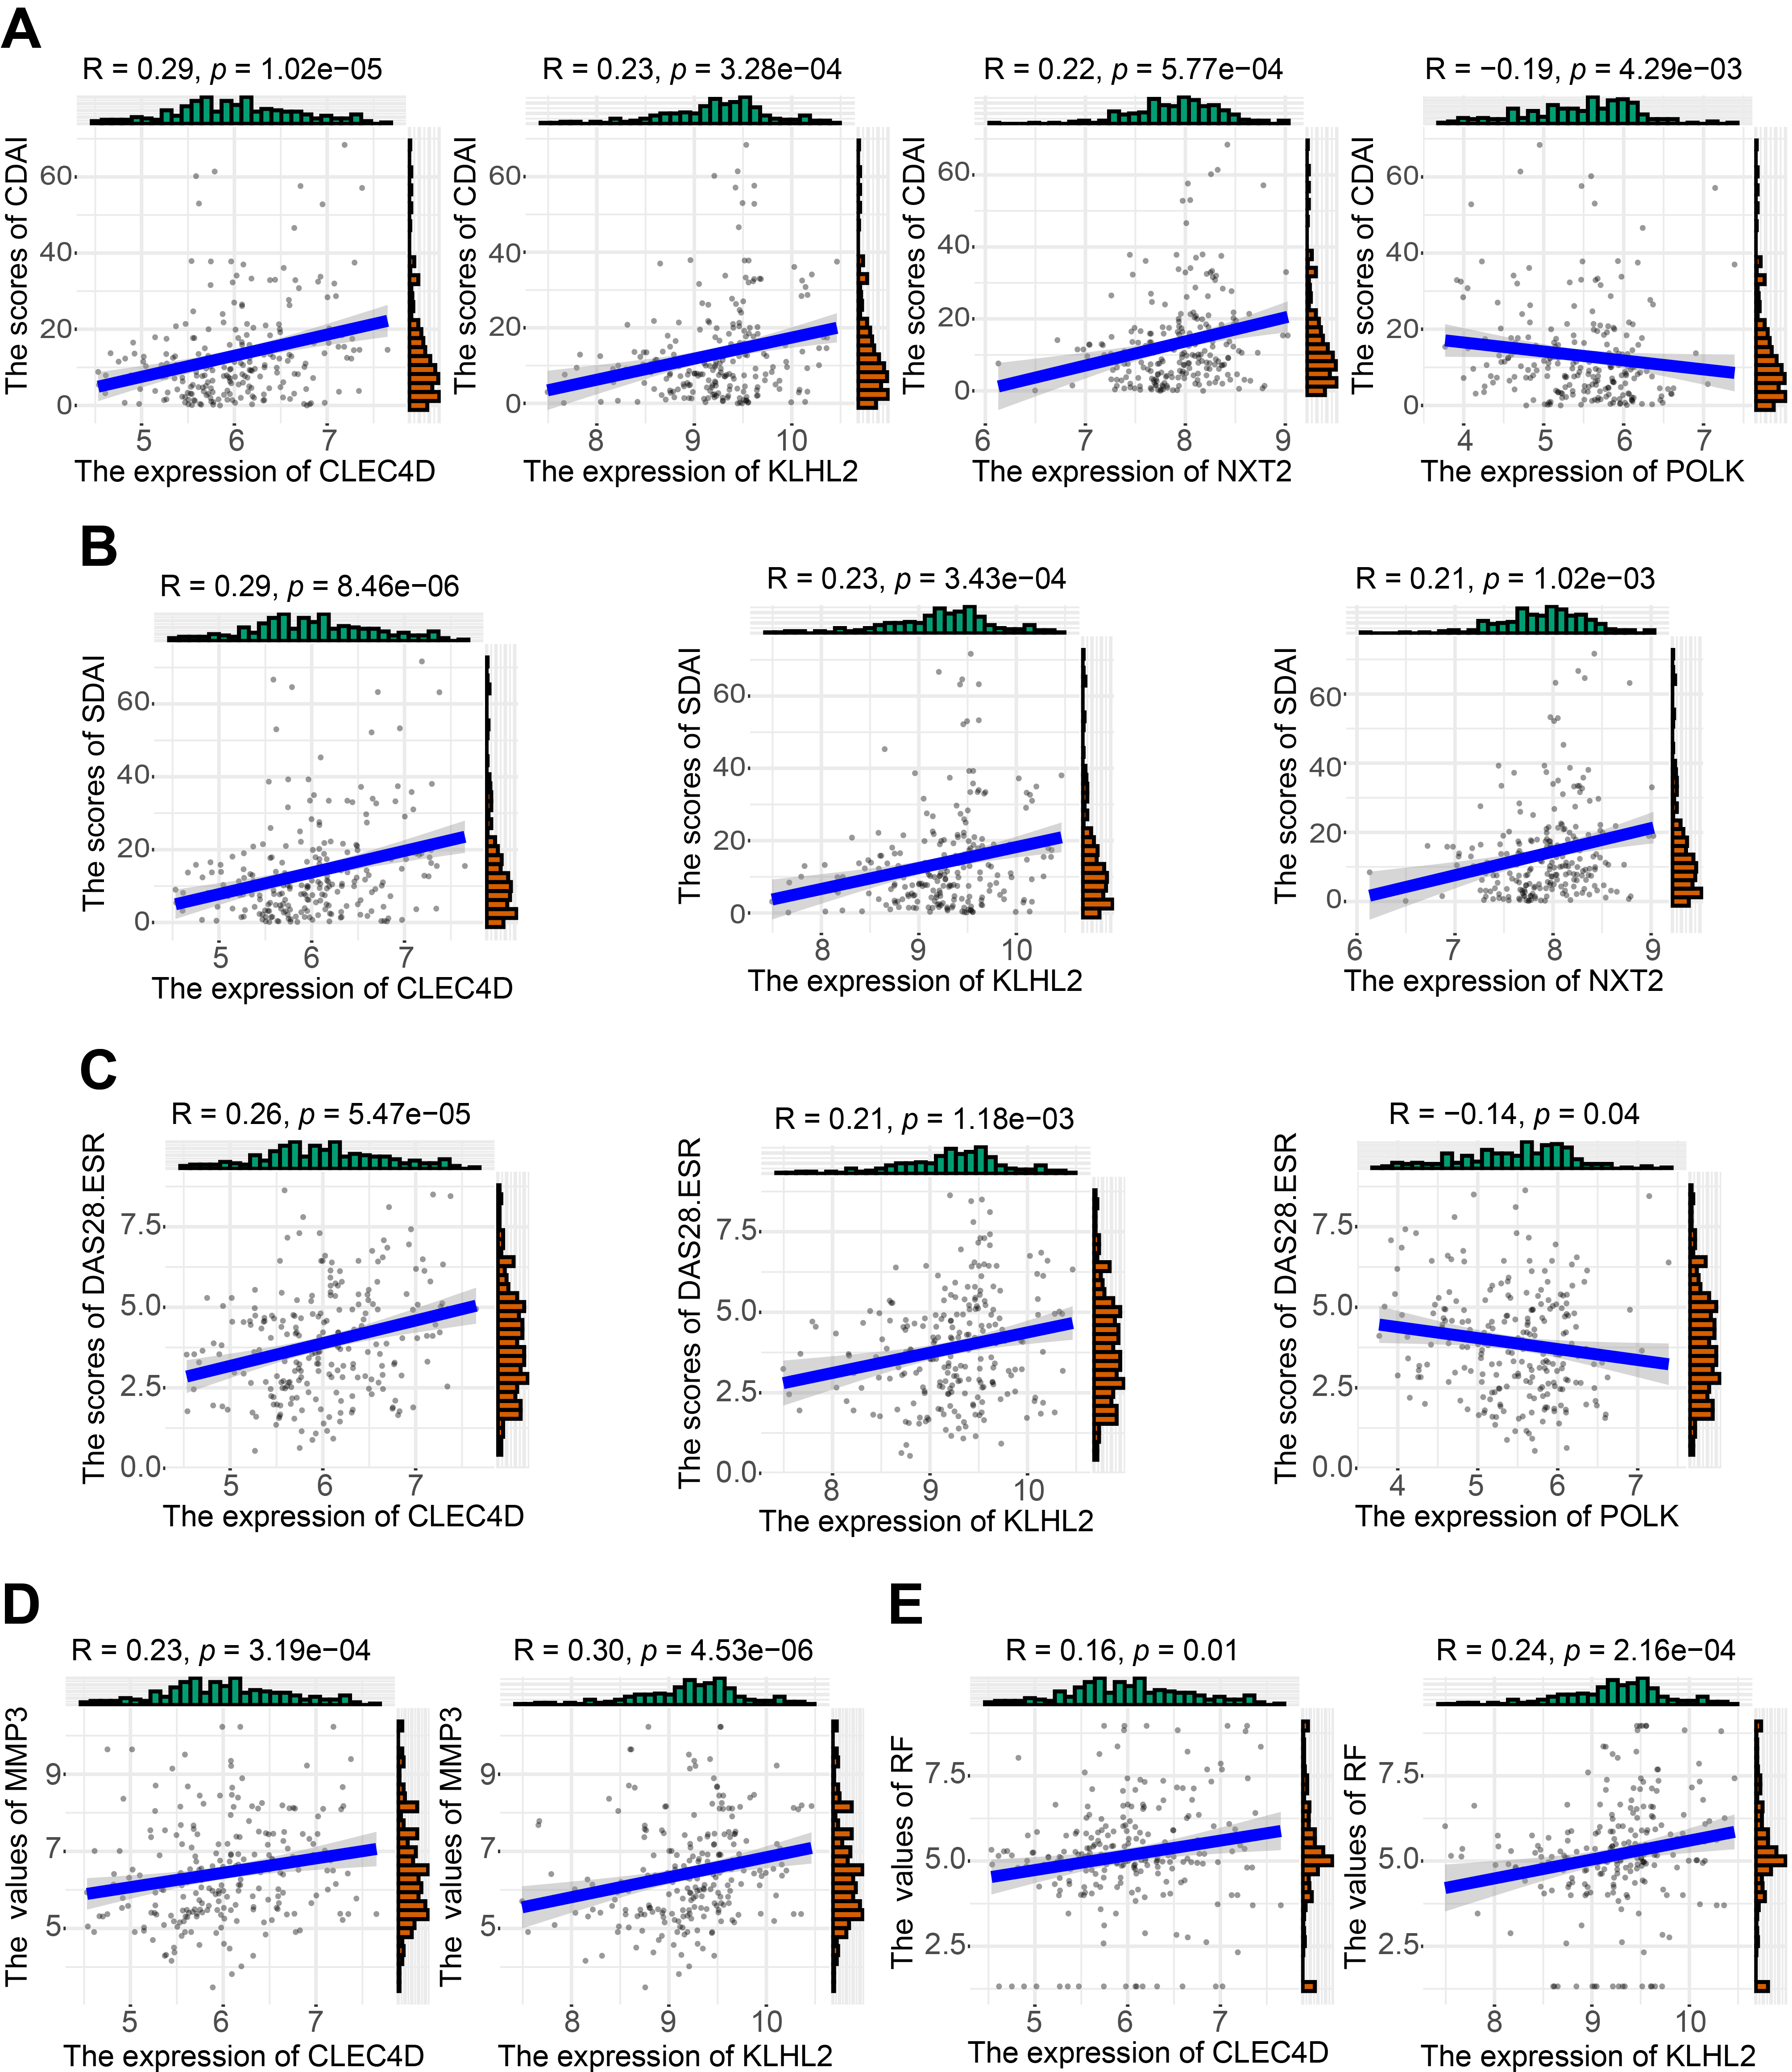
Supplementary Figure 12. The scatter plots illustrated the correlation between hub genes and clinical markers. (A) The correlation between four hub genes and CDAI. (B) The correlation between CLEC4D, KLHL2, NXT2, and SDAI. (C) The correlation between CLEC4D, KLHL2, POLK, and DAS28.ESR. (D) The correlation between CLEC4D, KLHL2, and MMP3. (E) The correlation between CLEC4D, KLHL2, and RF. Abbreviations: CDAI, clinical disease activity index; DAS28, disease activity score in 28 joints; SDAI, simplified disease activity index.
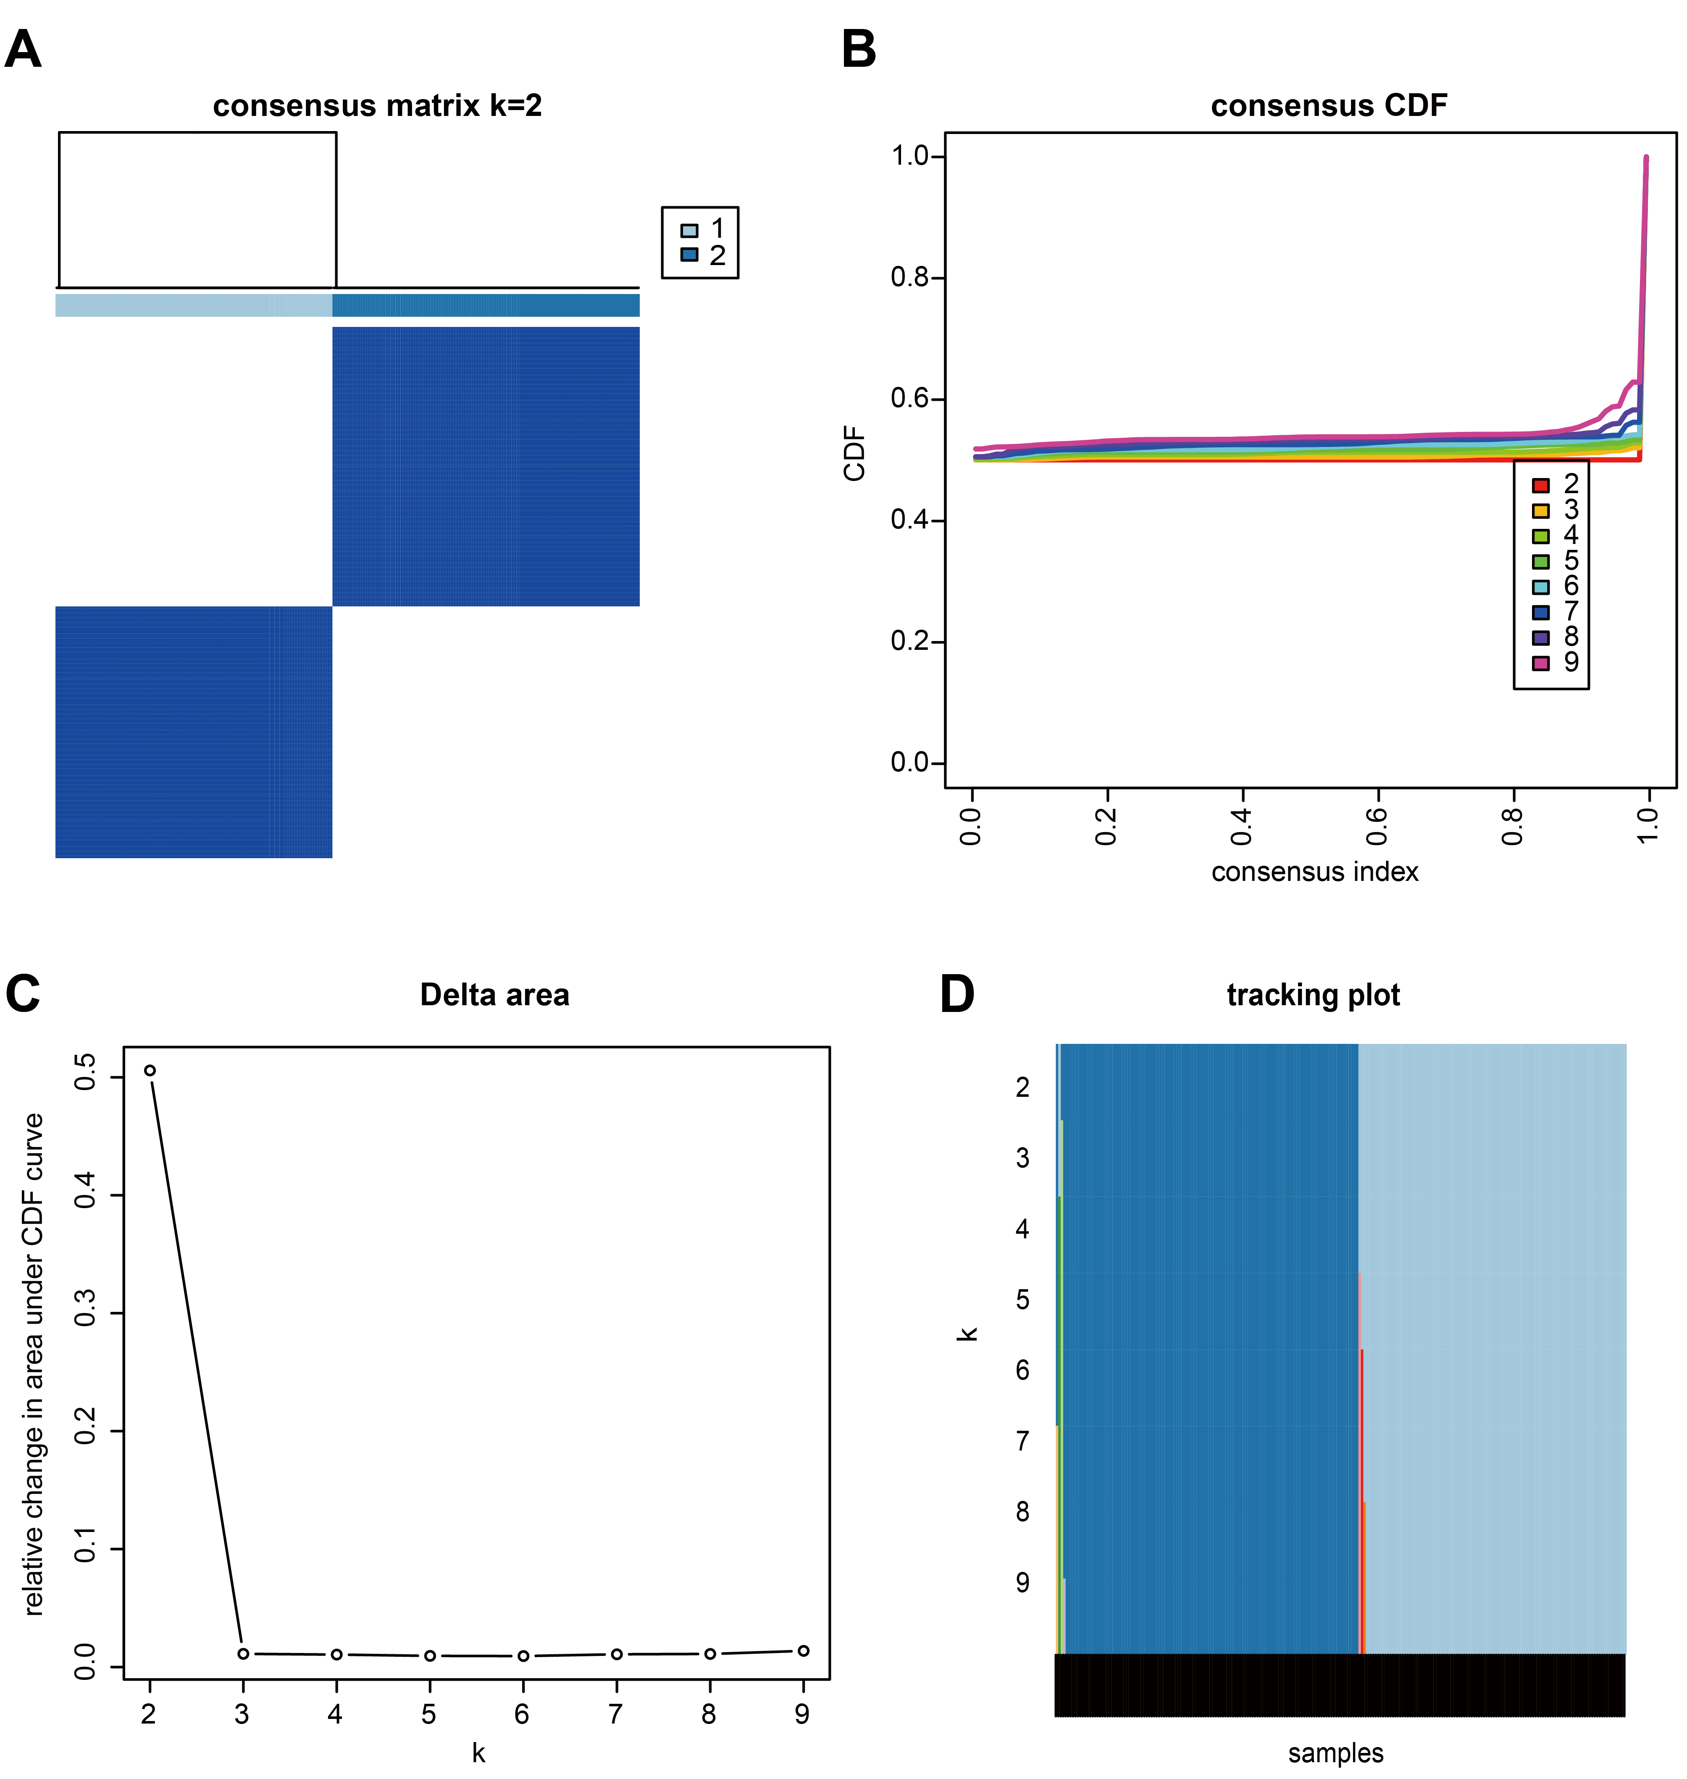
Supplementary Figure 13. Identification of two subtypes based on the hub genes. (A) Consensus matrix heatmap when k=2. (B) Consensus CDF when k = 2-9. (C) Relative change in area under CDF curve. (D) Tracking plot showed the sample classification when k=2-9. Abbreviations: CDF, cumulative distribution function.

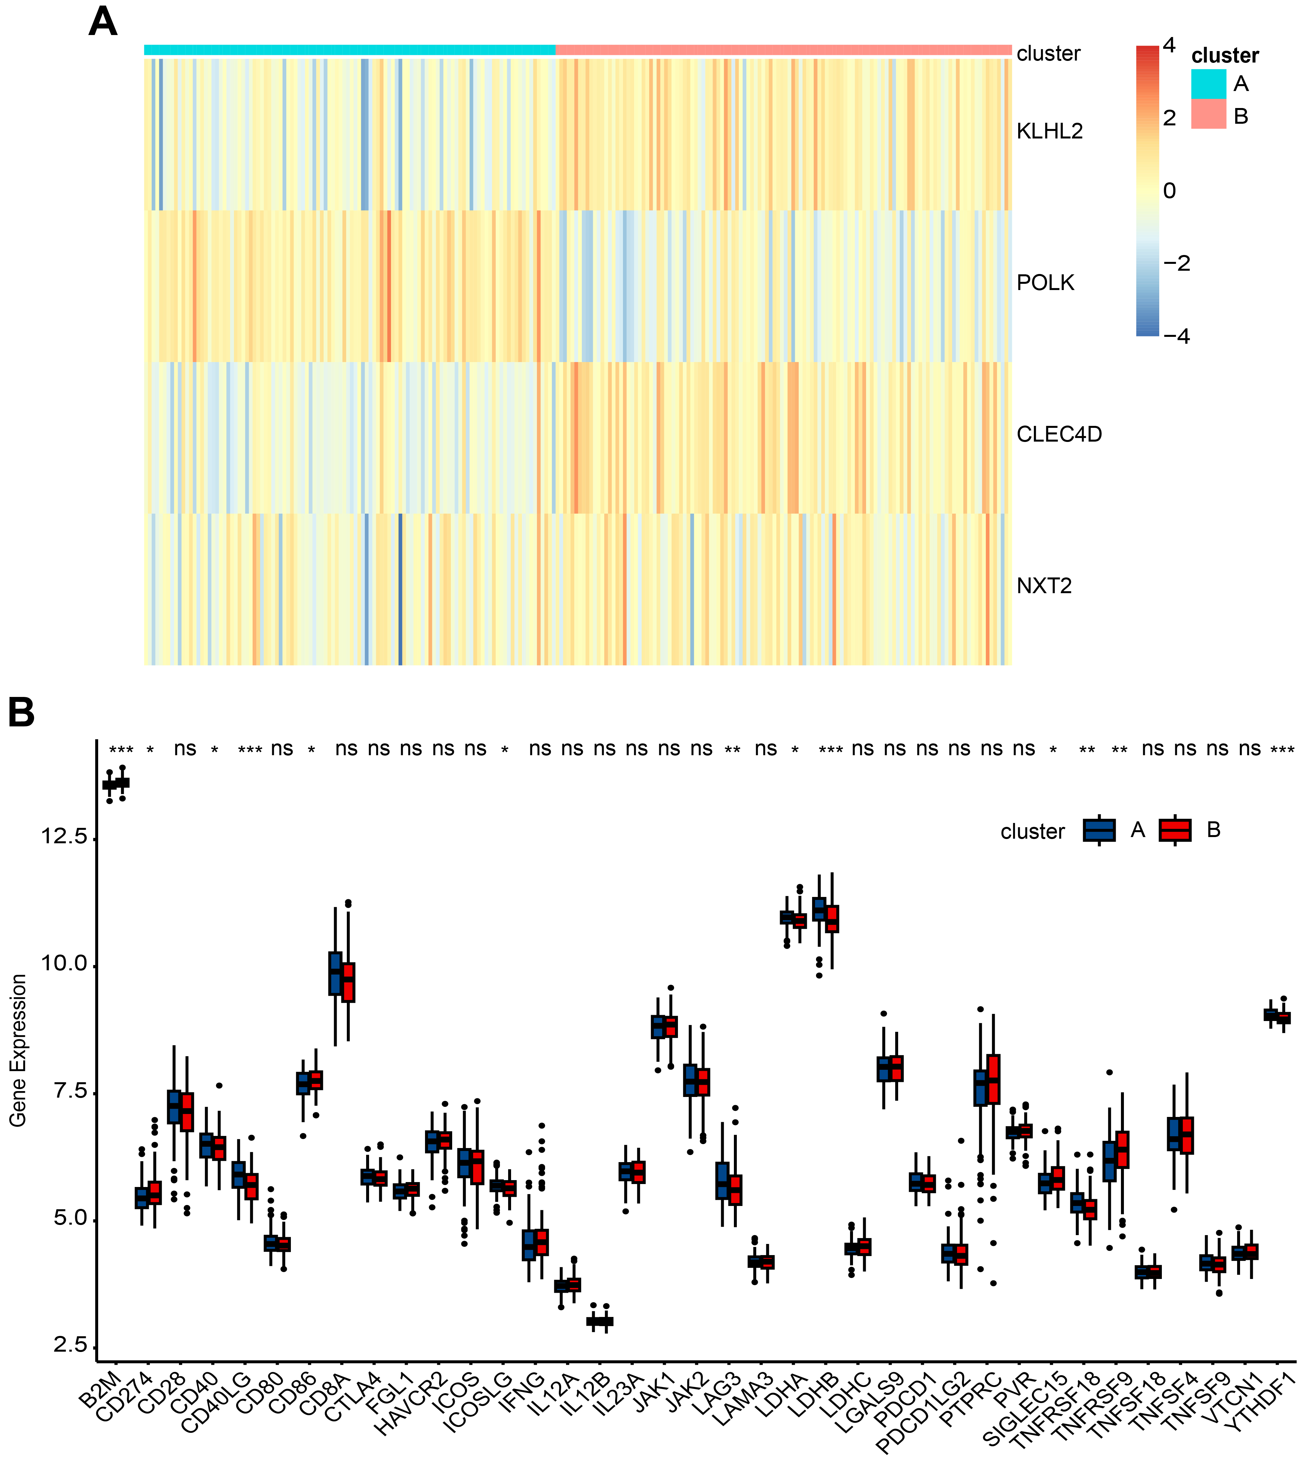
Supplementary Figure 14. The difference of characteristics between two subtypes. (A) The heatmap showed the expression of hub genes in two subtypes of RA. (B) The expression of immune checkpoints in the two subtypes; ns: no significance; *: P < 0.05; **: P < 0.01; ***: P < 0.001. Abbreviations: RA, rheumatoid arthritis.

