Supporting Information

Optimizing Triple-Negative Breast Cancer Therapy via Ultrasound-Enhanced Piezocatalysis for Targeted Chemodrug Release

Qingwen Xue^{1#}, Ningning He^{2,#}, Yuxiu Gao¹, Xuehui Zhang¹, Shuao Li¹, Fang Chen¹, Chunping Ning¹, Xiaoyu Wu², Jingtong Yao², Ziheng Zhang², Shangyong Li^{1,2,*}, Cheng Zhao^{1,*}

¹Department of Ultrasound, the Affiliated Hospital of Qingdao University, Qingdao 266003, China

²School of Basic Medicine, Qingdao Medical College, Qingdao University, Qingdao 266003, China

*To whom correspondence should be addressed.

E-mail: zhaochengdr@163.com
lisy@qdu.edu.cn
heningning@qdu.edu.cn

Figure Legends

Fig. S1. XRD patterns of BaTiO₃ NPs.
Fig. S2. The picture of DBRL nanoparticles distributed in different media.
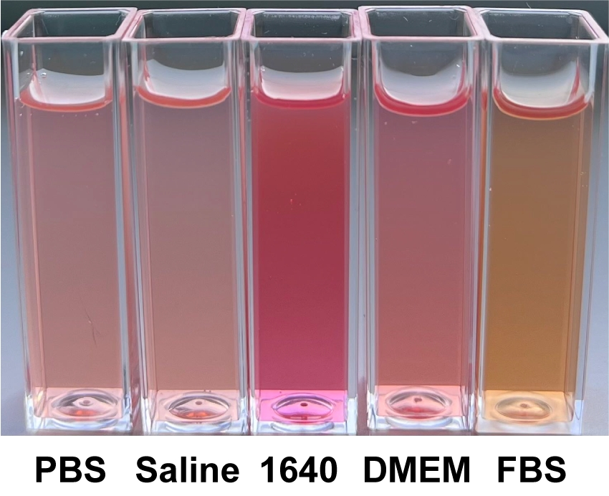

Fig. S3. Viability of MCF-10A cells after co-incubation with DBRL NPs.
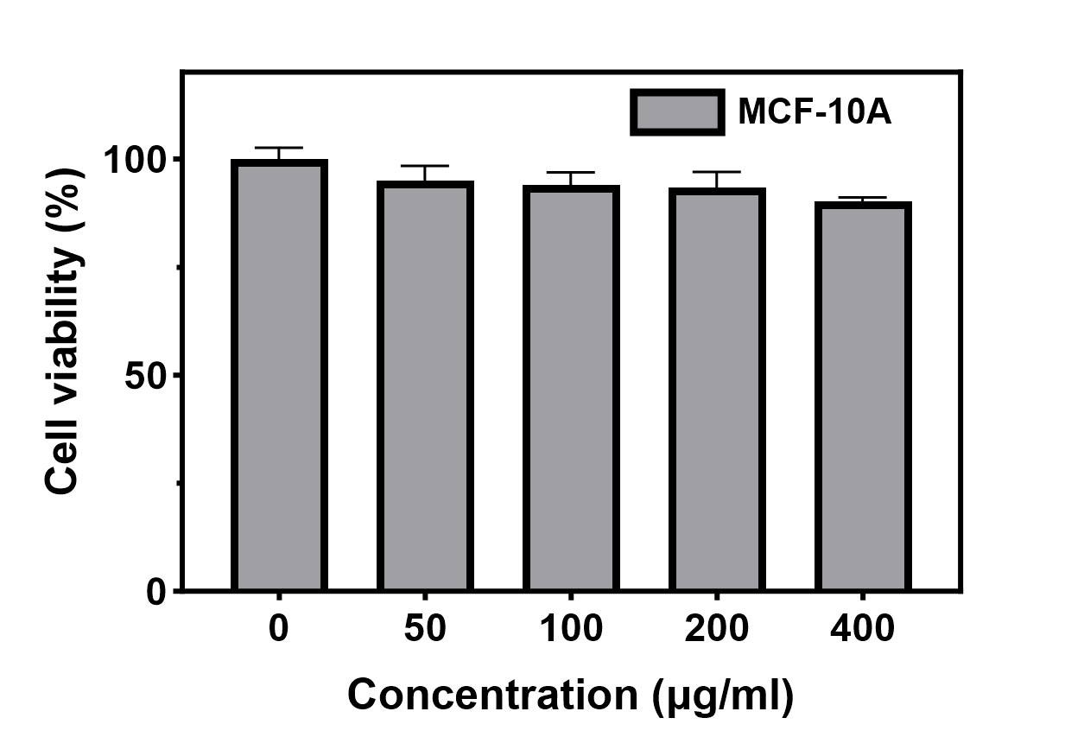
Fig. S4. Cell viabilities of MDA-MB-231 cells under different treatments (n = 4).
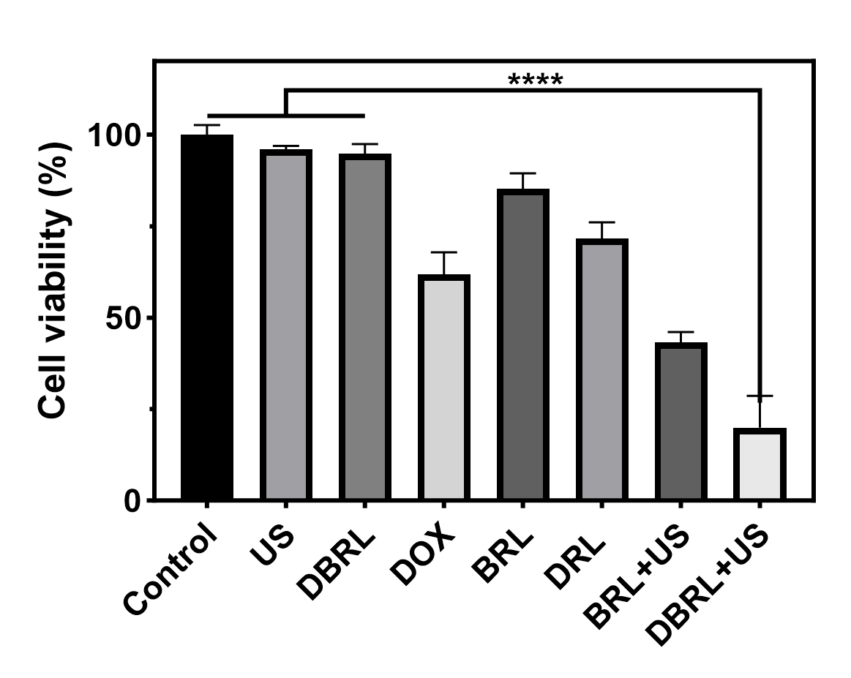
Fig. S5. H&E staining images of main organs of different groups after 14 days treatments (scale bar: 100 μm).

