Supplementary content

Viscoelastic imaging uses the Voigt model to calculate the viscosity coefficient Vmean related to tissue viscosity. The Voigt model employs more complex equations to explain velocity variations associated with frequency, and the formula is as follows:
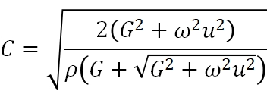
where c is the shear wave phase speed (m/s), G is the renal tissue shear modulus (Pa), ρ is the media density, 𝜇 is the renal tissue shear viscosity (Pa·s), and 𝜔 is the angular frequency (rad/s).

Supplementary Table 1 ISN/RPS type distribution for the patient group
ISN/RPS type distribution | Number of case
Type I | 16
Type II | 23
Type III | 21
Type IV | 51
Type V | 14
Type III+V | 4
Type IV+V | 14
ISN/RPS International Society of Nephrology/Renal Pathology Society

Supplementary Table 2 Clinical parameters between PLN group and nPLN group
Characteristic | nPLN group  (n = 53) | PLN group group  (n = 90) | p
Scr (mg/dL) | 0.64 (0.52 - 0.80) | 0.92 (0.70 - 1.49) | < 0.001
Anti-dsDNA (IU/ml) | 63.5 (22.8 - 285.0) | 158 (40.5 - 300.0) | 0.019
eGFR (mL/min/1.73m²) | 117.22 (89.48 - 131.13) | 89.28 (48.42 - 120.25) | < 0.001
C3 (g/L) | 0.62 (0.42 - 0.81) | 0.53 (0.38 - 0.65) | 0.092
C4 (g/L) | 0.13 (0.07 - 0.19) | 0.11 (0.06 - 0.15) | 0.187

Supplementary Table 3 Correlation analysis between viscoelastic parameters and pathological parameters
Characteristic | activity index  Spearman’s rho (p value) | chronic index  Spearman’s rho (p value)
Emean | -0.02 (0.798) | 0.02 (0.794)
Vmean | 0.57 (< 0.001) | 0.34 (< 0.001)
Dmean | 0.43 (< 0.001) | 0.20 (0.016)

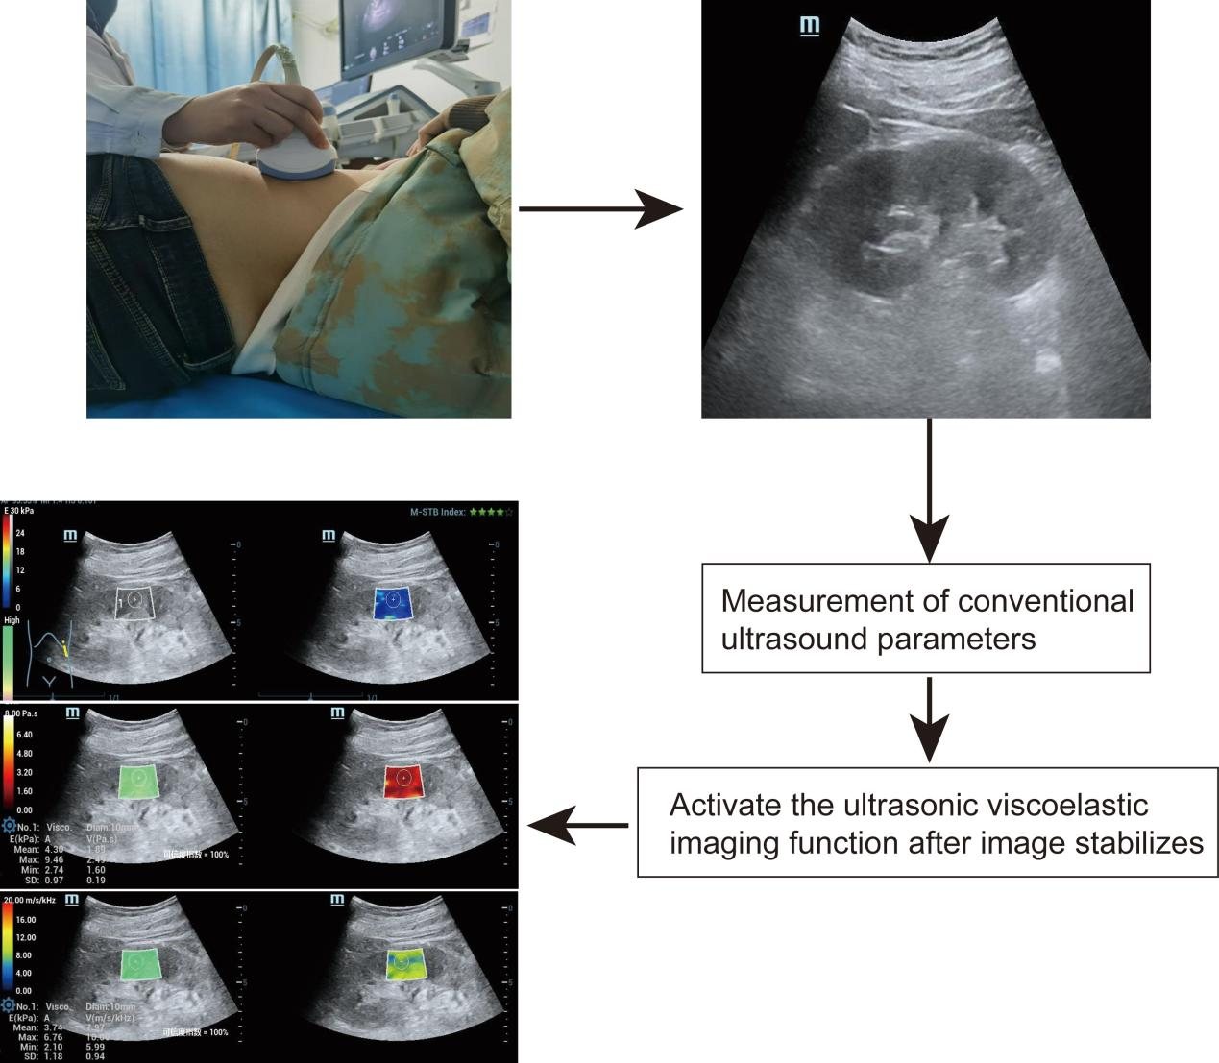
Supplementary Figure 1 Technical Flowchart

With the patient in the right lateral decubitus position, the largest coronal plane along the long axis of the kidney was selected for conventional ultrasonic parameter measurements. These measurements included the longitudinal diameter of the kidney, the peak systolic flow velocity (PSV) of the interlobar artery, and the resistance index (RI). Subsequently, the mode was switched to shear wave elastography (SWE). After ensuring image stability, the viscoelastic imaging function was activated to obtain viscoelastic parameters of the renal parenchyma at the mid-section within this plane. These parameters encompassed the mean elastic value (Emean), mean viscosity coefficient (Vmean), and mean dispersion coefficient (Dmean).
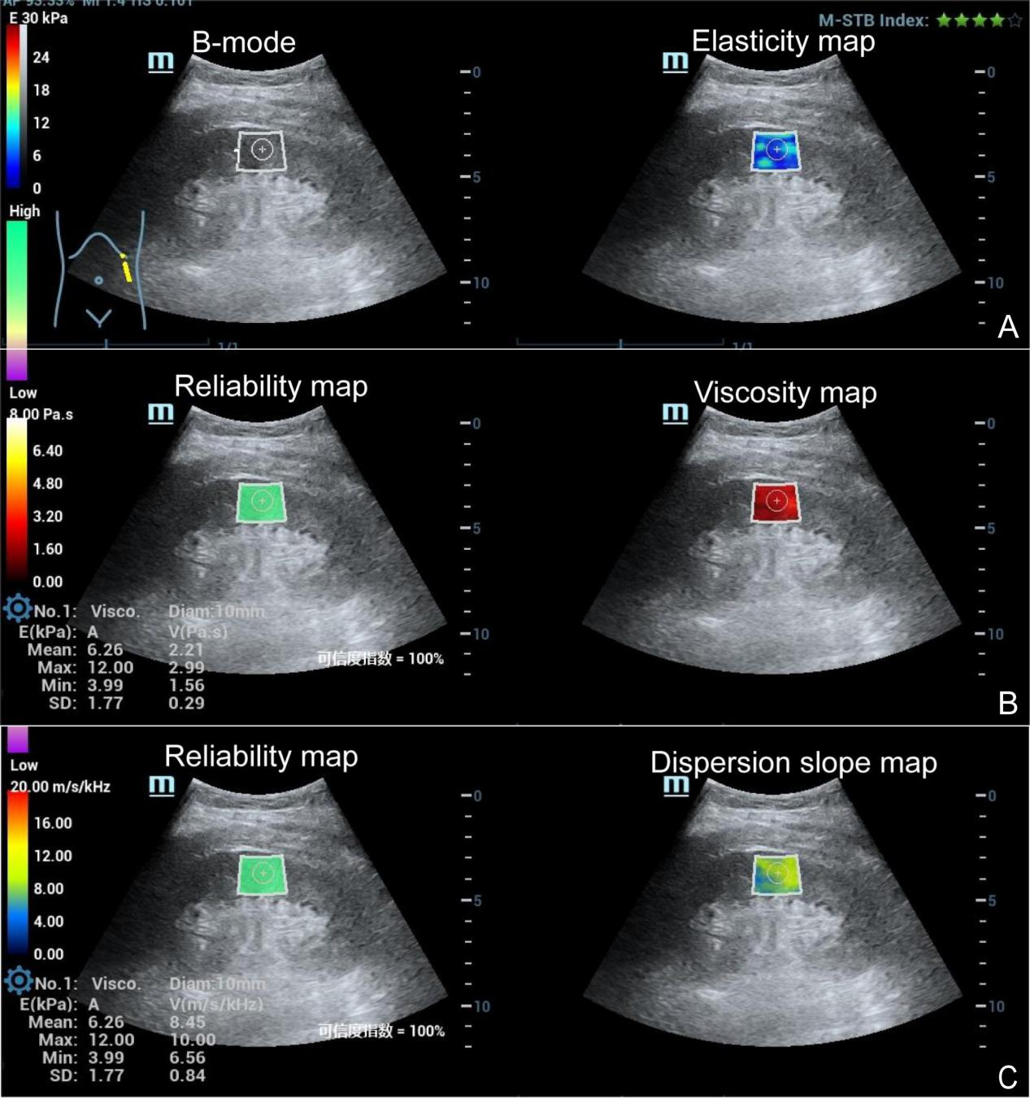
Supplementary Figure 2 Schematic diagram of viscoelastic imaging measurement.

After activating the viscoelastic imaging function, grayscale images (B - mode), elasticity images, reliability maps, viscosity maps, and dispersion maps are displayed simultaneously. We place the sampling box in the kidney cortex at the middle of the kidney, and position the Qbox in the center of the sampling box, close to the renal capsule, for measurement. (A) SWE imaging. (B) Viscosity imaging. (C) Dispersion slope imaging.

