The Quality Control of RNA Sample and Sequencing Data
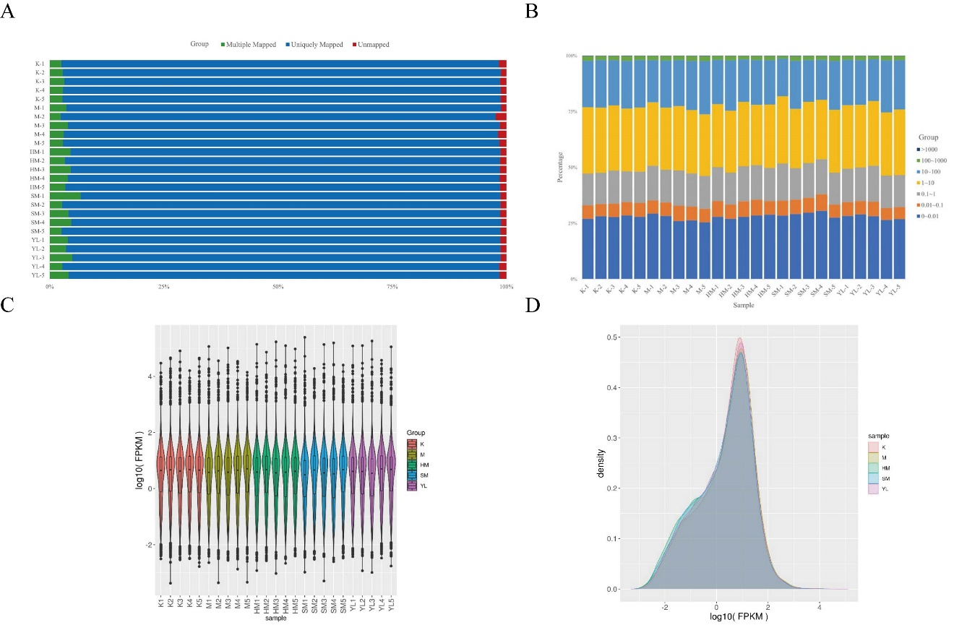
Figure S1 Sequestration Data Quality Assessment
- Comparison rate of reference genes. (B) The overall distribution of sample gene expression. (C) FPKM trend comparison: gene expression abundance violin plot. (D) FPKM trend comparison: Density distribution curve.

The Quality Control of RNA Sample and Sequencing Data
Table S1 High-Quality Clean Reads Obtained
Sample ID | Raw reads, bp | Clean reads, bp | Clean ratio, % | Q20 content, /% | Q30 content, % | GC content, %
Control_1 | 52,746,278 | 51,943,452 | 98.48 | 98.10 | 96.37 | 49.02
Control_2 | 53,310,834 | 52,479,666 | 98.44 | 98.16 | 96.49 | 48.45
Control_3 | 51,754,192 | 50,833,080 | 98.22 | 98.07 | 96.27 | 49.54
Control_4 | 50,153,072 | 49,249,234 | 98.20 | 98.00 | 96.18 | 49.39
Control_5 | 54,056,228 | 53,218,164 | 98.45 | 98.16 | 96.49 | 48.71
Model_1 | 39,462,780 | 38,748,682 | 98.19 | 97.96 | 96.1 | 49.39
Model_2 | 52,351,020 | 51,421,682 | 98.22 | 97.97 | 96.14 | 48.72
Model_3 | 56,284,740 | 55,307,326 | 98.26 | 98.00 | 96.18 | 50.06
Model_4 | 50,428,394 | 49,597,732 | 98.35 | 98.07 | 96.34 | 49.93
Model_5 | 50,273,674 | 49,394,202 | 98.25 | 97.98 | 96.14 | 49.52
H-M_1 | 56,828,612 | 55,930,646 | 98.42 | 98.10 | 96.38 | 50.31
H-M_2 | 52,043,152 | 51,109,620 | 98.21 | 97.96 | 96.11 | 49.29
H-M_3 | 47,547,542 | 46,777,004 | 98.38 | 98.02 | 96.23 | 50.35
H-M_4 | 52,703,624 | 51,805,290 | 98.30 | 98.02 | 96.23 | 49.91
H-M_5 | 40,133,204 | 39,407,064 | 98.19 | 98.04 | 96.23 | 49.52
S-M_1 | 42,458,504 | 41,735,402 | 98.30 | 98.04 | 96.25 | 51.78
S-M_2 | 51,541,260 | 50,724,326 | 98.41 | 98.11 | 96.42 | 49.12
S-M_3 | 44,369,472 | 43,584,412 | 98.23 | 97.92 | 95.61 | 50.16
S-M_4 | 45,282,122 | 44,502,590 | 98.28 | 97.99 | 96.15 | 50.40
S-M_5 | 45,033,966 | 44,283,122 | 98.33 | 98.05 | 96.3 | 49.42
Y-L_1 | 40,835,894 | 40,179,224 | 98.39 | 98.10 | 96.37 | 50.36
Y-L_2 | 38,173,922 | 37,529,680 | 98.31 | 98.01 | 96.22 | 49.96
Y-L_3 | 43,484,264 | 42,816,992 | 98.47 | 98.12 | 96.41 | 50.99
Y-L_4 | 37,592,348 | 36,933,476 | 98.25 | 97.98 | 96.14 | 49.65
Y-L_5 | 39,016,322 | 38,394,100 | 98.41 | 98.04 | 96.27 | 50.22
Notes: Q20, base quality score indicating a sequencing error probability of less than 1%; Q30, base quality score indicating a sequencing error probability of less than 0.1%; GC, total percentage of guanine and cytosine in the sample.

