Supplementary File

An injectable ibuprofen sustained-release composite hydrogel system effectively accelerates diabetic wound healing via anti-inflammatory effects and angiogenesis

Zhibin Li¹, Haijiang Dong¹, Shenyu Yang², Ximei Wang¹, Zhen Li^{*3}
1 Department of Plastic and Aesthetic Surgery. The First Affiliated Hospital of Zhengzhou University, Zhengzhou, 450052, China
2 Medical 3D Printing Center. The First Affiliated Hospital of Zhengzhou University, Zhengzhou, 450052, China
3 Department of Endovascular Surgery. The First Affiliated Hospital of Zhengzhou University, Zhengzhou, 450052, China

Correspondence: Zhen Li, Department of Endovascular Surgery. The First Affiliated Hospital of Zhengzhou University, Zhengzhou, 450052, China
E-mail: lizhen1029@hotmail.com

This supplementary file includes Materials and Methods, Figure S1- S18.

Supplementary information 1
Materials
𝛽-cyclodextrin (𝛽-CD, 98%), 1,1-carbonyldiimidazole (CDI, 99%), dimethyl sulfoxide (DMSO, 99%), ethylenediamine dihydrochloride (ED, 99%), ibuprofen (IBU, ≥98%, GC) were purchased from Shanghai Maclean Biochemical Technology Co., Ltd. (Shanghai, China). Sodium alginate (SA, medium viscosity, viscosity≥2000 cP [2 %, 25 ◦C]), Gelatin (Type A, Bloom 300, MW 50−100 kDa), D-(+)-Gluconic acid δ-lactone (GDL, ≥99.0%, GC), methacrylic anhydride (MA, ≥98%) and Lithium phenyl-2,4,6-trimethylbenzoylphosphinate (LAP, ≥95%) were purchased from Sigma Aldrich (St. Louis, MO, USA). Sodium periodate (NaIO₄, ≥99.5%), Ethylene glycol (AR, ≥98%), 2,4,6-trinitrobenzene-sulfonic acid (TNBS, ≥99%), calcium carbonate (CaCO₃, AR, ≥99%) and Streptozotocin (STZ) were obtained from Shanghai Aladdin Biochemical Technology Co., Ltd. (Shanghai, China). The reagents were analytically pure and not further purified. The information of antibodies used for immunofluorescence staining are as follows:
CD86 (1:100, Abcam, ab239075, Cambridge, MA, USA),
CD206 (1:1000, Abcam, ab64693, Cambridge, MA, USA)
INOS (1:500, Abcam, ab178945, Cambridge, MA, USA)
ARG1 (1:500, Affinity, DF6657, Jiangsu, China)
F4/80 (1:200, Abcam, ab6640, Cambridge, MA, USA)
CD31 (1:100, Abcam, ab222783, Cambridge, MA, USA)
α-SMA (1:1000; Huabio, ET1607-53, Hangzhou, China)
iFluor™ 488-conjugated goat anti-rabbit IgG (1:1000; Huabio, HA1125, Hangzhou, China)
iFluor™ 594-conjugated goat anti-rabbit IgG (1:1000; Huabio, HA1122, Hangzhou, China)
Synthesis of β-CD-NH₂ and IBU/CD-NH₂
β-CD (2.5 g) and 1,1-carbonyldiimidazole (CDI) (0.75 g) were dissolved in 10 mL and 5 mL of anhydrous DMSO, respectively. CDI solution was added dropwise into β-CD solution and react at room temperature under a nitrogen atmosphere with stirring for 5 hours. Then, excessive ED (2.4 ml) in 5 ml DMSO was added into above mixture solution and stirred for 15 hours. The final mixture was precipitated and washed with excess acetone three times, then dissolved in 5 mL deionized water and dialyzed at room temperature for 72 h. The CD-NH₂ was collected by lyophilization. CD-NH₂ and IBU were dissolved in deionized water and ethanol solution, respectively. Mix IBU (0.1 mM) and CD-NH₂ (4 mM) solution with equal volume and stirred at room temperature for 24 h. Then IBU/ CD-NH₂ inclusion complex was obtained after filtered lyophilized.
Synthesis of OSA
Sodium alginate (10 g) was dispersed in ethanol (50 mL). sodium periodate (5.35 g) was dissolved in DDW (50 mL) and then added to sodium alginate solution and stirred for 6 h at room temperature in darkness. The oxidation reaction was stopped by adding ethylene glycol (3 mL) and stirring for 15 min. Subsequently, the reaction solution was dialyzed against DDW exhaustively for 3 days with 6 water changes per day. The dried OSA was obtained by lyophilization and stored at 4 °C until further use. The oxidation degree (OD) of OSA was calculated using hydroxylamine hydrochloride titration method as previously described.
Preparation of GelMA
Gelatin (10 g) was dissolved in 100 mL phosphate-buffered saline (PBS) at 50 °C, followed by the addition of methacrylic anhydride at a rate of 1 mL/min while stirring vigorously at 50°C for 3 h. Final concentrations of MA of 0.25, 1.25, 5, 10 and 20% (v/v) were used to obtain different degrees of methacrylation (referred to herein as 0.25%, 1.25%, 5%, 10%, and 20% GelMA). Then, the mixed solution was diluted by adding 400 mL PBS and dialyzed for 5 days at 40 °C to remove the unreacted methacrylic anhydride. Finally, the solution was lyophilized and stored at 4 °C until use. The degree of substitution (DS) of GelMA was determined by 2,4,6-trinitrobenzene-sulfonic acid (TNBS) assay according to the Habeeb method.
Rheological properties of hydrogels
The rheological properties of the composite hydrogels were measured by a rotational rheometer (DHR-2, TA Company, USA) at room temperature. The hydrogels were placed between parallel plates with a diameter of 25 mm at an interval of 1mm. The frequency sweep was performed over the frequency range from 0.1 to 100 rad/s at 1% strain. The storage modulus (G') and loss modulus (G") of hydrogels at different frequencies were recorded.
Real-time quantitative PCR (qPCR)
To evaluate the anti-inflammatory effect of the composite hydrogel, the gene expression of inflammatory markers, including iNOS, Arg1, IL-1β, and IL-10, was analyzed by real-time PCR assay. Total RNA was isolated from RAW264.7 macrophages samples in 2.6 using TRIzol reagent, and the total RNA concentration was measured with a NanoDrop spectrometer. cDNA was synthesized, and q-PCR was performed in a real-time qPCR instrument (ABI 7500, Thermo Fisher Scientific). The 2−∆∆Ct method was employed to analyze the relative gene expression. The primer sequences are listed in Table 1.
Primer | Sequences
iNOS-Forward | GTTCTCAGCCCAACAATACAAGA
iNOS-Reverse | GTGGACGGGTCGATGTCAC
Arg1-Forward | CTCCAAGCCAAAGTCCTTAGAG
Arg1-Reverse | AGGAGCTGTCATTAGGGACATC
IL-1β-Forward | TGCCACCTTTTGACAGTGATG
IL-1β-Reverse | TGATACTGCCTGCCTGAAGC
IL-10-Forward | GAAGCATGGCCCAGAAATCAAG
IL-10-Reverse | ACAGGGGAGAAATCGATGACAG
GAPDH-Forward | GCCTCCTCCAATTCAACCCTTA
GAPDH-Reverse | TTTGTCTACGGGACGAGGAAAC

Fig S1- S19.
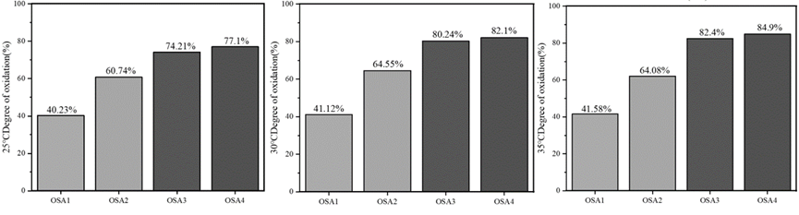
Fig S1 Oxidation degree of OSA at different temperatures and dosages.
Fig S2 Characterization of hydrogels with different MA volume ratios. A). The stress-strain curves of the hydrogels with 5 different MA volume ratios. B). The swelling ratio of the hydrogels with 5 different MA volume ratios. C). The stability and remaining characteristics of the hydrogels with 5 different MA volume ratios. D-E). The (D)storage modulus(G') and (E)loss modulus (G") (kPa) of the hydrogel with different MA volume ratios.

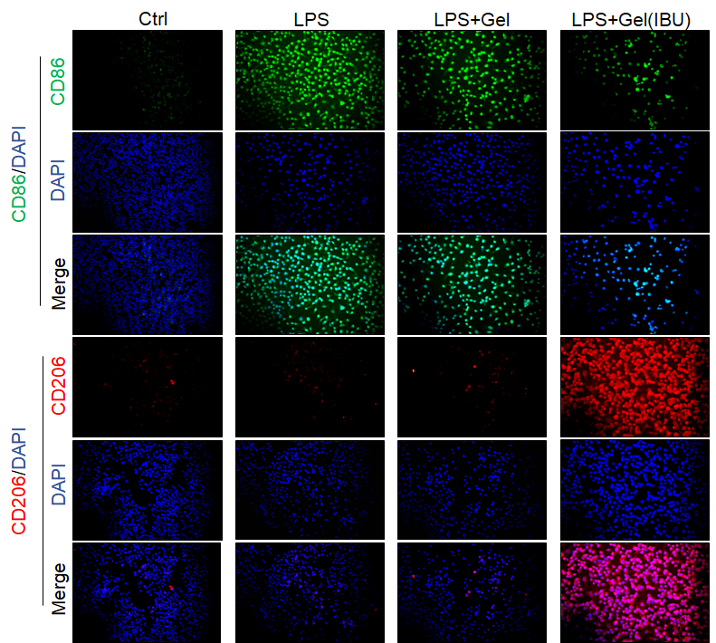
Fig S3 Immunofluorescence staining results of CD86/CD206 of Raw264.7 under different treatment conditions.
Fig S4 Immunofluorescence staining results of iNOS/Arg-1 of Raw264.7 under different treatment conditions.

Fig S5 H&E staining results of different treatment groups. (200 X).
Fig S6 Masson's trichrome staining results of different treatment groups on day 3.
Fig S7 Masson's trichrome staining results of different treatment groups on day 7.
Fig S8 Immunofluorescence staining results of CD86 in different treatment groups on day 3 (200 X).

Fig S9 Immunofluorescence staining results of CD206 in different treatment groups on day 3 (200 X).

Fig S10 Immunofluorescence staining results of iNOS in different treatment groups on day 3 (200 X).

Fig S11 Immunofluorescence staining results of Arg-1 in different treatment groups on day 3 (200 X).

Fig S12 Immunofluorescence staining results of CD86 in different treatment groups on day 7 (200 X).

Fig S13 Immunofluorescence staining results of CD206 in different treatment groups on day 7 (200 X).

Fig S14 Immunofluorescence staining results of iNOS in different treatment groups on day 7 (200 X).

Fig S15 Immunofluorescence staining results of Arg-1 in different treatment groups on day 7 (200 X).

Fig S16 Immunofluorescence staining results of CD86 in different treatment groups on day 14 (200 X).

Fig S17 Immunofluorescence staining results of CD206 in different treatment groups on day 14 (200 X).

Fig S18 Immunofluorescence staining results of iNOS in different treatment groups on day 14 (200 X).

Fig S19 Immunofluorescence staining results of Arg-1 in different treatment groups on day 14 (200 X).

