Supplementary Materials

Wei Zhou ¹, Fan Feng ³, Jieli Zhang ², Shuang Cao ⁴, Yunzhi Zhou ^{2,}*, Yanming Li ^{1,}*

¹ Department of Pulmonary and Critical Care Medicine, Beijing Hospital, National Center of Gerontology, Institute of Geriatric Medicine, Chinese Academy of Medical Science, Beijing, 100730, China;
² Department of Respiratory and Critical Care Medicine, Emergency General Hospital, Beijing, 100028, China;
³ Clinical Laboratory, The Fifth Medical Center of Chinese People's Liberation Army General Hospital, Beijing 100039, China;
⁴ School of Chemical Engineering and Pharmacy, Wuhan Institute of Technology, Wuhan, 430205, China.

*Correspondence:
Yanming Li
Department of Pulmonary and Critical Care Medicine, Beijing Hospital, National Center of Gerontology, Institute of Geriatric Medicine, Chinese Academy of Medical Science, Beijing, 100730, China
Email address: liyanming2632@bjhmoh.cn

Yunzhi Zhou
Department of Respiratory and Critical Care Medicine, Emergency General Hospital, Beijing, 100028, China
Email address: zhouyunzhi2017@126.com

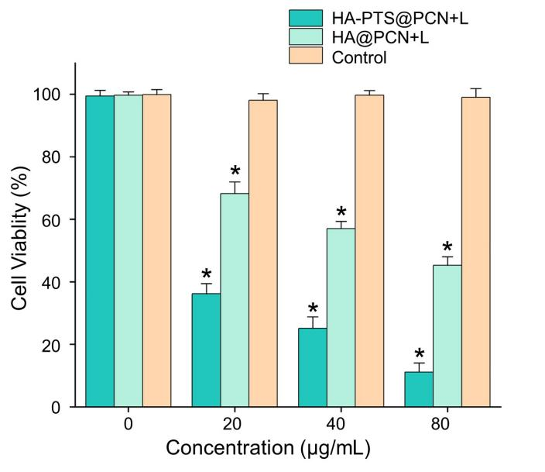
Figure S1 Cytotoxicity of different concentrations of HA-PTS@PCN and HA@PCN NPs (measured as PTS) on H520 cells after 660 nm laser irradiation. Data are expressed as the mean ± SD (n = 6 or more independent biological replicates); *P<0.05.

Table S1 Data on tumor weight and body weight
Groups | Tumor or aninal No. | 1 | 2 | 3 | 4 | 5 | 6 | 7 | 8 | 9 | 10 | mean | SD
Groups | Weight | (g) |  |  |  |  |  |  |  |  |  | mean | SD
Control | Tumor weight | 1.81 | 1.75 | 1.27 | 1.83 | 1.59 | 1.72 | 1.89 | 1.64 | 1.79 | 1.72 | 1.70 | 0.17
Control | Initial body weight | 20.98 | 20.67 | 21.58 | 19.41 | 20.54 | 21.2 | 20.18 | 20.93 | 20.41 | 19.91 | 20.58 | 0.61
Control | End-point body weight | 24.56 | 25.38 | 26.03 | 22.19 | 23.85 | 24.53 | 26.94 | 21.11 | 22.47 | 25.14 | 24.22 | 1.73
HA-PTS@PCN+L | Tumor weight | 0.9 | 0.69 | 0.81 | 0.63 | 0.58 | 0.85 | 0.73 | 0.46 | 0.61 | 0.82 | 0.71 | 0.13
HA-PTS@PCN+L | Initial body weight | 19.92 | 20.34 | 20.94 | 21.50 | 21.56 | 20.24 | 20.71 | 19.78 | 21.38 | 22.00 | 20.84 | 0.72
HA-PTS@PCN+L | End-point body weight | 25.1 | 26.43 | 23.64 | 26.72 | 24.83 | 25.65 | 26.87 | 23.04 | 24.97 | 24.81 | 25.21 | 1.19
PTS@PCN+L | Tumor weight | 1.40 | 1.56 | 1.24 | 1.61 | 1.39 | 1.53 | 1.36 | 1.18 | 1.33 | 1.50 | 1.41 | 0.13
PTS@PCN+L | Initial body weight | 18.92 | 19.40 | 20.46 | 19.42 | 21.87 | 20.06 | 22.70 | 21.21 | 20.89 | 20.62 | 20.56 | 1.11
PTS@PCN+L | End-point body weight | 24.34 | 22.43 | 23.28 | 25.85 | 22.33 | 21.16 | 22.21 | 23.77 | 24.72 | 22.13 | 23.22 | 1.36
HA-PTS@PCN | Tumor weight | 1.28 | 1.07 | 1.36 | 1.37 | 1.05 | 1.47 | 1.58 | 1.12 | 1.16 | 1.25 | 1.27 | 0.17
HA-PTS@PCN | Initial body weight | 20.77 | 21.15 | 20.84 | 21.60 | 19.68 | 20.65 | 21.05 | 22.36 | 21.14 | 19.43 | 20.87 | 0.81
HA-PTS@PCN | End-point body weight | 22.38 | 21.98 | 23.95 | 22.37 | 24.69 | 22.28 | 24.86 | 23.95 | 25.56 | 23.17 | 23.52 | 1.20
PTS@PCN | Tumor weight | 1.76 | 1.38 | 1.46 | 1.58 | 1.52 | 1.67 | 1.53 | 1.59 | 1.70 | 1.53 | 1.57 | 0.11
PTS@PCN | Initial body weight | 20.19 | 20.22 | 19.82 | 21.04 | 19.93 | 20.97 | 21.10 | 20.92 | 21.58 | 21.23 | 20.70 | 0.58
PTS@PCN | End-point body weight | 23.81 | 22.45 | 26.00 | 24.17 | 22.03 | 24.39 | 23.02 | 23.58 | 22.98 | 23.33 | 23.58 | 1.06
Light | Tumor weight | 1.624 | 1.46 | 1.56 | 1.34 | 1.46 | 1.52 | 1.81 | 1.48 | 1.37 | 1.31 | 1.49 | 0.14
Light | Initial body weight | 20.97 | 19.62 | 21.72 | 20.60 | 21.26 | 20.93 | 19.84 | 21.53 | 20.27 | 23.09 | 20.98 | 0.96
Light | End-point body weight | 24.28 | 25.86 | 23.21 | 24.13 | 25.04 | 23.77 | 2.69 | 22.04 | 23.99 | 23.08 | 21.81 | 6.45

