S1 Supplemental

A photograph of the Rosenbaum near card and the Amsler grid that was provided for the patients as part of the vision screening kit.

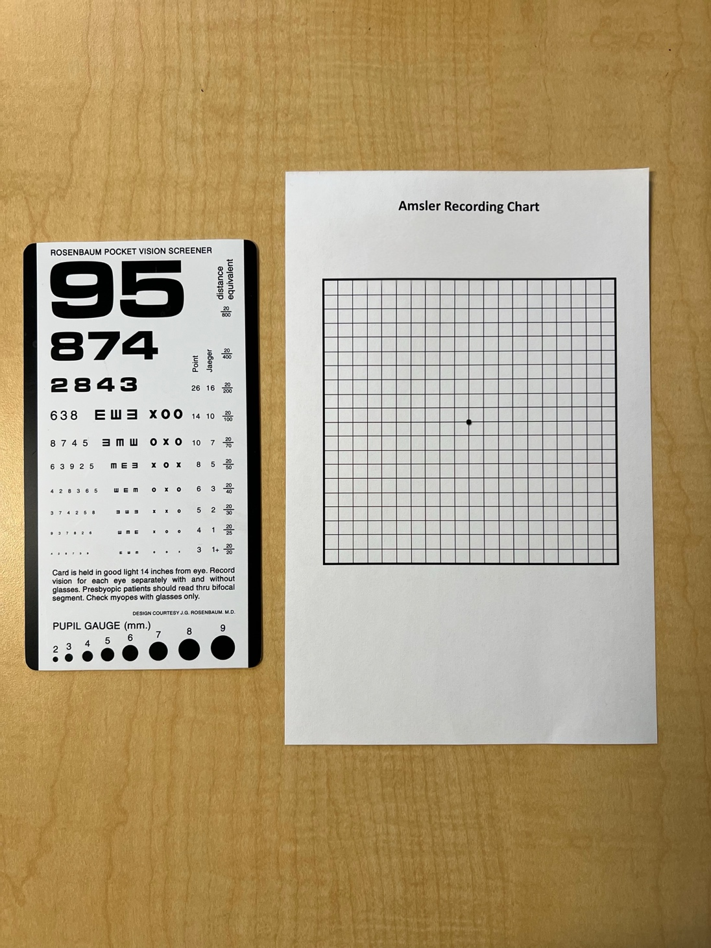

The survey questions asked at the initial enrollment period and the follow-up telephone call regarding the usability of the vision screening kit.

Initial Enrollment Period Survey Questions

- Do you have difficulty accessing regular eye care services? If yes, why? (e.g. no insurance, financial barriers, lack of transportation, difficulty navigating the healthcare system, etc.)
- Has COVID-19 impacted your ability to receive eye care services?

Survey Questions on Usability of Vision Screening Kit

- On a scale of 1 (extremely difficult) to 5 (extremely easy), how would you rate the ease of use for the vision screening kit?
- Do you plan to continue using the vision screening kit?
- Would you recommend this vision screening kit for your family and friends?

