Supplementary materials

Selection of best-unloaded siRNA removal method
Density gradient centrifugation. Various stocks of sucrose (from 90 to 10% w/v) were freshly prepared and layered in a thin-walled polypropylene tube (5 ml nominal volume, Beckman Coulter Life Sciences, catalog number 342194) with increasing concentrations from bottom to top. 2 ml of siRNA-EMVs were then placed on sucrose cushion, and centrifuged for 40 minutes at 100.000 g (27.200 rpm) on a Beckman Coulter Optima-Xe 90 ultracentrifuge, equipped with an SW 60-Ti swinging rotor. The presence of EMVs was confirmed via DLS and Quantifluor RNA assay.
Conventional ultracentrifugation. 2 ml of siRNA-EMVs in PBS were loaded in a thin-walled polypropylene tube and subjected to ultracentrifugation in the same conditions as above. SiRNA-EMVs were collected as a pellet.
Amicon Ultrafiltration filter. 0.5 ml of siRNA-EMVs in PBS were loaded in a pre-activated Amicon ultrafiltration device (EMD Millipore, catalogue number, UFC503008) and centrifuged on a tabletop Eppendorf Minispin centrifuge (model number Model 5415R) for 5 minutes at maximum speed, up to a final volume of 50 μl. The sample was then resuspended with PBS back at original volume and the siRNA concentration was analysed via Quantifluor RNA assay. Subsequently, retentate and eluate were re-dispersed in original volume and used for RNA quantification.
Size exclusion column chromatography. 1 ml of siRNA-EMVs was applied to a PD10 G25 Sephadex column (GE Healthcare), and, upon subsequent addition of 1 ml PBS aliquotes, 12 fractions were collected. EMVs and siRNA presences were respectively confirmed via DLS and Quantifluor RNA assay. EMVs and siRNA were recovered as in Figure 1, Supplementary Materials.
SDS-page on erythrocytes ghosts, DCC-siRNA-EMVs, and DCC-pellet
RBC ghosts, DCC-siRNA-EMVs and DCC-pellet protein concentration were obtained via Bradford assay. RBC membrane (i.e. ghosts) and EMV proteins were solubilized for 2 hours at 4°C under continuous shaking in 10 mM Tris-HCl, 150 mM NaCl, pH 7.4, containing 1% (m/v) Triton X-100. After solubilization, the samples were centrifuged at 16.100 × g for half an hour, and the supernatant was stored for further use. Aliquots of samples were loaded (15 μg/lane) on a 10% (m/v) SDS-PAGE gel and the proteins were stained with colloidal silver. Gels were imaged on a ChemiDoc MP System gel imager (Bio-Rad, Hercules, CA, USA). PageRuler™ Plus Prestained Protein Ladder was from Thermo Fisher Scientific (catalogue number 26619).
Figure S1. Recovery of siRNA from Sephadex PD10 column loaded with siRNA-EMVs and eluted with 1 ml of each fraction of PBS. The presence of EMVs was confirmed via DLS.

Figure S2 SDS-page of red blood cell ghosts, DCC-siRNA-EMVs, and the pellet resulting from density changing centrifugation.
Figure 3 Comparison between confocal (left) and STED imaging on CM-DiI labeled EMVs. Scale bar is 1 µm.
Figure S4 Self-digestion protease assay on DCC-siRNA-EMVs and extruded EMVs, not subjected to ultracentrifugation, compared with Trypsin.
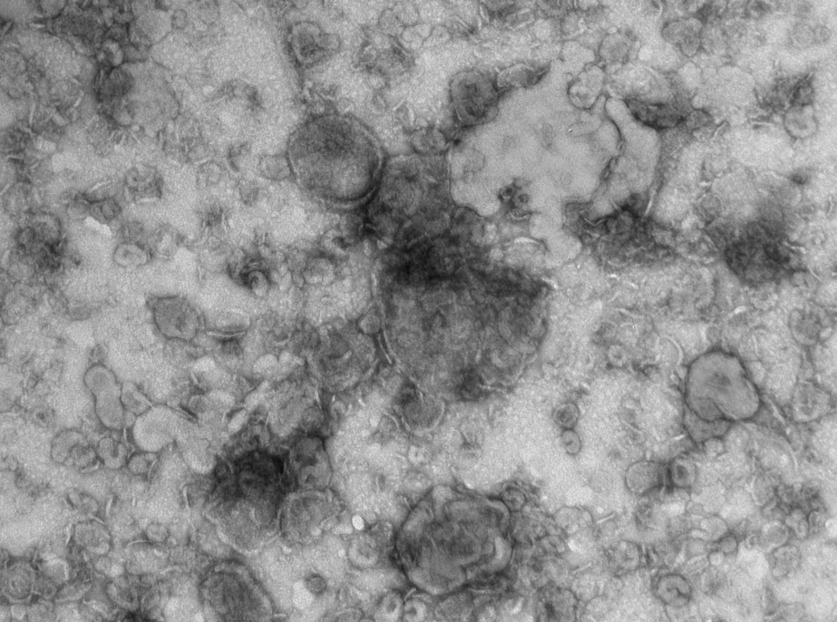
Figure S5 DCC-siRNA-EMVs as negatively stained with uranyl acetate 0,5 w/v.
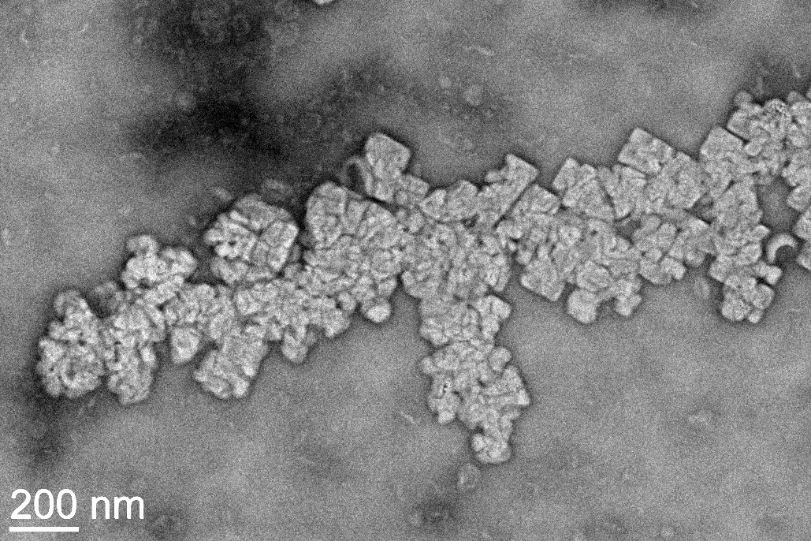
Figure S6 DCC-siRNA-EMVs freeze-dried only in the presence of PBS and subsequently stained with UA-zero. A slight change in pH due to freeze-drying caused the deposition of heavy metal crystals on the grid.
Figure S7 Average β-actin threshold cycle for untreated cells (ctrl), and those transfected with empty EMVs, DCC-siRNA-EMVs (FD and not) and RNAiMAX. ANOVA one way was carried out (Graphpad 9) in order to ascertain whether transfection significantly affects β-actin basal levels.
DCC-siRNA-EMVs
0
24
48
Figure S8 Standard curve used for Taqman quantification of lead-strand siRNA in tissues and plasma of mice. To generate the standard curve, serial dilutions of Cy5-siRNA cDNA were used as a template for real-time PCR, while reverse transcription followed the same procedure already described in Materials and Methods.

Figure S9 Distribution of Cy-5/DiO DCC-siRNA-EMVs at different timepoints in frozen section of mouse liver via siRNA-Cy-5 (red) and DiO (green) signals. Nuclei were labelled with Hoechst 33342 (blue). The scalebar is 100 µm.
Figure S10 Distribution of Cy-5/DiO DCC-siRNA-EMVs at different time points in frozen section of mouse heart via siRNA-Cy-5 (red) and DiO (green) signals. Nuclei were labeled with Hoechst 33342 (blue). The scalebar is 100 µm.

Figure S11 a) DCC-EMVs, DiO labeled, in PBS, imaged via CLSM . b)Volume-weighted DLS particle size frequency distribution for DCC-EMVs incubated with PBS, RPMI medium, and RPMI medium addition with Glutamax; c) CLSM imaging of DiD-RBC, ex vivo incubated with DiO-EMVs. The scalebar is 10 µm.

Figure S12. Fluorescence-weighted mosaic pictures of tdTomato+ B16F10 induce tumors in mice. The scalebar is 5 mm.

Figure S13 Mean fluorescence intensity of tdTomato protein in control tumors (mice number = 4, 5 measurements each mouse), 24 (mice number = 5), and 48h (mice number = 5) DCC-EMVs-siRNA treated mice. p≤0.01 **

