Identification and evaluation of Lipocalin-2 in Sepsis-Associated Encephalopathy via Machine Learning Approaches

Supplementary material
Fig. S1
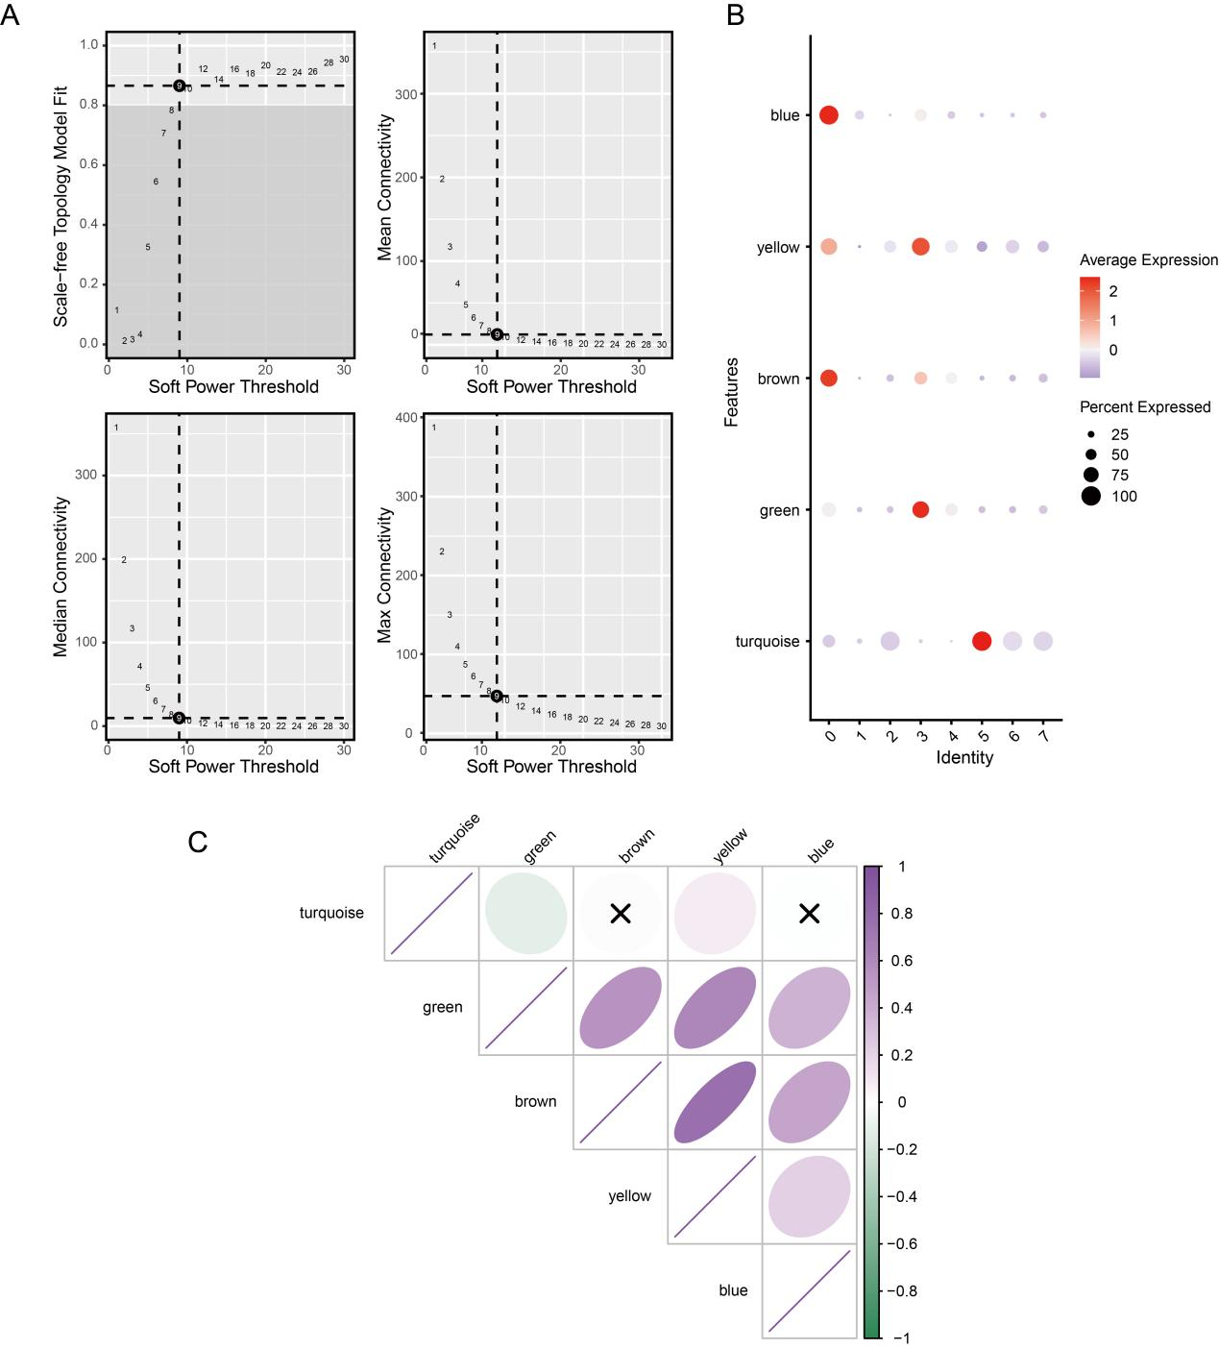
Fig. S1 hdWGCNA analysis.
(A) Selection of the correct softpower number.
(B) Correlations between different modules and specific cell subpopulations.
(C) Correlations among different gene modules.
Fig. S2
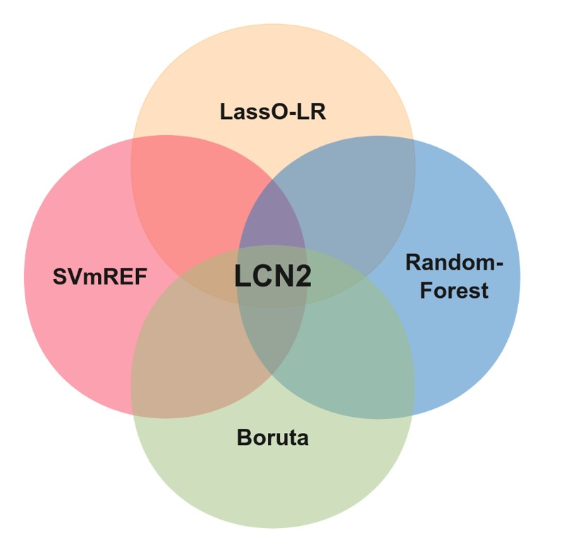
Fig. S2 The Venn diagram showed the intersection of four algorithms is LCN2.

Fig. S3
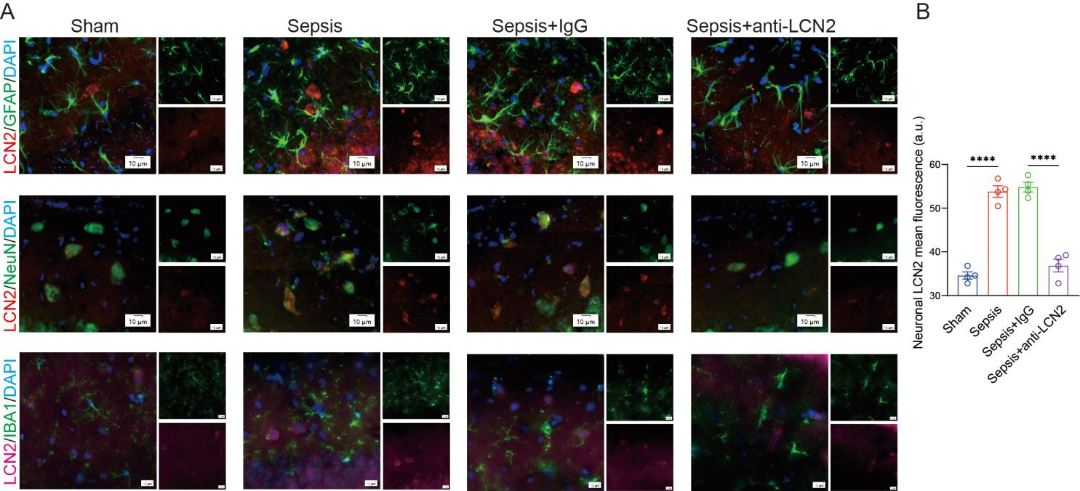
Fig. S3 Elevated LCN2 originates from neurons.
- Representative immunofluorescence micrographs illustrated that elevated LCN2 originated from neurons.
- Quantification of LCN2 signal (red) in NeuN+ neurons (grenn) of hippocampi.
All data were presented as mean ± SEM, ****P＜0.0001.

