Supplemental Table 1. PubMed/MEDLINE search strategy and results
Retrieval procedure | Retrieval strategy | Result
#1 | “implicit” [Title/Abstract] | 31,973
#2 | “mental” [Title/Abstract] OR psychia* [Title/Abstract] OR “psycho*” [Title/Abstract] OR “mood disorder” [Title/Abstract] OR “substance use disorder” [Title/Abstract] OR “personality disorder” [Title/Abstract] OR “schizopren*” [Title/Abstract] OR “depress*” [Title/Abstract] OR “anxiety*” [Title/Abstract] OR “bipolar disorder” [Title/Abstract] | 1,948,526
#3 | “stigma*” [Title/Abstract] OR “stereotyp*” [Title/Abstract] OR “discriminat*” [Title/Abstract] OR “prejudice” [Title/Abstract] OR “bias” [Title/Abstract] OR “attitude” [Title/Abstract] OR “belief” [Title/Abstract] | 786,451
#4 | #1 AND #2 AND #3 | 1,336
#5 | #4 Filters: English, Humans, from 1998-2025 | 986

Supplemental Table 2. PsychINFO search strategy and results
Retrieval procedure | Retrieval strategy | Result
#1 | Abstract: implicit | 43,952
#2 | Abstract: mental OR Abstract: psychia* OR Abstract: psycho* OR Abstract: mood disorder OR Abstract: substance use disorder OR Abstract: personality disorder OR Abstract: schizophren* OR Abstract: depress* OR Abstract: anxiety OR Abstract: bipolar disorder | 2,214,832
#3 | Abstract: stigma* OR Abstract: stereotyp* OR Abstract: discriminat* OR Abstract: prejudice OR Abstract: bias OR Abstract: attitude OR Abstract: belief | 703,900
#4 | #1 AND #2 AND #3 | 3,628
#5 | #4 Filters: Peer-Reviewed Journals only, Year: 1998-2025, Database: APA PsycArticles | 188
Supplemental Table 3. Embase search strategy and results
Retrieval procedure | Retrieval strategy | Result
#1 | implicit:ab,ti | 34,399
#2 | mental:ab,ti OR psychia*:ab,ti OR psycho*:ab,ti OR 'mood disorder':ab,ti OR 'substance use disorder':ab,ti OR 'personality disorder':ab,ti OR schizophren*:ab,ti OR depress*:ab,ti OR anxiety:ab,ti OR 'bipolar disorder':ab,ti | 2,603,485
#3 | stigma*:ab,ti OR stereotyp*:ab,ti OR discriminat*:ab,ti OR prejudice:ab,ti OR bias:ab,ti OR attitude:ab,ti OR belief:ab,ti | 954,675
#4 | #1 AND #2 AND #3 | 1,693
#5 | #4 AND 'human'/de AND [english]/lim AND [1998-2025]/py | 1,543

Supplemental Table 4. Web of Science search strategy and results
Retrieval procedure | Retrieval strategy | Result
#1 | AB=(implicit) | 186,151
#2 | (((((((((AB=(mental)) OR AB=(psychia*)) OR AB=(psycho*)) OR AB=(mood disorder)) OR AB=(substance use disorder)) OR AB=(personality disorder)) OR AB=(schizophren*)) OR AB=(depress*)) OR AB=(anxiety)) OR AB=(bipolar disorder) | 3,016,771
#3 | ((((((AB=(stigma*)) OR AB=(stereotyp*)) OR AB=(discriminat*)) OR AB=(prejudice)) OR AB=(bias)) OR AB=(attitude)) OR AB=(belief) | 2,715,812
#4 | #1 AND #2 AND #3 | 4,797
#5 | #4 AND PY=(1998-2025) AND English (Languages) | 4,025

Supplemental Table 5. Cochrane Library search strategy and results
Retrieval procedure | Retrieval strategy | Result
#1 | (implicit): ti, ab, kw | 2,133
#2 | (mental OR psychia* OR psycho* OR mood disorder OR substance use disorder OR personality disorder OR schizophren* OR depress* OR anxiety OR bipolar disorder): ti, ab, kw | 358,038
#3 | (stigma* OR stereotyp* OR discriminat* OR prejudice OR bias OR attitude OR belief): ti, ab,kw | 66,392
#4 | #1 AND #2 AND #3 with Publication Year from 1998 to 2025, in Trials | 498

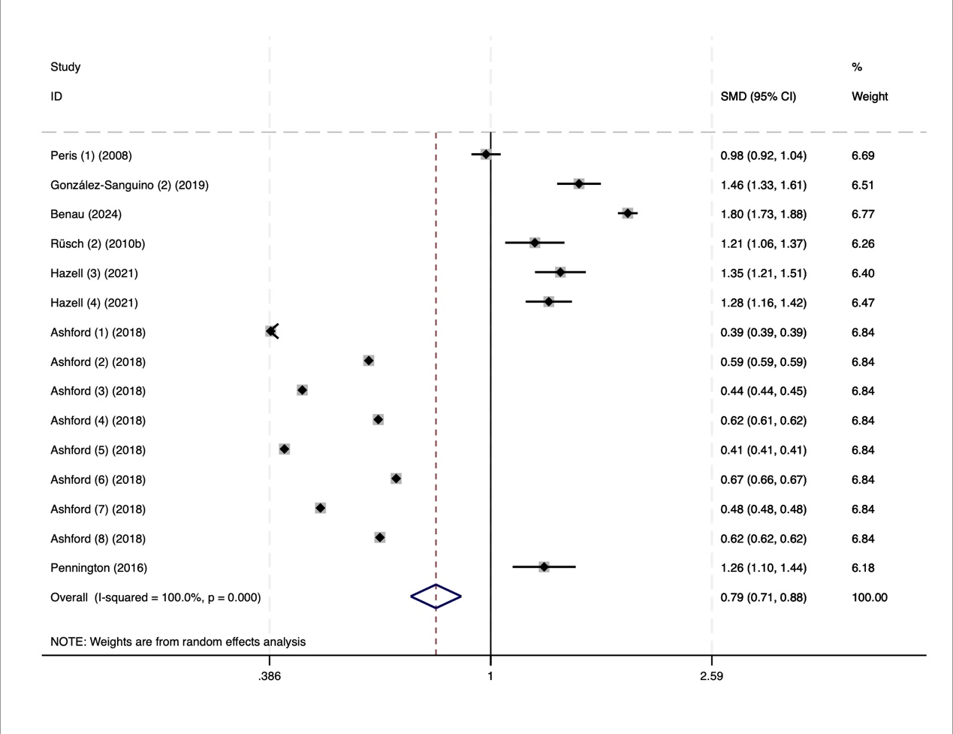Supplemental Figure 1. Forest plot of studies included in the meta-analysis (General population)
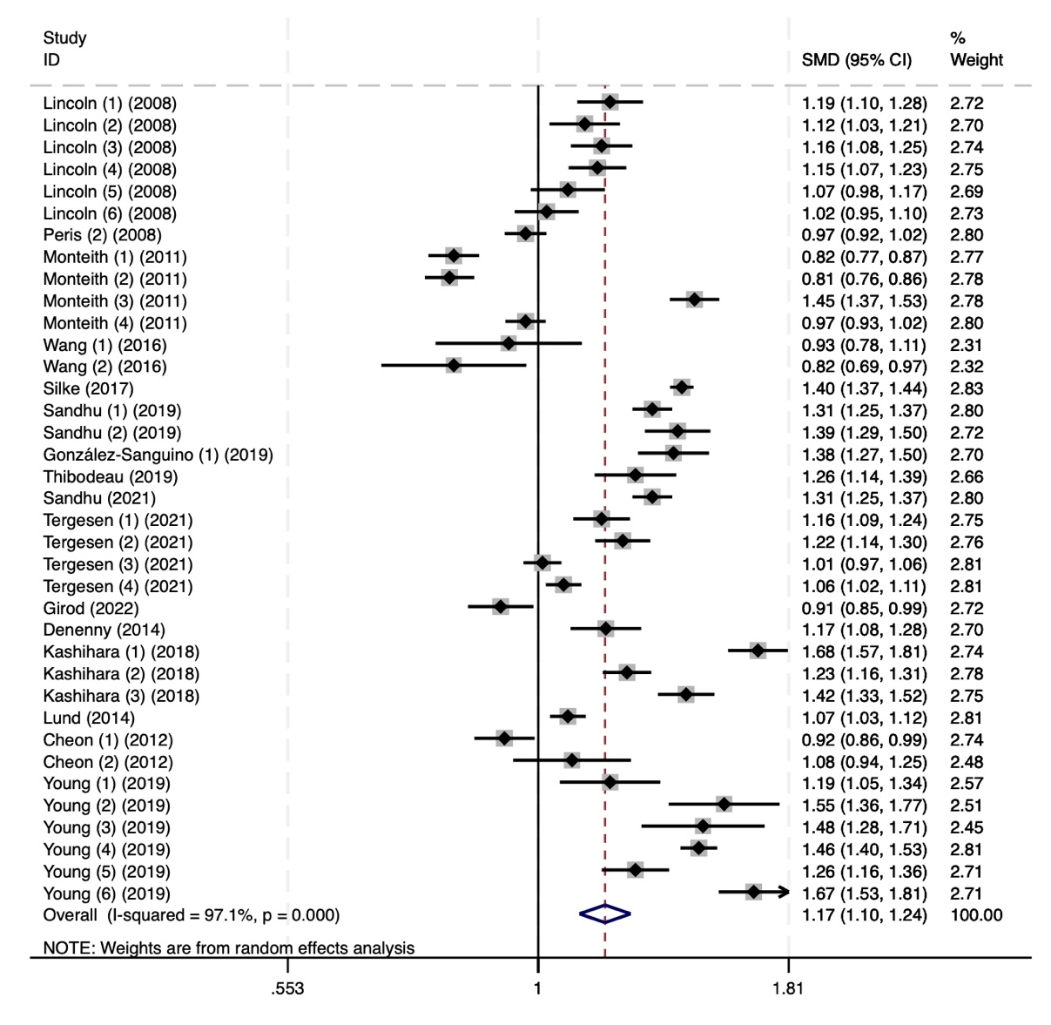 Supplemental Figure 2. Forest plot of studies included in the meta-analysis (Student) 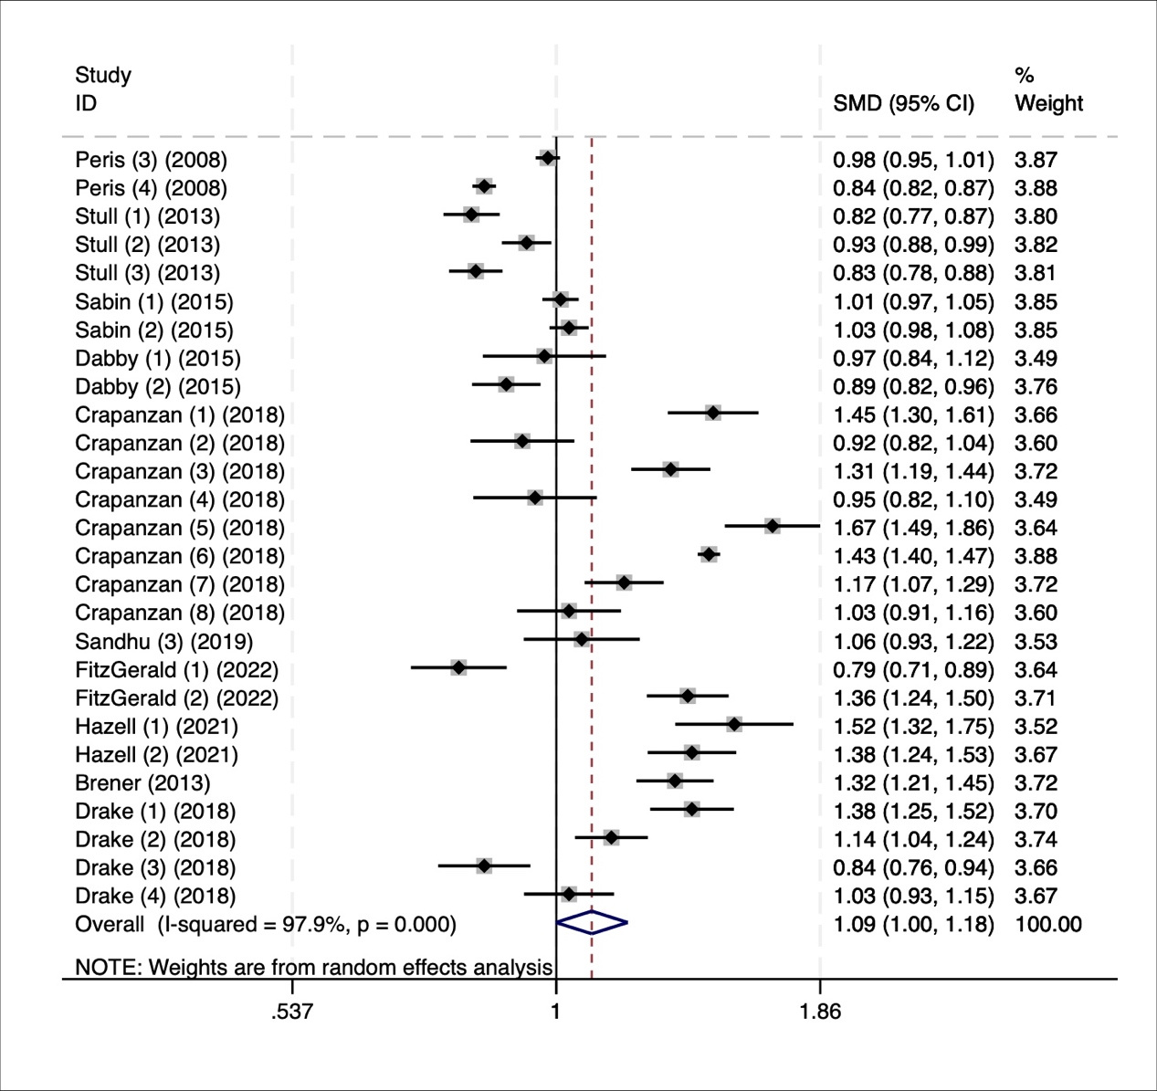 Supplemental Figure 3. Forest plot of studies included in the meta-analysis (Healthcare provider)

Supplemental Figure 4. Forest plot of studies included in the meta-analysis (People with mental illness)
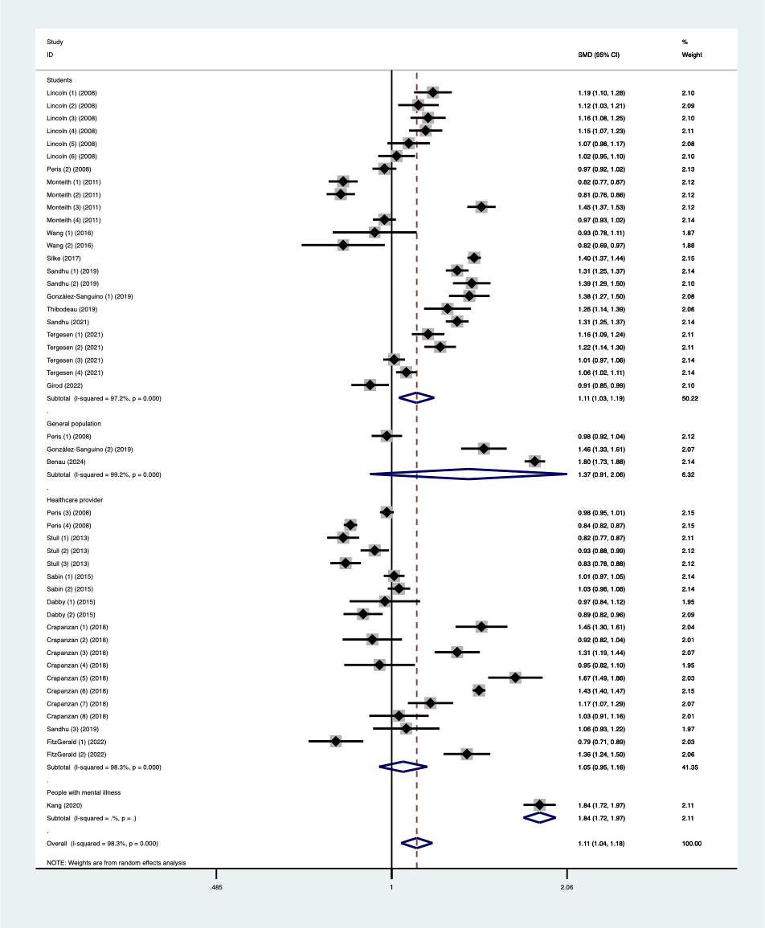
Supplemental Figure 5. Forest plot of studies included in the meta-analysis (IAT)

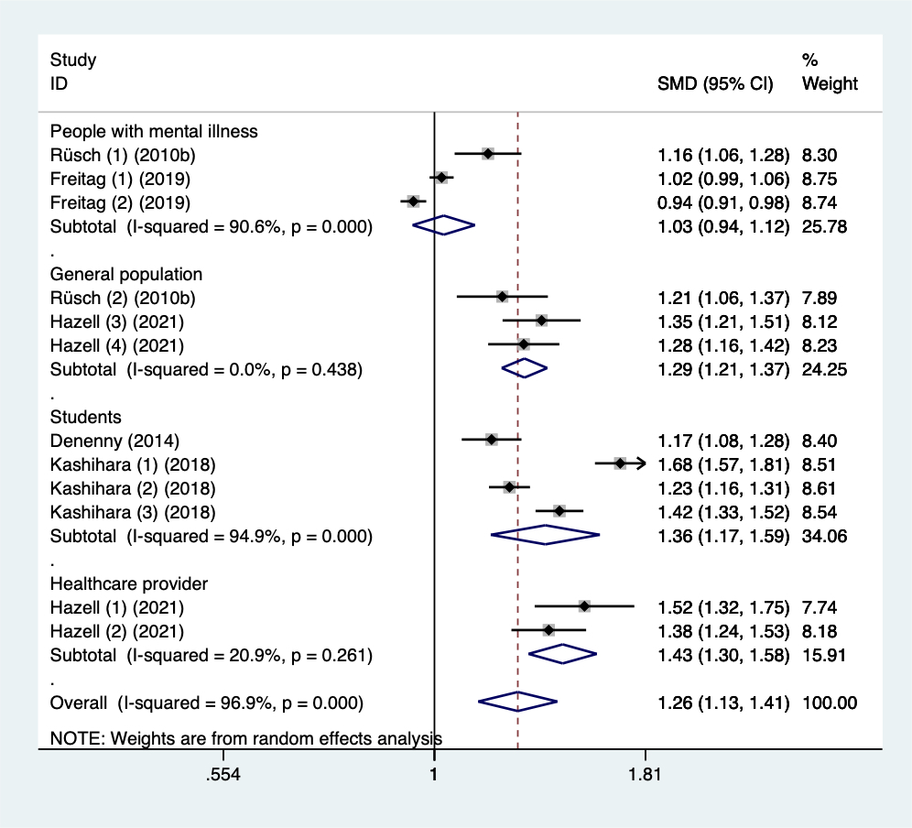
Supplemental Figure 6. Forest plot of studies included in the meta-analysis (BIAT)

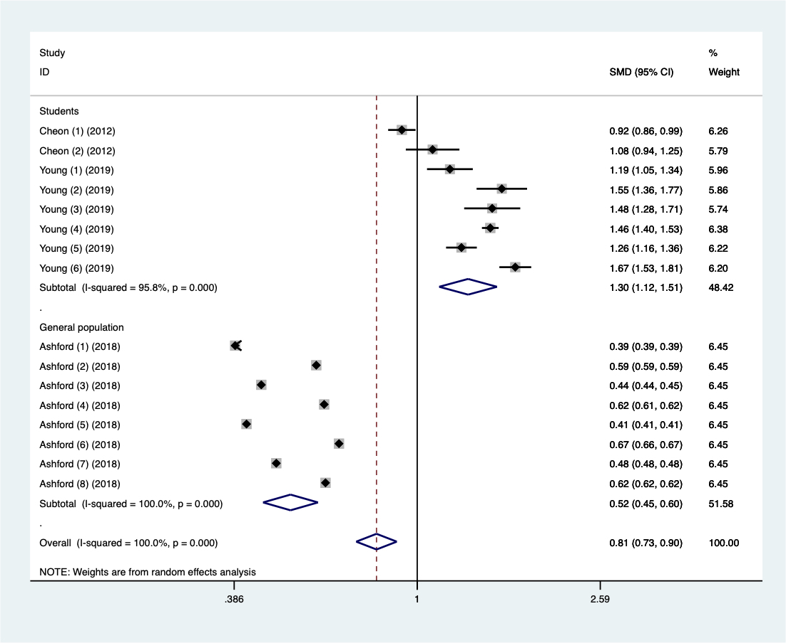
Supplemental Figure 7. Forest plot of studies included in the meta-analysis (GNAT)

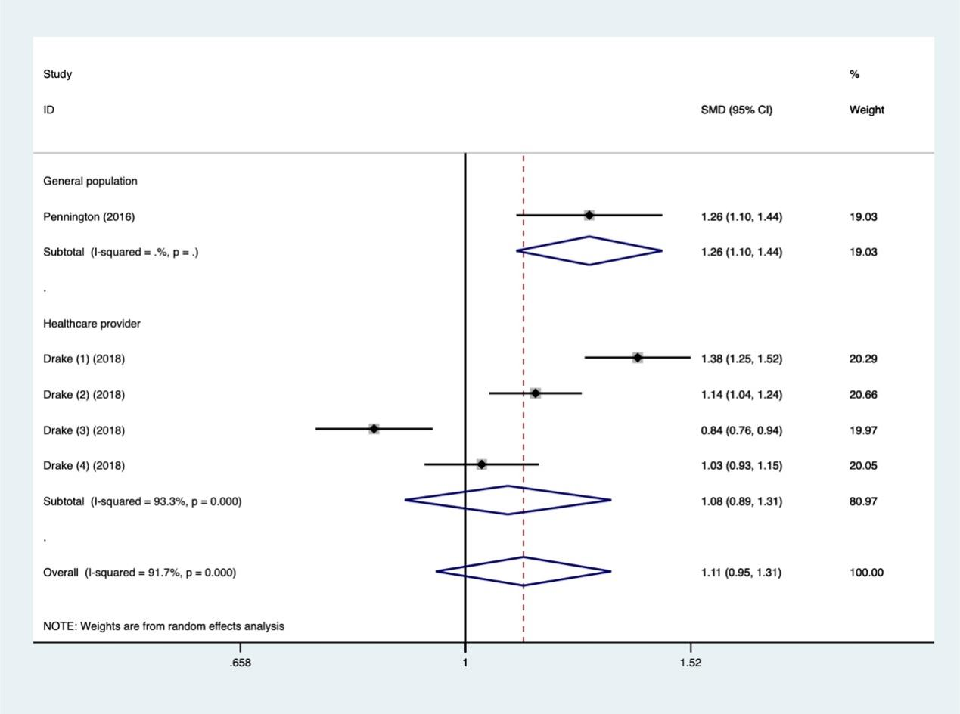
Supplemental Figure 8. Forest plot of studies included in the meta-analysis (IRAP)

Supplemental Figure 9. Forest plot of studies included in the meta-analysis (North America)

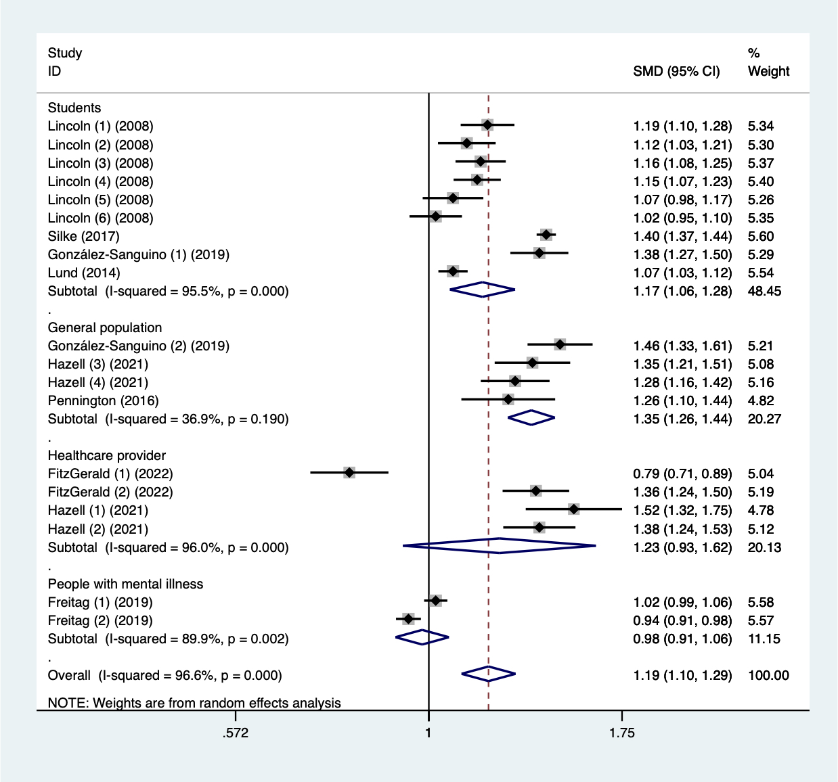
Supplemental Figure 10. Forest plot of studies included in the meta-analysis (Europe)

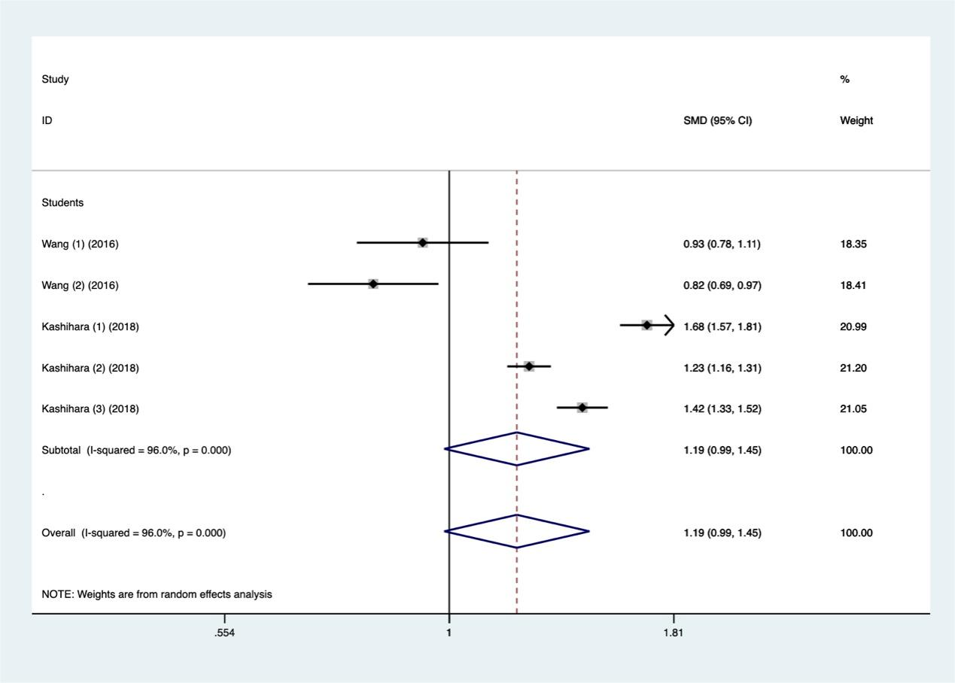
Supplemental Figure 11. Forest plot of studies included in the meta-analysis (Asia)

