Supplementary Material S1
Search Records
search_manager_search
Search Name:
Date Run: 08/01/2024 07:42:52
Comment:

ID Search Hits
#1 MeSH descriptor: [Nerve Block] explode all trees 5882
#2 (Block, Nerve):ti,ab,kw OR (Blocks, Nerve):ti,ab,kw OR (Nerve Blocks):ti,ab,kw OR (Nerve Blockade):ti,ab,kw OR (Blockade, Nerve):ti,ab,kw 16408
#3 (Blockades, Nerve):ti,ab,kw OR (Nerve Blockades):ti,ab,kw OR (Chemical Neurolysis):ti,ab,kw OR (Chemical Neurolyses):ti,ab,kw OR (Neurolyses, Chemical):ti,ab,kw 137
#4 (Neurolysis, Chemical):ti,ab,kw OR (Chemodenervation):ti,ab,kw OR (Chemodenervations):ti,ab,kw 67
#5 #1 OR #2 OR #3 OR #4 16626
#6 genicular 263
#7 MeSH descriptor: [Pain] explode all trees 75424
#8 (Pain, Burning):ti,ab,kw OR (Burning Pain):ti,ab,kw OR (Burning Pains):ti,ab,kw OR (Pains, Burning):ti,ab,kw OR (Suffering, Physical):ti,ab,kw 5282
#9 (Physical Suffering):ti,ab,kw OR (Physical Sufferings):ti,ab,kw OR (Sufferings, Physical):ti,ab,kw OR (Pain, Migratory):ti,ab,kw OR (Migratory Pain):ti,ab,kw 2517
#10 (Migratory Pains):ti,ab,kw OR (Pains, Migratory):ti,ab,kw OR (Pain, Radiating):ti,ab,kw OR (Pains, Radiating):ti,ab,kw OR (Radiating Pain):ti,ab,kw 544
#11 (Radiating Pains):ti,ab,kw OR (Pain, Splitting):ti,ab,kw OR (Pains, Splitting):ti,ab,kw OR (Splitting Pain):ti,ab,kw OR (Splitting Pains):ti,ab,kw 89
#12 (Ache):ti,ab,kw OR (Aches):ti,ab,kw OR (Pain, Crushing):ti,ab,kw OR (Crushing Pain):ti,ab,kw OR (Crushing Pains):ti,ab,kw 1200
#13 (Pains, Crushing):ti,ab,kw 1
#14 #7 or #8 or #9 or #10 or #11 or #12 or #13 81452
#15 #5 and #6 and #14 36

PubMed Search History
Search number | Query | Sort By | Filters | Search Details | Results | Time
7 | ((("Nerve Block"[Mesh]) OR ((((((((((((((Nerve Block[Title/Abstract]) OR (Block, Nerve[Title/Abstract])) OR (Blocks, Nerve[Title/Abstract])) OR (Nerve Blocks[Title/Abstract])) OR (Nerve Blockade[Title/Abstract])) OR (Blockade, Nerve[Title/Abstract])) OR (Blockades, Nerve[Title/Abstract])) OR (Nerve Blockades[Title/Abstract])) OR (Chemical Neurolysis[Title/Abstract])) OR (Chemical Neurolyses[Title/Abstract])) OR (Neurolyses, Chemical[Title/Abstract])) OR (Neurolysis, Chemical[Title/Abstract])) OR (Chemodenervation[Title/Abstract])) OR (Chemodenervations[Title/Abstract]))) AND (genicular)) AND ((((((((((((((((((((((((((Pain[Title/Abstract]) OR (Pain, Burning[Title/Abstract])) OR (Burning Pains[Title/Abstract])) OR (Pains, Burning[Title/Abstract])) OR (Suffering, Physical[Title/Abstract])) OR (Physical Suffering[Title/Abstract])) OR (Physical Sufferings[Title/Abstract])) OR (Sufferings, Physical[Title/Abstract])) OR (Pain, Migratory[Title/Abstract])) OR (Migratory Pain[Title/Abstract])) OR (Migratory Pains[Title/Abstract])) OR (Pains, Migratory[Title/Abstract])) OR (Pain, Radiating[Title/Abstract])) OR (Pains, Radiating[Title/Abstract])) OR (Radiating Pain[Title/Abstract])) OR (Radiating Pains[Title/Abstract])) OR (Pain, Splitting[Title/Abstract])) OR (Pains, Splitting[Title/Abstract])) OR (Splitting Pain[Title/Abstract])) OR (Splitting Pains[Title/Abstract])) OR (Ache[Title/Abstract])) OR (Aches[Title/Abstract])) OR (Pain, Crushing[Title/Abstract])) OR (Crushing Pain[Title/Abstract])) OR (Crushing Pains[Title/Abstract])) OR (Pains, Crushing[Title/Abstract])) |  |  | ("Nerve Block"[MeSH Terms] OR ("Nerve Block"[Title/Abstract] OR "block nerve"[Title/Abstract] OR "blocks nerve"[Title/Abstract] OR "nerve blocks"[Title/Abstract] OR "nerve blockade"[Title/Abstract] OR "blockade nerve"[Title/Abstract] OR (("Blockade"[All Fields] OR "blockaded"[All Fields] OR "Blockades"[All Fields] OR "blockading"[All Fields]) AND "Nerve"[Title/Abstract]) OR "nerve blockades"[Title/Abstract] OR "chemical neurolysis"[Title/Abstract] OR "chemical neurolyses"[Title/Abstract] OR ("Neurolyses"[All Fields] AND "Chemical"[Title/Abstract]) OR ("Neurolysis"[All Fields] AND "Chemical"[Title/Abstract]) OR "Chemodenervation"[Title/Abstract] OR "Chemodenervations"[Title/Abstract])) AND "genicular"[All Fields] AND ("Pain"[Title/Abstract] OR "pain burning"[Title/Abstract] OR "burning pains"[Title/Abstract] OR "pains burning"[Title/Abstract] OR "suffering physical"[Title/Abstract] OR "physical suffering"[Title/Abstract] OR "physical sufferings"[Title/Abstract] OR (("stress, psychological"[MeSH Terms] OR ("stress"[All Fields] AND "psychological"[All Fields]) OR "psychological stress"[All Fields] OR "Suffering"[All Fields] OR "Pain"[MeSH Terms] OR "Pain"[All Fields] OR "suffer"[All Fields] OR "suffered"[All Fields] OR "suffereing"[All Fields] OR "sufferer"[All Fields] OR "sufferer s"[All Fields] OR "sufferers"[All Fields] OR "Sufferings"[All Fields] OR "sufferred"[All Fields] OR "suffers"[All Fields]) AND "Physical"[Title/Abstract]) OR "pain migratory"[Title/Abstract] OR "migratory pain"[Title/Abstract] OR "migratory pains"[Title/Abstract] OR "pains migratory"[Title/Abstract] OR "pain radiating"[Title/Abstract] OR "pains radiating"[Title/Abstract] OR "radiating pain"[Title/Abstract] OR "radiating pains"[Title/Abstract] OR "pain splitting"[Title/Abstract] OR (("Pain"[MeSH Terms] OR "Pain"[All Fields] OR "painful"[All Fields] OR "Pains"[All Fields] OR "pain s"[All Fields] OR "painfulness"[All Fields]) AND "Splitting"[Title/Abstract]) OR "splitting pain"[Title/Abstract] OR (("split"[All Fields] OR "splits"[All Fields] OR "splitted"[All Fields] OR "Splitting"[All Fields] OR "splittings"[All Fields]) AND "Pains"[Title/Abstract]) OR "Ache"[Title/Abstract] OR "Aches"[Title/Abstract] OR "pain crushing"[Title/Abstract] OR "crushing pain"[Title/Abstract] OR (("crush injuries"[MeSH Terms] OR ("crush"[All Fields] AND "injuries"[All Fields]) OR "crush injuries"[All Fields] OR "crushed"[All Fields] OR "crush"[All Fields] OR "crushes"[All Fields] OR "Crushing"[All Fields] OR "crushings"[All Fields]) AND "Pains"[Title/Abstract]) OR (("Pain"[MeSH Terms] OR "Pain"[All Fields] OR "painful"[All Fields] OR "Pains"[All Fields] OR "pain s"[All Fields] OR "painfulness"[All Fields]) AND "Crushing"[Title/Abstract])) | 94 | 21:57:19
6 | (((((((((((((((((((((((((Pain[Title/Abstract]) OR (Pain, Burning[Title/Abstract])) OR (Burning Pains[Title/Abstract])) OR (Pains, Burning[Title/Abstract])) OR (Suffering, Physical[Title/Abstract])) OR (Physical Suffering[Title/Abstract])) OR (Physical Sufferings[Title/Abstract])) OR (Sufferings, Physical[Title/Abstract])) OR (Pain, Migratory[Title/Abstract])) OR (Migratory Pain[Title/Abstract])) OR (Migratory Pains[Title/Abstract])) OR (Pains, Migratory[Title/Abstract])) OR (Pain, Radiating[Title/Abstract])) OR (Pains, Radiating[Title/Abstract])) OR (Radiating Pain[Title/Abstract])) OR (Radiating Pains[Title/Abstract])) OR (Pain, Splitting[Title/Abstract])) OR (Pains, Splitting[Title/Abstract])) OR (Splitting Pain[Title/Abstract])) OR (Splitting Pains[Title/Abstract])) OR (Ache[Title/Abstract])) OR (Aches[Title/Abstract])) OR (Pain, Crushing[Title/Abstract])) OR (Crushing Pain[Title/Abstract])) OR (Crushing Pains[Title/Abstract])) OR (Pains, Crushing[Title/Abstract]) |  |  | "Pain"[Title/Abstract] OR "pain burning"[Title/Abstract] OR "burning pains"[Title/Abstract] OR "pains burning"[Title/Abstract] OR "suffering physical"[Title/Abstract] OR "physical suffering"[Title/Abstract] OR "physical sufferings"[Title/Abstract] OR (("stress, psychological"[MeSH Terms] OR ("stress"[All Fields] AND "psychological"[All Fields]) OR "psychological stress"[All Fields] OR "Suffering"[All Fields] OR "Pain"[MeSH Terms] OR "Pain"[All Fields] OR "suffer"[All Fields] OR "suffered"[All Fields] OR "suffereing"[All Fields] OR "sufferer"[All Fields] OR "sufferer s"[All Fields] OR "sufferers"[All Fields] OR "Sufferings"[All Fields] OR "sufferred"[All Fields] OR "suffers"[All Fields]) AND "Physical"[Title/Abstract]) OR "pain migratory"[Title/Abstract] OR "migratory pain"[Title/Abstract] OR "migratory pains"[Title/Abstract] OR "pains migratory"[Title/Abstract] OR "pain radiating"[Title/Abstract] OR "pains radiating"[Title/Abstract] OR "radiating pain"[Title/Abstract] OR "radiating pains"[Title/Abstract] OR "pain splitting"[Title/Abstract] OR (("Pain"[MeSH Terms] OR "Pain"[All Fields] OR "painful"[All Fields] OR "Pains"[All Fields] OR "pain s"[All Fields] OR "painfulness"[All Fields]) AND "Splitting"[Title/Abstract]) OR "splitting pain"[Title/Abstract] OR (("split"[All Fields] OR "splits"[All Fields] OR "splitted"[All Fields] OR "Splitting"[All Fields] OR "splittings"[All Fields]) AND "Pains"[Title/Abstract]) OR "Ache"[Title/Abstract] OR "Aches"[Title/Abstract] OR "pain crushing"[Title/Abstract] OR "crushing pain"[Title/Abstract] OR (("crush injuries"[MeSH Terms] OR ("crush"[All Fields] AND "injuries"[All Fields]) OR "crush injuries"[All Fields] OR "crushed"[All Fields] OR "crush"[All Fields] OR "crushes"[All Fields] OR "Crushing"[All Fields] OR "crushings"[All Fields]) AND "Pains"[Title/Abstract]) OR (("Pain"[MeSH Terms] OR "Pain"[All Fields] OR "painful"[All Fields] OR "Pains"[All Fields] OR "pain s"[All Fields] OR "painfulness"[All Fields]) AND "Crushing"[Title/Abstract]) | 865,264 | 21:52:37
5 | Pain[Title/Abstract] |  |  | "Pain"[Title/Abstract] | 796,009 | 21:35:30
4 | "Pain"[Mesh] | Most Recent |  | "Pain"[MeSH Terms] | 468,145 | 21:34:14
3 | (("Nerve Block"[Mesh]) OR ((((((((((((((Nerve Block[Title/Abstract]) OR (Block, Nerve[Title/Abstract])) OR (Blocks, Nerve[Title/Abstract])) OR (Nerve Blocks[Title/Abstract])) OR (Nerve Blockade[Title/Abstract])) OR (Blockade, Nerve[Title/Abstract])) OR (Blockades, Nerve[Title/Abstract])) OR (Nerve Blockades[Title/Abstract])) OR (Chemical Neurolysis[Title/Abstract])) OR (Chemical Neurolyses[Title/Abstract])) OR (Neurolyses, Chemical[Title/Abstract])) OR (Neurolysis, Chemical[Title/Abstract])) OR (Chemodenervation[Title/Abstract])) OR (Chemodenervations[Title/Abstract]))) AND (genicular) |  |  | ("Nerve Block"[MeSH Terms] OR ("Nerve Block"[Title/Abstract] OR "block nerve"[Title/Abstract] OR "blocks nerve"[Title/Abstract] OR "nerve blocks"[Title/Abstract] OR "nerve blockade"[Title/Abstract] OR "blockade nerve"[Title/Abstract] OR (("Blockade"[All Fields] OR "blockaded"[All Fields] OR "Blockades"[All Fields] OR "blockading"[All Fields]) AND "Nerve"[Title/Abstract]) OR "nerve blockades"[Title/Abstract] OR "chemical neurolysis"[Title/Abstract] OR "chemical neurolyses"[Title/Abstract] OR ("Neurolyses"[All Fields] AND "Chemical"[Title/Abstract]) OR ("Neurolysis"[All Fields] AND "Chemical"[Title/Abstract]) OR "Chemodenervation"[Title/Abstract] OR "Chemodenervations"[Title/Abstract])) AND "genicular"[All Fields] | 110 | 21:28:22
2 | (((((((((((((Nerve Block[Title/Abstract]) OR (Block, Nerve[Title/Abstract])) OR (Blocks, Nerve[Title/Abstract])) OR (Nerve Blocks[Title/Abstract])) OR (Nerve Blockade[Title/Abstract])) OR (Blockade, Nerve[Title/Abstract])) OR (Blockades, Nerve[Title/Abstract])) OR (Nerve Blockades[Title/Abstract])) OR (Chemical Neurolysis[Title/Abstract])) OR (Chemical Neurolyses[Title/Abstract])) OR (Neurolyses, Chemical[Title/Abstract])) OR (Neurolysis, Chemical[Title/Abstract])) OR (Chemodenervation[Title/Abstract])) OR (Chemodenervations[Title/Abstract]) |  |  | "nerve block"[Title/Abstract] OR "block nerve"[Title/Abstract] OR "blocks nerve"[Title/Abstract] OR "nerve blocks"[Title/Abstract] OR "nerve blockade"[Title/Abstract] OR "blockade nerve"[Title/Abstract] OR (("Blockade"[All Fields] OR "blockaded"[All Fields] OR "Blockades"[All Fields] OR "blockading"[All Fields]) AND "Nerve"[Title/Abstract]) OR "nerve blockades"[Title/Abstract] OR "chemical neurolysis"[Title/Abstract] OR "chemical neurolyses"[Title/Abstract] OR ("Neurolyses"[All Fields] AND "Chemical"[Title/Abstract]) OR ("Neurolysis"[All Fields] AND "Chemical"[Title/Abstract]) OR "Chemodenervation"[Title/Abstract] OR "Chemodenervations"[Title/Abstract] | 23,693 | 21:24:58
1 | "Nerve Block"[Mesh] | Most Recent |  | "Nerve Block"[MeSH Terms] | 26,333 | 21:20:55

Queries
No. | Query | Results | Date
#45 | #15 AND #16 AND #44 | 152 | 8-Jan-24
#44 | #17 OR #18 OR #19 OR #20 OR #21 OR #22 OR #23 OR #24 OR #25 OR #26 OR #27 OR #28 OR #29 OR #30 OR #31 OR #32 OR #33 OR #34 OR #35 OR #36 OR #37 OR #38 OR #39 OR #40 OR #41 OR #42 OR #43 | 1754678 | 8-Jan-24
#43 | 'pains, crushing':ab,ti | 0 | 8-Jan-24
#42 | 'crushing pains':ab,ti | 0 | 8-Jan-24
#41 | 'crushing pain':ab,ti | 14 | 8-Jan-24
#40 | 'pain, crushing':ab,ti | 4 | 8-Jan-24
#39 | 'aches':ab,ti | 3964 | 8-Jan-24
#38 | 'ache':ab,ti | 25245 | 8-Jan-24
#37 | 'splitting pains':ab,ti | 0 | 8-Jan-24
#36 | 'splitting pain':ab,ti | 12 | 8-Jan-24
#35 | 'pains, splitting':ab,ti | 0 | 8-Jan-24
#34 | 'pain, splitting':ab,ti | 3 | 8-Jan-24
#33 | 'radiating pains':ab,ti | 10 | 8-Jan-24
#32 | 'radiating pain':ab,ti | 878 | 8-Jan-24
#31 | 'pains, radiating':ab,ti | 8 | 8-Jan-24
#30 | 'pain, radiating':ab,ti | 2654 | 8-Jan-24
#29 | 'pains, migratory':ab,ti | 0 | 8-Jan-24
#28 | 'migratory pains':ab,ti | 1 | 8-Jan-24
#27 | 'migratory pain':ab,ti | 47 | 8-Jan-24
#26 | 'pain, migratory':ab,ti | 6 | 8-Jan-24
#25 | 'sufferings, physical':ab,ti | 0 | 8-Jan-24
#24 | 'physical sufferings':ab,ti | 14 | 8-Jan-24
#23 | 'physical suffering':ab,ti | 426 | 8-Jan-24
#22 | 'suffering, physical':ab,ti | 104 | 8-Jan-24
#21 | 'pains, burning':ab,ti | 4 | 8-Jan-24
#20 | 'burning pains':ab,ti | 34 | 8-Jan-24
#19 | 'burning pain':ab,ti | 2249 | 8-Jan-24
#18 | 'pain, burning':ab,ti | 567 | 8-Jan-24
#17 | 'pain'/exp | 1729198 | 8-Jan-24
#16 | genicular | 1001 | 8-Jan-24
#15 | #1 OR #2 OR #3 OR #4 OR #5 OR #6 OR #7 OR #8 OR #9 OR #10 OR #11 OR #12 OR #13 OR #14 | 54726 | 8-Jan-24
#14 | 'chemodenervations':ab,ti | 1 | 8-Jan-24
#13 | 'chemodenervation':ab,ti | 695 | 8-Jan-24
#12 | 'neurolysis, chemical':ab,ti | 2 | 8-Jan-24
#11 | 'neurolyses, chemical':ab,ti | 0 | 8-Jan-24
#10 | 'chemical neurolyses':ab,ti | 1 | 8-Jan-24
#9 | 'chemical neurolysis':ab,ti | 156 | 8-Jan-24
#8 | 'nerve blockades':ab,ti | 101 | 8-Jan-24
#7 | 'blockades, nerve':ab,ti | 0 | 8-Jan-24
#6 | 'blockade, nerve':ab,ti | 11 | 8-Jan-24
#5 | 'nerve blockade':ab,ti | 2283 | 8-Jan-24
#4 | 'nerve blocks':ab,ti | 8342 | 8-Jan-24
#3 | 'blocks, nerve':ab,ti | 85 | 8-Jan-24
#2 | 'block, nerve':ab,ti | 140 | 8-Jan-24
#1 | 'nerve block'/exp | 52296 | 8-Jan-24

Search-history
Permission | # | Search strategy | Database | Search results | Running date
- WOS.IC: 1993 to 2024  - WOS.CCR: 1985 to 2024  - WOS.SCI: 1900 to 2024  - WOS.AHCI: 1975 to 2024  - WOS.BHCI: 2005 to 2024  - WOS.BSCI: 2005 to 2024  - WOS.ESCI: 2015 to 2024  - WOS.ISTP: 1990 to 2024  - WOS.SSCI: 1900 to 2024  - WOS.ISSHP: 1990 to 2024 | 1 | TS=(Nerve Block) OR TS=(Block, Nerve) OR TS=(Blocks, Nerve) OR TS=(Nerve Blocks) OR TS=(Nerve Blockade) OR TS=(Blockade, Nerve) OR TS=(Blockades, Nerve) OR TS=(Nerve Blockades) OR TS=(Chemical Neurolysis) OR TS=(Chemical Neurolyses) OR TS=(Neurolyses, Chemical) OR TS=(Neurolysis, Chemical) OR TS=(Chemodenervation) OR TS=(Chemodenervations) | Web of Science 核心合集 | 49150 | Mon Jan 08 2024 23:55:40 GMT+0800 (China Standard Time)
- WOS.IC: 1993 to 2024  - WOS.CCR: 1985 to 2024  - WOS.SCI: 1900 to 2024  - WOS.AHCI: 1975 to 2024  - WOS.BHCI: 2005 to 2024  - WOS.BSCI: 2005 to 2024  - WOS.ESCI: 2015 to 2024  - WOS.ISTP: 1990 to 2024  - WOS.SSCI: 1900 to 2024  - WOS.ISSHP: 1990 to 2024 | 2 | TS=(genicular) | Web of Science 核心合集 | 687 | Mon Jan 08 2024 23:56:37 GMT+0800 (China Standard Time)
- WOS.IC: 1993 to 2024  - WOS.CCR: 1985 to 2024  - WOS.SCI: 1900 to 2024  - WOS.AHCI: 1975 to 2024  - WOS.BHCI: 2005 to 2024  - WOS.BSCI: 2005 to 2024  - WOS.ESCI: 2015 to 2024  - WOS.ISTP: 1990 to 2024  - WOS.SSCI: 1900 to 2024  - WOS.ISSHP: 1990 to 2024 | 3 | TS=(Pain) OR TS=(Pain, Burning) OR TS=(Burning Pain) OR TS=(Burning Pains) OR TS=(Pains, Burning) OR TS=(Suffering, Physical) OR TS=(Physical Suffering) OR TS=(Physical Sufferings) OR TS=(Sufferings, Physical) OR TS=(Pain, Migratory) OR TS=(Migratory Pain) OR TS=(Migratory Pains) OR TS=(Pains, Migratory) OR TS=(Pain, Radiating) OR TS=(Pains, Radiating) OR TS=(Radiating Pain) OR TS=(Radiating Pains) OR TS=(Pain, Splitting) OR TS=(Pains, Splitting) OR TS=(Splitting Pain) OR TS=(Splitting Pains) OR TS=(Ache) OR TS=(Aches) OR TS=(Pain, Crushing) OR TS=(Crushing Pain) OR TS=(Crushing Pains) OR TS=(Pains, Crushing) | Web of Science | 887377 | Tue Jan 09 2024 00:03:21 GMT+0800 (China Standard Time)
- WOS.IC: 1993 to 2024  - WOS.CCR: 1985 to 2024  - WOS.SCI: 1900 to 2024  - WOS.AHCI: 1975 to 2024  - WOS.BHCI: 2005 to 2024  - WOS.BSCI: 2005 to 2024  - WOS.ESCI: 2015 to 2024  - WOS.ISTP: 1990 to 2024  - WOS.SSCI: 1900 to 2024  - WOS.ISSHP: 1990 to 2024 | 4 | #3 AND #2 AND #1 | Web of Science | 130 | Tue Jan 09 2024 00:04:15 GMT+0800 (China Standard Time)

Supplementary Material S2
Basic characteristics of the included studies
Study | Year | Country | Sample size |  | Gender(M/F) | Diagnosis | Mean age(years) |  | intervention |  | Outcomes
Study | Year | Country | EG | CG | Gender(M/F) | Diagnosis | EG | CG | EG | CG | Outcomes
Radwan | 2023 | Egypt | 51 | 53 | 41/63 | Juvenile idiopathic arthritis | 11.63 | 11.83 | GNB: lidocaine 2ml, | steroid injection | Pain socres(VAS)
Ragab | 2021 | Egypt | 20 | 20 | 9/31 | Chronic knee osteoarthritis | 57.70 | 58.05 | GNB: TA(20mg) and 6 mL of lidocaine | IACSI:  TA(40 mg) and 5 mL of lidocaine | Pain socres(VAS)
Elsaman | 2021 | Egypt | 33 | 31 | 17/47 | Rheumatoid arthritis (RA) knees | 51.3 | 49.5 | GNB: bupivacaine 0.5% | steroid injection | Pain socres(VAS)
Eid | 2023 | Egypt | 44 | 44 | 51/37 | postoperative pain of in knee arthroplasty | 58.88 | 61.43 | GNB: 15 mL bupivacaine 0.25% with 2.5 g/mL adrenaline | PAI: 0.5 mL adrenaline [4.5 μg/mL], 20 mL bupivacaine 0.5% | Pain socres(NRS)
＃Lebleu | 2020 | Belgium | 14 | 12 | 5/21 | knee osteoarthritis | 64.5 | 50.6 | GNB:1 mL of lidocaine plus 20mg of triamcinolone | Healthy | Pain socres(NRS)
Basavaraju | 2023 | India | 26 | 26 | 15/37 | knee osteoarthritis | 65.53 | 68.26 | GNB: lidocaine+TA  (20mg) | GNB: lidocaine | Pain socres(VAS)
Elashmawy | 2022 | Egypt | 23 | 23 | 19/27 | advanced knee osteoarthritis patients | 57.6 | 56.7 | GNB:1ml triamcinolone + 6ml bupivacaine | GNA:0.5–0.75ml solution containing 50% alcohol in 0.25% bupivacaine | Pain socres(VAS)
Rambhia | 2021 | USA | 20 | 20 | 23/17 | primary total knee arthroplasty | 67.1 | 70.9 | GNB:0.25% bupivacaine  +dexamethasone | sham block performed with saline. | Pain socres(NRS)
Qudsi-Sinclair | 2017 | Spain | 14 | 14 | 7/19 | Pain after a Total Knee Arthroplasty | 71.08 | 67.4 | GNB: 1 mL of 2% lidocaine | RF: | Pain socres(NRS)
Akesen | 2020 | Turkey | 20 or20 | 20 | 14/46 | Pain after a Total Knee Arthroplasty | 68 or 67.5 | 63 | GNB: bupivacaine solution (18 mL 0.25% isobaric bupivacaine with 2 mL | Nothing  : | Pain socres(VAS)
Cunat | 2022 | Spain | 29 | 30 | 16/43 | Total Knee Arthroplasty | 72.6 | 71.8 | GNB：20 ml ropivacaine 0.2% with adrenaline 10ug.ml⁻¹ (4 ml per nerve) (Fig. 1) | Local infiltration analgesia | Pain socres(NRS)
Güler | 2021 | Turkey | 51 | 51 | 21/81 | chronic knee osteoarthritis | 55.88 | 53.01 | GNB：5 ml of 2% lidocaine and 1 ml of 40 mg triamcinolone | physical therapy | Pain socres(VAS)
Kumar | 2022 | India | 25 | 25 | (p value 1.000) | Knee  Osteoarthritis Treated | 55.63 | 54.26 | GNB: lignocaine 2% 3 mL + Inj. 0.25% bupivacaine 2 mL + depot methylprednisolone 40 mg/mL 1 mL | TENS | Pain socres(VAS)
Yilmaz | 2019 | Turkey | 20 | 20 | 5/35 | Knee  Osteoarthritis Treated | 61.05 | 61.60 | GNB: 2 mL lidocaine+ 1 mL betamethasone | IACSI:2 mL of lidocaine | Pain socres(VAS)
Kertkiatkachorn | 2023 | Thailand | 69 | 70 | 19/121 | Pain after a Total Knee Arthroplasty | 70.8 | 69.5 | GNB: 40mL of 0.125% bupivacaine with 5µg/mL of epinephrine and 30mg of ketorolac | PAI:100mL of 0.1% bupivacaine with 3µg/mL of epinephrine and 30mg of ketorolac | Pain socres(NRS)
Tabur | 2021 | Turkey | 24 | 22 | 8/38 | Pain after a Total Knee Arthroplasty | 67.29 | 69.50 | GNB: 5 mL solution in the form of 2 mL %0.5 bupivacaine, 1 mL (4 mg) dexamethasone | FAS: 10 mL 0.5% bupivacaine, 1mL (4 mg) dexamethasone | Pain socres(VAS)
EG: experimental group；CG: control group；IACSI: Intra-articular corticosteroid injection；NB: Genicular nerve block；GNA: genicular nerve alcoholic neurolyisis；
VAS: visual analogue scale；RS: numerical rating scale；A: Triamcinolone Acetonide；AI: periarticular infiltration；F: Neurolysis Using Radiofrequency；PACK: Popliteal artery and posterior knee capsule；ENS: Transcutaneous electric nerve stimulation；AS: femoral + anterior sciatic nerve block

Analysis result plots
Plot for results at 1 month
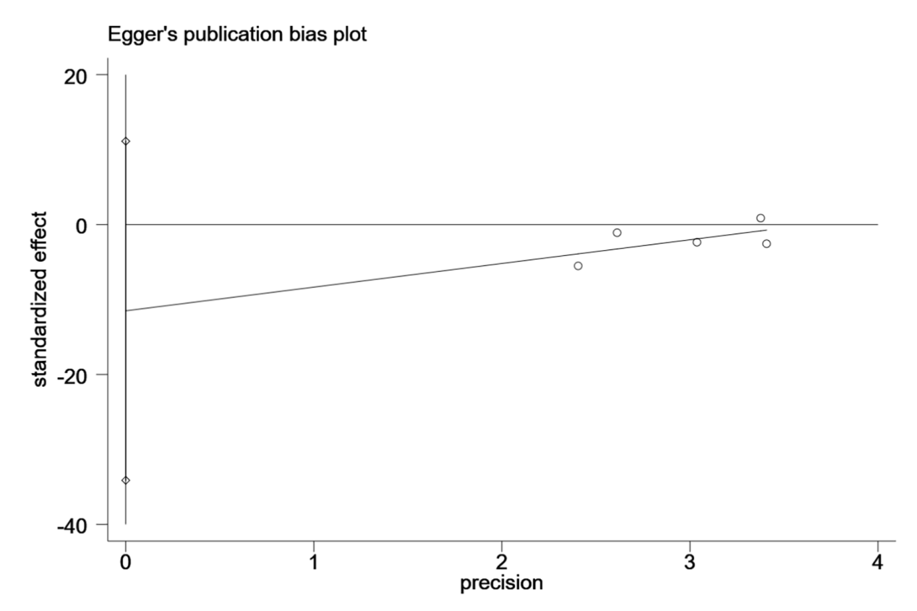
Egger’s test at 1 month (P=0.204)

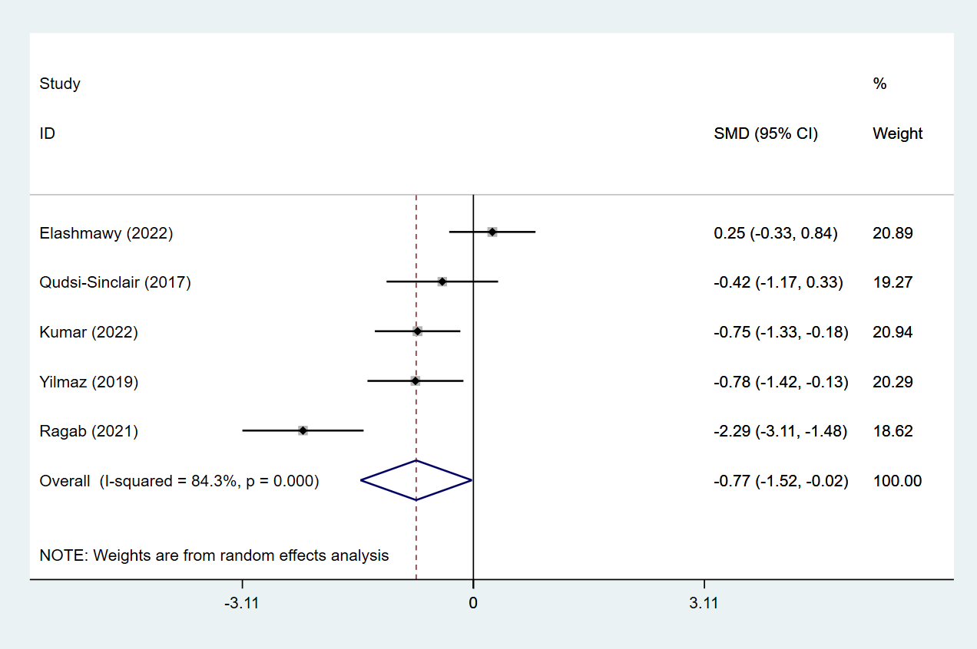
Forest plot for pain at 1 month

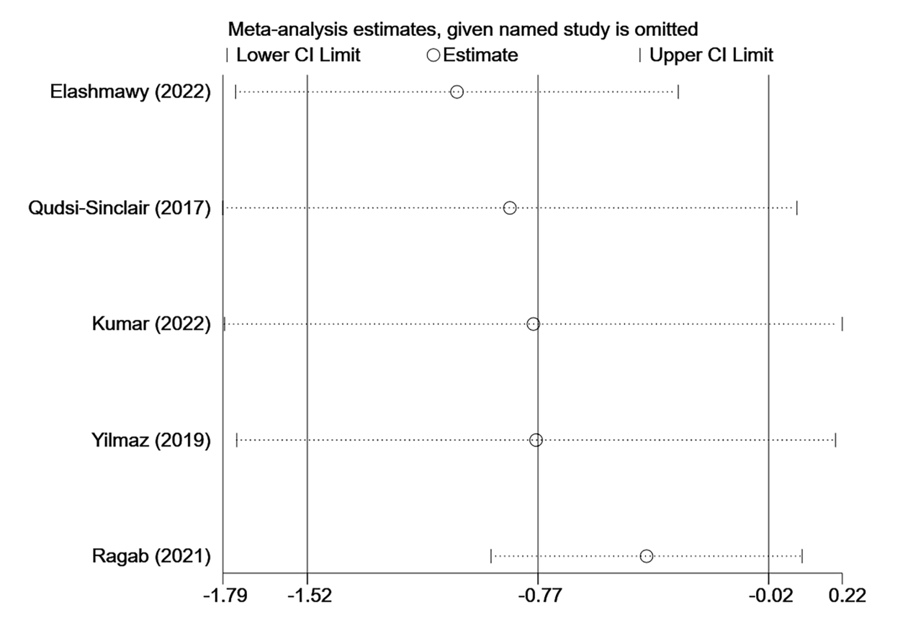
Sensitivity analysis at 1 month

Plot for results at 2 weeks
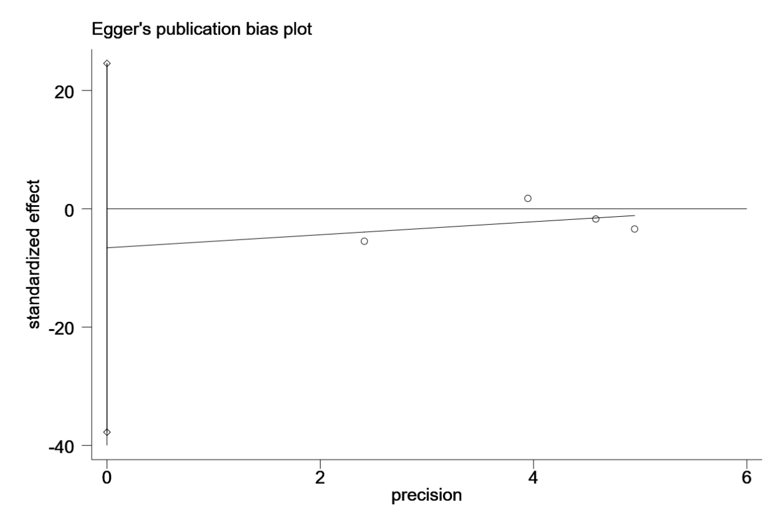
Egger’s test at at 2 weeks (0.459)

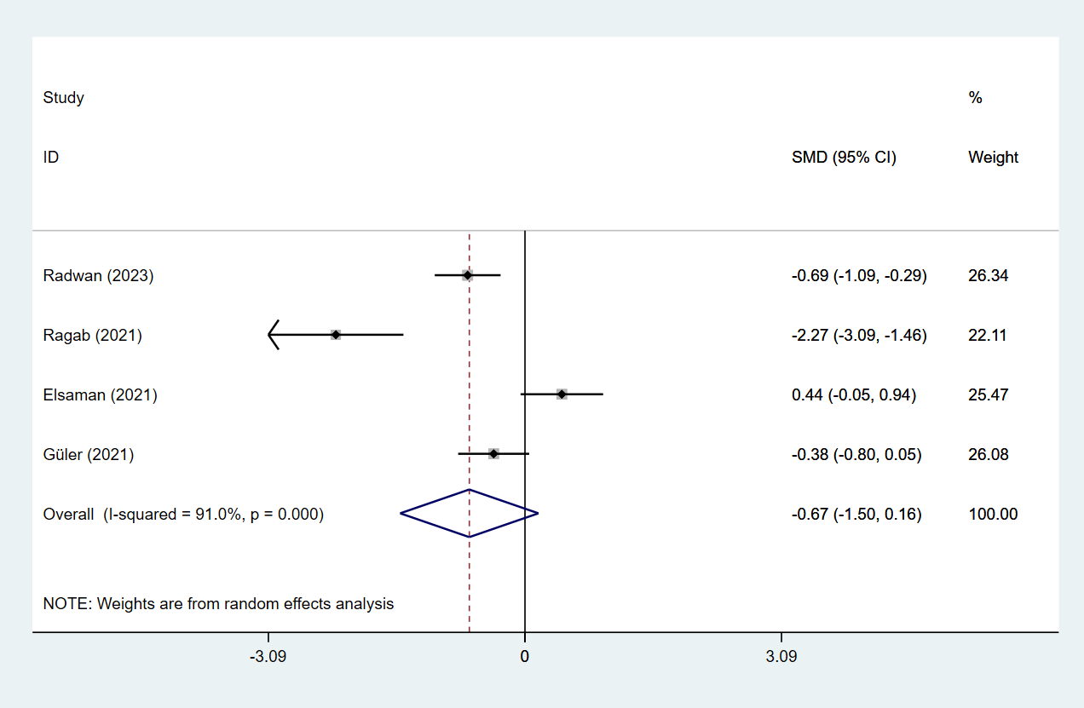
Forest plot for pain at 2 weeks

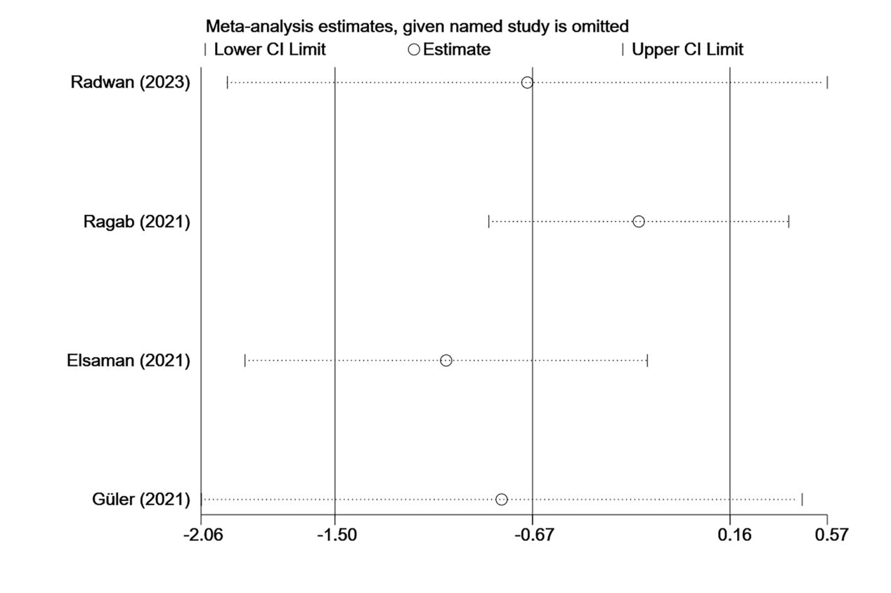
Sensitivity analysis at 2 weeks

Plot for results at 3 months
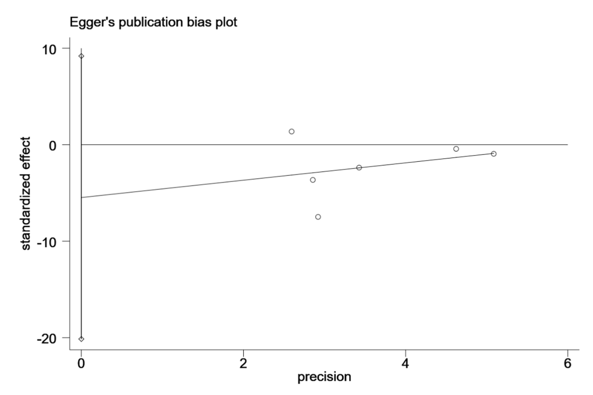
Egger’s test at 3 months (P=0.358)

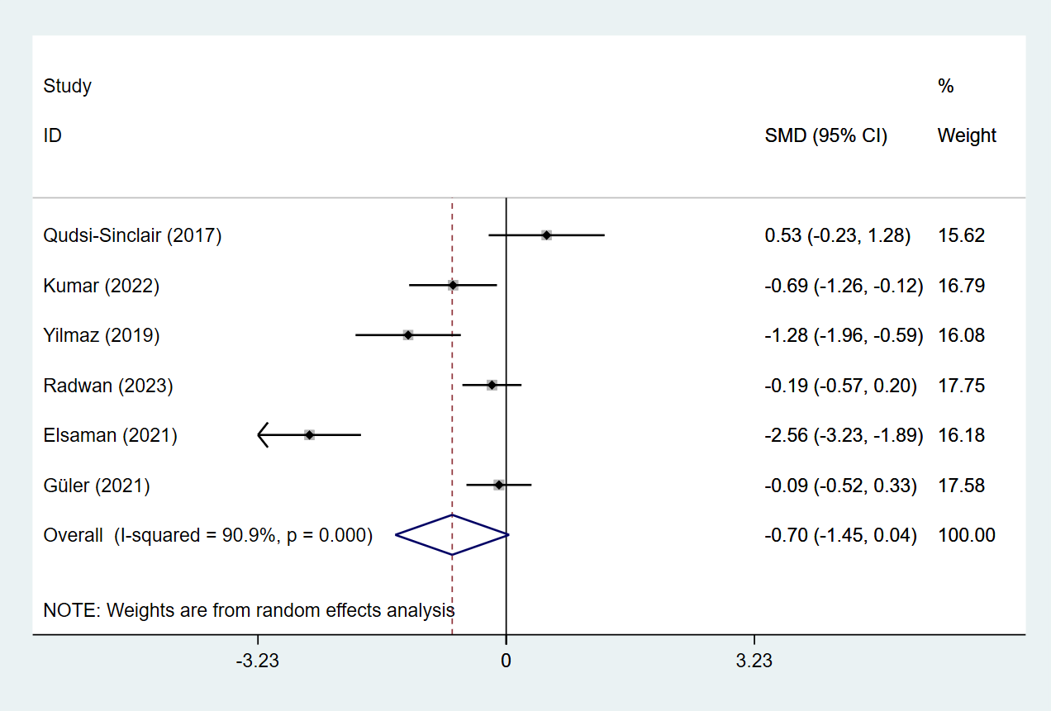
Forest plot for pain at 3 months

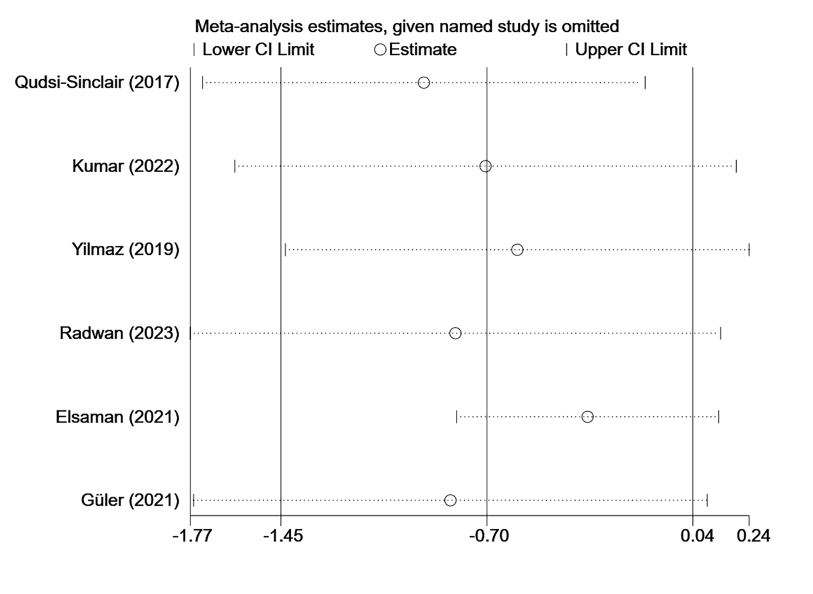
Sensitivity analysis at 3 months

Plot for results at 6 hours
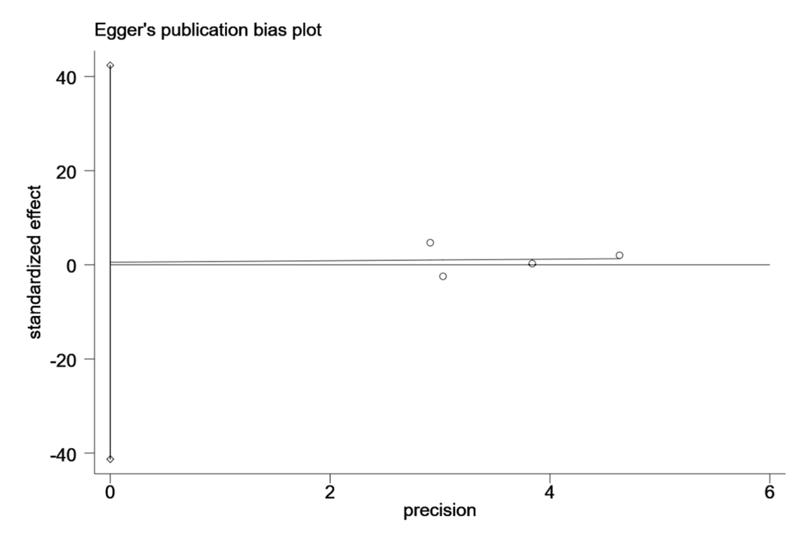
Egger’s test at 6 hours (P=0.961)

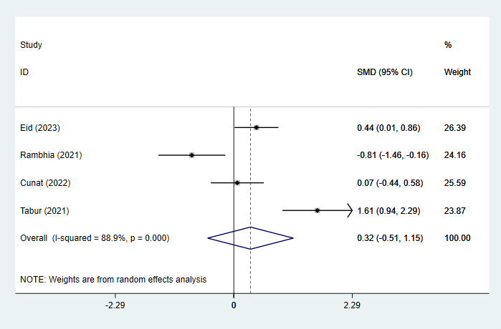
Forest plot for pain at 6 hours

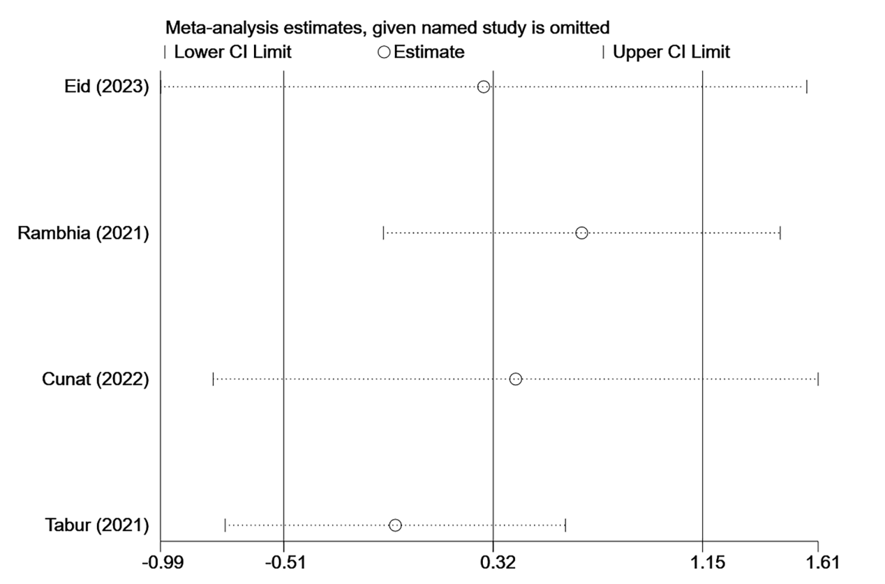
Sensitivity analysis at 6 hours

Plot for results at 6 months
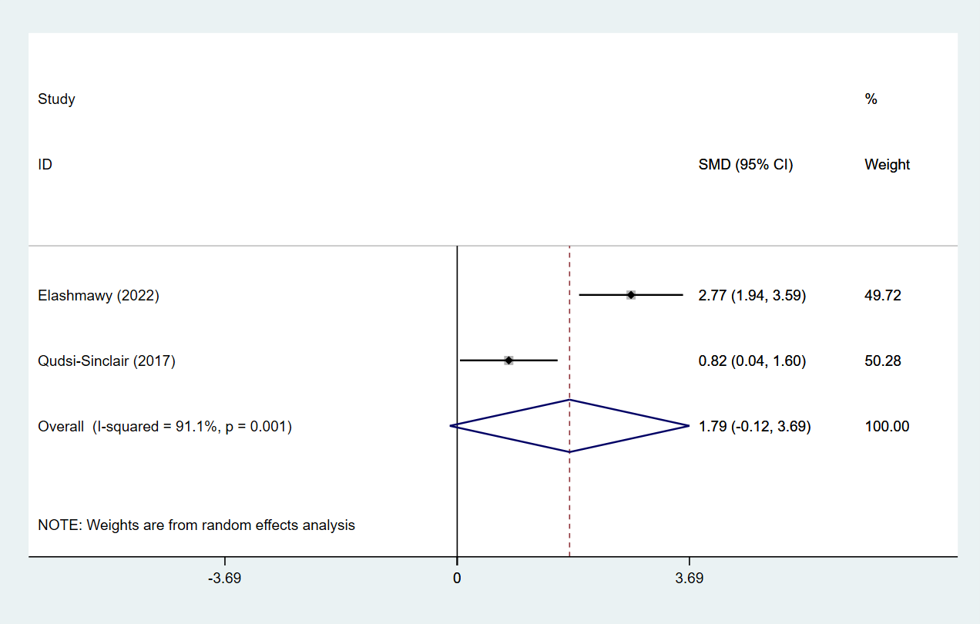
Forest plot for pain at 6 months

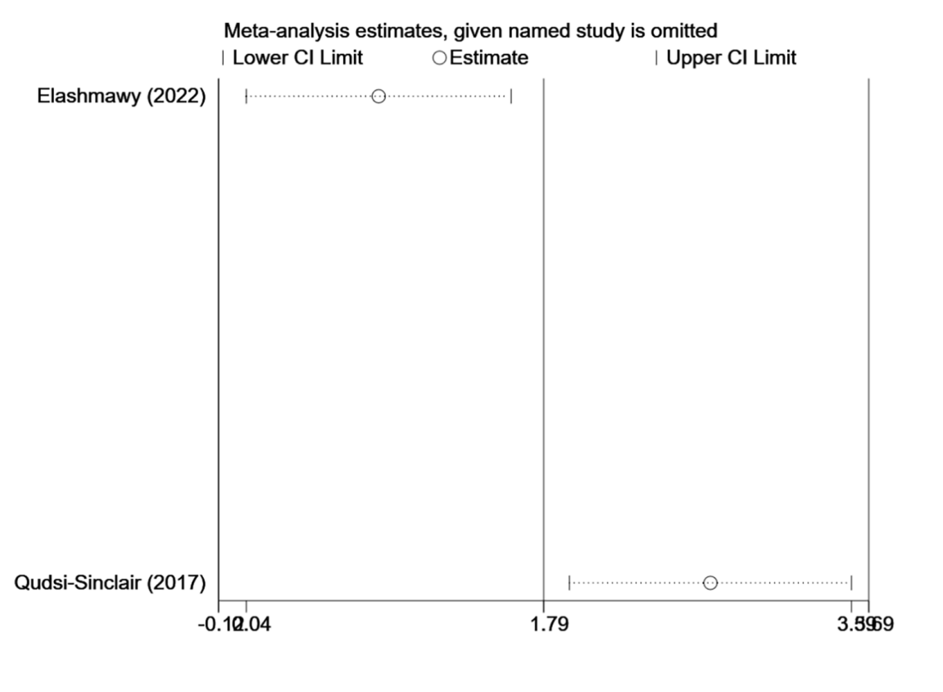
Sensitivity analysis at 6 months

Plot for results at 12 hours
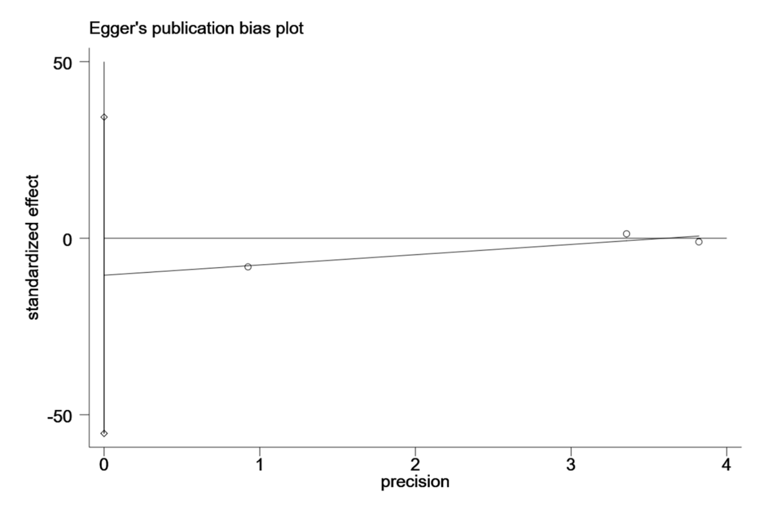
Egger’s test at 12 hours (P=0.206)

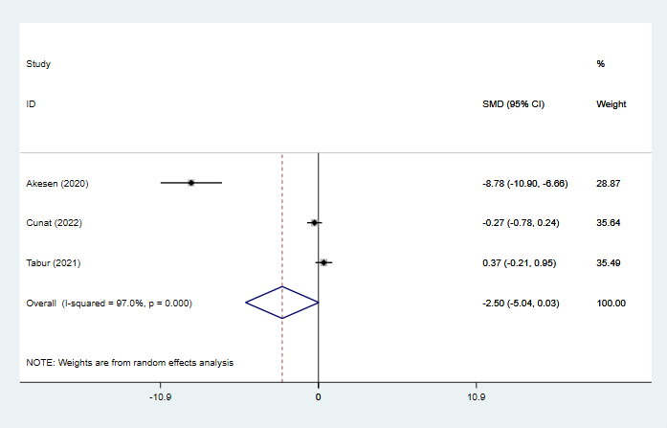
Forest plot for pain at 12 hours

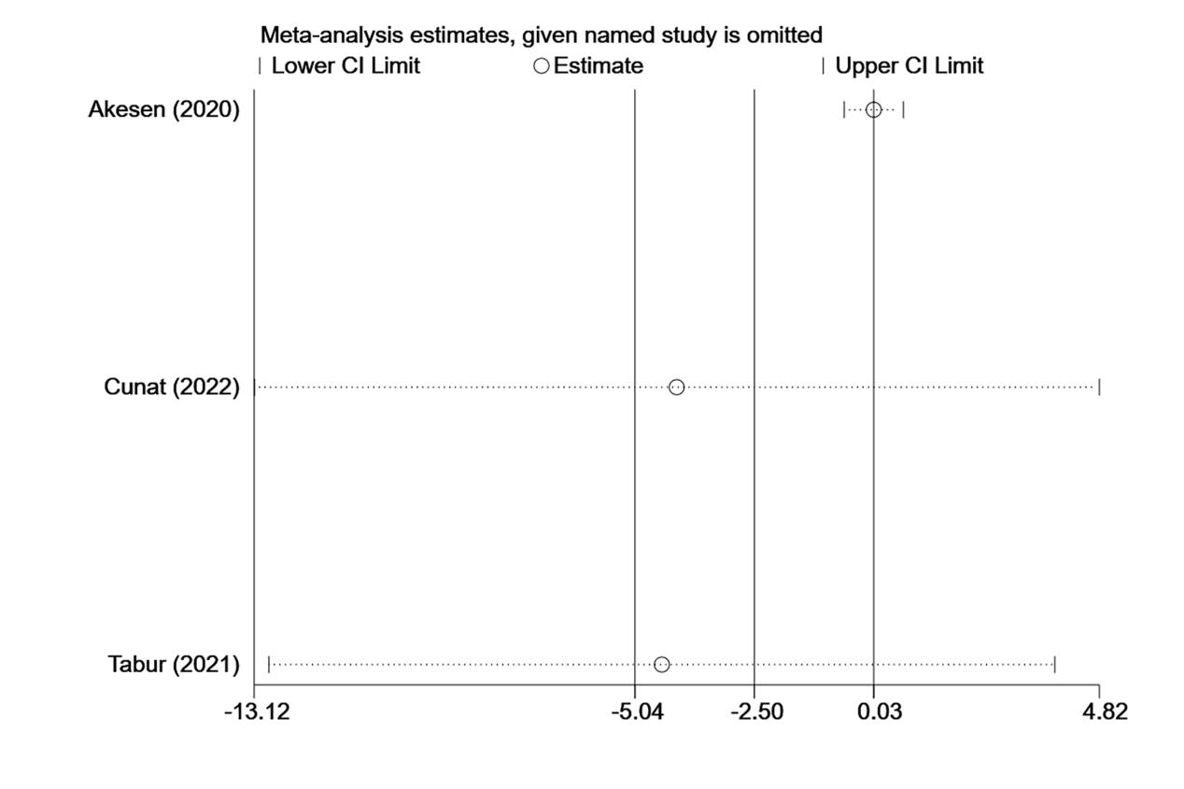
Sensitivity analysis at 12 hours

Plot for results at 24 hours
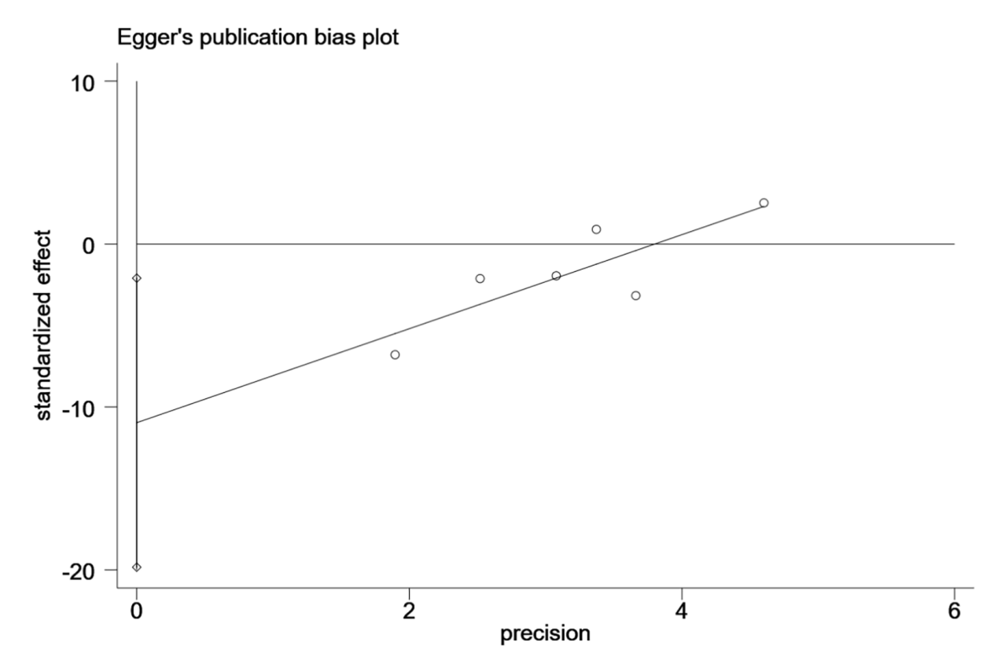
Egger’s test at 24 hours (P=0.026)

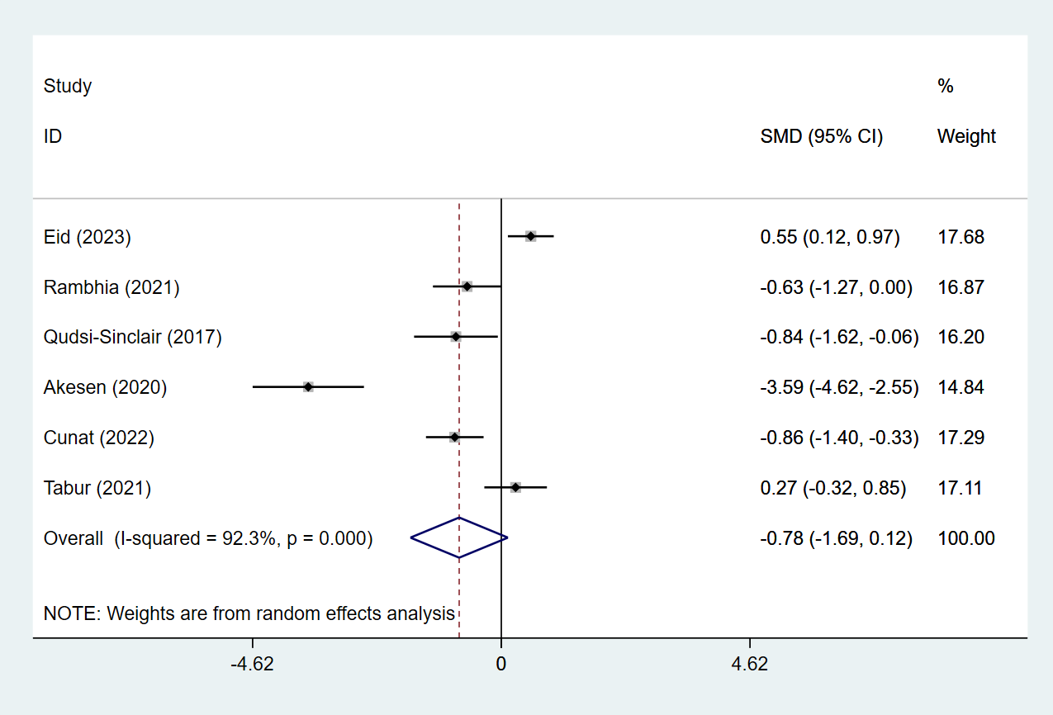
Forest plot for pain at 24 hours

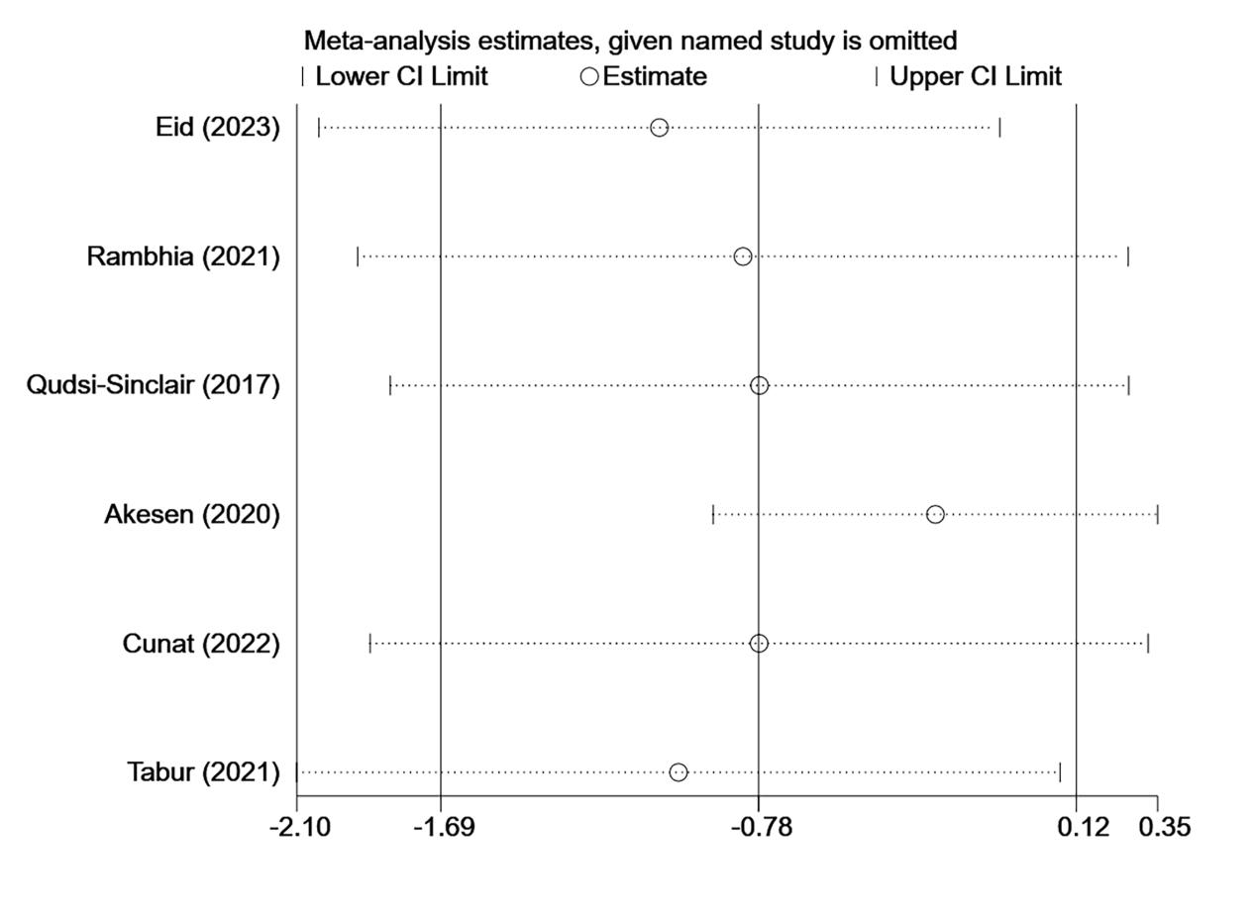
Sensitivity analysis at 24 hours

Plot for results at all time points
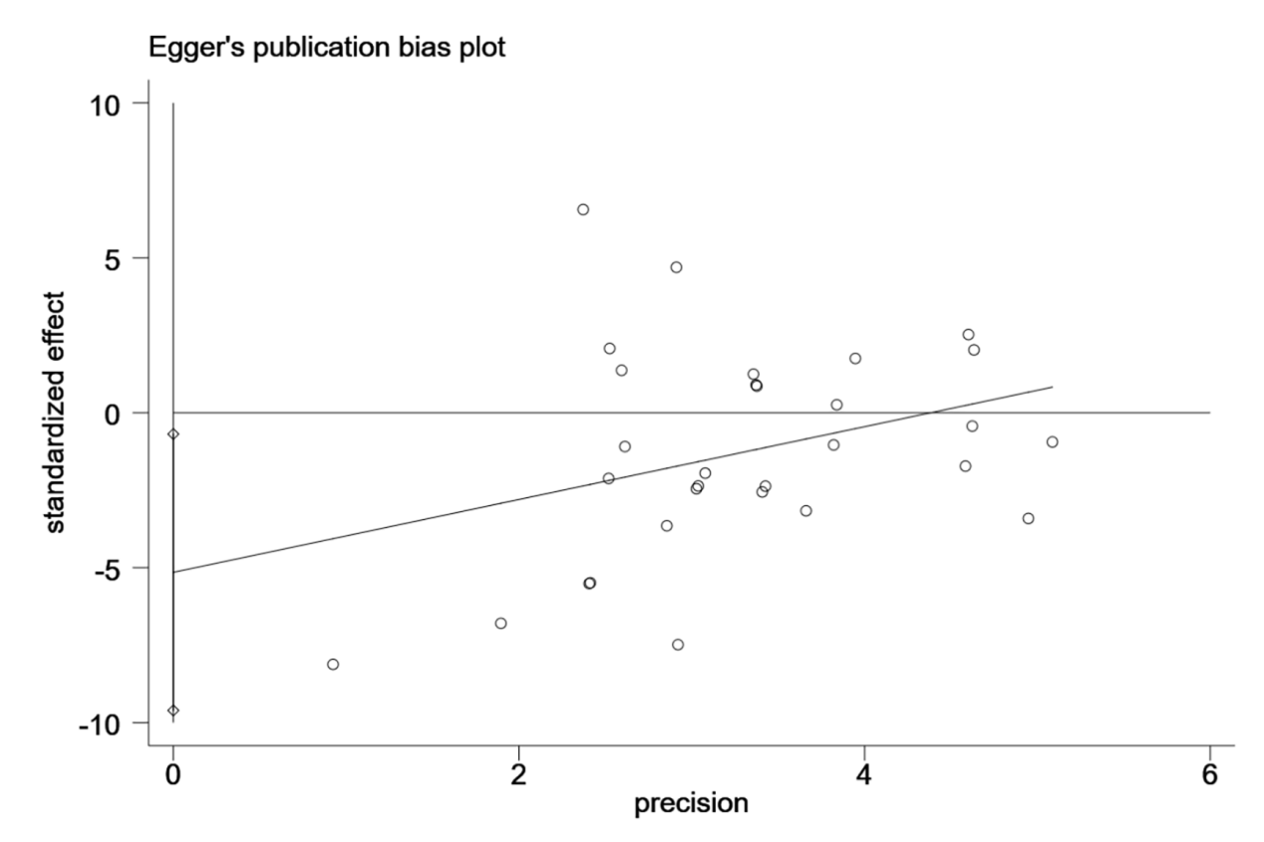
Egger’s test at all time points (P=0.025)

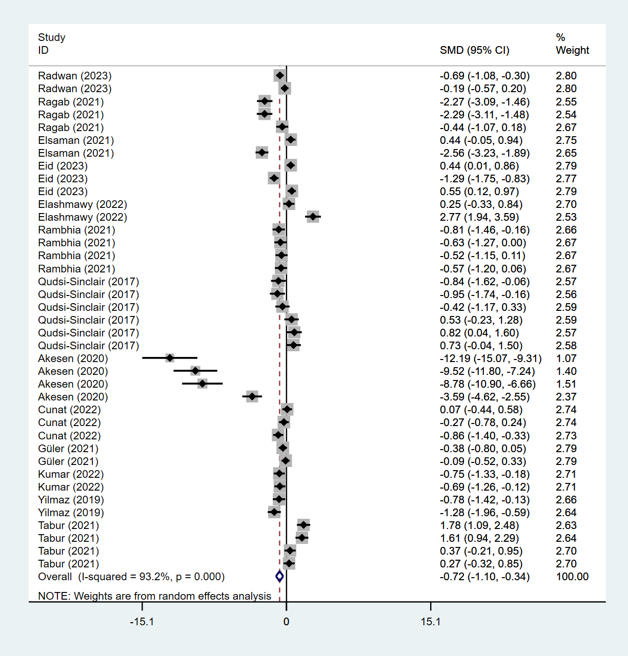
Forest plot for pain at all time points

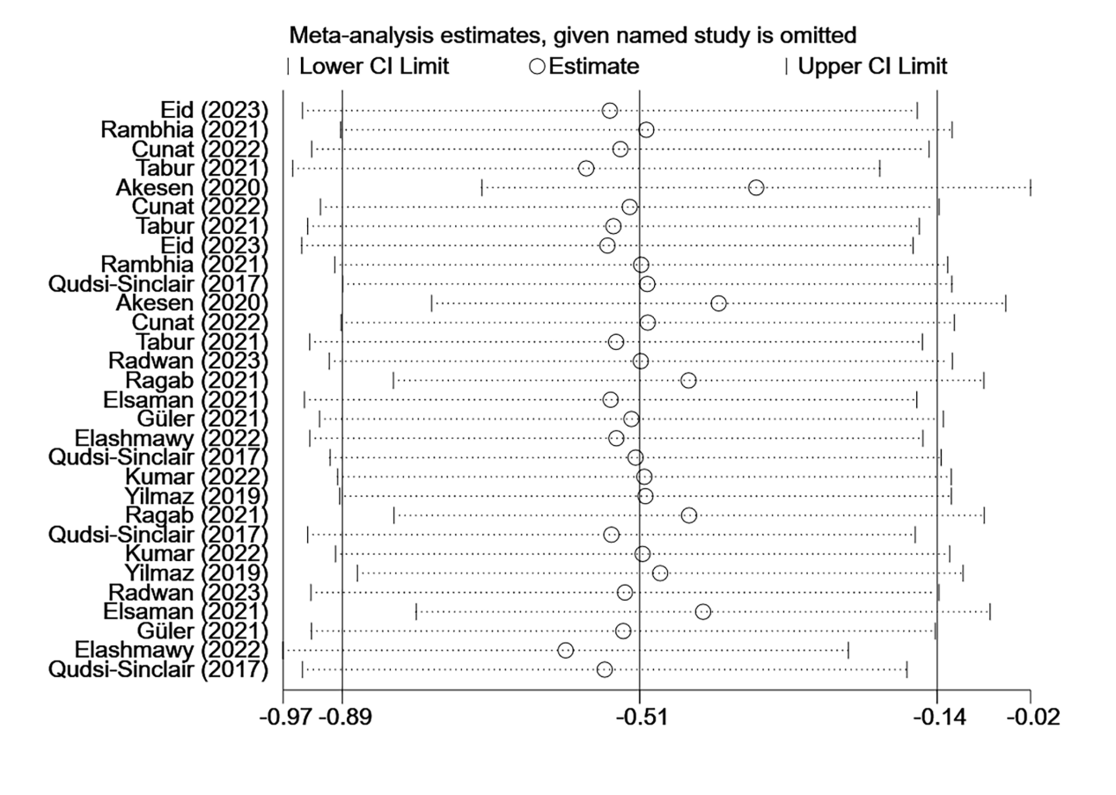
Sensitivity analysis at all time points

Supplementary Material S3
Forest plot of subgroup analysis
Control group
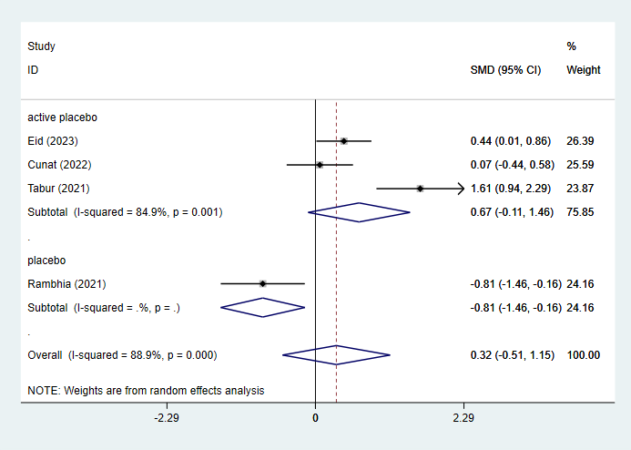
Subgroup analysis by control subgroup at 6 hours

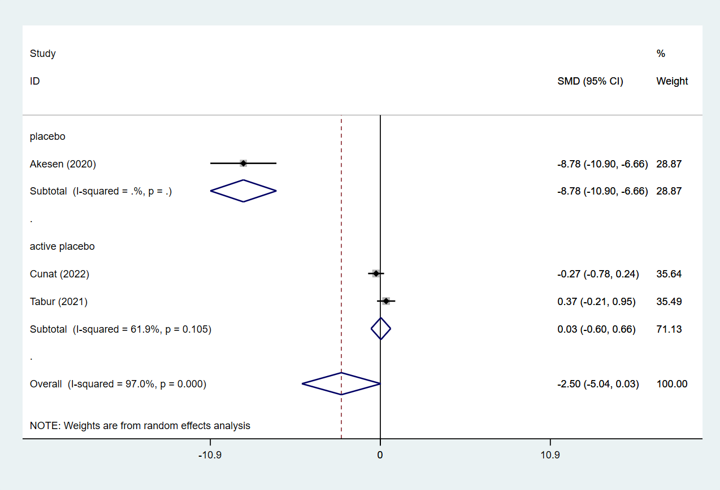
Subgroup analysis by control subgroup at 12 hours

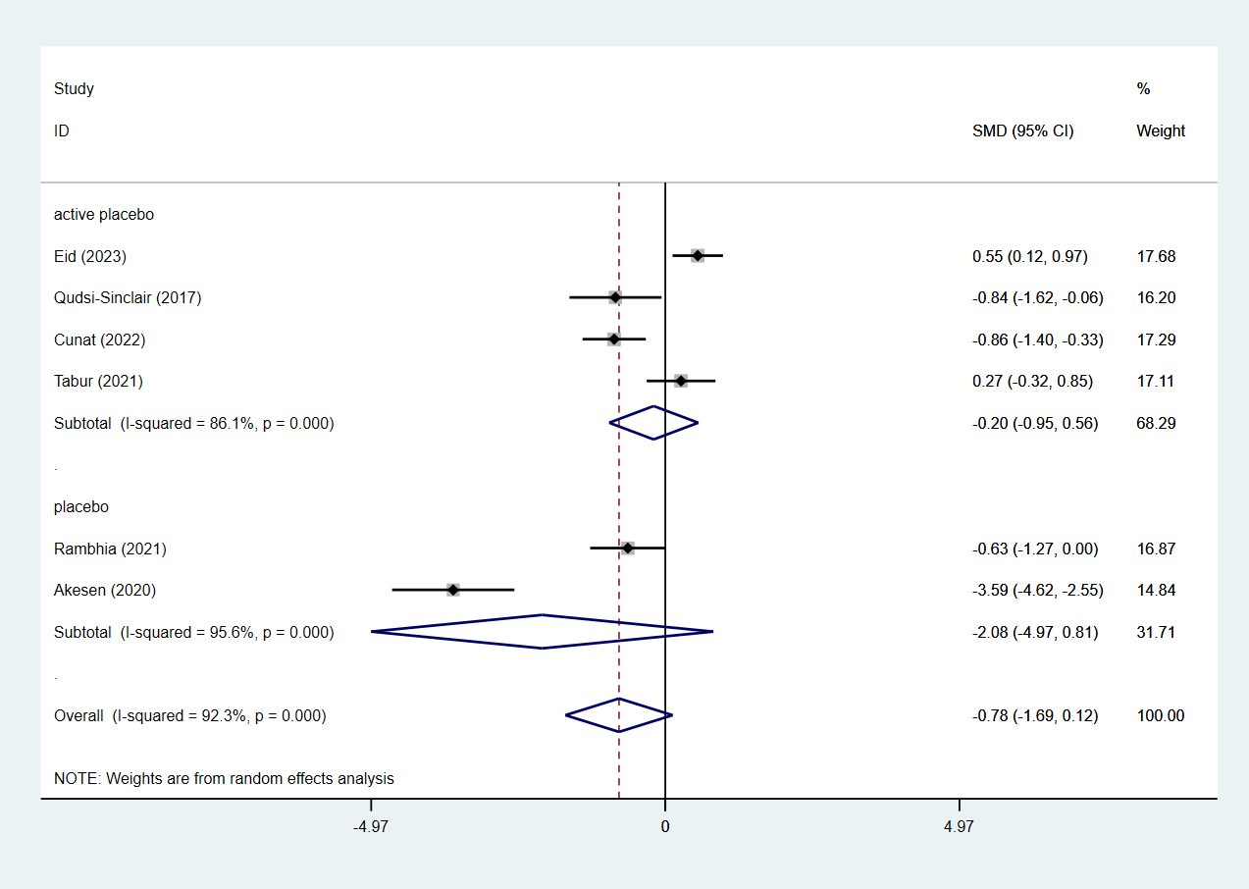
Subgroup analysis by control subgroup at 24 hours

Diagnoses
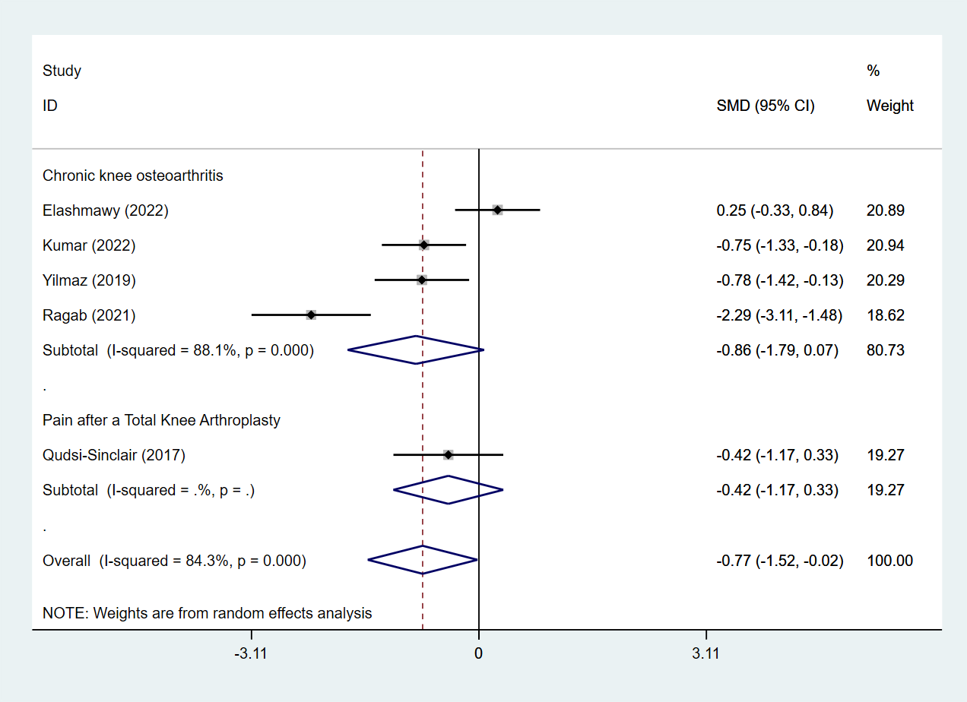
Subgroup analysis by diagnoses at 1 month

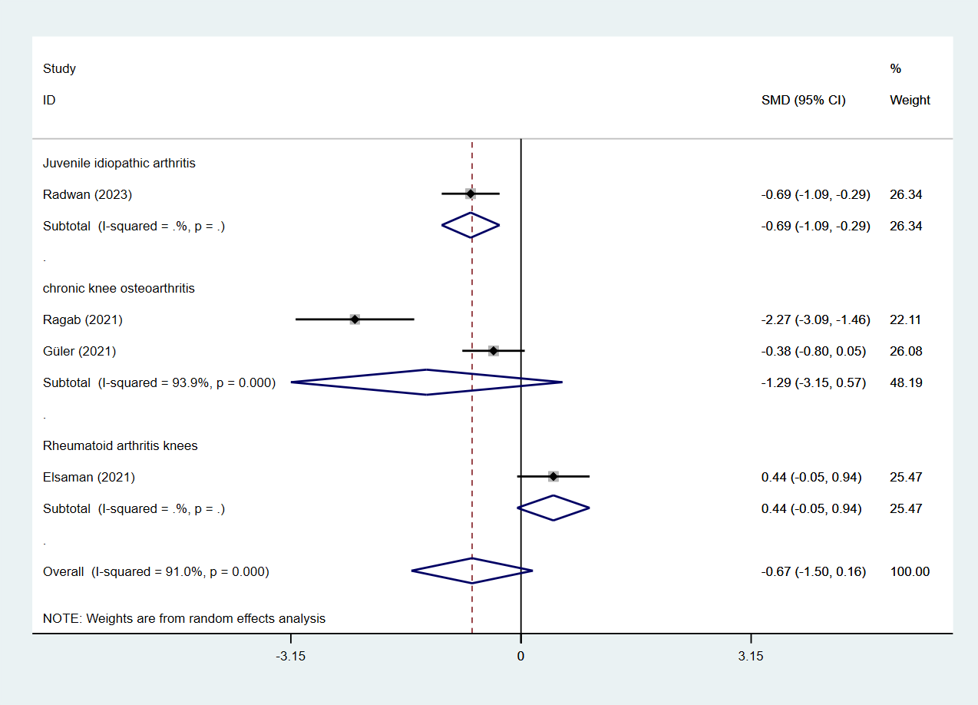
Subgroup analysis by diagnoses at 2 weeks

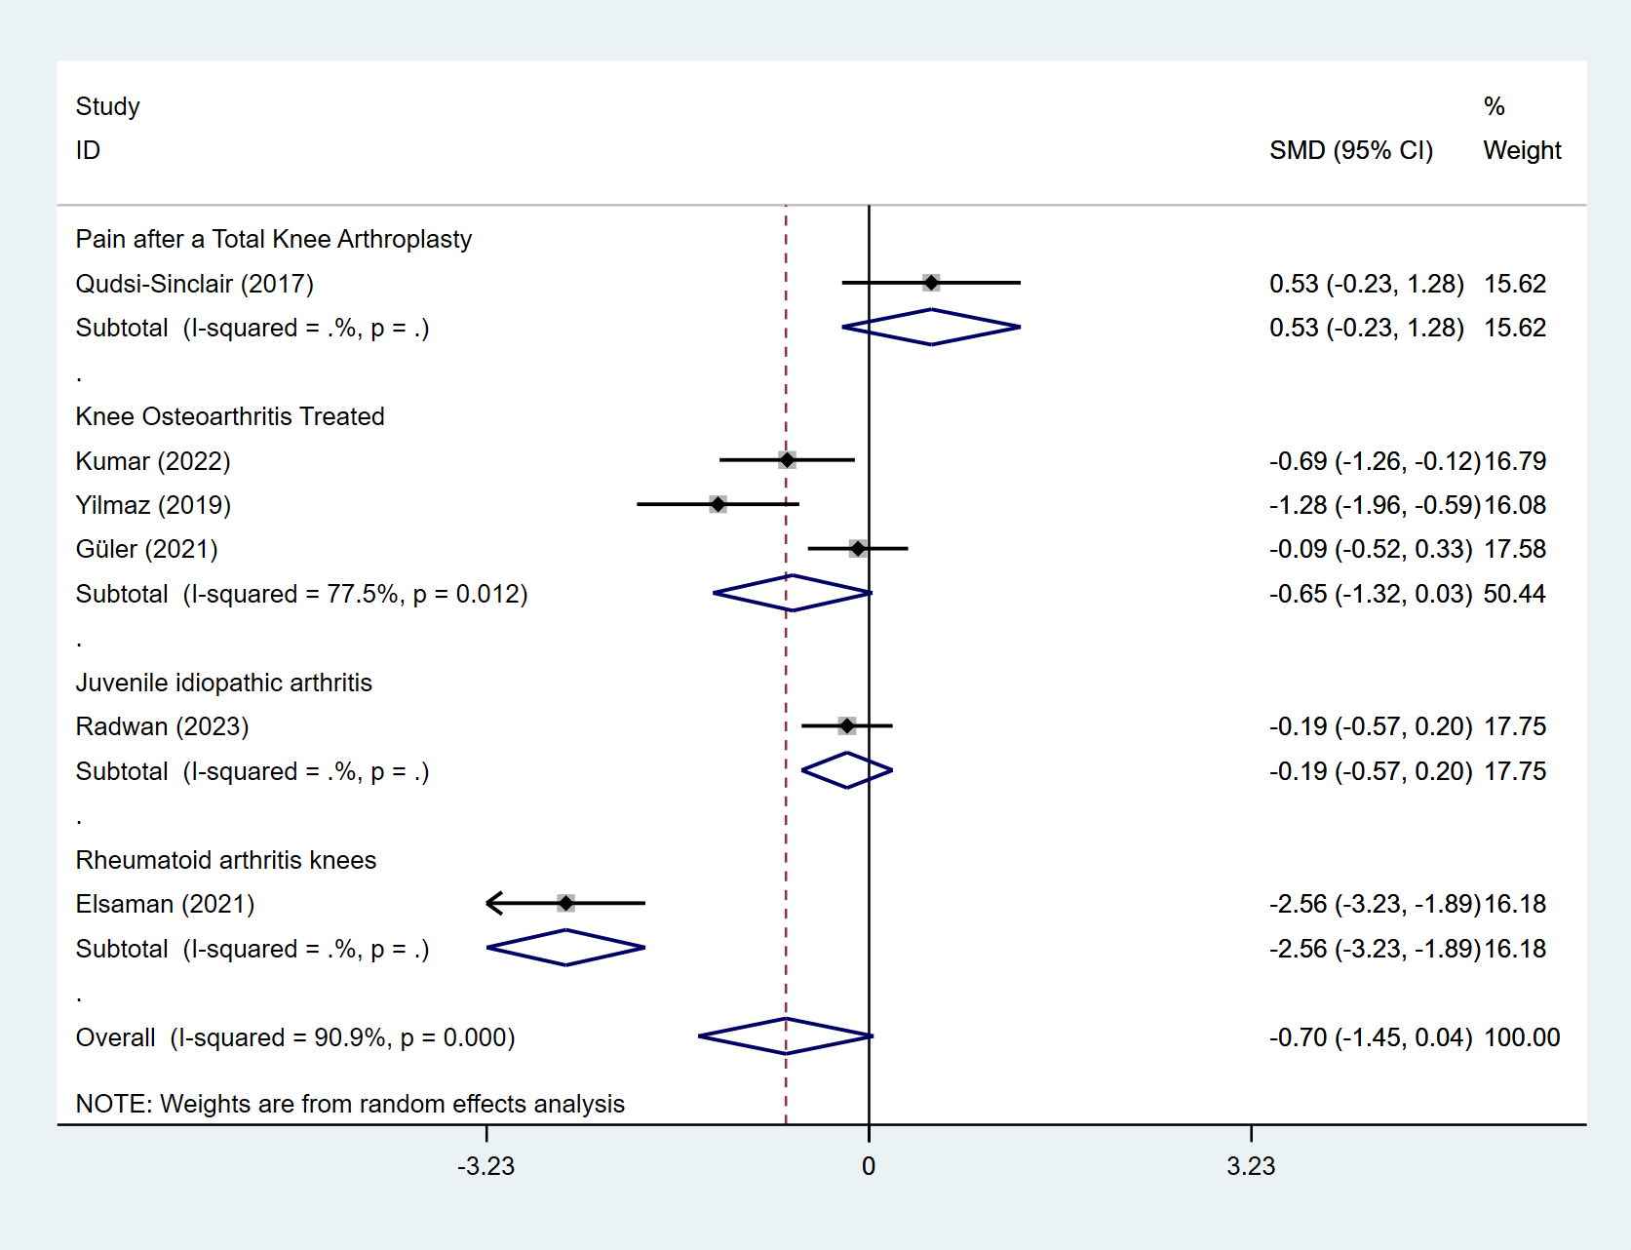
Subgroup analysis by diagnoses at 3 months

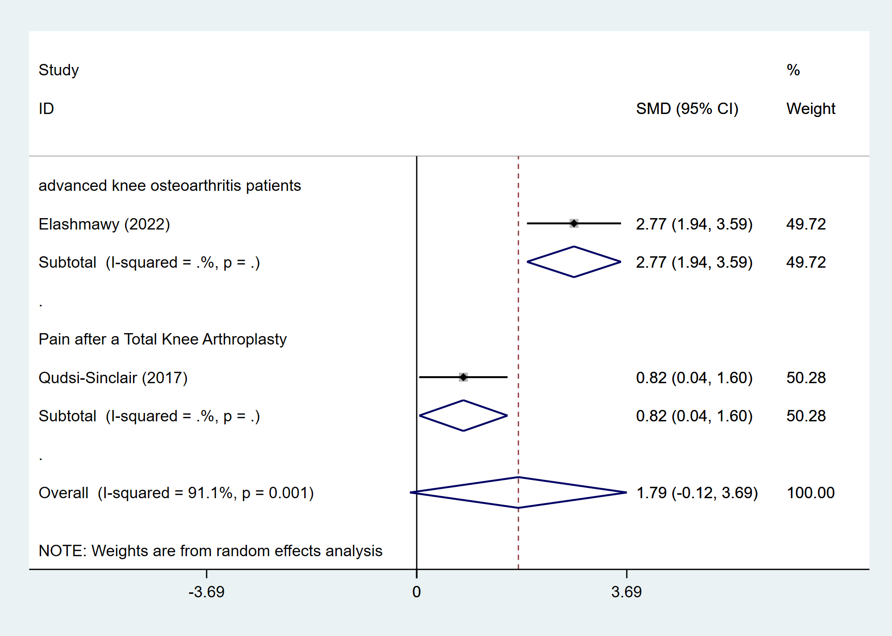
Subgroup analysis by diagnoses at 6 months

Drugs
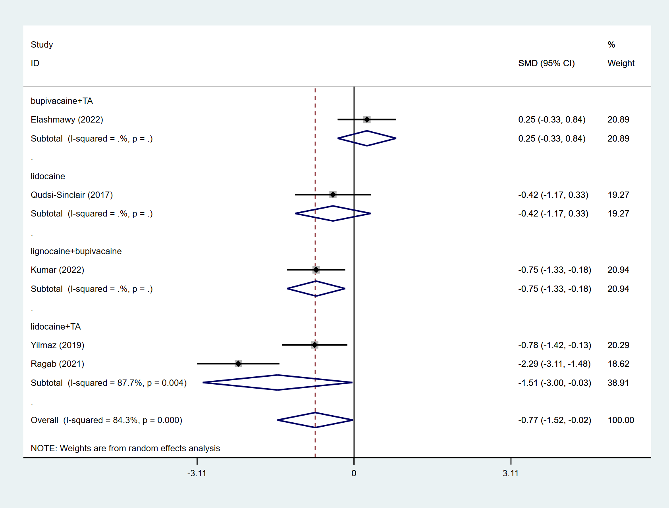
Subgroup analysis by drugs at 1 month

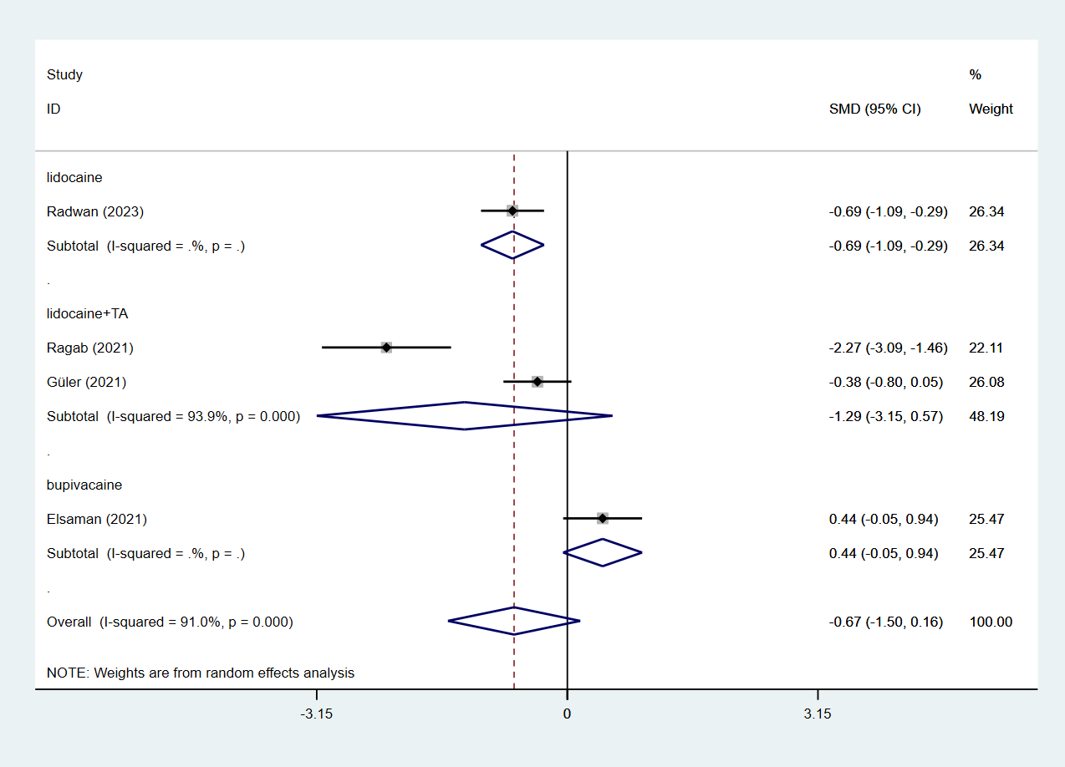
Subgroup analysis by drugs at 2 weeks

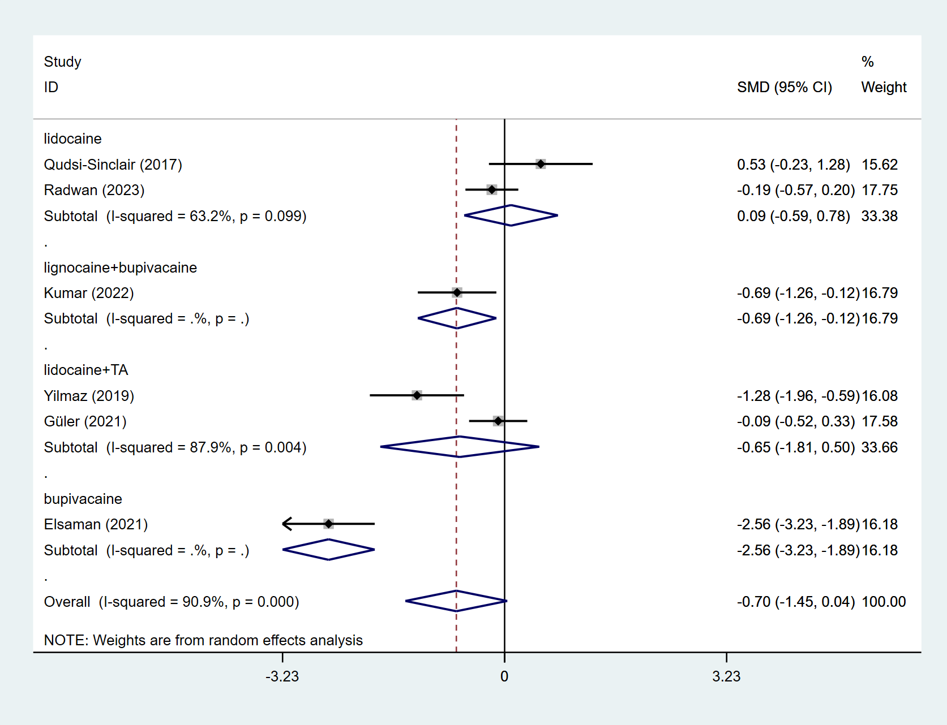
Subgroup analysis by drugs at 3 months

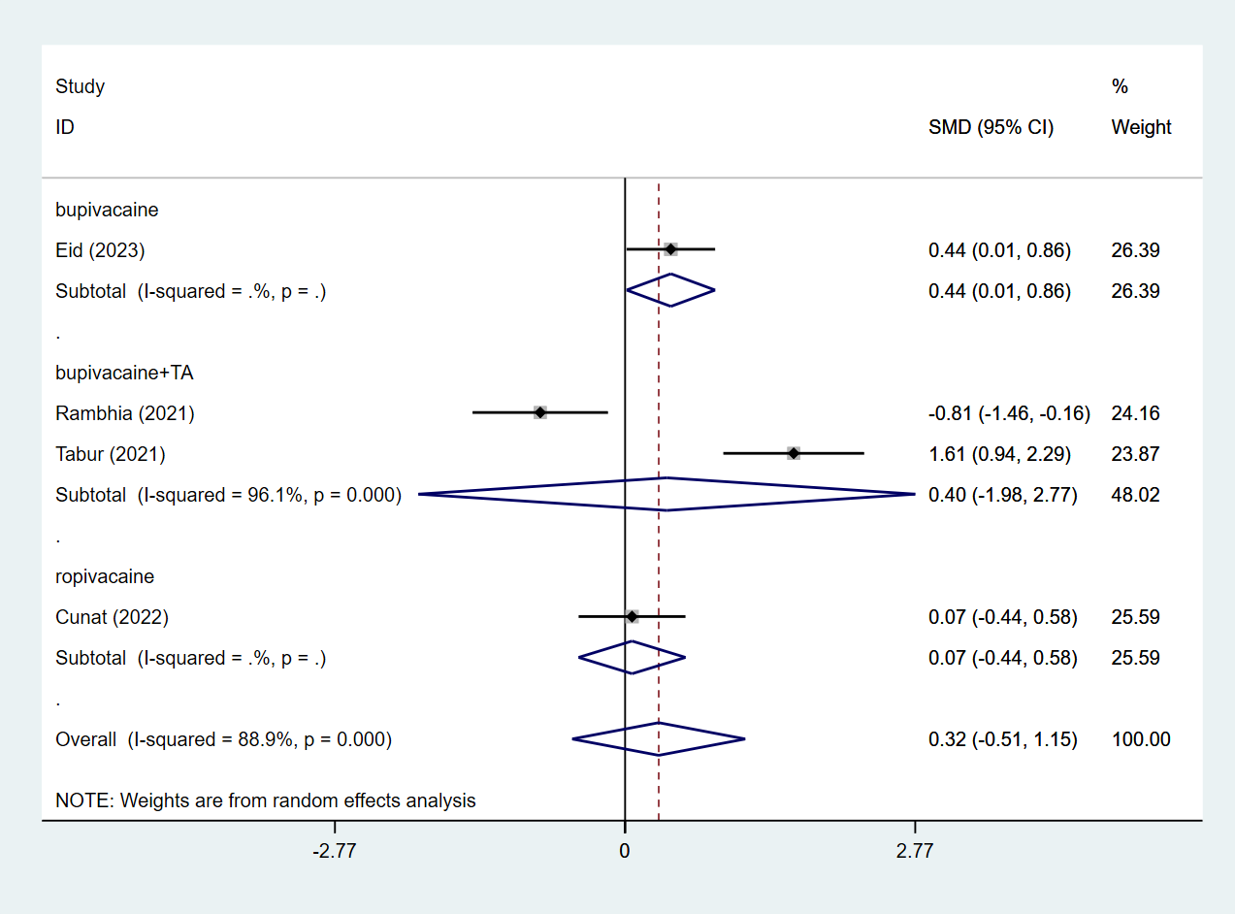
Subgroup analysis by drugs at 6 hours

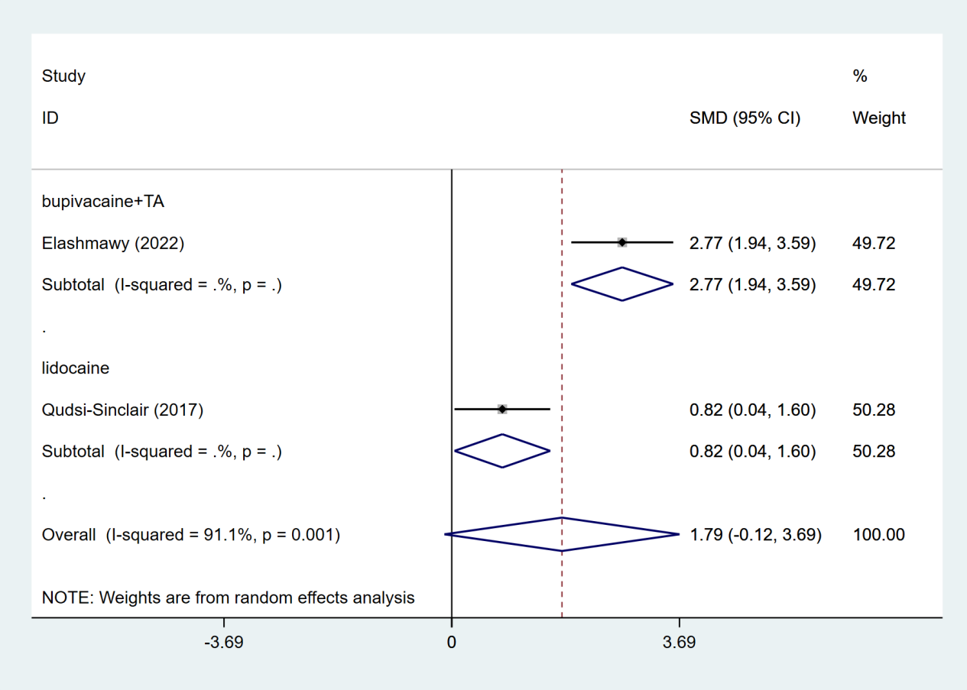
Subgroup analysis by drugs at 6 months

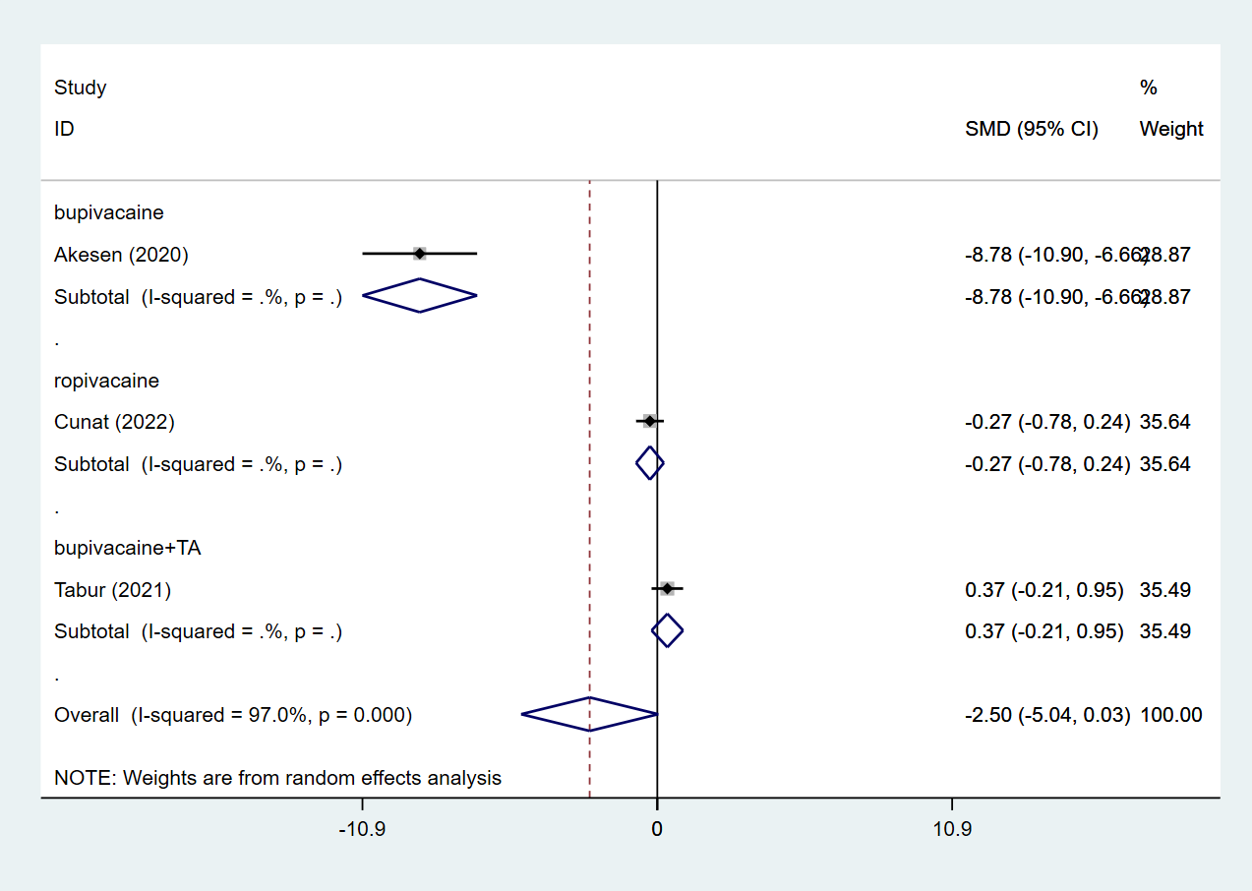
Subgroup analysis by drugs at 12 hours

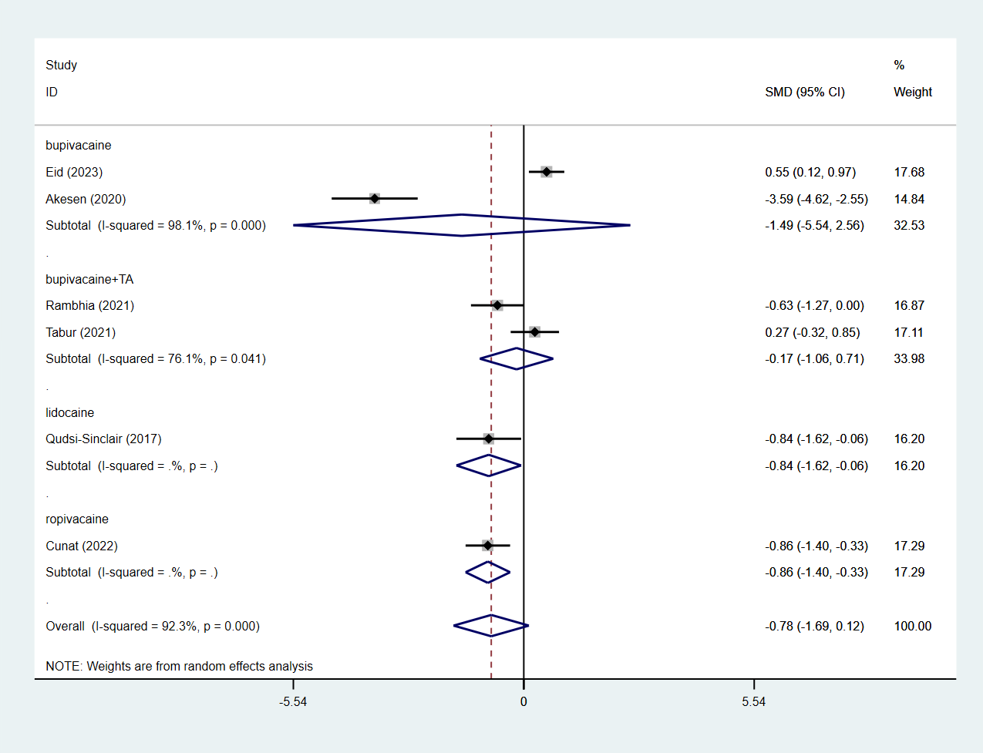
Subgroup analysis by drugs at 24 hours

Scales
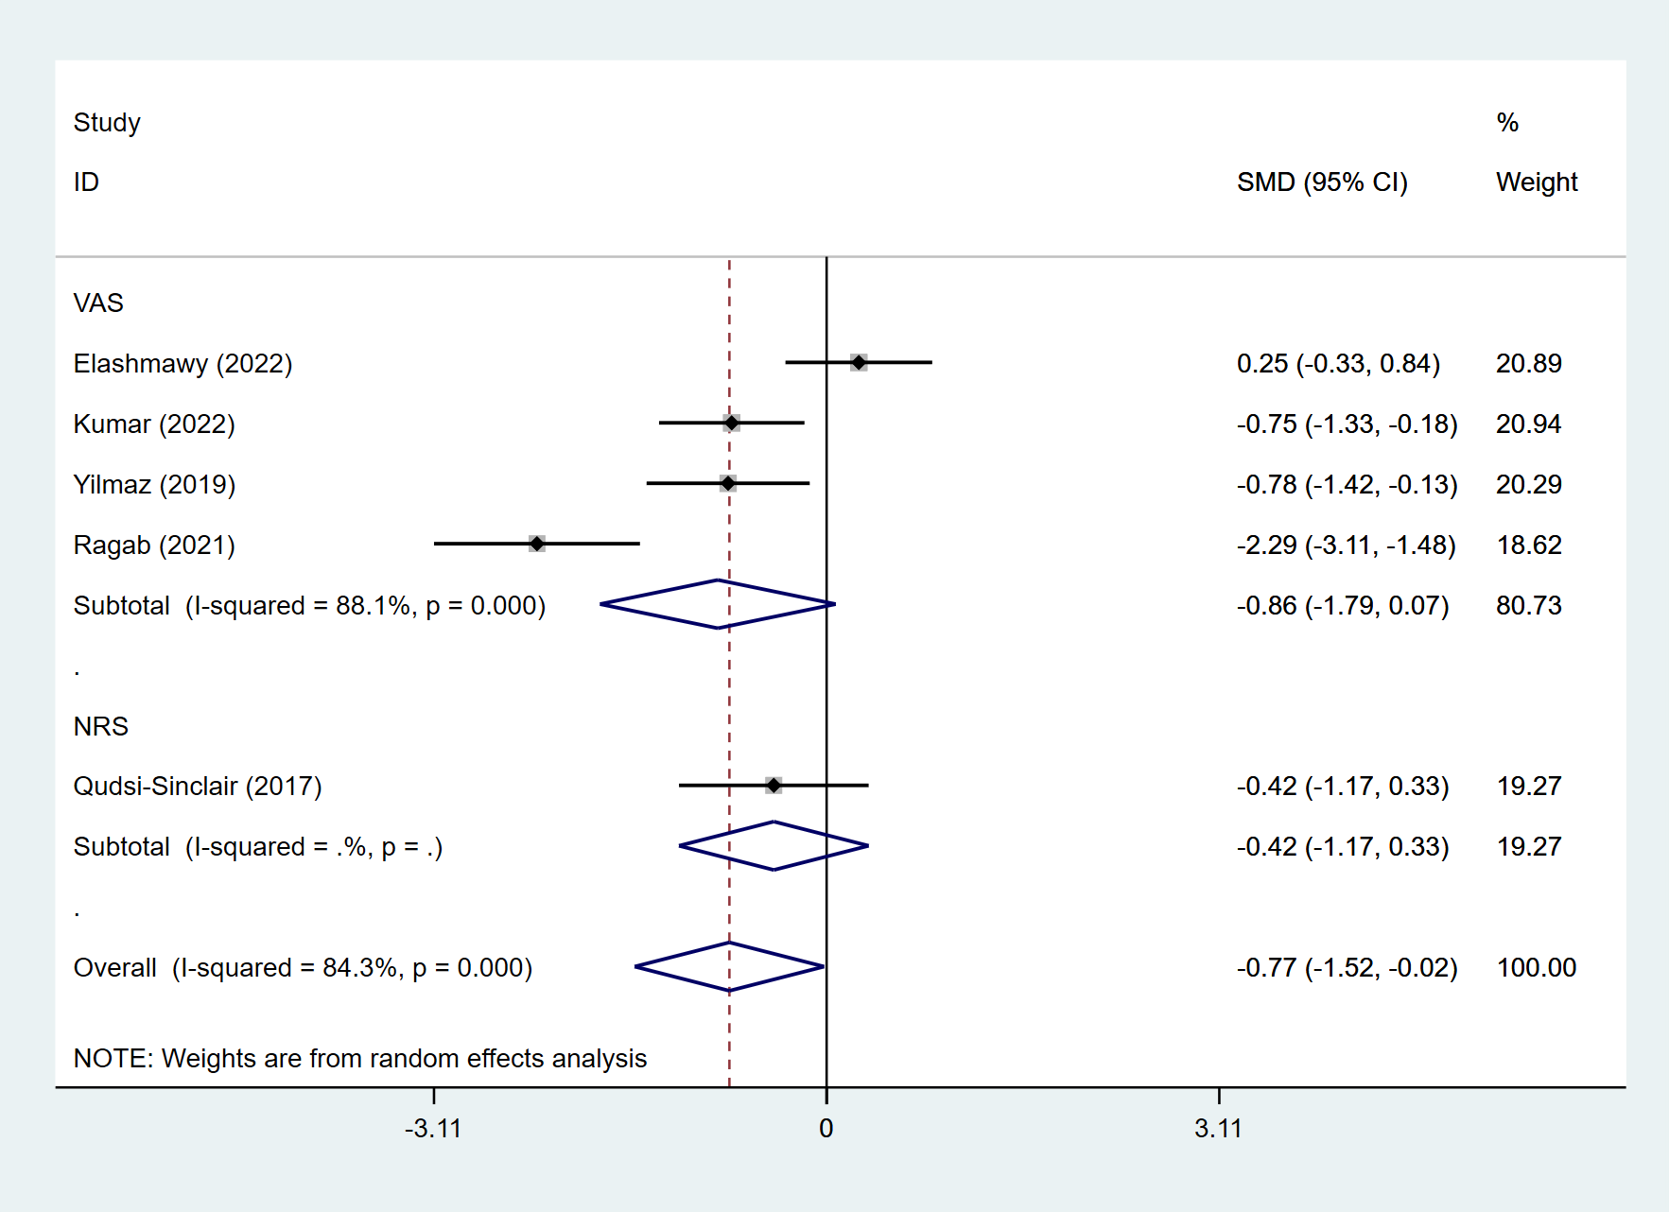
Subgroup analysis by scales at 1 month

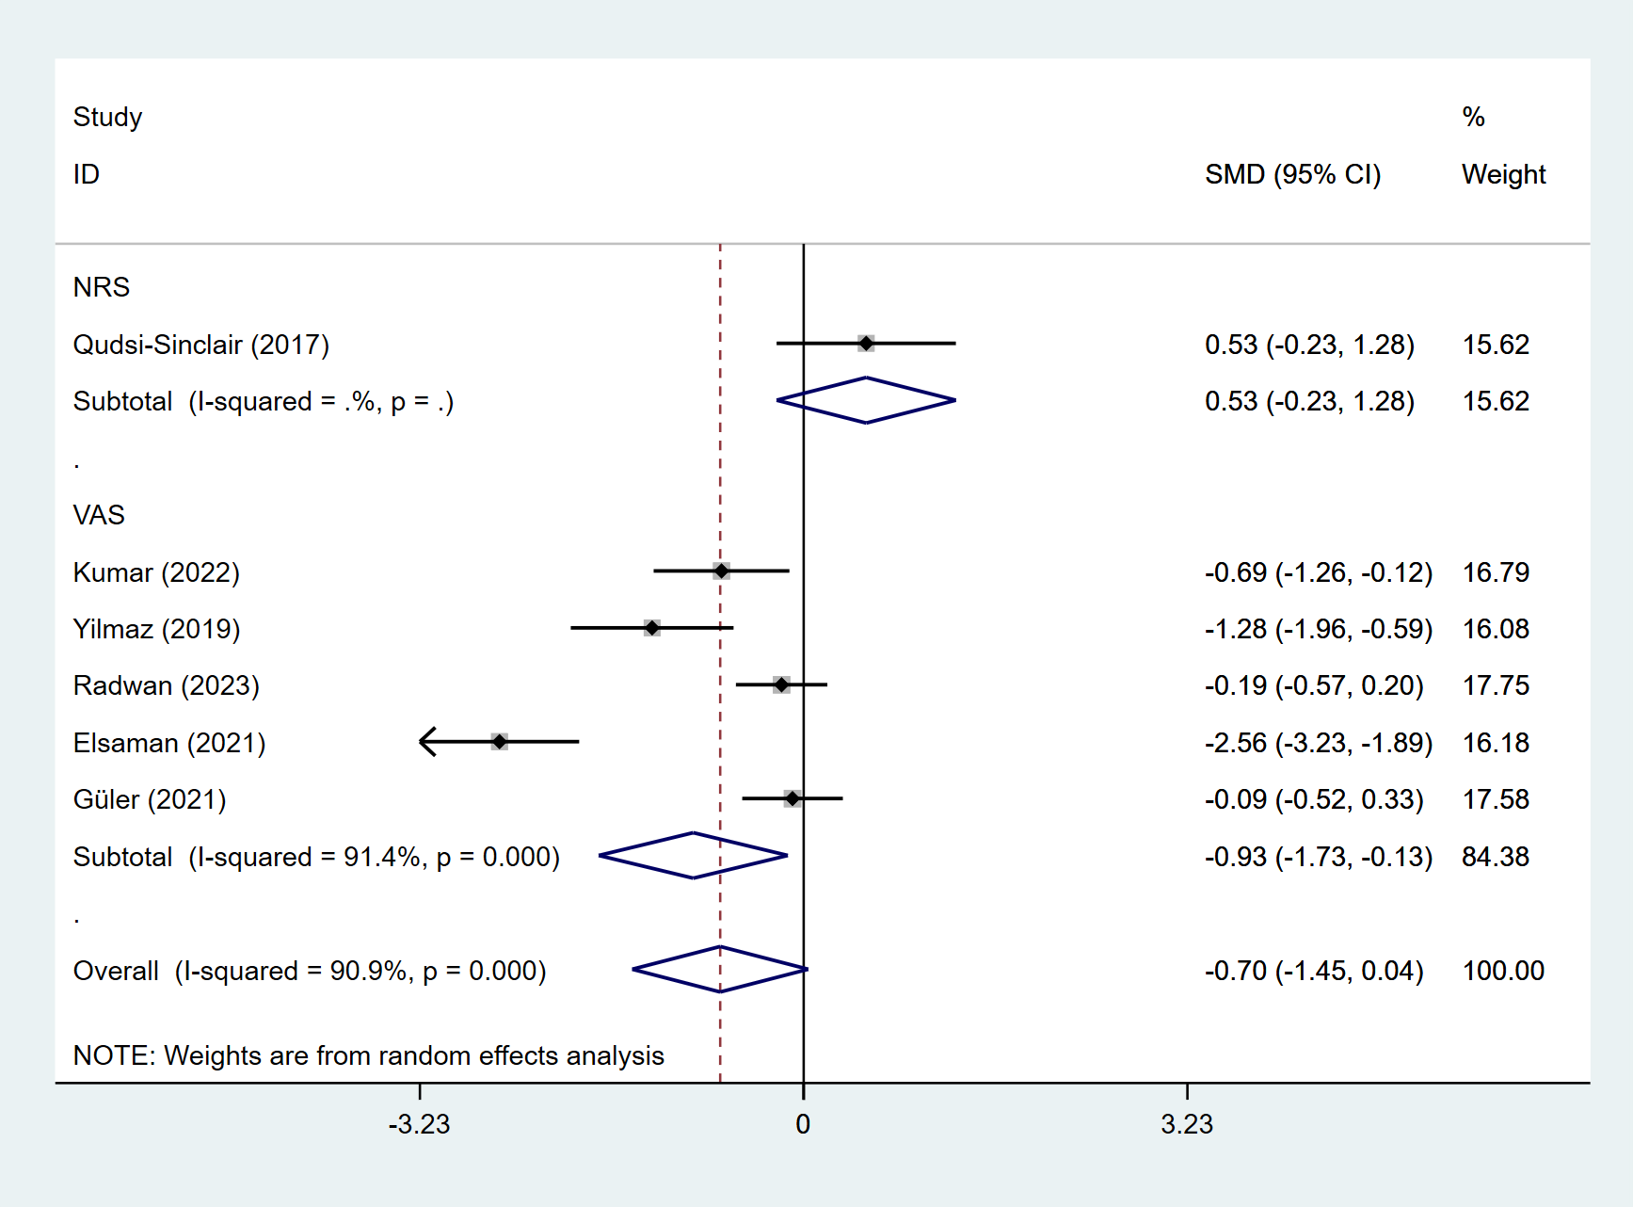
Subgroup analysis by scales at 3 months

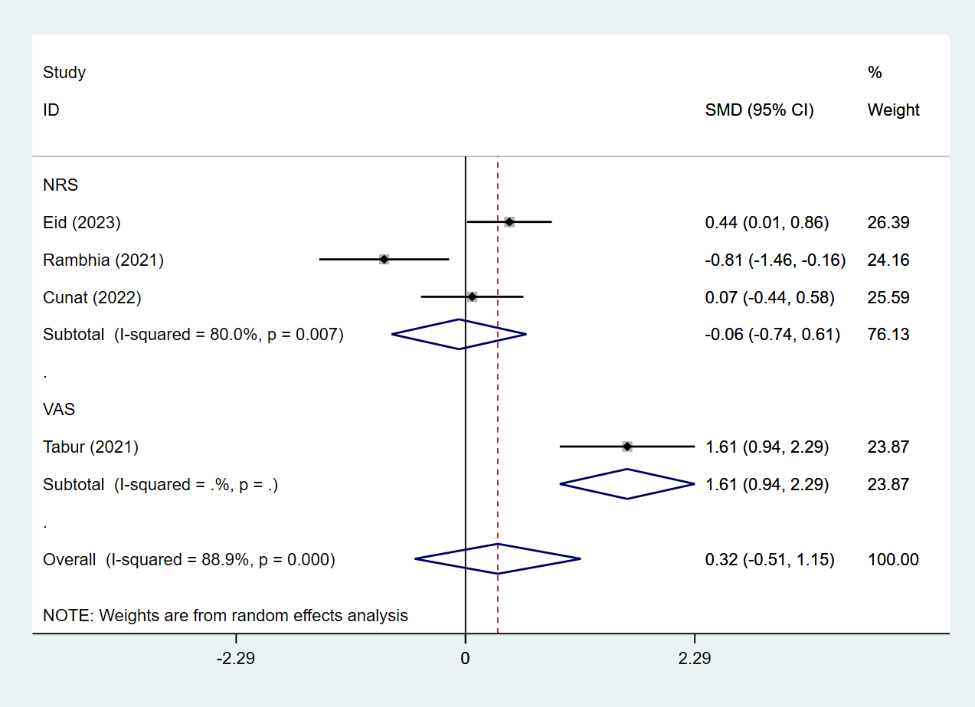
Subgroup analysis by scales at 6 hours

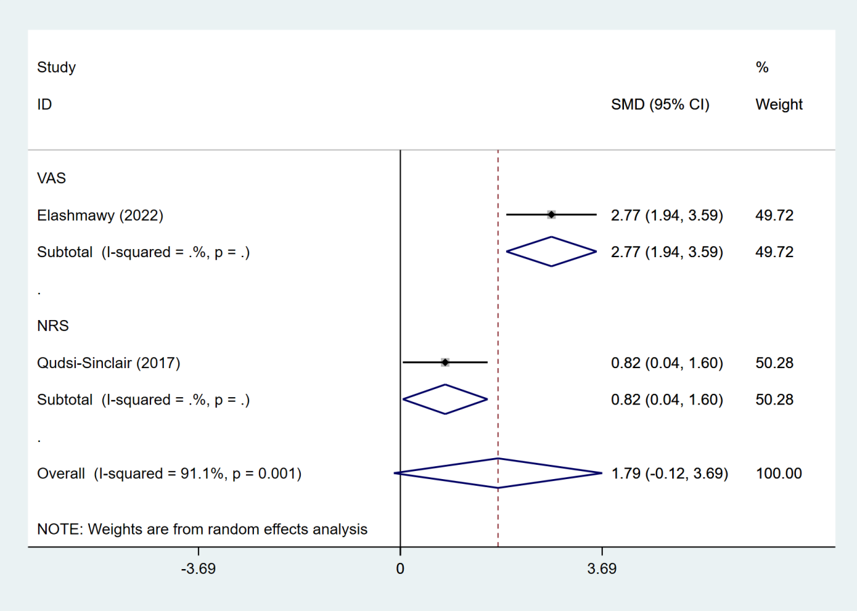
Subgroup analysis by scales at 6 months

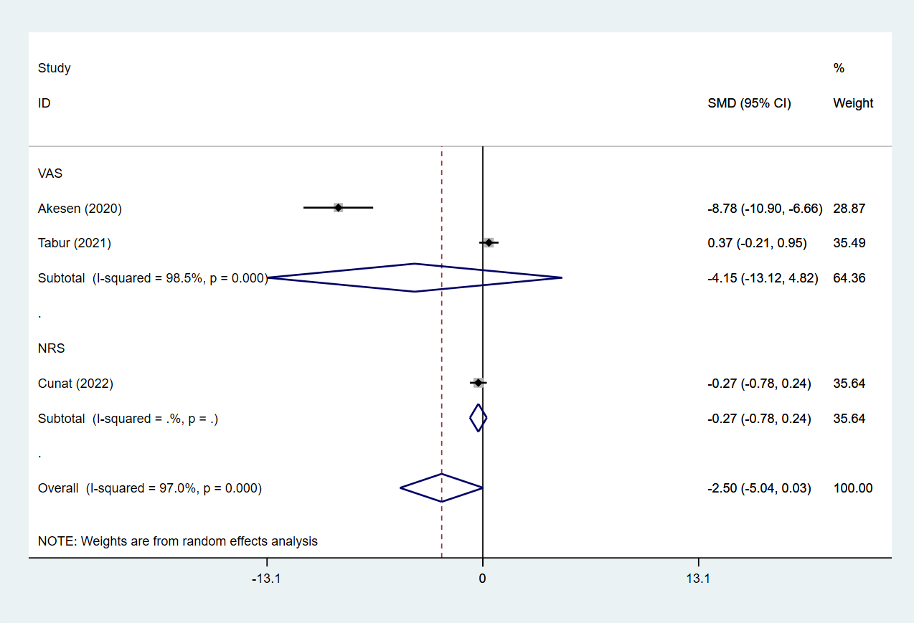
Subgroup analysis by scales at 12 hours

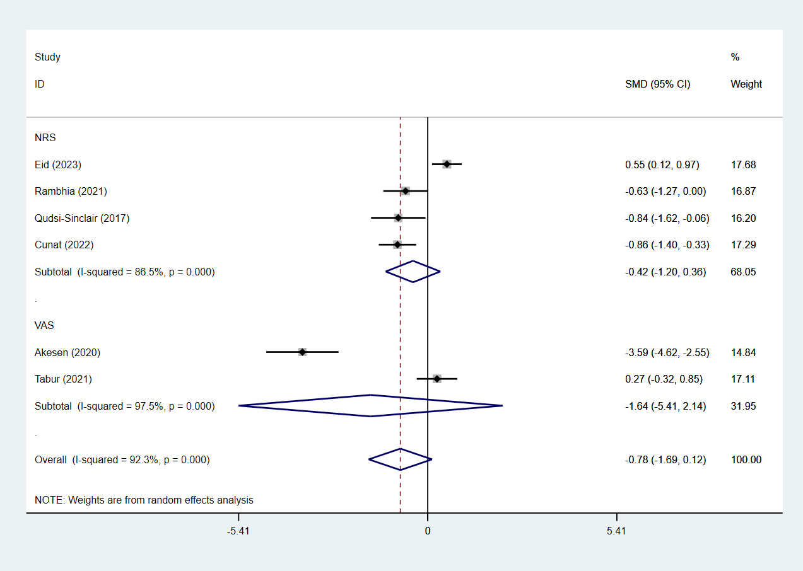
Subgroup analysis by scales at 24 hours

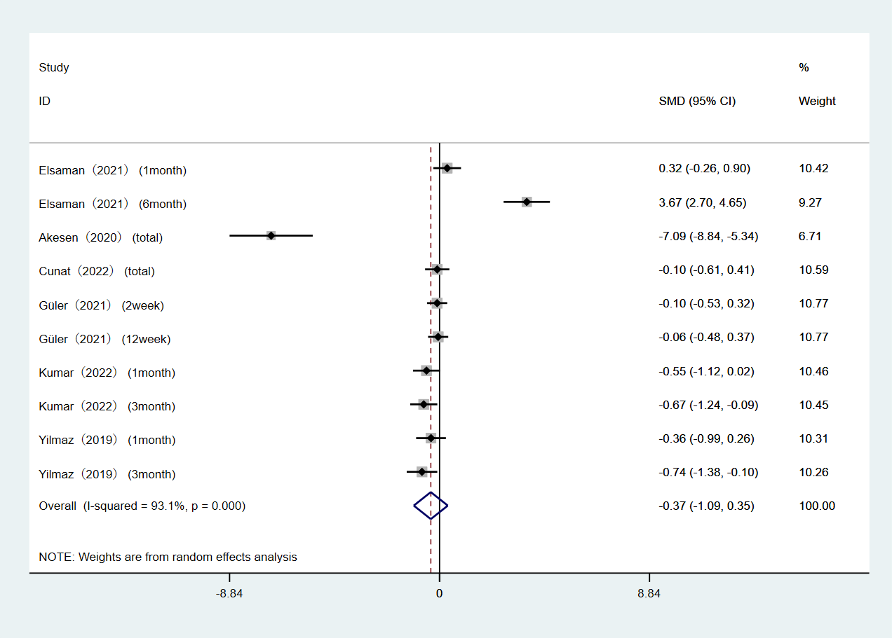
Forest plot for WOMAC

