Supporting Information
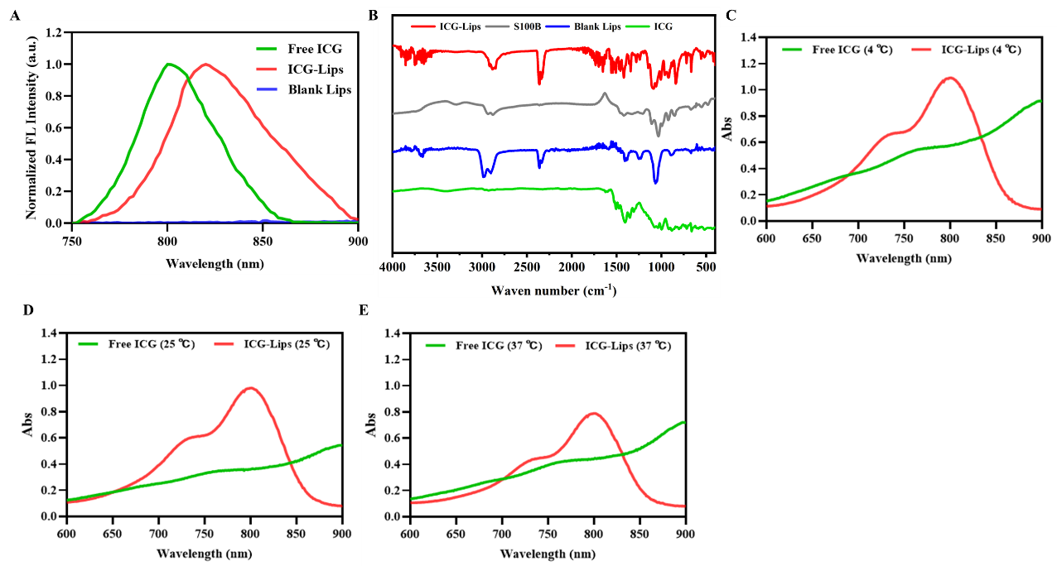
Figure S 1. (A) Fluorescence (FL) spectra of free ICG, blank liposomes, and ICG-Lips. (B) FTIR spectra of ICG, blank liposomes, streptavidin-conjugated S100B antibody, and ICG-Lips. (C-E) Stability determination of free ICG and ICG-Lips. (A-C) UV-Vis spectra of free ICG and ICG-Lips at day 13 at different storage temperatures.

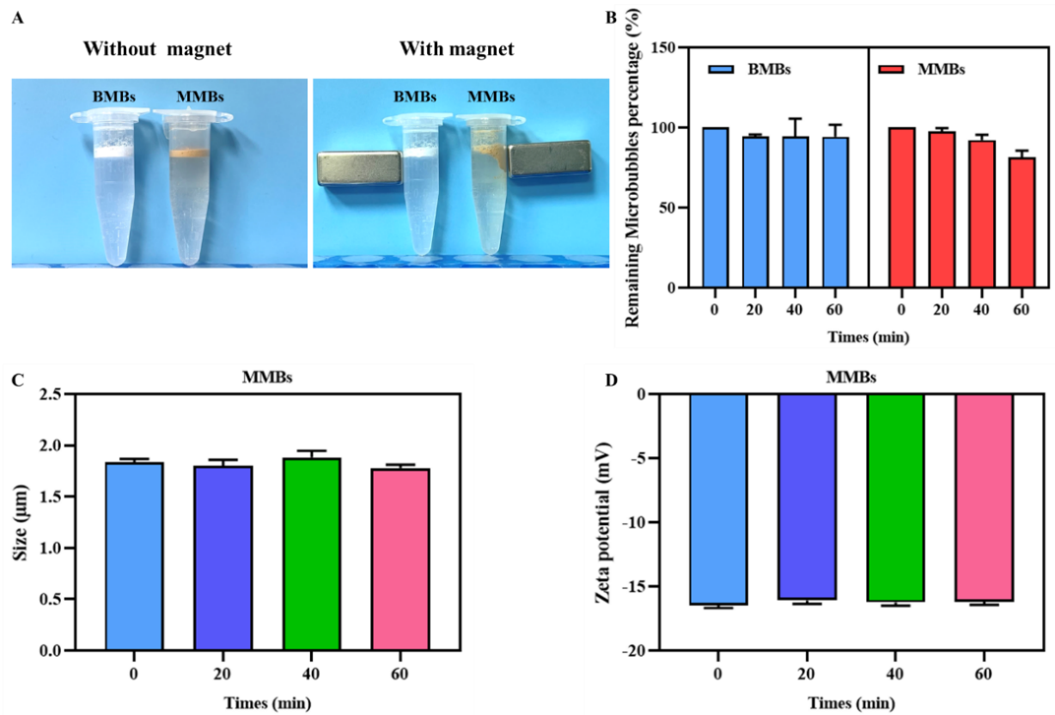
Figure S 2. (A) Optical images of the prepared biotinylated MBs and magnetic MBs in the absence and presence of a magnet. (B) The remaining percentage of MMBs with default timepoints. (C) The particle size distribution of MMBs changes at different timepoints. (D) The zeta potential of MMB at different timepoints.
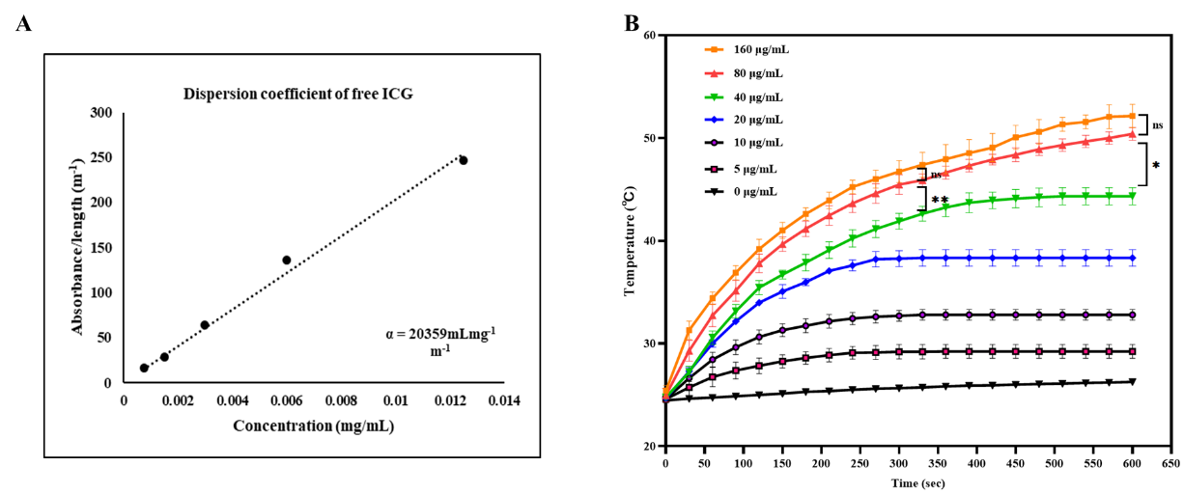 Figure S 3. (A) The dispersion coefficient of free ICG. (B) Temperature elevation of ICG-Lips at the different concentrations with NIR Laser irradiation (808 nm, 2.0 W/cm², 10 min). ns: not significant (p > 0.05), *p<0.05, compared to the free ICG group.

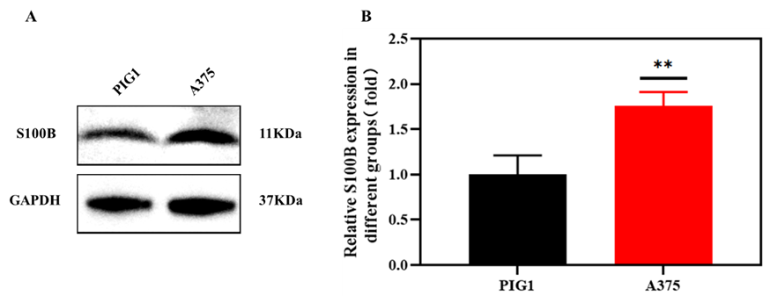
Figure S 4. (A)Western blotting analysis of S100B expression of PIG1 cells and A375 cells. (B) is the quantitative value of (A). **p<0.01, compared to the PIG1 group.

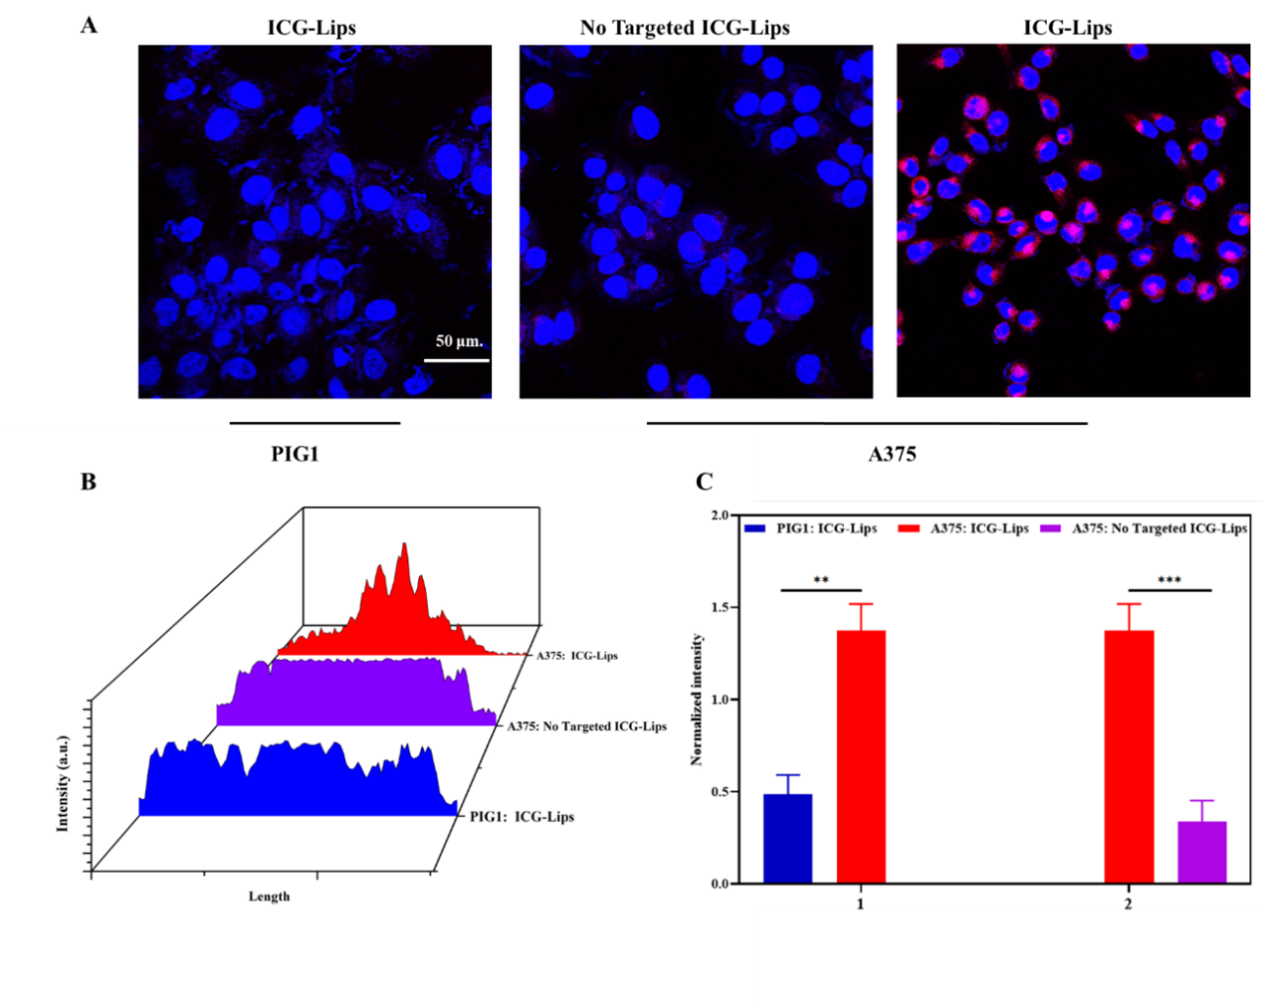Figure S 5. (A) Internalization of ICG-Lips and non-targeted ICG liposomes by A375 and internalization of ICG-Lips by PIG1 cells; (B) is a visualization of the different internalization scenarios in (A); and (C) Quantitative results of fluorescent intensity of internalized particles in (A). Targeted ICG-Liposomes: ICG-Lips; No Targeted ICG-Liposomes: No Targeted ICG-Lips. Scale bar: 50μm. **p<0.01, ***p<0.001, compared to the ICG-Lips (PIG1) group/ No Targeted ICG-Lips (A375) group.

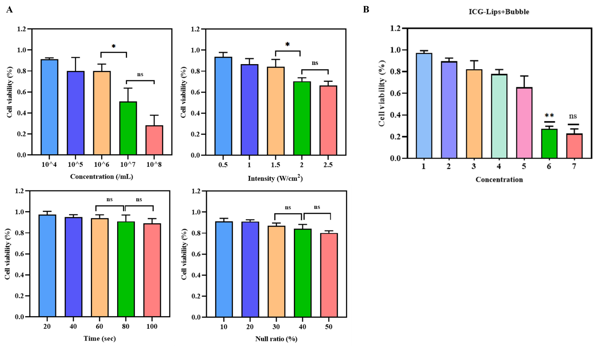 Figure S 6. (A) Cell viability of A375 cancer cells at different MMBs concentrations, different US interaction intensity, different time of US interaction and different duty cycles. (B) Cell viability of A375 cells co-incubated with MMBs and different concentrations of ICG-Lips and treated with US combination laser irradiation. (1: 2.5 μg/mL (ICG)+10⁶/mL (Bubble); 2: 5 μg/mL (ICG)+10⁶/mL (Bubble); 3: 10 μg/mL (ICG)+10⁶/mL (Bubble); 4: 20 μg/mL (ICG)+10⁶/mL (Bubble); 5: 40 μg/mL (ICG)+10⁶/mL (Bubble); 6: 80 μg/mL (ICG)+10⁶/mL (Bubble); 7: 160 μg/mL (ICG) +10⁶/mL (Bubble). ns: not significant (p > 0.05), *p<0.05, **p<0.01, comparison between groups.

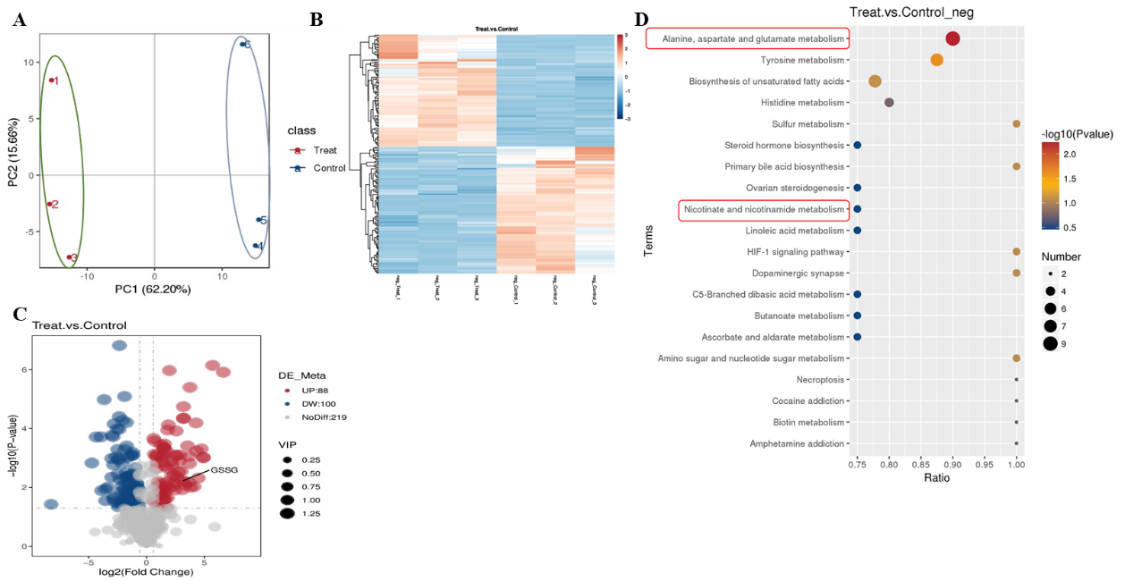
Figure S 7. (A) PCA score plot showing differences between the control and synergistic treatment group of A375 cells. (B) Heat map of metabolites in each treatment group. (C)Volcano plot demonstrating altered metabolite levels between the control and synergistic treatment groups. (D) Pathway analysis of significant differential metabolites between the control and synergistic treatment groups. Ion mode: negative.

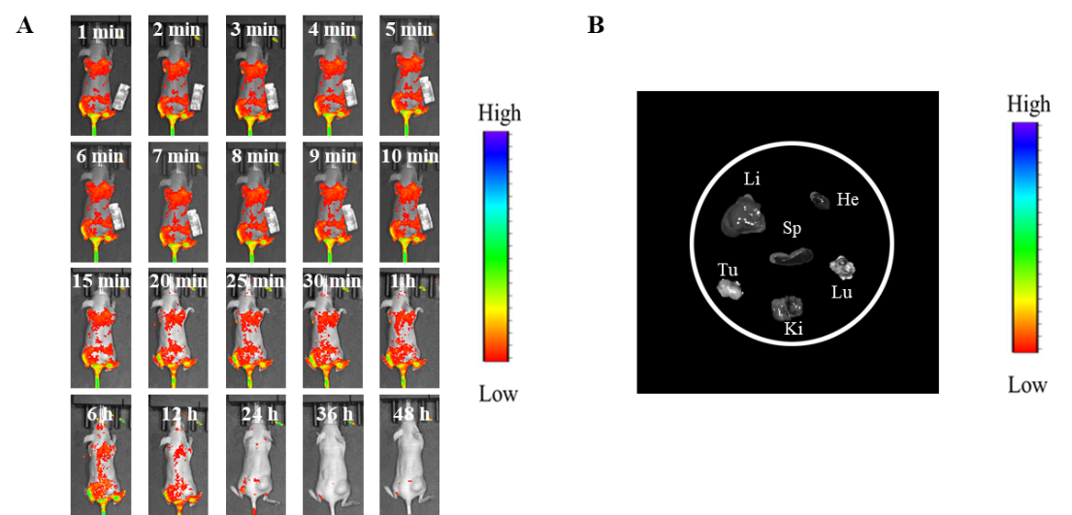
Figure S 8. (A) In vivo fluorescent images at default timepoints of A375-bearing tumor mice intravenously administered with DIR-labelled MMBs. (B) Ex vivo biodistribution imaging of MMBs 48 h after post-injection.

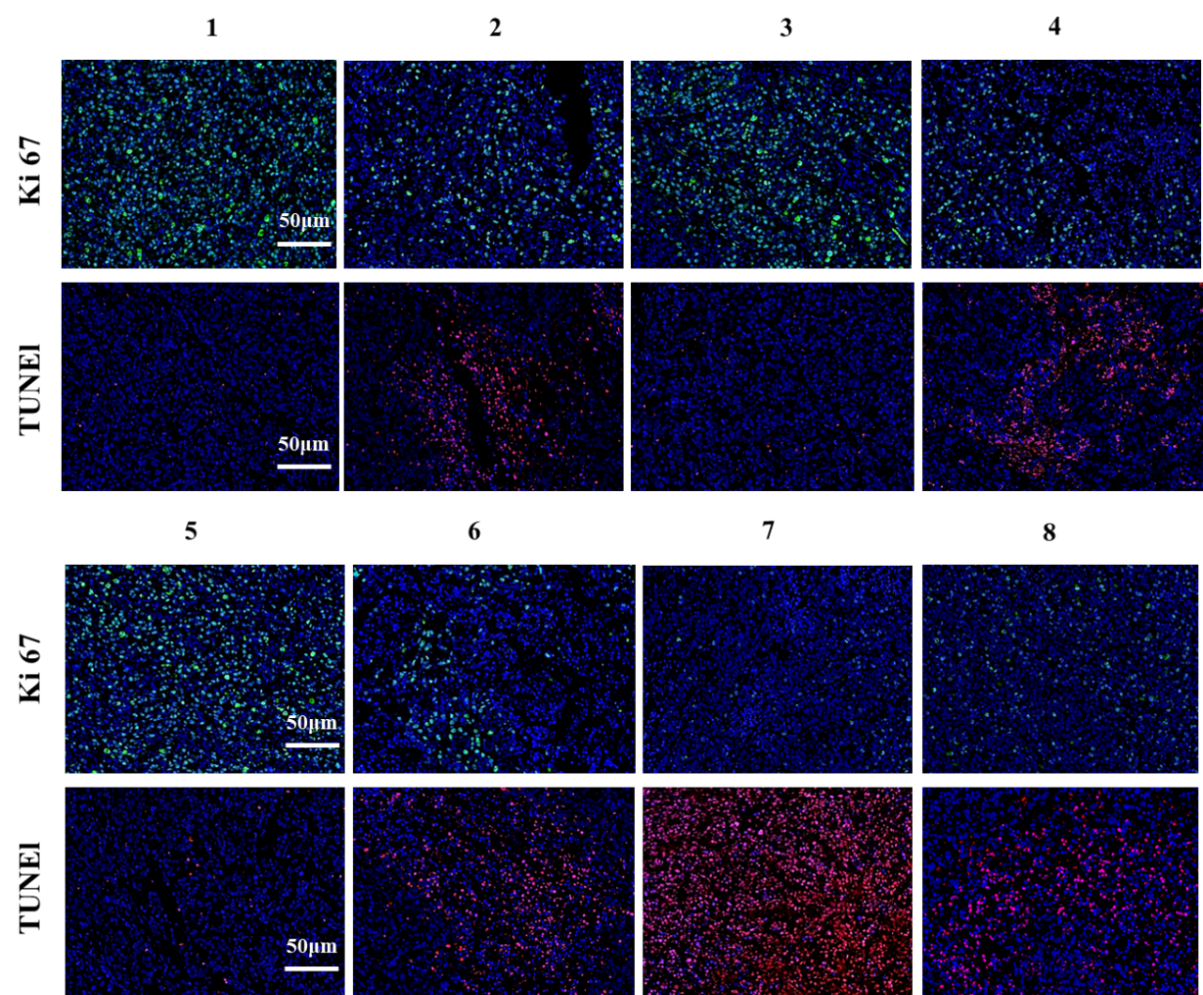
Figure S 9. Fluorescent staining of Ki 67 and TUNEL of the mice with different treatments. (n = 4, 1: PBS group (control); 2: free ICG + US + laser group; 3: MMBs + US + laser group; 4: ICG-Lips + US + laser group; 5: ICG-Lips + MMBs + US group; 6: ICG-Lips + MMBs + laser group; 7: ICG-Lips + MMBs + US + laser group (synergistic treatment group) and 8: ICG-Lips + MMBs + US + laser + Fer-1 group)

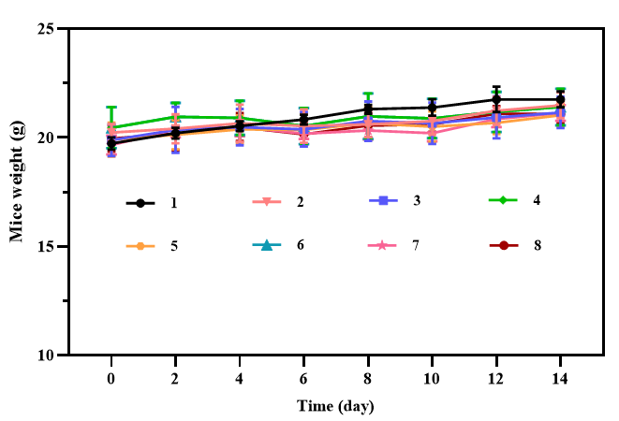
Figure S 10. Mean body weights of different groups of mice during therapy. Grouping is the same as Figure S 9.

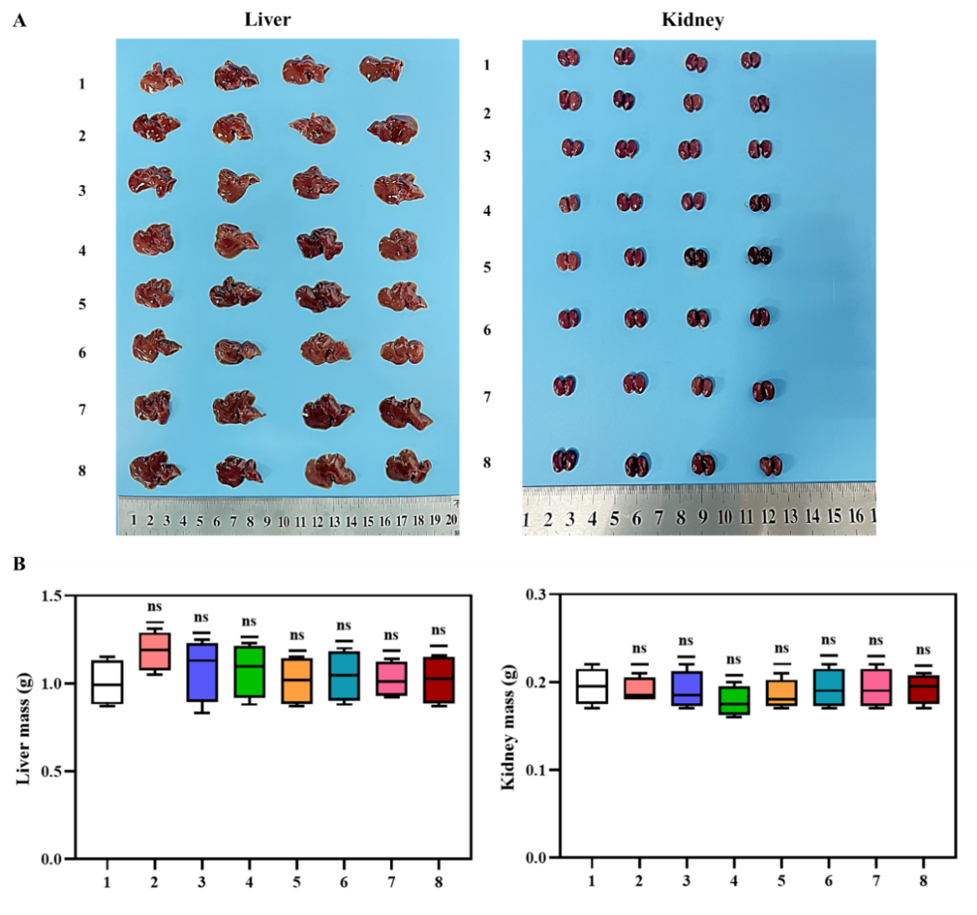
Figure S 11. (A) Captured liver and kidney of mice at the end of treatment from groups; (B) Mass weight of the liver and kidney. Grouping is the same as Figure S 9.

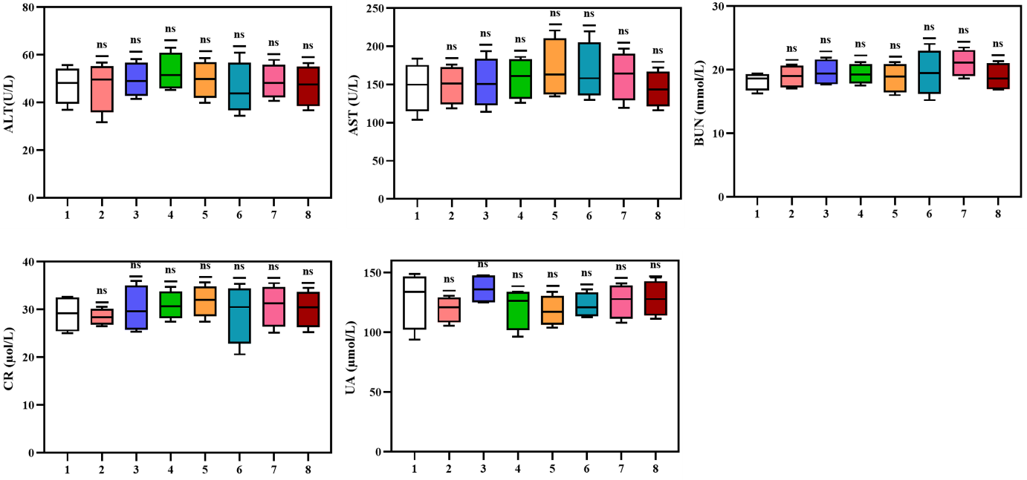
Figure S 12. Blood biochemical parameter measurements after different treatments. Grouping is the same as Figure S 9.

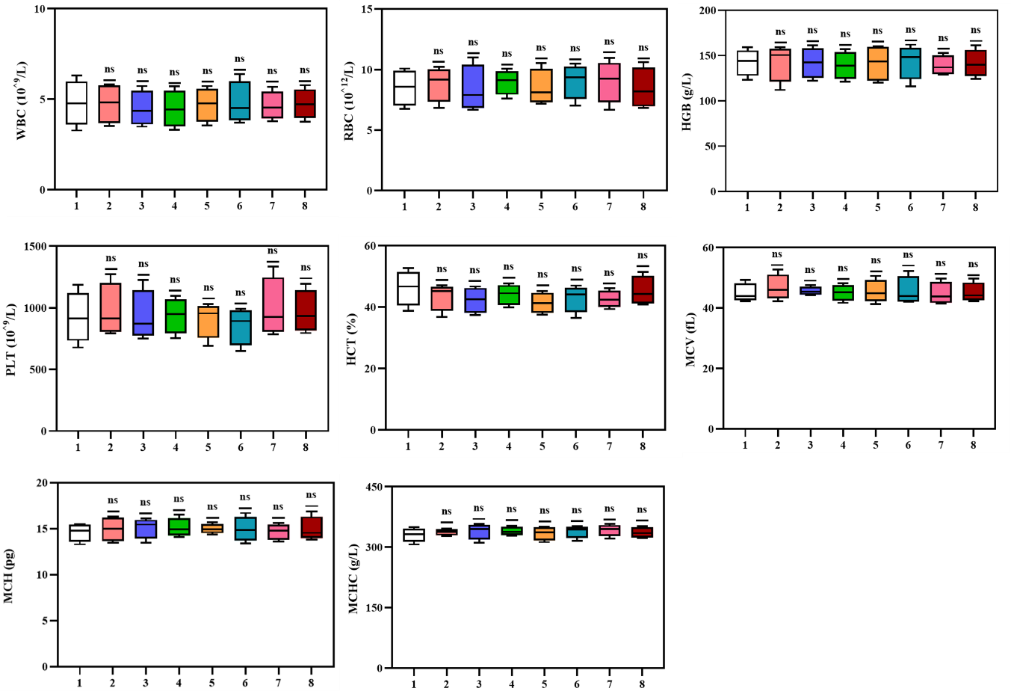
Figure S 13. Blood routine parameters analysis after different treatments. Grouping is the same as Figure S 9.

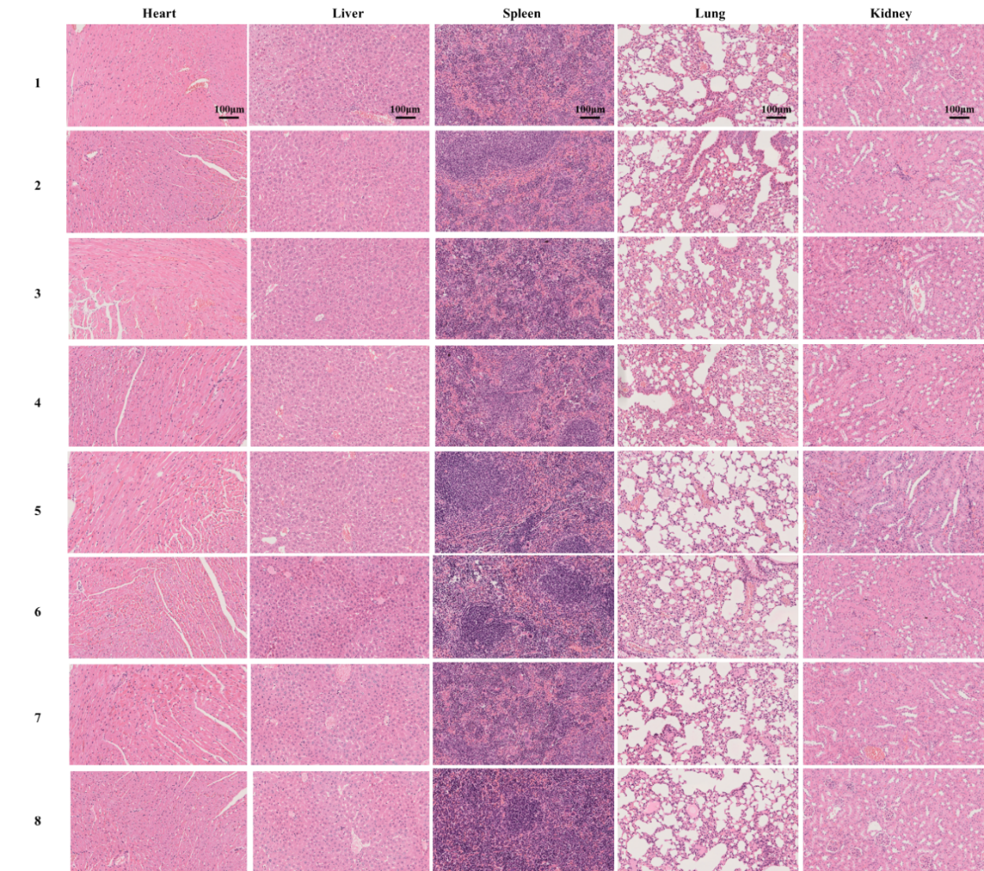
Figure S 14. H&E staining of the major organs at the end of the various treatments. Scale bar: 100 μm. Grouping is the same as Figure S 9.

Table S 1. The particle size, polydispersity index (PDI), and zeta potential of ICG-Lips and MMBs.
Samples | Size (nm) | PDI | Zeta potentials (mV)
ICG-Lips | 180 ± 2.2 | 0.187 ± 0.10 | -22.2 ± 1.6
MMBs | 1855.3 ± 0.9 | 0.16 ± 0.1 | -16.4 ± 0.2
The data are presented as mean ± SD (n = 3)

Table S 2. Differential metabolites between control and ICG-Lips combined with MMBs groups in positive ion mode. (L-Glutathione oxidized (GSSG), an important indicator of ferroptosis, is highlighted in bold in the table).
Name | Formula | log₂FC |  | P-value
3-{[(4fluorophenyl) sulfonyl] amino}-5-phenylthiophene-2-carboxamide | C₁₇ H₁₃ FN₂ O₃ S₂ | -2.52 | 3.05E-05
S-(Methyl)Glutathione | C₁₁ H₁₉ N₃ O₆ S | 5.63 | 3.69E-05
4-(1H-pyrazol-1-yl)-N, N-bis(2-pyridinylmethyl) benzenesulfonamide | C₂₁ H₁₉ N₅ O₂ S | 1.50 | 5.10E-05
4-(2-phenyl-1H-indol-1-yl) butan-1-ol | C₁₈ H₁₉ N O | -6.24 | 5.34E-05
S-Adenosyl-L-methionine | C₁₅ H₂₂ N₆ O₅ S | 3.17 | 7.63E-05
KPK | C₁₇ H₃₃ N₅ O₄ | -3.27 | 0.000114
Hypotaurine | C₂ H₇ N O₂ S | 3.01 | 0.000544
NAD+ | C₂₁ H₂₇ N₇ O₁₄ P₂ | 0.95 | 0.000769
2-Benzyl-5-[(3S)-1-isopropyl-3-pyrrolidinyl]-1,3,4-oxadiazole | C₁₆ H₂₁ N₃ O | -0.92 | 0.000834
Triacanthine | C₁₀ H₁₃ N₅ | 3.45 | 0.00087
(3-Methoxy-4-hydroxyphenyl) ethylene glycol sulfate | C₉ H₁₂ O₇ S | -1.01 | 0.000977
PLK | C₁₇ H₃₂ N₄ O₄ | -4.57 | 0.000991
Acetyl-L-carnitine | C₉ H₁₇ N O₄ | 2.30 | 0.001231
DL-Carnitine | C₇ H₁₅ N O₃ | 1.66 | 0.001316
5,6-dimethoxy-2-(2-methoxyphenyl)-4H-chromen-4-one | C₁₈ H₁₆ O₅ | -3.87 | 0.001367
2-[(3S)-1-(2-Methylbenzyl)-3-pyrrolidinyl]-1H-imidazo[4,5-b] pyridine | C₁₈ H₂₀ N₄ | -1.71 | 0.00141
Hexanoylcarnitine | C₁₃ H₂₅ N O₄ | 1.09 | 0.001485
Lysopa 18:0 | C₂₁ H₄₃ O₇ P | 2.51 | 0.001529
Epigallocatechin | C₁₅ H₁₄ O₇ | 2.80 | 0.001641
N8-Acetylspermidine | C₉ H₂₁ N₃ O | 1.86 | 0.00169
L-beta-Imidazolelactic acid | C₆ H₈ N₂ O₃ | 1.14 | 0.001718
Creatine phosphate | C₄ H₁₀ N₃ O₅ P | 2.80 | 0.001788
Phosphocholine | C₅ H₁₄ N O₄ P | 1.11 | 0.001851
ANK | C₁₃ H₂₅ N₅ O₅ | -2.79 | 0.001856
HNK | C₁₆ H₂₇ N₇ O₅ | -2.28 | 0.001873
S-Adenosylmethionine | C₁₅ H₂₂ N₆ O₅ S | 3.43 | 0.002007
N-[2-chloro-6-(trifluoromethoxy) phenyl]-2,2-dimethylpropanamide | C₁₂ H₁₃ Cl F₃ N O₂ | 2.14 | 0.002063
LPH | C₁₇ H₂₇ N₅ O4 | -3.81 | 0.002346
5,6-Dihydroxyindole-2-Carboxylic Acid | C₉ H₇ N O₄ | 1.34 | 0.002384
L-Glutamic acid | C₅ H₉ N O₄ | 1.29 | 0.002384
L-5-Hydroxytryptophan | C₁₁ H₁₂ N₂ O₃ | 1.95 | 0.002422
7,8-Dihydroneopterin | C₉ H₁₃ N₅ O₄ | -2.81 | 0.002523
1-(2-pyridin-2-yldiazenyl)-2-naphthol | C₁₅ H₁₁ N₃ O | 3.21 | 0.002586
Nicotinic acid adenine dinucleotide | C₂₁ H₂₆ N₆ O₁₅ P₂ | 2.78 | 0.002624
Homo-Gamma-Linolenic Acid (C20:3) | C₂₀ H₃₄ O₂ | -2.24 | 0.002864
Picolinic acid N-oxide | C₆ H₅ N O₃ | -1.27 | 0.002864
N3, N4-Dimethyl-L-arginine | C₈ H₁₈ N₄ O₂ | -1.68 | 0.003075
13,14-dihydro Prostaglandin E1 | C₂₀ H₃₆ O₅ | -1.55 | 0.003258
Gamma-Glu-Leu | C₁₁ H₂₀ N₂ O₅ | 4.21 | 0.003295
Adenosine 5'-diphosphoglucose | C₁₆ H₂₅ N₅ O₁₅ P₂ | 1.95 | 0.003453
4'-Methoxyflavone | C₁₆ H₁₂ O₃ | 2.69 | 0.004548
Arachidonoyl ethanolamide phosphate | C₂₂ H₃₈ N O₅ P | -3.65 | 0.004737
Coenzyme Q2 | C₁₉ H₂₆ O₄ | -1.34 | 0.004885
UR-144 N-(5-Chloropentyl) analog | C₂₁ H₂₈ Cl N O | -2.90 | 0.005053
N1-Acetylspermine | C₁₂ H₂₈ N₄ O | 1.54 | 0.005155
18-HETE | C₂₀ H₃₂ O₃ | -2.23 | 0.005298
N-Acetyl-L-histidine | C₈ H₁₁ N₃ O₃ | -1.29 | 0.005333
3-amino-2-phenyl-2H-pyrazolo[4,3-c] pyridine-4,6-diol | C₁₂ H₁₀ N₄ O₂ | 0.85 | 0.005449
Spermine | C₁₀ H₂₆ N₄ | 1.09 | 0.005643
3-[1-(dimethylamino)-1H-pyrrol-2-yl]-2-(2-furylcarbonyl) acrylonitrile | C₁₄ H₁₃ N₃ O₂ | 3.78 | 0.005691
Thiazolidine-4-carboxylic acid | C₄ H₇ N O₂ S | -0.74 | 0.005792
D-Fructose 1,6-bisphosphate | C₆ H₁₄ O₁₂ P₂ | 3.05 | 0.005854
2-acetamido-3-(4-methoxyphenyl) propanoic acid | C₁₂ H₁₅ N O₄ | 3.13 | 0.006086
2-Amino-1,3-octadecanediol | C₁₈ H₃₉ N O₂ | -2.69 | 0.006235
Andrographolide | C₂₀ H₃₀ O₅ | -1.16 | 0.006288
Phosphoethanolamine | C₂ H₈ N O₄ P | -1.33 | 0.007253
α-Linolenoyl ethanolamide | C₂₀ H₃₅ N O₂ | -1.48 | 0.007519
Cytidine 5'-monophosphate (hydrate) | C₉ H₁₄ N₃ O₈ P | -1.43 | 0.007813
Cytidine 5'-Monophosphate-N-Acetylneuraminic Acid | C₂₀ H₃₁ N₄ O₁₆ P | 10.57 | 0.007816
Cyclic ADP-ribose | C₁₅ H₂₁ N₅ O₁₃ P₂ | 0.93 | 0.008062
2,3-dihydroxypropyl 12-methyltridecanoate | C₁₇ H₃₄ O₄ | -1.20 | 0.008122
2,5-Furandicarboxylic acid | C₆ H₄ O₅ | 2.41 | 0.008449
Cocaethylene | C₁₈ H₂₃ N O₄ | 0.95 | 0.008629
17(S)-HETE | C₂₀ H₃₂ O₃ | -1.33 | 0.009347
CAR 18:2 | C₂₅ H₄₆ N O₄ | 2.32 | 0.009546
3-Oxo-7alpha,12alpha-hydroxy-5beta-cholanoic acid | C₂₄ H₃₈ O₅ | 2.42 | 0.00994
Adenosine 3'5'-cyclic monophosphate | C₁₀ H₁₂ N₅ O₆ P | 3.36 | 0.010217
Propionyl-L-carnitine | C₁₀ H₁₉ N O₄ | 4.09 | 0.010669
APH | C₁₄ H₂₁ N₅ O₄ | -2.79 | 0.011763
octadec-9-ynoic acid | C₁₈ H₃₂ O₂ | -2.38 | 0.012393
DL-Lysine | C₆ H₁₄ N₂ O₂ | -0.69 | 0.012772
Pipecolic acid | C₆ H₁₁ N O₂ | -0.69 | 0.012772
D-Raffinose | C₁₈ H₃₂ O₁₆ | -3.13 | 0.012978
Cyclocytidine | C₉ H₁₁ N₃ O₄ | 1.38 | 0.013004
4-(4-methylbenzyl)-1lambda~6~,4-thiazinane-1,1-dione | C₁₂ H₁₇ N O₂ S | 2.02 | 0.013255
N-Acetyl-aspartic acid | C₆ H₉ N O₅ | 1.27 | 0.013418
L-Glutathione oxidized | C₂₀ H₃₂ N₆ O₁₂ S₂ | 2.63 | 0.01392
Guanine | C₅ H₅ N₅ O | -1.21 | 0.014043
Corey Lactone Diol | C₈ H₁₂ O₄ | 0.59 | 0.014184
SPB 16:1;2O | C₁₆ H₃₃ N O₂ | -1.53 | 0.014586
2,6-Dihydroxypurine | C₅ H₄ N₄ O₂ | -0.85 | 0.014644
2,4-dihydroxyheptadec-16-en-1-yl acetate | C₁₉ H₃₆ O₄ | -2.40 | 0.015618
Dl-3-Hydroxynorvaline | C₅ H₁₁ N O₃ | 0.79 | 0.016141
4-(3-Methyl-5-oxo-4,5-dihydro-1H-pyrazol-1-yl) benzoic acid | C₁₁ H₁₀ N₂ O₃ | 2.34 | 0.016275
Guanosine monophosphate | C₁₀ H₁₄ N₅ O₈ P | -2.49 | 0.016389
Stearamide | C₁₈ H₃₇ N O | -1.54 | 0.016667
L-Ergothioneine | C₉ H₁₅ N₃ O₂ S | 4.11 | 0.01783
Benzoylecgonine | C₁₆ H₁₉ N O₄ | -1.89 | 0.01804
GKK | C₁₄ H₂₉ N₅ O₄ | -3.60 | 0.018128
CAR 20:4 | C₂₇ H₄₆ N O₄ | 2.31 | 0.018215
Penicillin G | C₁₆ H₁₈ N₂ O₄ S | -1.45 | 0.01944
Gly-Phe | C₁₁ H₁₄ N₂ O₃ | -2.88 | 0.020664
D-Sphingosine | C₁₈ H₃₇ N O₂ | -1.96 | 0.020691
L-Tyrosinemethylester | C₁₀ H₁₃ N O₃ | 0.59 | 0.020843
5'-S-Methyl-5'-thioadenosine | C₁₁ H₁₅ N₅ O₃ S | 3.64 | 0.020865
N-[(4-hydroxy-3-methoxyphenyl) methyl]-8-methylnonanamide | C₁₈ H₂₉ N O₃ | -1.87 | 0.020901
Nicotinic acid | C₆ H₅ N O₂ | -2.93 | 0.022099
ANH | C₁₃ H₂₀ N₆ O₅ | -2.11 | 0.022221
DL-Arginine | C₆ H₁₄ N₄ O₂ | -0.70 | 0.02244
LPC 18:2-SN1 | C₂₆ H₅₀ N O₇ P | -1.54 | 0.022788
3-(5-phenyl-1,3-oxazol-2-yl)-4-(trifluoromethyl)pyridine | C₁₅ H₉ F₃ N₂ O | -1.87 | 0.023384
CAR 18:0 | C₂₅ H₅₀ N O₄ | -1.46 | 0.023524
SPB 22:1;2O | C₂₂ H₄₅ N O₂ | 1.63 | 0.024761
Cystathionine | C₇ H₁₄ N₂ O₄ S | 2.45 | 0.025998
2-[5-(2-hydroxypropyl) oxolan-2-yl] propanoic acid | C10 H18 O₄ | 1.17 | 0.026128
5-Methyl-2'-deoxycytidine | C₁₀ H₁₅ N₃ O₄ | 2.71 | 0.026215
D- (-)-Glutamine | C₅ H₁₀ N₂ O₃ | -0.73 | 0.027531
Homotaurine | C₃ H₉ N O₃ S | -1.43 | 0.028108
3-methyl-5-oxo-5-(4-toluidino) pentanoic acid | C₁₃ H₁₇ N O₃ | 1.52 | 0.029528
Leucylproline | C₁₁ H₂₀ N₂ O₃ | -1.48 | 0.029758
ELK | C₁₇ H₃₂ N₄ O₆ | -1.16 | 0.030207
Thiamine | C₁₂ H₁₆ N₄ O S | -0.62 | 0.030211
PC 19:0_20:5 | C₄₇ H₈₄ N O₈ P | -1.17 | 0.030368
1,2-dihydroxyheptadec-16-yn-4-yl acetate | C₁₉ H₃₄ O₄ | -2.95 | 0.030517
Royal jelly acid | C₁₀ H₁₈ O₃ | 1.91 | 0.030938
(3S,9aS)-3-benzyl-octahydro-1H-pyrido[1,2-a] pyrazin-1-one | C₁₅ H₂₀ N₂ O | -0.88 | 0.030941
L-Aspartic acid | C₄ H₇ N O₄ | 1.24 | 0.031618
(5-L-Glutamyl)-L-Amino Acid | C₈ H₁₄ N₂ O₅ | -1.34 | 0.033721
Solvent blue 4 | C₃₃ H₃₃ N₃ O | 2.90 | 0.034278
PC 19:2_19:2 | C₄₆ H₈₄ N O₈ P | -2.24 | 0.034365
Gly-Tyr | C₁₁ H₁₄ N₂ O₄ | -2.16 | 0.035495
Pyridoxamine | C₈ H₁₂ N₂ O₂ | -1.01 | 0.035594
R-1 Methanandamide phosphate | C₂₃ H₄₀ N O₅ P | -2.93 | 0.035911
LPC 16:1-SN1 | C₂₄ H₄₈ N O₇ P | -1.28 | 0.038753
PC O-20:4 | C₂₈ H₅₀ N O₇ P | -0.95 | 0.038848
Nicotinamide | C₆ H₆ N₂ O | 1.66 | 0.039791
JNJ-1661010 | C₁₉ H₁₉ N₅ O S | 0.79 | 0.040205
2'-fluoro-N, N-diisopropyl[1,1'-biphenyl]-4-carboxamide | C₁₉ H₂₂ F N O | -1.36 | 0.041357
7-(2-hydroxypropan-2-yl)-1,4a-dimethyl-decahydronaphthalen-1-ol | C₁₅ H₂₈ O₂ | -1.29 | 0.042861
2-chloro-6-{4-[1-(methylsulfonyl)-1H-pyrazol-5-yl] phenoxy} benzonitrile | C₁₇ H₁₂ Cl N₃ O₃ S | -2.79 | 0.04371
D-Panthenol | C₉ H₁₉ N O₄ | 2.78 | 0.043943
PC 19:2_18:3 | C₄₅ H₈₀ N O₈ P | -2.41 | 0.044575
PC (16:0/16:0) | C₄₀ H₈₀ N O₈ P | 1.81 | 0.046036
Proline-hydroxyproline | C₁₀ H₁₆ N₂ O₄ | -1.75 | 0.046731
Tyramine | C₈ H₁₁ N O | -1.53 | 0.047571
PC O-36:3 | C₄₄ H₈₄ N O₇ P | -2.75 | 0.048372
1-morpholino-3-(4-nitrophenoxy) propan-2-ol | C₁₃ H₁₈ N₂ O₅ | -1.58 | 0.049372
Methandrostenolone | C₂₀ H₂₈ O₂ | -1.46 | 0.04982
Pantetheine | C₁₁ H₂₂ N₂ O₄ S | 1.99 | 0.049848

Table S 3. Differential metabolites between control and ICG-Lips combined with MMBs groups in negative ion mode. (Glutathione disulfide (GSSG), an important indicator of ferroptosis, is highlighted in bold in the table.)
Name | Formula | log2FC | Pvalue
δ-Ribono-1,4-lactone | C₅ H₈ O₅ | -2.34 | 1.52E-07
2-({[4-(6-methyl-1,3-benzothiazol-2-yl) phenyl] imino} methyl) phenol | C₂₁ H₁₆ N₂ O S | 5.71 | 7.20E-07
Pyrrole-2-carboxylic acid | C₅ H₅ N O₂ | 1.98 | 1.07E-06
3-[3-(beta-D-Glucopyranosyloxy)-2-hydroxyphenyl] propanoic acid | C₁₅ H₂₀ O₉ | 6.64 | 1.23E-06
1a,1b-Dihomo prostaglandin E1 | C₂₂ H₃₈ O₅ | 3.76 | 4.01E-06
2-Isopropylmalic acid | C₇ H₁₂ O₅ | -1.90 | 8.15E-06
4-Amino-5-imidazolecarboxamide | C₄ H₆ N4 O | -3.66 | 1.04E-05
N-Oleoyl Glycine | C₂₀ H₃₇ N O₃ | 3.19 | 1.81E-05
N-Lauroylsarcosine | C₁₅ H₂₉ N O₃ | -2.35 | 3.94E-05
6α-Prostaglandin I1 | C₂₀ H₃₄ O₅ | 3.20 | 4.48E-05
5α-Dihydrotestosterone | C₁₉ H₃₀ O₂ | 3.19 | 4.51E-05
N-(4-chlorophenethyl)-N'-(4-chlorophenyl) urea | C₁₅ H₁₄ Cl₂ N₂ O | -2.07 | 5.26E-05
JWH 250 N-pentanoic acid metabolite | C₂₂ H₂₃ N O₄ | -1.72 | 6.25E-05
5-Methyltetrahydrofolic acid | C₂₀ H₂₅ N₇ O₆ | 4.27 | 6.45E-05
Cholic acid | C₂₄ H₄₀ O₅ | -2.80 | 6.98E-05
4-Hydroxy-L-Glutamic Acid | C₅ H₉ N O₅ | 1.89 | 7.55E-05
Deoxycholic acid | C₂₄ H₄₀ O₄ | -2.53 | 0.000102
(R)-3-Hydroxy myristic acid | C₁₄ H₂₈ O₃ | -2.37 | 0.000106
3,4-Dihydroxyphenylpropionic acid | C₉ H₁₀ O₄ | 1.83 | 0.000112
Leu-Pro | C₁₁ H₂₀ N₂ O₃ | 2.58 | 0.000121
13(S)-HOTrE | C₁₈ H₃₀ O₃ | -2.99 | 0.000169
Glycoursodeoxycholic acid | C₂₆ H₄₃ N O₅ | -2.88 | 0.000189
LPE 17:1 | C₂₂ H₄₄ N O₇ P | -3.92 | 0.000192
Glu-Val-Phe | C₁₉ H₂₇ N₃ O₆ | -4.35 | 0.000194
N-Acetylalanine | C₅ H₉ N O₃ | 0.62 | 0.000218
H-Gly-Pro-OH | C₇ H₁₂ N₂ O₃ | 0.71 | 0.000264
N-Carbamyl-L-glutamicacid | C₆ H₁₀ N₂ O₅ | 1.56 | 0.000339
L-Dopa | C₉ H₁₁ N O₄ | 1.25 | 0.000357
1-[(1R,2S,3R,5R)-5-Cyclohexyl-2,3-dihydroxycyclopentyl]-3-ethylurea | C₁₄ H₂₆ N₂ O₃ | 3.55 | 0.00039
Nonanoic acid | C₉ H₁₈ O₂ | -1.71 | 0.000395
N-Acetyl-D-tryptophan | C₁₃ H₁₄ N₂ O₃ | 1.48 | 0.000433
Boc-beta-cyano-L-alanine | C₉ H₁₄ N₂ O₄ | 1.49 | 0.000448
Nicotinamide adenine dinucleotide | C₂₁ H₂₇ N₇ O₁₄ P₂ | 1.52 | 0.000475
Adenylosuccinic acid | C₁₄ H₁₈ N₅ O₁₁ P | 4.74 | 0.000494
Glycocholic acid | C₂₆ H₄₃ N O₆ | -2.49 | 0.000513
LPE 16:1 | C₂₁ H₄₂ N O₇ P | -1.87 | 0.000523
trans-Aconitic acid | C₆ H₆ O₆ | 4.34 | 0.000581
Levodopa | C₉ H₁₁ N O₄ | 1.76 | 0.000588
acetyl phospahte | C₂ H₅ O₅ P | -1.22 | 0.000645
N-Acetyl-1-aspartylglutamic acid | C₁₁ H₁₆ N2 O₈ | 0.68 | 0.000748
Oxaceprol | C₇ H₁₁ N O₄ | 1.59 | 0.000766
Phosphocreatine | C₄ H₁₀ N₃ O₅ P | 2.89 | 0.000786
Phenylacetylglycine | C₁₀ H₁₁ N O₃ | -1.15 | 0.000789
2-Furoic acid | C₅ H₄ O₃ | 2.48 | 0.000791
N-Acetyl-Asp-Glu | C₁₁ H₁₆ N₂ O₈ | 0.88 | 0.000797
N,5-Bis(3-(trifluoromethyl) phenyl) oxazol-2-amine | C₁₇ H₁₀ F₆ N₂ O | -1.38 | 0.00081
Cys-Gly | C₅ H₁₀ N₂ O₃ S | -1.28 | 0.000842
3-[(methoxycarbonyl)amino]-2,2,3-trimethylbutanoic acid | C₉ H₁₇ N O₄ | 2.62 | 0.000845
N-Acetylneuraminic acid | C₁₁ H₁₉ N O₉ | 1.33 | 0.000872
N-lactoyl-phenylalanine | C₁₂ H₁₅ N O₄ | 3.68 | 0.000885
N-Acetylaspartic acid | C₆ H₉ N O₅ | 0.83 | 0.000886
Guanosine monophosphate (GMP) | C₁₀ H₁₄ N₅ O₈ P | -2.63 | 0.000921
Piceatannol | C₁₄ H₁₂ O₄ | 4.90 | 0.000957
Adenylocuccinic Acid | C₁₄ H₁₈ N₅ O₁₁ P | 4.92 | 0.000976
5-Methoxypsoralen | C₁₂ H₈ O₄ | -1.64 | 0.000979
o-Toluic Acid | C₈ H₈ O₂ | 1.33 | 0.00099
Uric acid | C₅ H₄ N₄ O₃ | -3.01 | 0.001045
Feruloyl Putrescine | C₁₄ H₂₀ N₂ O₃ | -2.38 | 0.001067
Eicosapentaenoic acid | C₂₀ H₃₀ O₂ | -2.43 | 0.001142
cis-Aconitic acid | C₆ H₆ O₆ | 2.84 | 0.001254
Uridine diphosphate galactose | C₁₅ H₂₄ N₂ O₁₇ P₂ | 2.20 | 0.001295
Nicotinamide adenine dinucleotide phosphate | C₂₁ H₂₈ N₇ O₁₇ P₃ | 1.44 | 0.001335
Biotin | C₁₀ H₁₆ N₂ O₃ S | -4.72 | 0.001477
Isorhapontigenin | C₁₅ H₁₄ O₄ | 0.92 | 0.001485
alpha-Ketoglutaric acid | C₅ H₆ O₅ | 3.71 | 0.001543
Arachidonic acid | C₂₀ H₃₂ O₂ | -2.11 | 0.001566
Ureidosuccinic acid | C₅ H₈ N₂ O₅ | -2.85 | 0.001699
Taurine | C₂ H₇ N O₃ S | 2.17 | 0.001757
Citric acid | C₆ H₈ O₇ | 1.66 | 0.001898
ethyl 3-[(1-benzyl-4-piperidyl) amino]-2-cyanoacrylate | C₁₈ H₂₃ N₃ O₂ | -0.96 | 0.002129
Lipoic acid | C₈ H₁₄ O₂ S₂ | 0.86 | 0.002246
2-Hydroxy-4-methylthiobutanoic acid | C₅ H₁₀ O₃ S | 1.87 | 0.002309
N'1-(3,4,5-trimethoxybenzylidene)-3-(4-hydroxyphenyl) propanohydrazide | C₁₉ H₂₂ N₂ O₅ | 3.00 | 0.00285
dAMP | C₁₀ H₁₄ N₅ O₆ P | 2.78 | 0.002904
Acetylenedicarboxylic acid | C₄ H₂ O₄ | -1.75 | 0.003237
3-Methylindole | C₉ H₉ N | -1.07 | 0.003361
Adenosine 3-phosphate 5-phosphosulfate | C₁₀ H₁₅ N₅ O₁₃ P₂ S | -2.46 | 0.003485
Desthiobiotin | C₁₀ H₁₈ N₂ O₃ | -1.29 | 0.003694
N-Acetylsphingosine | C₂₀ H₃₉ N O₃ | 2.39 | 0.003702
Lauric Acid | C₁₂ H₂₄ O₂ | -1.56 | 0.004138
D-Gluconic acid | C₆ H₁₂ O₇ | 2.16 | 0.004251
LPE 16:0 | C₂₁ H₄₄ N O₇ P | -1.68 | 0.004278
Tenofovir | C₉ H₁₄ N₅ O₄ P | 2.64 | 0.004409
15(S)-HpETE | C₂₀ H₃₂ O₄ | -1.59 | 0.004426
Glycolithocholic acid | C₂₆ H₄₃ N O₄ | -3.02 | 0.004507
SDMA | C₈ H₁₈ N₄ O₂ | -1.77 | 0.004512
10-Nitrolinoleate | C₁₈ H₃₁ N O₄ | 4.48 | 0.004805
trans-10-Heptadecenoic Acid | C₁₇ H₃₂ O₂ | -2.31 | 0.005445
Mevalonic acid | C₆ H₁₂ O₄ | -1.49 | 0.005788
glutathione disulfide | C₂₀ H₃₂ N₆ O₁₂ S₂ | 3.05 | 0.006144
Linoleic Acid | C₁₈ H₃₂ O₂ | 3.25 | 0.006149
Asp-glu | C₉ H₁₄ N₂ O₇ | 1.05 | 0.006381
Adrenic acid | C₂₂ H₃₆ O₂ | -1.87 | 0.006531
3-Methoxytyramine | C₉ H₁₃ N O₂ | 3.70 | 0.006664
5-Hydroxytryptophan | C₁₁ H₁₂ N₂ O₃ | 1.75 | 0.006741
Ofloxacin impurity E | C₁₇ H₁₈ F N₃ O₄ | 2.36 | 0.006923
Docosapentaenoic acid | C₂₂ H₃₄ O₂ | -1.61 | 0.007268
aminoimidazole carboxamide ribonucleotide | C₉ H₁₅ N₄ O₈ P | -0.79 | 0.007369
Fumaric acid | C₄ H₄ O₄ | 1.24 | 0.007506
Traumatic acid | C₁₂ H₂₀ O₄ | -0.85 | 0.007545
UDP-N-acetylglucosamine | C₁₇ H₂₇ N₃ O₁₇ P₂ | 3.34 | 0.008371
Dodecanedioic acid | C₁₂ H₂₂ O₄ | -1.51 | 0.008479
5 methyl THF | C₂₀ H₂₅ N₇ O₆ | -2.09 | 0.008801
Glu-Glu | C₁₀ H₁₆ N₂ O₇ | 1.68 | 0.008844
13,14-dihydro-19(R)-hydroxy Prostaglandin E1 | C₂₀ H₃₆ O₆ | 0.97 | 0.008872
(+/-)10(11)-EpDPA | C₂₂ H₃₂ O₃ | 2.31 | 0.008917
(±)9(10)-DiHOME | C₁₈ H₃₄ O₄ | -0.92 | 0.008997
8(S)-Hydroxy-(5Z,9E,11Z,14Z)-eicosatetraenoic acid | C₂₀ H₃₂ O₃ | -1.14 | 0.009118
PB-22 N-pentanoic acid-3-carboxyindole metabolite | C₁₄ H₁₅ N O₄ | 4.13 | 0.009388
Folic acid | C₁₉ H₁₉ N₇ O₆ | -3.34 | 0.009809
2-(3,4-dimethoxyphenyl) ethanamine | C₁₀ H₁₅ N O₂ | 3.83 | 0.009931
7-Hydroxy-4-chromone | C₉ H₆ O₃ | -0.83 | 0.009941
Succinic acid | C₄ H₆ O₄ | 1.39 | 0.010448
α-D-Glucose-1,6-bisphosphate | C₆ H₁₄ O₁₂ P₂ | 1.97 | 0.010491
(+/-)19(20)-DiHDPA | C₂₂ H₃₄ O₄ | -1.09 | 0.010831
8-Hydroxyguanosine | C₁₀ H₁₃ N₅ O₆ | -0.67 | 0.011144
Ascorbic acid | C₆ H₈ O₆ | -3.56 | 0.011304
Acetylcarnitine | C₉ H₁₇ N O₄ | 3.10 | 0.011805
16-Hydroxyhexadecanoic acid | C₁₆ H₃₂ O₃ | -1.53 | 0.012237
D-Ribose | C₅ H₁₀ O₅ | 2.46 | 0.012242
2-Aminobenzenesulfonic acid | C₆ H₇ N O₃ S | -1.97 | 0.012322
Guanosine 5'-diphospho-??-L-fucose | C₁₆ H₂₅ N₅ O₁₅ P₂ | 1.37 | 0.012867
5-(tert-butyl)-2-methyl-N-(5-methyl-3-isoxazolyl)-3-furamide | C₁₄ H₁₈ N₂ O₃ | -3.88 | 0.012888
D-2-Aminoadipic acid | C₆ H₁₁ N O₄ | 1.21 | 0.013464
Adenosine triphosphate (ATP) | C₁₀ H₁₆ N₅ O₁₃ P₃ | 1.37 | 0.013536
Orotidine | C₁₀ H₁₂ N₂ O₈ | 1.64 | 0.013694
12-Hydroxydodecanoic acid | C₁₂ H₂₄ O₃ | -2.20 | 0.013939
L-Ascorbate | C₆ H₈ O₆ | -1.81 | 0.014299
Glycerol 3-phosphate | C₃ H₉ O₆ P | -0.90 | 0.014672
Methylmalonic acid | C₄ H₆ O₄ | 1.13 | 0.015072
Pregnenolone | C₂₁ H₃₂ O₂ | -1.52 | 0.016209
N4-Acetylcytidine | C₁₁ H₁₅ N₃ O₆ | 1.22 | 0.016394
LPE 18:2 | C₂₃ H₄₄ N O₇ P | -1.49 | 0.016666
Asaraldehyde | C₁₀ H₁₂ O₄ | -1.02 | 0.017297
2-Phenylpropionic acid | C₉ H₁₀ O₂ | -1.02 | 0.017297
11-Ketoetiocholanolone | C₁₉ H₂₈ O₃ | 1.46 | 0.017434
4-Methyl-2-Oxopentanoic Acid | C₆ H₁₀ O₃ | -1.79 | 0.018149
3-Indoleacrylic acid | C₁₁ H₉ N O₂ | 0.72 | 0.018187
2-Methylbutyroylcarnitine | C₁₂ H₂₃ N O₄ | -1.51 | 0.018575
5-Phosphoribosyl 1-pyrophosphate | C₅ H₁₃ O₁₄ P₃ | 1.28 | 0.018586
AICA ribonucleotide | C₉ H₁₅ N₄ O₈ P | -0.84 | 0.018771
CDP | C₉ H₁₅ N₃ O₁₁ P₂ | -2.84 | 0.020147
2-Hydroxycaproic acid | C₆ H₁₂ O₃ | -1.11 | 0.020332
N1-{3-[2-(2-pyridyl) ethyl] phenyl}-4-chlorobenzene-1-sulfonamide | C₁₉ H₁₇ Cl N₂ O₂ S | -1.73 | 0.020767
Delta-Tridecalactone | C₁₃ H₂₄ O₂ | 0.73 | 0.020908
1a,1b-Dihomo prostaglandin F2α | C₂₂ H₃₈ O₅ | 1.81 | 0.022774
LPE 19:1 | C₂₄ H₄₈ N O₇ P | -2.88 | 0.023682
N6-Succinyl Adenosine | C₁₄ H₁₇ N₅ O₈ | 1.63 | 0.023787
Cytidine-5'-monophosphate | C₉ H₁₄ N₃ O₈ P | 0.84 | 0.024272
Docosatrienoic Acid | C₂₂ H₃₈ O₂ | -1.30 | 0.025186
Isobutyryl carnitine | C₁₁ H₂₁ N O₄ | -1.69 | 0.025445
Sedoheptulose 1,7-bisphosphate | C₇ H₁₆ O₁₃ P₂ | 1.53 | 0.025636
8Z,11Z,14Z-Eicosatrienoic acid | C₂₀ H₃₄ O₂ | -1.77 | 0.025806
beta-Nicotinamide adenine dinucleotide phosphate | C₂₁ H₂₈ N₇ O₁₇ P₃ | 0.63 | 0.026132
LPE 22:5 | C₂₇ H₄₆ N O₇ P | -1.10 | 0.026376
Androsterone glucuronide | C₂₅ H₃₈ O₈ | 1.44 | 0.027263
LPI 20:4 | C₂₉ H₄₉ O₁₂ P | -1.17 | 0.027617
Uridine | C₉ H₁₂ N₂ O₆ | -2.17 | 0.02806
Docosahexaenoic acid | C₂₂ H₃₂ O₂ | -1.11 | 0.028137
Taurolithocholic acid 3-sulfate | C₂₆ H₄₅ N O₈ S₂ | -3.55 | 0.028181
LPC 20:4 | C₂₈ H₅₀ N O₇ P | -1.10 | 0.030116
Oleoyl-L-alpha-lysophosphatidic acid | C₂₁ H₄₀ Na O₇ P | -2.76 | 0.030345
2-Phenylglycine | C₈ H₉ N O₂ | -1.99 | 0.030568
7,8-Dihydrofolate | C₁₉ H₂₁ N₇ O₆ | 0.62 | 0.030961
Metanephrine | C₁₀ H₁₅ N O₃ | -1.37 | 0.031253
12-epi Leukotriene B4 | C₂₀ H₃₂ O₄ | -1.01 | 0.032154
Xanthine | C₅ H₄ N₄ O₂ | -1.24 | 0.032698
19(R)-hydroxy Prostaglandin E2 | C₂₀ H₃₂ O₆ | -2.05 | 0.03272
LPC 22:4 | C₃₀ H₅₄ N O₇ P | -2.28 | 0.033614
LPE 18:1 | C₂₃ H₄₆ N O₇ P | -0.65 | 0.034926
Ala-Gln | C₈ H₁₅ N₃ O₄ | -2.53 | 0.035639
N-acetyl-D-glucosamine | C₈ H₁₅ N O₆ | 1.40 | 0.036148
Uridine 5'-diphosphate (UDP) | C₉ H₁₄ N₂ O₁₂ P₂ | -2.02 | 0.036413
PE 18:0_18:1 | C₄₁ H₈₀ N O₈ P | -8.24 | 0.037579
4-Nitrophenol | C₆ H₅ N O₃ | -1.25 | 0.037927
LPC 22:5 | C₃₀ H₅₂ N O₇ P | -2.12 | 0.038643
Prolylleucine | C₁₁ H₂₀ N₂ O₃ | -1.50 | 0.042631
(+/-)-Cannabichromeorcin | C₁₇ H₂₂ O₂ | -0.68 | 0.043879
Gly-Tyr-Ala | C₁₄ H₁₉ N₃ O₅ | -2.01 | 0.044822
all-cis-4,7,10,13,16-Docosapentaenoic acid | C₂₂ H₃₄ O₂ | -1.18 | 0.046915
3-Phosphoglyceric acid | C₃ H₇ O₇ P | -2.45 | 0.047123
Benzyl 6-O-beta-D-glucopyranosyl-beta-D-glucopyranoside | C₁₉ H₂₈ O₁₁ | 1.75 | 0.047204
4-Methoxycinnamic Acid | C₁₀ H₁₀ O₃ | -1.06 | 0.047298
Phe-Pro | C₁₄ H₁₈ N₂ O₃ | -1.86 | 0.047945
PE 16:1_18:2 | C₃₉ H₇₂ N O₈ P | -0.71 | 0.048402
5-Methoxyindole-3-Carbaldehyde | C₁₀ H₉ N O₂ | 1.19 | 0.04848
(+/-)7(8)-DiHDPA | C₂₂ H₃₄ O₄ | 1.10 | 0.04926
2'-O-Methyluridine | C₁₀ H₁₄ N₂ O₆ | 0.99 | 0.049557

