Supplementary Figures and Tables

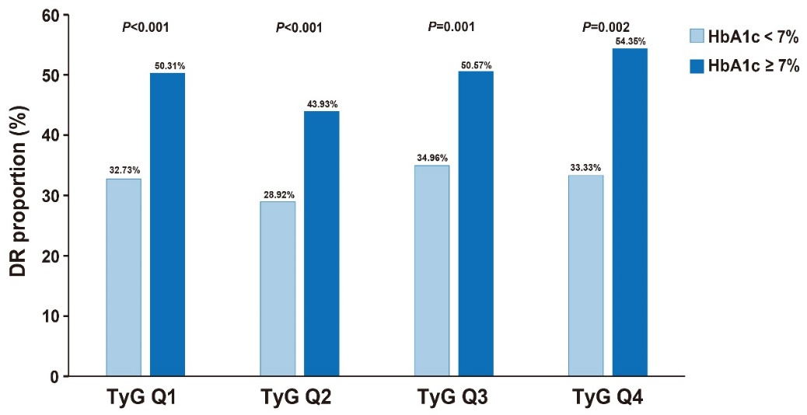

Figure S1 The proportion of diabetic retinopathy in HbA1c <7% and HbA1 ≥7% groups, stratified by TyG index quartiles. P<0.05 indicated that there was a significant difference in the proportion of DR between HbA1c <7% and HbA1c ≥7% groups. TyG index quartiles: TyG Q1 (TyG <8.67), TyG Q2 (8.67≤TyG<9.13), TyG Q3 (9.13≤TyG<9.63), TyG Q4 (TyG ≥9.63). Abbreviations as in Table 1.
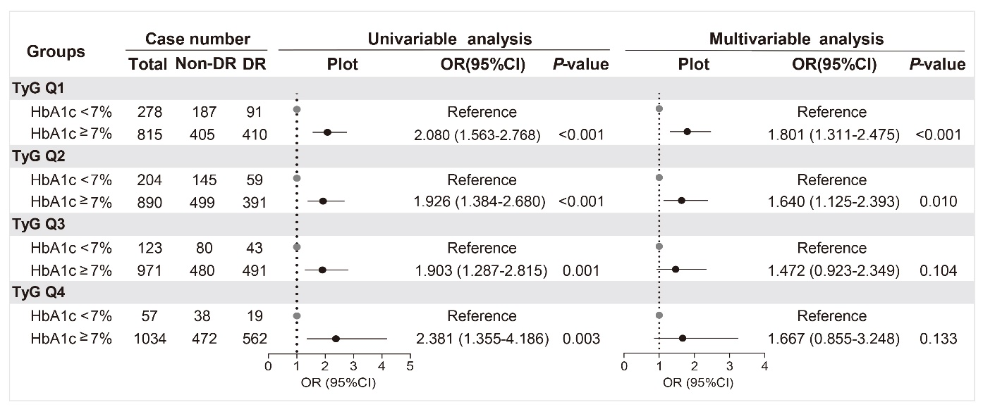

Figure S2 The risk of diabetic retinopathy in HbA1c <7% and HbA1c ≥7% groups, stratified by TyG index quartiles. Multivariable logistic regression analyses adjusted for for gender, age, T2DM duration, BMI, SBP, DBP, BUN, Cr, ALB, hsCRP, LP(a), TC, HDL-C, LDL-C. TyG index quartiles: TyG Q1 (TyG <8.67), TyG Q2 (8.67≤TyG<9.13), TyG Q3 (9.13≤TyG<9.63), TyG Q4 (TyG ≥9.63). Abbreviations as in Table 1.

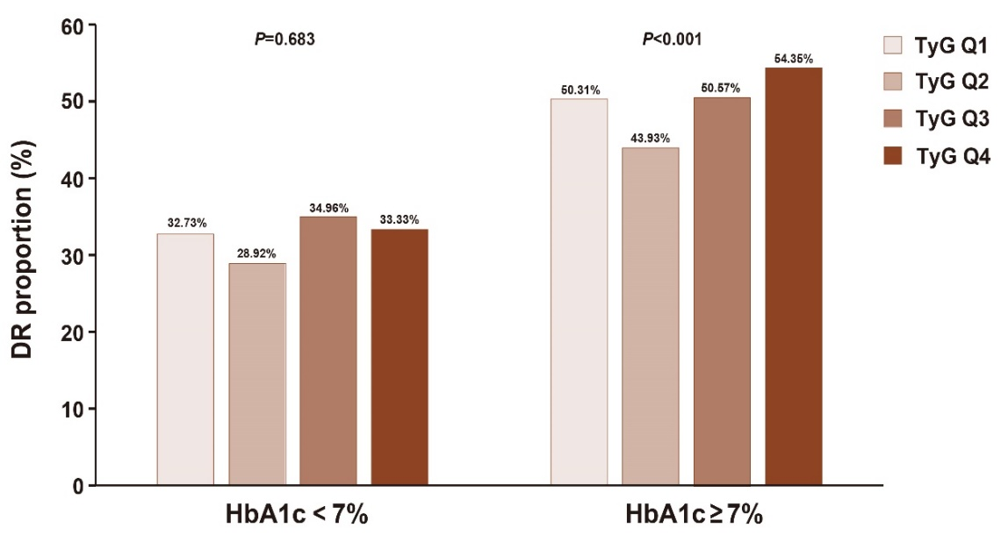

Figure S3 The proportion of diabetic retinopathy in TyG index quartiles, stratified by HbA1c <7% and HbA1c ≥7%. P<0.05 indicated a significant difference in the proportion of DR among TyG index quartiles groups. TyG index quartiles: TyG Q1 (TyG <8.67), TyG Q2 (8.67≤TyG<9.13), TyG Q3 (9.13≤TyG<9.63), TyG Q4 (TyG ≥9.63). Abbreviations as in Table 1.

Table S1 Characteristics of included T2DM patients stratified by HbA1c <7% and HbA1c ≥7% groups
Characteristics | Glycemic control
Characteristics | Controlled glycemia  (HbA1c<7%) | Uncontrolled glycemia  (HbA1c≥7%) | P-value
Case number | 662 | 3710
Gender，N (%) |  |  | 0.325
Male | 391 (15.60%) | 2115 (84.40%)
Female | 271 (14.52%) | 1595 (85.48%)
Age（year-old） | 57.93±11.40 | 56.95±12.15 | 0.053
T2DM duration (years) | 10.00(5.00-15.00) | 11.00 (5.00-18.00) | <0.001
BMI (kg/m²) | 25.45±3.67 | 25.88±3.77 | 0.006
SBP (mmHg) | 129.61±16.41 | 131.07±16.80 | 0.039
DBP (mmHg) | 77.10±10.51 | 77.31±10.62 | 0.637
FBG (mmol/L) | 5.98±1.31 | 8.33±2.82 | <0.001
BUN (mmol/L) | 5.34±2.01 | 5.40±1.94 | 0.475
Cr (μmol/L) | 74.67±27.37 | 69.99±25.16 | <0.001
ALB (g/L) | 39.12±3.88 | 38.66±3.84 | 0.004
hsCRP (mg/L) | 0.89(0.40-2.23) | 1.18 (0.50-2.90) | <0.001
LP(a) (mg/dL) | 12.94(6.32-25.68) | 14.73(6.70-29.62) | 0.043
TG (mmol/L) | 1.40(1.02-1.94) | 1.56(1.11-2.31) | <0.001
TC (mmol/L) | 4.20±1.01 | 4.55±1.16 | <0.001
HDL-C (mmol/L) | 1.07±0.34 | 1.05±0.30 | 0.037
LDL-C (mmol/L) | 2.53±0.89 | 2.77±0.94 | <0.001
HbA1c (%) | 6.33±0.46 | 9.46±1.76 | <0.001
TyG index | 8.81±0.60 | 9.25±0.74 | <0.001
Notes: The continuous variables were expressed as mean ± standard deviation (SD) or the medians with interquartile ranges (IQRs) after the normality distribution test. Abbreviations as in Table 1.

Table S2 The multivariable analysis for the relationship between TyG index and DR risk, with and without adjustment for T2DM duration as a confounding variable
Parameters | Case number |  |  |  | Model A |  |  | Model B
Parameters | Total | Non-DR (%) | DR (%) |  | OR (95%CI) | P-value |  | OR (95%CI) | P-value
TyG index  (as continuous variable) | 4372 | 2306 | 2066 |  | 1.175(1.019-1.354) | 0.026 |  | 1.269(1.109-1.451) | 0.001
TyG index quartiles
TyG Q1 | 1093 | 592(54.16%) | 501(45.84%) |  | Reference |  |  | Reference
TyG Q2 | 1094 | 644(58.87%) | 450(41.13%) |  | 0.879(0.720-1.072) | 0.203 |  | 0.916(0.760-1.105) | 0.361
TyG Q3 | 1094 | 560(51.19%) | 534(48.81%) |  | 1.091(0.884-1.346) | 0.417 |  | 1.157(0.949-1.410) | 0.149
TyG Q4 | 1091 | 510(46.75%) | 581(53.25%) |  | 1.289(1.008-1.648) | 0.043 |  | 1.449(1.149-1.827) | 0.002
P for trend |  |  |  |  | 0.009 |  |  | <0.001
Notes: OR, odds ratio; CI, confidence intervals.
TyG index quartiles: TyG Q1 (TyG <8.67), TyG Q2 (8.67≤TyG<9.13), TyG Q3 (9.13≤TyG<9.63), TyG Q4 (TyG ≥9.63).
Model A adjustment for gender, age, T2DM duration, BMI, SBP, DBP, BUN, Cr, ALB, hsCRP, LP(a), TC, HDL-C, LDL-C, and HbA1c.
Model B adjustment for gender, age, BMI, SBP, DBP, BUN, Cr, ALB, hsCRP, LP(a), TC, HDL-C, LDL-C, and HbA1c. Abbreviations as in Table 1.

Table S3 The logistic regression analysis for the risk of diabetic retinopathy according to glycemic control and TyG index quartiles
Groups | Case number |  |  |  | Multivariable analysis  (TyG Q1 as reference) |  |  | Multivariable analysis  (TyG Q2 as reference)
Groups | Total | Non-DR (%) | DR (%) |  | OR (95%CI) | P-value |  | OR (95%CI) | P-value
HbA1c<7%
TyG Q1 | 278 | 187(67.27%) | 91(32.73%) |  | Reference
TyG Q2 | 204 | 145(71.08%) | 59(28.92%) |  | 1.033(0.642-1.663) | 0.893 |  | Reference
TyG Q3 | 123 | 80(65.04%) | 43(34.96%) |  | 1.493(0.801-2.783) | 0.208 |  | 1.370(0.752-2.497) | 0.304
TyG Q4 | 57 | 38(66.67%) | 19(33.33%) |  | 1.960(0.699-5.494) | 0.200 |  | 1.927(0.689-5.391) | 0.211
P for trend |  |  |  |  | 0.464 |  |  | 0.402
HbA1c≥7%
TyG Q1 | 815 | 405(49.69%) | 410(50.31%) |  | Reference
TyG Q2 | 890 | 499(56.07%) | 391(43.93%) |  | 0.875(0.701-1.092) | 0.236 |  | Reference
TyG Q3 | 971 | 480(49.43%) | 491(50.57%) |  | 1.086(0.865-1.363) | 0.478 |  | 1.260(1.015-1.564) | 0.036
TyG Q4 | 1034 | 472(45.65%) | 562(54.35%) |  | 1.344(1.039-1.738) | 0.024 |  | 1.570(1.232-1.999) | <0.001
P for trend |  |  |  |  | 0.005 |  |  | 0.001
Note: OR, odds ratio; CI, confidence intervals. OR with 95%CI was estimated by multivariable logistic regression analysis adjusted for gender, age, T2DM duration, BMI, SBP, DBP, BUN, Cr, ALB, hsCRP, LP(a), TC, HDL-C, LDL-C. TyG index quartiles: TyG Q1 (TyG <8.67), TyG Q2 (8.67≤TyG<9.13), TyG Q3 (9.13≤TyG<9.63), TyG Q4 (TyG ≥9.63). Abbreviations as in Tables 1.

