Figure S1
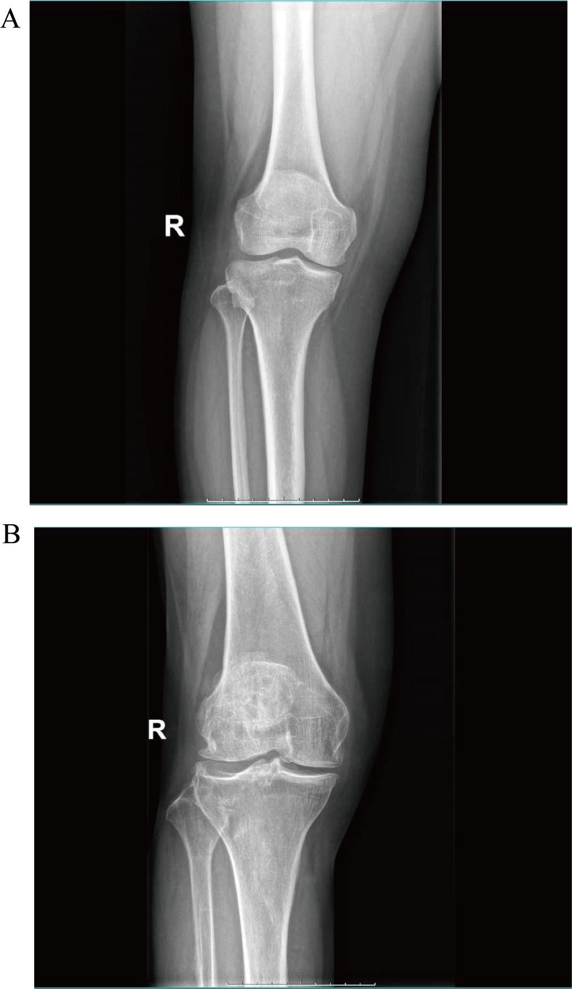
Figure S1: Radiographic imaging of patients included based on KL grading: (A) mild patients (grades 1-2) and (B) severe patients (grades 3-4).

Figure S2
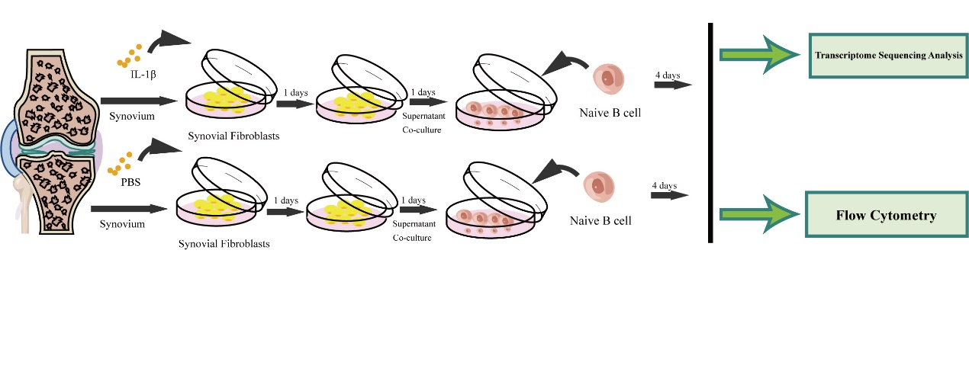
Figure S2：Flowchart of the co-culture process for synovial fibroblasts and B cells. In brief, primary synovial fibroblasts were seeded into 6-well plates and stimulated with IL-1β (10 ng/ml) for 24 hours to simulate the OA environment, designated as the experimental group, while the control group received an equal volume of PBS. The supernatant was then replaced and further cultured for 24 hours. Subsequently, the collected supernatant was co-cultured with naive B cells for 4 days before being used for further analysis.

