Supporting Information

Reactive oxygen species-responsive pyroptosis nanoinitiators promote immune cell infiltration and activate anti-tumor immune response
Hongbo Yan¹, Yilun Liu¹, Maoshan Wang¹, Zhenbo Shu¹, Xuedong Fang^{1,} , and Zhongmin Li^{1,}
1. Department of Gastrointestinal and Colorectal Surgery, China-Japan Union Hospital of Jilin University, Changchun 130033, P. R. China
Corresponding author: Xuedong Fang (fangxd@jlu.edu.cn), Zhongmin Li (lizhongmin1211@jlu.edu.cn)

Experimental Section
1.Materials
N(ε)-benzyloxycarbonyl-L-lysine N-carboxyanhydride (Cbz-Lys NCA) was purchased from GL Biochem, Ltd. (Shanghai, P. R. China). The amino-terminal methoxy poly(ethylene glycol) (mPEG-NH₂) was obtained from Sigma-Aldrich (Shanghai, P. R. China). n-Hexylamine (n-HA), 33 wt% hydrogen bromide/acetic acid (HBr/HAc) solution, trifluoroacetic acid (TFA), 3-mercaptopropionic acid (3-MPA), and acetone were obtained from Aladdin (Shanghai, P. R. China). Diisopropylcarbodiimide/4-dimethylaminopyridine (DIC/DMAP) were supplied by Sigma-Aldrich (Shanghai, P. R. China). Doxorubicin (DOX) and decitabine (DAC) were purchased from Solarbio Life Sciences (Beijing, P. R. China).
Roswell Park Memorial Institute (RPMI) 1640 medium and fetal bovine serum (FBS) were purchased from Gibco (Grand Island, NY, USA). Penicillin-streptomycin liquid was obtained from Solarbio Life Sciences (Beijing, P. R. China).
The primary antibodies of Gasdermin E (GSDME) and N-terminal fragment of GSDME (GSDME-N) were purchased from Abcam (Shanghai, P. R. China). The primary antibody of cleaved caspase-3 was obtained from Cell Signaling Technology Inc. (Danvers, MA, USA). For flow cytometry, anti-CD45-Brilliant Violet 570 (103136, clone: 30-F11), anti-CD3-PE-Dazzle594 (100246, clone: 17A2), anti-CD4-Brilliant Violet 421 (116023, clone: RM4-4), anti-CD8-PE/Cy5 (100710, clone: 53-6.7), anti-CD11c-APC/Cy7 711 (117324, clone: N418), anti-CD40-APC (124612, clone: 3/23), anti-CD80-Pacific Blue™ (104724, clone: 16-10A1), anti-CD11b-Brilliant Violet 711 (101242, clone: M1/70), anti-Gr-1-Alexa Fluor® 700 (108422, clone: RB6-8C5), and Zombie Aqua™ Fixable Viability Kit were purchased from BioLegend (CA, USA). For immunohistochemical and immunofluorescence staining, the primary antibodies of Ki-67, TUNEL, CD3, and CD4 were purchased from ABclonal Biotechnology Co., Ltd. (Wuhan, P. R. China).
Dehydrogenase (LDH), adenosine triphosphate (ATP), interferon-γ (IFN-γ), tumor necrosis factor-α (TNF-α), and IL-10 enzyme-linked immunosorbent assay (ELISA) kits were purchased from Anoric Biotechnology Co., Ltd. (Tianjin, P. R. China). Cell Counting Kit-8（CCK-8）was supplied by Sigma-Aldrich (Shanghai, P. R. China).
2. Characterizations
Proton nuclear magnetic resonance (¹H NMR) spectra were detected on a Bruker AV 500 NMR spectrometer (Rheinstetten, Germany) in deuterated TFA (TFA-d) or deuterated dimethyl sulfoxide (DMSO-d). Dynamic light scattering (DLS) was performed on Zetasizer Proinstrument (Malvern Instruments Ltd., Malvern, WR, UK). Transmission electron microscopy (TEM) measurement was performed on a JEM-1011 transmission electron microscope (JEOL, Japan) with an accelerating voltage of 100 kV.
3. Preparation of monomethoxy (polyethylene glycol)-block-poly(_{L}-lysine)
Using monmethoxy polyethylene glycol amine (mPEG-NH₂) as an initiator, monomethoxy (polyethylene glycol)-block-poly(N(ε)-benzyloxycarbonyl-_{L}-lysine) (mPEG-b-P(Cbz-Lys)) was synthesized by the ring-opening polymerization of N(ε)-benzyloxycarbonyl-_{L}-lysine N-carboxyanhydride (Cbz-Lys NCA). Subsequently, mPEG-b-P(Cbz-Lys) was dissolved in TFA, then HBr/HAc solution was added. After stirring for 30 min at 25 °C, the mixture was poured into 100.0 mL of ethyl ether and filtered to collect the crude product. The product was further moved into a dialysis bag and dialyzed against deionized water for 24 h. Finally, mPEG-b-PLL was obtained after lyophilization.
4. Synthesis of thioketal
Anhydrous 3-MPA and anhydrous acetone were mixed in a dried flask, then concentrated hydrochloric acid was added, and the solution was stirred at 25 °C for 6 h. At the end of the reaction, the flask was chilled in an ice-salt mixture, and white crystals were obtained. The crystals were filtered and washed with hexane and cold water when crystallization was complete. Thioketal (TK) was obtained after drying in a vacuum desiccator.
5. Synthesis of mPEG-b-PLL-TK
TK (830 mg), DIC (1000 mg), and DMAP (400 mg) were dissolved in 5 mL of N,N-dimethylformamide (DMF), and the solution was stirred at room temperature for 6 h. 500.0 mg of mPEG-b-PLL was dissolved in 5.0 mL of DMF. Then the two solutions were mixed and stirred for 24 h. Subsequently, the mixture was poured into 100.0 mL of ethyl ether and filtered to collect the crude product. The product was further moved into a dialysis bag and dialyzed against deionized water for 24 h. Finally, mPEG-b-PLL-TK was obtained after lyophilization.
6. Preparation of NP/(DAC+DOX)
DAC and DOX were encapsulated in nanomicelles through a sequential dispersion and dialysis technique. 25.0 mg DOX and 125.0 mg DAC were dissolved in 2.0 mL and 10.0 mL DMF solutions, respectively. 450.0 mg of mPEG-b-PLL-TK was dispersed in 12.0 mL of DMF. After stirring for 12 h, the three solutions were mixed and then stirred for another 2 h. Then a mixture of 19.2 mL of Milli-Q water and 4.8 mL of phosphate-buffered saline (PBS; 0.01 M) was added into the solution and stirred for 6 h. Finally, the solution was dialyzed against deionized water for 24 h, filtrated, and freeze-dried to obtain NP/(DAC+DOX).
The amount of DAC and DOX was measured by high-performance liquid chromatography (HPLC). Specifically, samples were detected at 244 nm (DAC) and 233 (DOX) on a Brownlee Analytical C18 column (5 μm; 4.6 mm × 250 mm) (Agilent; USA) via ultraviolet (UV) detector (Agilent 1260, USA). The mobile phase for DAC consists of PBS (pH 6.5) and methanol (40:60 v/v), with a flow rate of 1.0 mL/min. The mobile phase for DOX consists of acetonitrile and water (70:30 v/v), with a pH of 3.0 and a flow rate of 1.0 mL/min. The drug loading content (DLC) of NP/(DAC+DOX) was calculated by Equations (1), respectively.
$$\text{DLC }\left(\text{\%}\right)\text{=}\frac{\text{Amount of drug in nanogel}}{\text{Amount of loading nanogel}}\text{×100\%}\text{ (1)}$$
7. In vitro drug release
To study the in vitro drug release profile, 2.0 mg of NP/(DAC+DOX) was dissolved in 20.0 mL of PBS containing 1.0 mM H₂O₂ and 20.0 mL of PBS without H₂O₂, respectively. The solutions were transferred to end-sealed dialysis bags (molecular weight cut-off (MWCO) = 3,500 Da) and immersed in 50.0 mL of the corresponding buffer at 37 °C on an orbital shaker. At predetermined periods (1, 3, 12, 24, 48, and 72 h), 2.0 mL of the dialysis solution was collected for analysis, and 2.0 mL of fresh release buffer was replenished to maintain a constant volume. The amount of DAC and DOX released from NP/(DAC+DOX) was detected through HPLC, using the same method as described above.
8. Cell lines and animals
Murine colon carcinoma cells (CT26) and murine breast cancer cells (4T1) were purchased from China Center for Type Culture Collection (CCTCC), and they were cultured in RPMI 1640 medium with 10% FBS and 1% penicillin-streptomycin solution.
Female BABL/c mice (5 − 6 weeks, 18 − 20 g) and Sprague-Dawley rats (5 − 6 weeks, 230 ± 10 g) were purchased from Beijing Vital River Laboratory Animal Technology Co., Ltd. (Beijing, P. R. China). All the animal experiments were conducted in strict accordance with the ethical guidelines outlined in the "Guide for the Care and Use of Laboratory Animals: Eighth Edition." The study received approval from the Animal Care and Ethics Committee of Changchun Weishi Testing Technology Service Co., Ltd. All procedures involving animals were carried out with the utmost consideration for their welfare, and measures were taken to minimize suffering throughout the study.
9. Cellular uptake of NP/(DAC+DOX)
The cellular uptake of NP/(DAC+DOX) was detected by HPLC. CT26 cells were plated at 2 × 10⁵ cells per well in 6-well plates and incubated overnight before treatment. The cells were then treated with DAC+DOX and NP/(DAC+DOX) at 37 °C for 1 h or 4 h, respectively, with the concentration of DAC at 50 µg/mL and DOX at 10 µg/mL. The cells were washed twice with cold PBS and lysed with RIPA Lysis Buffer. After centrifugation at 12,000 rpm at 4 °C for 10 min, the supernatant was collected. The drug contents were determined by HPLC.
10. In vitro cytotoxicity
The cytotoxicity of polymer micelle, DAC, DOX, DAC+DOX, and NP/(DAC+DOX) on CT26 cells or 4T1 cells was assessed by CCK-8. Briefly, cells were seeded on a 96-well plate at a density of 1 × 10⁴ cells per well and cultured overnight. The cells were treated with PBS, polymer micelle, DAC, DOX, DAC+DOX, and NP/(DAC+DOX) at different concentrations of DAC (7.8125, 15.625, 31.25, 62.50, 125.0, 250.0 μg mL⁻¹) and DOX (1.5625, 3.125, 6.25, 12.50, 25.0, and 50.0 μg mL⁻¹). After incubation for 24 h, the cell viability was evaluated by CCK-8. Cell viability was expressed as the relative cell viability compared with cells treated with PBS.
11. Pyroptosis evaluation in vitro
CT26 cells were seeded at a density of 1 × 10⁶ cells per dish and allowed to adhere. After the cells attached, they were incubated with a medium containing PBS and NP/(DAC+DOX) for 24 hours. Subsequently, the CT26 cells were observed under an optical microscope. The typical morphological characteristics of pyroptosis include cell swelling, formation of large bubbles from the cytoplasmic membrane, and cell membrane rupture. Cells were then trypsinized and centrifuged at 1000 rpm for 5 minutes, discarding the supernatant. The cell pellet was washed with 1 ml PBS and transferred to a 2 ml EP tube, followed by another centrifugation at 1000 rpm to remove the supernatant. Finally, the cell pellet was snap-frozen in liquid nitrogen and sent to the Beijing Genomics Institution（BJI） for genetic analysis.
12. Pharmacokinetics and biodistribution
To detect the pharmacokinetics of NP/(DAC+DOX), female Sprague-Dawley rats were injected with DAC+DOX or NP/(DAC+DOX) through the tail vein at an equivalent DAC dose of 15.0 mg per kg body weight (mg (kg BW)⁻¹) and DOX dose of 3.0 mg (kg BW)⁻¹. Blood samples were collected from the orbital venous plexus at 15 min, 30 min, and 1, 3, 12, 24, 48, 72 h post-injection. The collected blood was promptly transferred into heparin-coated tubes to prevent clotting. The samples were then centrifuged at 3000 rpm for 10 min to separate the plasma. The plasma was carefully aliquoted into sterile tubes and stored at −80 °C. Prior to analysis, the plasma samples were thawed and analyzed using HPLC, as described above.
The in vivo distribution of NP/(DAC+DOX) was assessed in a CT26 tumor-bearing mouse model. The subcutaneous CT26 tumor-bearing mouse model was constructed by subcutaneous injection of 1.0 × 10⁶ CT26 cells into the right armpit of BALB/c mouse. When the tumor grew to about 80.0 mm³, the mice were injected with DAC+DOX and NP/(DAC+DOX) through the tail vein, respectively. At 12 h post-injection, tumors and major organs (heart, liver, spleen, lung, and kidney) were collected and homogenized with cold PBS. The homogenates were thoroughly mixed with methanol (1:1; V/V) and centrifuged at 8000 rpm for 15 min. The supernatant was added to an equal volume of methanol to precipitate proteins, and supernatants were collected after centrifugation. The concentrations of DAC and DOX were detected by HPLC, as described above.
NP/Cy5 was prepared by loading cyanine 5 (Cy5) in mPEG-b-PLL-TK to further explore the pharmacokinetics and tissue distribution of ROS-responsive nanomedicine through fluorescence imaging. When the tumor grew to about 80.0 mm³, NP/Cy5 and free Cy5 was injected into CT26 tumor-bearing mice via tail vein and imaged at different time points of 1, 12, and 24 h using the VISQUE® In Vivo Smart-LF imaging system. At 24 h post-injection, the mice were euthanized by cervical dislocation. The tumor tissues and major organs (heart, liver, spleen, lung, and kidney) were collected and imaged.
13. Antitumor efficacy in vivo
The antitumor efficacy of NP/(DAC+DOX) was evaluated in subcutaneous CT26 and 4T1 tumor-bearing mouse models. BALB/c mice were administrated subcutaneously with 1.5 × 10⁶ of CT26 cells or 4T1 at the right armpit. When the tumor volume grew to about 80.0 mm³, mice were randomly divided into five groups and treated with PBS, DAC, DOX, DAC+DOX, or NP/(DAC+DOX) via tail vein injection at an equal DAC dose of 15.0 mg mg (kg BW)⁻¹ and DOX dose of 3.0 mg (kg BW)⁻¹. The tumor volume and body weight of mice were monitored every other day. The tumor volume (V) was calculated using Equation (2).
$$\text{V}\text{=}\frac{\text{L}\text{×}\text{W}\text{2}}{\text{2}}\text{ (2)}$$
L and W (mm) represent the length and width of the tumor, respectively.
Tumor inhibition rate was calculated using Equation (3).
$$\text{Tumor inhibition rate (\%)=}\frac{\text{(}\text{V}\text{control}\text{-}\text{V}\text{sample}\text{)}}{\text{V}\text{control}}\text{× 100\% (3)}$$
V_{control} and V_{sample} represented the tumor volumes of control groups and sample groups, respectively.
14. Histopathological, immunohistochemical, and immunofluorescence analysis
The mice were sacrificed by conventional cervical dislocation after 15 days of treatment. Tumors and major organs (heart, liver, spleen, lung, and kidney) were collected and fixed with 4% PFA and then embedded in paraffin. Tumor tissues were cut into about 5.0 μm slices for hematoxylin and eosin (H&E) staining, immunohistochemical analyses (Ki-67), and immunofluorescence detection (TUNEL, CD3, CD8, and Arg-1).
15. Immune activation assay
After treating with PBS, DAC, DOX, DAC+DOX, or NP/(DAC+DOX) for 10 days, tumor tissues and tumor-draining lymph nodes (TDLNs) were extracted from experimental animals and minced before being incubated in collagenase-containing medium at 37 °C for 30 min to dissociate into a single-cell suspension. The resulting suspension was filtered, centrifuged, and resuspended in PBS. Cell concentration was adjusted to 1×10⁶ cells mL⁻¹ using a cell counting chamber. For tumor tissues, cells were allocated to flow cytometry tubes and stained with anti-CD45-Brilliant Violet 570, anti-CD3-PE-Dazzle594, anti-CD4-Brilliant Violet 421, anti-CD8-PE/Cy5, anti-CD11b-Brilliant Violet 711, and anti-Gr-1-Alexa Fluor® 700 and incubated at 4 °C in the dark for 30 min. Cells were then washed twice with PBS to remove unbound antibodies. For TDLNs, cells were stained with anti-CD45-Brilliant Violet 570, anti-CD3-PE-Dazzle594, anti-CD4-Brilliant Violet 421, anti-CD8-PE/Cy5, anti-CD11c-APC/Cy7 711, anti-CD40-APC, anti-CD80-Pacific Blue™, anti-CD11b-Brilliant Violet 711, and anti-Gr-1-Alexa Fluor® 700, followed by incubation and washing under the same conditions. Cells were fixed with 4% paraformaldehyde for 15 min, then washed twice with PBS. Finally, the stained cells were detected on a Cytek Aurora Flow Cytometer (Cytek Biosciences Inc., CA, USA) using BD FACSDiva software (BD Bioscience). Data were analyzed using Flowjo10 software.
300.0 μL of blood without anticoagulant was collected from the above mice and centrifuged at 3000 rpm for 10 min. The serum of mice was obtained to detect the levels of cytokines related to immune response, including IFN-γ, TNF-α, and IL-10, by ELISA kits according to the manufacturer's instructions.

16. Western blotting analysis

The samples were lysed by RIRA reagent (Pierce, Rockford, IL, USA) and the supernatants were collected followed by centrifuging at 13,000 rpm for 10 min at 4 °C to acquire the proteins. After protein quantification through the bicinchoninic acid method, 12% sodium dodecyl sulfate polyacrylamide gel electrophoresis (SDS-PAGE) was used for protein separation. Then the proteins were transferred onto polyvinylidene fluoride membranes (Millipore) and incubated with 5% skimmed milk for 1 h at room temperature. Afterwards, the proteins were incubated with primary antibodies against GSDME, GSDME-N, cleaved caspase-3 at 4 °C overnight and horseradish peroxidase (HRP)-labeled secondary antibody at room temperature for 1 h. The protein blots were obtained using the ECL kit and the Odyssey system (BIO-RAD) was used to visualize the protein band. The exposed membrane was removed, 4 mL of Stripping Buffer was added and incubated with 5% skimmed milk for 1 h at room temperature. Afterwards, the proteins were incubated with primary antibodies against β-actin at 4 °C overnight and HRP-labeled secondary antibody at room temperature for 1 h. The protein blots were obtained using the ECL kit and the Odyssey system was used to visualize the protein band.
17. Statistical analysis
All data were expressed as mean ± standard deviation (SD). Differences between experimental groups were assessed by Student's t-test using statistical software SPSS 21.0 (SPSS Inc., Chicago, IL, USA). *P < 0.05 was considered statistically significant, and **P < 0.01 and ***P < 0.001 were considered highly significant.

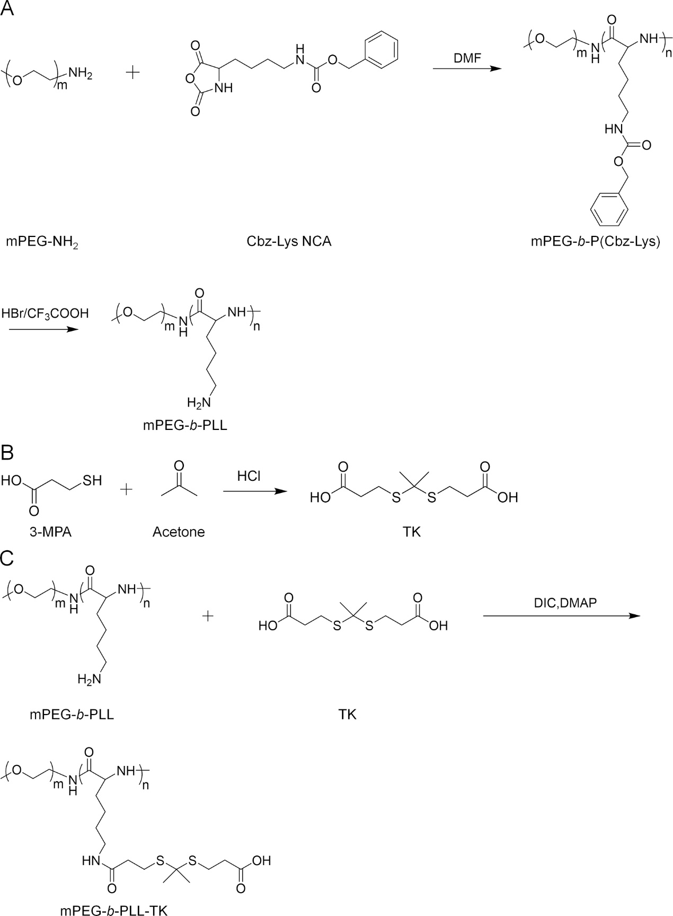
Scheme S1. Synthesis route of (A) mPEG-b-PLL, (B) TK, and (C) mPEG-b-PLL-TK.

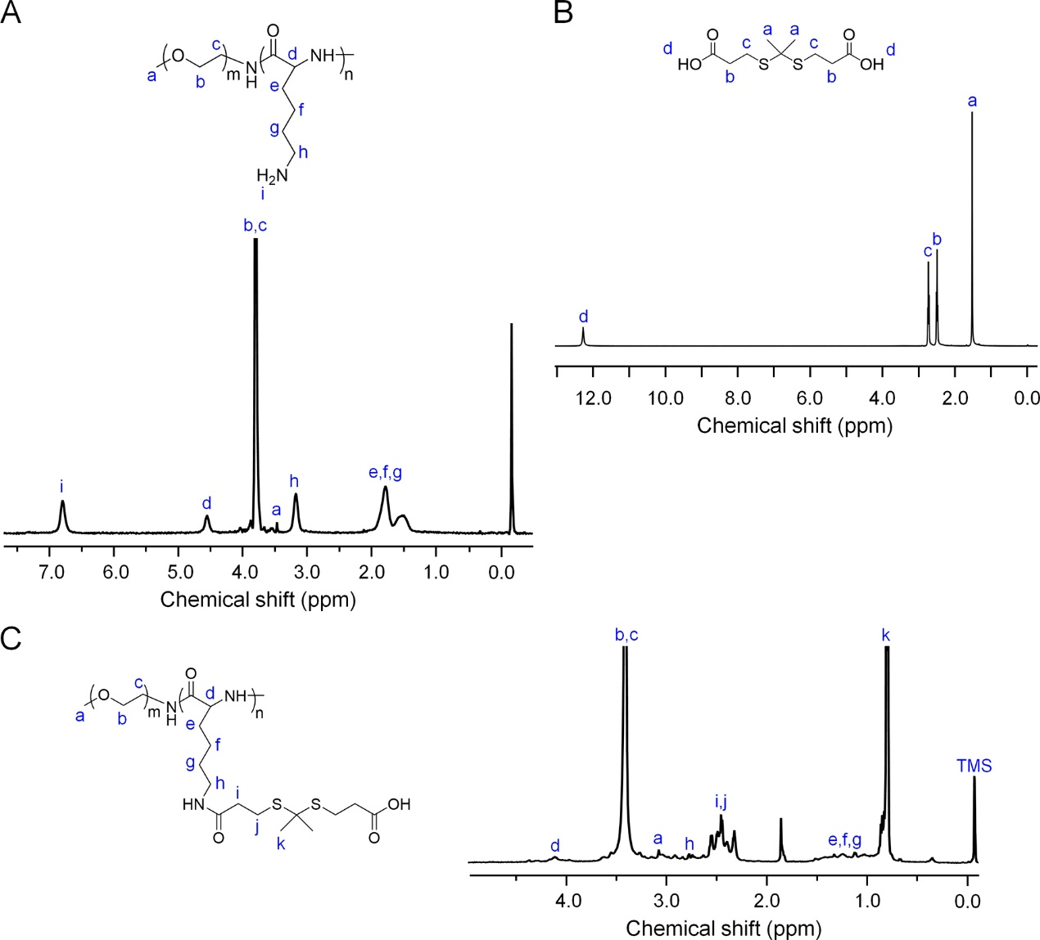
Figure S1. ¹H NMR spectra of (A) mPEG-b-PLL in TFA-d, (B) TK in DMSO-d, and (C) mPEG-b-PLL-TK in TFA-d.

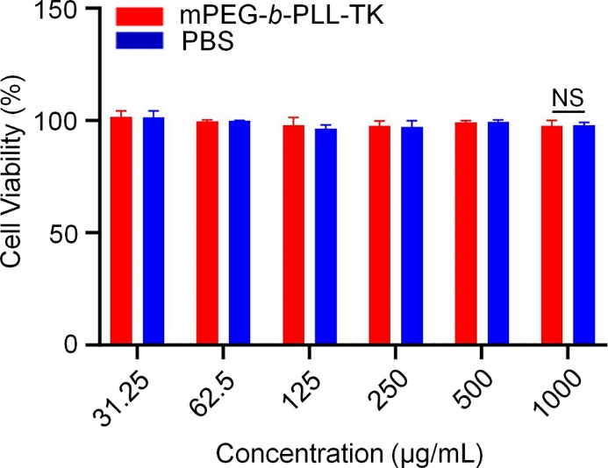
Figure S2. In vitro cytotoxicity of mPEG-b-PLL-TK on CT26 cells. (NS: no significance).

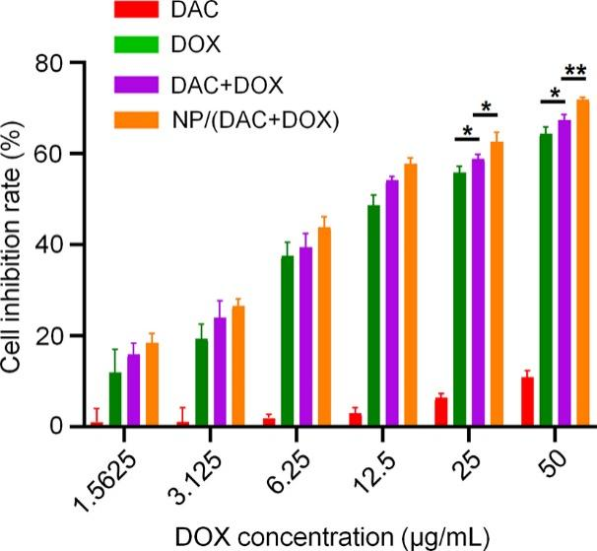
Figure S3. In vitro cytotoxicity of DAC, DOX, DAC+DOX and NP/(DAC+DOX) on 4T1 cells. The concentrations of DAC used were 7.8125, 15.625, 31.25, 62.5, 125.0 and 250.0 μg/mL. The concentrations of DOX used were 1.5625, 3.125, 6.25, 12.5, 25.0 and 50.0 μg/mL. All statistical data are presented as mean ± SD (n = 3; *P< 0.05, **P < 0.01).

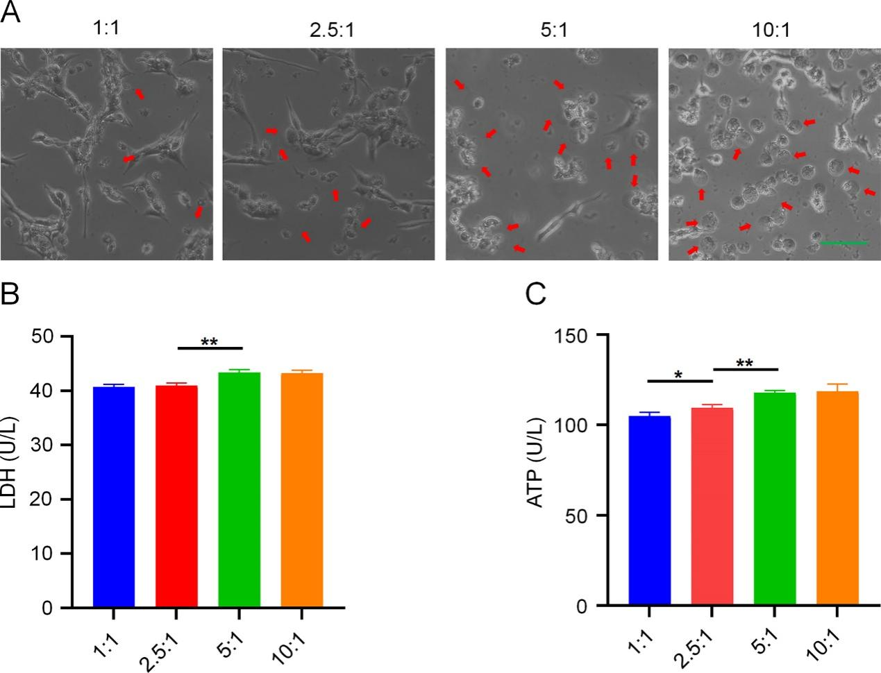
Figure S4. Pyroptosis induced by DAC+DOX with different mass ratios. (A) Light microscopy images of CT26 cells after different treatments. DOX was administered at a dose of 10 µg/mL and the mass ratios of DAC and DOX were set at 1:1, 2.5:1, 5:1, and 10:1, respectively. Scale bars: 100 μm. The release of (B) LDH and (C) ATP form CT26 cells receiving different treatments. All statistical data are presented as mean ± SD (n = 3; *P< 0.05, **P < 0.01).

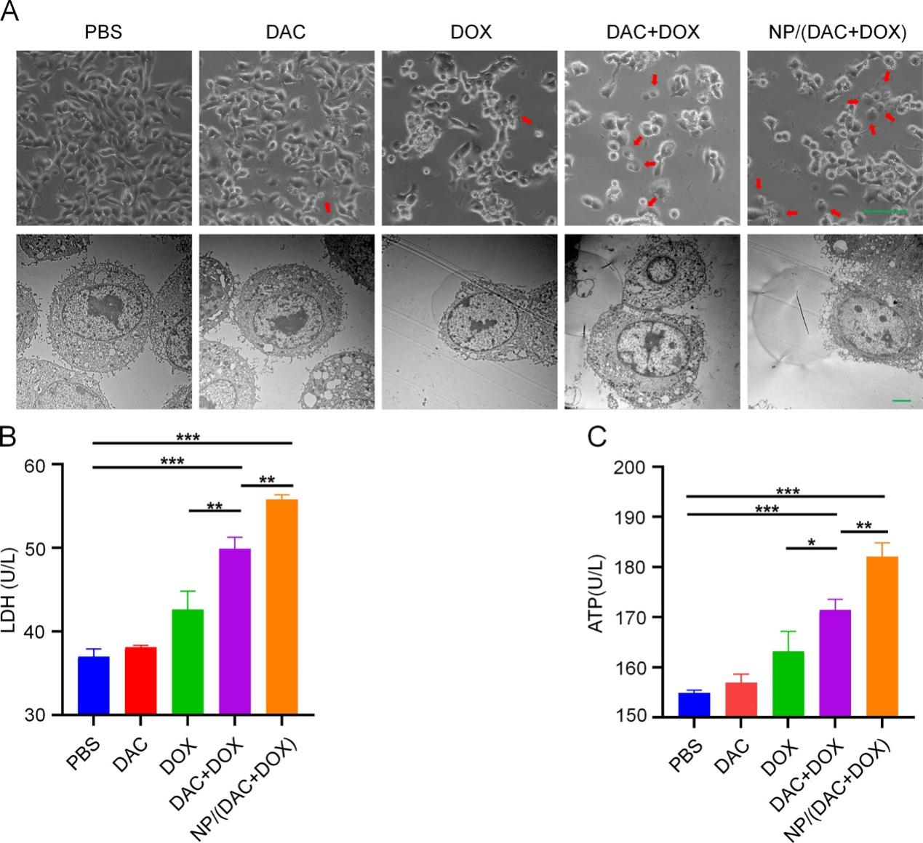
Figure S5. Pyroptosis of 4T1 cells induced by NP/(DAC+DOX) in vitro. (A) Representative light microscopy and bio-TEM images of 4T1 cells after different treatments. Red arrows indicate pyroptotic cells. Scale bars: 100 μm (light microscopy) and 2 μm (bio-TEM). The release of (B) LDH and (C) ATP from 4T1 cells after different treatments. All statistical data are presented as mean ± SD (n = 3; *P < 0.05, **P < 0.01, ***P < 0.001).

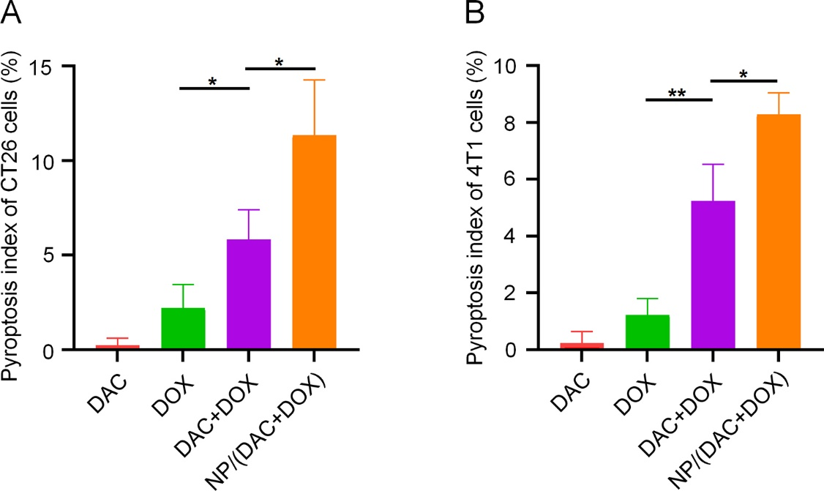
Figure S6. Pyroptosis index of (A) CT26 cells and (B) 4T1 cells receiving different treatment. All statistical data are presented as mean ± SD (n = 3; *P< 0.05, **P < 0.01).

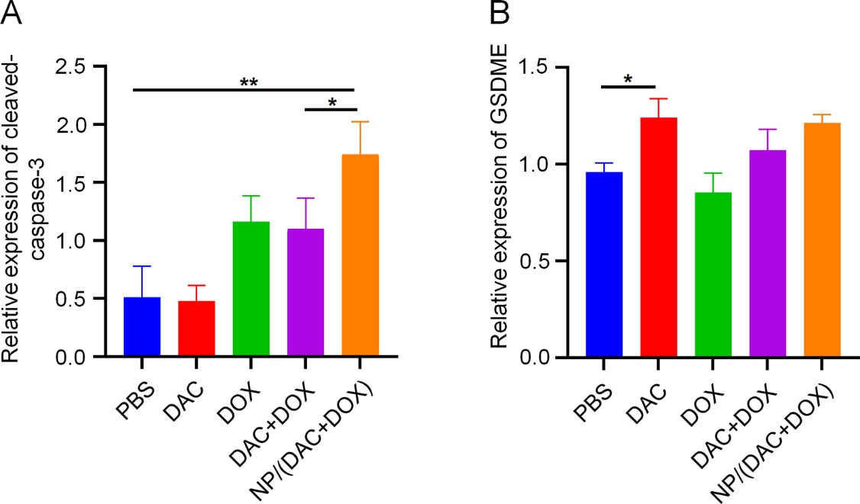
Figure S7. The relative expression of (A) cleaved-caspase-3 and (B) GSDME in CT26 cells after different treatments. All statistical data are presented as mean ± SD (n = 3; *P < 0.05, **P < 0.01).

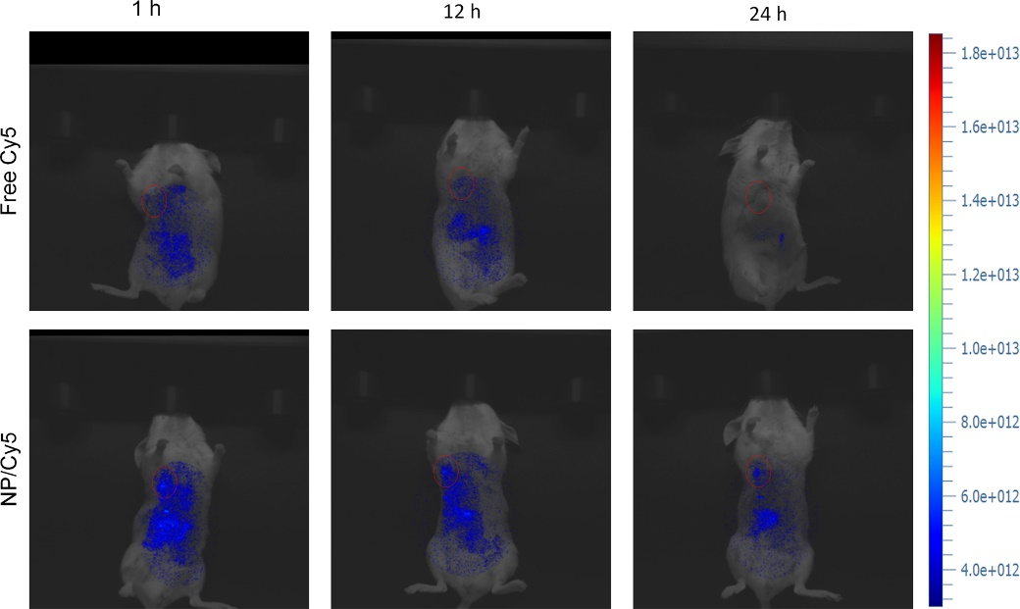
Figure S8. In vivo fluorescence images of the CT26-bearing mice at different times upon injection of NP/Cy-5 or free Cy5 via tail vein injection. The red circle indicated the tumor region.

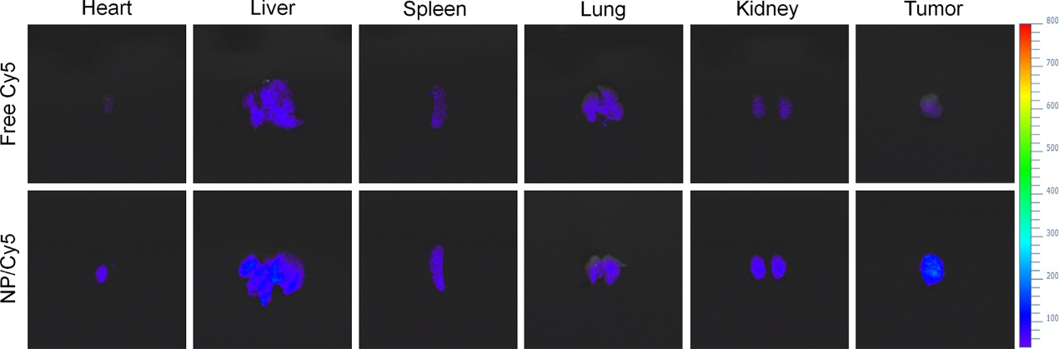
Figure S9. The fluorescence images of tumor and major organs at 24 h upon injection of NP/Cy-5 or free Cy5 via tail vein injection.

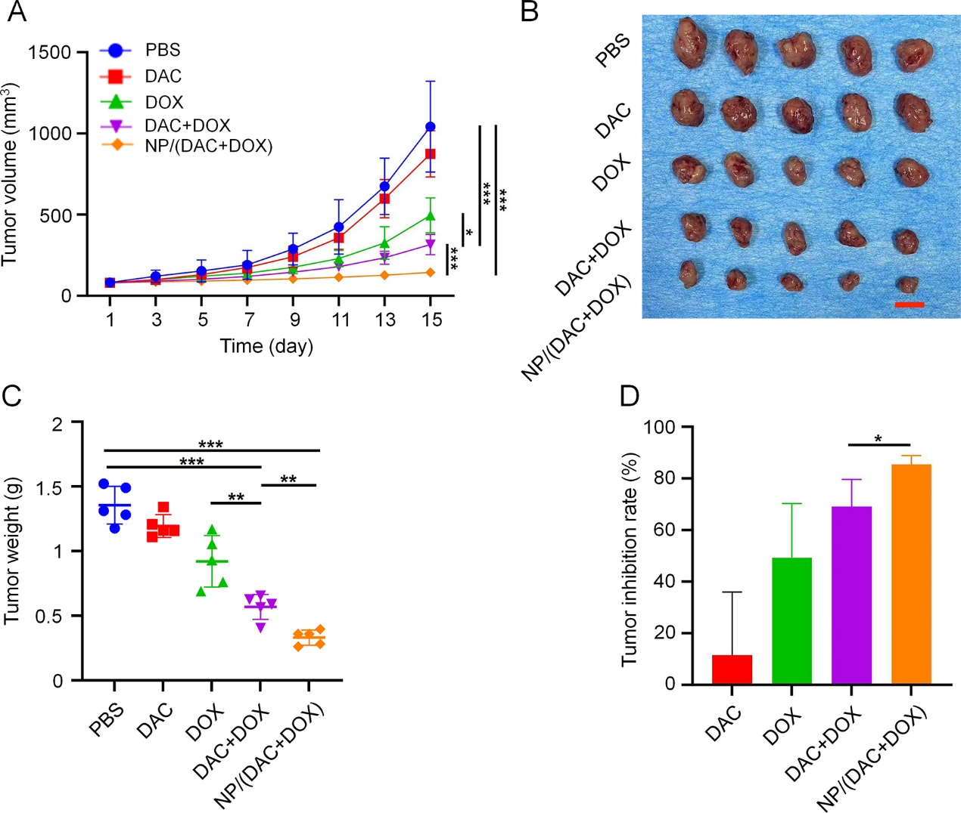
Figure S10. In vivo anti-tumor effect of NP/(DAC+DOX) in 4T1 tumor bearing mice. (A) Tumor volume in 4T1 tumor-bearing mice after treatment with PBS, DAC, DOX, DAC+DOX, or NP/(DAC+DOX). (B) Image of tumor and (C) tumor weight in different treatment groups on day 15, scale bar = 1.0 cm. (D) Tumor inhibition rate in different treatment groups. All statistical data are presented as mean ± SD (n = 5; *P < 0.05, **P < 0.01, ***P < 0.001).

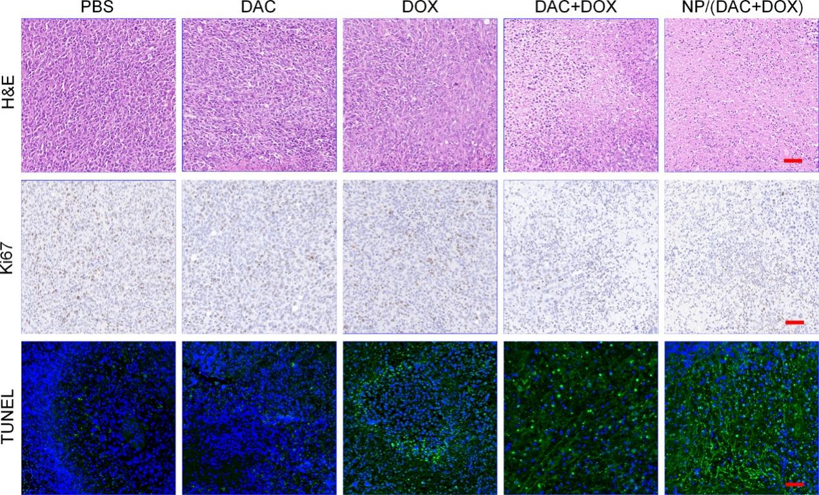
Figure S11. H&E, Ki-67, and TUNEL staining of tumor sections from 4T1 tumor-bearing mice receiving different treatments. Scale bar: 50 µm.

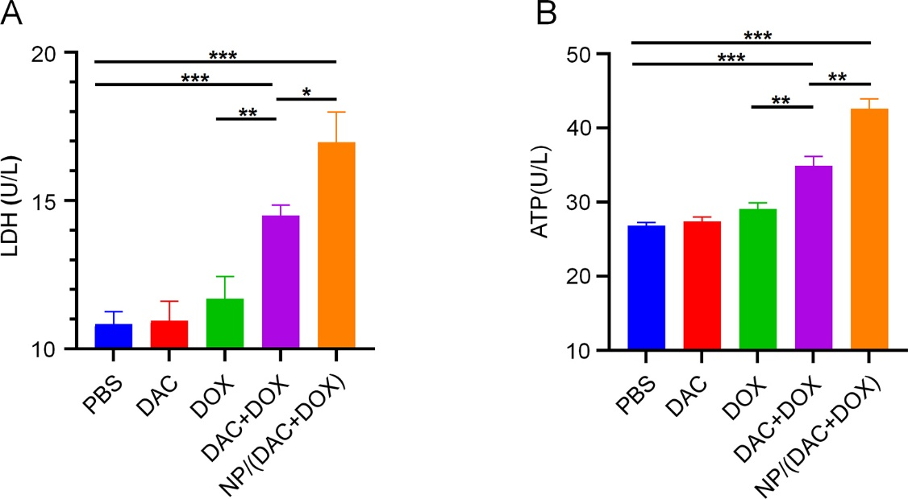
Figure S12. Levels of (A) LDH and (B) ATP in the serum of CT26 tumor-bearing mice from different treatment groups. All statistical data are presented as mean ± SD (n = 3; *P < 0.05, **P < 0.01, ***P < 0.001).

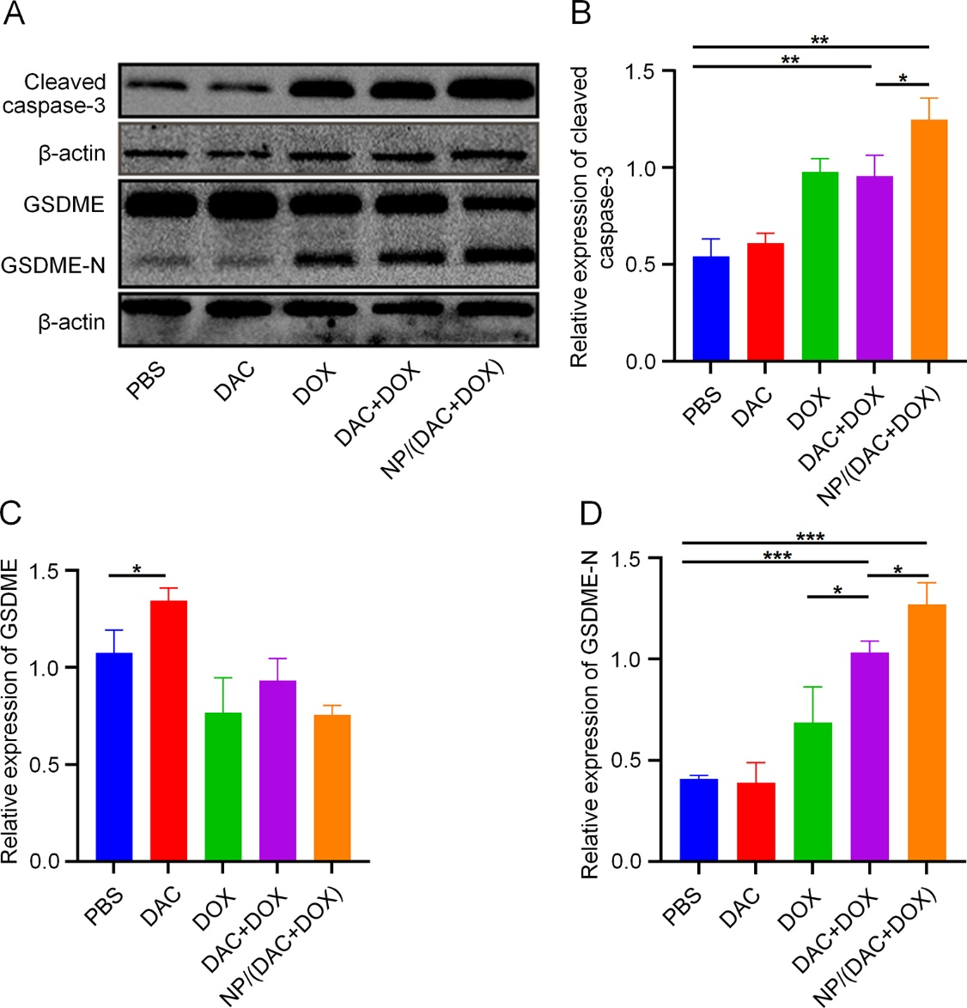
Figure S13. Pyroptosis induced by NP/(DAC+DOX) in CT26 tumor-bearing mice. (A) Western blotting analysis of pyroptosis-related proteins (cleaved caspase-3, GSDME, and GSDME-N) in CT26 tumors receiving different treatments. The relative expression of (B) cleaved caspase-3, (C) GSDME, and (D) GSDME-N in CT26 tumors receiving different treatments. All statistical data are presented as mean ± SD (n = 3; *P < 0.05, **P < 0.01, ***P < 0.001).

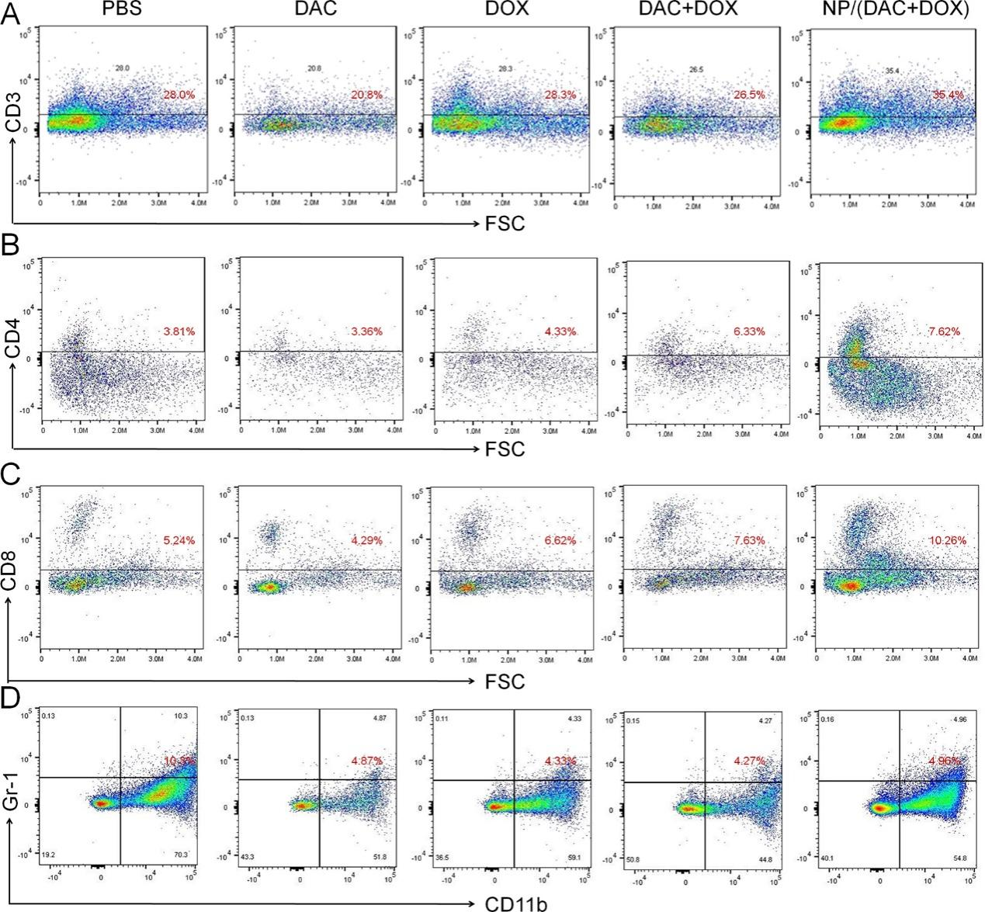
Figure S14. Representative images of (A) CD3⁺ T cells, (B) CD4⁺ T cells, (C) CD8⁺ T cells, and (D) MDSCs in CT26 tumors detected by flow cytometry.

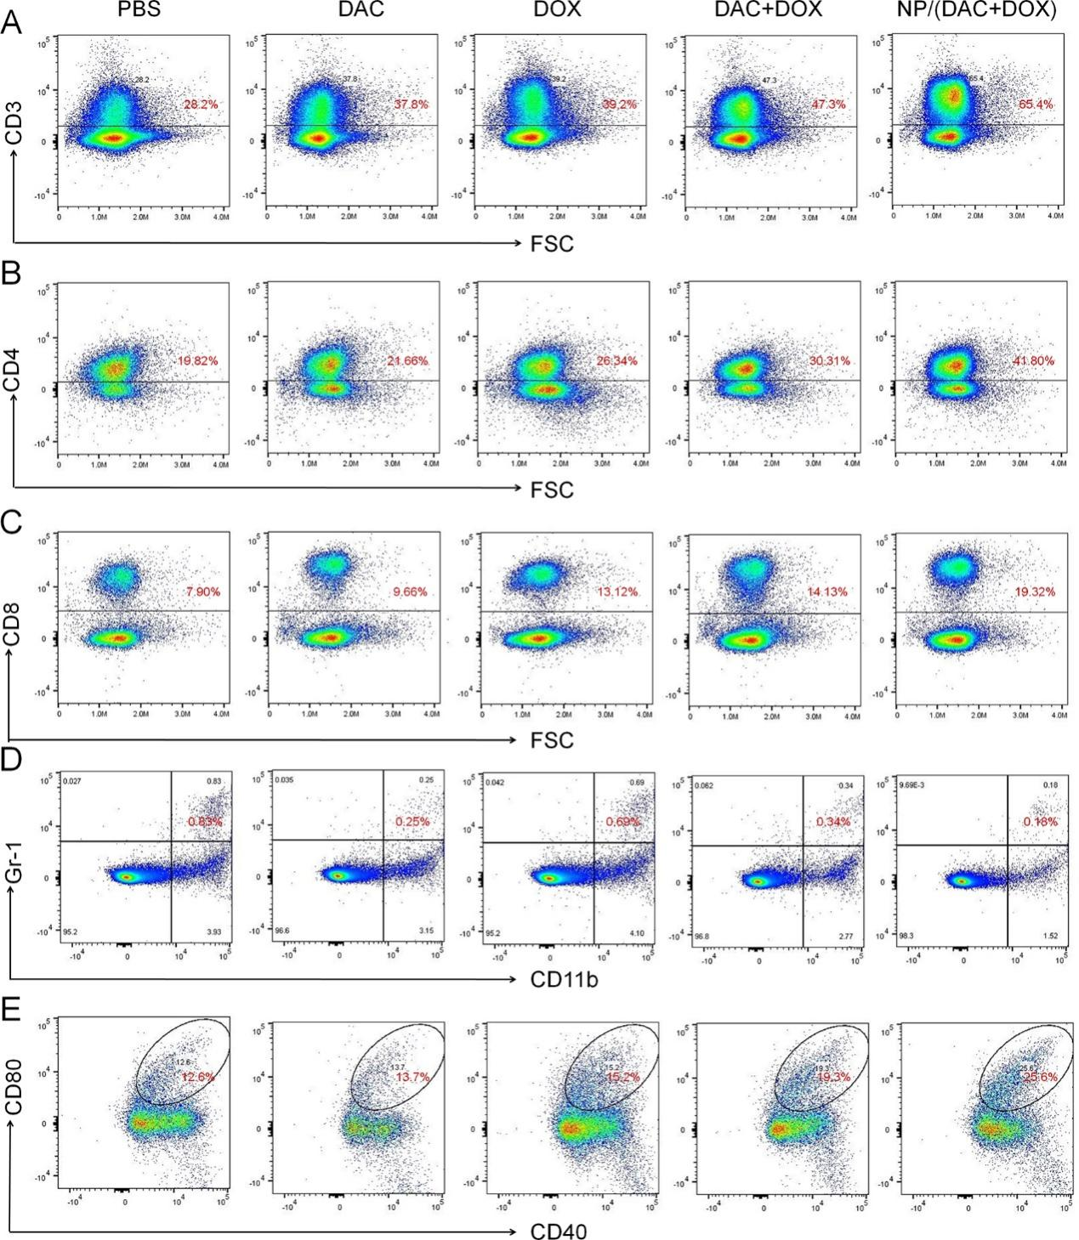
Figure S15. Representative images of (A) CD3⁺ T cells, (B) CD4⁺ T cells, (C) CD8⁺ T cells, (D) MDSCs, and (E) mature DCs in TDLNs from CT26 tumor-bearing mice detected by flow cytometry.

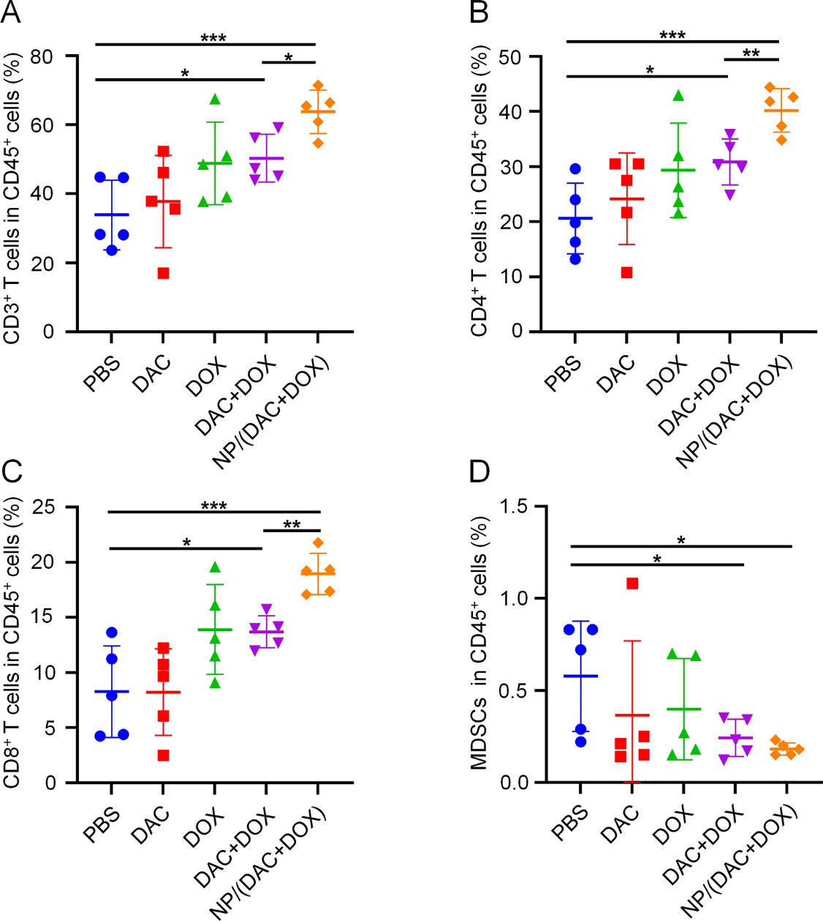
Figure S16. Frequencies of (A) CD3⁺, (B) CD4⁺, (C) CD8⁺ T cells and (D) MDSCs in CD45⁺ cells in TDLNs from CT26 tumor-bearing mice. All statistical data are presented as mean ± SD (n = 5; *P < 0.05, **P < 0.01, ***P < 0.001).

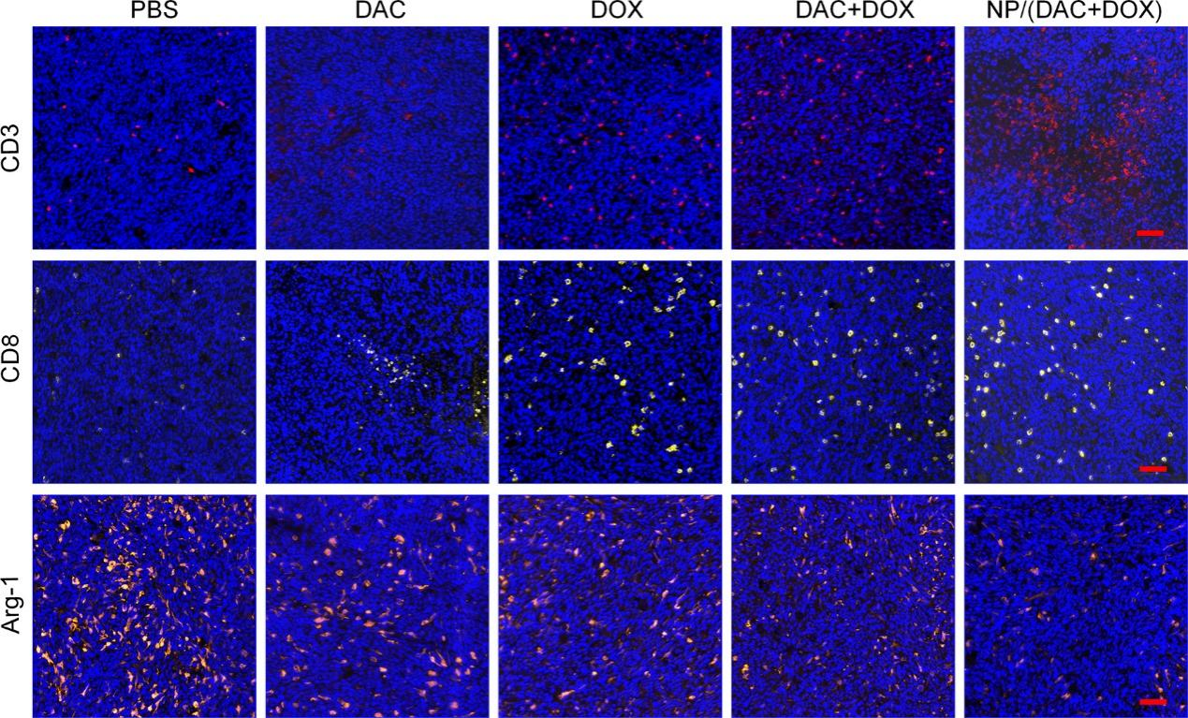
Figure S17. CD3, CD8, and Arg-1 staining of tumor sections from CT26 tumor-bearing mice receiving different treatments. Scale bar: 50 µm.

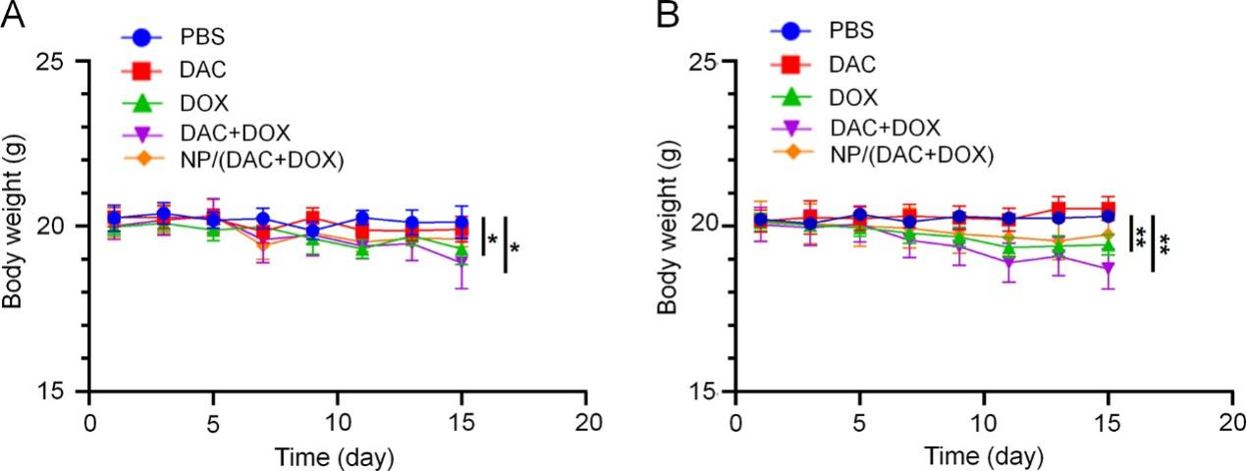
Figure S18. Body weight of (A) CT26 and (B) 4T1 tumor-bearing mice treated with different formulations. All statistical data are presented as mean ± SD (n = 5; *P < 0.05, **P < 0.01).

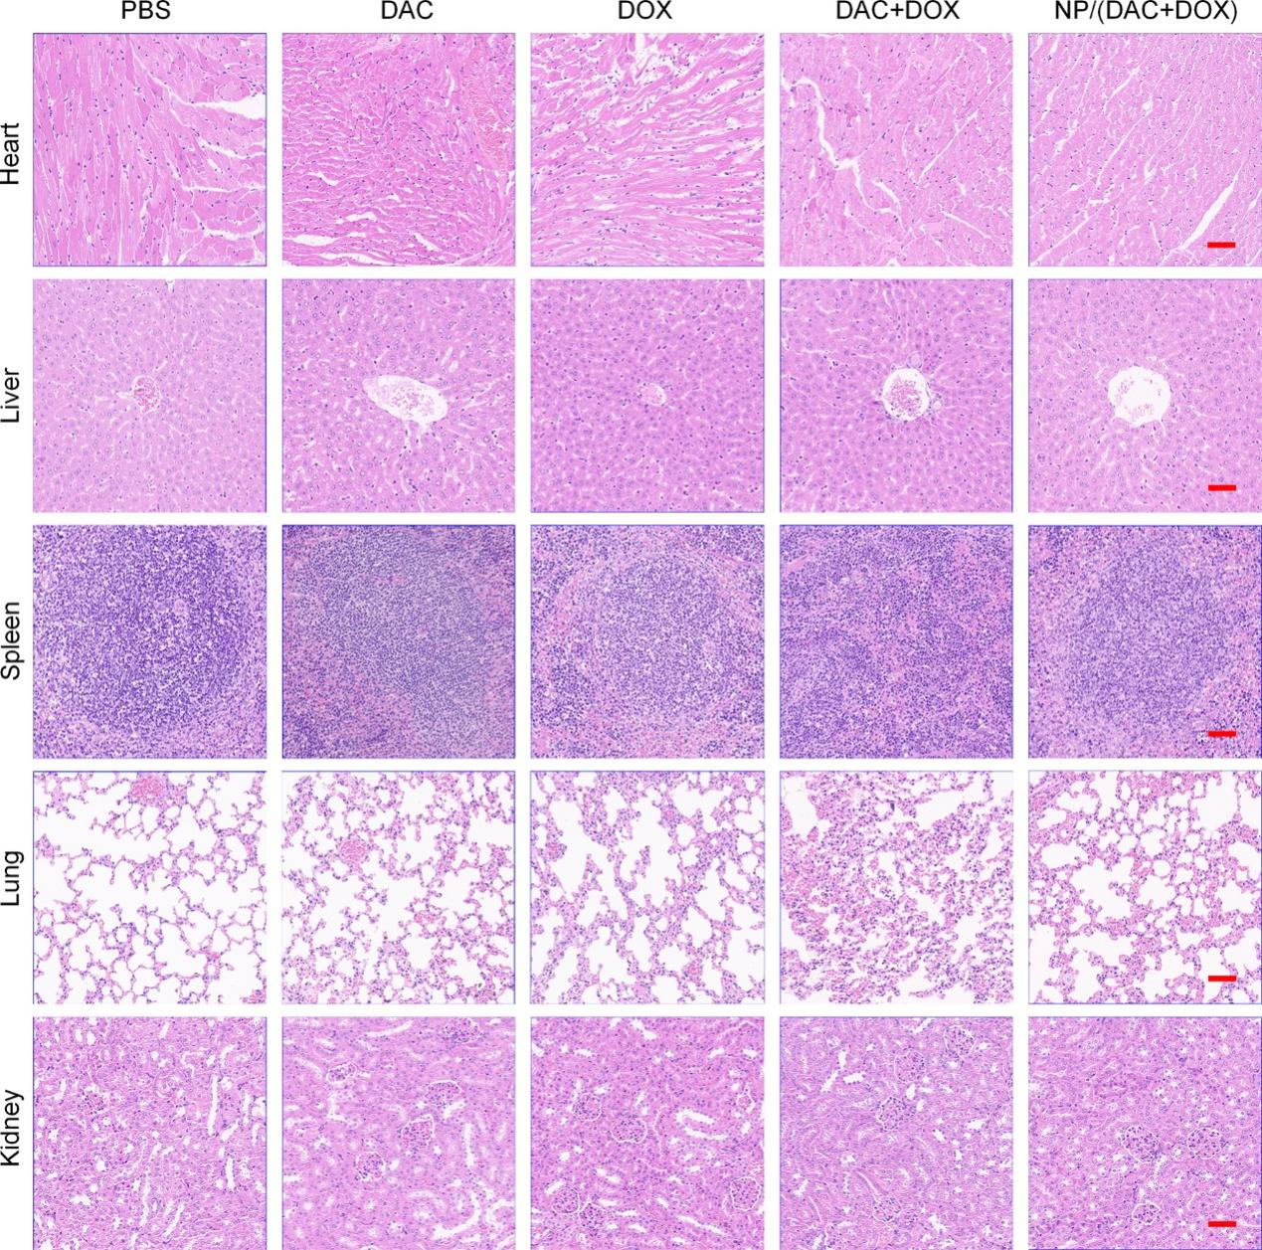
Figure S19. Histological analysis of major organs (i.e., heart, liver, spleen, lung, and kidney) obtained from the CT26 tumor-bearing mice treated with different formulations. Scale bar = 50 μm.

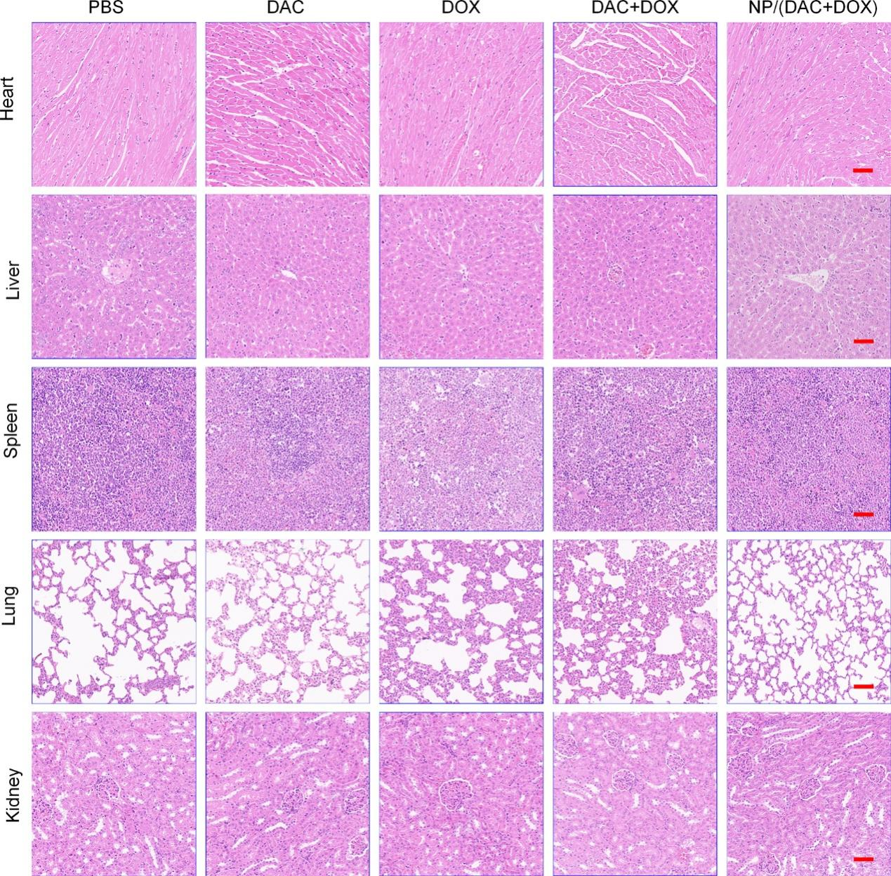
Figure S20. Histological analysis of major organs (i.e., heart, liver, spleen, lung, and kidney) obtained from the 4T1 tumor-bearing mice treated with different formulations. Scale bar = 50 μm.

