Functionalized carbon dots with intrinsic Wnt/β-catenin inhibition to synergistically promote chemotherapy
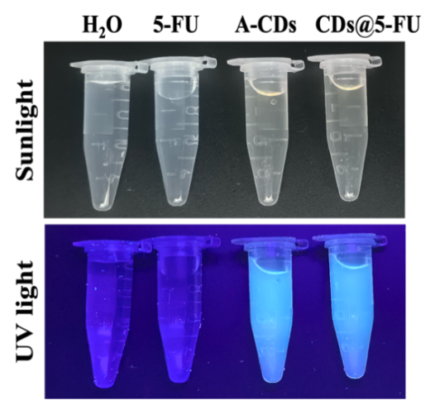
Figure S1. Photographs of H2O, 5-FU, A-CDs, and CDs@5-FU solutions under sunlight and UV light.
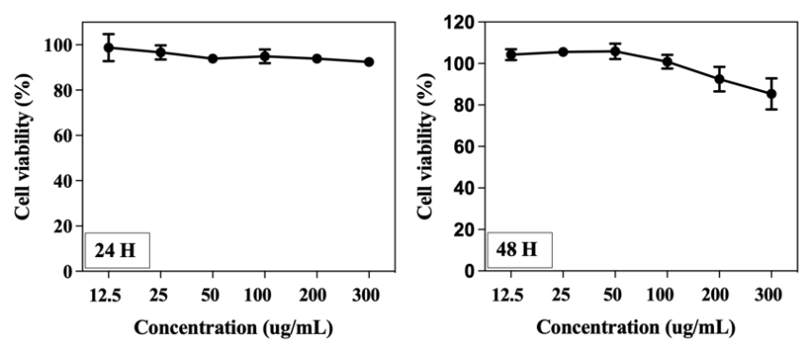
Figure S2. Cell viability of LLC-1 cells treated with A-CDs for 24 h and 48 h, respectively (n = 4).
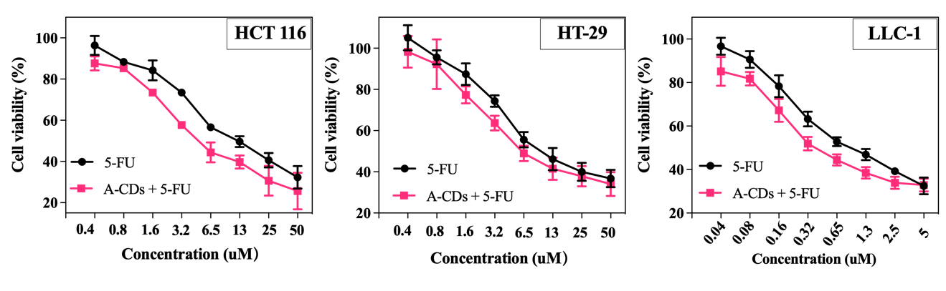Figure S3. Effect of single 5-FU treatment or combination treatment on cancer HCT116, HT-29 and LLC-1 cells.
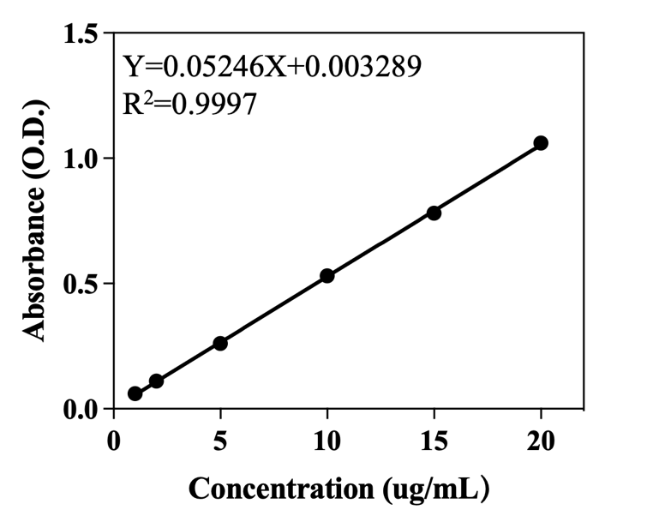
Figure S4. The calibration curve for 5-FU (1, 2, 5, 10, 15, 20 µg/mL) under UV-vis detector.
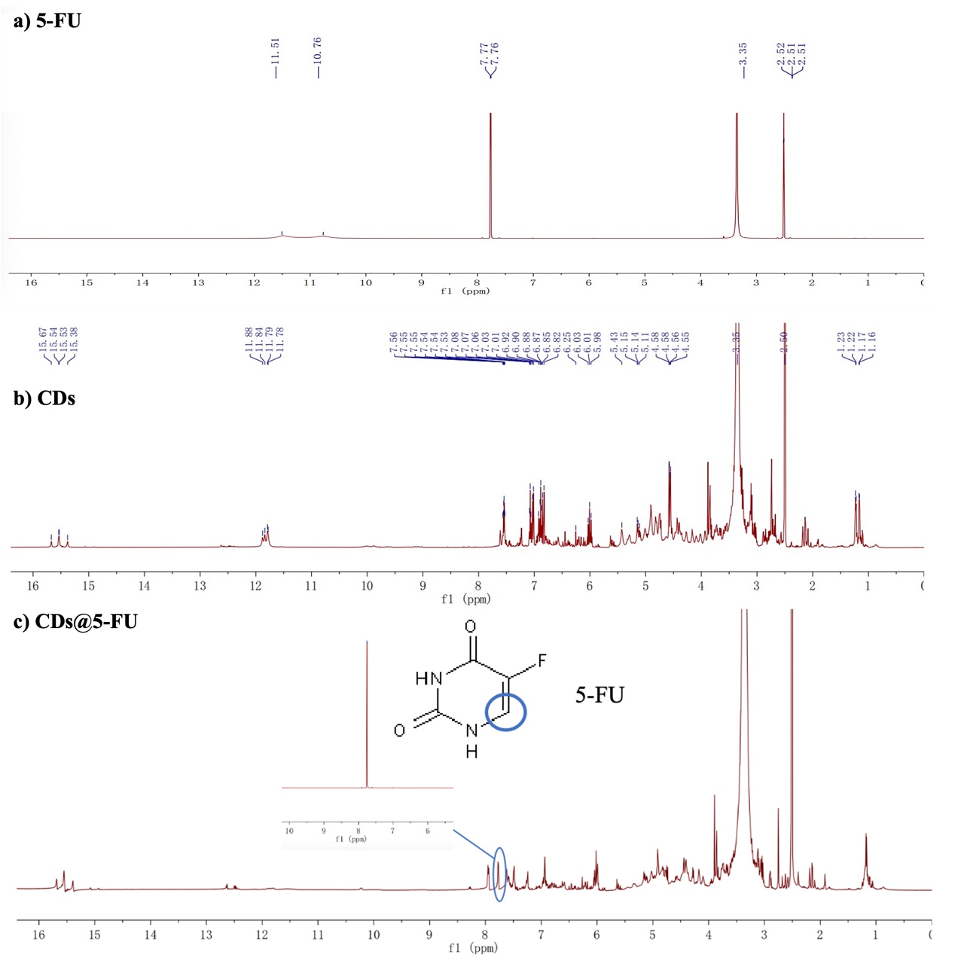
Figure S5. The NMR spectrum of a) 5-FU, b) CDs, and c) CDs@5-FU.
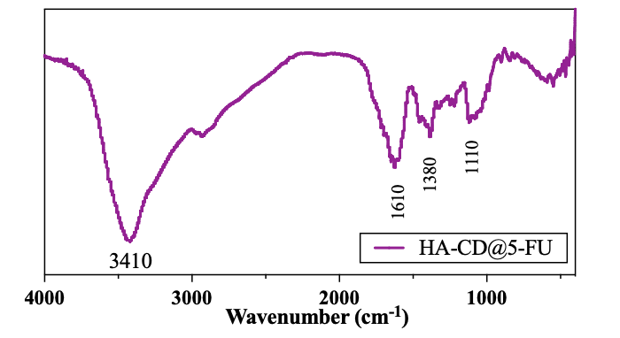
Figure S6. The FTIR spectra of HA-CDs@5-FU.
Figure S7. In vitro release behaviors of CDs@5-FU and HA-CDs@5-FU in the PBS solution (pH 6.8).
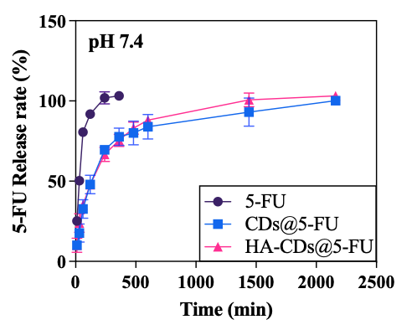
Figure S8. In vitro release behaviors of 5-FU, CDs@5-FU, and HA-CDs@5-FU in the PBS solution (pH 7.4).
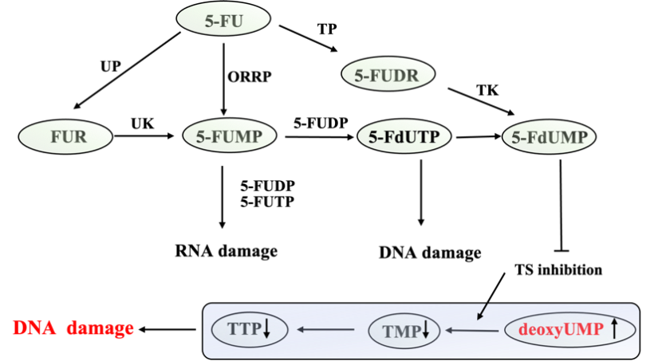
Figure S9. 5-Fluorouracil metabolism.
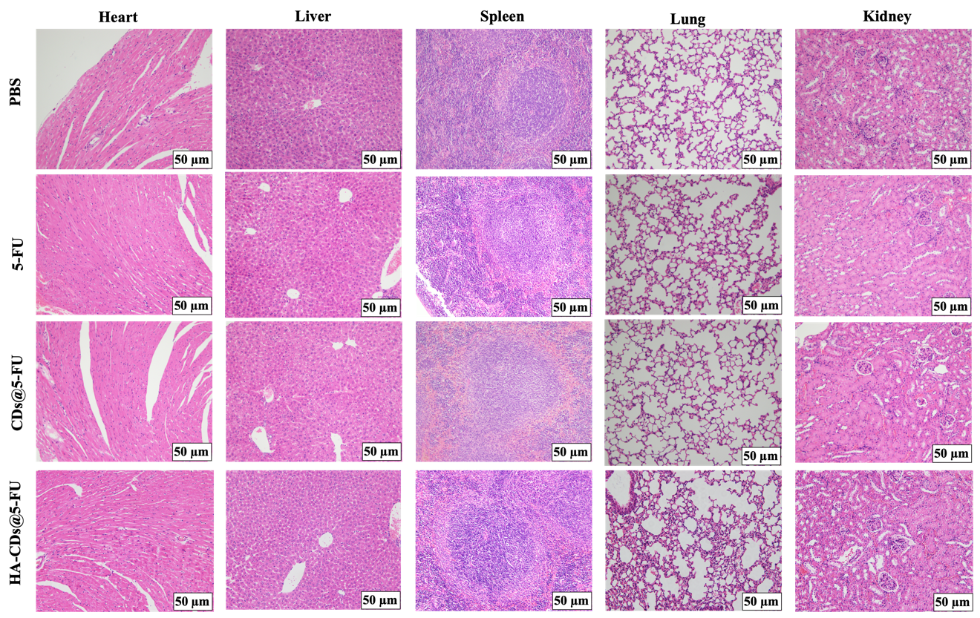
Figure S10. H&E staining histological images of tissue sections from major organs (heart, liver, lung, kidney, and spleen) after 25 days of treatments. Scale bars: 50 µm.
Table S1 IC₅₀ values of HCT 116, LLC-1, HT-29, and LO2 cells
 | HCT 116 (48 h) | LLC-1 (48 h) | HT-29 (72 h） | LO2 (48 h)
5-FU | 12.82 ± 2.72 | 1.11 ± 0.16 | 14.00 ± 2.00 | 33.53 ± 3.15
CDs@5-FU | 8.23 ± 2.47 * | 0.68 ± 0.08 * | 9.08 ± 1.58 * | 31.30 ± 4.36
HA-CDs@5-FU | 4.48 ± 1.22 **# | 0.44 ± 0.06 **# | 6.59 ± 0.79 * | 37.19 ± 9.89
Note: * p < 0.05, ** p < 0.01, compared with 5-FU group; # p < 0.05, compared with CDs@5-FU group).

Table S2 RNs pools in LLC-1 cells of different groups at 24 h (pmol/10⁶ cells).
 | Control | 5-FU | CDs@5-FU | HA-CDs@5-FU
AMP | 95.71 ± 12.72 | 133.18 ± 10.11 ** | 164.5 ± 22.28 **# | 21.5 ± 1.76
ADP | 472.15 ± 40.77 | 751.16 ± 124.03 ** | 1001.39 ± 179.27 **# | 221.87 ± 88.44 **##
ATP | 1417.76 ± 145.61 | 1806.11± 282.87 * | 2459.89 ± 282.87 **# | 4926.18 ± 564.11 **##
GMP | 41.32 ± 15.38 | 70.49 ± 6.48 ** | 93.26 ± 9.88 **## | 4.81 ± 3.65 **##
GDP | 86.12 ± 15.37 | 189.40 ± 42.7 ** | 238.12 ± 28.92 **# | 73.34 ± 14.12 #
GTP | 437.04 ± 74.78 | 717.03 ± 119.60 ** | 1397.32 ± 359.18 **## | 943.30 ± 159.98 **#
CMP | 87.73 ± 17.49 | 79.42 ± 14.05 | 56.27 ± 7.67 **## | 18.03 ± 4.91 **##
CDP | 87.53 ± 15.03 | 79.72 ± 15.1 | 78.57 ± 35.97 | 10.83 ± 4.48 **##
CTP | 349.69 ± 57.24 | 230.11 ± 104.07 | 212.77 ± 119.45 | 755.62 ± 389.12 *##
UMP | 62.23 ± 9.49 | 56.91 ± 12.31 | 39.58 ± 3.30 **## | 10.15 ± 4.37 **##
UDP | 85.29 ± 8.27 | 78.41 ± 3.92 | 72.79 ± 16.36 | 15.23 ± 9.02 **##
UTP | 859.26 ± 245.55 | 1018.70 ± 219.23 | 1003.30 ± 366.18 | 1879.08 ± 518.41
Note: ** p < 0.05, * p < 0.01, compared with control group. # p < 0.05, ## p < 0.01, compared with single 5-FU group.

Table S3 dRNs pools in LLC-1 cells of different groups at 24 h (pmol/10⁶ cells).
 | Control | 5-FU | CDs@5-FU | HA-CDs@5-FU
dAMP | 0.08 ± 0.03 | 0.17 ± 0.11 ** | 0.14 ± 0.03 ** | 0.04 ± 0.02 **##
dADP | 1.27 ± 0.54 | 2.45 ± 0.72 ** | 4.86 ± 1.44 **## | 0.49 ± 0.33 **#
dATP | 4.99 ± 4.27 | 14.82 ± 8.24 * | 38.31 ± 20.17 *# | 75.20 ± 23.26 **##
dGMP | 0.43 ± 0.23 | 0.29 ± 0.09 | 0.28 ± 0.13 | 0.05 ± 0.04
dCMP | 0.38 ± 0.22 | 0.50 ± 0.09 | 0.31 ± 0.17 | 0.03 ± 0.01 **##
dCDP | 0.82 ± 0.17 | 0.54 ± 0.24 * | 0.21 ± 0.10 **# | 0.09 ± 0.08 **##
dCTP | 4.76 ± 3.65 | 5.26 ± 4.97 | 6.52 ± 5.36 | 3.7 ± 2.85
TMP | 0.71 ± 0.12 | 0.44 ± 0.12 ** | 0.15 ± 0.02 **## | 0.01 ± 0.01 **##
TDP | 2.27 ± 0.59 | 1.76 ± 0.43 | 0.67 ± 0.32 **## | 0.06 ± 0.03 **##
TTP | 24.03 ± 13.7 | 8.47 ±3.48 * | 3.18 ± 2.09 **## | 9.84 ± 4.74 **
dUMP | 0.53 ± 0.28 | 21.56 ± 4.18 ** | 38.7 ± 5.67 **## | 68.65 ± 10.21 **##
Note: ∗ p < 0.05, ∗∗ p < 0.01, compared with control group. # p < 0.05, ## p < 0.01, compared with single 5-FU group.

