Supplementary file:

Acid-unlocked two-layer Ca-loaded nanoplatform to interfere with mitochondria for synergistic tumor therapy

Figure S1 XPS spectra showing the C 1s regions for CaO₂@ZIF8:CUR@PAA NPs

Figure S2 XRD patterns of CaO₂@ZIF8:CUR@PAA NPs with an enlargement of the CaO₂@ZIF8:CUR@PAA NPs pattern in the region 30-50°.

Figure S3 Particle size distribution of CaO₂, CaO₂@ZIF8 and CaO₂@ZIF8:CUR@PAA NPs

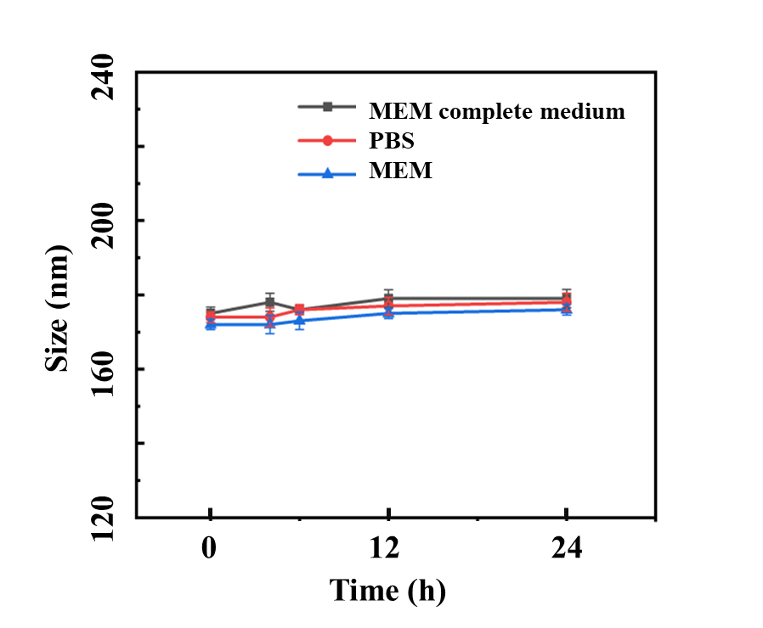

Figure S4 Particle size of CaO₂@ZIF8:CUR@PAA NPs as a function of time in MEM complete medium (with 10% v/v FBS), MEM and PBS

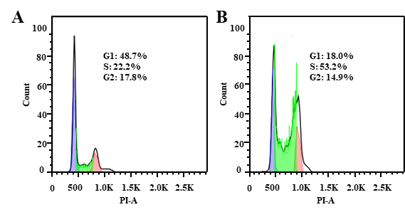
Figure S5 Proportion of 143B cells in different cycle phases after 24 h treatment with PBS (A) and CaO₂@ZIF8:CUR@PAA NPs (B).

Figure S6 Quantitative analysis of the DCFH-DA fluorescence intensity of 143B cells after various treatments. The data are displayed as mean ± S.D., n=3. *** P < 0.001, ** P < 0.01, *P < 0.05, N.S.: not significant.

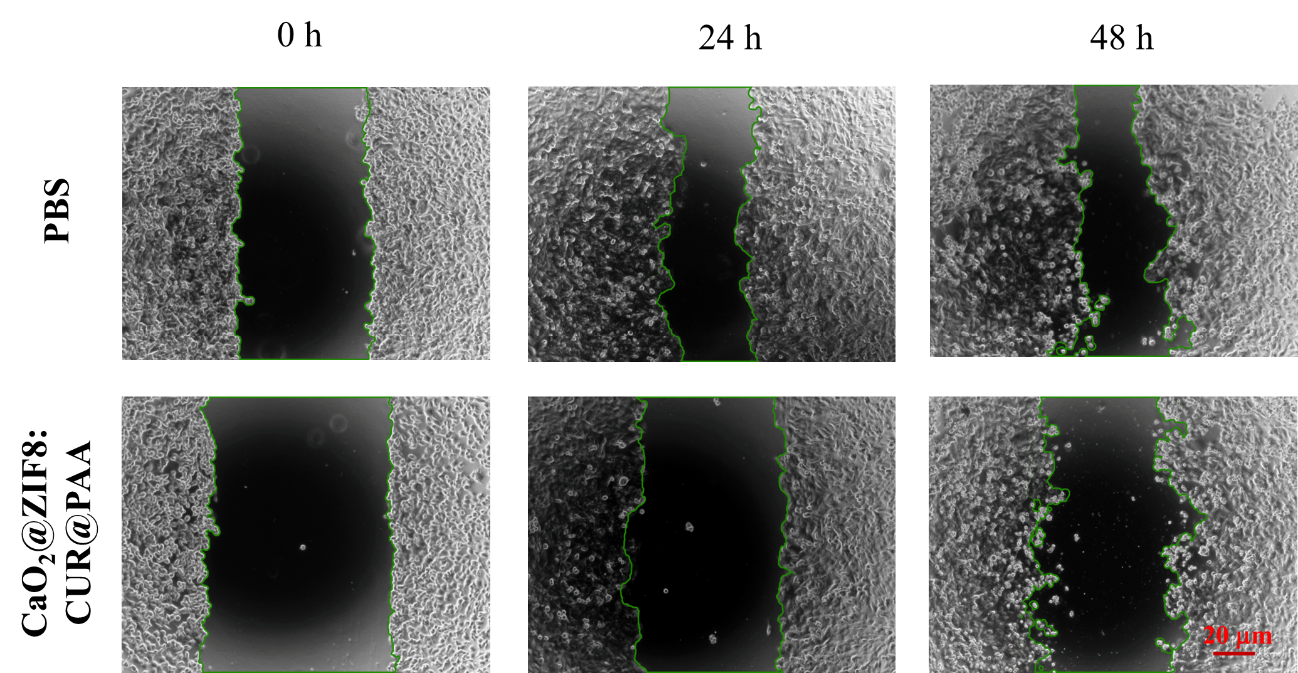
Figure S7 Results of a scratch assay to investigate the effect of CaO₂@ZIF8:CUR@PAA NPs on the lateral migration of 143B tumor cells.

Figure S8 Pharmacokinetic profile after intravenous injection of CaO₂@ZIF8:CUR@PAA. The data are displayed as mean ± S.D., n=3.

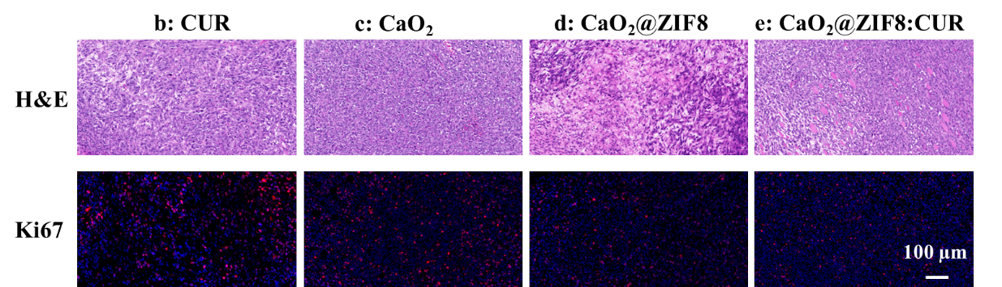
Figure S9 H&E and Ki67 staining of tumor tissue at the end of the treatment period.

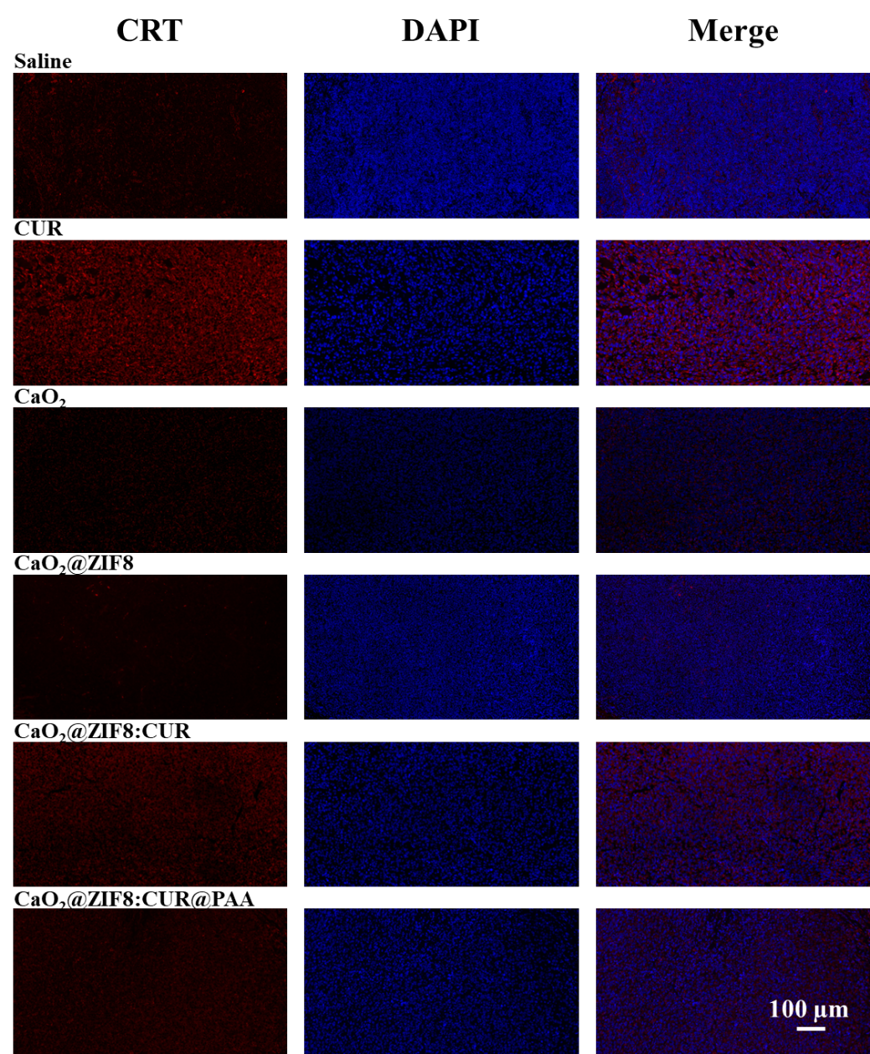
Figure S10 CRT staining of tumor tissue after various treatments. Blue fluorescence arises from DAPI-stained nuclei, and red fluorescence from CRT staining.

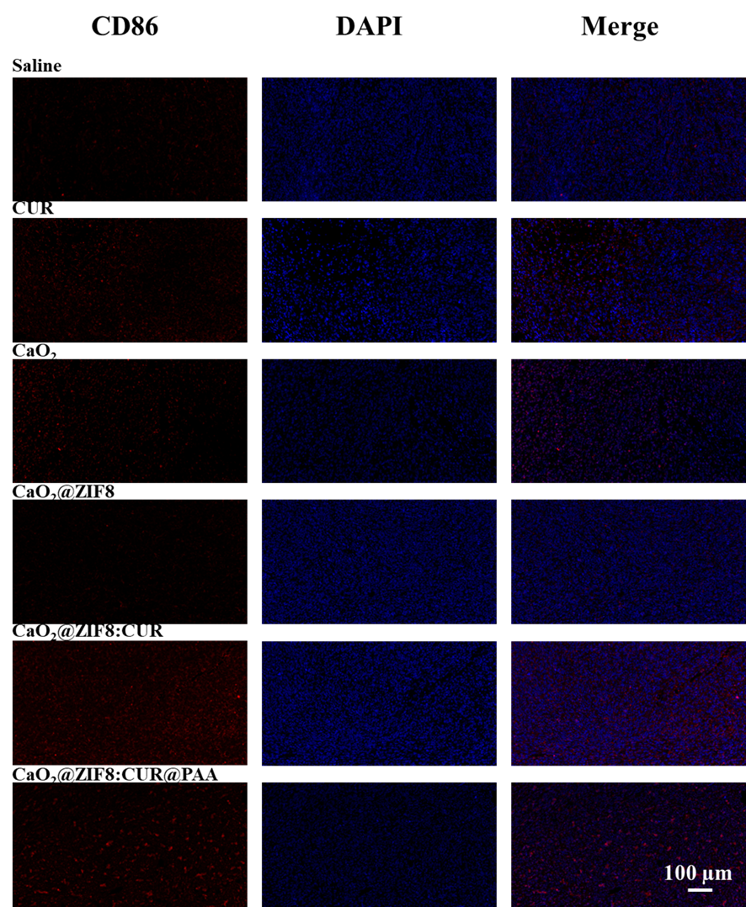
Figure S11 Staining of tumor tissue for the presence of CD86⁺ M1 macrophages after various treatments. Blue fluorescence arises from DAPI-stained nuclei, and red fluorescence from CD86 stained macrophages.

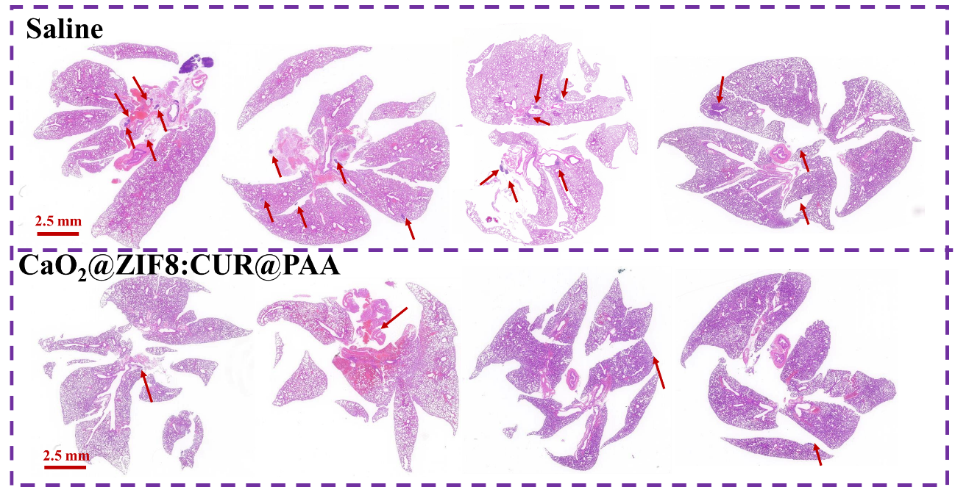
Figure S12 H&E staining of lung tissue after the treatment period. The area indicated by the arrow is the tumor lung metastasis area.

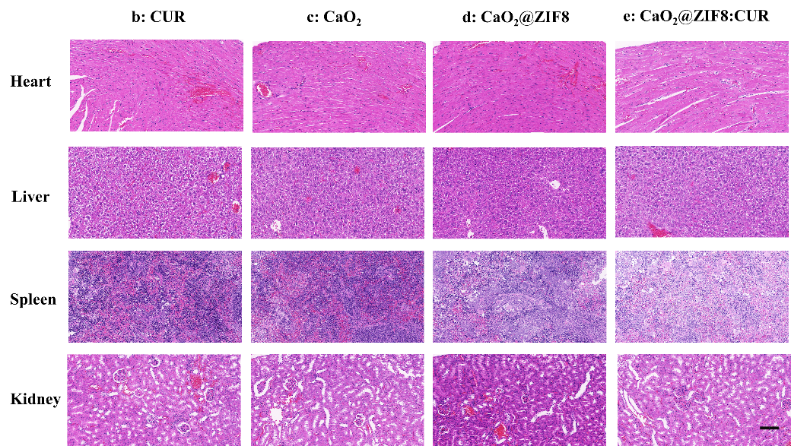

Figure S13 Histopathologic examination of organ sections (heart, liver, spleen and kidney) from BALB/c mice after different treatments (scale bar = 100 μm).

